Supplementary Figures

Supplementary Figure 1. FACS analysis confirming human DLBCL cells isolated from resected organs
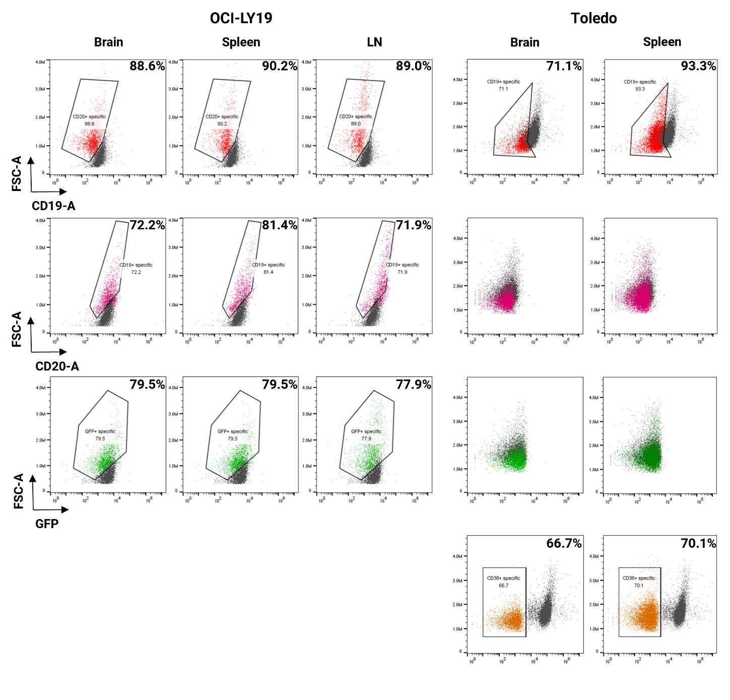

Supplementary Figure 2. Complete pathway enrichment results corresponding to Figure 2F.
