Supplementary materials
Rhizobium lichense sp. nov., a novel rhizobial species lacking nodC and nifH genes, isolated from a lichen sample Xanthoparmelia orientalis
Xiao-Li Wang¹, Da-Fei Luo¹, Shou-Hao Zhang¹, Shu-Ya Zuo¹, Guo-Hua Chen¹, Rui Yang¹, Li-Song Wang^{2,3}, Cheng-Lin Jiang¹, Xin-Yu Wang^{2,3}, Yi Jiang^{1*}

Authors affiliations:
¹ The Key Lab for Research & Development of Actinomycete Resources, Yunnan Institute of Microbiology, Chenggong Campus of Yunnan University, Chenggong District, Kunming (City) 650500, Yunnan, P. R. China.
² State Key Laboratory of Phytochemistry and Natural Medicines, Kunming Institute of Botany, Chinese Academy of Sciences, Kunming 650201, P. R. China.
³ Yunnan Key Laboratory for Fungal Diversity and Green Development, Kunming Institute of Botany, Chinese Academy of Sciences, Kunming 650201, P. R. China.

Authors Email:
Xiao-Li Wang-2568174547@qq.com; Da-Fei Luo-3081433131@qq.com; Shou-Hao Zhang-2123713259@qq.com; Shu-Ya Zuo-2505123742@qq.com; Guo-Hua Chen-3354146066@qq.com; Rui Yang-3037511571@qq.com; Li-Song Wang-wanglisong@mail.kib.ac.cn; Cheng-Lin Jiang-lihxu@ynu.edu.cn; Xin-Yu Wang-wangxinyu@mail.kib.ac.cn; Yi Jiang-jiangyi@ynu.edu.cn

*Corresponding authors:
Yi Jiang
E-mail: jiangyi@ynu.edu.cn

Table S1 Average Nucleotide Identity (%) and Digital DNA-DNA hybridization values (%) obtained for Rhizobium lichense YIM 134829^{T} strains and type strains from phylogenetically closely-related species calculated through Ezbiocloud online ANI calculator and Genome-to-Genome Distance Calculator 3.0 (GGDC)
strain | accession numbersª | ANI (%) | dDDH (%)
R. herbae CCBAU 83011^{T} | SAMN18247418 | 76.59 | 20.7
R. alarense TRM95111^{T} | SAMN24424999 | 75.87 | 20.9
R. azooxidifex Po 20/26^{T} | SAMN13172624 | 75.82 | 21.0
R. phaseoli ATCC 14482^{T} | SAMN10387098 | 75.44 | 20.3
R. metallidurans ChimEc512^{T} | SAMN13172625 | 75.06 | 20.4
R. pisi DSM 30132^{T} | SAMN10387321 | 74.99 | 20.0
R. esperanzae CNPSo 668^{T} | SAMN06555453 | 74.98 | 20.2
R. aethiopicum HBR26^{T} | SAMN04487815 | 74.95 | 20.5
R. fabae CCBAU 33202^{T} | SAMN10386394 | 74.90 | 19.9
R. vallis CCBAU 65647^{T} | SAMN10390720 | 74.86 | 20.1
R. laguerreae FB206^{T} | SAMN06094799 | 74.81 | 19.9
R. indigoferae CCBAU 71042^{T} | SAMN14341972 | 74.75 | 20.2
R. hainanense I66^{T} | SAMN04487811 | 74.53 | 20.4
R. endolithicum JC140^{T} | SAMEA5739410 | 74.44 | 19.9
R. mayense CCGE 526^{T} | SAMN33553147 | 74.33 | 20.2
R. altiplani BR 10423^{T} | SAMN04259806 | 74.24 | 20.1
R. viscosum LMG 16473^{T} | SAMN43282620 | 74.14 | 20.2
R. wuzhouense W44^{T} | SAMN09298572 | 74.12 | 19.9
R. mongolense USDA 1844^{T} | SAMN02440561 | 74.08 | 19.8
R. rhizophilum 7209-2^{T} | SAMN11458302 | 74.05 | 19.8
R. tubonense CCBAU 85046^{T} | SAMN07689693 | 73.79 | 19.7
R. rhizoryzae J3-AN59^{T} | SAMN14167853 | 72.82 | 20.4
R. helianthi CGMCC 1.12192^{T} | SAMN43282647 | 72.76 | 19.8
R. lemnae L6-16^{T} | SAMN27301724 | 72.67 | 19.5
R. skierniewicense Ch11^{T} | SAMN10606665 | 72.56 | 19.3
ANI, Average Nucleotide Identity; dDDH, Digital DNA-DNA hybridization; ª: GenBank Biosample accession numbers indicated in brackets.

Fig. S1 Maximum-likelihood phylogenetic tree based on 16S rRNA gene sequences shows the phylogenetic relationships of strain YIM 134829^{T} among closest related species of the genus Rhizobium. Bootstrap values >50% based on 1000 replications are shown at branching points. Bar, 0.01 substitutions per nucleotide position

Rhizobium jaguaris CCGE525^{T} (JX855169)
Rhizobium vallis CCBAU65647^{T} (FJ839677)
Rhizobium hainanense I66^{T} (U71078)
Rhizobium mayense CCGE526^{T} (JX855172)
Rhizobium laguerreae FB206^{T} (JN558651)
Rhizobium phaseoli ATCC 14482^{T} (EF141340)
Rhizobium fabae CCBAU 33202^{T} (DQ835306)
Rhizobium pisi DSM 30132^{T} (NR115253)
Rhizobium etli CFN 42^{T} (EU488751)
Rhizobium altiplani BR 10423^{T} (KX022634)
Rhizobium alamii GBV016^{T} (AM931436)
Rhizobium mesosinicum CCBAU 25010^{T} (DQ100063)
Rhizobium yanglingense SH22623^{T} (AF003375)
Rhizobium mongolense USDA 1844^{T} (U89817)
Rhizobium soli DS-42^{T} (EF363715)
Rhizobium panacihumi DCY116^{T} (KY996486 )
Rhizobium lichense YIM 134829^{T} (PQ821077)
Rhizobium helianthi CGMCC1.12192^{T} (NR145866)
Rhizobium capsici CC-SKC2^{T} (HQ113369)
Rhizobium rhizoryzae J3-AN59^{T} (EF649779)
Rhizobium lemnae L6-16^{T} (AB738386)
Rhizobium tarimense PL-41^{T} (HM371420)
Rhizobium pseudoryzae J3-A127^{T} (DQ454123)
Rhizobium straminoryzae CC-LY845^{T} (KF444510)
Rhizobium sphaerophysae CCNWGS0238^{T} (FJ154088)
Rhizobium herbae CCBAU 83011^{T} (NR117530)
Rhizobium skierniewicense Ch11^{T} (HQ823551)
Rhizobium rhizophilum 7209-2^{T} (KX017286)
Rhizobium wuzhouense W44^{T} (MF066952)
Azorhizobium caulinodans LMG 6465^{T} (X67221)
92
98
91
99
73
97
96
52
55
71
100
52
70
52
92
81
99
51
95
81
58
76
36
86
0.01

Fig. S2 Maximum-parsimony phylogenetic tree based on 16S rRNA gene sequences shows the phylogenetic relationships of strain YIM 134829^{T} among closest related species of the genus Rhizobium. Bootstrap values > 50% based on 1000 replications are shown at branching points
Rhizobium pseudoryzae J3-A127^{T} (DQ454123)
Rhizobium straminoryzae CC-LY845^{T} (KF444510)
Rhizobium capsici CC-SKC2^{T} (HQ113369)
Rhizobium helianthi CGMCC1.12192^{T} (NR 145866)
Rhizobium lichense YIM 134829^{T} (PQ821077)
Rhizobium lemnae L6-16^{T} (AB738386)
Rhizobium tarimense PL-41^{T} (HM371420)
Rhizobium rhizoryzae J3-AN59^{T} (EF649779)
Rhizobium panacihumi DCY 116^{T} (KY996486 )
Rhizobium soli DS-42^{T} (EF363715)
Rhizobium mongolense USDA 1844^{T} (U89817)
Rhizobium yanglingense SH 22623^{T} (AF003375)
Rhizobium alamii GBV 016^{T} (AM931436)
Rhizobium mesosinicum CCBAU 25010^{T} (DQ100063)
Rhizobium laguerreae FB 206^{T} (JN558651)
Rhizobium phaseoli ATCC 14482^{T} (EF141340)
Rhizobium fabae CCBAU 33202^{T} (DQ835306)
Rhizobium pisi DSM 30132^{T} (NR115253)
Rhizobium etli CFN 42^{T} (EU488751)
Rhizobium vallis CCBAU 65647^{T} (FJ839677)
Rhizobium jaguaris CCGE 525^{T} (JX855169)
Rhizobium hainanense I66^{T} (U71078)
Rhizobium mayense CCGE 526^{T} (JX855172)
Rhizobium altiplani BR 10423^{T} (KX022634)
Rhizobium herbae CCBAU 83011^{T} (NR117530)
Rhizobium sphaerophysae CCNWGS 0238^{T} (FJ154088)
Rhizobium skierniewicense Ch11^{T} (HQ823551)
Rhizobium rhizophilum 7209-2^{T} (KX017286)
Rhizobium wuzhouense W44^{T} (MF066952)
Azorhizobium caulinodans LMG 6465^{T} (X67221)
97
86
99
86
99
86
94
75
99
89
100
69
76
100
10.00

Fig. S3 Neighbor-joining phylogenetic tree based on atpD (ATP synthase subunit beta) gene sequences shows the phylogenetic relationships of strain YIM 134829^{T} among closest related species of the genus Rhizobium. Bradyrhizobium agreste CNPSo 4010^{T} (MT683853) was used as an outgroup. Bootstrap values > 50% based on 1000 replications are shown at branching points. Bar, 0.02 substitutions per nucleotide position

Rhizobium changzhiense WYCCWR 11279^{T} (MH778818)
Rhizobium sophorae CCBAU 03386^{T} (KJ831235)
Rhizobium anhuiense CCBAU 23252^{T} (JQ585863)
Rhizobium sophoriradicis CCBAU 03470^{T} (KJ8312310
Rhizobium vallis CCBAU 65647^{T} (GU211768)
Rhizobium fabae CCBAU 33202^{T} (EF579929)
Rhizobium pisi DSM 30132^{T} (DQ431673)
Rhizobium sullae IS123^{T} (DQ345069)
Rhizobium mongolense USDA1844^{T} (AY907372)
Rhizobium lentis BLR27^{T} (JN648941)
Rhizobium miluonense CCBAU 41251^{T} (HM047116)
Rhizobium multihospitium CCBAU 83401^{T} (EF490019)
Rhizobium lichense YIM 134829^{T} (PX726326)
Rhizobium herbae CCBAU 83011^{T} (GU565542)
Rhizobium huautlense HAMBI 2409^{T} (KF206569)
Rhizobium vignae HAMBI 3093^{T} (KF206603)
Rhizobium aquaticum SA-276^{T} (KY947543)
Rhizobium helianthi CGMCC 1.12192^{T} (JX094429)
Rhizobium grahamii CCGE 502^{T} (JF424612)
Rhizobium cauense CCBAU 101002^{T} (JQ308329)
Rhizobium rosettiformans W3^{T} (GU559878)
Rhizobium panacihumi DCY116^{T} (MF314825)
Rhizobium paknamense L6-8^{T} (AB739026)
Rhizobium pseudoryzae J3-A127^{T} (KJ863423)
Rhizobium taibaishanense HAMBI 3214^{T} (KF206635)
Bradyrhizobium agreste CNPSo 4010^{T} (MT683853)
53
87
99
99
52
93
98
82
62
52
54
88
0.02

Fig. S4 Neighbor-joining phylogenetic tree based on glnII (glutamine synthetase II) gene sequences shows the phylogenetic relationships of strain YIM 134829^{T} among closest related species of the genus Rhizobium. Bradyrhizobium agreste CNPSo 4010^{T} (MK860831) was used as an outgroup. Bootstrap values > 50% based on 1000 replications are shown at branching points. Bar, 0.05 substitutions per nucleotide position
Rhizobium anhuiense CCBAU 23252^{T} (JQ585847)
Rhizobium indigoferae CCBAU 71042^{T} (JN580717)
Rhizobium changzhiense WYCCWR 11279^{T} (MT169727)
Rhizobium sophorae CCBAU 03386^{T} (KJ831241)
Rhizobium vallis CCBAU 65647^{T} (GU211771)
Rhizobium lentis BLR27^{T} (JN648976)
Rhizobium sophoriradicis CCBAU 03470^{T} (KJ831237)
Rhizobium vignae HAMBI 3093^{T} (KF206775)
Rhizobium herbae CCBAU 83011^{T} (GU565556)
Rhizobium lusitanum P1-7^{T} (EF639841)
Rhizobium miluonense CCBAU 41251^{T} (HM047120)
Rhizobium multihospitium CCBAU 83401^{T} (EF490040)
Rhizobium rosettiformans W3^{T} (KX131139)
Rhizobium skierniewicense Ch11^{T} (KX131141)
Rhizobium aquaticum SA-276^{T} (KY947544)
Rhizobium mongolense USDA 1844^{T} (AY929453)
Rhizobium sullae IS123^{T} (FJ816280)
Rhizobium helianthi CGMCC 1.12192^{T} (JX123317)
Rhizobium pseudoryzae J3-A127^{T} (HM132108)
Rhizobium grahamii CCGE 502^{T} (JF424618)
Rhizobium cauense CCBAU 101002^{T} (JQ308332)
Rhizobium mesoamericanum CCGE 501^{T} (JF424617)
Bradyrhizobium agreste CNPSo 4010^{T} (MK860831)
Rhizobium lichense YIM 134829^{T} (PX726328)
Rhizobium panacihumi DCY116^{T} (MF314826)
100
99
63
99
77
99
96
78
67
82
97
73
59
57
53
58
43
0.05

Fig. S5 Annotation of biosynthetic gene clusters (BGCs) of strain YIM 134829^{T}, identified by antiSMASH (version 8.0.4.)
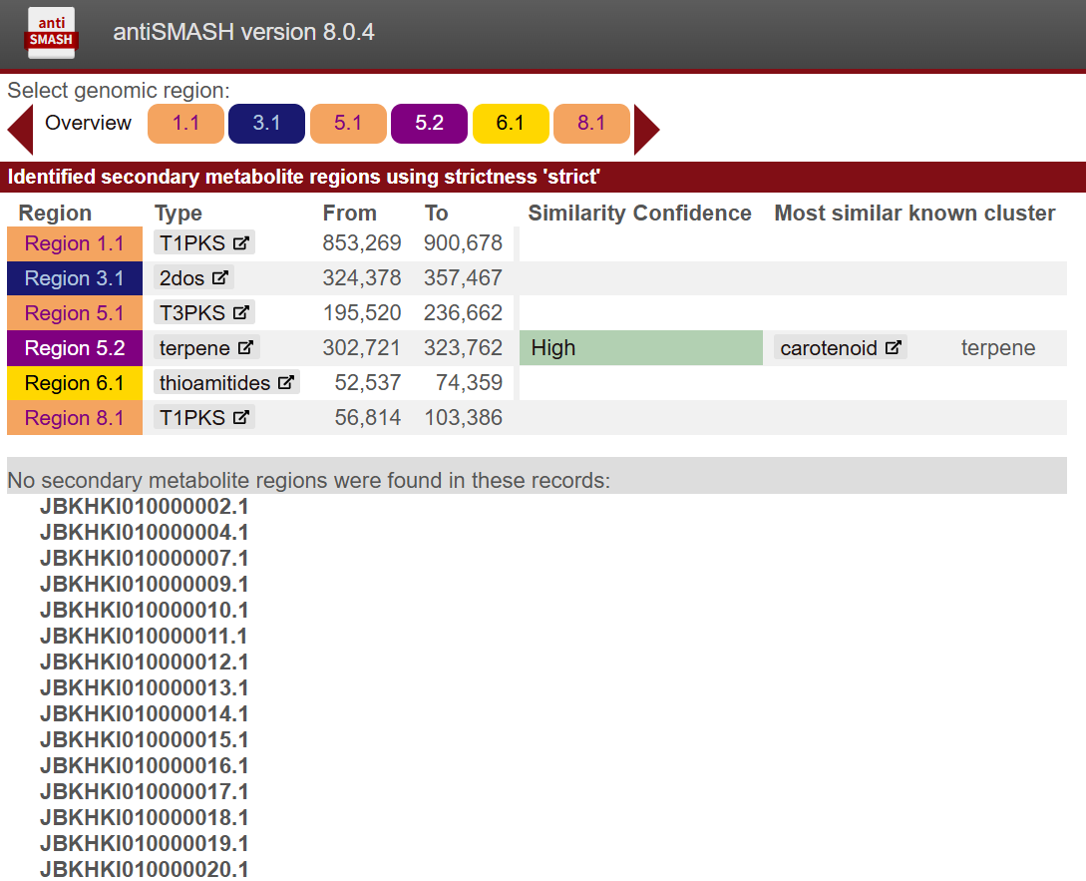

Fig. S6 Polar lipids profiles of strain YIM 134829^{T} after two-dimensional TLC (2D-TLC). PG, phosphatidylglycerol; DPG, diphosphatidylglycerol; PE, phosphatidyletha nolamine; PME, phosphatidylmethylethanolamine; PC, phosphatidylcholine; PL, unidentified phospholipids; L, unidentified lipids. A: phosphomolybdic acid chromogenic reagents; B: molybdenum blue chromogenic reagents; C: ninhydrin chromogenic reagents
