Quantum-resilient optical links using micro-LEDs generated quantum random numbers and physical unclonable functions
Heming Lin¹, Wenqing Niu¹, Taeyong Park¹, Hang Lu¹, Zhican Zhou¹, Yating Wan¹, Tien Khee Ng^{1,} *, Boon S. Ooi^{1, 2,} *
¹ Electrical and Computer Engineering Department, Computer Electrical and Mathematical Sciences and Engineering Division, King Abdullah University of Science and Technology (KAUST), Thuwal 23955-6900, Saudi Arabia
²Department of Electrical, Computer, and Systems Engineering, Rensselaer Polytechnic Institute, Troy, NY, USA
³Korea Institute of Ceramic Engineering and Technology (KICET), Jinju, Republic of Korea
[*] Corresponding Author
Email: tienkhee.ng@kaust.edu.sa, boon.ooi@kaust.edu.sa, ooib@rpi.edu

Supplementary Section 1 | Fabrication process of micro-LEDs
Supplementary Section 2 | Quantum and classical noise contributions in micro-LED-based QRNG
Supplementary Section 3 | Statistical evaluation of bits distribution histogram at different processing stages
Supplementary Section 4 | Statistical validation of randomness using NIST SP 800-22 and Dieharder tests
Supplementary Section 5 | Scalability and device-to-device uniformity of micro-LEDs for QRNG and PUF applications
Supplementary Section 6 | Neural network architecture for micro-LED-based PUF extraction
Supplementary Section 7 | Fuzzy extractor implementation for PUF key stabilization
Supplementary Section 8 | High-temperature stability of micro-LED-based PUFs
Supplementary Section 9 | QRNG- and PUF-enabled post-quantum cryptographic framework
Supplementary Section 10 | Experimental configuration and implementation of the optical wireless communication link
Supplementary References
Appendix | Pseudo-code of micro-LED-based PUF extraction framework

Supplementary Section 1. Fabrication process of micro-LEDs
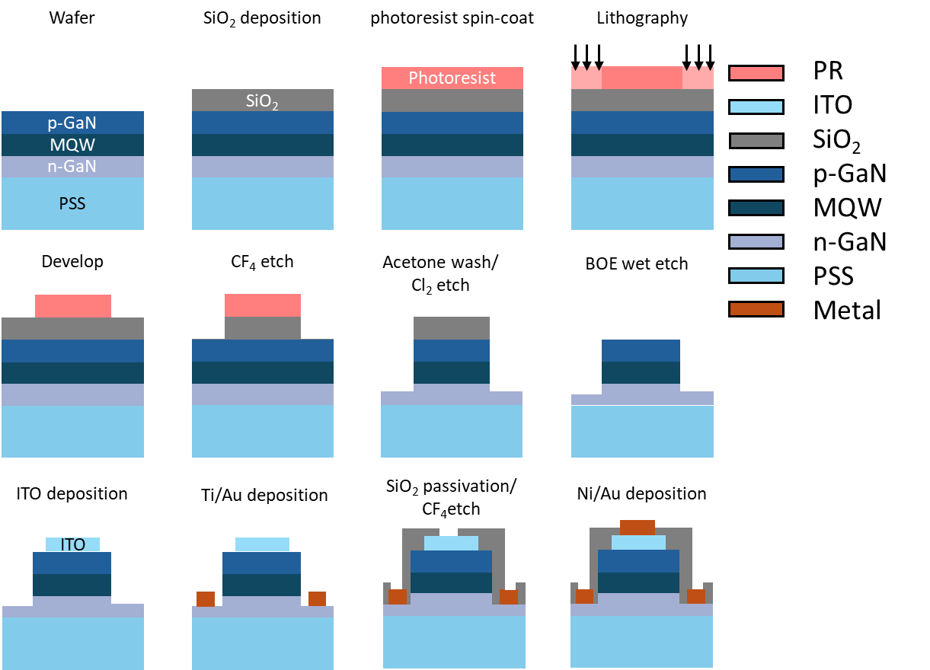
Supplementary figure 1. Schematic of fabrication process of micro-LEDs¹.

Supplementary Section 2. Quantum and classical noise contributions in micro-LED-based QRNG
In the active region of the micro-LED, radiative recombination of an electron-hole pair from an initial electronic state $\left.|i\right\rangle$ to a final state $\left.|f\right\rangle$, accompanied by the emission of a photon, is governed by Fermi’s golden rule. The transition rate is²
$$\begin{aligned}W_{i→j}=\frac{2π}{ℏ}{\left|〈f\left|{\hat{H}}_{int}\right|i〉\right|}^{2}ρ\left(ℏω\right),\#\left(S1\right)\end{aligned}$$
where ${\hat{H}}_{int}=-\hat{d}∙\hat{E}$ is the light-matter interaction Hamiltonian, $\hat{d}$ is the dipole operator and $\hat{E}$ is the quantized electric field. Summing over all photon modes at frequency $ω_{0}$ gives the total spontaneous emission rate³
$$\begin{aligned}Γ_{sp}=\sum_{k, σ}{W_{i→f, kσ}}=\frac{2π}{ℏ}{\left|d_{if}\right|}^{2}ρ_{ph}\left(ω-0 \right),\#\left(S2\right)\end{aligned}$$
where $d_{if}=\left\langle f | \hat{d} | i\right\rangle$ and $ρ_{ph}(ω_{0})$ is the photonic density of states at $ω_{0}$. In free space this reduces to
$$\begin{aligned}Γ_{sp}^{0}=\frac{ω_{0}^{3}{\left|d_{if}\right|}^{2}}{3πε_{0}ℏc^{3}}.\#\left(S3\right)\end{aligned}$$
In micro-LED cavities, the total spontaneous emission rate can be written as
$$\begin{aligned}Γ_{sp}=F_{p}Γ_{sp}^{0},\#\left(S4\right)\end{aligned}$$
where $F_{p}$ is the Purcell factor that accounts for local modifications of $ρ_{ph}\left(ω_{0}, r\right).$
Crucially, $Γ_{sp}$ is a constant rate for a given local environment and carrier population. This implies that each electron–hole pair behaves as a quantum two-level system with a memoryless decay process.
For a single emitter with spontaneous emission rate $Γ_{sp},$ the probability that a photon is emitted in a short time interval $[t, t+dt]$, given that no emission has occurred before $t$, is
$$\begin{aligned}p\left(emission in \left[t, t+dt\right]\right)=Γ_{sp}dt+Ο\left({dt}^{2}\right).\#\left(S5\right)\end{aligned}$$
Solving the rate equation
$$\begin{aligned}\frac{dP_{0}\left(t\right)}{dt}=-Γ_{sp}P_{0}\left(t\right),\#\left(S6\right)\end{aligned}$$
$$\begin{aligned}P_{0}\left(t\right)=e^{-Γ_{sp}t}.\#\left(S7\right)\end{aligned}$$
So, the waiting-time distribution for an emission event is exponential, written as
$$\begin{aligned}p_{wait}\left(t\right)=Γ_{sp}e^{-Γ_{sp}t},\#\left(S8\right)\end{aligned}$$
which is the defining property of a Poisson point process. For an ensemble of $N_{act}$ independent emitters in the active region, the total emission process is again Poissonian, with effective rate
$$\begin{aligned}Λ=N_{act}Γ_{sp}.\#\left(S9\right)\end{aligned}$$
Hence, the number of photons radiated into a given spatial angle and spectral band during a time window $τ_{e}$ follows
$$\begin{aligned}N_{emit}\sim Poisson\left(μ_{0}\right), \#\left(S10\right)\end{aligned}$$
where $μ_{0}=Λ_{eff}τ_{e},$ and $Λ_{eff}$ includes the effect of the emission pattern, extraction efficiency and internal quantum efficiency.
A fraction $η$ of the emitted photons is collected and directed onto the PD. Within a detection window $τ_{d}$, the number of incident photon is
$\begin{aligned}N_{detect}\sim Poisson\left(μ\right),\#\left(S11\right)\end{aligned}$where $μ=\frac{ηPτ_{d}}{hν}$, $P$ is the optical power incident on the detector and $hν$ is the photon energy. Each detected photon produces one electron-hole pair, so the photoelectron number $N_{e}$ satisfies
$$\begin{aligned}N_{e}\sim Poisson\left(μ_{e}\right),\#\left(S12\right)\end{aligned}$$
where $μ_{e}=η_{d}μ$, $η_{d}$ is the detector quantum efficiency. The corresponding average current and variance in a bandwidth $B≈\frac{1}{2τ_{d}}$ are
$$\begin{aligned}〈I〉=\frac{qμ_{e}}{τ_{d}},\#\left(S13\right)\end{aligned}$$
$$\begin{aligned}Var\left(I\right)=2q〈I〉B,\#\left(S14\right)\end{aligned}$$
which is the standard shot-noise relation
$$\begin{aligned}S_{I,q}\left(f\right)=2q〈I〉 \left(\frac{A^{2}}{Hz}\right).\#\left(S15\right)\end{aligned}$$
After transimpedance amplification with gain $R_{T}$, the quantum-limited voltage noise spectral density reads
$$\begin{aligned}S_{V,q}\left(f\right)=R_{T}^{2}\left(f\right)2q〈I〉=α_{q}\left(f\right)P, \#\left(S16\right)\end{aligned}$$
where $〈I〉=RP$, $α_{q}\left(f\right)$ is frequency-dependent quantum noise transfer coefficient, R is PD responsivity.
This behavior is consistent with a Poissonian emission model under steady-state and independence assumptions constituting the fundamental quantum noise floor of the micro-LED-based source.
In practice, the measured voltage at the ADC input contains additional classical contributions $V_{c}(t)$, including LED RIN, thermal noise, electronics noise, etc.:
$$\begin{aligned}V\left(t\right)=V_{q}\left(t\right)+V_{c}\left(t\right),\#\left(S17\right)\end{aligned}$$
with total spectral density
$$\begin{aligned}S_{tot}\left(f\right)=S_{V, q}\left(f\right)+S_{V,c}\left(f\right).\#\left(S18\right)\end{aligned}$$
Classical excess noise contains intensity noise (e.g., LED RIN), for which the fluctuations scale with optical power, resulting in a voltage noise power spectral density exhibits a quadratic dependence on the optical power, i.e., $S_{V, RIN}∝P^{2}$.
$$\begin{aligned}S_{V, RIN}\left(f\right)=α_{c}\left(f\right)P^{2},\#\left(S19\right)\end{aligned}$$
where $α_{c}(f)$ denotes the frequency-dependent transfer coefficient of classical excess noise.
The power-independent contributions, including thermal and electronics noise form an additive floor for classical noise:
$$\begin{aligned}S_{V, c}=S_{V, RIN}+S_{V, in},\#\left(S20\right)\end{aligned}$$
$$\begin{aligned}S_{V, in}\left(f\right)=α_{0}\left(f\right),\#\left(S21\right)\end{aligned}$$
where $α_{0}(f)$ describes the power-independent noise floor.
Another classical noise is technical excess noise, which is also important at low-current injection condition, including current-source noise, non-ideal carrier fluctuations at low injection in the LED active region, et al. It doesn’t have a clear relationship with power $P$, the variance of which can be noted as $σ_{tech}^{2}$.
The band-limited variance $σ_{V}^{2}(P)$ over a specific frequency interval $[f_{1}, f_{2}]$ then can be written as:
$$\begin{aligned}σ_{V}^{2}\left(P\right)=\int_{f_{1}}^{f_{2}}{S_{tot}^{ }\left(f;P\right)df}\#\left(S22\right)\end{aligned}$$
$$\begin{aligned}σ_{V}^{2}\left(P\right)=\int_{f_{1}}^{f_{2}}{S_{V,q}^{ }\left(f;P\right)df}+\int_{f_{1}}^{f_{2}}{S_{V,RIN}^{ }\left(f;P\right)df}+\int_{f_{1}}^{f_{2}}{S_{V,in}^{ }\left(f\right)df}+σ_{tech}^{2},\#\left(S23\right)\end{aligned}$$
$$\begin{aligned}σ_{V}^{2}\left(P\right)=\left(\int_{f_{1}}^{f_{2}}{α_{q}\left(f\right)df}\right)P+\left(\int_{f_{1}}^{f_{2}}{α_{c}\left(f\right)df}\right)P^{2}+\int_{f_{1}}^{f_{2}}{α_{0}\left(f\right)df}+σ_{tech}^{2},\#\left(S24\right)\end{aligned}$$
which can be written compactly as
$$\begin{aligned}σ_{V}^{2}=g_{Q}P+g_{C}P^{2}+BG+σ_{tech}^{2},\#\left(S25\right)\end{aligned}$$
where
$$\begin{aligned}g_{Q}=\int_{f_{1}}^{f_{2}}{α_{q}\left(f\right)df}, g_{C}=\int_{f_{1}}^{f_{2}}{α_{c}\left(f\right)df}, BG=\int_{f_{1}}^{f_{2}}{α_{0}\left(f\right)df}.\#\left(S26\right)\end{aligned}$$
In a specific frequency interval $[f_{1}, f_{2}]$ where $S_{tot}(f)$ is flat and close to $R_{T}^{2}2q〈I〉$, define:
$$\begin{aligned}S_{V,q}^{\left(lb\right)}\left(f\right)=\min\left(S_{tot}\left(f\right), R_{T}^{2}2q〈I〉\right),\#\left(S27\right)\end{aligned}$$
and obtain a certified quantum variance
$$\begin{aligned}σ_{q}^{2}=\int_{f_{1}}^{f_{2}}{S_{V,q}^{\left(lb\right)}\left(f\right)}.\#\left(S28\right)\end{aligned}$$
In an untrusted environment, all remaining variance $σ_{c}^{2}=σ_{tot}^{2}-σ_{q}^{2}$ can be conservatively treated as classical and potentially known to an adversary.
Under this consideration, for an n-bit ADC with quantization step $Δ$, each sample $K$ results from quantizing a continuous voltage $V$ that can be modelled, conditioned on any classical side information, as a Gaussian variable with variance at least $σ_{q}^{2}$. The conditional min-entropy per sample is then lower-bounded by
$$\begin{aligned}H_{min}\left(K | classical\right)≳\log_{2}\left(\frac{\sqrt{2π}σ_{q}}{Δ}\right),\#\left(S29\right)\end{aligned}$$
which quantifies the provable quantum randomness per ADC output value. A suitable randomness extractor (Toeplitz Hash, Trevisan Extractor, etc.) can compress the raw sequence to nearly uniform bits whose unpredictability is ultimately rooted in the spontaneous-emission process described by Fermi’s golden rule.
Although a strict separation of quantum and classical noise is not experimentally accessible, evaluating their relative contributions remains useful for characterizing the operating regime of the system. the expression of band limited variance $σ_{V}^{2}$ can be reformed as:
$$\begin{aligned}\frac{σ_{V}^{2}-BG}{P}=g_{Q}+g_{C}P+\frac{σ_{tech}^{2}}{P},\#\left(S30\right)\end{aligned}$$
The power-independent part $BG$ is measured by turning the electronics on (including amplifier and APD) without injecting any current to the micro-LED.
Figure S2. a shows the integrated RF noise power of the QRNG system measured with and without background noise. As the injection current increases toward 60 mA, the integrated RF power gradually saturates at approximately −9 dBm, indicating the upper operating limit of the detection chain under the present measurement conditions. Figure S2. b presents the optical-power dependence of the background-subtracted noise variance normalized by the optical power, $(σ_{V}^{2}-B)∙P^{-1}$. No region with a positive slope is observed over the entire measurement range, excluding the dominance of relative intensity noise (RIN). At low optical powers ($<0.5$ mW), the rapid decrease of the normalized noise variance reflects the contribution of excess technical noise, which is progressively suppressed with increasing optical power. At higher powers, the curve gradually flattens, indicating an increasing contribution from quantum noise. The normalized noise variance can be described by a constant-plus-inverse-power model,
$$\begin{aligned}\frac{σ_{V}^{2}-BG}{P}=g_{Q}+\frac{σ_{tech}^{2}}{P},\#\left(S31\right)\end{aligned}$$
from which a quantum noise coefficient of $g_{Q}=4.589×{10}^{-4} V^{2}/mW$ and a constant technical noise term of $σ_{tech}^{2}=8.105×{10}^{-4} V^{2}$ are extracted. The excellent goodness of fit ($R^{2}=0.9982$) confirms the validity of the noise decomposition.
Figure S2. c depicts quantum noise fraction $η_{q}$ evaluated with and without background noise, defined respectively as:
$$\begin{aligned}η_{q, woBG}=\frac{g_{q}∙P}{σ_{V}^{2}-BG}=\frac{g_{q}∙P}{g_{q}P+σ_{tech}^{2}},\#\left(S32\right)\end{aligned}$$
$$\begin{aligned}η_{q,wBG}=\frac{g_{q}∙P}{σ_{V}^{2}}=\frac{g_{q}∙P}{g_{q}P+σ_{tech}^{2}+BG},\#\left(S33\right)\end{aligned}$$
For LOP exceeding 1.8 mW, the quantum noise contribution surpasses the classical technical noise, while for LOP above 2.5 mW, quantum noise becomes the dominant noise source of the detected signal.
In the present measurements, the quantum noise fraction does not reach saturation because the optical power incident on the photodetector is significantly lower than the total micro-LED output power ($∼3$ mW) and remains well below the PD operating limitation of 10 mW. Consequently, the system operates in a regime where technical noise contributions are not fully suppressed, and the quantum noise-dominated limit is not completely reached.
To achieve the maximum quantum noise fraction,
$$\begin{aligned}g_{Q}P≫σ_{tech}^{2}+BG,\#\left(S34\right)\end{aligned}$$
which yields a threshold optical power $P≫2.67$ mW under the present experimental parameters. Achieving higher quantum noise fractions would therefore require either higher micro-LED output power or improved optical collection efficiency between the source and the PD.

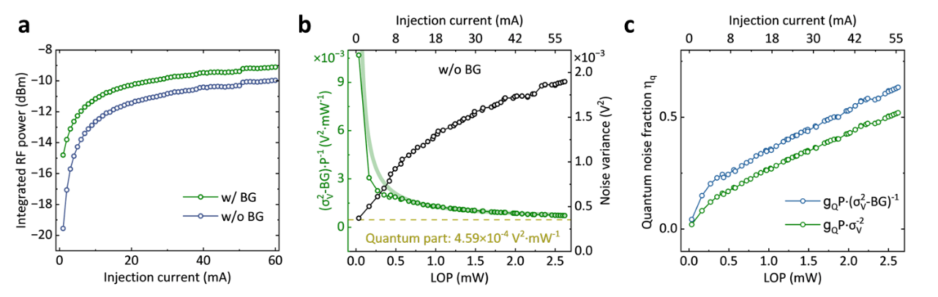
Supplementary figure 2. Power-dependent noise scaling and separation of quantum and technical noise contributions. a. Integrated RF noise power as a function of micro-LED injection current, with and without background noise. b. Light-output-power (LOP) dependence on the background-subtracted integrated RF noise power normalized by optical power. The absence of a positive slope and the emergence of a plateau at high optical power indicate a transition to a quantum-noise-dominated regime. The dashed line marks the extracted quantum noise contribution. The right y-axis shows the background-subtracted integrated RF noise power as a function of optical power.

Supplementary Section 3. Statistical evaluation of bits distribution histogram at different processing stages
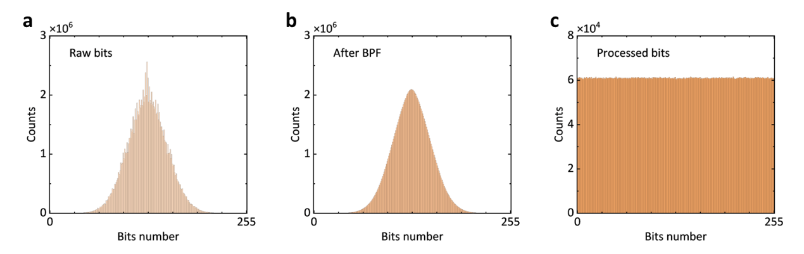
Histograms of the raw QRNG bits, band-pass-filtered bits, and post-processed bits are shown in Fig. S3 a-c, respectively. The raw output exhibits a Gaussian-like distribution with a small number of bins showing slightly elevated counts, which arise from finite analog-to-digital converter (ADC) resolution and residual low-frequency components prior to filtering. After band-pass filtering, the distribution becomes more stationary, resulting in a distribution that more closely follows an ideal Gaussian form. The final extracted bits exhibit a near-uniform distribution, consistent with effective post-processing for randomness extraction.
Supplementary figure 3. Statistical evolution of QRNG bit distributions from raw detection to post-processed extraction. a-c. Histograms showing the distributions of raw bits, band-pass-filtered bits, and post-processed bits.

Supplementary Section 4. Statistical validation of randomness using NIST SP 800-22 and Dieharder tests
Supplementary Table 1. Results of NIST randomness test
Test | P-Value | Proportion | Result
Frequency | 0.170817 | 1785/1800 | Pass
Block frequency | 0.937555 | 1775/1800 | Pass
Cumulative sums* | 0.140810 | 1785/1800 | Pass
Runs | 0.047342 | 1784/1800 | Pass
Longest run of ones | 0.729870 | 1780/1800 | Pass
Binary matrix rank | 0.326749 | 1781/1800 | Pass
Fourier transform | 0.207118 | 1780/1800 | Pass
Non-overlapping template* | 0.000404 | 1770/1800 | Pass
Overlapping template | 0.099183 | 1776/1800 | Pass
Maurer's universal | 0.304944 | 1787/1800 | Pass
Approximate entropy | 0.325035 | 1784/1800 | Pass
Random excursions* | 0.142198 | 1067/1076 | Pass
Random excursions variant* | 0.002302 | 1055/1076 | Pass
Serial test* | 0.378138 | 1773/1800 | Pass
Linear complexity | 0.168215 | 1785/1800 | Pass
* These tests were repeated multiple times, and the worst-case values of the P-value and proportion are reported.

Supplementary Table 2. Results of Dieharder randomness test
Test | P-Value | Result
diehard_birthdays | 0.08878551 | Pass
diehard_operm5 | 0.86743525 | Pass
diehard_rank_32x32 | 0.15254832 | Pass
diehard_rank_6x8 | 0.68343379 | Pass
diehard_bitstream | 0.34518785 | Pass
diehard_opso | 0.18026302 | Pass
diehard_oqso | 0.03231922 | Pass
diehard_dna | 0.41229846 | Pass
diehard_count_1s_str | 0.59529821 | Pass
diehard_count_1s_byt | 0.35750097 | Pass
diehard_parking_lot | 0.48712953 | Pass
diehard_2dsphere | 0.85691948 | Pass
diehard_3dsphere | 0.77812718 | Pass
diehard_squeeze | 0.13757983 | Pass
diehard_sums | 0.03749737 | Pass
diehard_runs* | 0.27538460 | Pass
diehard_craps* | 0.12939216 | Pass
marsaglia_tsang_gcd* | 0.00155047 | Weak
sts_monobit | 0.26472596 | Pass
sts_runs | 0.79511325 | Pass
sts_serial* | 0.03424183 | Pass
rgb_bitdist* | 0.99514594 | Weak
rgb_minimum_distance* | 0.78069082 | Pass
rgb_permutations* | 0.98200972 | Pass
rgb_lagged_sum* | 0.01040580 | Pass
rgb_kstest_test | 0.12288895 | Pass
dab_bytedistrib | 0.99535907 | Weak
dab_dct | 0.34148442 | Pass
dab_filltree* | 0.57476348 | Pass
dab_filltree2* | 0.14387227 | Pass
dab_monobit2 | 0.73066954 | Pass
* These tests were repeated multiple times, and the worst-case values of the P-value and results are reported.

Supplementary Section 5. Scalability and device-to-device uniformity of micro-LEDs for QRNG and PUF applications
To evaluate the scalability and uniformity of the micro-LED-based quantum-resilient platform, we characterized nine identical micro-LED devices fabricated using the same wafer-level process. Figure S4. a presents the light-current (L-I) characteristics of these devices over an injection-current range up to 60 mA. The maximum optical output power reaches approximately 2.5 mW, with only minor device-to-device variation, indicating uniform carrier injection and heat dissipation across the array. Figure S4. b further compares the PSD of the intensity fluctuations measured from the same set of micro-LEDs operating at an injection current of 30 mA. Under identical measurement conditions, the PSD curves from all nine devices show closely overlapping spectral profiles across the entire detection bandwidth, demonstrating highly reproducible noise characteristics and minimal device-to-device variation. This consistency confirms that the extracted quantum noise properties are governed by intrinsic spontaneous-emission statistics rather than by incidental fabrication irregularities.
The observed uniformity in both L–I characteristics and noise spectra reflects the robustness of the fabrication process, which follows standard GaN micro-LED manufacturing protocols without introducing additional processing complexity. As a result, the QRNG and PUF functionality does not rely on fine-tuned or device-specific optimization but instead emerges reproducibly across devices. These results indicate that the proposed micro-LED-based architecture is inherently scalable and compatible with wafer-level fabrication, supporting its deployment in large-scale and practical secure photonic systems.
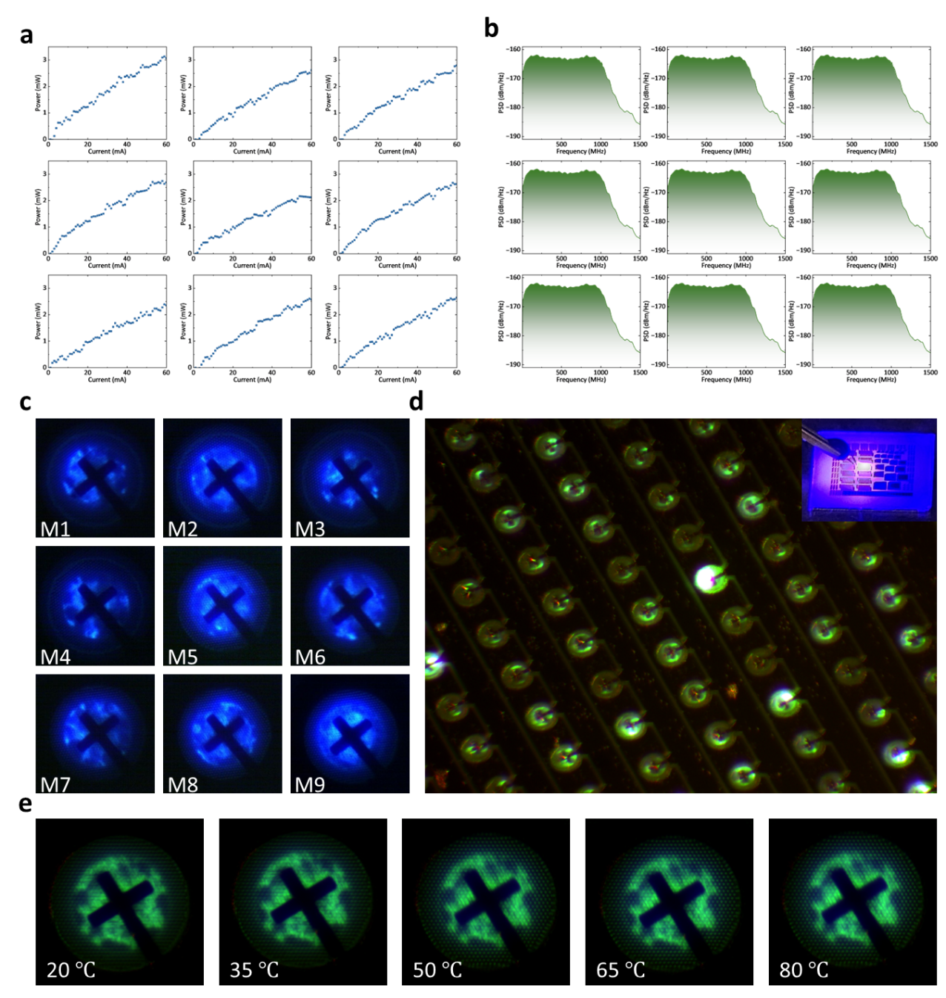
Supplementary figure 4. Scalability and uniformity of micro-LED arrays. a, LI curves of 9 different micro-LEDs. b, PSD plots of 9 different micro-LEDs with injection current of 30 mA. c, Near-field images of 9 different micro-LEDs. d, Simultaneous illumination of a micro-LED array. e, Near-field images of 1 typical micro-LED with working temperature from 20 ℃ to 80 ℃.
Supplementary Section 6. Neural network architecture for micro-LED-based PUF extraction
The deep learning model mainly has two parts. A YOLOv8-based object detection model (Ultralytics, 2023) was used to identify the luminous regions of micro-LEDs in near-field emission images⁴. The network was trained on 75 manually annotated images and validated on 46 images, with a single target class (“micro-LED”). Training was performed using the pretrained YOLOv8 model at an input size of 640 × 640 pixels for 50 epochs and a batch size of 16. During inference, each image was processed with a confidence threshold of 0.25 to locate the emission region. The detected region was cropped into a square area centered on the bounding box and resized to 256 × 256 pixels to produce standardized image inputs for subsequent analysis.
For the second part, a customized deep neural network (DNN) was developed to extract robust and device-specific binary embeddings from grayscale micro-LED Physical Unclonable Function (PUF) images. Each input image was resized to 80 × 80 pixels and normalized to zero mean and unit variance (mean = 0.5, std = 0.5). The overall architecture comprised three functional modules:
(1) A Spatial Transformer Network (STN) for geometric alignment, consisting of two convolutional layers (Conv2d(1,16,kernel=7) and Conv2d(16,32,kernel=5)), each followed by max-pooling (2×2), and two fully connected layers (32×16×16 → 32 → 6) predicting a 2×3 affine transformation initialized as an identity mapping⁵.
(2) A ResNet-34 backbone pretrained on ImageNet (ResNet34_Weights.IMAGENET1K_V1) and modified to accept single-channel input. Each residual block was enhanced by a Convolutional Block Attention Module (CBAM) combining both channel attention (reduction ratio = 16) and spatial attention (kernel size = 7), thus emphasizing discriminative local patterns across both spectral and spatial domains^{6,7}.
(3) An embedding head that converts the 512-dimensional feature vector after global average pooling into a 256-dimensional continuous embedding through a fully connected layer. This embedding is then passed through a sigmoid activation to produce probabilistic bit values, which are binarized via a straight-through estimator (STE) defined as
$$\begin{aligned}b={\left(1\left\{σ\left(z\right)>0.5\right\}-σ\left(z\right)\right)}_{detach}+σ\left(z\right), \#\left(S35\right)\end{aligned}$$
ensuring gradient propagation during training while yielding deterministic binary codes at inference. The binary embedding is used both for feature matching and as input to a linear classification layer (Linear(256 → N_classes)).
The model was optimized by jointly minimizing five complementary loss functions:
(i) Classification loss, $L_{cls}$, a standard cross-entropy term;
(ii) Batch-hard triplet loss, $L_{trip}$, with margin = 1.0 enforcing large inter-class and small intra-class Euclidean distances;
(iii) Quantization loss, $L_{quant}=MSE(σ(z),round(σ(z)))$, encouraging stable binarization;
(iv) Bit-balance loss, $L_{bal}=\frac{1}{L}\sum_{k}{({\overset{ˉ}{b}}_{k}-0.5)^{2}}$, maintaining uniform bit distribution; and
(v) Distribution-separation loss, $L_{sep}$, penalizing overlap between intra-class and inter-class normalized Hamming distances with margin = 0.05.
The total loss was formulated as
$$\begin{aligned}L_{total}=λ_{cls}L_{cls}+λ_{trip}L_{trip}+λ_{quant}L_{quant}+λ_{bal}L_{bal}+λ_{sep}L_{sep},\#\left(S36\right)\end{aligned}$$
where the empirically chosen weights were: $λ_{cls}=1.0$, $λ_{trip}=0.5$, $λ_{quant}=0.1$, $λ_{bal}=0.8,$ $λ_{sep}=1.5$
Optimization was performed using the Adam optimizer (learning rate = 1 × 10⁻⁴, weight decay = 1 × 10⁻⁵) with learning-rate scheduling via ReduceLROnPlateau (factor = 0.5, patience = 5). Each mini batch contained 64 samples. A maximum of 50 epochs were executed, and training was terminated early if validation accuracy failed to improve for 5 consecutive epochs. Random seeds were fixed to 42 for reproducibility.
Data augmentation was applied with probability = 0.8, including random rotations (±180°), affine translations (±10%), scaling (0.8–1.2×), and brightness/contrast jittering (±0.2).
The trained network was evaluated using accuracy, confusion matrices, and class-wise reports. Continuous and binary embeddings were extracted from the test set and analyzed via normalized Hamming distance to quantify intra- and inter-class separability. Embedding distributions were further visualized using t-SNE (perplexity = 30, iterations = 1000) to confirm cluster compactness and inter-class spacing.

Supplementary Table 3. Layer configuration of the DNN pipeline
Layer | Input Shape | Output Shape | Comments
Original Input | (64, 1, 80, 80) | (64, 1, 80, 80) | Grayscale image, batch size 64
Spatial Transformer Network (STN)
STN Conv1 + ReLU + MaxPool | (64, 1, 80, 80) | (64, 16, 37, 37) | Kernel=7, stride=1, MaxPool 2×2
STN Conv2 + ReLU + MaxPool | (64, 16, 37, 37) | (64, 32, 16, 16) | Kernel=5, stride=1, MaxPool 2×2
STN FC1 + ReLU | (64, 8192) | (64, 32) | Flatten: 32×16×16=8192
STN FC2 (Affine params) | (64, 32) | (64, 6) | Output: [θ₁₁, θ₁₂, θ₁₃, θ₂₁, θ₂₂, θ₂₃]
Affline Transform | (64, 1, 80, 80) | (64, 1, 80, 80) | Apply spatial transform
ResNet-34 with CBAM Backbone
Conv1 + BN + ReLU | (64, 1, 80, 80) | (64, 64, 40, 40) | Kernal=7, stride=2, padding=3
MaxPool | (64, 64, 40, 40) | (64, 64, 20, 20) | Kernal=3, stride=2, padding=1
Layer1 (3 × BasicBlock-CBAM) | (64, 64, 20, 20) | (64, 64, 20, 20) | 3 blocks, each with CBAM attention
Block 1: Conv-BN-ReLU-Conv-BN | (64, 64, 20, 20) | (64, 64, 20, 20) | Kernal=3, stride=1, padding=1
CBAM (Channel + Spatial) | (64, 64, 20, 20) | (64, 64, 20, 20) | Channel ratio=16, Spatial kernel=7
Layer2 (4 × BasicBlock-CBAM) | (64, 64, 20, 20) | (64, 128, 10, 10) | First block stride=2, downsample
Block 1: Conv-BN-ReLU-Conv-BN | (64, 64, 20, 20) | (64, 128, 10, 10) | Kernel=3, stride=2, padding=1
CBAM (Channel + Spatial) | (64, 128, 10, 10) | (64, 128, 10, 10) | Channel ratio=16, Spatial kernel=7
Layer3 (6 × BasicBlock-CBAM) | (64, 128, 10, 10) | (64, 256, 5, 5) | First block stride=2, downsample
Block 1: Conv-BN-ReLU-Conv-BN | (64, 128, 10, 10) | (64, 256, 5, 5) | Kernel=3, stride=2, padding=1
CBAM (Channel + Spatial) | (64, 256, 5, 5) | (64, 256, 5, 5) | Channel ratio=16, Spatial kernel=7
Layer4 (6 × BasicBlock-CBAM) | (64, 256, 5, 5) | (64, 512, 3, 3) | First block stride=2, downsample
Block 1: Conv-BN-ReLU-Conv-BN | (64, 256, 5, 5) | (64, 512, 3, 3) | Kernel=3, stride=2, padding=1
CBAM (Channel + Spatial) | (64, 512, 3, 3) | (64, 512, 3, 3) | Channel ratio=16, Spatial kernel=7
AdaptiveAvgPool | (64, 512, 3, 3) | (64, 512, 1, 1) | Global average pooling
Flatten | (64, 512, 1, 1) | (64, 512) | Flatten to vector
Binary Embedding Layers
FC Embedding (Linear) | (64, 512) | (64, 256) | Continuous embedding, L_{bit} = 256
Sigmoid + Binarization | (64, 256) | (64, 256) | $$p=σ\left(e\right), b=1(p>0.5)$$
Straight-Through Estimator | (64, 256) | (64, 256) | $$b_{STE}=\left(b-p\right).detach\left( \right)+p$$
Classification Layer
FC Classification (Linear) | (64, 256) | (64, C) | C = number of classes (e.g., 9)
Output
Class Logits | (64, C) | (64, C) | For classification loss
Continuous Embedding | (64, 256) | (64, 256) | For triplet and quantization loss
Binary Bitstream | (64, 256) | (64, 256) | For balance and separation loss

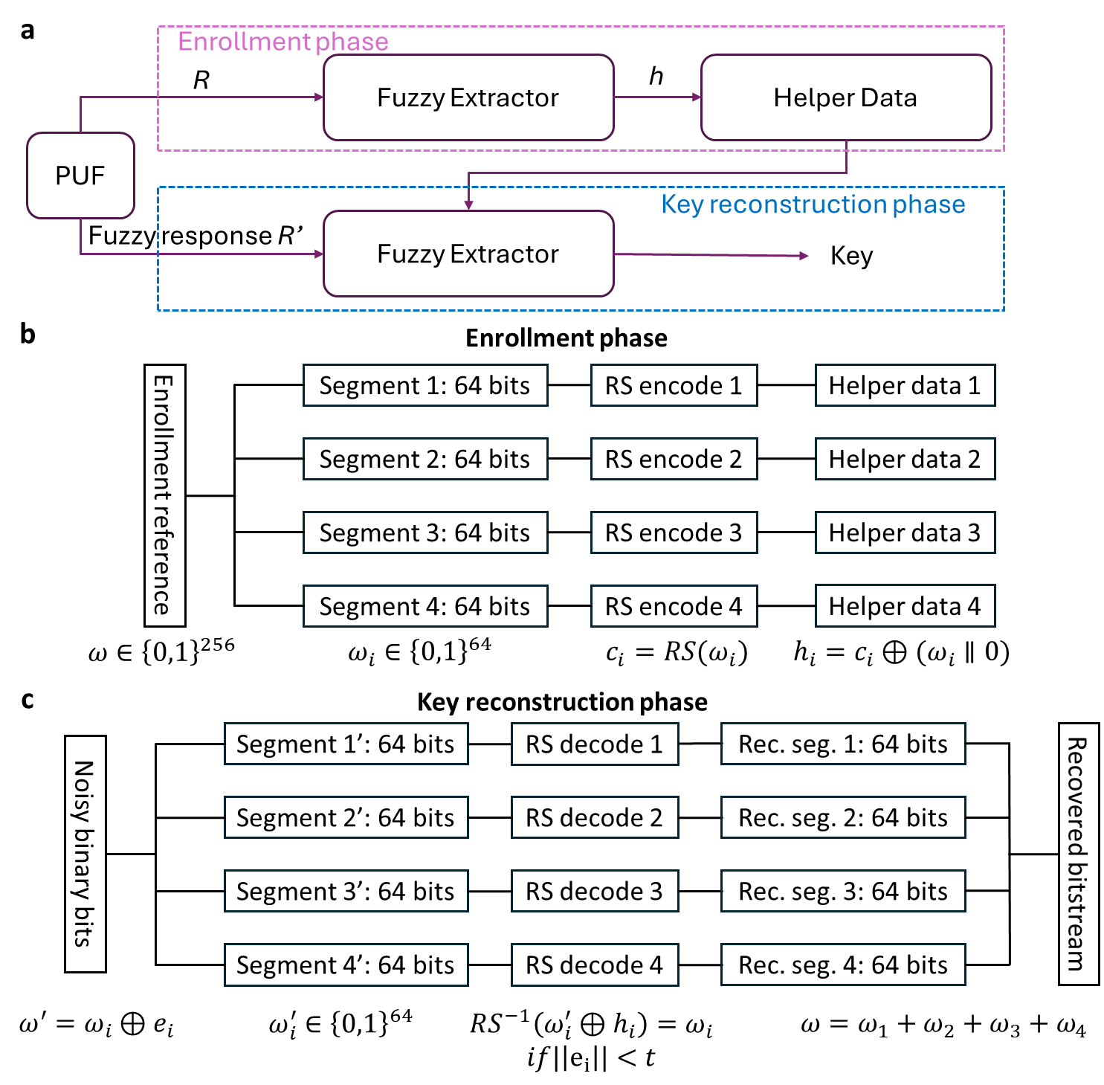
Supplementary Section 7. Fuzzy extractor implementation for PUF key stabilization
Supplementary Figure 5. a, Overall workflow of PUF enrollment and key reconstruction. b, Implementation details of the enrollment phase. c, Implementation details of the key reconstruction phase.

Supplementary Section 8. High-temperature stability of micro-LED-based PUFs
To evaluate the robustness of the micro-LED-based PUFs under elevated operating temperatures, the same neural-network model trained on near-field emission patterns acquired between 20 °C and 50 °C, as described in the main text, was directly applied to previously unseen data collected at higher temperatures ranging from 65 °C to 80 °C.
Despite the increased thermal stress, the extracted PUF responses remain highly reproducible, with classification performance comparable to that observed within the training temperature range. Confusion-matrix analysis (Fig. S6a) confirms that device identities are preserved without noticeable degradation, and the separation between intra-device and inter-device Hamming distance distributions remains well defined (Fig. S6b). These results indicate that the micro-LED near-field emission patterns retain their device-specific characteristics under elevated temperatures, supporting the robustness of the proposed PUF approach against thermal variations.
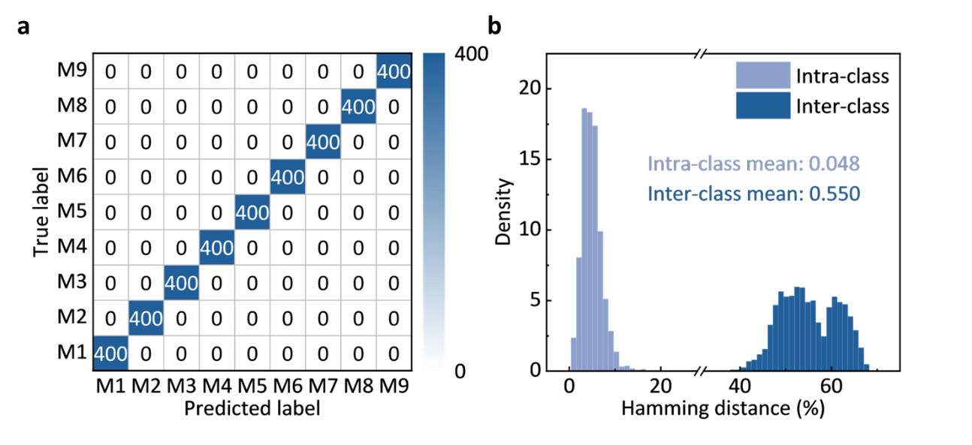
Supplementary Figure 6. DNN model generalization under elevated temperature. a-b, Confusion matrix and Hamming distances plots demonstrate robust classification and PUF performance on unseen samples across elevated operating temperatures (65–80 ℃).

Supplementary Section 9. QRNG- and PUF- enabled post-quantum cryptographic framework
To establish a secure link between Alice and Bob, mutual authentication is first performed. Over a public channel, both parties share their public keys derived from their PUF responses; these public keys remain valid until a potential compromise of the corresponding secret keys or a scheduled periodic update requires a refresh. To verify Bob’s identity, Alice generates a nonce (Nonce_{A}) using her QRNG_{A} and transmits it to Bob. Nonces generated from local QRNGs ensure freshness and prevent replay attacks. Upon receiving Nonce_{A}, Bob responds with his own nonce (Nonce_{B}) generated from QRNG_{B}. Alice then signs Nonce_{B} with her secret key (SK_{A}) to produce Sig_{A}, which she sends to Bob. Bob generates Sig_{B} analogously by signing Nonce_{A} with his secret key (SK_{B}) and returns it to Alice. Alice verifies Sig_{B} using Bob’s public key PKB. Successfully verification confirms that Bob possesses the corresponding secret key SKB. Simultaneously, Bob can authenticate Alice in the same manner, establishing mutual authentication without revealing any PUF responses.
Following authentication, the communication link is further secured against quantum threats using a post-quantum cryptographic (PQC) protocol. Crystals-Kyber scheme is adopted to resist quantum attacks due to hardness of lattice problems underlying its key encapsulation mechanism. After mutual authentication, Alice and Bob independently generate random seeds (ξ_{A} and ξ_{B}) for their public and secret authentication key pairs (pk_{A}, sk_{A} and pk_{B}, sk_{B}) to support authenticated key exchange. The initiator (Alice) then generates a random message m_{a}​ and encapsulates it using Bob’s public key (pk_{B}) to produce ciphertext c_{A}. Through a key derivation function (KDF), Alice derives a shared encryption key K_{A} from m_{a}​. KDF ensures the key is uniformly random and suitable for symmetric encryption. Upon receiving c_{A}, Bob decapsulates it with his private key sk_{B} to obtain the same shared key K_{A} without knowing m_{a}. With K_{A} established, Alice and Bob can perform quantum-resilient communication using Advanced Encryption Standard in Galois/Counter Mode (AES-GCM), a symmetric encryption algorithm providing both confidentiality and integrity of transmitted data.

Supplementary Section 10. Experimental configuration and implementation of the optical wireless communication link
Figure S7a illustrates the digital signal processing (DSP) architecture at the transmitter and receiver. A bit- and power-loading discrete multitone (BPL-DMT) modulation scheme is adopted to maximize spectral efficiency. Prior to BPL data transmission, the signal-to-noise ratio (SNR) of each subcarrier is estimated. Random binary data are mapped onto quadrature phase-shift keying (QPSK) symbols during the quadrature amplitude modulation (QAM) mapping stage and the sequential data stream is then partitioned into parallel groups corresponding to the individual subcarriers. In our experiment, 512 subcarriers are employed. Low-frequency subcarriers are nulled to suppress low-frequency noise.
To generate a real-valued time-domain waveform, Hermitian symmetry is imposed on the frequency-domain symbols, followed by two-fold up-sampling prior to the inverse fast Fourier transform (IFFT). A cyclic prefix (CP) is then appended to mitigate inter-symbol interference (ISI).
At the receiver side, after synchronization, the received signal is equalized using a multilayer perceptron (MLP) to compensate for nonlinear and memory-dependent channel impairments⁸. DMT demodulation is subsequently performed, including CP removal, fast Fourier transform (FFT), and down-sampling. Zero-forcing equalization is applied to compensate for the non-flat frequency response, followed by phase recovery to eliminate residual phase offsets. The SNR of each subcarrier is estimated from the error vector magnitude (EVM) of the recovered QPSK symbols. Based on the estimated SNR, bit allocation and power loading are jointly optimized.
In the BPL-DMT implementation, the encrypted data stream is encoded using a Reed–Solomon (RS) forward error correction (FEC) code with 7% overhead. According to the optimized bit-loading profile, the number of bits and the allocated power for each subcarrier are configured. The signal then undergoes the same DMT modulation and demodulation procedures as described above and is finally reconstructed into a binary data stream after FEC decoding.
Figure S7b presents the detailed architecture of the proposed MLP equalizer. A sliding window extracts a 31-tap feature vector from the received temporal waveform, which is fed into a fully connected MLP to compensate for nonlinear distortion and channel-induced impairments. The network consists of two hidden layers with rectified linear unit (ReLU) activation functions, and the number of neurons in each hidden layer matches the dimensionality of the input feature vector.
The output-input amplitude correlation under nonlinear operating conditions, without and with MLP equalization are shown in Fig. S7d and S7e, respectively. Both input and output amplitudes are normalized. The blue dots represent the output amplitude corresponding to each input amplitude within a bin width of 0.01, while the black line indicates the ideal linear reference. Without MLP equalization, pronounced nonlinearity and asymmetry are observed in the amplitude transfer characteristic. In contrast, MLP equalization significantly linearizes the amplitude mapping, yielding a more symmetric and tightly clustered distribution around the ideal reference.
The corresponding received electrical spectra are shown in Fig. S7f, where the spectrum after MLP equalization exhibits improved flatness and reduced distortion. Collectively, the amplitude-domain and spectral-domain results confirm that the proposed MLP equalizer provides substantial performance improvement over conventional linear equalization. These enhancements are expected to reduce the bit error rate (BER), enable higher-order modulation formats, and improve the robustness of BPL-DMT links in high-speed optical communication systems.

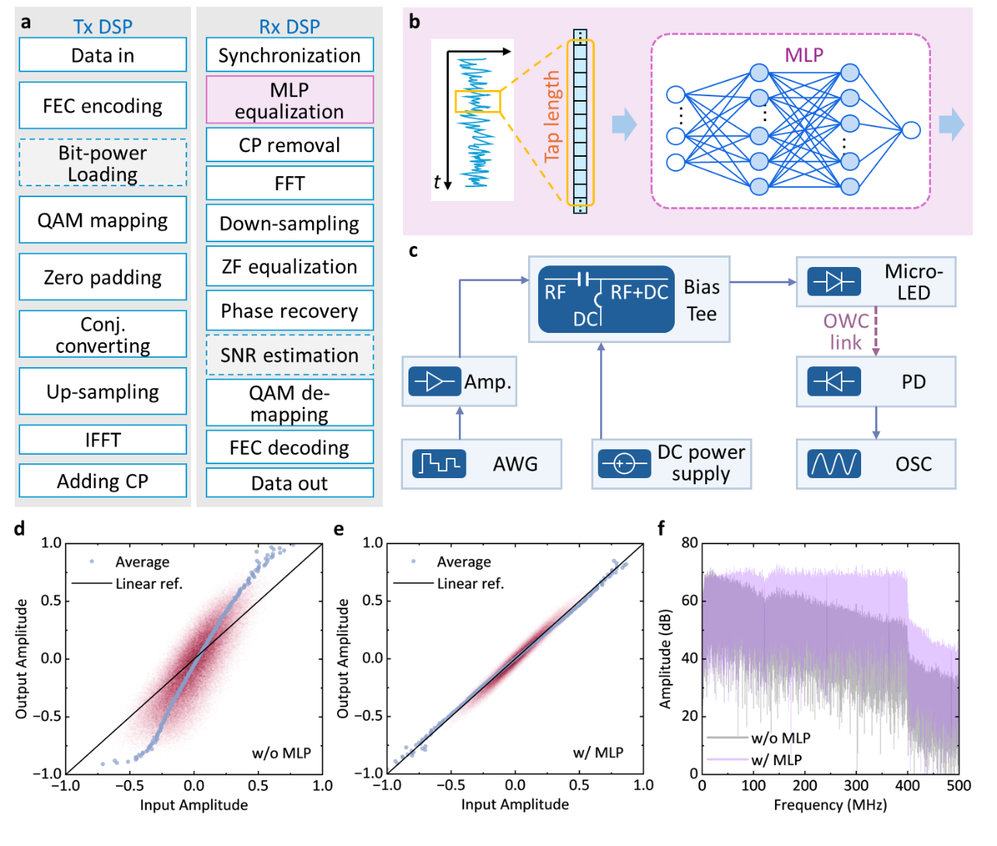
Supplementary figure 7. System-level architecture and experimental implementation of the optical wireless communication link. a, Schematic diagram of the transmitter (Tx) and receiver (Rx) digital signal processing (DSP) flow for bit- and power-loading discrete multitone modulation (BPL-DMT). b, Principle of the multilayer perceptron (MLP) equalizer. c, Illustration of OWC experimental setup. d, Output-input amplitude correlation without MLP equalization. e, Output-input amplitude correlation with MLP equalization, demonstrating improved linearization and amplitude fidelity. f, Electrical spectra of the received signals before and after MLP equalization.

References
1. Park, T.-Y. et al. 2-gb/s ultraviolet-light optical wireless communication by InGaN/GaN multi-quantum well dual-function micro-photodetector. Appl. Phys. Lett. 124, (2024).
2. Peyghambarian, N., Koch, S. W. & Mysyrowicz, A. Introduction to Semiconductor Optics. (Prentice-Hall, Inc., 1993).
3. Lasher, G. & Stern, F. Spontaneous and Stimulated Recombination Radiation in Semiconductors. Phys. Rev. 133, A553 (1964).
4. Reis, D., Kupec, J., Hong, J. & Daoudi, A. Real-Time Flying Object Detection with YOLOv8. Preprint at https://arxiv.org/abs/2305.09972v2 (2023).
5. Jaderberg, M., Simonyan, K., Zisserman, A. & Kavukcuoglu, K. Spatial transformer networks. Advances in Neural Information Processing Systems 28, (2015).
6. He, K., Zhang, X., Ren, S. & Sun, J. Deep residual learning for image recognition. in 2016 IEEE Conference on Computer Vision and Pattern Recognition (CVPR) 770–778 (IEEE, Las Vegas, NV, USA, 2016). doi:10.1109/CVPR.2016.90.
7. Woo, S., Park, J., Lee, J.-Y. & Kweon, I. S. CBAM: Convolutional block attention module. in 3–19 (2018).
8. Niu, W. et al. Key Technologies for High-Speed Si-Substrate LED Based Visible Light Communication. Journal of Lightwave Technology 41, 3316–3331 (2023).

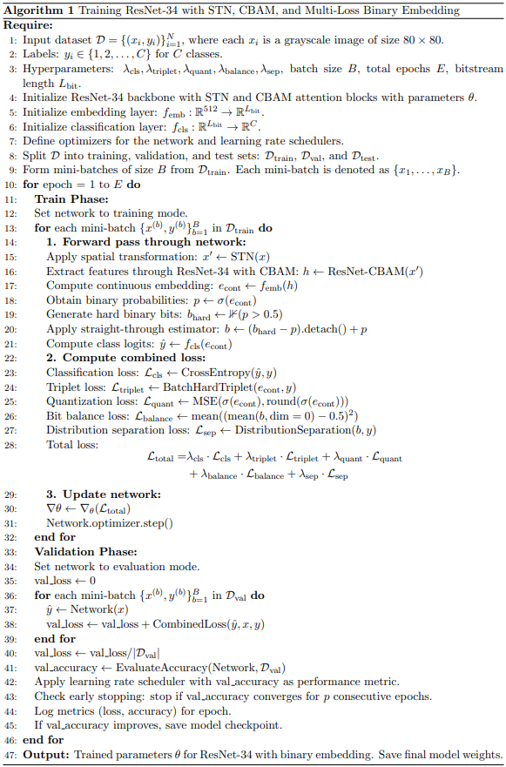
Appendix. Pseudo-code of micro-LED-based PUF extraction framework

