Table S3. Identified conserved motifs with their width, symbol and description
Motif | Sequence | Width | E-value | Description
1 |  | 50 | 1.5e-341 | Lipoxygenase family
2 |  | 50 | 6.0e-236 | Lipoxygenase family
3 |  | 50 | 2.8e-232 | Lipoxygenase family
4 |  | 41 | 3.0e-204 | Lipoxygenase family
5 | 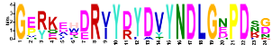 | 24 | 3.7e-141 | None predicted
6 | 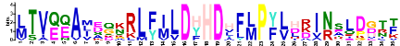 | 35 | 6.2e-133 | None predicted
7 |  | 50 | 8.2e-137 | Lipoxygenase family
8 | 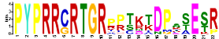 | 22 | 3.9e-108 | None predicted
9 | 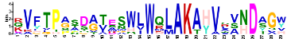 | 29 | 2.1e-104 | None predicted
10 | 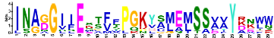 | 29 | 3.7e-104 | None predicted
11 | 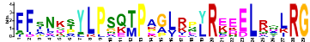 | 29 | 2.0e-103 | None predicted
12 | 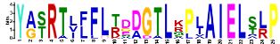 | 25 | 5.4e-113 | None predicted
13 | 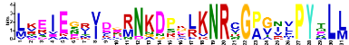 | 31 | 5.4e-082 | None predicted
14 | 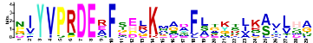 | 29 | 3.9e-075 | None predicted
15 | 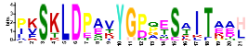 | 21 | 1.4e-060 | None predicted

