OsLOX1
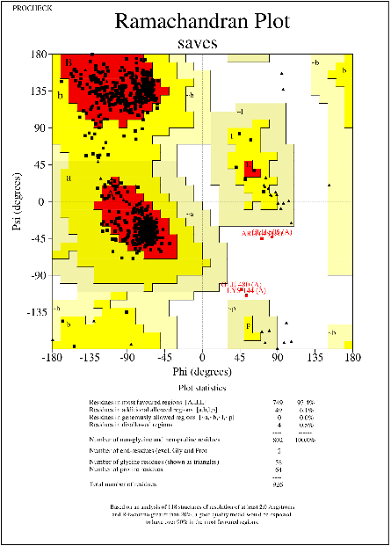
OsLOX2
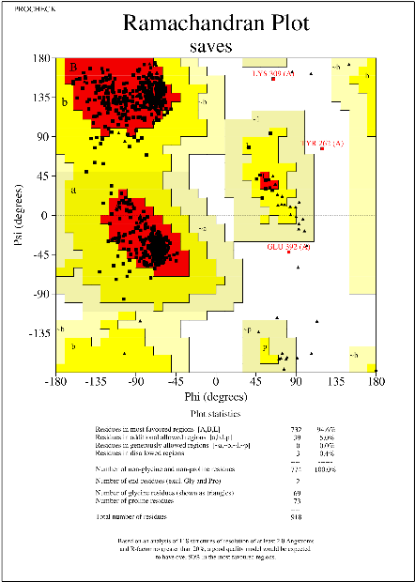
OsLOX3
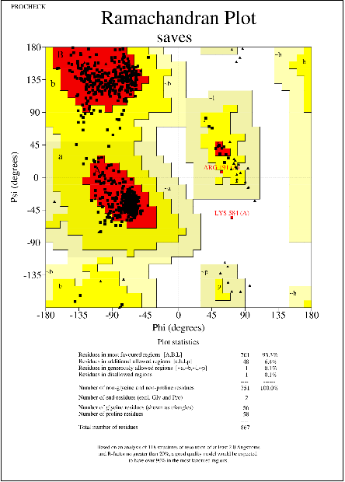
OsLOX4
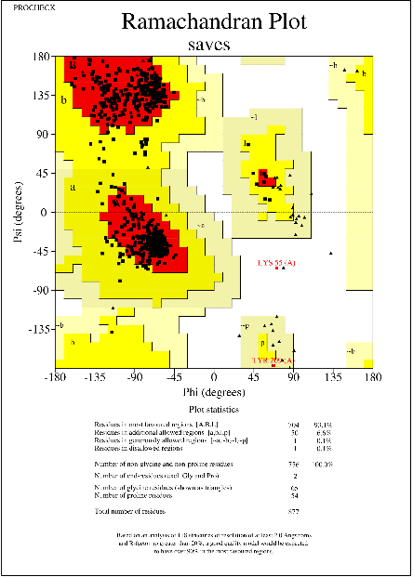
OsLOX5
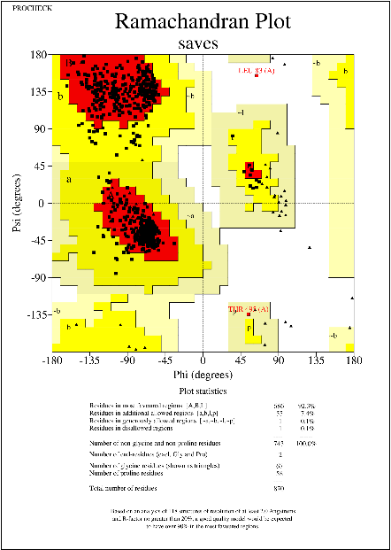
OsLOX6
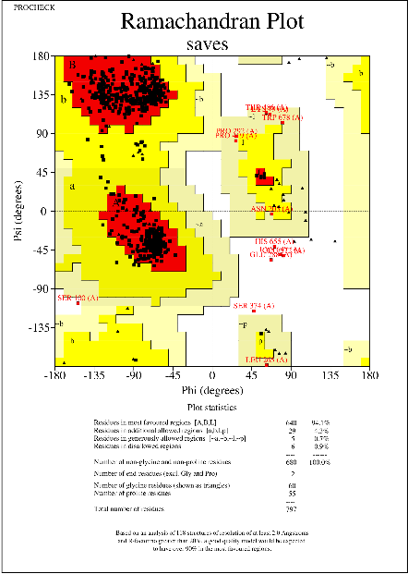
OsLOX7
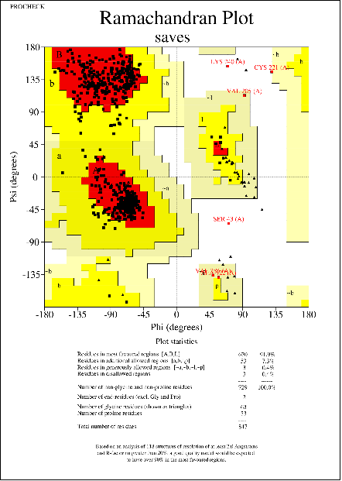
OsLOX8
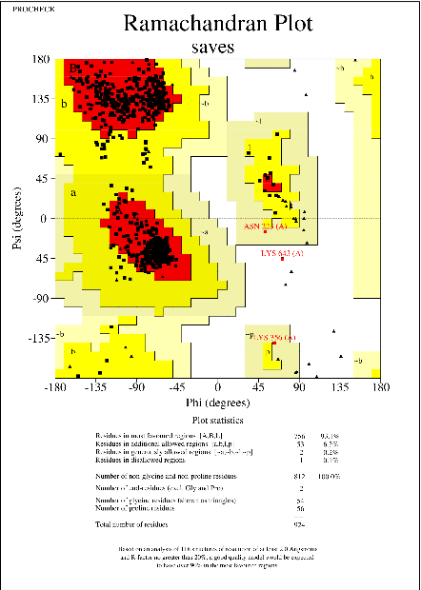
OsLOX9
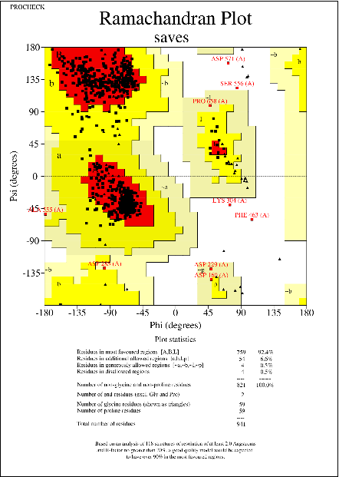
OsLOX10
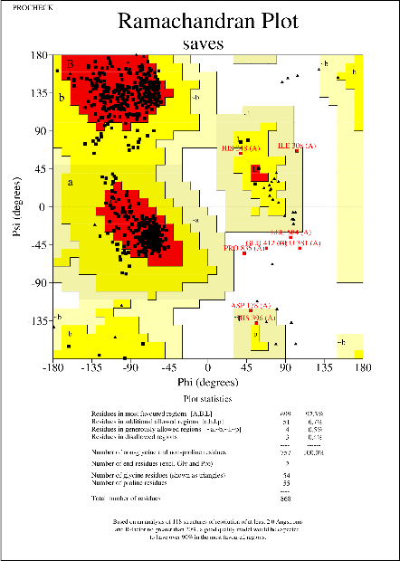
OsLOX11
Figure S2. Ramachandran plot of the 3D structures of OsLOXs. PROCHECK was utilized to create the Ramachandran plot. The hues red, yellow, light yellow, and white represent residues in the most favored, additional allowed, generously allowed, and disallowed regions respectively.
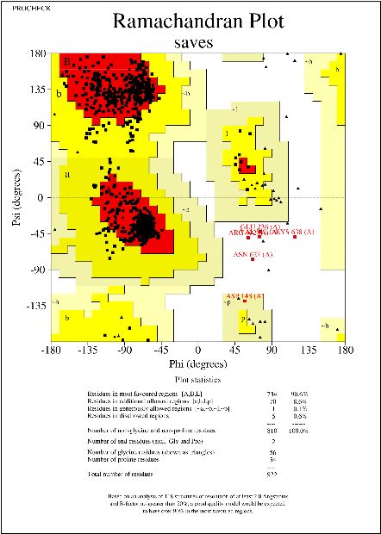
OsLOX12
