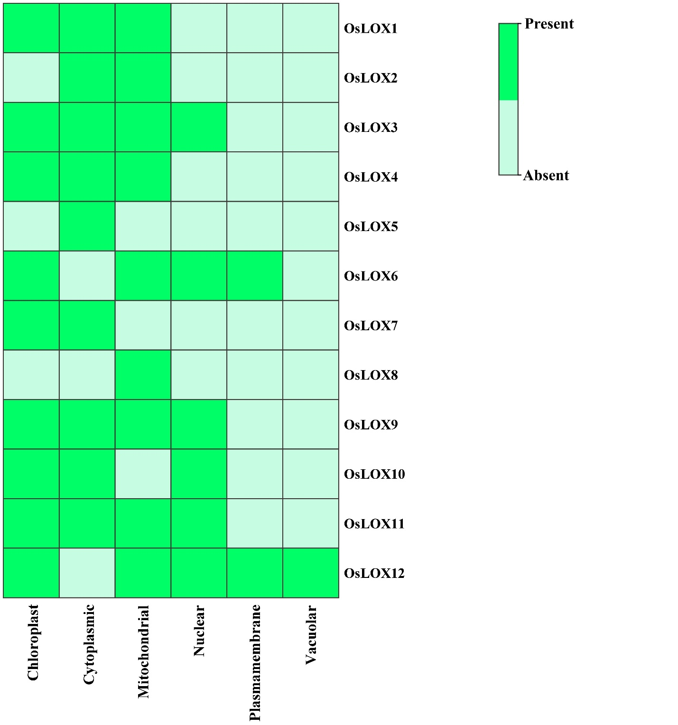
Figure S1. The heatmap illustrates the predicted sub-cellular localization of OsLOX proteins. The names of the corresponding cellular organelles are displayed at the bottom of the heatmap, whereas the names of each OsLOX protein are displayed on the left side. The presence of protein signals corresponding to the genes is shown by the color intensity on the right side of the heatmap.

