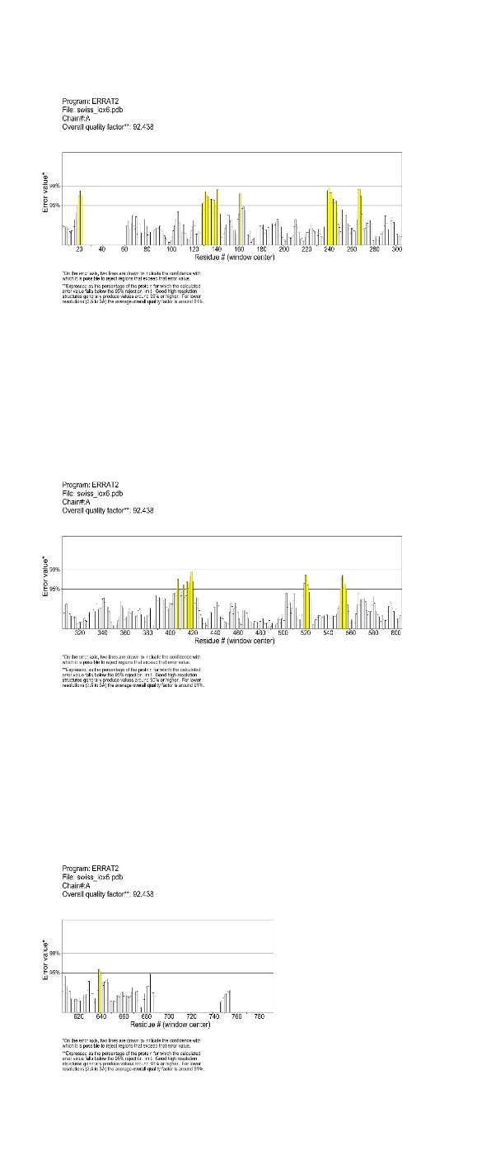
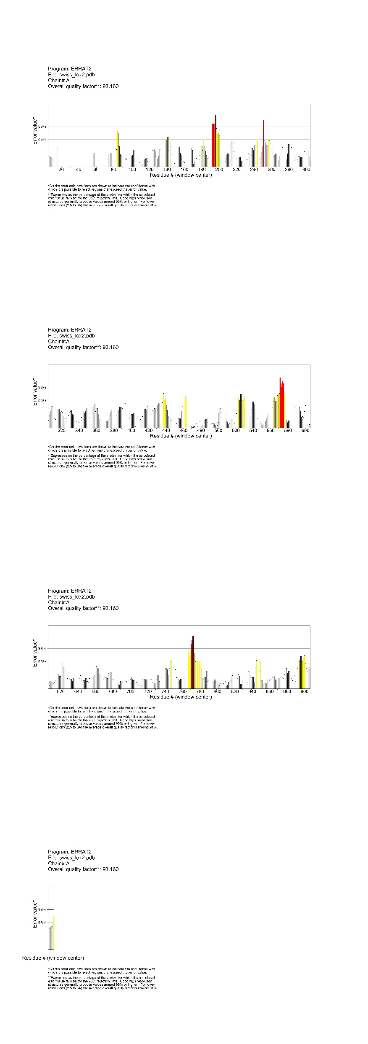
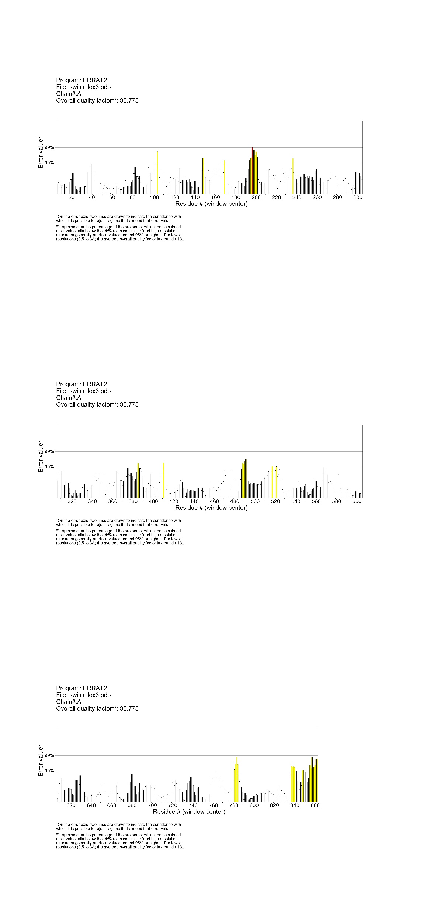
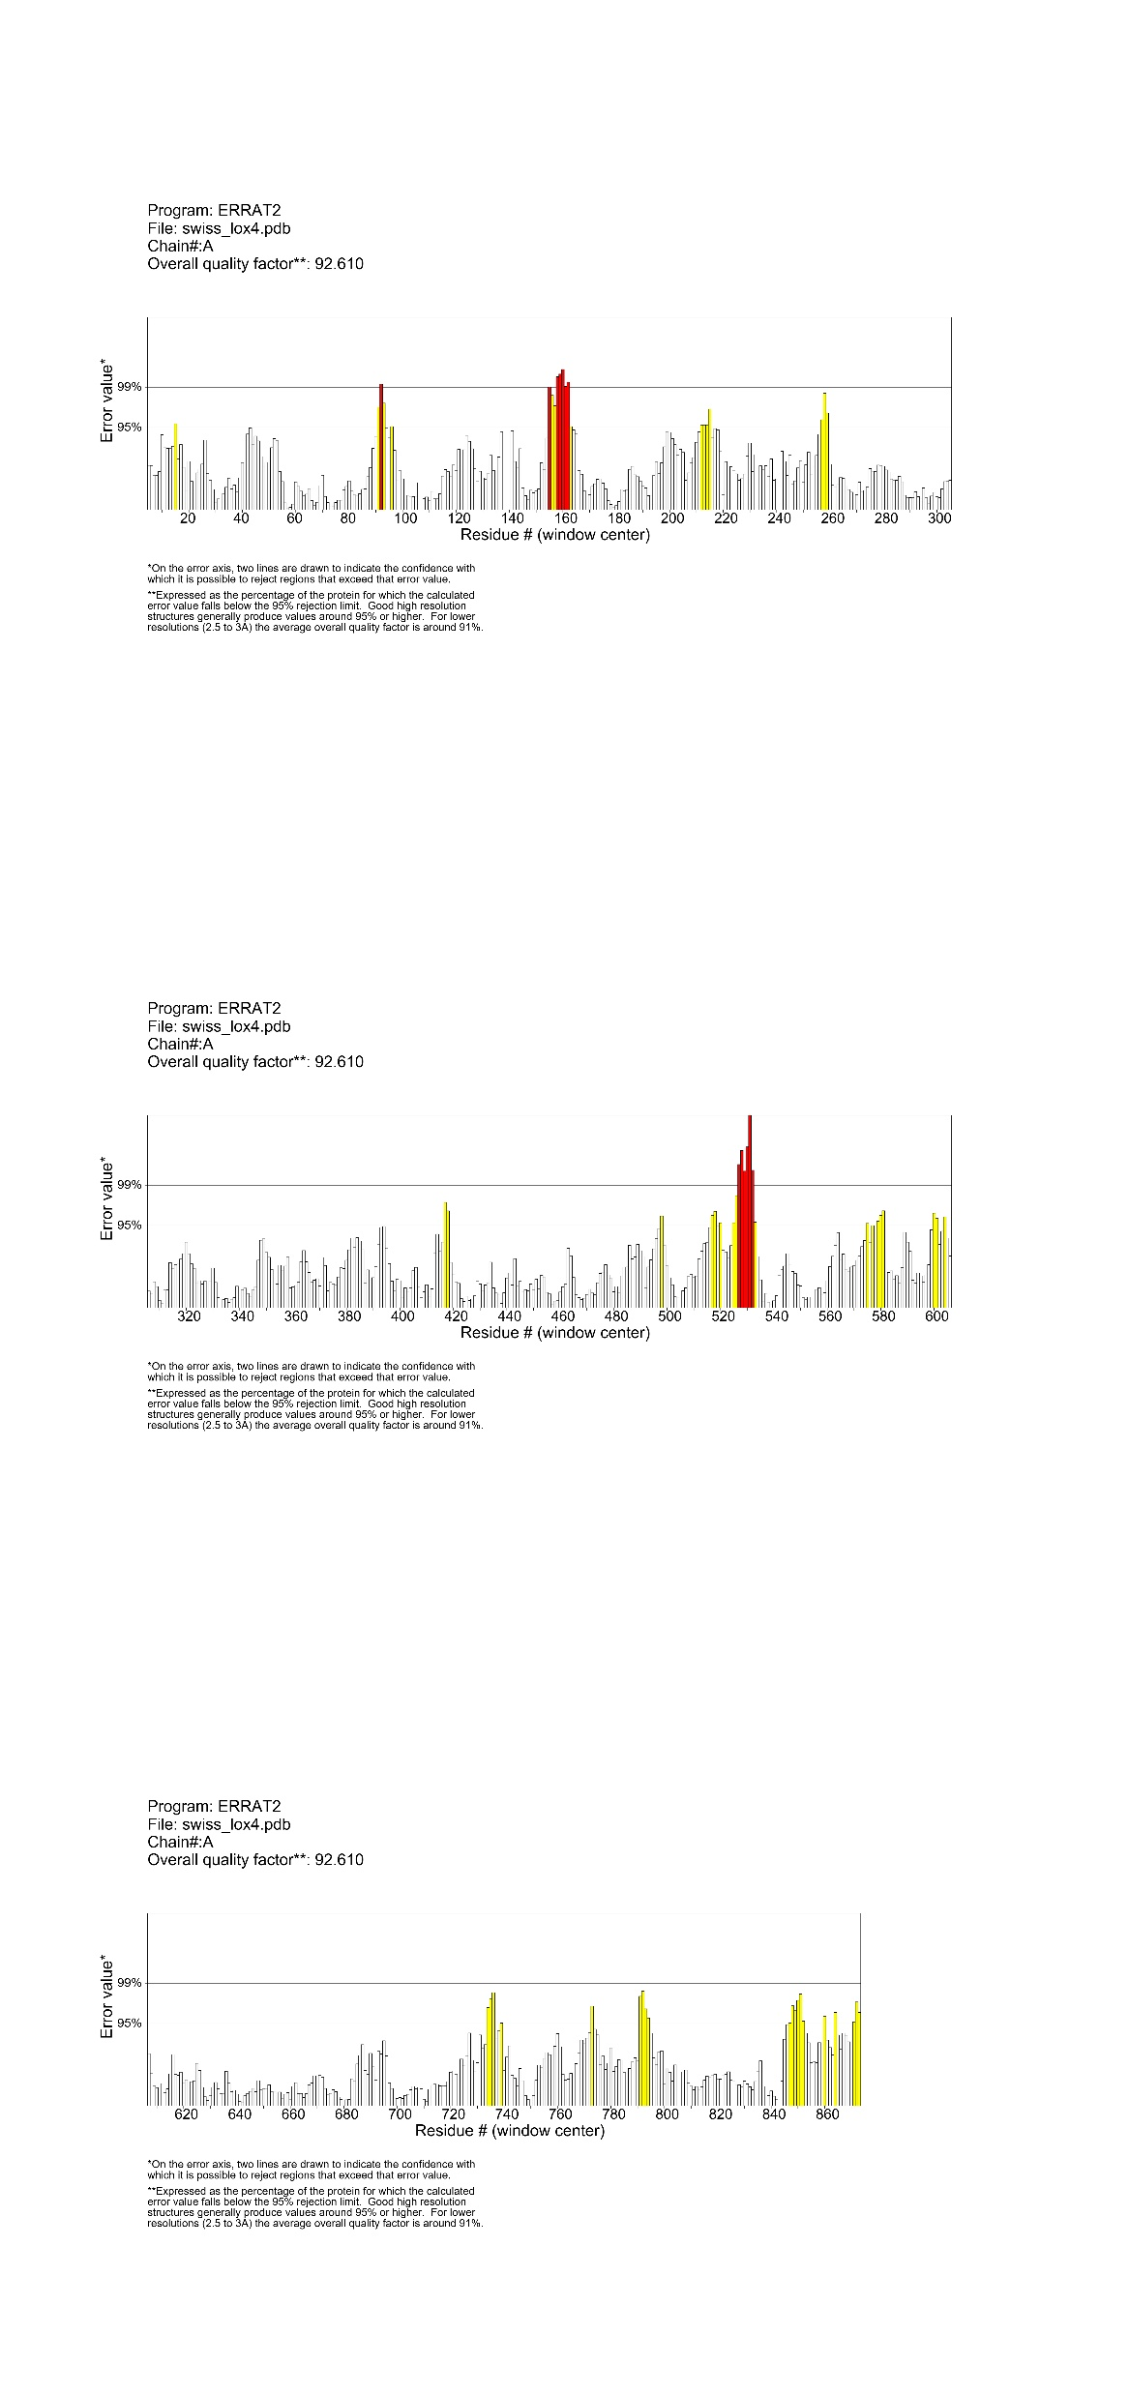
OsLOX1
OsLOX2
OsLOX3
OsLOX4
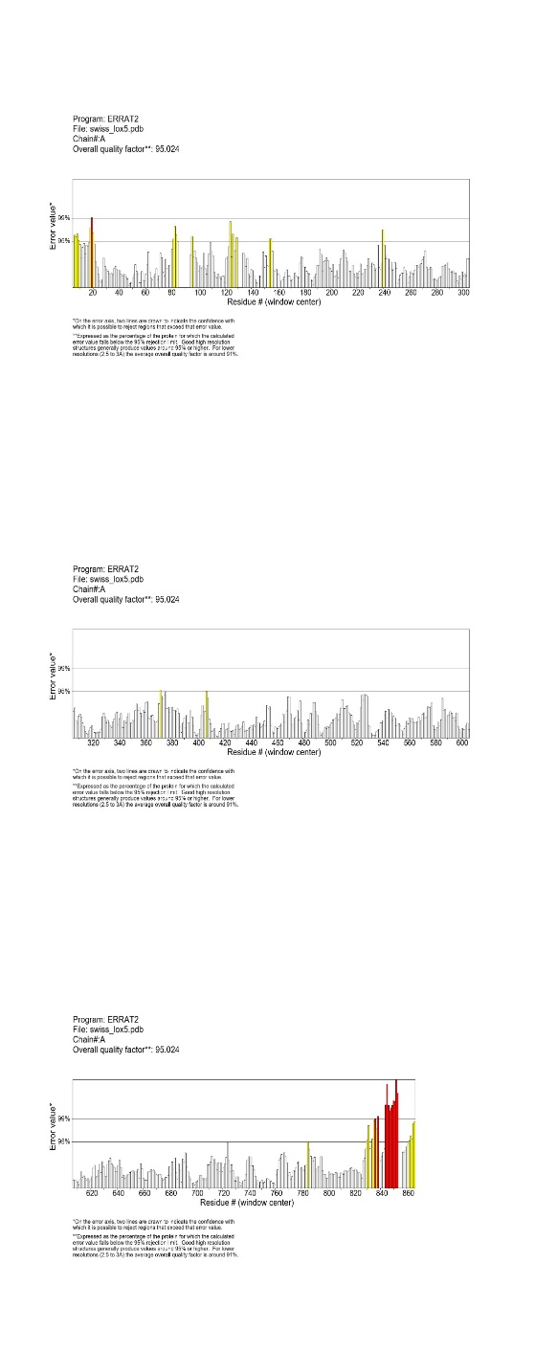
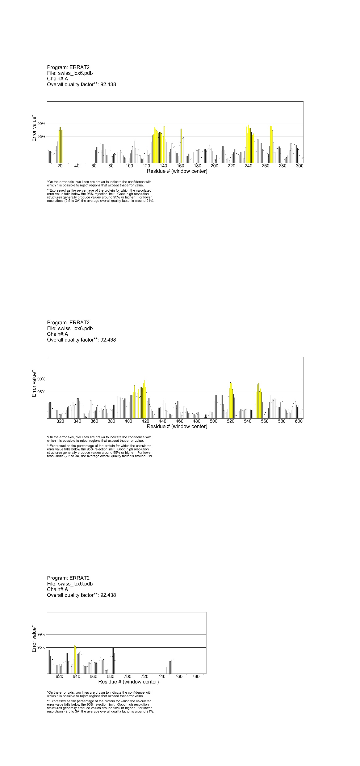
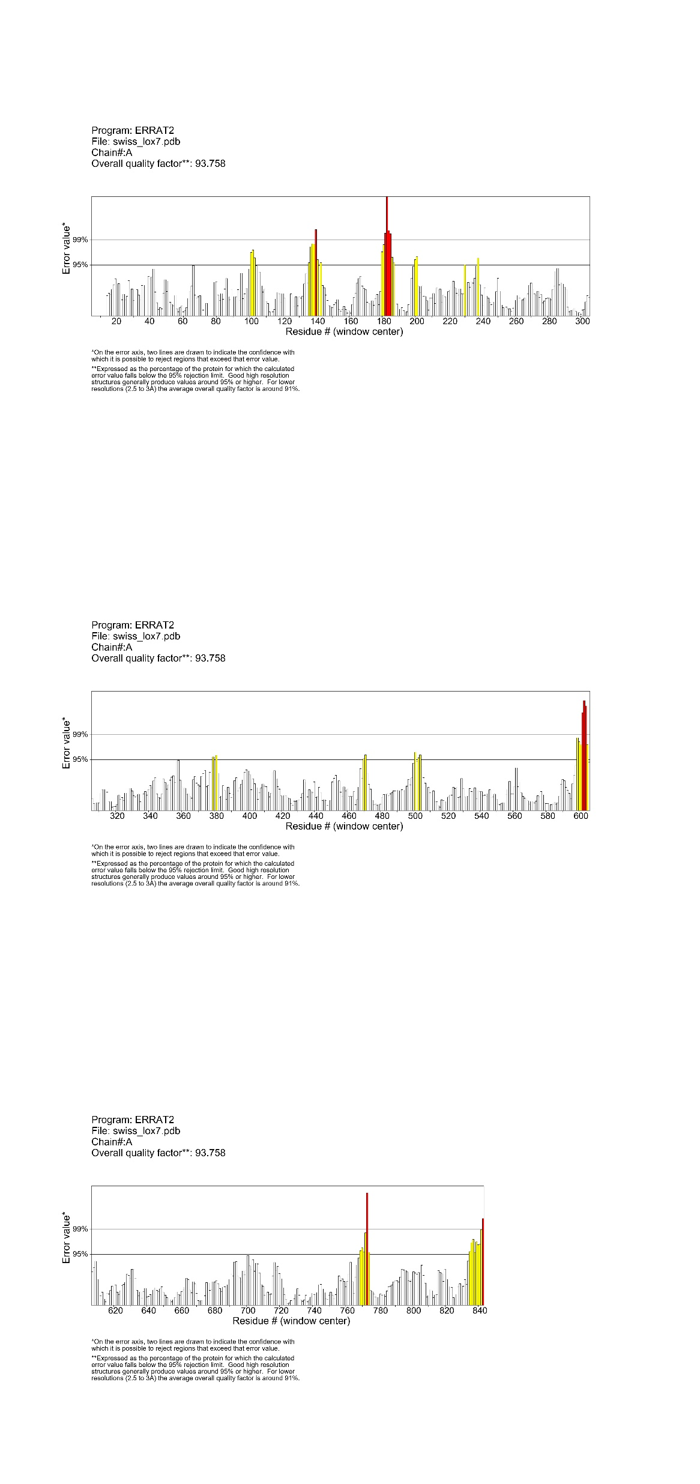
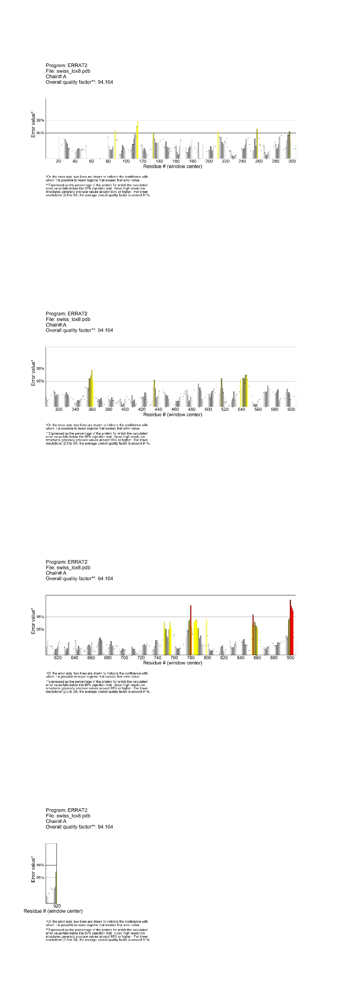
OsLOX5
OsLOX6
OsLOX7
OsLOX8

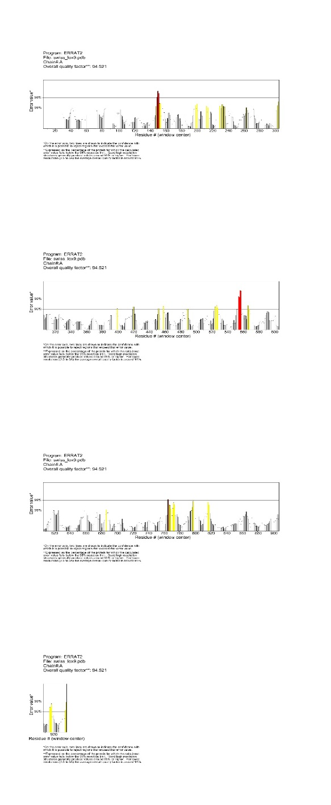
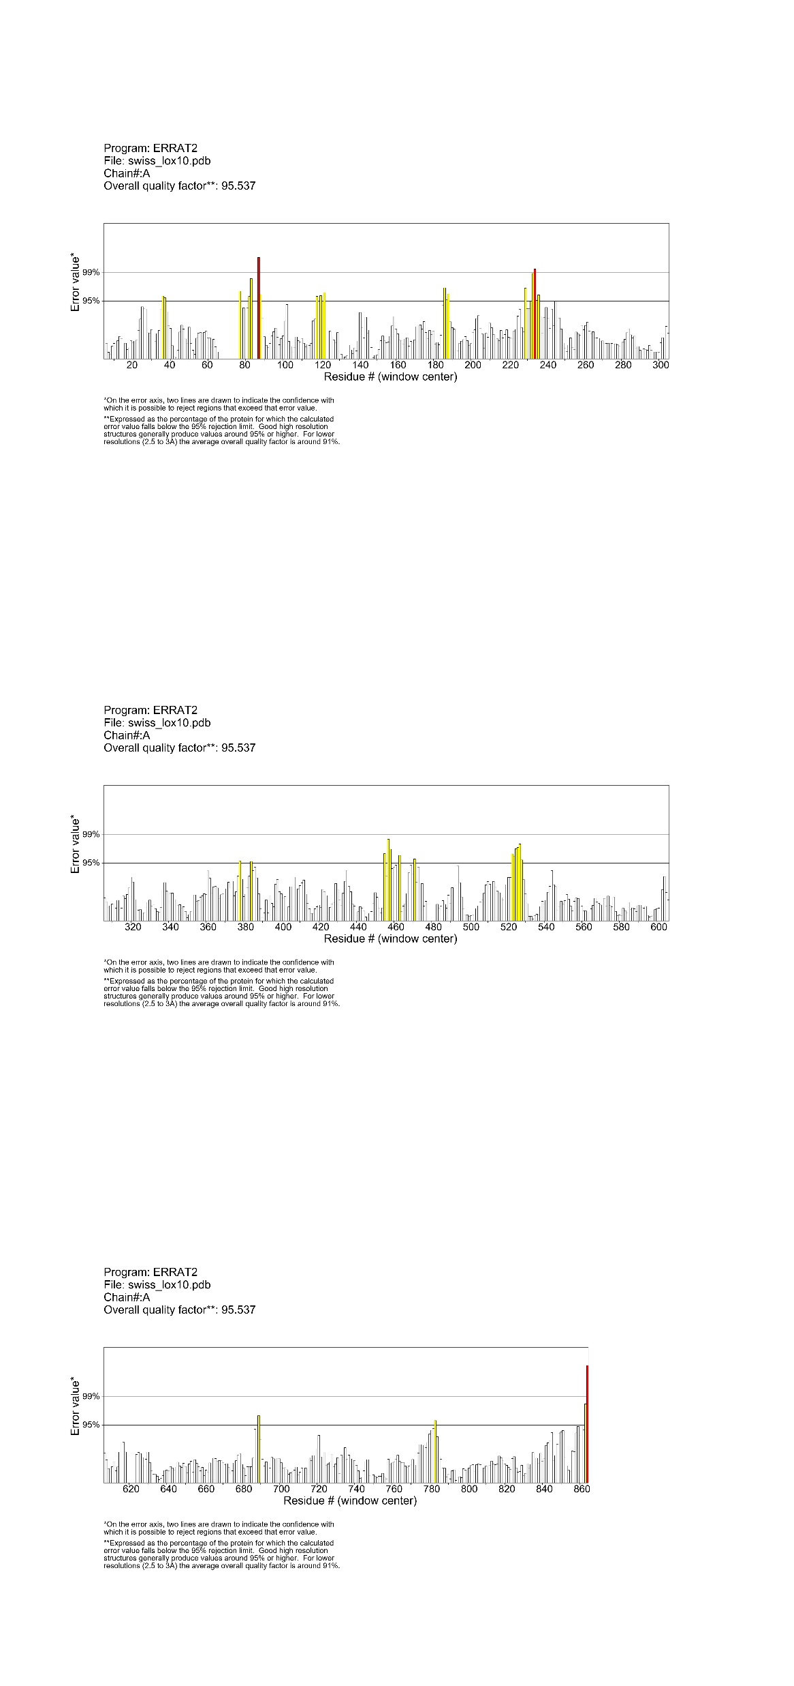
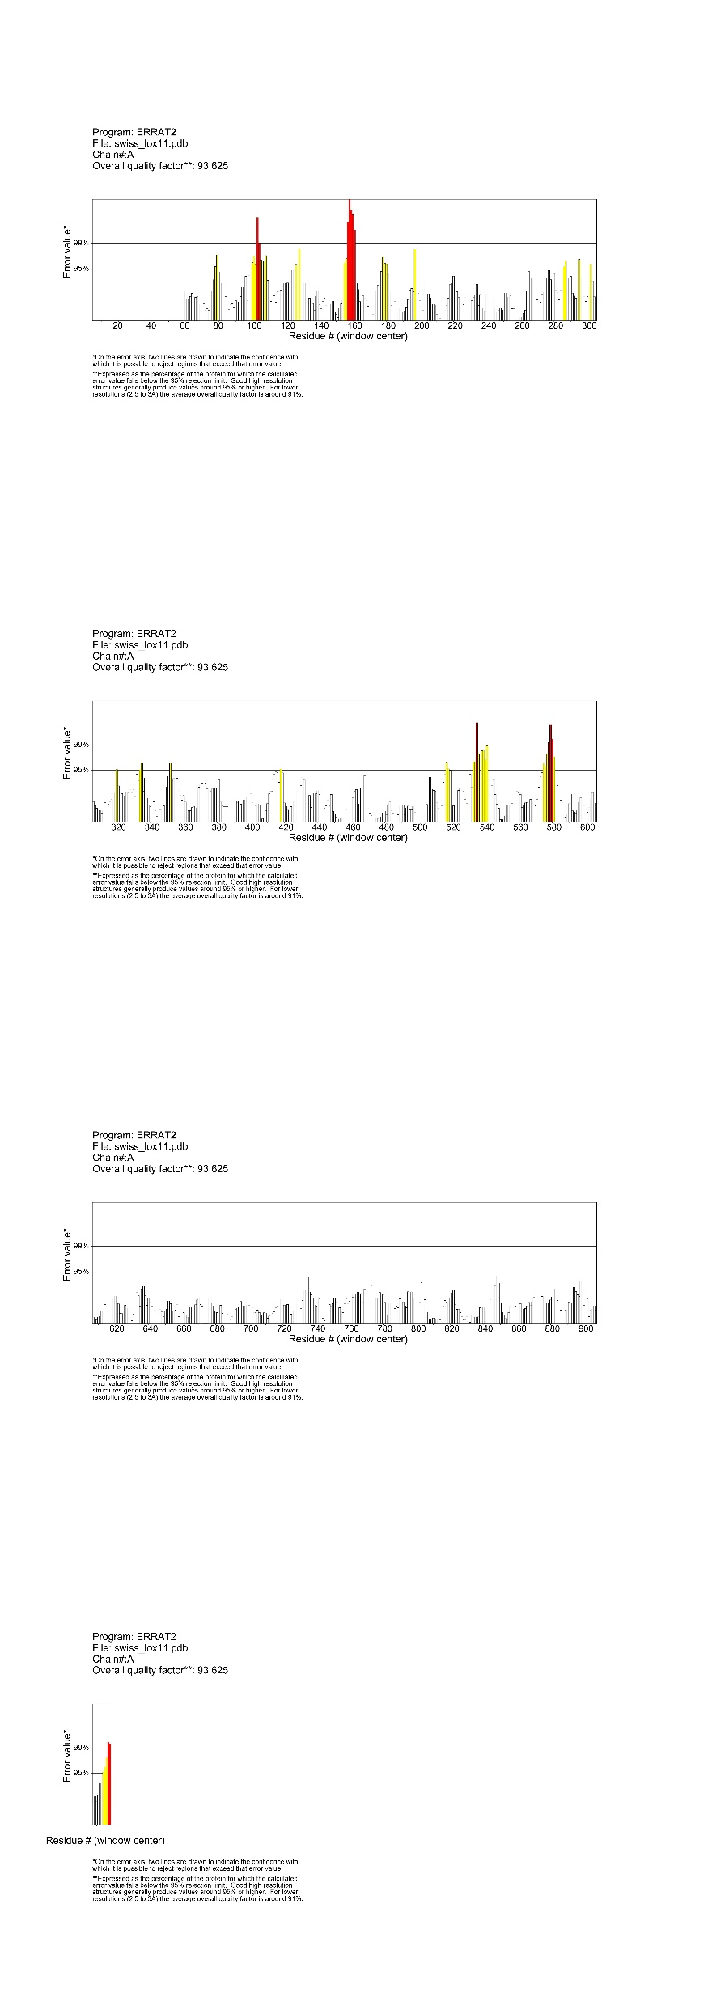
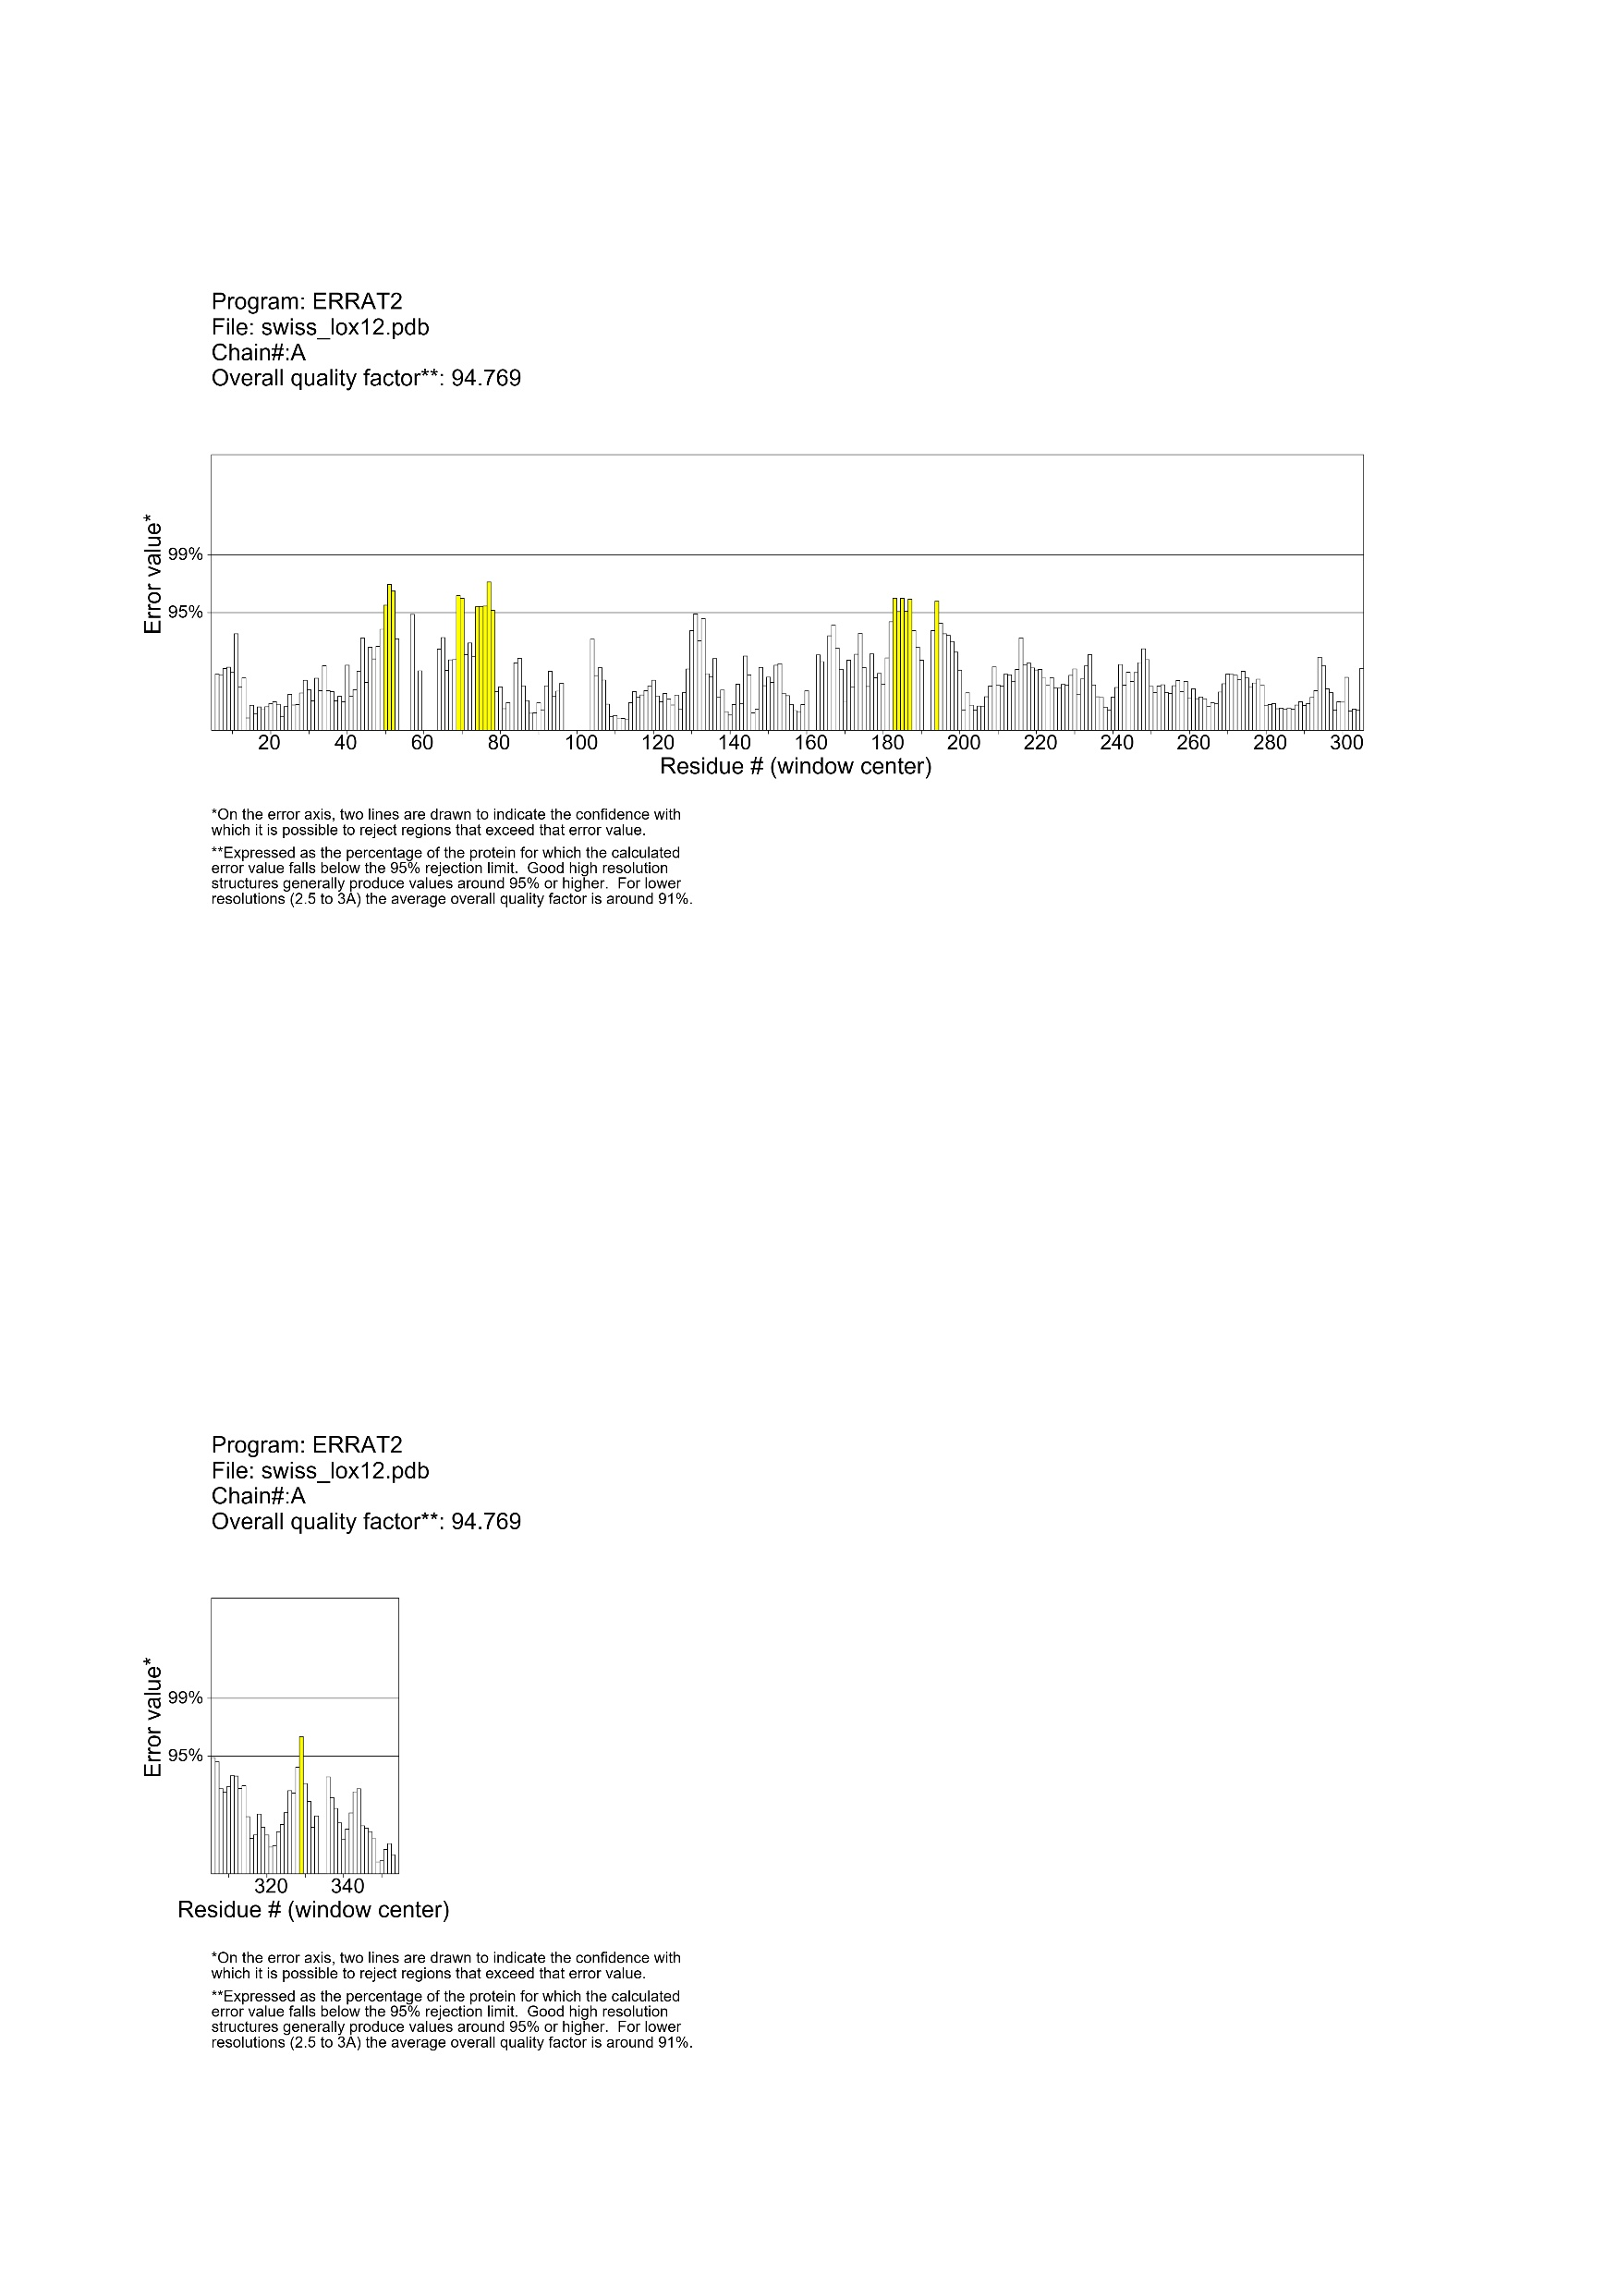
OsLOX9
OsLOX10
OsLOX11
OsLOX12

Figure S3. ERRAT plot of the 3D structures of OsLOXs. The plot was generated via the ERRAT server. Proteins that are capable of being excluded with a 95% confidence level are indicated by yellow bars, while those with a 99% confidence level are indicated by red bars. The segment with the least error rate is indicated by white bars.

