OsLOX1
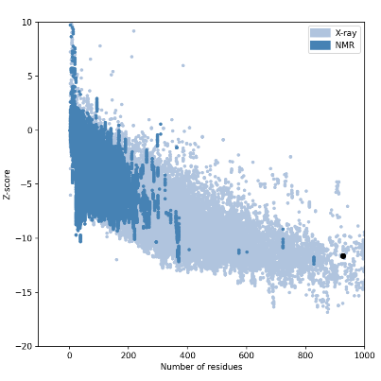
OsLOX2
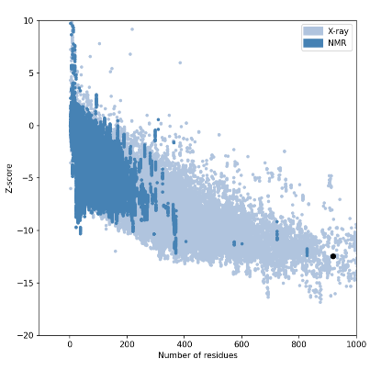
OsLOX3
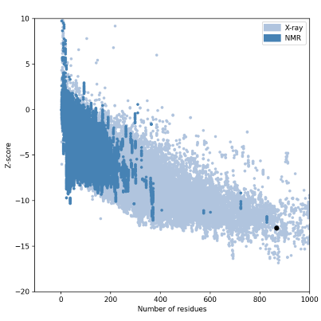
OsLOX4
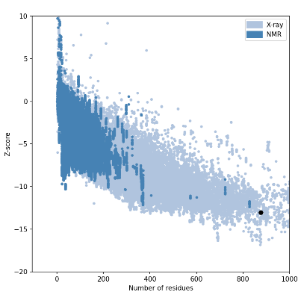
OsLOX5
Figure S4. Z-score representation of the 3D structures of OsLOXs. The Z-scores of proteins derived from X-ray crystallography are displayed in light blue, whereas those obtained from nuclear magnetic resonance (NMR) spectroscopy are represented in dark blue. Each protein's Z-score is displayed as a black dot.

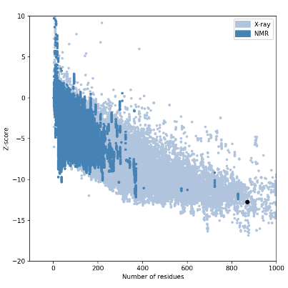
OsLOX6
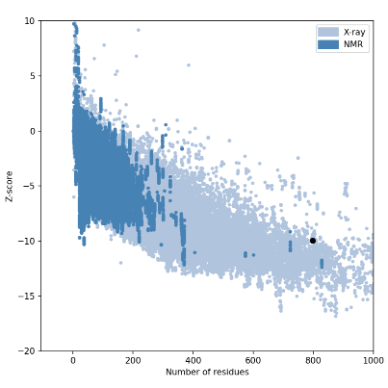
OsLOX7
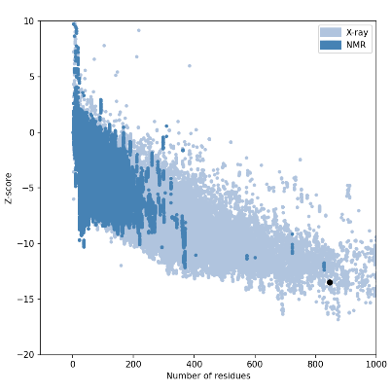
OsLOX8
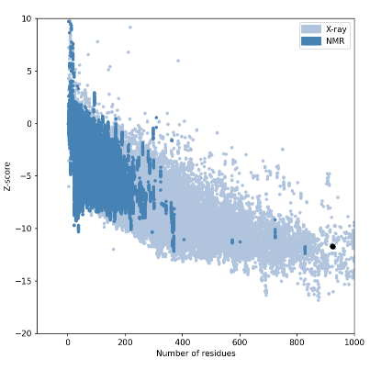
OsLOX9
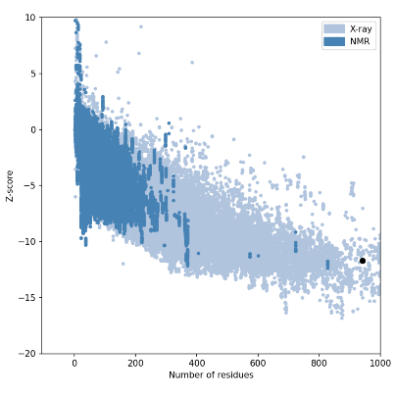
OsLOX10
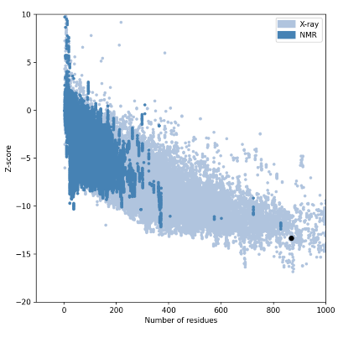
OsLOX11
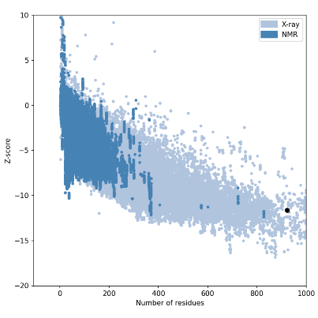
OsLOX12
