Supplementary Information

Development of a HiFi‐LAMP Assay for Detection of Herpes simplex virus type 1
Ziyan Wang ^{1,2,3}, Zhenzhou Wan ^{2,*}, Yongjuan Zhao ³, Zhengfang Wang ⁴, Shangwen Song ⁴, Zhi-Gang Song ³, Yu-Ye Li⁴, Chiyu Zhang ^{3,*}
¹ School of Medicine, Anhui University of Science and Technology, Huainan, 232001, China
² Medical Laboratory of Taizhou Fourth People’s Hospital, Taizhou, 225300, China
³ Shanghai Public Health Clinical Center, Fudan University, Shanghai, 201508, China
⁴ Department of Dermatology and Venereology, First Affiliated Hospital of Kunming Medical University, Kunming, 650032, China
* Correspondence: Zhenzhou Wan, wanlv@126.com, or Chiyu Zhang, chiyu_zhang1999@163.com

Table S1. Primers and probes used for LAMP in this study
Viruses | Primer sets | Primers/probes | Primer sequence (5'-3') | Length (nt) | Refs.
HSV-1 | Set 1 | F3 | CAGCCACACACCTGTGAA | 18 | ¹
HSV-1 | Set 1 | B3 | TCCGTCGAGGCATCGTTAG | 19 | ¹
HSV-1 | Set 1 | FIP | CCAGACGTTCCGTTGGTAGGTCTTTTACTTTGACTGTTCGCGCACC | 46 | ¹
HSV-1 | Set 1 | BIP | CCATCATCGCCACGTCGGACTTTTTCGGCGTCTGCTTTTTGTG | 43 | ¹
HSV-1 | Set 1 | LF | AAATCCTGTCGCCCTACACAGCGG | 24 | ¹
HSV-1 | Set 1 | LB | CACCCCGCGACGGGACGCCG | 20 | ¹
HSV-1 | set 2 | F3 | GCCTCTGGACTGGACCAC | 18 | This study
HSV-1 | set 2 | B3 | CCTGGCCGATGATAACCAC | 19 | This study
HSV-1 | set 2 | FIP | GCCAGCTCAGGCTCCATCAGGTTTCGGCGTGTGTTTCTG | 39 | This study
HSV-1 | set 2 | BIP | TAATCGTCGGTGCCAGACCGAGTCGGGGGTGCAATAACG | 39 | This study
HSV-1 | set 2 | LB | GCCGCGGGAGGATGTGTTTT | 20 | This study
HSV-1 | set 3 | F3 | GCCGTTGTTCCCATTATCCC | 20 | ²
HSV-1 | set 3 | B3 | TACTTGGCATGGGGGGTG | 18 | ²
HSV-1 | set 3 | FIP | GTTGGGTGGTGGAGGAGACGTCCTTTTGGTTCTTGTCGGT | 39 | ²
HSV-1 | set 3 | BIP | GGTCGTCCCTCGCATGAAGCGGCGTGGTAAGGCTGATG | 38 | ²
HSV-1 | set 3 | LF | TTGGTGGGAACCCCCGATAC | 20 | ²
HSV-1 | set 3 | LB | AACATGACCCAGACCGGCAC | 20 | ²
HSV-1 | set 3 | LF-probe | BHQ1-TTGGTGGGAACCCCCGATAC-FAM | 20 | ²
HSV-1 | set 3 | LB-probe | BHQ1-AACATGACCCAGACCGGCAC-FAM | 20 | ²
HSV-1 | set 4 | F3 | GAAGCCCCCAACATGACC | 18 | This study
HSV-1 | set 4 | B3 | CAGCCAACGGGAAGGC | 16 | This study
HSV-1 | set 4 | FIP | TCCGATACTTGGCATGGGGGGTACTCTCCCACCGCCATCA | 40 | This study
HSV-1 | set 4 | BIP | GAGGAAGAGGAGGAGGGGGCTAGGGTGTCACGGGTCC | 37 | This study
HSV-1 | set 4 | LF | TGGTCGGGCGTGGTAAG | 17 | This study
HSV-1 | set 4 | LB | GGGACGGCGAACATCTTGAGG | 21 | This study
HSV-1 | set 5 | F3 | ACCCCCCATGCCAAGT | 16 | This study
HSV-1 | set 5 | B3 | GGGGAGTTGTTGGGATCGG | 19 | This study
HSV-1 | set 5 | FIP | GGTCCCATCTCCCCCCTCAAGATGGACTGGAGGAGGAGGAA | 41 | This study
HSV-1 | set 5 | BIP | CGTGACACCCTACCCCAGTCCCGGGACGGTTGGGTTTGTC | 40 | This study
HSV-1 | set 5 | LB | CAGCCTTCCCGTTGGCTG | 18 | This study
HSV-1 | set 5 | LB2 | TTCCCGTTGGCTGAGGAC | 18 | This study
HSV-1 | set 5 | LB-probe | BHQ1-CAGCCTTCCCGTTGGCTG-FAM | 18 | This study
HSV-1 | set 5 | LB2-probe | BHQ1-TTCCCGTTGGCTGAGGAC-FAM | 18 | This study
Table S2. The information of the primers used in the qPCR assay.
Primer sets | Primer name | Primer sequence (5'-3') | Length (nt) | Refs.
HSV-1 | F | CGGCCGTGTGACACTATCG | 19 | ³
HSV-1 | R | CTCGTAAAATGGCCCCTCC | 19 | ³
HSV-1 | Probe | FAM-CCATACCGACCACACCGACGAATC-BHQ1 | 24 | ³

Table S3. Comparison between the HiFi-LAMP method and the qPCR method with clinical samples.
 |  | qPCR |  | Total
 |  | + | -
HiFi-LAMP(HSV-1) | + | 5 | 0 | 5
HiFi-LAMP(HSV-1) | - | 0 | 25 | 25
Total |  | 5 | 25 | 30
Relative sensitivity=5/5=100%
Relative specificity=25/25=100%
Compliance rate =30/30=100%

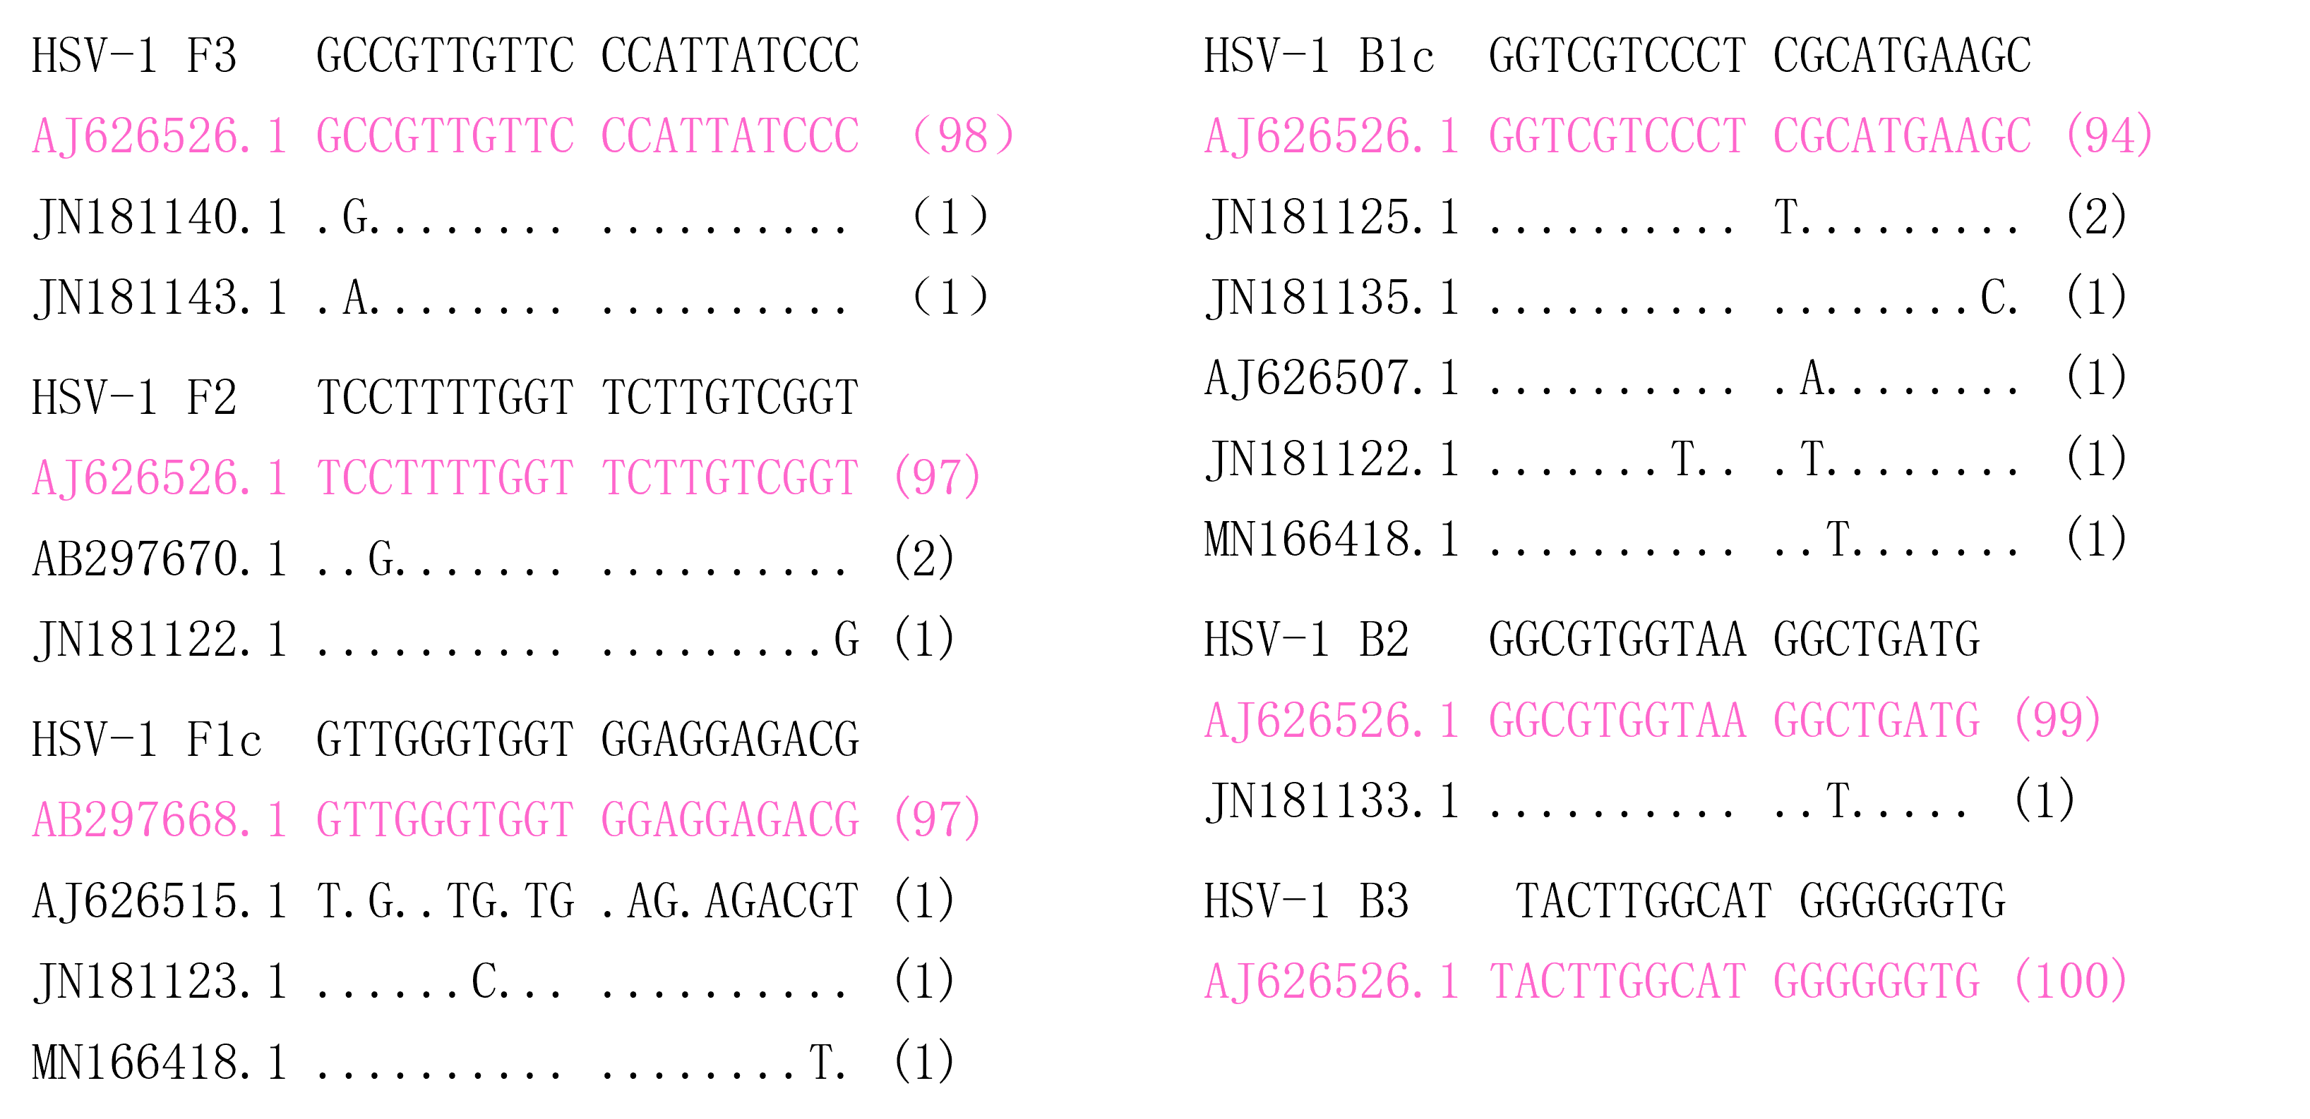

Fig. S1. Sequence alignmentsof the primer binding regions of HSV-1.
A total of 100 HSV-1 sequences were downloaded from National Center for Biotechnology Information (NCBI) (https://www.ncbi.nlm.nih.gov/) on May, 2025. The sequence number of each unique sequence/variant is shown in parenthesis. Dot, identity with the topmost sequence.

Supplementary References

1 Reddy, A. K., Balne, P. K., Reddy, R. K., Mathai, A. & Kaur, I. Loop-mediated isothermal amplification assay for the diagnosis of retinitis caused by herpes simplex virus-1. Clin Microbiol Infect 17, 210-213 (2011).
2 Enomoto, Y. et al. Rapid diagnosis of herpes simplex virus infection by a loop-mediated isothermal amplification method. J Clin Microbiol 43, 951-955 (2005).
3 Li, Y. et al. A Novel 2-dimensional Multiplex qPCR Assay for Single-Tube Detection of Nine Human Herpesviruses. Virol Sin 36, 746-754 (2021).

