Supplementary Information
Multimodal smart sensing via wavelength-selective hydrochromism in zero-dimensional metal halides
Joo Hyeong Han, Jeong Min Seo, Tuhin Samanta, Sung Woo Jang, Yong Min Park, San Ha Choi, Ji Hyeon Cha, and Won Bin Im*
Division of Materials Science and Engineering, Hanyang University, 222 Wangsimni-ro, Seongdong-gu, Seoul, 04763, Republic of Korea

*To whom correspondence should be addressed.
E-mail: imwonbin@hanyang.ac.kr

Supplementary Table 1. Rietveld refinement parameters of combined X-ray diffraction profiles of Cs₃GdCl₆. The numbers in parentheses are the estimated standard deviations of the last signiﬁcant ﬁgure.
parameters | value
symmetry | monoclinic
space group | C2/c
a (Å) | 27.025(8)
b (Å) | 8.172(2)
c (Å) | 13.235(9)
α (°) | 90.000
β (°) | 100.094(2)
γ (°) | 90.000
V (Å³) | 2877.568(2)
R_{wp} (%) | 7.63
χ² | 1.826

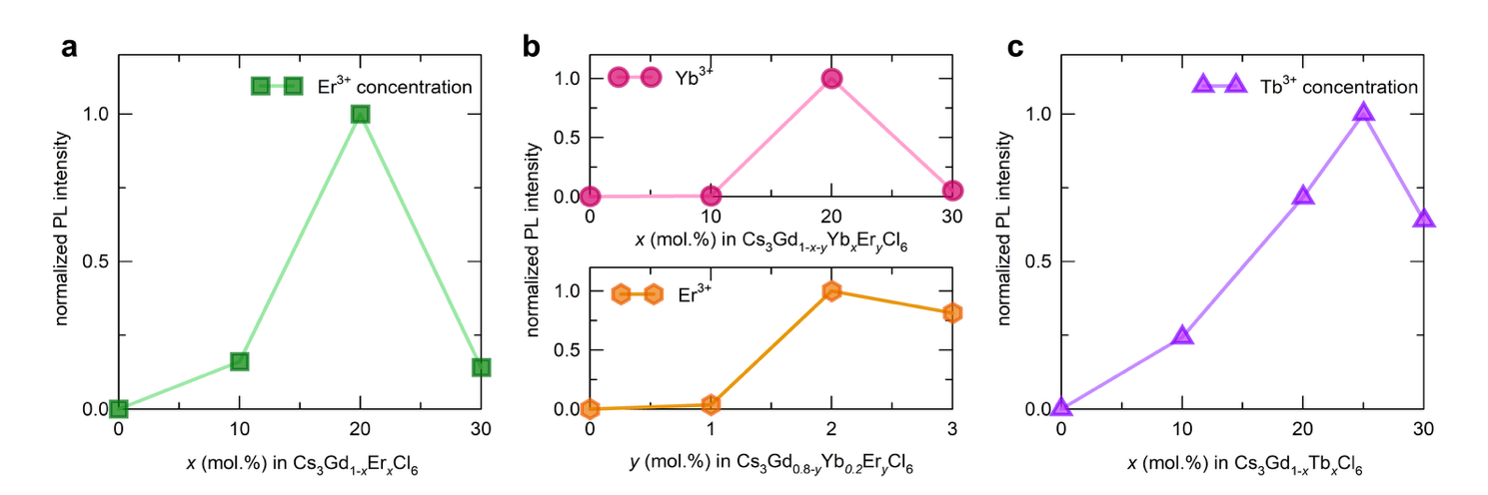
Supplementary Fig. 1. Normalized PL intensity of Cs₃Gd_{1-x}Ln_{x}Cl₆ as a function of a Er³⁺, b Yb³⁺-Er³⁺, and c Tb³⁺ concentration.
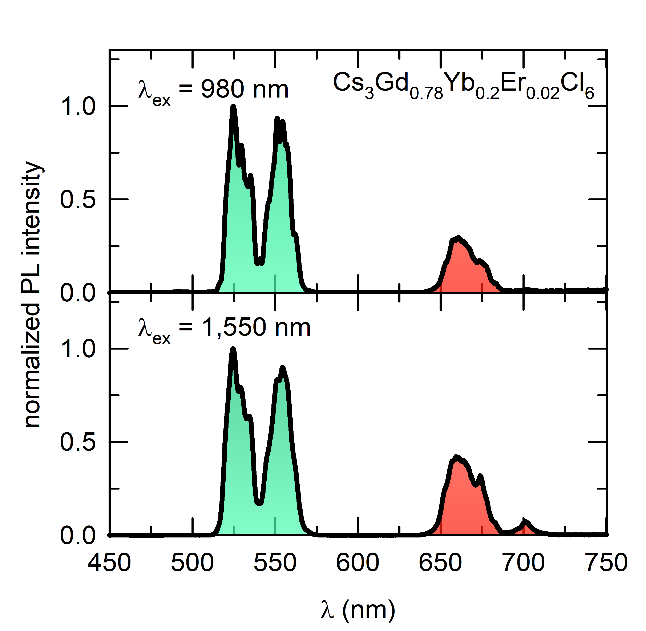

Supplementary Fig. 2. PL spectra under 980 nm and 1550 nm excitation of Cs₃Gd_{0.78}Yb_{0.2}Er_{0.02}Cl₆.
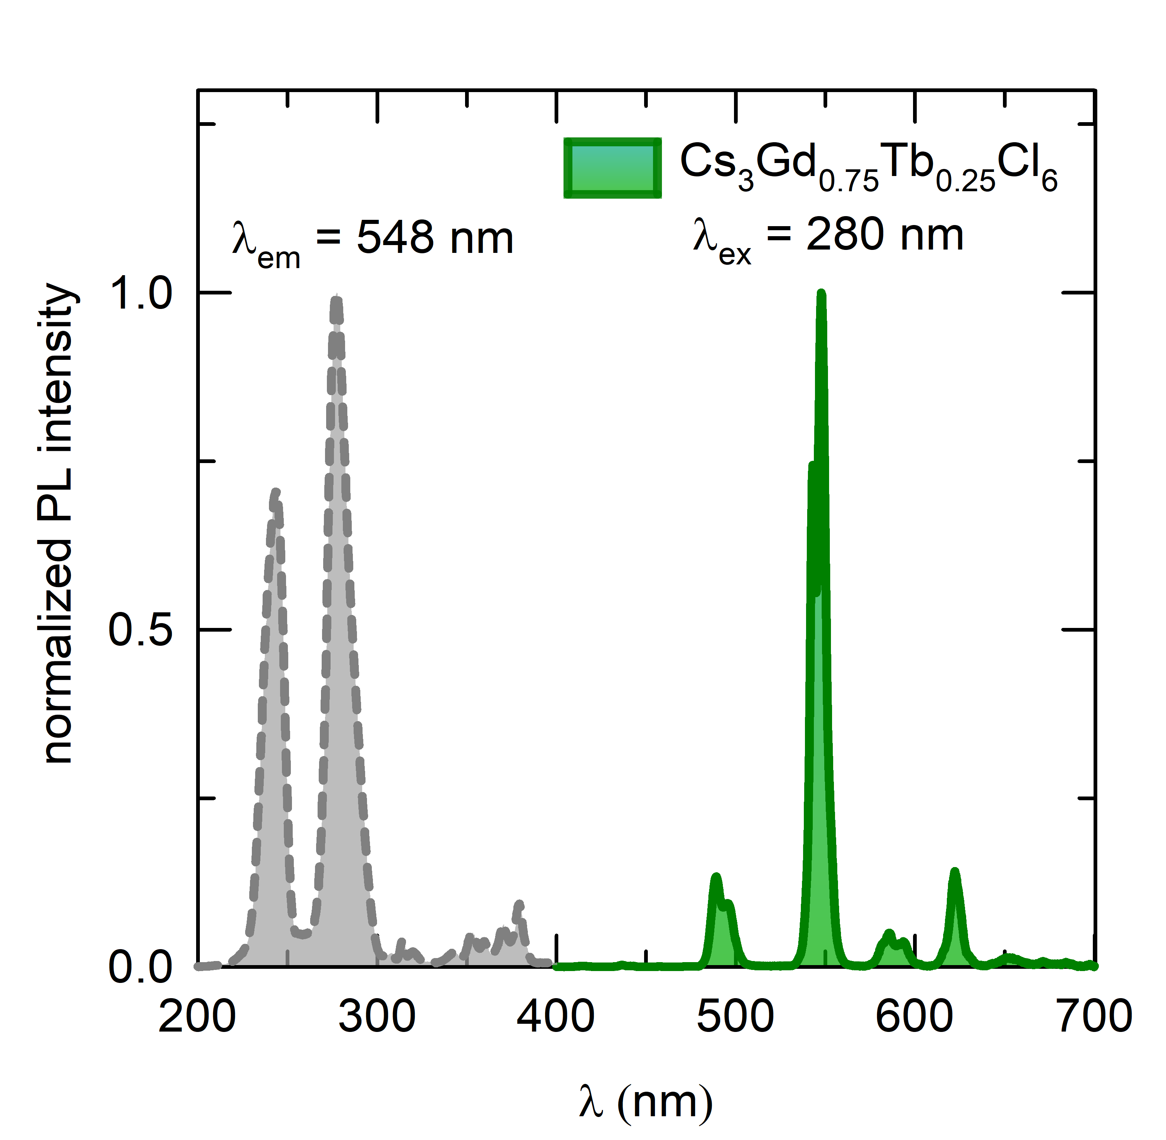
Supplementary Fig. 3. PL and PLE spectra of Cs₃Gd_{0.75}Tb_{0.25}Cl₆.

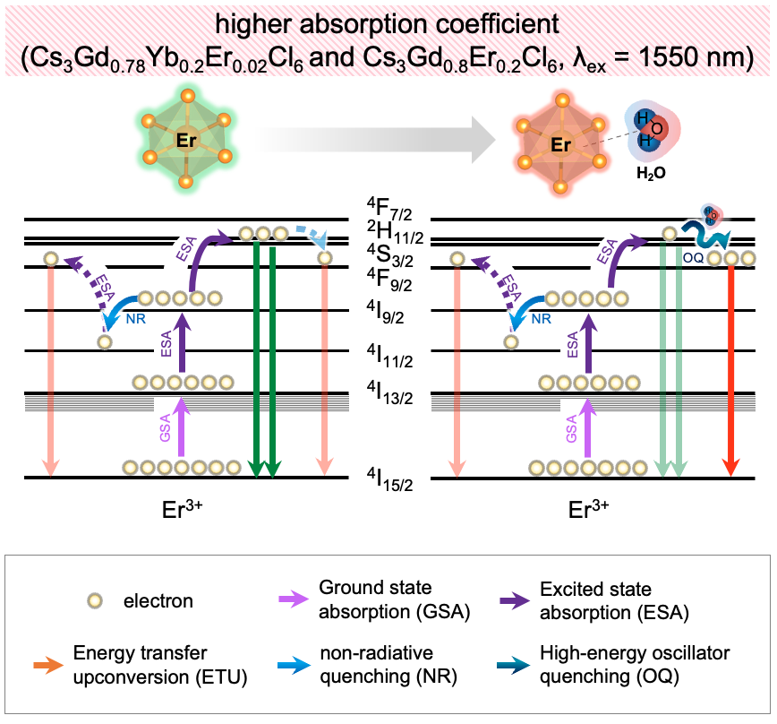
Supplementary Fig. 4. Schematic illustration of hydrochromic upconversion mechanism under 1550 nm excitation for Yb/Er co-doped and Er-doped systems.
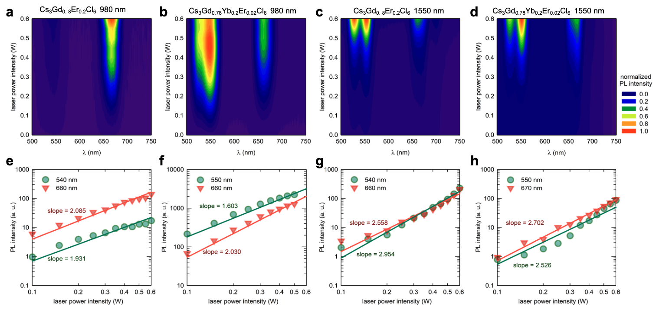
Supplementary Fig. 5. Laser power-dependent PL spectra under 980 nm and 1550 nm excitation of a-d Cs₃Gd_{0.8}Er_{0.2}Cl₆ and Cs₃Gd_{0.78}Yb_{0.2}Er_{0.02}Cl₆. Pump power dependence of green and red upconversion intensity: e-h Cs₃Gd_{0.8}Er_{0.2}Cl₆ and Cs₃Gd_{0.78}Yb_{0.2}Er_{0.02}Cl₆under 980 nm and 1550 nm excitation.

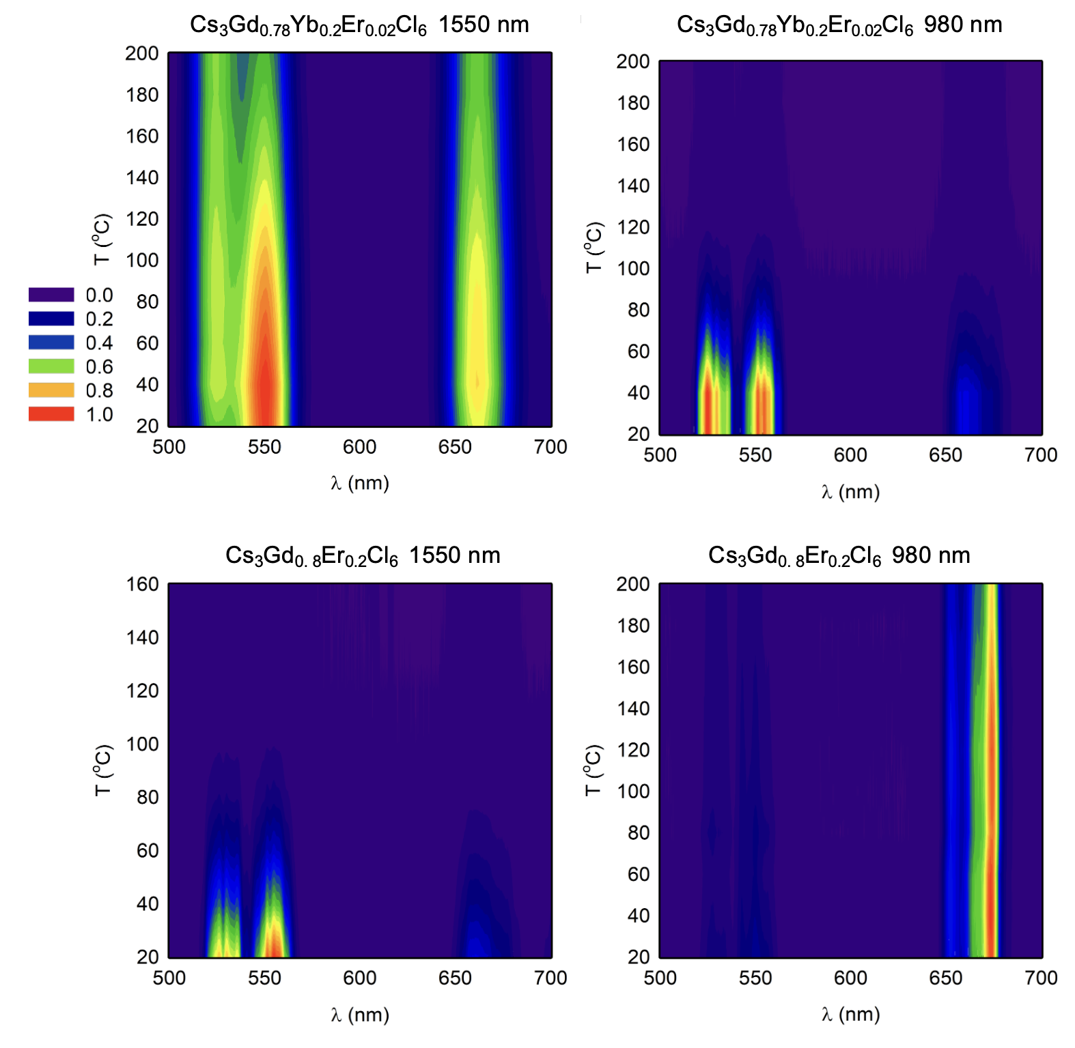
Supplementary Fig. 6. Temperature-dependent upconversion luminescence contour maps of Cs₃Gd_{0.8}Er_{0.2}Cl₆ and Cs₃Gd_{0.78}Yb_{0.2}Er_{0.02}Cl₆ under 980 nm and 1550 nm excitations in the temperature range of 20–200℃.

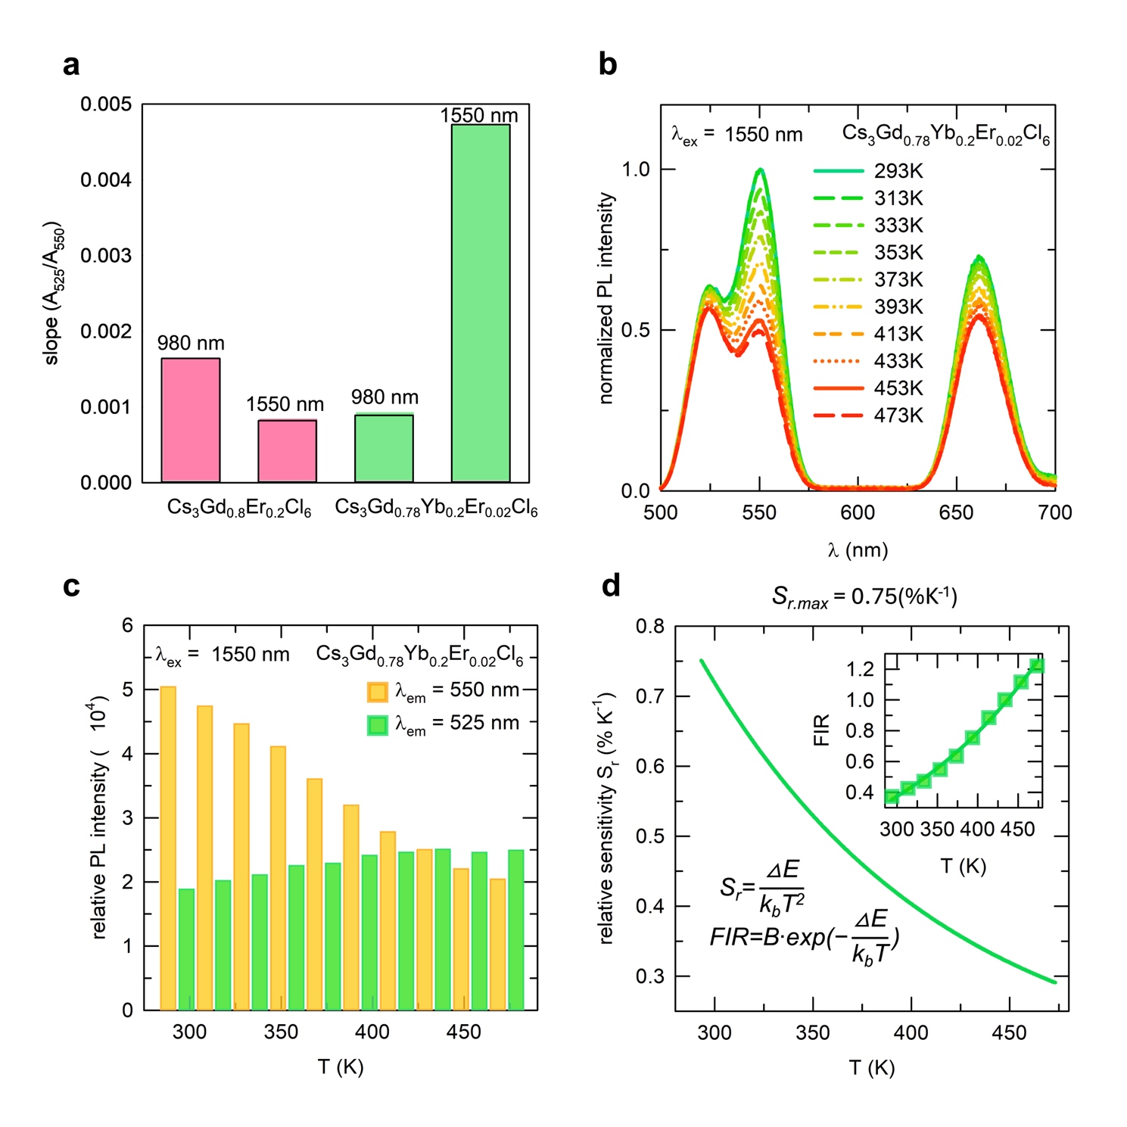
Supplementary Fig. 7. Optical thermometry performance of Cs₃Gd_{0.78}Yb_{0.2}Er_{0.02}Cl₆ under 1550 nm excitation. a Comparison of absorbance slopes, b temperature-dependent PL spectra showing thermally coupled level behavior, c relative PL intensity variations of 525 nm and 550 nm emissions, and d fluorescence intensity ratio (FIR) fitting and relative sensitivity (S_{r}) curve.

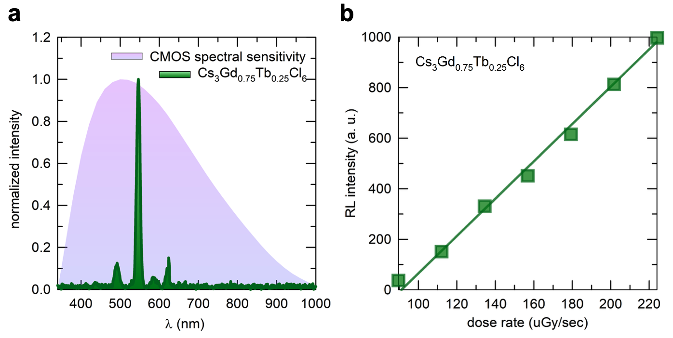
Supplementary Fig. 8. X-ray detection characteristics of Cs₃Gd_{0.75}Tb_{0.25}Cl₆. a Spectral matching between radioluminescence (RL) emission and the spectral sensitivity of a commercial CMOS sensor. b Linear relationship between RL intensity and X-ray dose rate.

