Supporting information
A Green Approach to Synthesis of 1,2,4-Triazolo-1,5-Benzothiazepine fused Pyrimidine Scaffolds by Cyclocondensation Reaction
Aruna Sharmaª*, Anjali Yadavª, Rajesh Kumar Meena^{c}, Hardik Pathak^{b}*, Bhawana Jangirª
ªDepartment of Chemistry, JECRC University, Jaipur, Rajasthan, Pin-303905, India
^{b}Department of Biotechnology, JECRC University, Jaipur-303905, Rajasthan, India.
^{c}Kalindi College, University of Delhi, Delhi-110008, India
*E-mail: arunasharma.ch@gmail.com, hardik.pathak@jecrcu.edu.in

Spectrum No. 1: IR Spectrum of 4-(3-methyldibenzo[b,f][1,2,4]triazolo[4,3-d][1,4]thiazepin-6-yl)-6-phenylpyrimidin-2-ol (2c)

Spectrum No. 2: IR Spectrum of 4-(3-methyldibenzo[b,f][1,2,4]triazolo[4,3-d][1,4]thiazepin-6-yl)-6-phenylpyrimidin-2-thiol (3c)

Spectrum No. 3: IR Spectrum of 4-(3-methyldibenzo[b,f][1,2,4]triazolo[4,3-d][1,4]thiazepin-6-yl)-6-phenylpyrimidin-2-amine(4c)

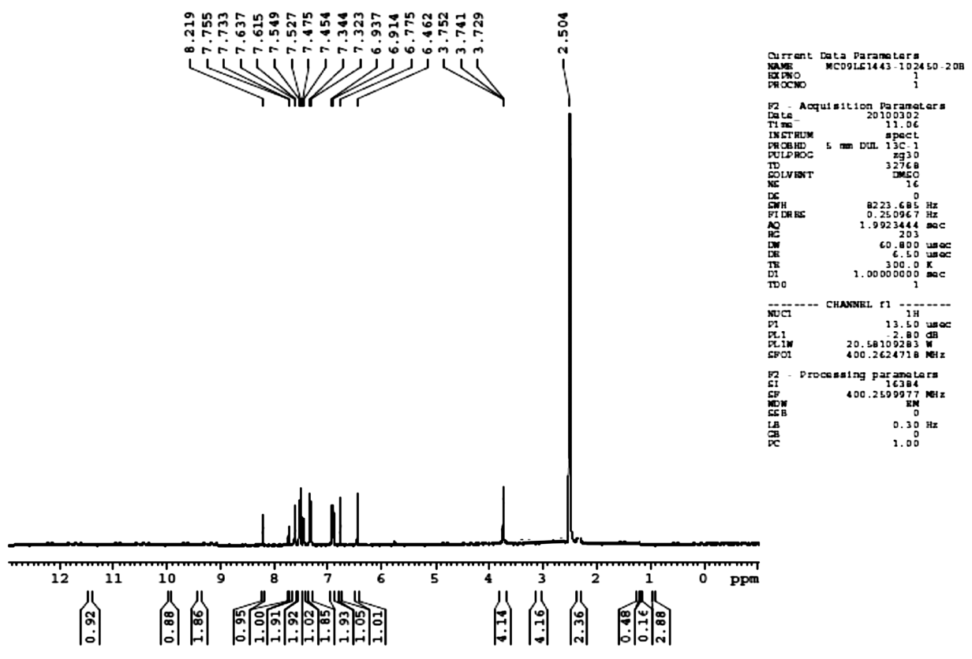
Spectrum No. 4: ¹H NMR Spectrum of 4-(3-methyldibenzo[b,f][1,2,4]triazolo[4,3-d][1,4]thiazepin-6-yl)-6-phenylpyrimidin-2-ol(2c)

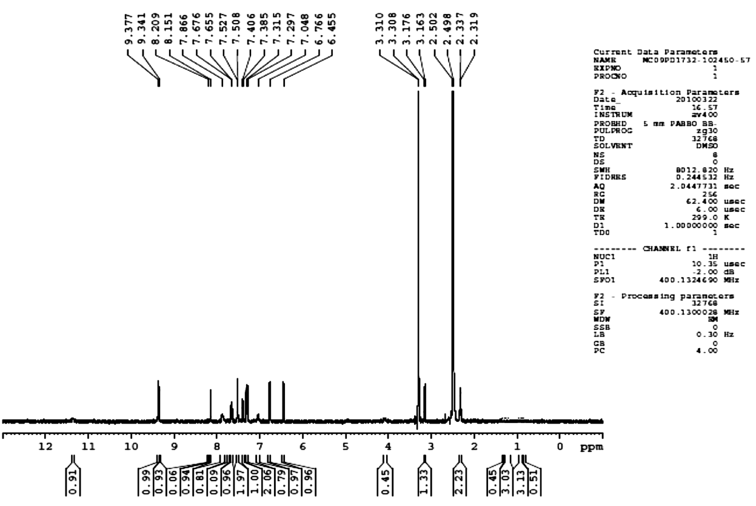
Spectrum No. 4.5: ¹H NMR Spectrum of 4-(3-methyldibenzo[b,f][1,2,4]triazolo[4,3-d][1,4]thiazepin-6-yl)-6-phenylpyrimidin-2-thiol(3c)

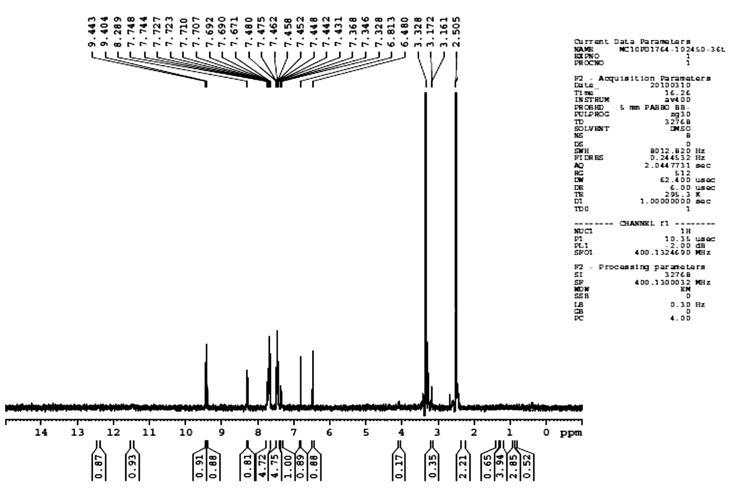
Spectrum No. 4.6: ¹H NMR Spectrum of 4-(3-methyldibenzo[b,f][1,2,4]triazolo[4,3-d][1,4]thiazepin-6-yl)-6-phenylpyrimidin-2-amine (4c)

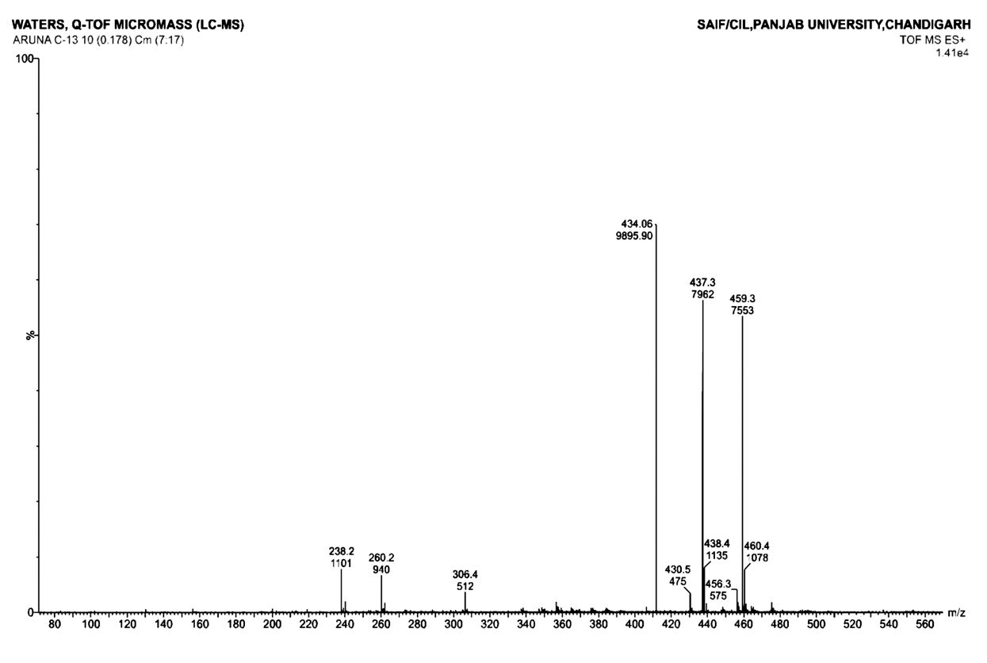
Spectrum No. 4.7: Mass Spectrum of 4-(3-methyldibenzo[b,f][1,2,4]triazolo[4,3-d][1,4]thiazepin-6-yl)-6-phenylpyrimidin-2-ol (2c)

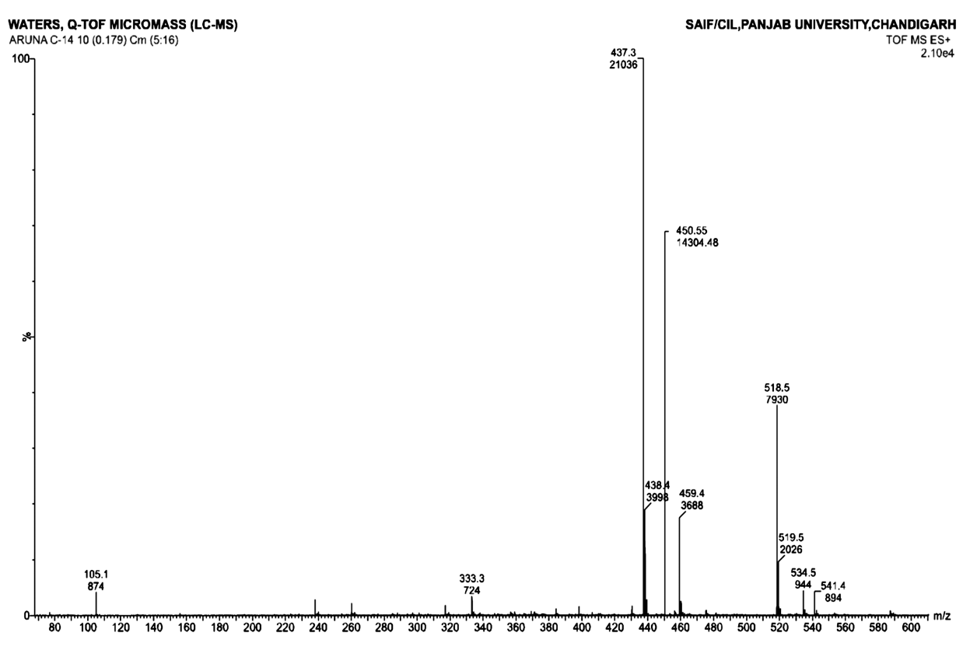
Spectrum No. 4.8: Mass Spectrum of 4-(3-methyldibenzo[b,f][1,2,4]triazolo[4,3-d][1,4]thiazepin-6-yl)-6-phenylpyrimidin-2-thiol (3c)

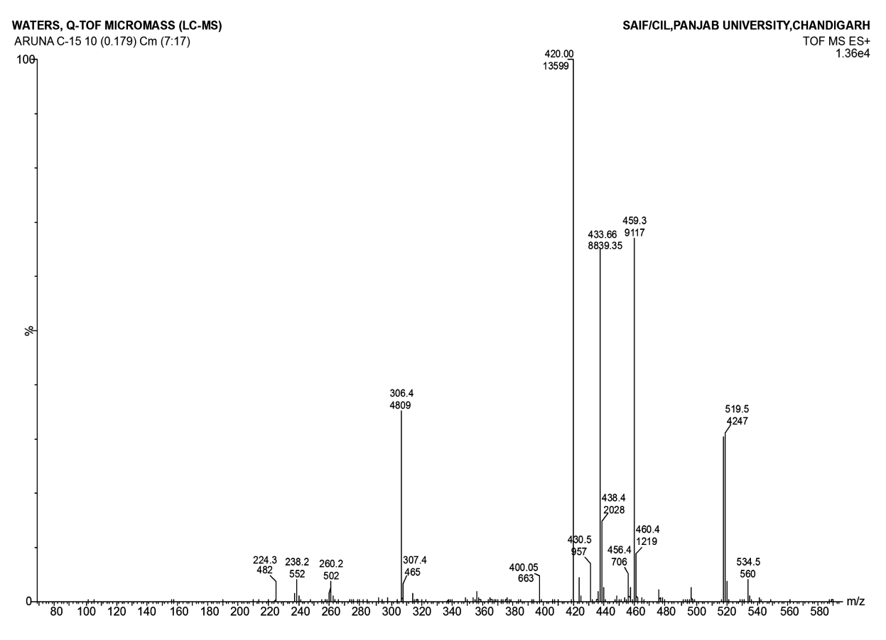
Spectrum No. 4.9: Mass Spectrum of 4-(3-methyldibenzo[b,f][1,2,4]triazolo[4,3-d][1,4]thiazepin-6-yl)-6-phenylpyrimidin-2-amine (4c)

