shear bond strength (MPa)
control | curodont | GC
5.93 | 25.33 | 24.67
16.11 | 15.14 | 19.35
11.92 | 8.87 | 26.16
22.37 | 27.24 | 25.66
3.77 | 27.68 | 16.53
22 | 20.96 | 24.91
14.68 | 24.95 | 14.38
33.9 | 11.47 | 13.21
0 | 18.75 | 25.52
20.42 | 24.24 | 26.48
10.59 | 33.13 | 6.2
25.92 | 37.07 | 26.82
16.76 | 15.13 | 18.27
15.44 | 31.53 | 9.71
28.63 | 0 | 6.02
18.61 | 31.83 | 37.32
27.87 | 13.62 | 25.06
20.67 | 21.85 | 10.87
23.35 | 10.47 | 15.81
15 | 4.58 | 7.84
10.92 | 3.96 | 25.69
30.3 | 22.42 | 19.31
10.76 | 10.61 | 12.16
14.4 | 39.8 | 26.78
33.57 | 21.11 | 23.82
9.75 | 21.29 | 31.73
12.85 | 27.88 | 61.86
21.84 | 15.12 | 24.24
26.47 | 21.79 | 18.01
40.51 | 19.71 | 5.86
S1: Raw data of individual shear bond strengths of different groups

S2: Pre Control

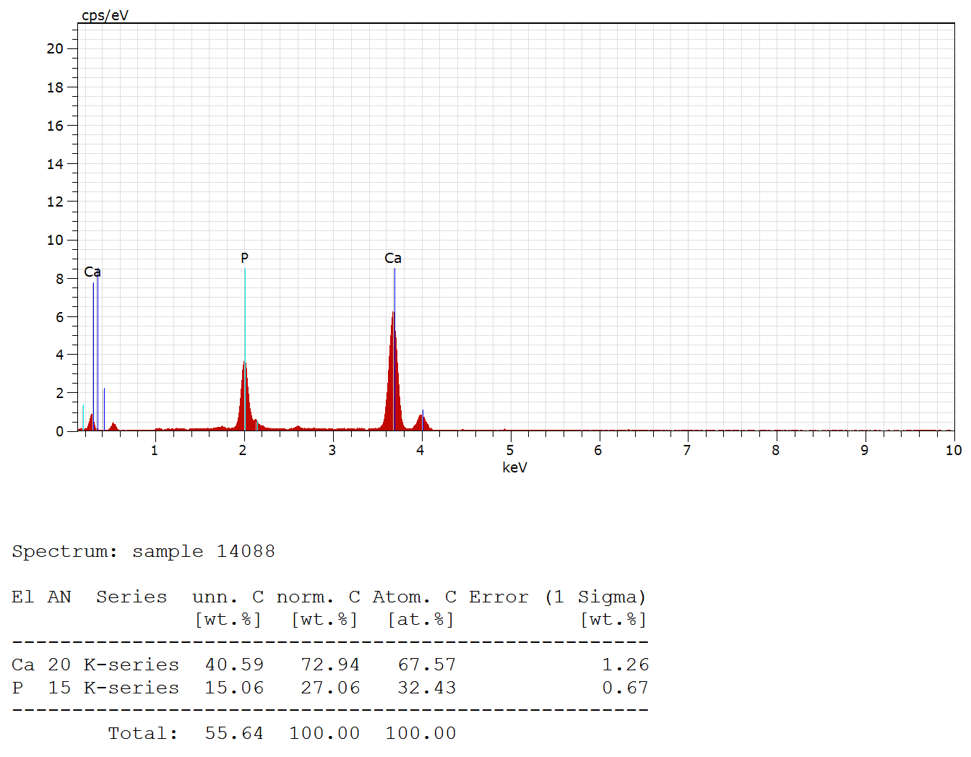
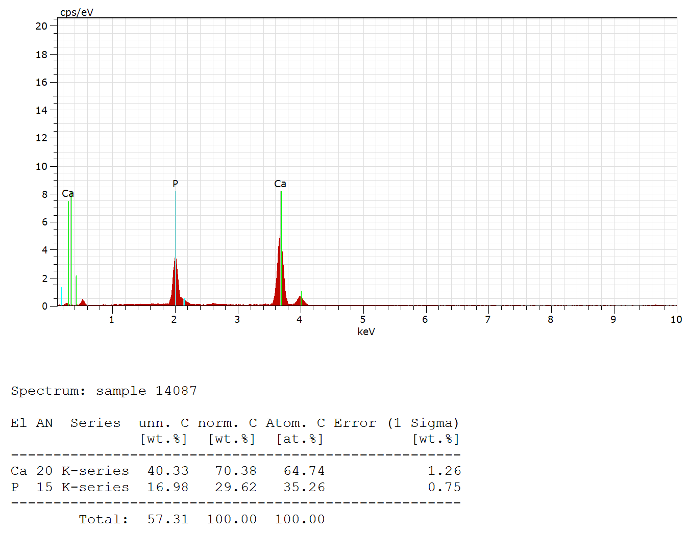

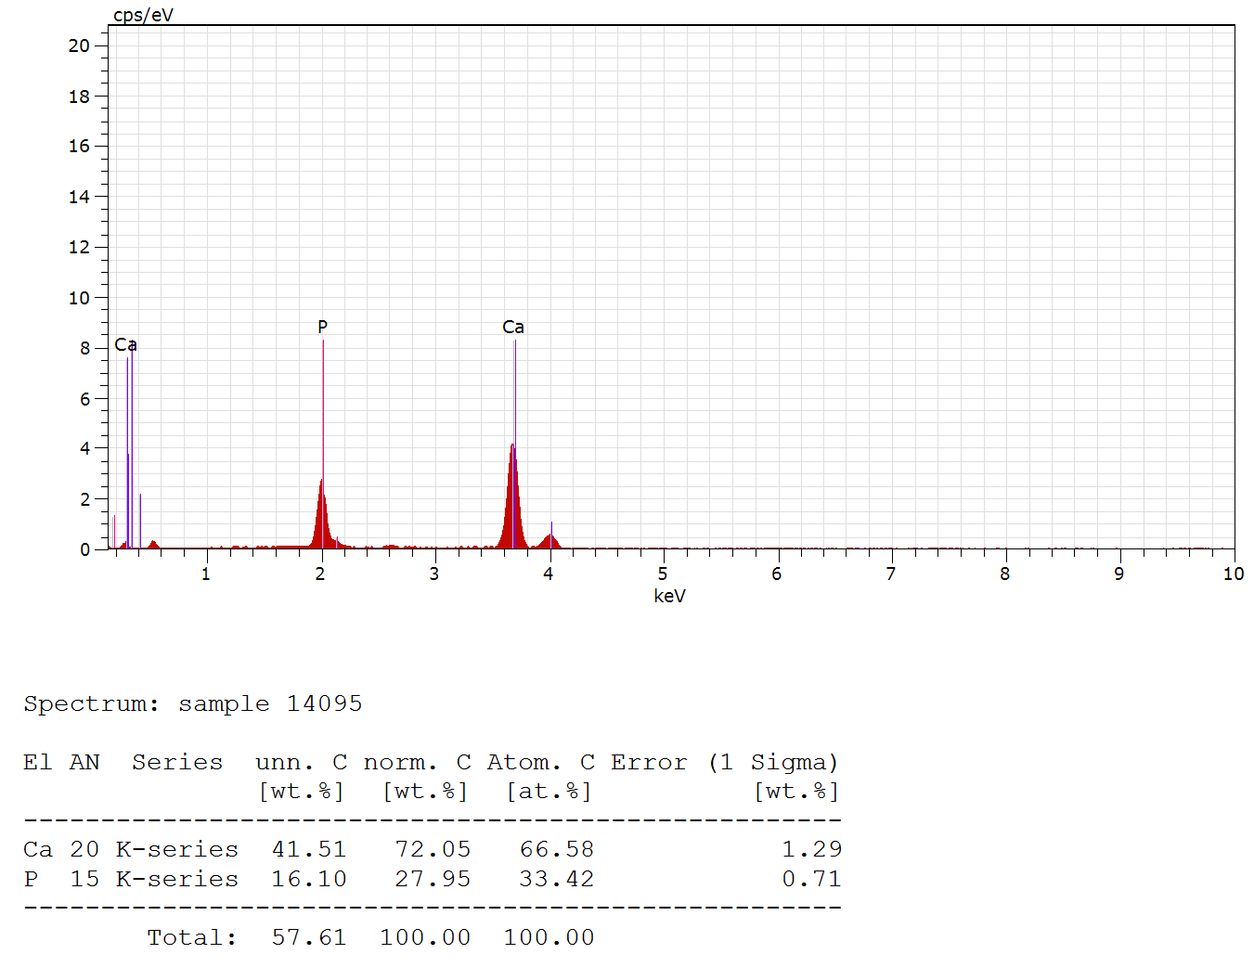
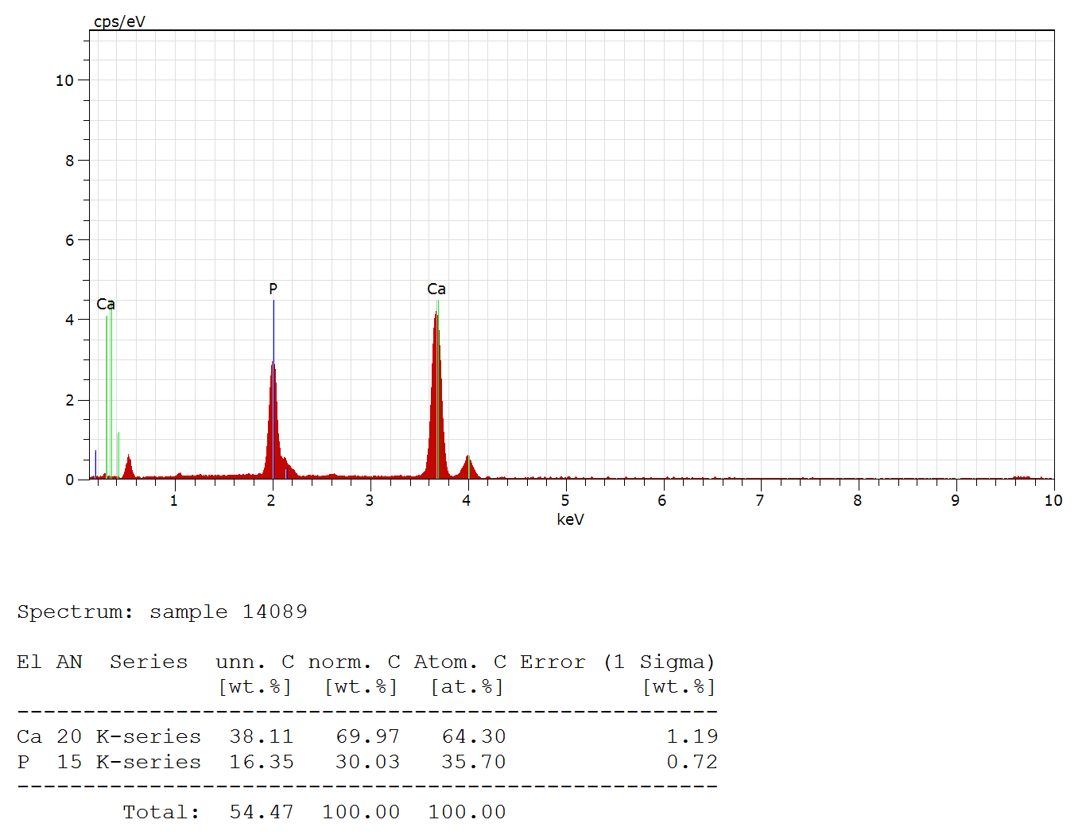

S3: Post Control

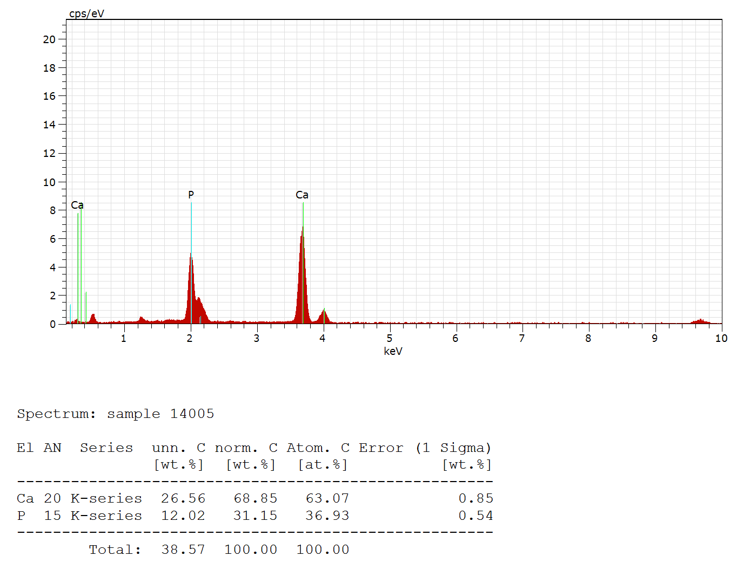
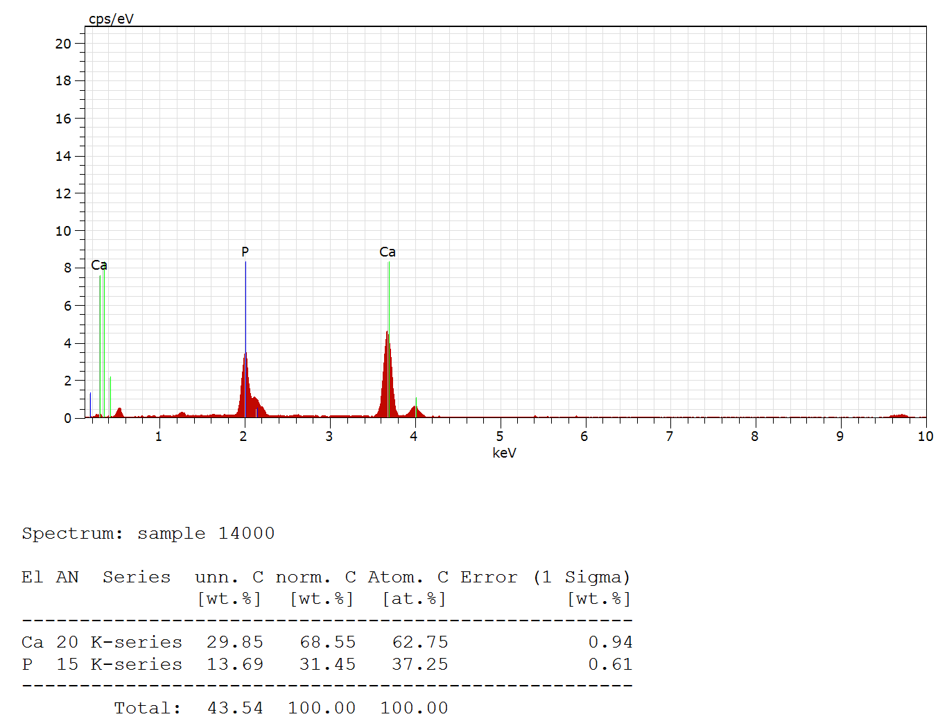

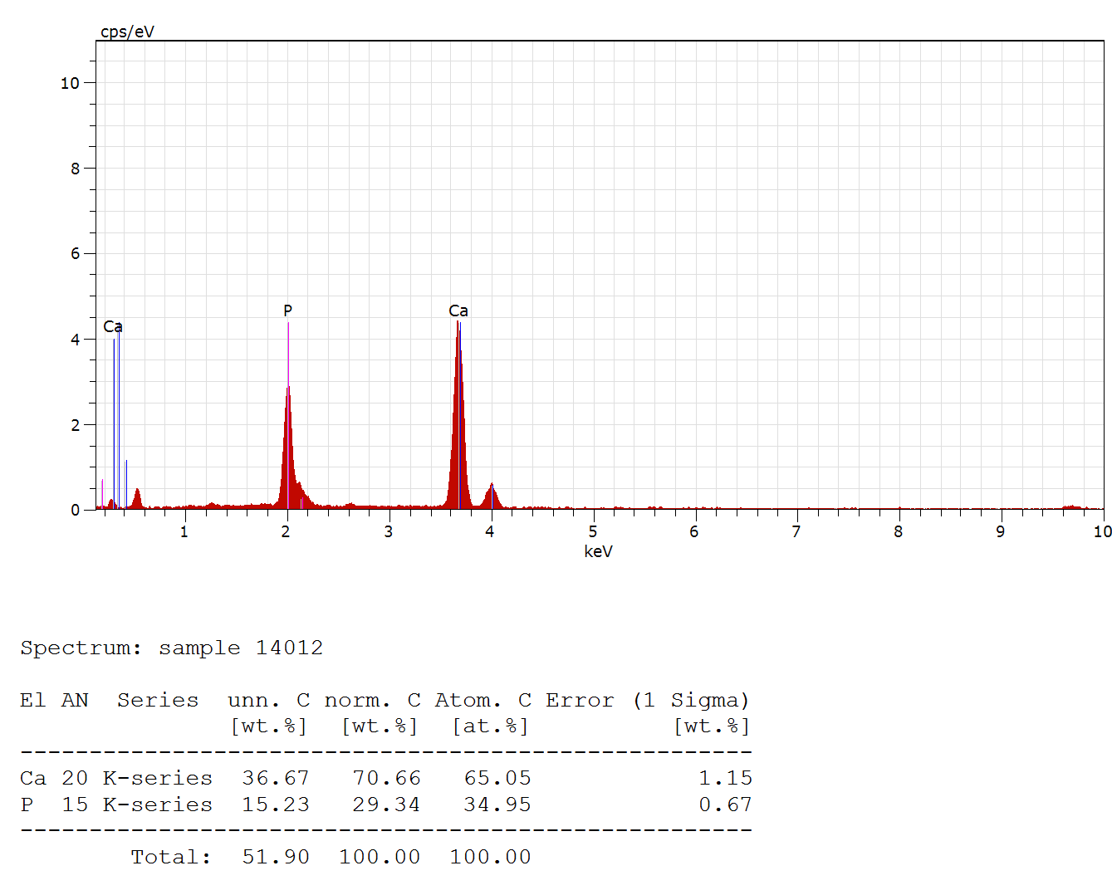
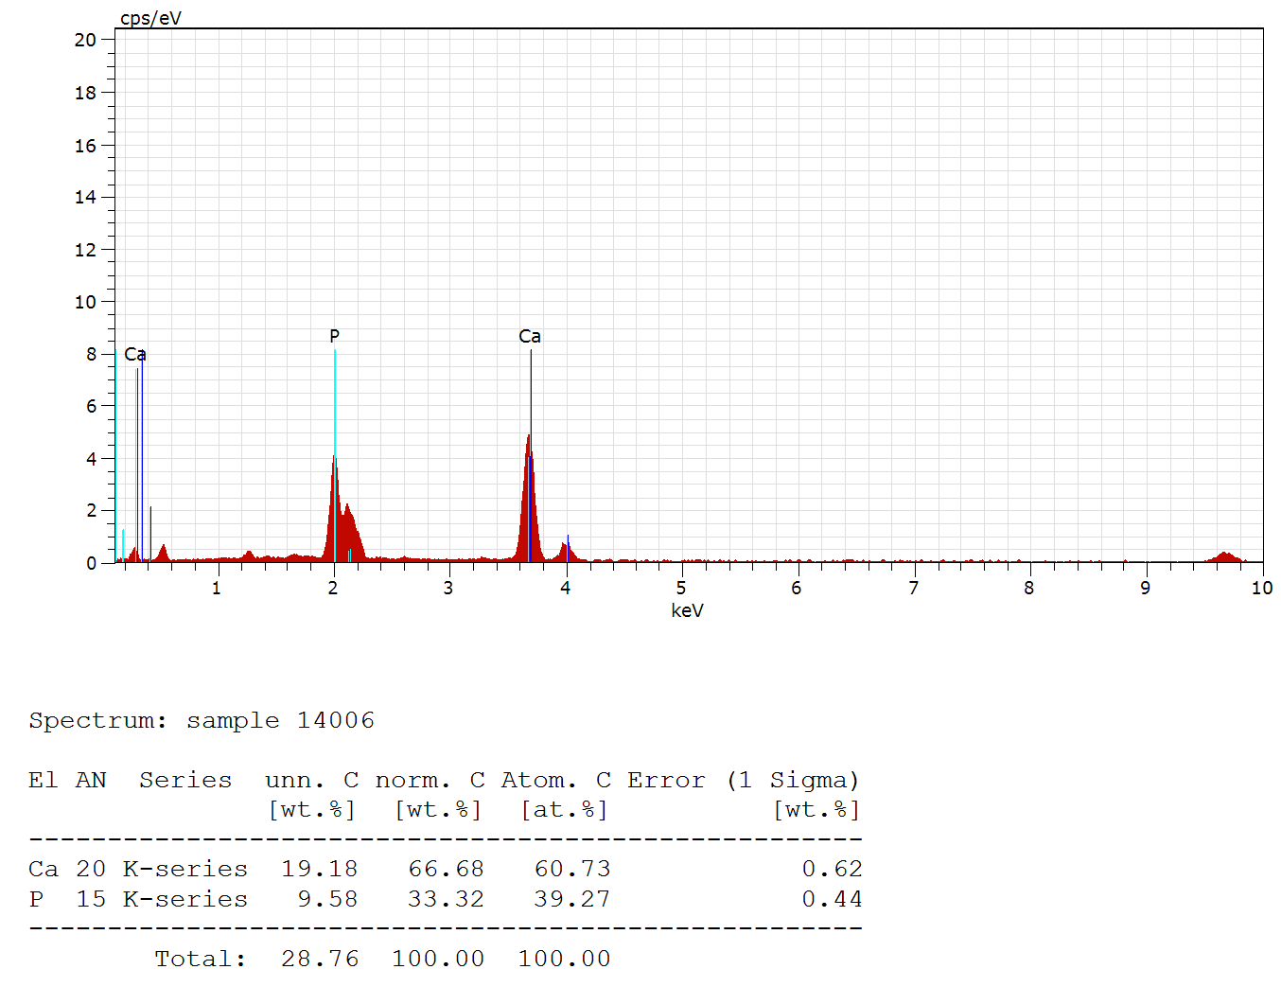

S4: GC Mousse
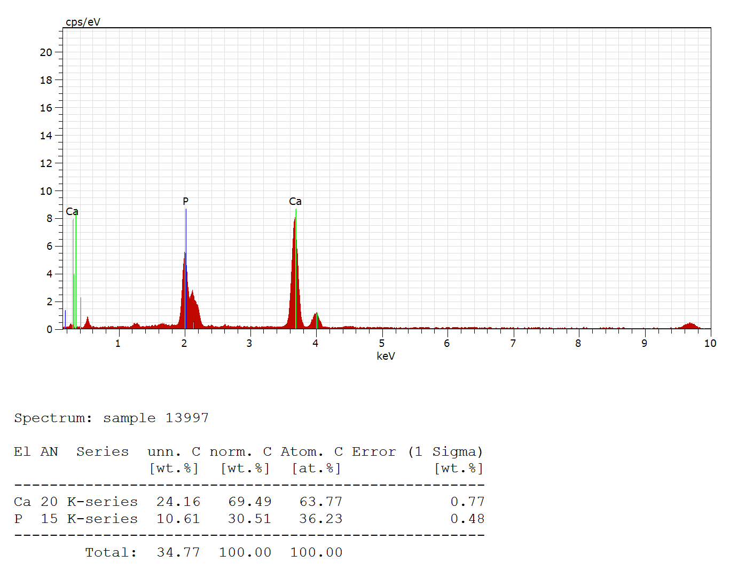
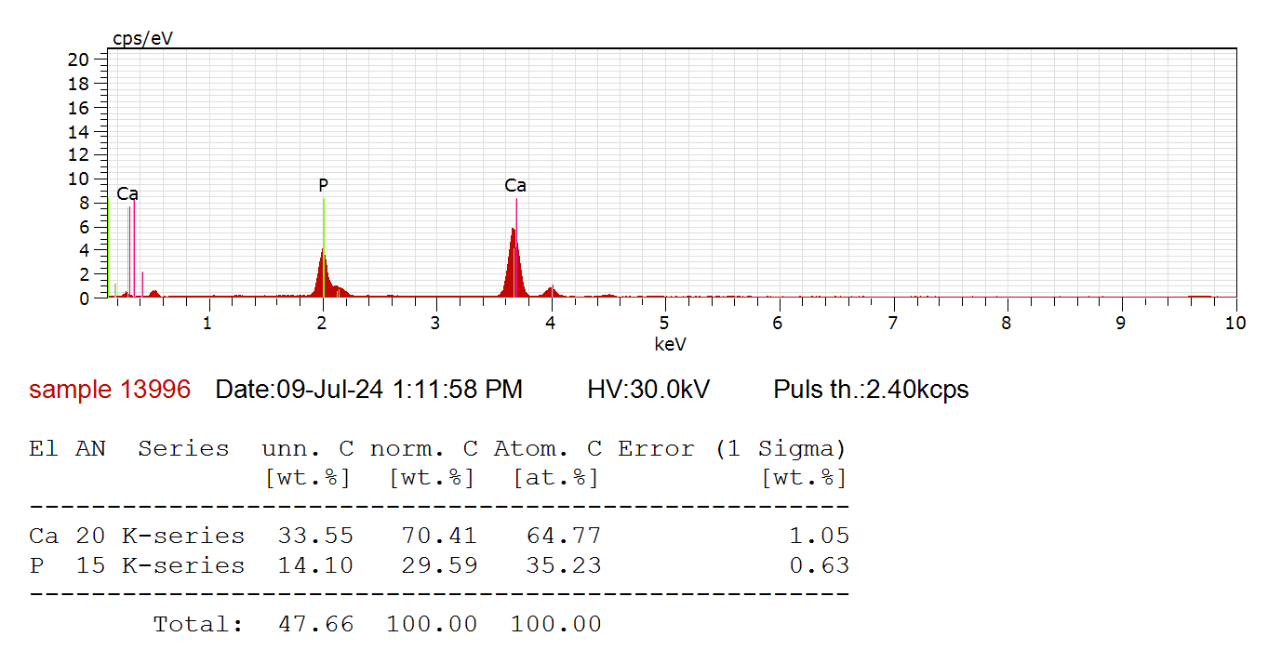

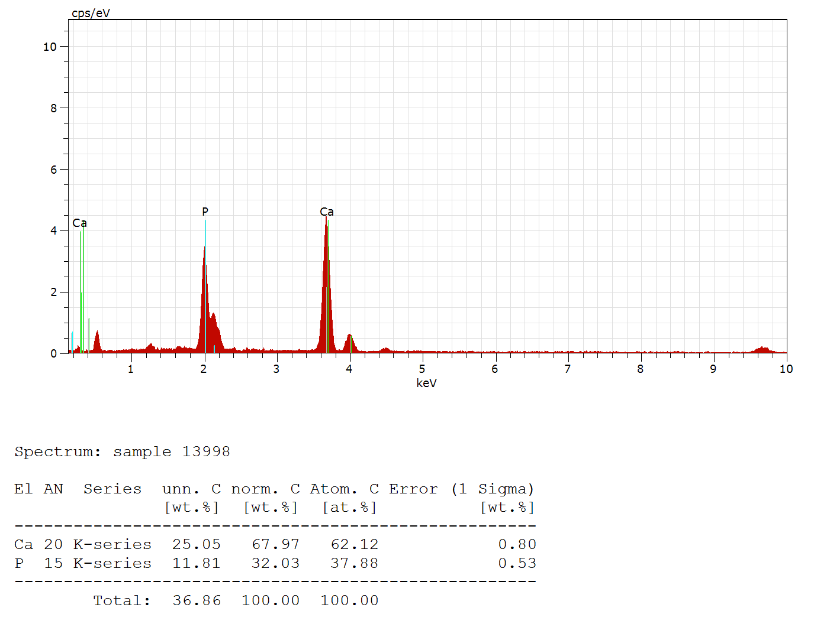
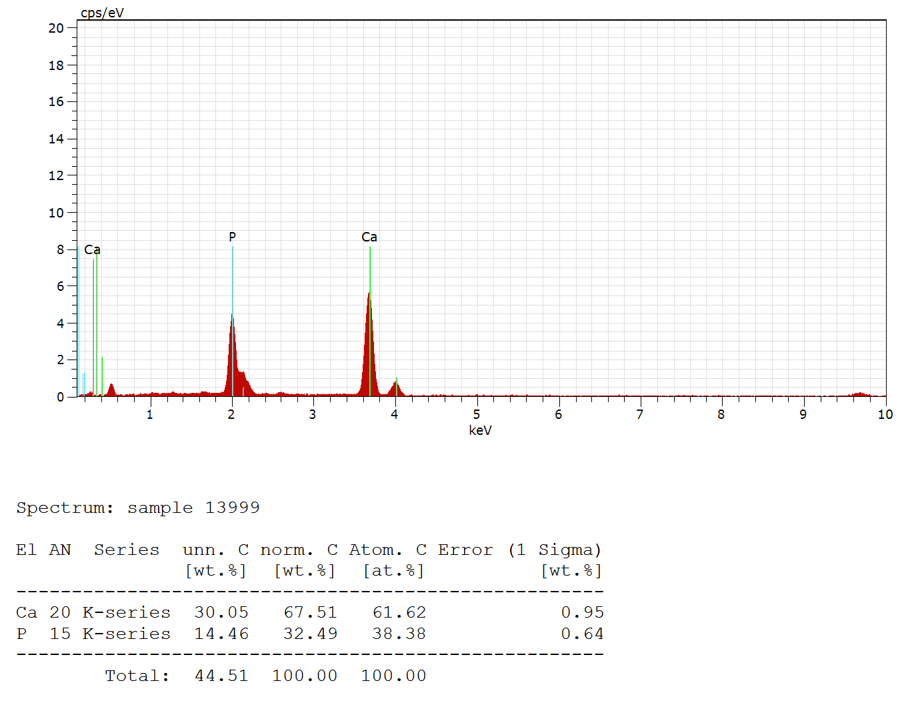

S5: Curodont
