Emergence of Human Enteric Adenovirus F41 Among Children with Gastroenteritis in North-central Bangladesh, 2022-2024
Nadim Sharif^{1,2*}, Abdullah Ibna Masud¹, Jannatin Naim¹, Rubayet Rayhan Opu^{1,3}, Afsana Khan⁴, Hiroshi Ushijima⁵, Shuvra Kanti Dey^{1*}

1. Method
1.1. Bacterial Genome Extraction and Polymerase Chain Reaction
The bacterial genome extraction was carried out by using the well-established boiled DNA method^{1,2}. Bacterial isolation was achieved through polymerase chain reaction (PCR). For the PCR assays, sequences of 16S rRNA primers (F- AGT TTG ATC CTG GCT CAG and R- ACC TTG TTA CGA CTT) were utilized. The composition of the PCR reaction mixture included 12.5 µl of 2X master mix (GoTaq Green Master Mix, Promega, USA), 1 µl each of the forward (F) and reverse (R) primers, 6.5 µl nuclease-free water, and 4 µl template DNA (Eppendorf, Germany), culminating in a 25 µl reaction volume. The PCR was executed in a thermal cycler (2720 Thermal Cycler, Applied Biosystems, USA), with the protocol setting at 94 °C for 5 min, then 35 cycles of 94 °C for 30 s, 53 °C for 30 s, and 72 °C for 60 s^{1,2}.
1.2. Synthesis of Complementary DNA (cDNA)
Through the in vitro reverse transcription (RT) reaction the RNA molecules were converted into the cDNA. To synthesize cDNA from the RNA genome the GoScript Reverse Transcription System (Promega, USA) was used. For reverse transcription, a reaction mixture consisting of 1 μl of oligo dT primer (Promega, Madison, USA) and 1 μl of nuclease free water was made in nano-centrifuge tube and 3 μl of extracted RNA was mixed with it. The thermal cycle consisted of 70 °C for 5 mins and then chilled for 5 min in ice. After that a reaction mixture containing 4 μl of 5X reaction buffer (Promega, Madison, USA), 1 μl of PCR Nucleotide Mix (Promega, Madison, USA), 1 μl of Reverse Transcriptase (Promega, Madison, USA), 2 μl of MgCl₂, 0.5 μl of Ribonuclease Inhibitor (Promega, Madison, USA), and 6.5 μl of nuclease free water were mixed for each sample. This reaction mixture was taken in a nano-centrifuge tube containing 5 μl of previously chilled genomic RNA. Total volume of the mixture was 20 μl. Then the mixture was heated at 25 °C for 5 mins, 42 °C for 60 min and 70 °C for 15 mins. The cDNA was prepared and stored at −20 °C^{3,4}.
1.3. Detection of Norovirus by Polymerase Chain Reaction
For amplification, 12.5 μl of the 2X master mix (GoTaq Green Master Mix, Promega, USA), 1 μl of forward (F) primer, 1 μl of reverse (R) primer, 6.5 μl of nuclease free water and 4 μl of template DNA were mixed in a nanocentrifuge tube (Eppendorf, Germany). The total volume of the PCR reaction mixture was 25 μl. The PCR mixture was amplified in a thermal cycler (2720 Thermal Cycler, Applied Biosystems, USA) following the proper thermal cycles. Primer pair, G1SKF (CTGCCCGAATTYGTAAATGA), G1SKR (CCAACCCARCCATTRTACA) for norovirus GI (330 base pair) and primer pair, COG2F (CARGARBCNATGTTYAGRTGGATGAG) and G2SKR (CCRCCNGCATRHCCRTTRTACAT) (344 base pair) for norovirus GII were used. The thermal cycle consisted of activation at 94 °C for 3 min, followed by 35 cycles of denaturation at 94 °C for 1 min, annealing at 50 °C for 1 min and extension at 72 °C for 1 min. A final extension was done at 72 °C for 10 min and then held at 4 °C^{4,5}.
1.4. Detection of Rotavirus by PCR
For rotavirus A, two specific primers F-¹GGCTTTAAAAGAGAGAATTTC²⁸ and R-³⁷³ACTGATCCTGTTGGCCATCCTTT³⁹⁵ were used to amplify VP7 gene. he PCR reaction was performed at 94°C for 3 min, followed by 35 cycles of denaturation at 94°C for 1 min, annealing at 55°C for 1 min and extension at 72°C for 1 min. Final extension was done at 72°C for 7 min and then held at 4°C. PCR reaction mixture contained 12.5 μL of the 2X master mix (GoTaq®Green Master Mix, Promega, USA), 1 μL of 1 μM forward (F) primer, 1 μL of 1 μM reverse (R) primer, 6.5 μL of nuclease free water, and 4 μL of template (200 ng). For rotavirus, 4 μL cDNA (200 ng) was used as template. Total volume of the PCR reaction mixture was 25 μL. Previously sequenced samples were used as positive controls. The PCR was performed in 2720 Thermal Cycler (Applied Biosystems, USA)³.
1.5. Rapid detection of norovirus by IC (IP Rota/Noro) kit
About 800 μl of extraction buffer (Imuuno Probe Co., Japan) was taken in a micro-centrifuge tube. About 25–50 mg or 50 μl of stool sample was mixed with this buffer by vortex. The mixture was kept at room temperature for 3 min according to the guidelines. The test device was taken and three drops of the mixture were given in the sample pouring area. The IC kit was observed for 15 min. We used the equation from previously published work to calculate the sensitivity and specificity⁴.

2. Results
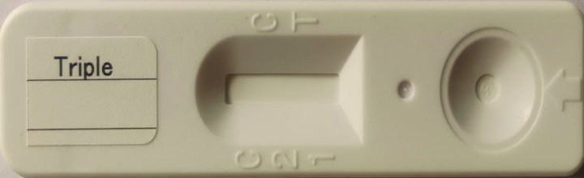
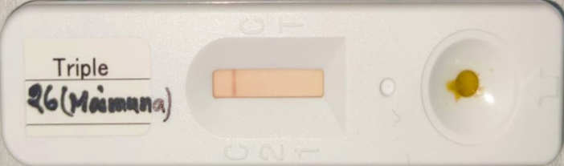
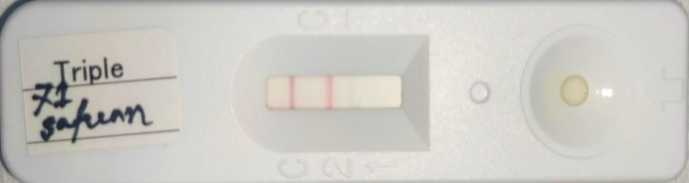
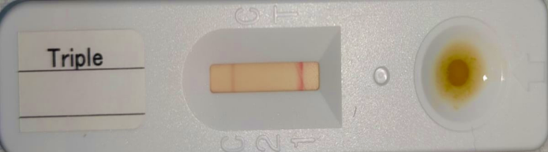
Figure i A. Unused IC kit.
Figure i C. Norovirus-positive IC kit.
Figure i D. Adenovirus-positive IC kit.
Figure i B. Functional IC kit.

References
1. Sharif N, Nobel NU, Sakib N, Liza SM, Khan ST, Billah B, et al. Molecular and epidemiologic analysis of diarrheal pathogens in children with acute gastroenteritis in Bangladesh during 2014–2019. The Pediatric infectious disease journal. 2020;39(7):580-5.
2. Sharif N, Ahmed SN, Khandaker S, Monifa NH, Abusharha A, Vargas DL, et al. Multidrug resistance pattern and molecular epidemiology of pathogens among children with diarrhea in Bangladesh, 2019–2021. Scientific Reports. 2023;13(1):13975.
3. Dey SK, Sharif N, Sarkar OS, Sarkar MK, Talukder AA, Phan T, et al. Molecular epidemiology and surveillance of circulating rotavirus among children with gastroenteritis in Bangladesh during 2014–2019. PLoS One. 2020;15(11):e0242813.
4. Sharif N, Ahmed SN, Sharif N, Alzahrani KJ, Alsuwat MA, Alzahrani FM, et al. High prevalence of norovirus GII. 4 Sydney among children with acute gastroenteritis in Bangladesh, 2018–2021. Journal of Infection and Public Health. 2023;16(7):1015-22.
5. Dey SK, Sharif N, Billah B, Siddique TT, Islam T, Parvez AK, et al. Molecular epidemiology and genetic diversity of norovirus infection in children with acute gastroenteritis in Bangladesh, 2014–2019. Journal of Medical Virology. 2021 Jun;93(6):3564-71.

