Supporting Information
Synergistic Modulation of PPy and CeO₂ in Hollow Carbon Nanocage Bimetal Catalysts for Enhanced Extracellular Electron Transfer
Tao Wuª, Yuan Gaoª, Tianyang Zhangª, Qing, Wen*^{,a}, Ye Chen*^{,a}, Cunguo Lin*^{,b}, Zhenghui Qiu ^{b}
a College of Materials Science and Chemical Engineering, Harbin Engineering University, Harbin, 150001, Heilongjiang, China.
b National Key Laboratory of Marine Corrosion and Protection，Luoyang Ship Material Research Institute, Luoyang 471023, Henan, China.
*Corresponding author.
Tel.: +86-13059004260.
Fax: +86-0451-82569792.
E-mail address: chenye511@126.com (Y. Chen), wenqing@hrbeu.edu.cn (Q. We
1.The recipes for the solutions used in this experiment are as follows:
NO. | Reagent Name | Concentration (g·L⁻¹) | Manufacturer/Source
1 | Na₂HPO₄·12H₂O | 10.32 | Tianjin Guangfu Technology Development Co., Ltd.
2 | NaH₂PO₄·2H₂O | 3.32 | Tianjin Guangfu Technology Development Co., Ltd.
3 | NH₄Cl | 0.31 | Tianjin Fuchen Chemical Reagent Factory
4 | KCl | 0.13 | Tianjin Komiou Chemical Reagent Co., Ltd.
Table 1. Phosphate buffer solution (0.05 mol·L⁻¹) used for electrochemical tests and MFC startup.
序号 | Reagent Name | Concentration (g·L⁻¹) | Manufacturer/Source
1 | Na₂HPO₄·12H₂O | 25.532 | Tianjin Guangfu Technology Development Co., Ltd.
2 | NaH₂PO₄·2H₂O | 7.9 | Tianjin Guangfu Technology Development Co., Ltd.
3 | NH₄Cl | 0.31 | Tianjin Fuchen Chemical Reagent Factory
4 | CaCl₂ | 0.15 | Liaoning Shenyang Pharmaceutical Co., Ltd.
5 | (NH₄)₂SO₄ | 0.56 | Tianjin Komiou Chemical Reagent Co., Ltd.
6 | MgSO₄ | 0.2 | Tianjin Dongli Tianda Chemical Reagent Factory
7 | KCl | 0.13 | Tianjin Komiou Chemical Reagent Co., Ltd.
8 | MnSO₄ | 0.02 | Tianjin Komiou Chemical Reagent Co., Ltd.
9 | FeCl₃ | 0.01 | Tianjin Shuangchuan Chemical Reagent Factory
Table 2. Formulation of the nutrient medium for culturing anode microorganisms in MFCs.
2. Materials and Methods
2.1. Materials
Zinc nitrate hexahydrate (Zn(NO₃)₂·6H₂O, 99%), iron(III) nitrate nonahydrate (Fe(NO₃)₃·9H₂O, 99%), manganese(II) chloride tetrahydrate (MnCl₂·4H₂O, 99%), 2-methylimidazole (99%), pyrrole (Py), and cerium(III) nitrate (Ce(NO₃)₃) were all purchased from Shanghai Aladdin Biochemical Technology Co., Ltd. The D520 Nafion solution (5 wt%) was obtained from DuPont, USA.
2.2. Experimental Methods
2.2.1. Synthesis of ZIF-8
ZIF-8 was synthesized according to a previously reported method. Briefly, 3.0 g of Zn(NO₃)₂·6H₂O was dissolved in 30 mL of deionized water, and 11.7 g of 2-methylimidazole (2-MIM) along with 9.7 mg of CTAB were dissolved in 50 mL of deionized water. The two solutions were mixed under stirring for 12 hour. The resulting product was collected by centrifugation at 9000 rpm for 10 min, washed three times with deionized water, and finally dried overnight in a vacuum oven at 60 °C.
2.2.2. Synthesis of FeMn-ZIF@PPy
A total of 0.67 g of ZIF-8 was dispersed in 120 mL of methanol via ultrasonication to form Solution A. Then, 80 mg of Fe(NO₃)₃·9H₂O and 40 mg of MnCl₂·4H₂O were dissolved in 30 mL of deionized water to form Solution B. Solution B was added to Solution A, followed by the dropwise addition of 8 mL of Py. The mixture was refluxed at 60 °C for 7 h, during which the solution color changed from yellow to brown. The resulting product was collected by centrifugation at 8000 rpm for 8 min, washed three times with methanol, and dried overnight under vacuum at 60 °C. FeMn-ZIF was prepared using the same procedure but without the addition of Py.
2.2.3. Synthesis of FeMn-ZIF@PPy/CeO₂
A total of 0.2 g of FeMn-ZIF@PPy was dispersed in 15 mL of ethanol via ultrasonication. To this dispersion, 60 mg of Ce(NO₃)₃·6H₂O and 0.13 g of 2-methylimidazole (2-MIM) were added under stirring for 10 minutes. The mixture was then transferred into a Teflon-lined autoclave and subjected to hydrothermal treatment at 180 °C for 3 h. The resulting product was collected by centrifugation at 9000 rpm for 5 min, washed alternately three times with deionized water and ethanol, respectively, and finally dried overnight under vacuum at 60 °C.
2.2.4. Pyrolysis of the Catalysts
The as-prepared FeMn-ZIF, FeMn-ZIF@PPy and FeMn-ZIF@PPy/CeO₂ were pyrolyzed under a nitrogen atmosphere with a heating rate of 5 °C·min-1 up to 920 °C and held for 2 h. The resulting products were designated as FeMn-DAs-NC, FeMn-IDAs/H-NC, and FeMn-IDAs/H-NC@CeO₂, respectively.
2.3. Preparation of Electrode
A mixture of 100 mg of active material and 25 mg of conductive acetylene black was dispersed in a suitable volume of ethanol. Subsequently, 100 μL of Nafion solution was added, and the mixture was ultrasonicated for 30 minutes to form a homogeneous slurry. The resulting ink was drop-cast onto pre-treated carbon felt (CF) and dried at 70 °C. This process was repeated multiple times to achieve the desired catalyst loading. The cathode was prepared following the same procedure.
2.4. Construction of MFC
MFC with an effective volume of 180 mL per chamber was used in this study. Deep-sea sediment was introduced into the anode chamber as an inoculum and acclimatized under continuous feeding with sodium acetate (2.8 g/L) as the carbon source. The as-prepared anode and cathode were installed into their respective chambers. The external circuit of the MFC was connected to a 1000 Ω resistor, and the entire system was maintained at a constant temperature of 30 °C in an incubator.
2.5. Characterization and Testing
The morphology of the samples was characterized using scanning electron microscopy (SEM, Inspect S50, USA). The crystal structure of the materials was determined by X-ray diffraction (XRD) on a TTRAX3 diffractometer (Japan) with Cu Kα radiation (λ = 1.54178 Å). X-ray photoelectron spectroscopy (XPS) was performed on a Thermo 250 instrument (USA) using a monochromatic Al Kα X-ray source (hν = 1486.6 eV) with a spot size of 500 μm. High-resolution spectra were recorded at a pass energy of 30 eV and a step size of 0.05 eV for elemental and molecular structure analysis.
The electrochemical performance was evaluated using cyclic voltammetry (CV), electrochemical impedance spectroscopy (EIS), and linear sweep voltammetry (LSV) on an electrochemical workstation (CHI 660e, China). A three-electrode system was employed with carbon felt loaded with each of the three catalysts serving as the working electrode and a phosphate buffer solution as the electrolyte. For anode testing, a platinum electrode (2 × 2 cm) was used as the counter electrode and a saturated calomel electrode (SCE) as the reference electrode. For cathode testing, a platinum mesh (1 × 1 cm) was used as the counter electrode and an Ag/AgCl electrode as the reference electrode.
When the MFC reached stable operation, polarization curves were obtained using the workstation. Power density was calculated as P = IU/ A. To ensure data reliability, all electrochemical measurements were performed in triplicate. Functional composition analysis of the electroactive microbial community was conducted using PICRUSt based on 16S rRNA gene high-throughput sequencing results.
3.Supporting Data
Fig. S1. FTIR spectra of ZIF-8, FeMn-ZIF, FeMn-ZIF@PPy, and FeMn-ZIF@PPy/CeO₂.
Fig. S2. XRD patterns of ZIF-8, FeMn-ZIF, FeMn-ZIF@PPy, and FeMn-ZIF@PPy/CeO₂.
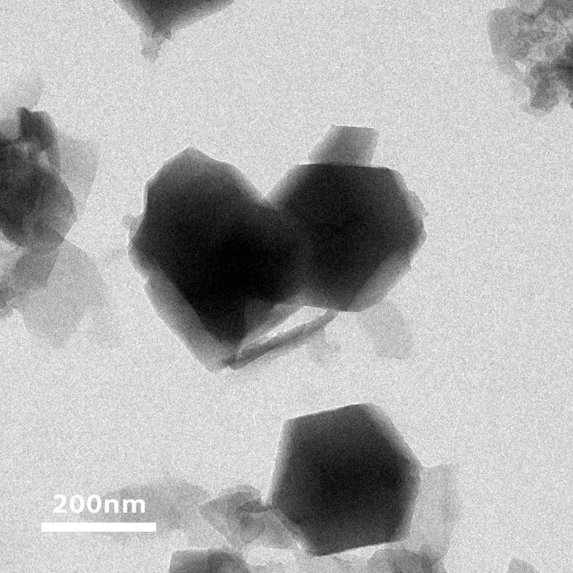
Fig. S3. TEM image of FeMn-DAs-NC.

Fig. S4. DFT structure optimization results of FeMn-IDAs/H-NC@CeO₂.

