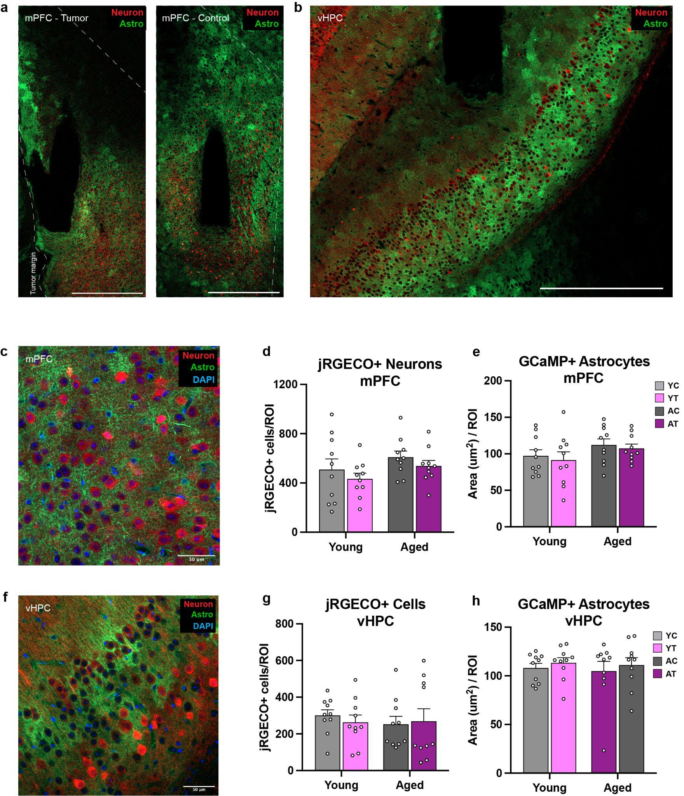
Extended Data Fig. 1 | Verification of neuronal and astrocytic reporter expression across age and tumor conditions. (a) Representative low-magnification coronal section showing tumor implantation site in the medial prefrontal cortex (mPFC) and contralateral recording hemisphere. Dashed line indicates tumor margin. (b) Representative coronal section of the ventral hippocampus (vHPC) from the contralateral hemisphere. (c) High-magnification image of the mPFC showing jRGECO1a-expressing neurons (red), GCaMP8f-expressing astrocytes (green), and DAPI (blue). (d) Quantification of jRGECO1a-positive neurons per region of interest (ROI) in the mPFC across young control (YC), young tumor (YT), aged control (AC), and aged tumor (AT) groups. (e) Quantification of GCaMP8f-positive astrocytic area per ROI in the mPFC across groups. (f) High-magnification image of the vHPC showing neuronal and astrocytic reporter expression. (g) Quantification of jRGECO1a-positive neurons per ROI in the vHPC across groups. (h) Quantification of GCaMP8f-positive astrocytic area per ROI in the vHPC across groups. Data are shown as mean ± SEM with individual animals overlaid. Statistical comparisons were performed using two-way ANOVA with age and tumor burden as factors; no significant main effects or interactions were detected. N=10 for each group. Scale bars not specified on image are 500μm.
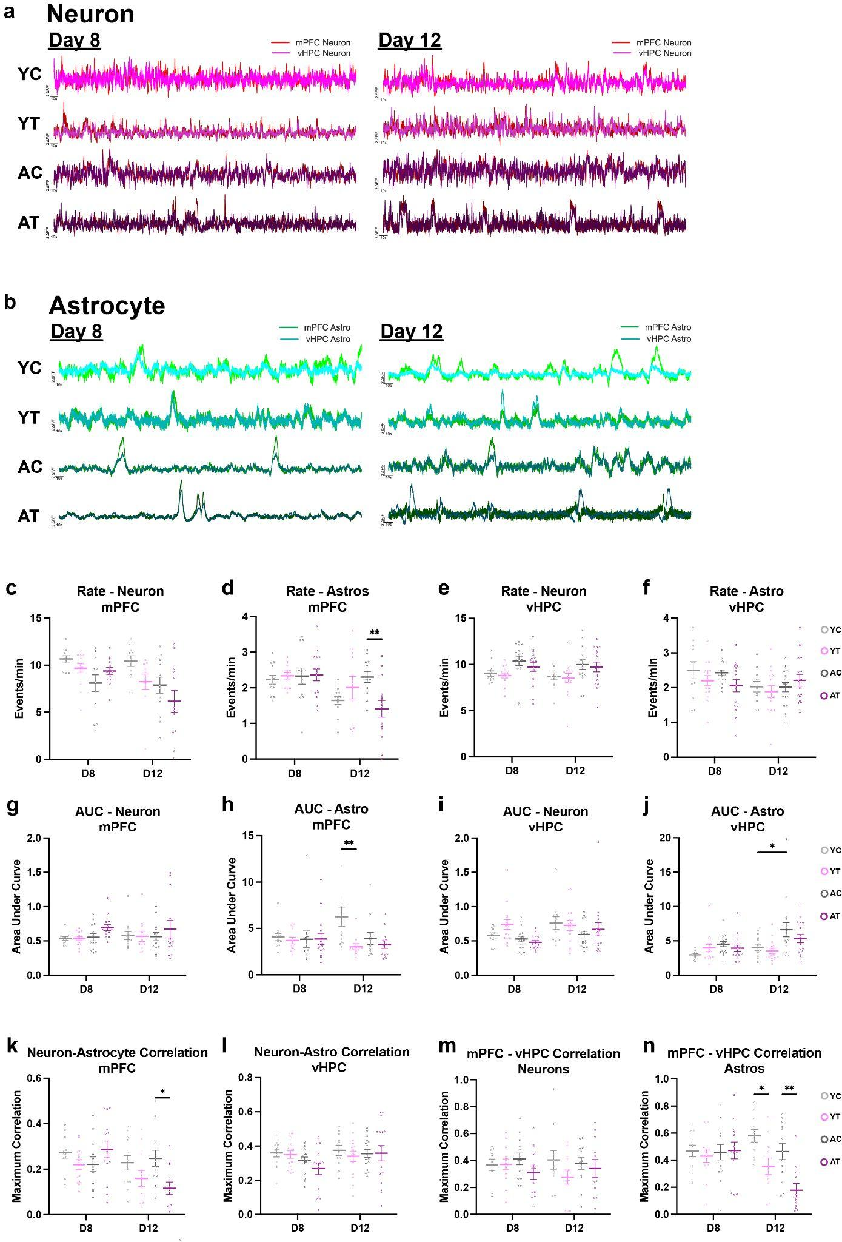
Extended Data Fig. 2 | Baseline neuronal and astrocytic activity during home cage behavior. (a–b) Representative dual-color fiber photometry traces showing spontaneous neuronal (jRGECO1a) and astrocytic (GCaMP8f) calcium activity recorded from the medial prefrontal cortex (mPFC) and ventral hippocampus (vHPC) during home cage behavior on day 8 and day 12 following tumor implantation in young control (YC), young tumor-bearing (YT), aged control (AC), and aged tumor-bearing (AT) mice. (c–d) Quantification of (c) neuronal and (d) astrocytic (AT v AC - D12: **P=0.0043) event rates in the mPFC across days and groups. (e–f) Quantification of (e) neuronal and (f) astrocytic event rates in the vHPC across days and groups. (g–h) Area under the curve (AUC) for (g) neuronal and (h) astrocytic (YT v YC - D12: **P=0.0048) events in the mPFC across days and groups. (i–j) Area under the curve (AUC) for (i) neuronal and (j) astrocytic (AC v YC - D12: *P=0.0270) events in the vHPC across days and groups. (k–l) Maximum local neuron–astrocyte correlations within the (k) mPFC (AT v AC - D12: *P=0.0165) and (l) vHPC. (m–n) Maximum cross-regional correlations between the mPFC and vHPC for (m) neurons and (n) astrocytes (AC v YC: *P=0.0263, AT v AC: **P=0.0013). For the mPFC event properties and neuron-astro correlations, the N were as follows: Neurons - YC: N=11-12 mice, YT: N=11-13 mice, AC: N=13 mice, AT: N=12-14; Astros - YC: N=12 mice, YT: N=11-12 mice, AC: N=12 mice, AT: N=12-15 mice. For the vHPC event properties and neuron-astro correlations: YC: N=11 mice, YT: N=15 mice, AC: N=16 mice, AT: N=16 mice. For mPFC-vHPC Correlations: Neurons - YC: N=10-11 mice, YT: N=12-13 mice, AC: N=13 mice, AT: N=12-14 mice; Astros - YC: N=11 mice, YT: N=11-13 mice, AC: N=13 mice, AT: N=12-13 mice. Data are shown as mean ± SEM with individual animals overlaid. Statistical comparisons were performed using mixed-effects models with age, tumor burden, and time as factors, followed by post hoc Sidak’s multiple-comparisons tests.

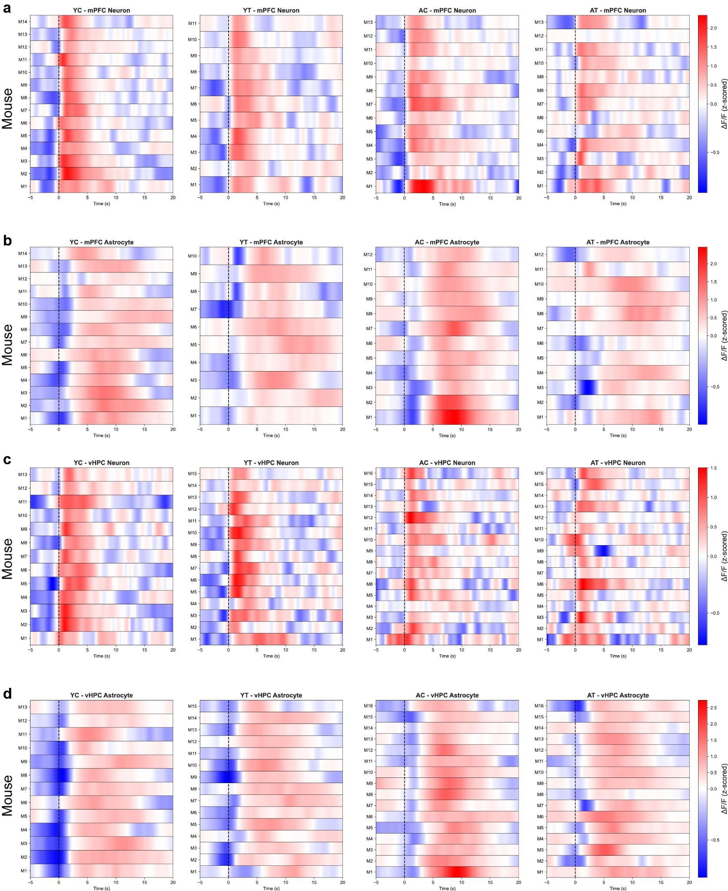
Extended Data Fig. 3 | Mouse-averaged neuronal and astrocytic responses aligned to struggle onset. (a–d) Heatmaps showing event-triggered calcium activity averaged within each mouse and aligned to the transition from immobility to struggling during the tail suspension test. Rows represent individual mice and columns represent time relative to struggle onset (vertical dashed line). (a) mPFC neuronal responses, (b) mPFC astrocytic responses, (c) vHPC neuronal responses, and (d) vHPC astrocytic responses are shown separately for young control (YC), young tumor (YT), aged control (AC), and aged tumor (AT) groups.
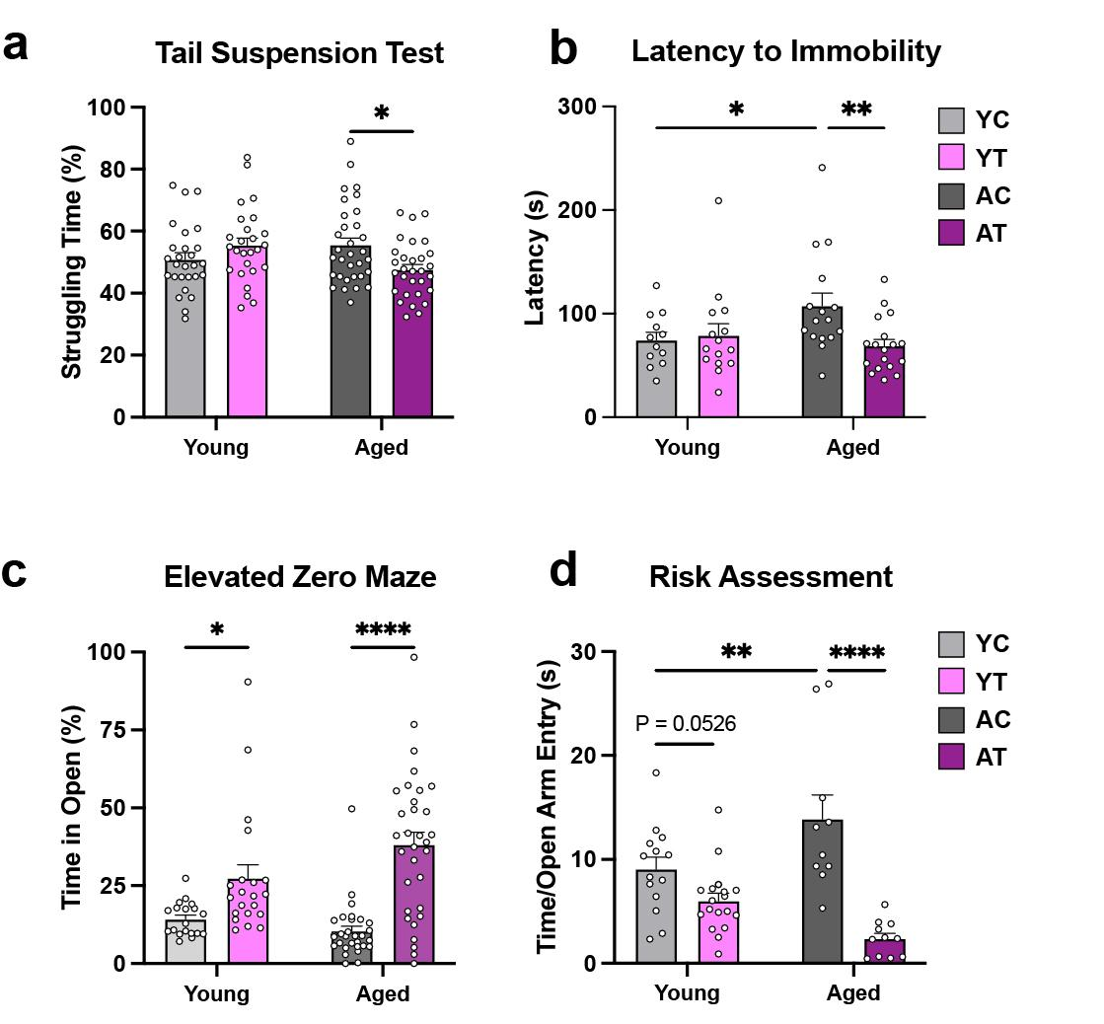
Extended Data Fig. 4 | Age- and tumor-dependent alterations in stress coping and anxiety-related behavior. (a) Percentage of time spent struggling during the tail suspension test across young control (YC), young tumor (YT), aged control (AC), and aged tumor (AT) mice (AT v AC: *P=0.0142); YC: N=27 mice, YT: N=26 mice, AC: N=32 mice, AT: N=30 mice. (b) Latency to first immobility during tail suspension across groups (AT v AC: **P=0.0045); YC: N=12 mice, YT: N=15 mice, AC: N=16 mice, AT: N=18 mice. (c) Percentage of time spent in the open arms during elevated zero maze exploration (YT v YC: *P=0.0141, AT v AC: ****P<0.0001); YC: N=19 mice, YT: N=21 mice, AC: N=30 mice, AT: N=32 mice. (d) Risk assessment behavior quantified as time spent at the open-arm entry per open-arm entry during elevated zero maze exploration (AC v YC: AT v AC: ****P<0.0001); YC: N=14 mice, YT: N=18 mice, AC: N=10 mice, AT: N=11 mice). Data are shown as mean ± SEM with individual animals overlaid. Statistical comparisons were performed using two-way ANOVA with age and tumor burden as factors followed by Sidak’s multiple-comparisons tests.

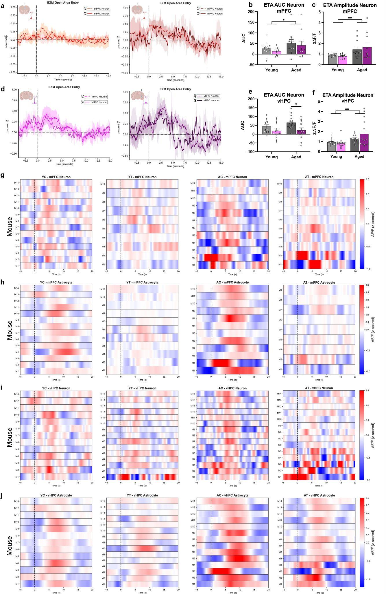
Extended Data Fig. 5 | Event-triggered neuronal and astrocytic responses aligned to open-area entry during elevated zero maze exploration. (a) Average neuronal event-triggered calcium responses in the medial prefrontal cortex (mPFC) aligned to open-area entry for young control (YC), young tumor (YT), aged control (AC), and aged tumor (AT) mice. (b,c) Quantification of neuronal event-triggered (b) area under the curve (AUC) (Aged v Young: *P=0.0403) and (c) peak amplitude (Aged v Young: **P=0.0029) in the mPFC; YC: n= 14 mice, YT: n=10 mice, AC: n=12 mice, AT: n=9 mice. (d) Average neuronal event-triggered calcium responses in the ventral hippocampus (vHPC) aligned to open-area entry. (e,f) Quantification of neuronal event-triggered (e) AUC (AT v AC: *P=0.0196) and (f) peak amplitude in the vHPC (Aged v Young: **P=0.0016); YC: n= 13 mice, YT: n=15 mice, AC: n=15 mice, AT: n=14 mice. (g,h) Mouse-averaged event-triggered heatmaps of (g) neuronal and (h) astrocytic calcium activity in the mPFC aligned to open-area entry, with each row representing one animal and time zero indicating entry. (i,j) Mouse-averaged event-triggered heatmaps of (i) neuronal and (j) astrocytic calcium activity in the vHPC aligned to open-area entry. Bar graphs show mean ± SEM with individual animals overlaid. Statistical comparisons were performed using 2-Way ANOVA with age and tumor burden as factors followed by Sidak’s multiple-comparisons tests.

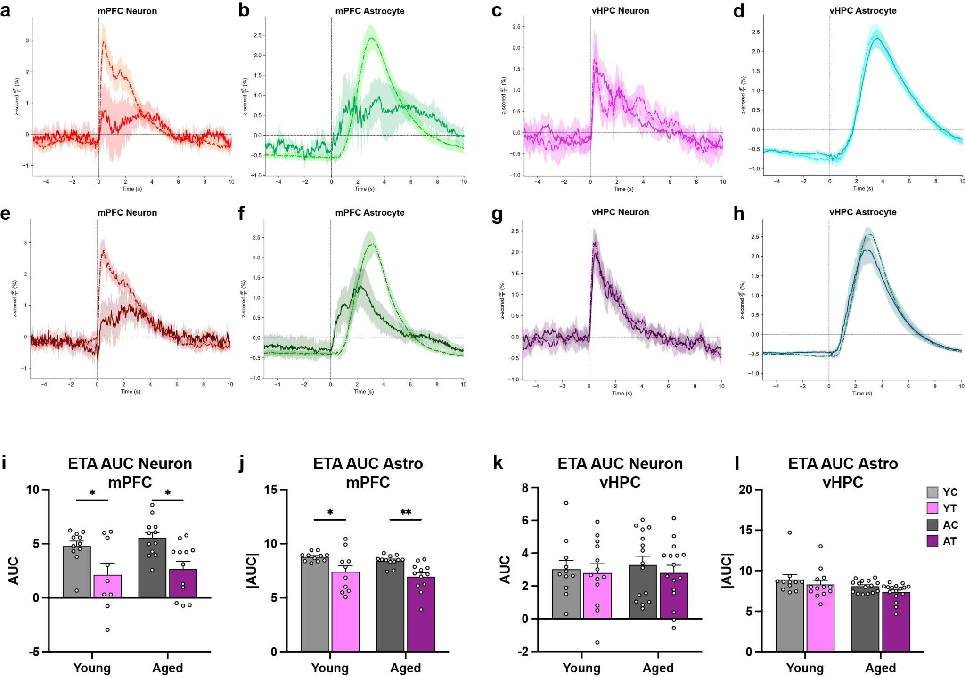
Extended Data Fig. 6 | Event-triggered neuronal and astrocytic responses aligned to foot shock. (a,b) Average neuronal event-triggered calcium responses in the medial prefrontal cortex (mPFC) aligned to foot shock onset for young control (YC), young tumor-bearing (YT), aged control (AC), and aged tumor-bearing (AT) mice. (c,d) Average neuronal event-triggered calcium responses in the ventral hippocampus (vHPC) aligned to foot shock onset. (e,f) Average astrocytic event-triggered calcium responses in the mPFC aligned to foot shock onset. (g,h) Average astrocytic event-triggered calcium responses in the vHPC aligned to foot shock onset. (i,j) Quantification of event-triggered area under the curve (AUC) for (i) neurons (YT vYC: *P=0.0410, AT v AC: *P=0.0112); YC n = 11 mice, YT n = 9 mice, AC n = 12 mice, AT n = 12 mice, and (j) astrocytes (YT vYC: *P=0.0296, AT v AC: *P=0.0099); YC: n = 11 mice, YT: n = 10 mice, AC: n = 12 mice, AT: n = 12 mice, in the mPFC across age and tumor groups. (k,l) Quantification of event-triggered AUC for (k) neurons and (l) astrocytes in the vHPC across age and tumor groups; YC: n = 11 mice, YT: n = 13 mice, AC: n = 15 mice, AT: n = 16 mice. Traces show mean ± SEM. Bar graphs show mean ± SEM with individual animals overlaid. Statistical comparisons were performed using 2-Way ANOVA with age and tumor burden as factors followed by Sidak’s multiple-comparisons tests.

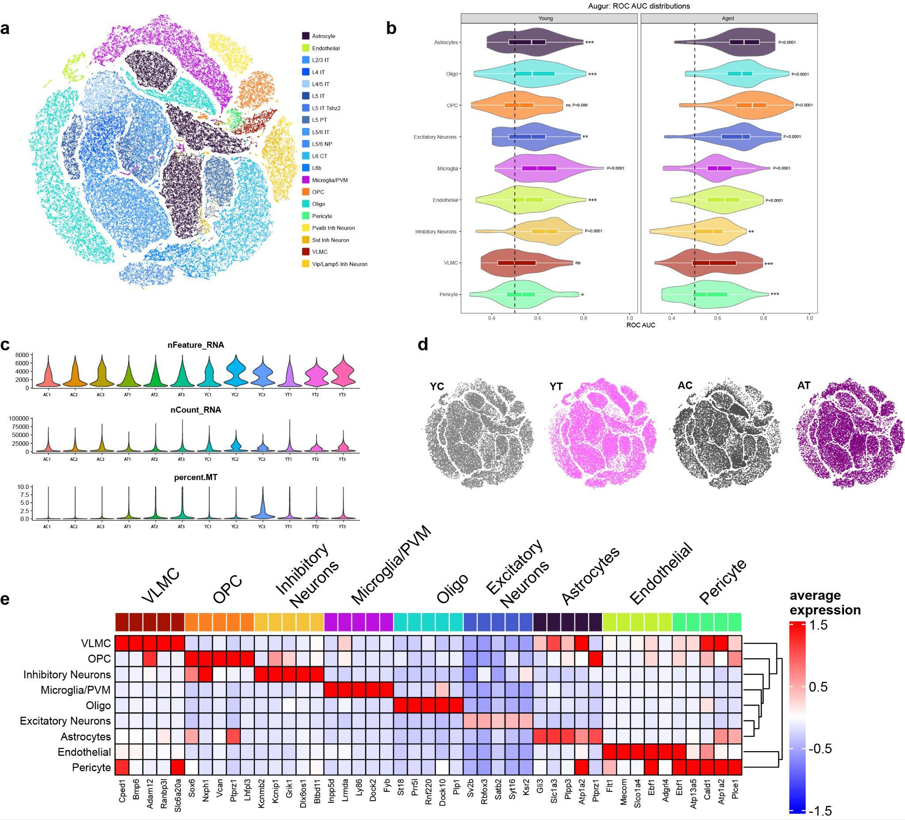
Extended Data Fig. 7 | Single-nucleus RNA-sequencing quality control and cell-type annotation of the medial prefrontal cortex. (a) UMAP embedding of nuclei from the medial prefrontal cortex colored by annotated cell type. Excitatory neurons are further subdivided by cortical layer identity (shades of blue), and inhibitory neurons are subdivided into molecular subtypes (shades of yellow). (b) Augur prioritization analysis showing distributions of ROC AUC values for each cell type comparing aged tumor-bearing versus aged control mice. Dashed line indicates chance-level classification performance (AUC = 0.5) (Astrocytes - YT v YC: ***P=0.0002, Oligo - YT v YC: ***P=0.0003, Excitatory Neuron - YT v YC: **P=0.0016, Endothelial - YT v YC: ***P=0.0009, Inhibitory Neuron - AT v AC: **P=0.0026, VLMC - AT v AC: ***P=0.0001, Pericyte - YT v YC: *P=0.0199, AT v AC: ***P=0.0008). (c) Violin plots showing per-sample distributions of quality control metrics, including number of detected genes (nFeature_RNA), total UMI counts (nCount_RNA), and mitochondrial read fraction (percent.mt). (d) UMAP projections split by experimental group (young control, young tumor, aged control, aged tumor). (e) Heatmap of average expression of top marker genes for each major cell type, a subset of genes used for cell-type annotation. Color scale indicates z-scored average expression.

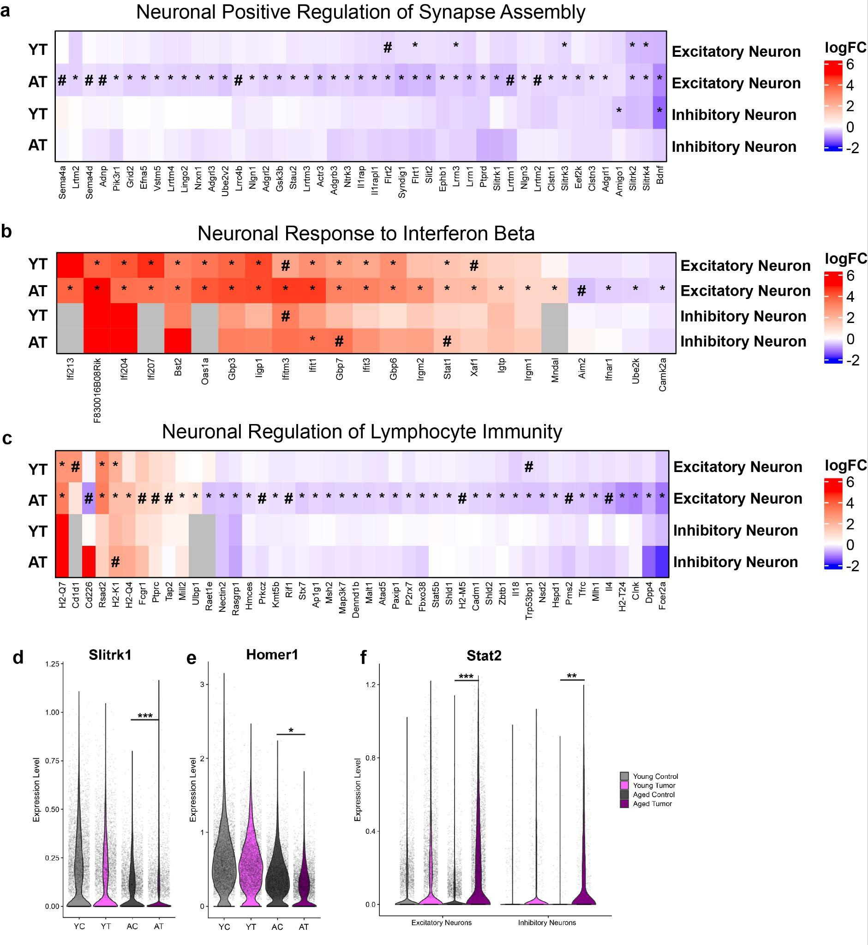
Extended Data Fig. 8 | Neuronal transcriptional changes associated with synaptic and immune-related gene programs. (a) Heatmap showing log fold-change (logFC) of genes annotated to the Gene Ontology (GO) term positive regulation of synapse assembly in excitatory and inhibitory neurons from young tumor-bearing (YT) and aged tumor-bearing (AT) mice relative to age-matched controls. (b) Heatmap of logFC values for genes associated with the GO term response to interferon beta in excitatory and inhibitory neurons from YT and AT mice. (c) Heatmap of logFC values for genes associated with the GO term regulation of lymphocyte mediated immunity in excitatory and inhibitory neurons from YT and AT mice. In all heatmaps, rows indicate experimental groups and neuronal subtypes, columns indicate individual genes, and colors represent logFC relative to age-matched controls. Asterisks denote genes with FDR-adjusted P < 0.05 within group, and hash symbols indicate genes with FDR-adjusted P<0.10. (d–f) Violin plots showing single-nucleus expression levels of (d) Slitrk1 (AT v AC: ***P=0.0003), (e) Homer1 (AT v AC: *P=0.0234), and (f) Stat2 (AT v AC - Excitatory: ***P=0.0004, AT v AC - Inhibitory: **P=0.0020) across young control (YC), young tumor(YT), aged control (AC), and aged tumor (AT) mice. Expression values are shown for excitatory and inhibitory neurons as indicated. Violin plots display the distribution of normalized expression values with individual nuclei overlaid.

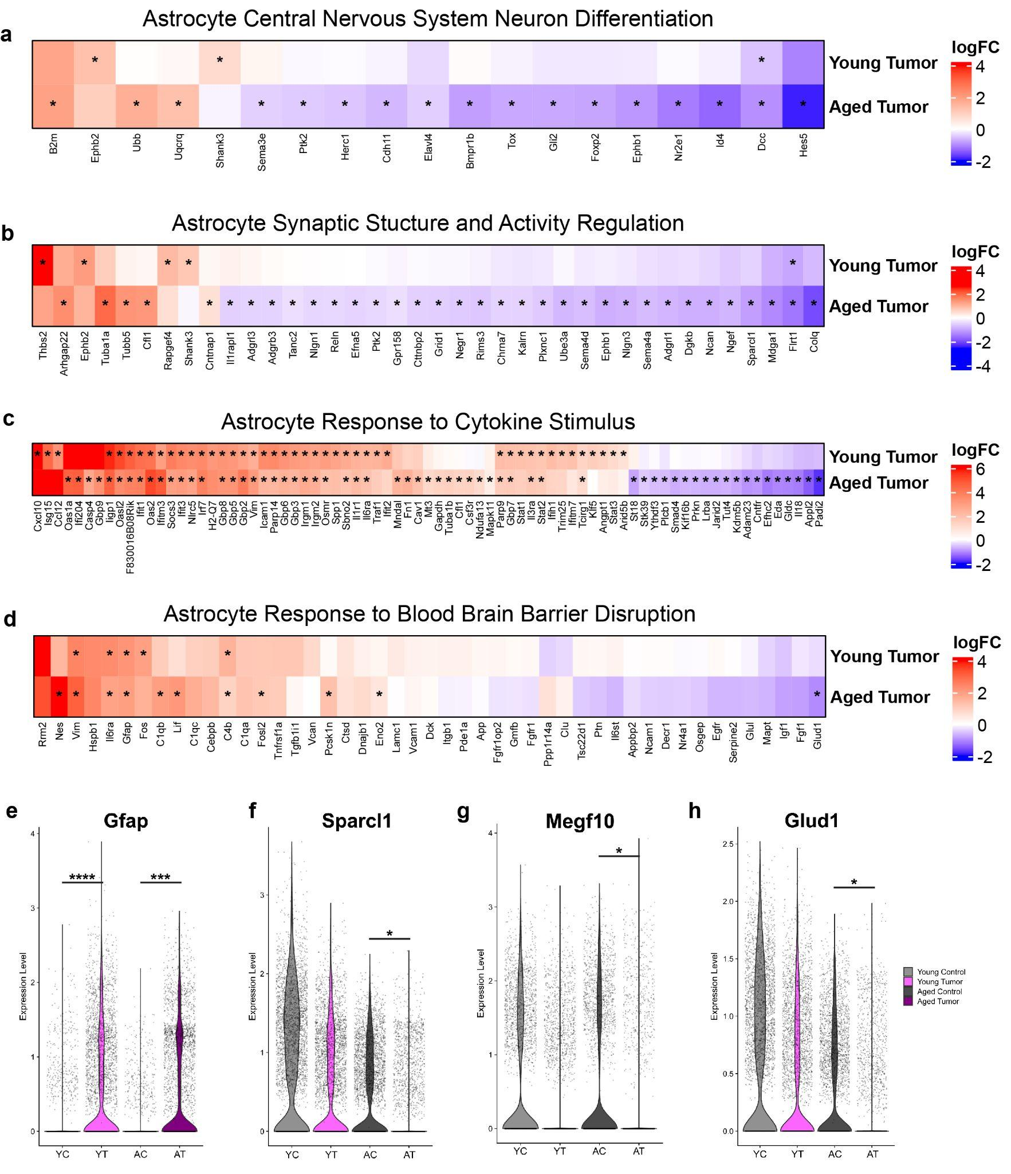
Extended Data Fig. 9 | Astrocyte transcriptional programs associated with differentiation, synaptic regulation, immune signaling, and blood–brain barrier disruption. (a) Heatmap showing log fold-change (logFC) of astrocytic genes annotated to the Gene Ontology (GO) term central nervous system neuron differentiation in young tumor-bearing and aged tumor-bearing mice relative to age-matched controls. (b) Heatmap of logFC values for astrocytic genes associated with synaptic structure and activity regulation. (c) Heatmap of astrocytic genes annotated to response to cytokine stimulus. (d) Heatmap of astrocytic genes associated with response to blood–brain barrier disruption, curated from prior published signatures. In heatmaps, rows indicate age group, columns indicate individual genes, and colors represent logFC relative to age-matched controls. Asterisks denote genes with FDR-adjusted P < 0.05. (e–h) Violin plots showing single-nucleus expression levels of (e) Gfap (YT v YC: ****P<0.0001, AT v AC: AT v AC: ***P=0.0003), (f) Sparcl1 (AT v AC: *P=0.0425), (g) Megf10 (AT v AC: *P=0.0208), and (h) Glud1 (AT v AC: *P=0.0243) across young control (YC), young tumor (YT), aged control (AC), and aged tumor (AT) mice. Violin plots display the distribution of normalized expression values with individual nuclei overlaid.
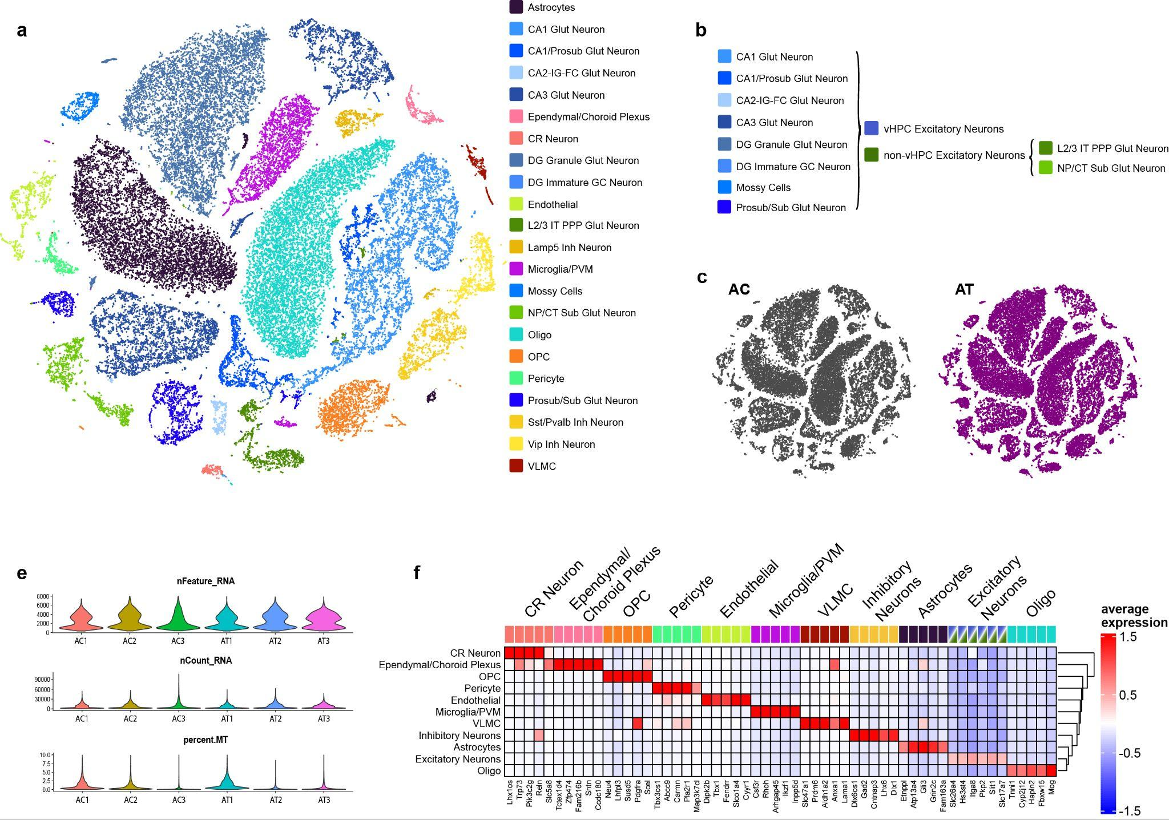
Extended Data Fig. 10 | Single-nucleus RNA sequencing of the ventral hippocampus in aged control and tumor-bearing mice. (a) UMAP embedding of nuclei from the ventral hippocampus (vHPC) and adjacent cortex, colored by annotated cell type. Excitatory neuronal populations are subdivided by hippocampal (shades of blue) and non-hippocampal (shades of green) subregion/layer, and inhibitory neurons by subtype (shades of yellow). (b) Grouping of excitatory neuronal populations into vHPC excitatory neurons and non-vHPC excitatory neurons for downstream analyses. (c) UMAPs showing nuclei from aged control (AC) and aged tumor (AT) mice overlaid on the same embedding. (d) Violin plots showing quality control metrics for each sample, including number of detected genes (nFeature_RNA), total UMI counts (nCount_RNA), and percentage of mitochondrial reads (percent.MT). (e) Heatmap of average expression of top marker genes used for each broad cell type, a subset of canonical genes used for annotation. Color scale indicates scaled average expression.

