Supplementary figures

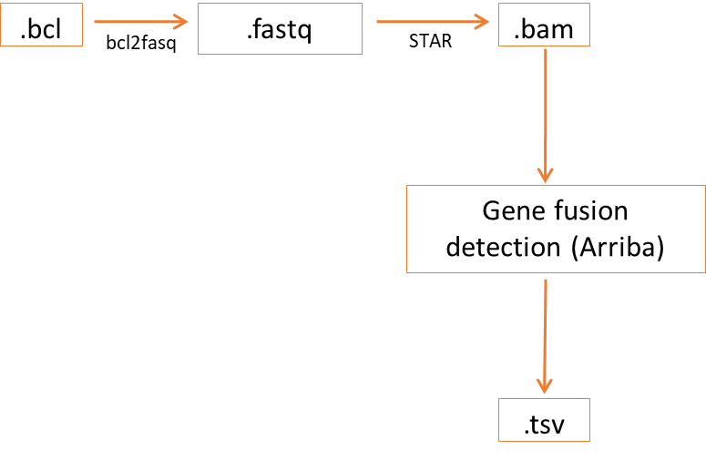
SF1. Schematic presentation of the gene fusion analysis bioinformatic pipeline
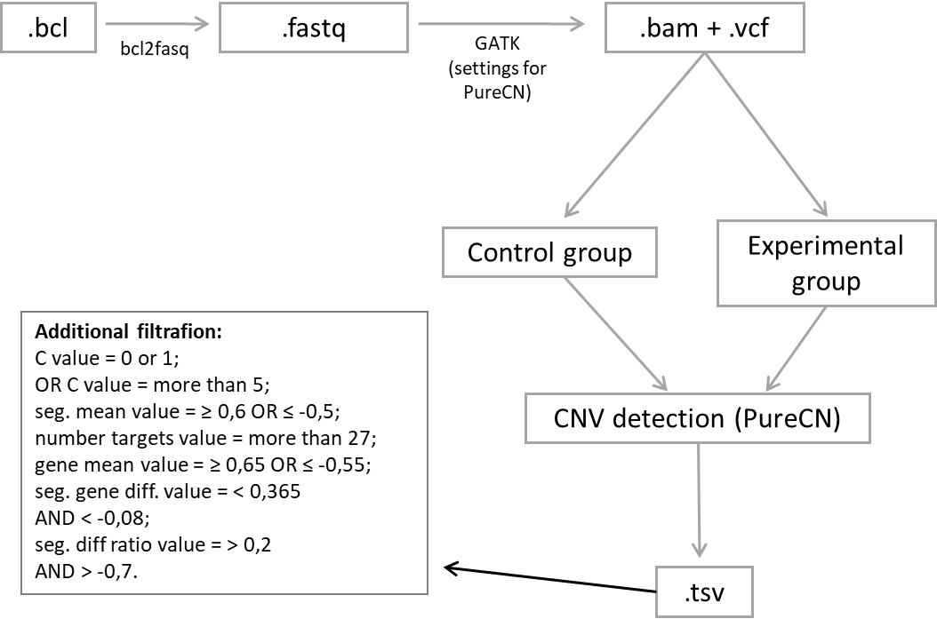
SF 2. Schematic presentation of the copy number variation analysis bioinformatic pipeline

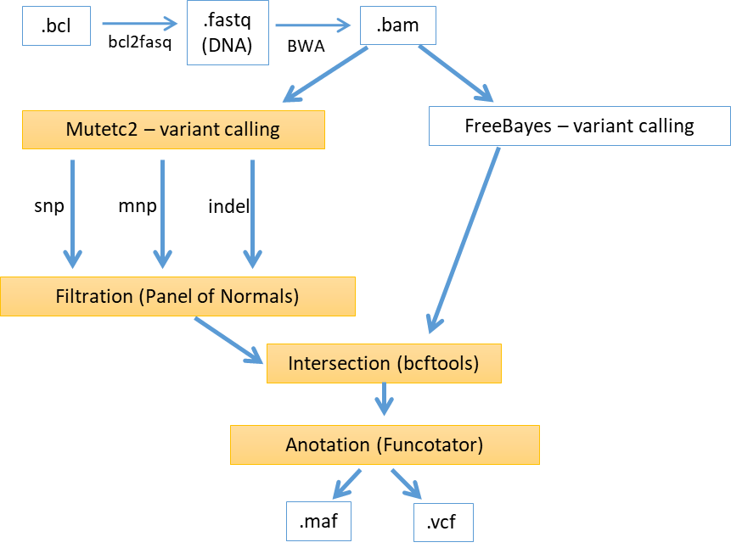
SF 3. Schematic presentation of the single-nucleotide variants analysis bioinformatic pipeline. yellow – the Genome Analysis Toolkit (GATK) package

SF 4. Type of detected aberrations. CNV – copy number variation, SNV - single-nucleotide variant

SF 5. The most frequently altered genes. SNV - single-nucleotide variant

SF6. Circos plot of all gene fusions. grey – translation, blue – inversion, green – duplication, red – deletion

SF7. Type and number of gene fusions detected in the study cohort

ST 1. Gene fusions detected in the study cohort, with coverage > 10%. black – genes with coverage more than 10%, red – genes with coverage less than 10%
Study group
Gene 1 | Gene 2
AXL | LOXL4
NTRK3 | B2M
PTCH1 | NTRK2
SYNPO2,MYOZ2 | ROS1
HMGA2 | HSPBAP1
RP11-118B18.1 | BRAF
PSD3 | ETV1
PHF1 | MAPK3
TP53 | RP11-846F4.11,RP11-260A9.1
MIR3687,TEKT4P2 | NOTCH2NL
STX11 | ROS1
SYNPO2,MYOZ2 | ROS1
FOXO1 | TRIO
ETS1 | NNT
FLT1 | PALM2-AKAP2
FLT1 | AKAP2
FLI1 | MIR3687,TEKT4P2

SF 8. Single-nucleotide variant classification

SF9. Gene fusion in a specific sarcoma subtype. MFS – myxofibrosarcoma, MLPS – myxoid liposarcoma, MPNST - malignant peripheral nerve sheath tumor, PLPS – pleomorphic liposarcoma, UPS – undifferentiated pleomorphic liposarcoma

SF10. Gene amplification in a specific sarcoma subtype. MFS – myxofibrosarcoma, MLPS – myxoid liposarcoma, MPNST - malignant peripheral nerve sheath tumor, PLPS – pleomorphic liposarcoma, UPS – undifferentiated pleomorphic liposarcoma

SF 11. Large deletion in a specific sarcoma subtype. MFS – myxofibrosarcoma, MLPS – myxoid liposarcoma, MPNST - malignant peripheral nerve sheath tumor, PLPS – pleomorphic liposarcoma, UPS – undifferentiated pleomorphic liposarcoma

SF12. Single-nucleotide variant in a specific sarcoma subtype. MFS – myxofibrosarcoma, MLPS – myxoid liposarcoma, MPNST - malignant peripheral nerve sheath tumor, PLPS – pleomorphic liposarcoma, SNV - single-nucleotide variant, UPS – undifferentiated pleomorphic liposarcoma
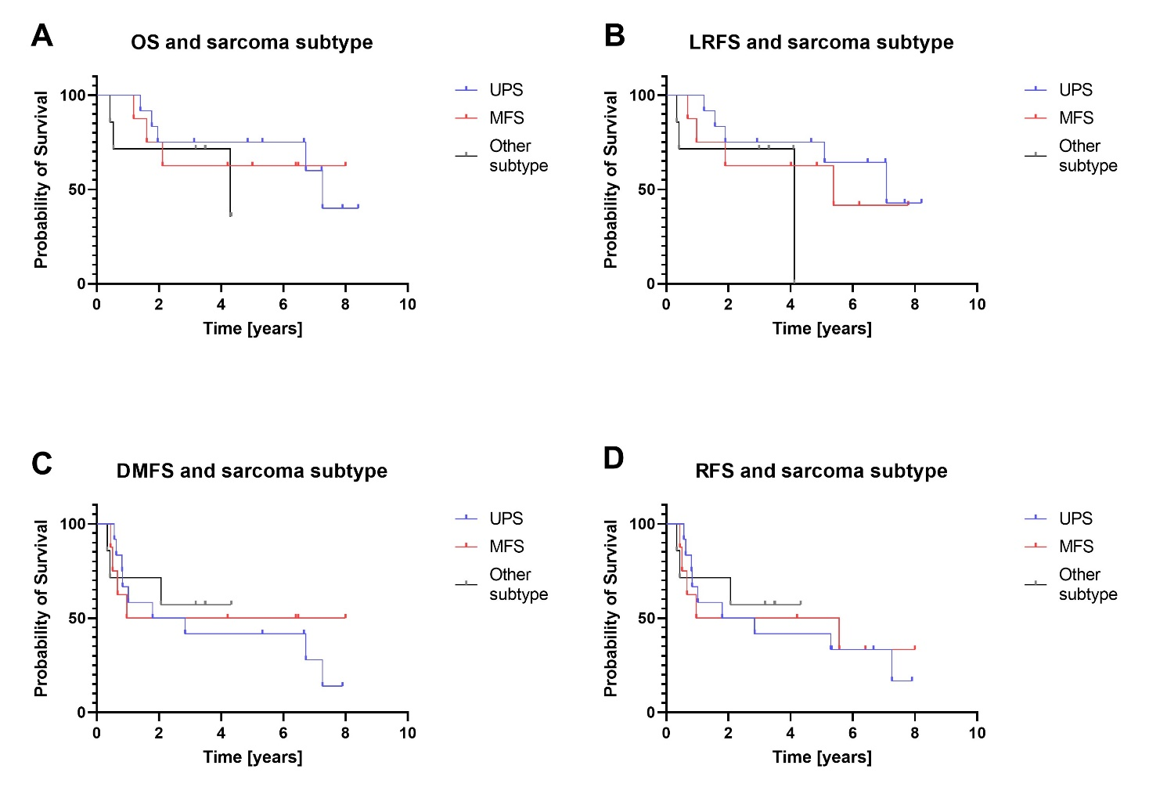

SF13. Survival analysis by sarcoma subtype: (A) Overall survival, (B) Local recurrence-free survival, (C) Progression-free survival. LRFS – local recurrence-free survival, OS – overall survival, PFS - progression-free survival
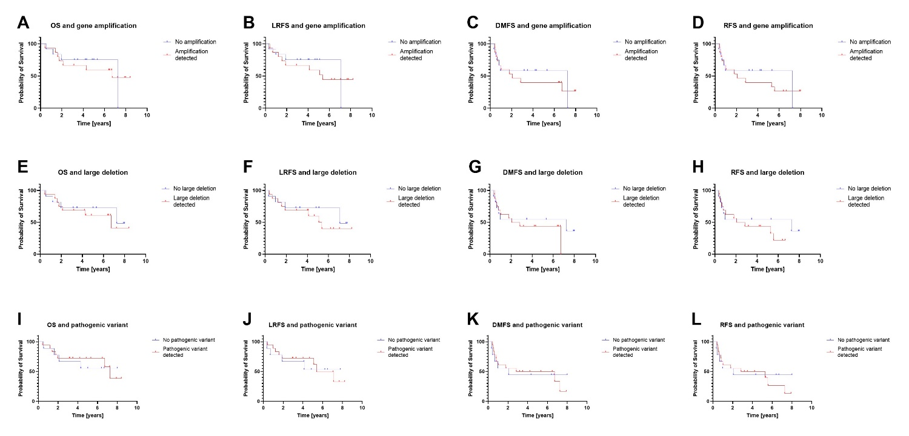
SF14. Survival analysis by genetic aberration: (A) OS by presence of gene amplification, (B) LRFS by presence of gene amplification, (C) DMFS by presence of gene amplification, (D) RFS by presence of gene amplification, (E) OS by presence of large deletion, (F) LRFS by presence of large deletion, (G) DMFS by presence of large deletion, (H) DMFS by presence of large deletion, (I) OS by presence of pathogenic single-nucleotide variant, (J) LRFS by presence of pathogenic single-nucleotide variant, (K) DMFS by presence of pathogenic single-nucleotide variant, (L) RFS by presence of pathogenic single-nucleotide variant. DMFS – distant metastasis-free survival, LRFS – local recurrence-free survival, OS – overall survival, RFS - progression-free survival

