Supplementary Information
Redox Implications of Oxygen Binding in Hemoglobin and Myoglobin: Thermodynamics of the (Fe³⁺/Fe²⁺) Oxidation-Reduction of Heme-bound fluoride Complexes versus Fluoride Binding
Kayla Flandersª, Annie Mathew^{b}, Mary Lockwood, Ashley Frankenfield^{c}, David Deysher^{b}, Kimberly Wodzanowski^{d}, Tanaka Mada^{e}, Thomas Nagle, and Jose Cerda^{f*}

ªBenjamin N. Cardozo School of Law, New York City, NY
^{b}Philadelphia College of Osteopathic Medicine, Philadelphia, PA
^{c}Department of Chemistry, The George Washington University, Washington, D.C.
^{d}Department of Biology, University of Pennsylvania, Philadelphia, PA
^{e}University of Washington School of Medicine, Seattle, WA
^{f}Department of Chemistry and Biochemistry, Saint Joseph's University, 5600 City Ave. Philadelphia, PA 19131
*Corresponding author

Kayla Flanders – kflander@law.cardozo.yu.edu
Annie Mathew- am3268@pcom.edu
Mary Lockwood – lockwoodmary1@gmail.com
Ashley Frankenfield – afrankenfield@gwmail.gwu.edu
David Deysher – dd9067@pcom.edu
Kimberly Wodzanowski – kwodz@sas.upenn.edu
Tanaka Mada - tmada@uw.edu
Thomas Nagle – thomassnagle@gmail.com
Jose Cerda – jcerda@sju.edu
Declarations of interest: none.
- Fluoride binding K_{d} values

The dissociation constant (K_{d}) values for the fluoride binding equilibrium between the heme protein and the heme-bound fluoride complexes of adult horse heart myoglobin (Hh-Mb) and adult hemoglobin (A-Hb) are reported below. The dissociation constant measurement procedure is explained in Section 2.2 of the Materials and Methods and elsewhere.¹⁻³ The standard state for the K_{d} measurements is 1.0 M NaF. The data was used to produce the van’t Hoff plots for Hh-Mb and A-Hb, shown in Fig. 5 in the Results section. Data handling for data fits and figures was performed by using Origin 2018b (OriginLab Corporation, Northampton, MA, USA).

Table 1. Fluoride binding K_{d} values for horse heart myoglobin

pH 5

T (ºC) Avg K_{d}
10 0.00161
15 0.00239
20 0.0025
25 0.00304
30 0.00325
35 0.00368
40 0.00387
45 0.0048
50 0.00473
55 0.00552
60 0.00568
65 0.00692

pH 6

T (ºC) Avg K_{d}
10 0.01283
15 0.01399
20 0.01446
25 0.02032
30 0.01926
35 0.01904
40 0.02386
45 0.02426
50 0.02608
pH 7
T (ºC) Avg K_{d}
10 0.02748
15 0.02599
20 0.02182
25 0.02244
30 0.02198
35 0.02603
45 0.02403
50 0.02288
55 0.02395
60 0.01919
65 0.02195

pH 8
T (ºC) Avg K_{d}
15 0.11925
20 0.07314
25 0.05796
30 0.0616
35 0.03838
40 0.04607
45 0.0323
50 0.03317
55 0.0256
- 0.0177

Table 2. Fluoride binding K_{d} values for adult hemoglobin

pH 5
T (ºC) Avg K_{d}
10 0.00629
15 0.00648
20 0.00878
25 0.00672
30 0.00684
35 0.011
40 0.01086
45 0.01041
50 0.01148
55 0.00846
60 0.01325

pH 6

T (ºC) Avg K_{d}
10 0.01842
15 0.01863
20 0.01846
25 0.02076
30 0.01969
35 0.01922
40 0.0186
45 0.02233
50 0.02195
55 0.02349
60 0.02123

pH 7

T (ºC) Avg K_{d}
10 0.00353
15 0.00347
20 0.00341
25 0.00336
30 0.0033
35 0.00325
40 0.00319
45 0.00314
50 0.0031
55 0.00305
60 0.003

pH 8

T (ºC) Avg K_{d}
10 0.50755
15 0.39142
20 0.22542
25 0.08183
30 0.08411
35 0.05637
40 0.06007
45 0.05437
50 0.05674
55 0.04124
60 0.02162

2.0 Fluoride binding enthalpy-entropy compensation plots
Enthalpy and entropy values were obtained from the Ln (K_{d}) vs 1/T van’t Hoff plots as shown in Fig. 5 in the Results section. The ΔH^{o’} and ΔS^{o’} values in Table 1 of the Results section are reported for the association equilibria between the heme proteins and the fluoride ion. Below are the enthalpy-entropy compensation plots for the fluoride binding association equilibria. The linear relation between ΔH^{o’} and ΔS^{o’} can be used to express the enthalpy as a function of entropy: ΔH^{o’} = ΔH₀ + T_{c} (ΔS^{o’}), with ΔH₀ representing the enthalpy change when ΔS^{o’} = 0 and T_{c} is the compensation temperature. For the plots, the ΔH₀ and T_{c} parameters are given by the y-intercept and the slope, respectively.

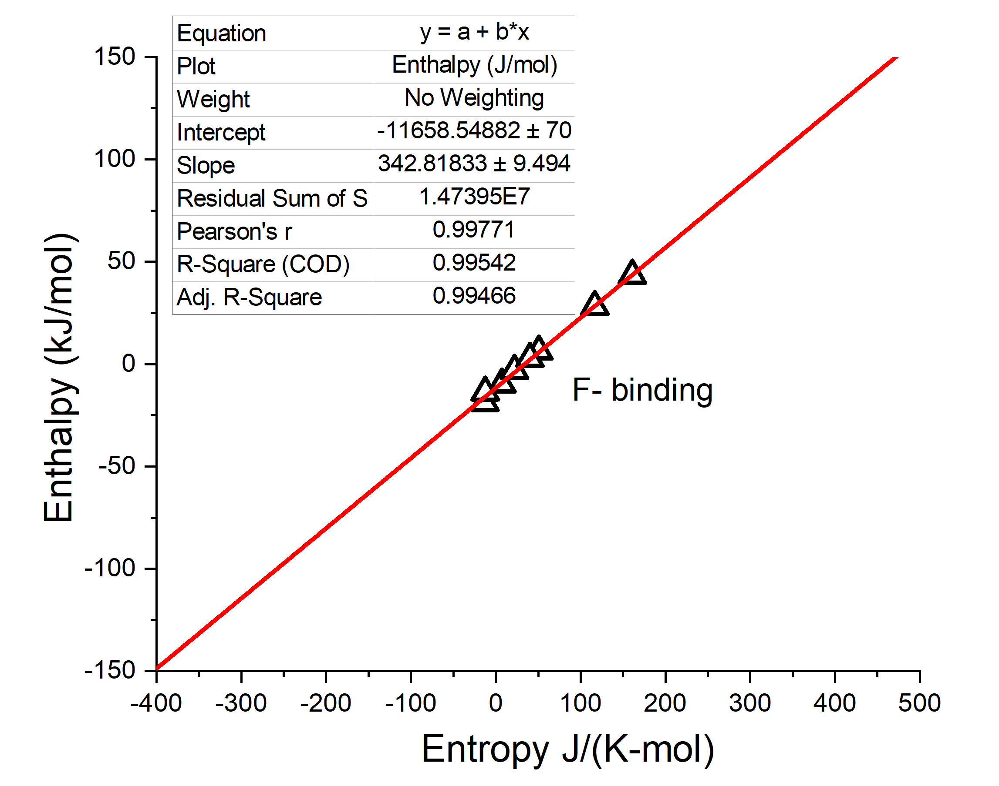
Fig. 1 The Ln (K_{d}) vs 1/T van’t Hoff plot from the ΔH^{o’} and ΔS^{o’} values in Table 1 of the Results section. The ΔH₀ is -11.7 kJ mol⁻¹, and the compensation temperature (T_{c}) is 343 K.
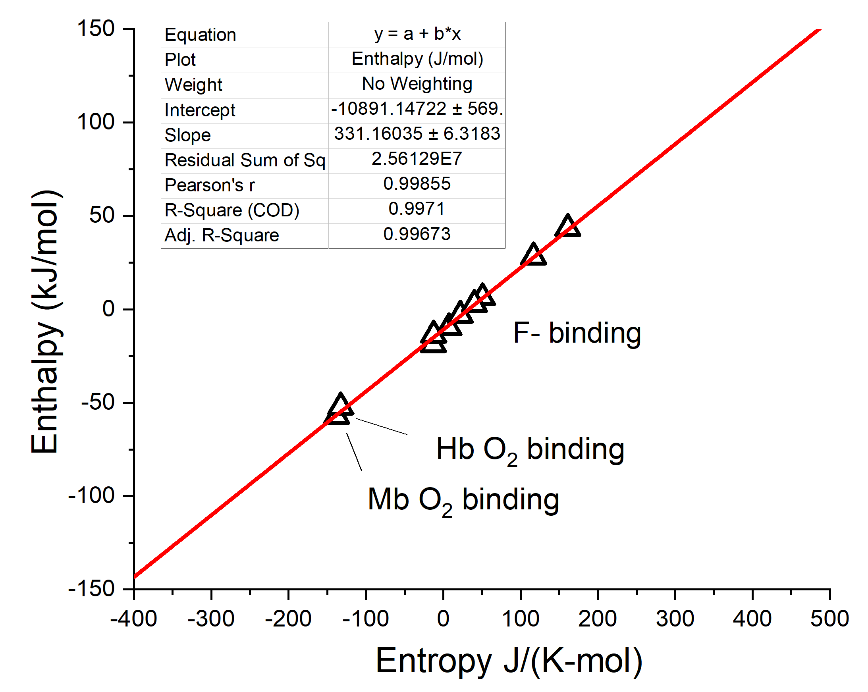

Fig. 2 The Ln (K_{d}) vs 1/T van’t Hoff plot from the ΔH^{o’} and ΔS^{o’} values in Table 1 of the Results section, and including the ΔH^{o’} and ΔS^{o’} values for oxygen binding equilibria measured by other groups. The values for Hh-Mb are -57 kJ mol⁻¹ and -138 J K⁻¹ mol⁻¹,⁴⁻⁶ and -52 kJ mol⁻¹ and -133 J K⁻¹ mol⁻¹ for the average value from the four individual oxygen binding measurements in A-Hb.^{7,8} . The plot with oxygen binding yields ΔH₀ and T_{c} values of -10.9 kJ mol⁻¹ and 331 K, respectively.

2.0 Reduction potential (E_{m}) measurements

The midpoint reduction potentials (E_{m}) values for the one-electron reduction of Hh-Mb and A-Hb of metaquo and their respective heme-fluoride complexes shown below. The measurements were obtained from the UV-vis spectroelectrochemical spectra as shown in Fig. 4 of the Results section. Experimental procedure is explained in Section 2.3 of the Materials and Methods and elsewhere.^{1,9} The reduction potentials are reported in mV vs Ag-AgCl. For the heme-fluoride complexes at pH 5, the midpoint reduction potentials are reported in two sets, one for the “low temperature” component, and the other set corresponds to the “high temperature” component. Measured E_{m} values for A-Hb at 30 ºC agree with those reported by Antonini and
Brunori.^{4,10,11}

Table 3. Reduction potential E_{m} values for horse heart myoglobin (metaquo)

pH 5

T(ºC) E_{m} (mV vs Ag-AgCl)
6.02 -97.0
10.52 -104
15.27 -108
20.37 -114
25.12 -111
29.72 -127
34.37 -123
39.12 -128

pH 7

T(ºC) E_{m} (mV vs Ag-AgCl)
10.6 -136
15.6 -148
20.4 -143
25 -151
25.3 -151
30 -144
35 -144
39.7 -151

Table 4. Reduction potential E_{m} values for adult hemoglobin (metaquo)

pH 5
T(ºC) E_{m} (mV vs Ag-AgCl)
5.97 -24.06
12.62 -28.43
22.2 -31.32
25.1 -46.5
29.7 -55.7
31.7 -63.84
34.3 -68.85

pH 7
T(ºC) E_{m} (mV vs Ag-AgCl)
6.02 35.75
11.12 15.24
15.72 1.5
21.62 -37.98
25.12 -46.34
29.72 -55.7
34.57 -76.31
39.32 -62.6

Table 5. Reduction potential E_{m} values for horse heart myoglobin (heme-fluoride complex)

pH 5

Low Temperature

T(ºC) E_{m} (mV vs Ag-AgCl)
11.4 -217
15.4 -226
18.2 -225
20.4 -226
25.4 -230

High Temperature

T(ºC) E_{m} (mV vs Ag-AgCl)
32.4 -227
34.1 -226
39.4 -218
44.5 -211

pH 7

T(ºC) E_{m} (mV vs Ag-AgCl)
10.5 -189
20.3 -200
39.8 -212
30 -206

Table 6. Reduction potential E_{m} values for adult hemoglobin (heme-fluoride complex)

pH 5

Low Temperature

T(ºC) E_{m} (mV vs Ag-AgCl)
5.72 -131
8.0 -137
11.2 -130
12.5 -126
15.7 -122
17.5 -121

High Temperature

T(ºC) E_{m} (mV vs Ag-AgCl)
21 -133
25 -128
25.5 -126
32.5 -137
35 -128
39.4 -147

pH 7

T(ºC) E_{m} (mV vs Ag-AgCl)

11.1 -117
25.3 -131
39.1 -149
17.5 -125.5

3.0 E_{m} vs Temperature plots
The E_{m} vs Temperature plots and the E_{m}/T vs 1/T plots for Hh-Mb and A-Hb are shown in Fig. 6 of the Results section. Below are the E_{m} vs Temperature plots for the one-electron reduction of the heme-fluoride complexes of Hh-Mb and A-Hb at pH 5. Here, we only show the E_{m} vs Temperature plots to show that the statistical analyses establish that the best way to represent the data for the heme-bound fluoride complexes at pH 5 is by using two temperature ranges: low and high temperatures.
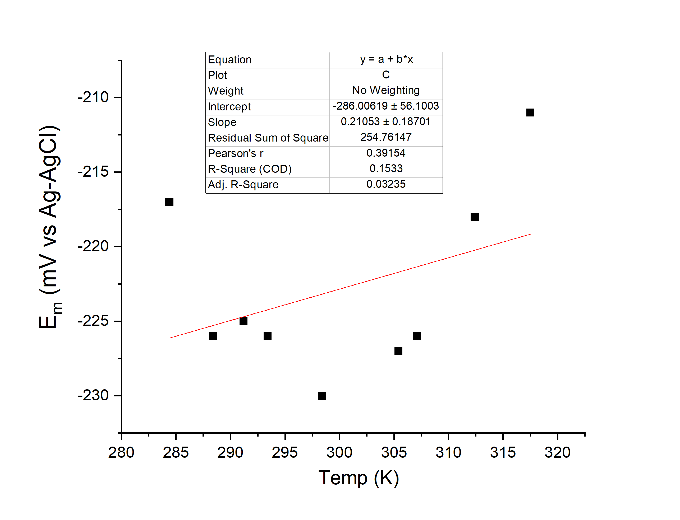
Fig. 3. E_{m} vs Temperature plot for horse heart myoglobin (heme-fluoride complex) at pH 5. The linear fit is used to fit all the data points from Table 5, pH 5. The complete statistical analysis is shown in Fig. 4.

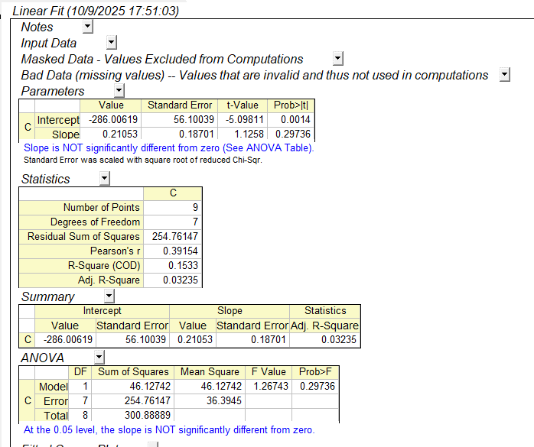

Fig. 4. Screenshot of the Origin 2018b© statistical analysis of the E_{m} vs Temperature plot for horse heart myoglobin (heme-fluoride complex) at pH 5 shown in Fig. 3.

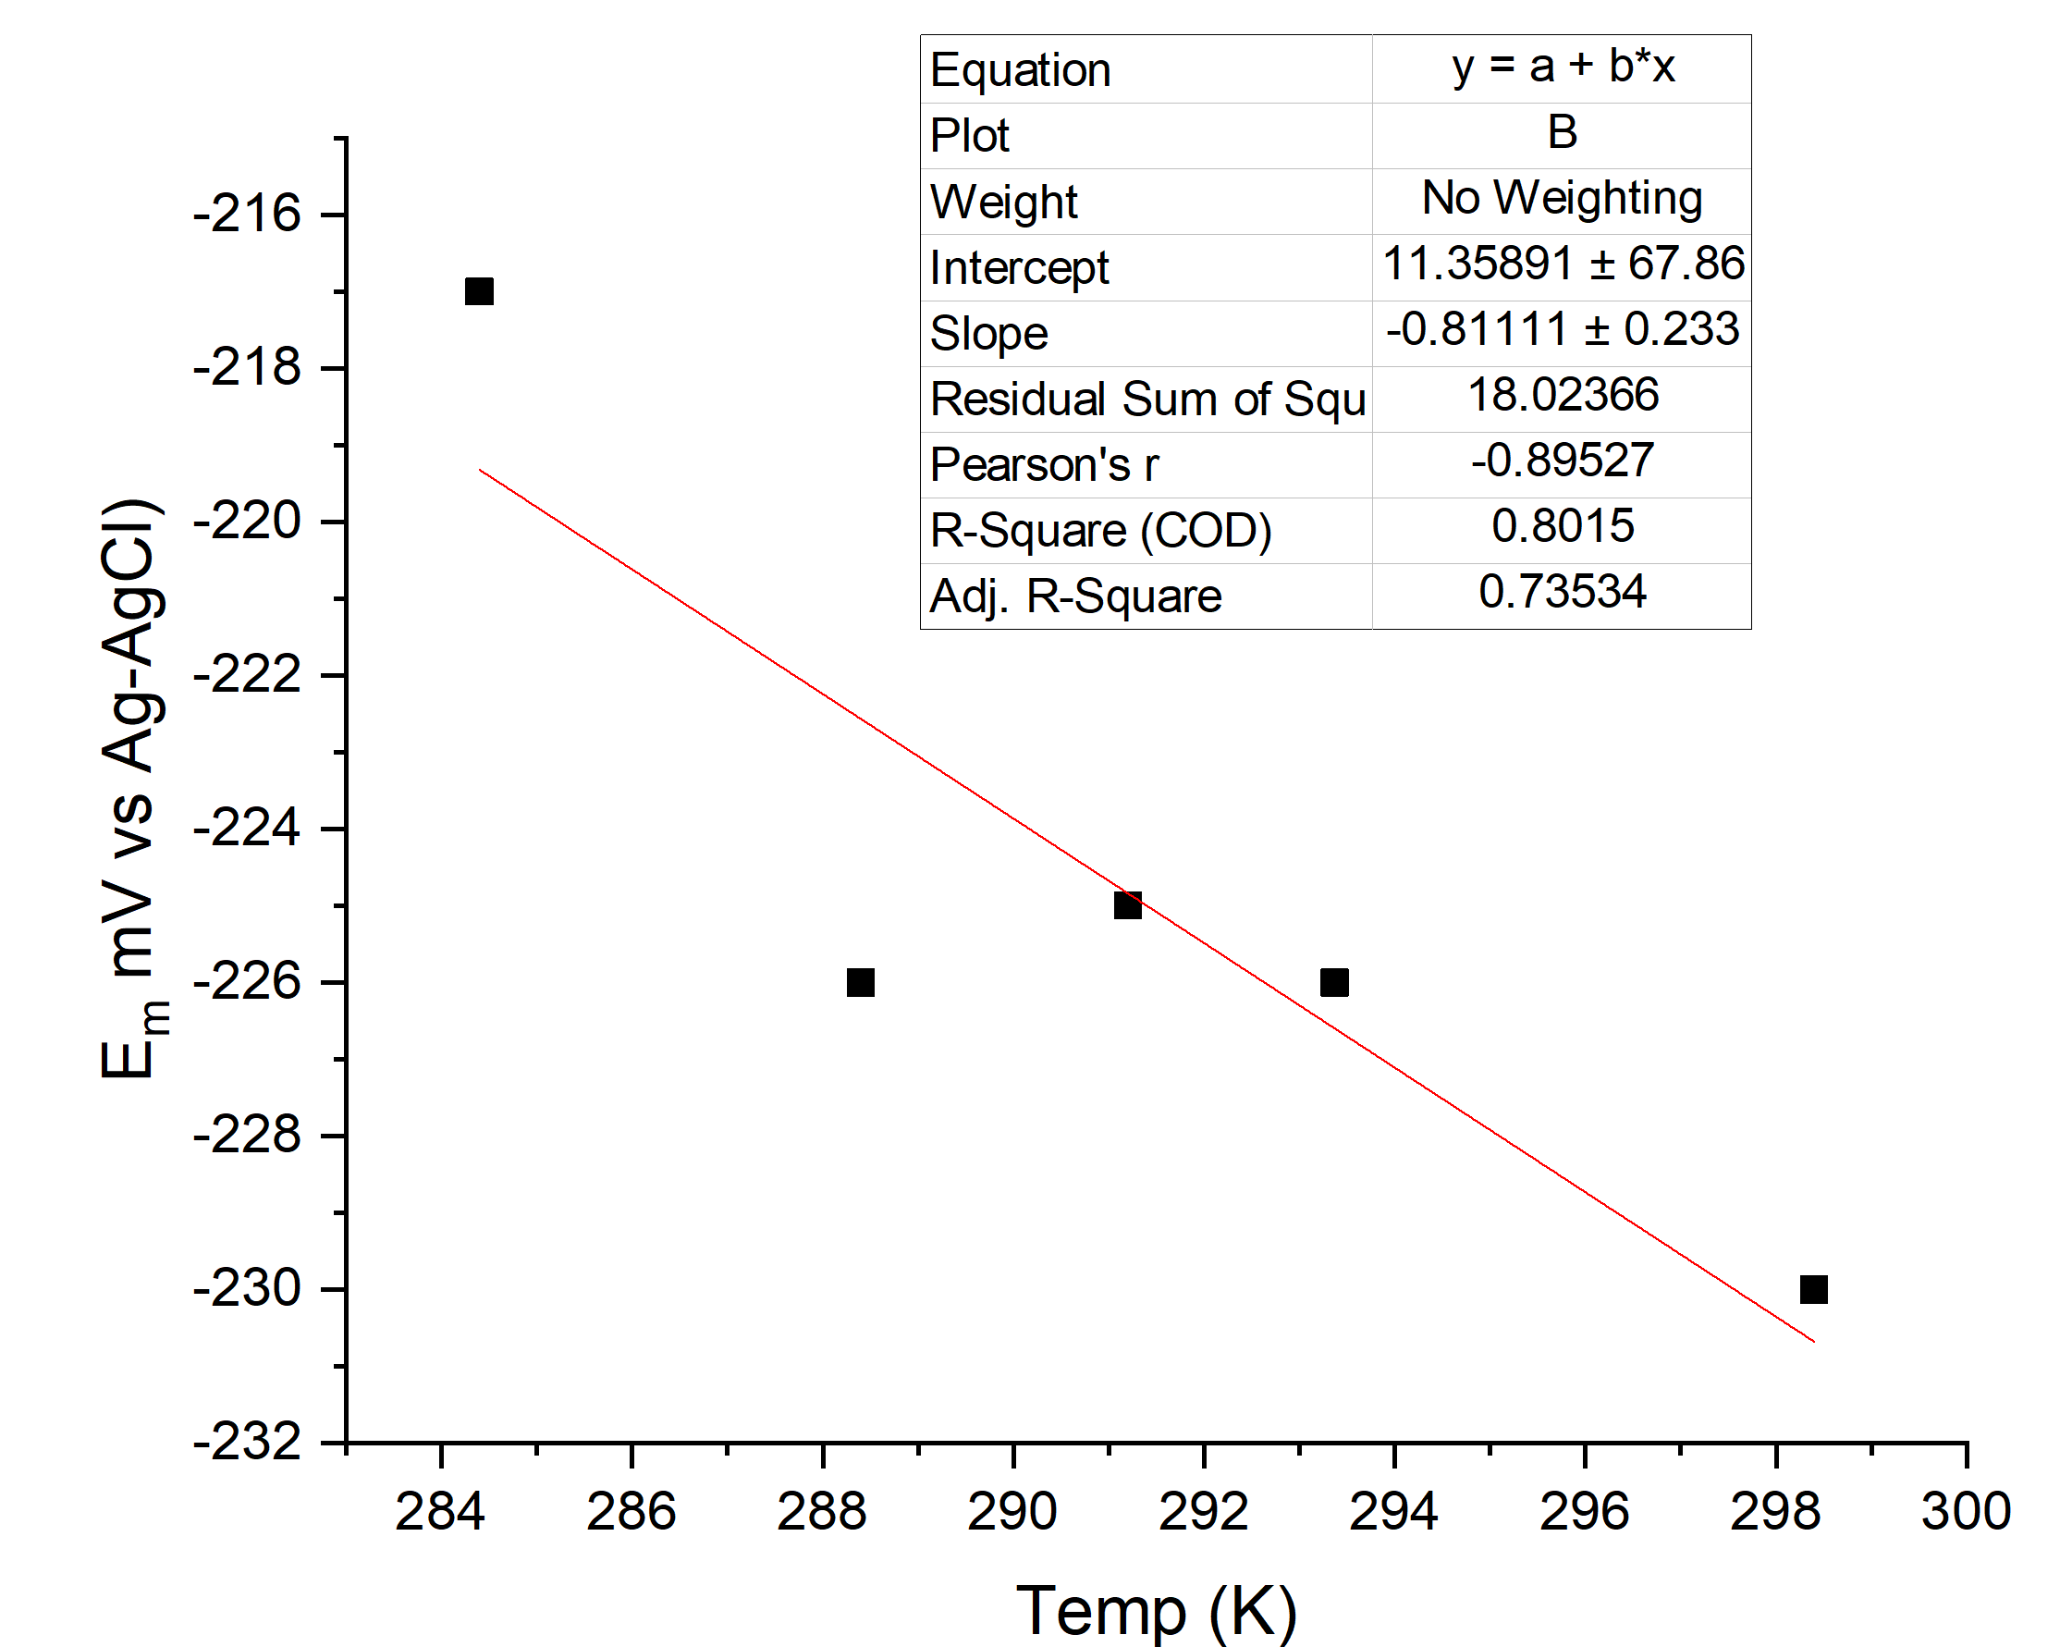
Fig. 5. E_{m} vs Temperature plot for horse heart myoglobin (heme-fluoride complex) at pH 5, low temperature range. The complete statistical analysis is shown in Fig. 6.

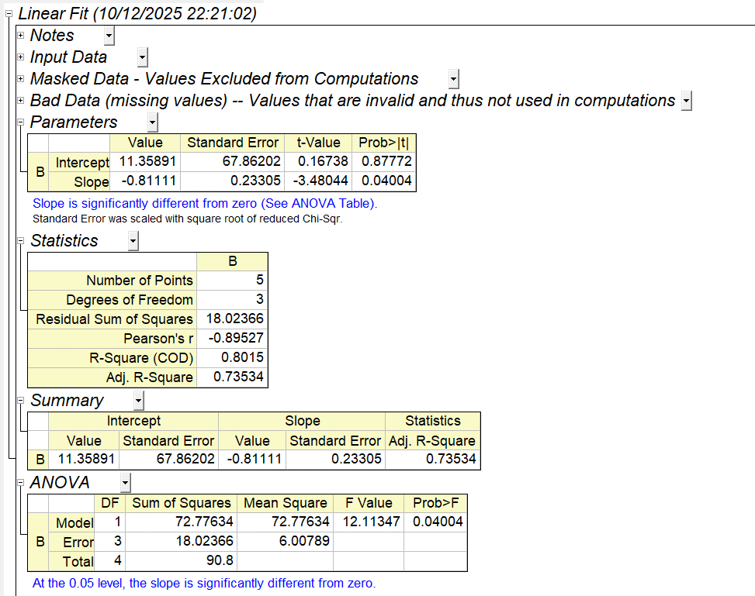
Fig. 6. Screenshot of the Origin 2018b© statistical analysis of the E_{m} vs Temperature plot for horse heart myoglobin (heme-fluoride complex) at pH 5, “low temperature” shown in Fig. 5.
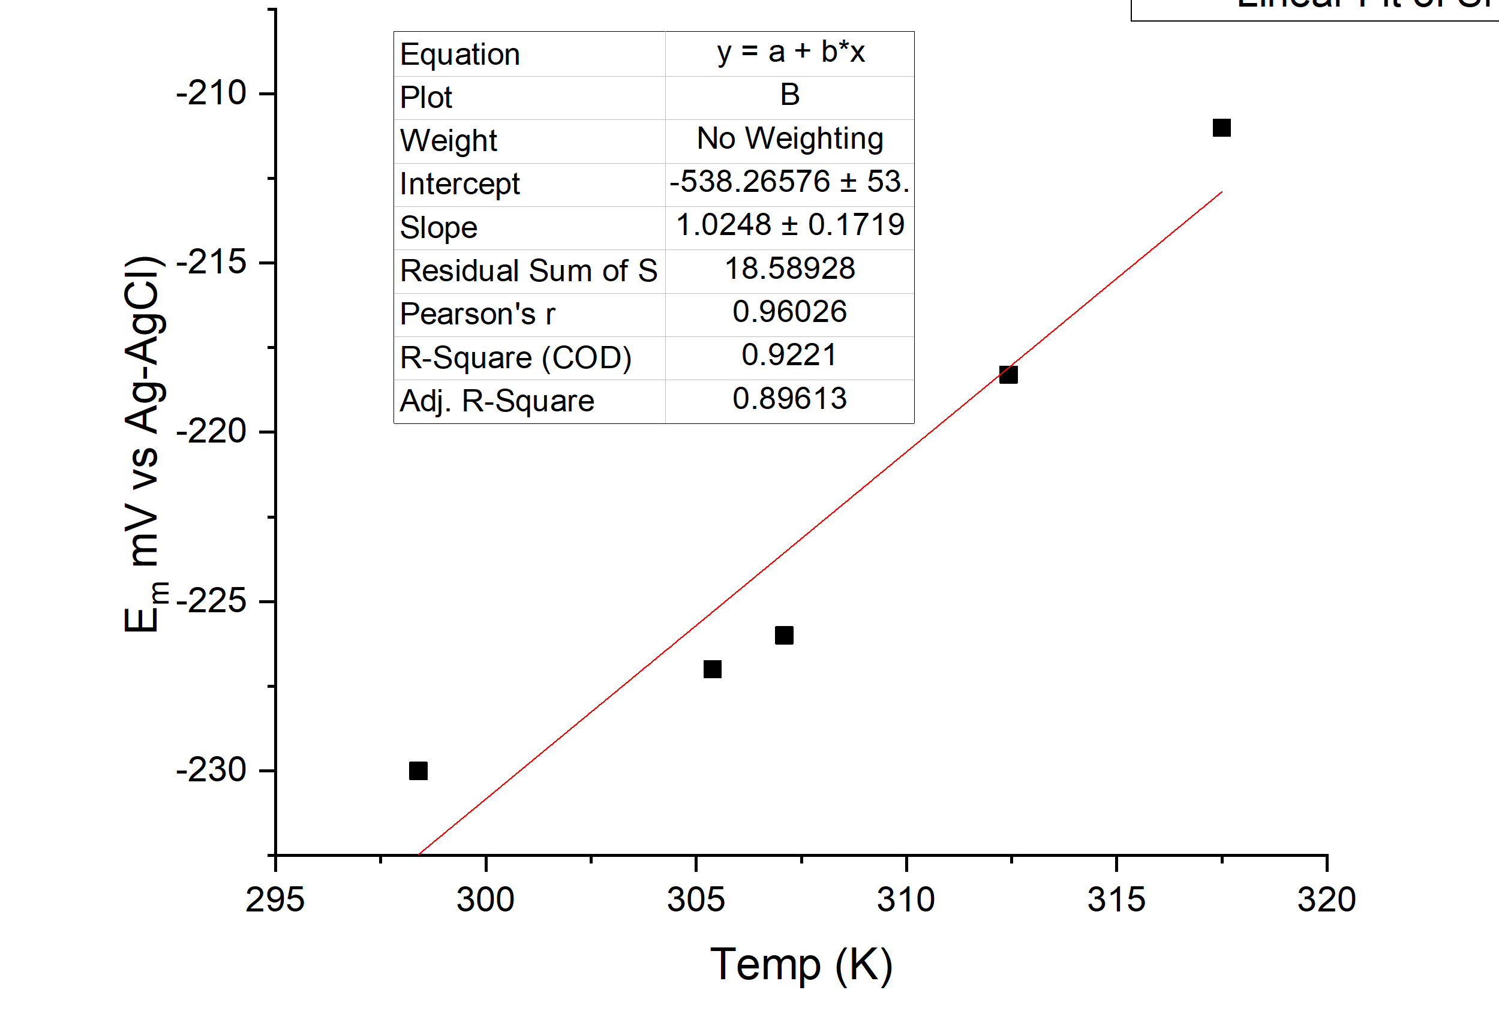
Fig. 7. E_{m} vs Temperature plot for horse heart myoglobin (heme-fluoride complex) at pH 5, high temperature range. The complete statistical analysis is shown in Fig. 8.

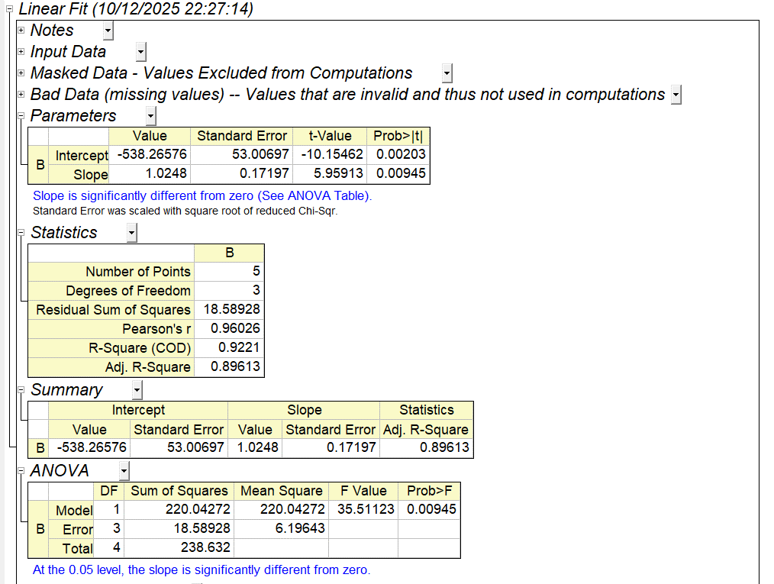

Fig. 8. Screenshot of the Origin 2018b© statistical analysis of the E_{m} vs Temperature plot for horse heart myoglobin (heme-fluoride complex) at pH 5, “high temperature” shown in Fig. 7.
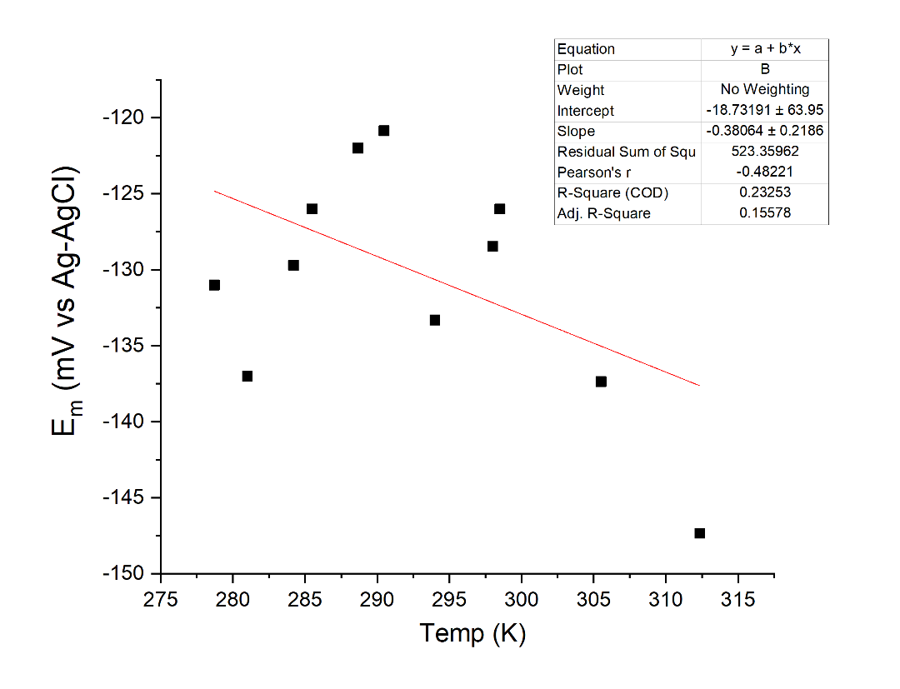

Fig. 9. E_{m} vs Temperature plot for adult hemoglobin (heme-fluoride complex) at pH 5. The linear fit is used to fit all the data points from Table 6, pH 5. The complete statistical analysis is shown in Fig. 10.
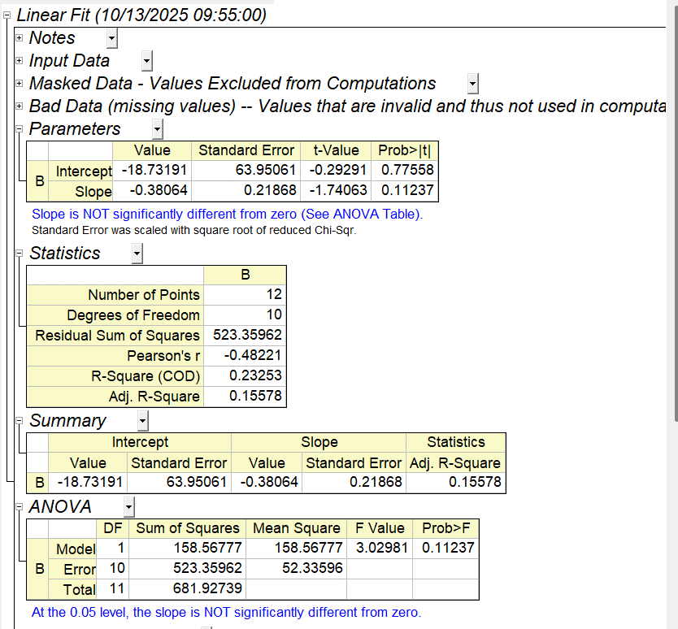

Fig. 10. Screenshot of the Origin 2018b© statistical analysis of the E_{m} vs Temperature plot for adult hemoglobin (heme-fluoride complex) at pH 5 shown in Fig. 9.
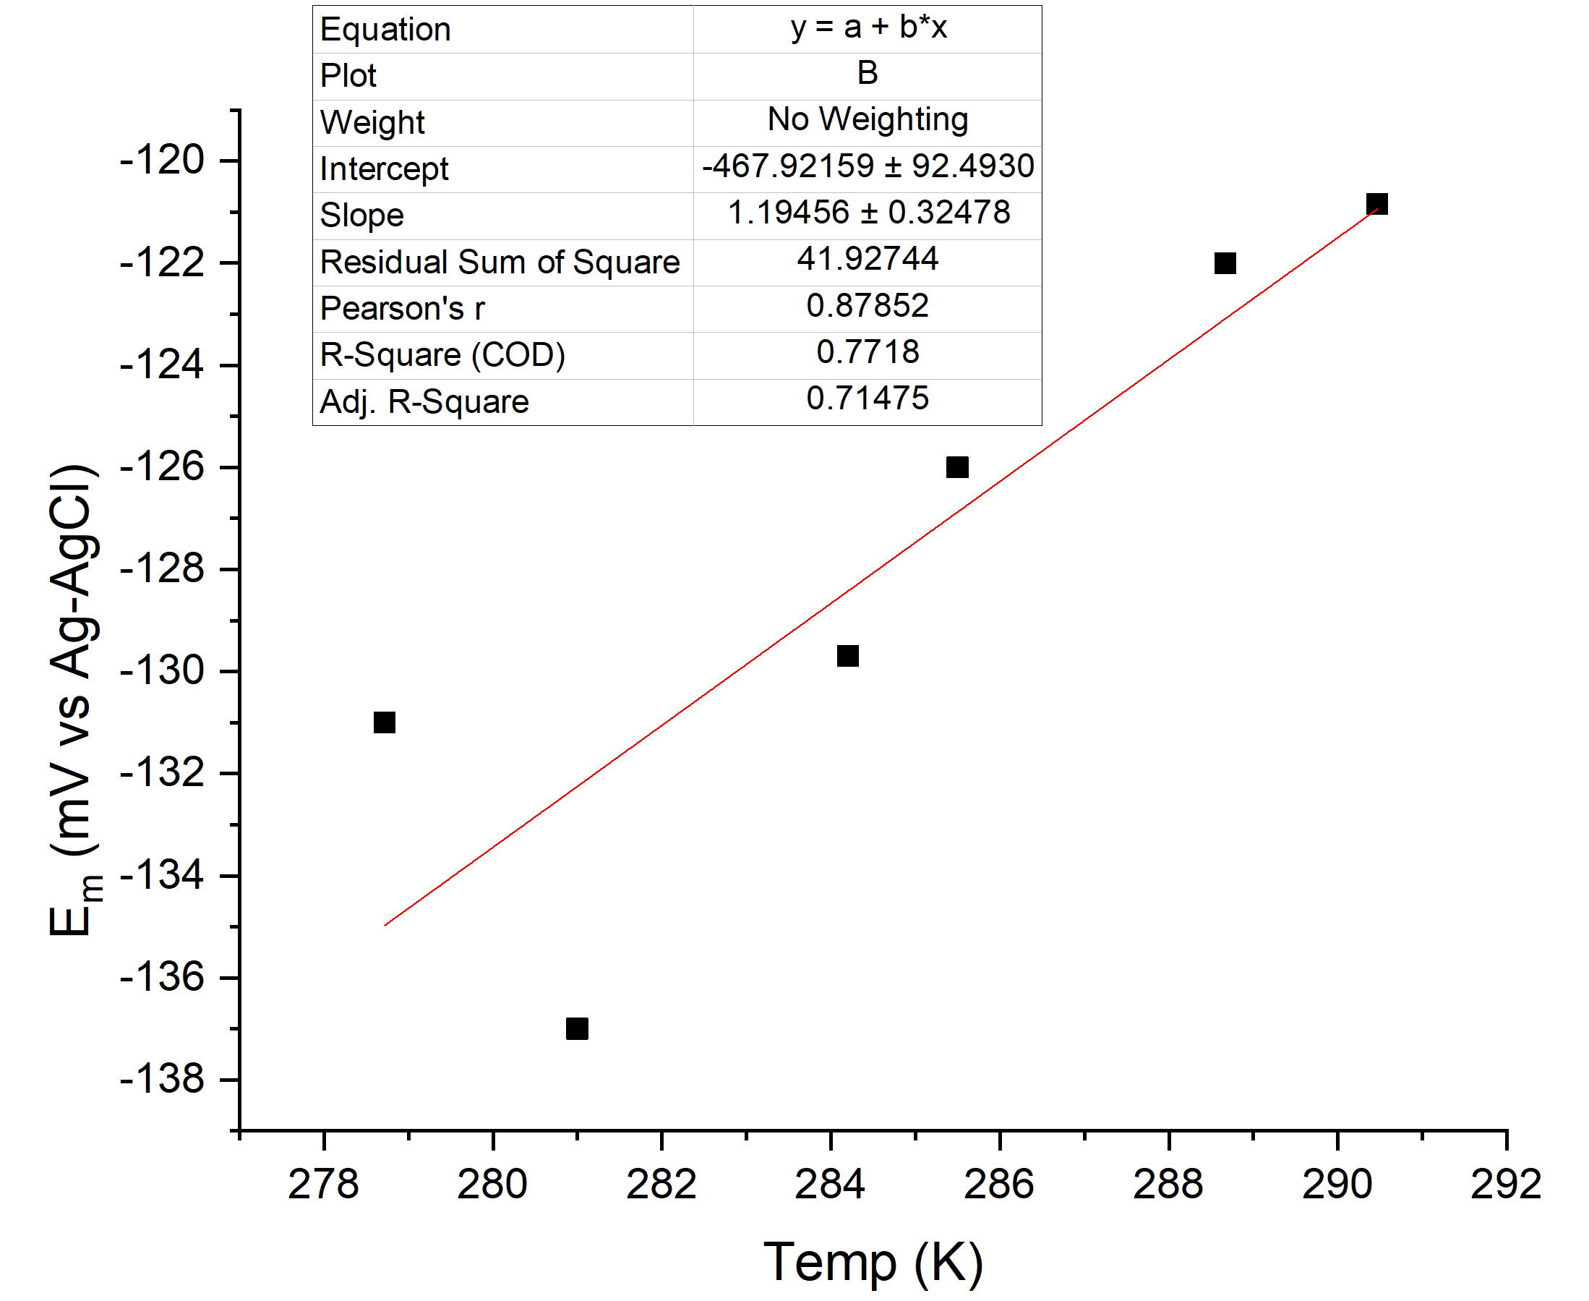
Fig. 11. E_{m} vs Temperature plot for adult hemoglobin (heme-fluoride complex) at pH 5, low temperature range. The complete statistical analysis is shown in Fig. 12.
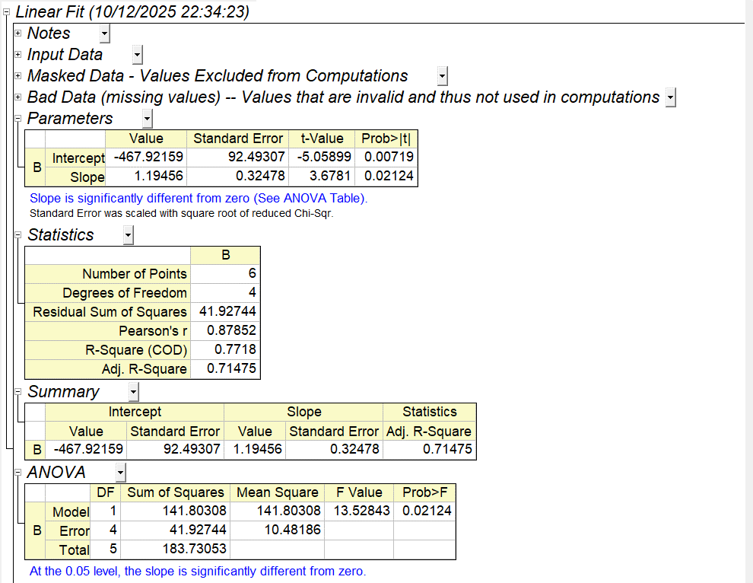
Fig. 12. Screenshot of the Origin 2018b© statistical analysis of the E_{m} vs Temperature plot for adult hemoglobin (heme-fluoride complex) at pH 5, “low temperature” shown in Fig. 11.
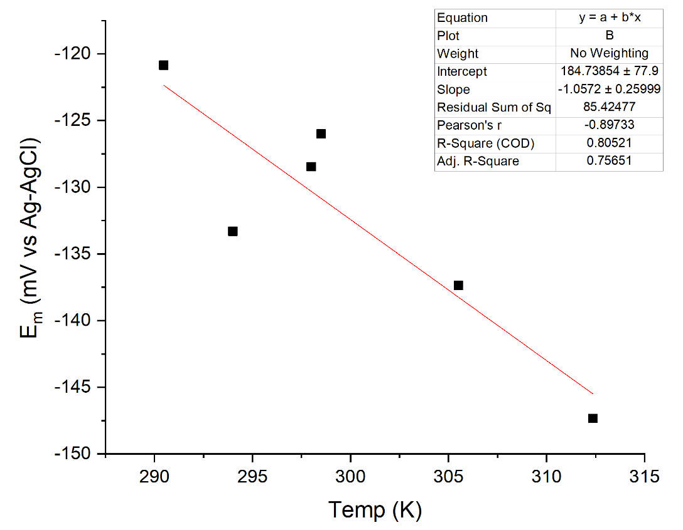

Fig. 13. E_{m} vs Temperature plot for adult hemoglobin (heme-fluoride complex) at pH 5, high temperature range. The complete statistical analysis is shown in Fig. 14.

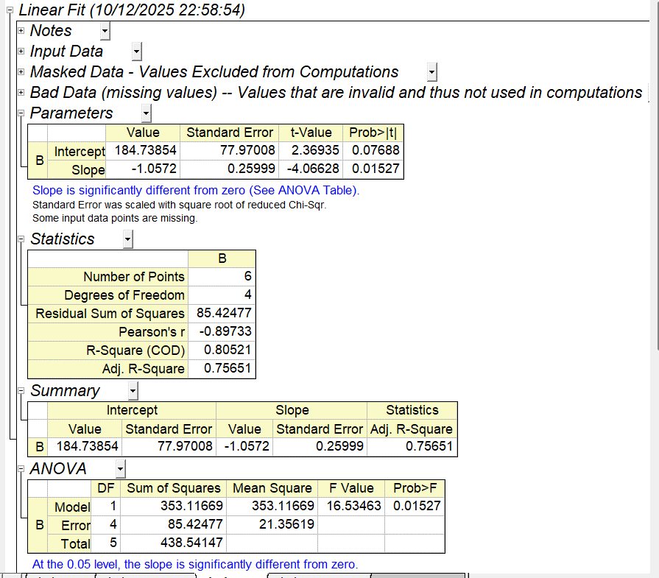

Fig. 14. Screenshot of the Origin 2018b© statistical analysis of the E_{m} vs Temperature plot for adult hemoglobin (heme-fluoride complex) at pH 5, “high temperature” shown in Fig. 13.
Redox changes (oxidation)

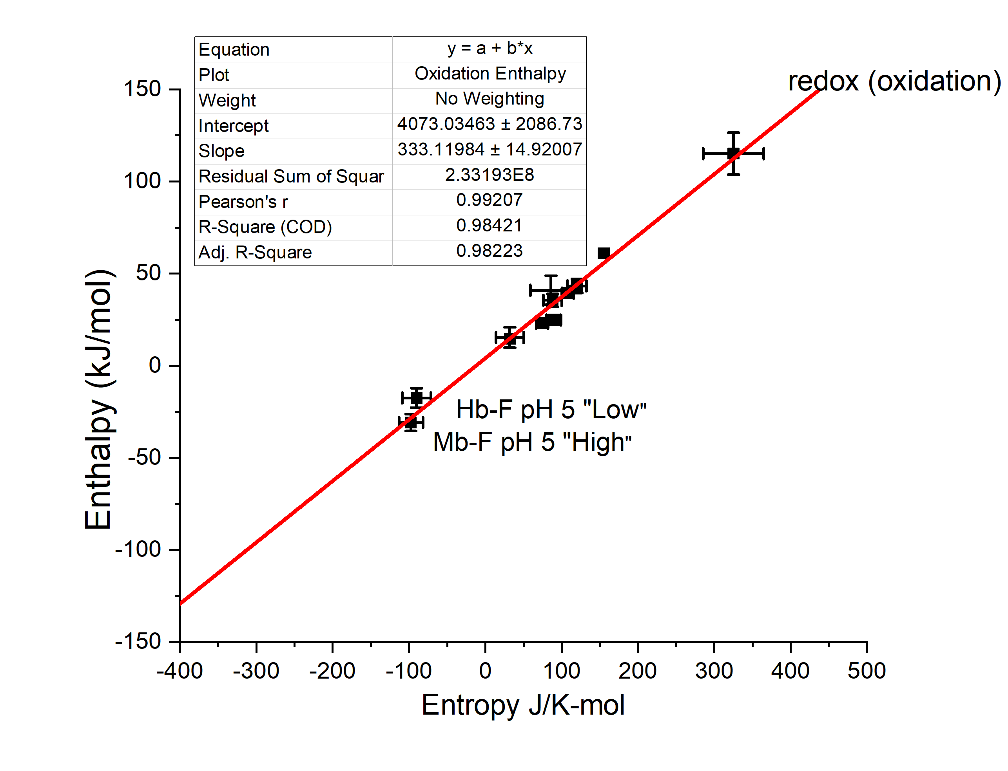

Fig. 15. Enthalpy versus entropy plot. The enthalpy-entropy compensation plot for the oxidation of Hh-Mb, A-Hb, Mb-F, and Hb-F.

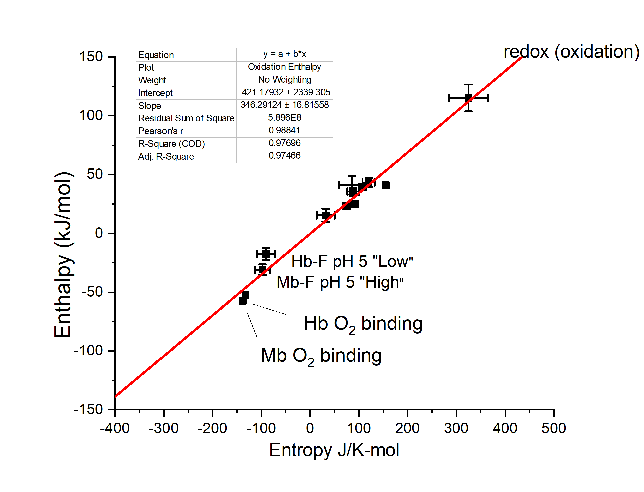
Fig. 16. Enthalpy versus entropy plot. The enthalpy-entropy compensation plot for the oxidation of Hh-Mb, A-Hb, Mb-F, and Hb-F. Oxygen binding equilibria data from Mb² and Hb²⁶ are included.

References
(1)Cerda, J. F.; Roeder, M. H.; Houchins, D. N.; Guzman, C. X.; Amendola, E. J.; Castorino, J. D.; Fritz, A. L. Anal. Biochem. 2013, 443, 75-77.
(2)Frankenfield, K.; Marchany-Rivera, D.; Flanders, K. G.; Cruz-Balberdy, A.; Lopez-Garriga, J.; Cerda, J. F. Journal of Inorganic Biochemistry 2021, 224, 111578.
(3)Flanders, K. G.; Pessagno, L. R.; Cerda, J. F. Polyhedron 2021, 203, 115238.
(4)Antonini, E.; Brunori, M. Hemoglobin and Myoglobin in their Reactions with Ligands; North-Holland Publishing Co.: Amsterdam, 1971; Vol. 21.
(5)Antonini, E. Physiol. Rev. 1965, 45, 123.
(6)Collman, J. P.; Brauman, J. I.; Suslick, K. S. Journal of the American Chemical Society 1975, 97, 7185-7186.
(7)Imai, K.; Yonetani, T. Journal of Biological Chemistry 1975, 250, 7093-7098.
(8)Atha, D. H.; Ackers, G. K. Biochemistry 1974, 13, 2376-2382.
(9)Cerda, J. F.; Guzman, C. X.; Zhang, H.; Amendola, E. J.; Castorino, J. D.; Millet, N.; Fritz, A. L.; Houchins, D. N.; Roeder, M. H. Electrochem. Commun. 2013, 33, 76-79.
(10)Antonini, E.; Wyman, J.; Brunori, M.; Taylor, J. F.; Rossi-Fanelli, A.; Caputo, A. J Biol Chem 1964, 239, 907-912.
(11)Brunori, M.; Wyman, J.; Antonini, E.; Rossi-Fanelli, A. Journal of Biological Chemistry 1965, 240, 3317-3324.

