Supplemental Information
Table SI.1: State level sample information
State | Total HH in EULP | Total owner-occ HH (OO-HH) | Total OO-LIHH (<80% AMI) | Med. LIHH EB | Med. LIHH Annual Energy Cost | Total LIHH EB>6%
AL | 9,105 | 5,168 | 2,044 | 11.3% | $2,863 | 1,749
AR | 5,528 | 3,044 | 1,154 | 10.9% | $2,651 | 970
AZ | 12,004 | 6,592 | 2,392 | 7.4% | $2,271 | 1,512
CA | 57,367 | 28,786 | 10,406 | 5.1% | $2,255 | 4,431
CO | 9,415 | 5,520 | 2,041 | 5.4% | $2,269 | 891
CT | 6,162 | 3,656 | 1,247 | 9.1% | $4,368 | 926
DC | 1,264 | 476 | 116 | 3.8% | $1,946 | 41
DE | 1,723 | 1,023 | 367 | 7.5% | $2,641 | 224
FL | 37,658 | 20,073 | 7,706 | 7.4% | $2,150 | 4,912
GA | 17,127 | 9,437 | 3,367 | 9.4% | $2,820 | 2,604
IA | 5,616 | 3,619 | 1,327 | 8.7% | $2,947 | 969
ID | 2,828 | 1,712 | 608 | 5.8% | $1,633 | 293
IL | 21,870 | 13,050 | 4,664 | 8.0% | $2,889 | 3,177
IN | 11,672 | 7,149 | 2,591 | 9.9% | $3,068 | 2,117
KS | 5,147 | 3,025 | 1,054 | 10.7% | $3,572 | 909
KY | 8,040 | 4,694 | 1,795 | 11.8% | $2,906 | 1,536
LA | 8,302 | 4,574 | 1,759 | 10.3% | $2,439 | 1,423
MA | 11,690 | 6,557 | 2,208 | 9.1% | $4,314 | 1,608
MD | 9,973 | 5,968 | 2,123 | 5.0% | $2,398 | 866
ME | 2,997 | 1,634 | 637 | 13.2% | $4,283 | 540
MI | 18,744 | 11,381 | 4,326 | 8.9% | $2,798 | 3,212
MN | 9,816 | 6,292 | 2,389 | 7.6% | $3,170 | 1,501
MO | 11,285 | 6,535 | 2,473 | 9.7% | $2,968 | 1,913
MS | 5,336 | 2,997 | 1,179 | 11.4% | $2,514 | 1,043
MT | 2,027 | 1,141 | 443 | 7.5% | $2,307 | 276
NC | 18,369 | 10,234 | 3,834 | 8.5% | $2,380 | 2,675
ND | 1,441 | 778 | 292 | 10.4% | $3,787 | 237
NE | 3,364 | 2,016 | 686 | 9.0% | $3,150 | 531
NH | 2,555 | 1,501 | 507 | 10.5% | $4,746 | 406
NJ | 14,783 | 8,429 | 2,619 | 5.1% | $2,281 | 1,073
NM | 3,762 | 2,114 | 814 | 8.8% | $2,040 | 568
NV | 4,946 | 2,420 | 828 | 6.3% | $2,096 | 431
NY | 33,676 | 15,973 | 5,818 | 9.0% | $3,837 | 4,152
OH | 21,219 | 12,533 | 4,486 | 9.2% | $2,966 | 3,405
OK | 7,007 | 3,903 | 1,495 | 11.6% | $3,200 | 1,314
OR | 7,025 | 3,998 | 1,389 | 5.1% | $1,826 | 543
PA | 23,052 | 14,029 | 5,060 | 8.7% | $2,783 | 3,526
RI | 1,910 | 1,023 | 327 | 11.0% | $3,975 | 269
SC | 9,029 | 5,246 | 2,047 | 9.2% | $2,507 | 1,553
SD | 1,546 | 919 | 338 | 9.2% | $3,174 | 256
TN | 11,834 | 6,842 | 2,489 | 9.1% | $2,473 | 1,902
TX | 43,058 | 23,435 | 8,261 | 8.2% | $2,605 | 5,766
UT | 4,224 | 2,643 | 845 | 4.2% | $1,734 | 242
VA | 14,180 | 8,362 | 2,772 | 7.4% | $2,745 | 1,696
VT | 1,345 | 741 | 278 | 12.6% | $4,432 | 236
WA | 12,224 | 7,039 | 2,375 | 4.5% | $1,847 | 798
WI | 10,917 | 6,392 | 2,305 | 8.3% | $2,925 | 1,596
WV | 3,648 | 2,168 | 897 | 10.6% | $2,557 | 719
WY | 1,106 | 639 | 232 | 8.7% | $3,090 | 177
ALL | 548,916 | 307,480 | 111,410 | 8.0% | $2,653 | 73,714

Table SI.2: Percent of Income Payment Plan (PiPP) programs across the United States
 | Program | Eligibility | Source
OH | This permanent program is one of the longest-running in the U.S. Monthly customer payment is fixed at 5% of gross income for natural gas and 5% for electric (10% if electric heat). Minimum bill of $10/month. 24 on-time and in-full payments eliminates outstanding balance. Annual income verification. Costs range depending on weather from low of $292.5M in 2012 to high of $405.5M in 2010.¹ In 2015, there were 386,491 customers and payments totaled $304M for electric and $28M for gas.² | 175% FPL | OH Dept. of Development³  OH PUC Case: 13-0274-AU-ORD⁴
NJ | Universal Service Fund is a statewide NJ Dept. of Human Services program that caps gas and electric bill at 6% of annual income. Annual cap at $1,800/year. | 60% SMI | NJ Dept. of Community Affairs USF fact sheet and FAQs⁵
IL | Permanent program that caps gas and electric bills at 6% of their income. Includes an arrearage forgiveness aspect in addition, requiring on time payments. There is a maximum benefit of $1,800 per year (monthly maximum of $100 for gas, $50 for electric). In FY 2015, 55,860 households received almost $55M. | 150% FPL | Summary on LIHEAP Clearinghouse⁶
NV | Permanent program that aims to provide assistance to qualifying households such that their energy burden is capped at the state median (determined annually) via an annual, one-time benefit paid to the energy provider. Program caps depend on FPL level and also take into account household members at or above 60 years old, disabled, or child less than 6 years old. Additionally account for oil or propane primary energy sourced homes. 19,394 households were served in 2021 and were awarded $7,715,759 (total expenditures were $8,844,556) | 150% FPL | SFY 2021 Evaluation: Energy and Weatherization Assistance Programs⁷
CA | Four year pilot programs (started 2023) for gas and/or electric customers. A monthly bill cap is set (additional to taxes, fees, and past due amounts) roughly based on 4% of gross income and subject to change on a yearly basis. The CA decision that applies to all three CA investor-owned utilities specifies a cap of 15,000 participants and estimated costs of $23M of subsidies over four years.  - SDG&E pilot can accept 1,000 customers with a cap of $38 (0-100% FPL) or $115 (100-200% FPL)  - PG&E pilot can accept 5,000 customers with a cap of $29 (electric) and $9 (gas) (0-100% FPL) of $86 (electric) and $29 (gas) (100-200% FPL)  SCE pilot can accept 4,000 customers offers a cap of $29 (0-100% FPL) or $86 (100-200% FPL) | Enrolled in CARE (200% FPL) and disconnected 2+ times due to nonpayment between 3/2019 - 2/2020; located in specific zip codes with high levels of disconnection | SDG&E⁸  PG&E⁹  SCE¹⁰  CA PUC Decision 21-10-012¹¹
Consumers Energy (MI) | Two-year pilot program (started Oct, 2022) for 1,500 gas and/or electric customers whose bills will be fixed at 6% of gross income ($10/month minimum bill) in addition to arrear forgiveness. Estimated cost per year is $1.75M. | 150% FPL | MI PSC Case: U-21021¹²
Table SI.3: Share of low-income households that are weatherization and/or solar ready along with median capital costs on one side and bill savings (and consequent energy burden point reduction) on the other
 | High energy burden (>6%) LIHH Potential | Mean Solar Size [kW]* | Med. Capital Cost** | Med. Year 1 Bill Savings | Med. Energy burden point reduction
PiPP | 73,714 (100%) |  |  | $1,373 | 4.5
Wx | 72,812 (99%) |  | $1,237 | $592 | 2.3
Solar | 71,388 (97%) | 4.6 kW | $11,968 | $1,001 | 3.7
Wx+Solar | 73,714 (100%) | 4.5 kW | $12,987 | $1,588 | 6
*Weatherization measures remain the same for Wx+solar case, but presence of weatherization reduces average annual electricity demand constraint for a subset of participating low-income households, which reduces the mean system size
** Costs reflect addition of state and federal tax incentives (see Methods)

Table SI.4: Solar system size constraints for energy burdened, solar-ready LIHH
PV | Electric share of cost  [% of all LIHH] | Electric share of cost  [% of all highEB, solar LIHH] | Share of 5 kW systems | Share with rooftop constraint | Share with avg. annual load const
Midwest | 46% | 44% | 56% | 2% | 42%
Northeast | 43% | 36% | 57% | 2% | 41%
South | 81% | 80% | 89% | 1% | 10%
West | 73% | 72% | 55% | 1% | 44%
All | 65% | 62% | 70% | 2% | 28%
Wx+PV | Electric share of cost  [% of all LIHH] | Electric share of cost  [% of all highEB, solar LIHH] | Share of 5 kW systems | Share with rooftop constraint | Share with avg. annual load const
Midwest | 49% | 47% | 50% | 2% | 49%
Northeast | 46% | 41% | 50% | 2% | 48%
South | 78% | 78% | 84% | 1% | 15%
West | 70% | 70% | 48% | 1% | 51%
All | 64% | 62% | 64% | 1% | 35%

Table SI.5: Weatherization measures considered (from NREL’s EUSS and cost database)¹³
Summary of Measure | Detailed Measure | Cost (Range)¹⁴ | Sample Share (Mean Cost where Applied)
Attic floor insulation up to IECC-Residential 2021 levels for dwelling units with vented attics and lower-performing insulation | Applies only to dwelling units with vented attics | $0.76/ft² of attic floor area  ($0.46 - $0.99) | 84%  ($1,008)
 | R-30 if…  - IECC climate zone 1A  - R-13 or less | $0.76/ft² of attic floor area  ($0.46 - $0.99) | 84%  ($1,008)
 | R-49 if…  - IECC climate zones 2A, 2B, 3A, 3B, 3C  - R-30 or less | $0.76/ft² of attic floor area  ($0.46 - $0.99) | 84%  ($1,008)
 | R-60 if…  - IECC CZ 4A, 4B, 4C, 5A, 5B, 6A, 6B, 7A, 7B  - R-38 or less | $0.76/ft² of attic floor area  ($0.46 - $0.99) | 84%  ($1,008)
General air sealing: 30% total reduction in ACH50 for dwelling units with greater than 10 ACH50 | 30% whole-home reduction in ACH50 if…  - 15 ACH50 or higher infiltration | $1.20/ft² of finished floor area  ($0.48 - $1.80) | 71%  ($1,818)
Duct sealing to 10% leakage, R-8 insulation | 10% Leakage, R-8 if…  - Leakier and/or less insulated ducts (than 10% or R-8) located in unconditioned space | $0.40/ft² of ducts if 20% leakage  ($0.20 - $0.59)  $0.81/ft² of ducts if 30% leakage  ($0.40 - $1.20) | 47%  ($294)
Drill-and-fill insulation (R-13) for dwelling units with no insulation and wood stud walls | R-13 insulation with wood stud walls if…  - Uninsulated wood stud walls | $2.20/ft² of exterior wall area above grade  ($1.20 - $2.90) | 38%  ($3,622)
Add R-10 interior insulation to foundation walls and rim joists in conditioned basements and crawlspaces; seal crawlspace vents | R-10 interior insulation for foundation walls and rim joists if…  - Unvented crawlspaces, vented crawlspaces, or heated basements  - Has no foundation wall insulation | $1.70/ft² of wall area below ground if crawlspace  ($1.20 - $2.20)  $3.10/ft² of wall area below ground if heated basement  ($2.30 - $4.00) | 33%  ($1,622)
 |  | $1.80/ft² of rim joist area  ($1.20 - $2.30) | 33%  ($1,622)
Insulate finished attics and cathedral ceilings to R-30 | R-30 roof insulation if…  - Single-family, or top-level multi-family unit  - Roof insulation of R-13 or less  - Has finished attics or cathedral ceilings | $4.30/ft² of roof area  ($2.60 - $5.50) | 0.3%  ($5,475)
Total |  |  | 98%  ($4,290)

Table SI.6: Maximum PV to load ratio allowed, by state, derived from Energy Sage data.
Values are used to set one of the three rooftop solar system size constraints (see “Methods”). “All” value is applied if state does not have its own value listed in this table.
State | PV-to-Load Ratio
AR | 0.87725
AZ | 1.0246
CA | 1.0552
CT | 1
FL | 1
IL | 1.0036
MA | 1.0262
MN | 1.0032
NC | 0.9167
NH | 1.0025
NJ | 1.0063
NM | 1.0047
NV | 1.0016
NY | 1.02
OR | 0.9816
PA | 1.0098
RI | 1
TX | 1.00315
UT | 1.0092
VT | 0.9114
WA | 0.8503
All | 1.0156

Table SI.7: Rooftop solar cost per Watt (2022) derived from Berkeley Lab’s Tracking the Sun¹⁵ after filtering out any (1) third-party owned, (2) self-installed, (3) expansions, (4) non-residential systems and filtering for (5) solar-only. Then, discounted 20% to account for origination fees.
Region | Median $/W | Mean $/W | St. Dev. $/W | N
Midwest | 2.79916 | 3.04064 | 0.981451 | 2524
Northeast | 3.505355 | 3.645517 | 1.288238 | 26519
South | 3.6 | 3.662053 | 1.419439 | 11906
West | 3.327394 | 3.419469 | 1.165417 | 171258

Table SI.8: Active state investment tax credits used in the main analysis (removed in sensitivity without tax credit)
 | State ITC Level | Max. Incentive Level
AZ | 25% | $1000
MA | 15% | $1000
NY | 25% | $5000
NM | 10% | $6000

Figure SI.1: Regional comparison of various program designs:
Dotted lines include the installed measures with bill assistance (percent of income payment plan). Line segments represent changes moving (left to right) from fully loan-financed (empty circle) to a full upfront rebate. For the weatherization + solar case, weatherization is fully rebated. Dotted axes show efficacy and NPC of PiPP. Thus, points in the upper-left quadrant are cheaper, but less effective; lower-left are both cheaper and more effective; lower-right are more expensive and more effective when compared to PiPP alone.
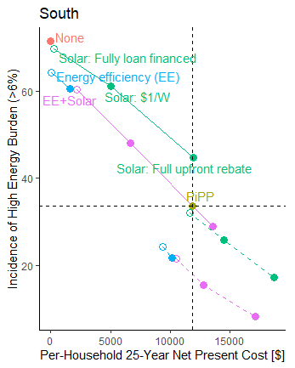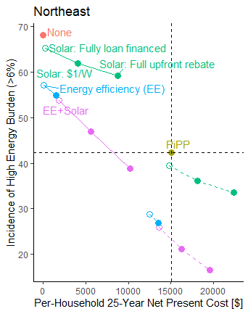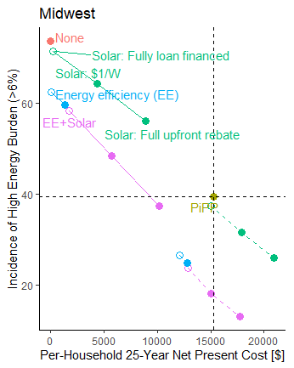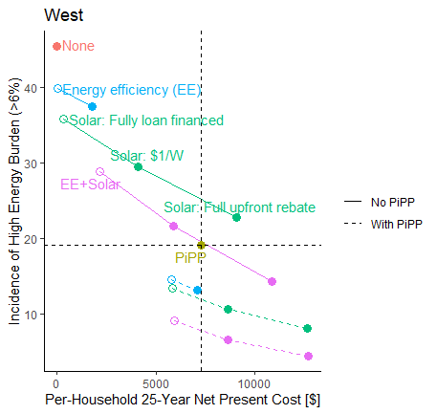

Figure SI.2: Cost effective share of eligible households as a function of incentive level, without federal or state tax incentives:
Dotted line follows share of household investments that yield savings-to-investment ratio (SIR) over 1 (cost effective from program perspective) while solid line follows share of household investments that yield positive net savings (cost effective from household perspective). The rebate levels for weatherization go from zero to full, while that for solar include intermediate $/W levels. For the combination of solar and weatherization, weatherization is fully rebated while solar is incentivized at varying levels.
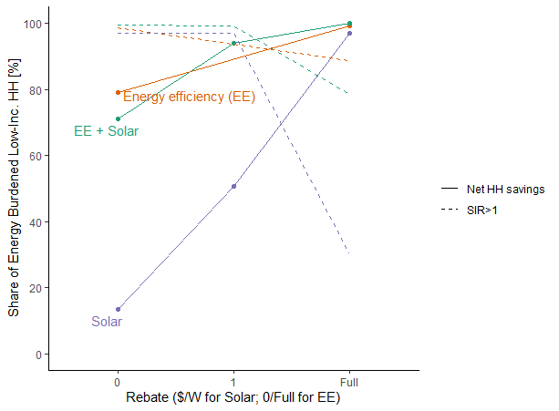

Supplemental References
1. Ohio Legislative Service Commission. SB 156 of the 131st GA Fiscal Note & Local Impact Statement: Modifies the funding process for the Percent of Income Payment Plan (PIPP) Program. (2015).
2. LIHEAP Clearinghouse. State PBF/USF History, Legislation, Implementation: Ohio. https://liheapch.acf.gov/dereg/states/ohio.htm (2016).
3. Ohio Department of Development. Percentage of Income Payment Plan (PIPP). https://development.ohio.gov/individual/energy-assistance/2-percentage-of-income-payment-plan-plus.
4. Ohio PUC. 13-0274-AU-ORD: Commission’s review of its rules for the establishment of credit for residential utility. (2023).
5. NJ DCA. Universal Service Fund (USF). https://dis.puc.state.oh.us/CaseRecord.aspx?CaseNo=13274.
6. LIHEAP Clearinghouse. State PBF/USF History, Legislation, Implementation: Illinois. https://liheapch.acf.gov/dereg/states/illinois.htm (2016).
7. H. Gil Peach & Associates. Energy and Weatherization Assistance Programs: Executive Summary SFY 2021 Evaluation. at https://www.leg.state.nv.us/Division/Research/Documents/RTTL_NRS702.280_2022.pdf (2021).
8. SDG&E. Percentage of Income Payment Plan (PIPP). https://www.sdge.com/pipp.
9. PG&E. Percentage of Income Payment Plan (PIPP). https://www.pge.com/en/account/billing-and-assistance/financial-assistance/percentage-of-income-payment-plan.html.
10. SCE. Percentage of Income Payment Plan (PIPP). https://www.sce.com/sites/default/files/custom-files/Web files/PIPP-Letter.pdf.
11. Rulemaking 18-07-005: Order Instituting Rulemaking to Consider New Approaches to Disconnections and Reconnections to Improve Energy Access and Contain Costs: Decision authorizing percentage of income payment plan pilot programs. (2021).
12. MI PSC. U-21021: In the matter of the application of Consumers Energy Company for approval of a Percent of Income Payment Plan Pilot. (2021).
13. NREL. End-Use Savings Shapes: Public Dataset Release. https://docs.nrel.gov/docs/fy23osti/84931.pdf (2022).
14. NREL. National Residential Efficiency Measures Database. https://remdb.nrel.gov/group_listing.
15. Barbose, G., Darghouth, N., O’Shaughnessy, E. & Forrester, S. P. Tracking the sun: Pricing and design trends for distributed photovoltaic systems in the United States. https://emp.lbl.gov/tracking-the-sun (2022).

