Supplementary Material For:
Temporary land carbon storage can avoid slow-responding climate changes

Mitchell Dickau¹ and H. Damon Matthews¹

¹Department of Geography, Planning and Environment, Concordia University, Montréal, Quebec, Canada

* Corresponding author at: Mitchell.dickau@mail.concordia.ca

This file includes:
Supplementary Figures: 1 to 5

SUPPLEMENTARY FIGURES 1 to 6:

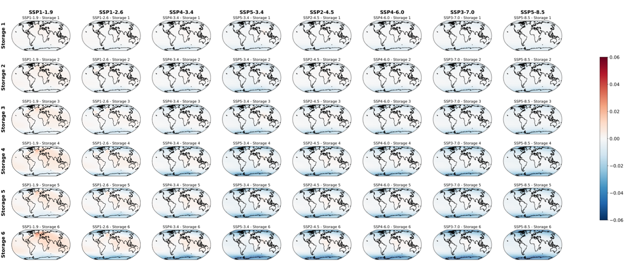
SM Figure 1 – Average difference in surface air temperature between storage SSPs and baseline SSPs between 2100 to 2120. Shown is the 20-year mean difference in surface air temperature (SAT) between storage and baseline SSPs (i.e., storage SAT subtracted by baseline SAT) for the period 2100–2120, corresponding to the two decades following the re-emission of all temporarily stored carbon. Columns indicate baseline SSPs (listed above), and rows indicate storage pathways (listed to the left). In general, storage SSPs remain cooler at high latitudes and exhibit equal or slightly warmer temperature in equatorial and mid-latitude regions relative to their baselines. This regional warming pattern strengthens with increasing magnitude of temporary carbon storage.
SM Figure 2 – CO₂ emissions and temperature responses in baseline and storage SSPs up until 2300. (A) Annual anthropogenic CO₂ emissions from fossil fuels and land-use change. (B) Cumulative CO₂ emissions from 2015 to 2300. (C) Global mean surface air temperature anomaly relative to a 1850-1900 preindustrial baseline. (D) Temperature difference between storage SSPs and their corresponding baseline SSPs. Colours indicate SSP ensembles, with solid lines showing baseline simulations and dashed/dotted lines showing the six storage pathways applied to each SSP.
SM Figure 3 – Storage-years in storage pathways and their relationship to degree-years of avoided warming in storage SSPs up until 2300. (A) Storage-years of the six storage pathways applied to each SSP baseline. (B) The quasi-linear relationship between degree-years of avoided warming and storage-years of temporary carbon storage across all 48 storage SSPs.
SM Figure 4 – Differences in slow-responding climate variables between storage and baseline SSPs for each of the six storage pathways to 2300. Each subplot shows the difference between storage SSPs and baseline SSPs for a single slow-responding variable under one storage pathway. Rows correspond to climate variables (listed on the left), and columns correspond to storage pathways (listed above). Aside from meridional overturning (a.k.a. AMOC), all variables show avoided change from temporary carbon storage up to 2300, with the magnitude of avoided change increasing under storage pathways with greater storage. The AMOC response to temporary carbon storage by 2300 is more variable. There is almost no effect in stabilization SSPs – i.e. SSP2-4.5, SSP4-6.0, SSP3-7.0, SSP5-8.5 – and both positive and negative responses in peak-and-decline SSPs – i.e. SSP1-1.9, SSP1-2.6, SSP4-3.4, SSP5-3.4. Coloured lines in each subplot indicate the storage SSPs.
SM Figure 5 – Relationship between storage-years and avoided change of slow-responding variables in storage SSPs relative to their baseline SSPs to 2300. Figure 4) shows the relationship between storage-years of temporary carbon storage and avoided change in: (A) permafrost carbon, (B) thermosteric sea level rise, (C) AMOC, (D) average ocean temperature, and (E) total ocean carbon. Non-linear dashed/dotted lines represent SSP ensembles (colours) and storage pathways (line types), with coloured dots marking 2300 values for each storage SSP. Solid lines indicate linear relationships between storage-years and avoided change. In panels (B), (D), and (E), these linear fits are shown in red, with R² values displayed on the left. Linear correlations in panels (B), (D), and (E) are calculated across all storage SSPs, whereas correlations in panels (A) and (C) are calculated within each SSP ensemble, with solid lines and R² colours corresponding to each SSP ensemble.

