Supplementary Material
Table of Contents
Supplemental Methods 2
DNA Methylation Probe and Sampling Filtering 2
Epigenetic Age Measures 3
Marginal Structural Bayesian Relevant Life-course Model (MSBRLM) 3
Identification proof 6
Multiple imputation 8
Table S1. Demographic characteristics of comparison with the total HCHS/SOL population and the study samples 10
Table S2. Measures of psychosocial adversity in childhood and adulthood 11
Table S3. Prevalence of life-course adversity 12
Figure S1. Direct acyclic graph for the hypothetical relationship between childhood adversity, adulthood adversity, EAA, and covariates 13
Figure S2. Description of included life-course models 14
Figure S3. Correlation between childhood and adulthood adversity 15
Figure S4. The association between life-course adversity and EAA assessed by the Marginal Structural Model (MSM) 16
Figure S5. Comparison between MSBRLM and MSM 17
Figure S6. The association between life-course adversity and EAA assessed by the MSBRLM adjusting for cell-type proportions 18
Figure S7. Causal mediation analysis for childhood adversity and EAA adjusting for cell-type proportions 19
Figure S8. The association between life-course adversity and epigenetic age acceleration assessed by the MSM adjusting for cell-type proportions 20
Figure S9. The association of life-course adversity on epigenetic age acceleration assessed by the MSBRLM adjusting for smoking status 21
Figure S10. Causal mediation analysis for childhood adversity and EAA adjusting for smoking status 22
Figure S11. The association between life-course adversity and EAA assessed by the MSM adjusting for smoking status 23

Supplemental Methods

DNA Methylation Probe and Sampling Filtering
Sex was predicted based on the median total methylation intensity of X- and Y-mapped CpG probes. We used the signal intensities (unmethylated and methylated) of the sex chromosomes to estimate the copy number of each sex chromosome, and predicted sex based on the expectation that males have one X and one Y chromosome and females have two X chromosomes. Normalized samples were filtered for unreliable CpG probe signals in one or more samples (probe intensity detection p<0.01; removed 41,541 CpGs), probes on sex chromosomes (removed 17,605 CpGs), probes whose sequence covered known SNPs (removed 2,488 CpGs), and cross-reactive probes (removed 40,074), which resulted in 2,079 samples with reliable data across 764,530 CpGs. Samples whose methylation-predicted sex did not match clinical classification were removed from downstream analyses (n=2 from timepoint 1) since this likely occurred as a result of a technical error in sample processing. Outlier detection was conducted using the lumi¹ and wateRmelon² R packages, and outlier samples were removed if detected by either method (n=4). Forty-eight technical duplicate pairs and 21 control pairs were assessed for batch effects, and no obvious batch effects were seen. Subsequently, one of each technical duplicate pair was removed at random (n=48), and all control samples were removed for downstream analysis (n=42). After sample and probe filtering, 970 samples at timepoint 2, and 764,530 probes remained for analysis.

To address batch effect, we examined the distribution of samples by plate and chip using principal component analysis (PCA) and boxplots. Specifically, PCA of DNA methylation profiles (color-coded by plate or chip) showed no distinct clustering or separation, and boxplots of mean methylation levels by plate and chip indicated minimal differences across batches. Given the absence of detectable batch effects, we decided not to apply surrogate variable analysis or batch correction, as doing so could risk adjusting out true biological variation between participants.

Epigenetic Age Measures
GrimAge, one of the second-generation DNAm clocks for predicting biological age, incorporates seven DNAm-based surrogate markers of plasma proteins, age, sex, and DNAm-predicted smoking history to model the mortality before transforming the results into an age scale. GrimAge was trained and tested using 1,030 CpG sites from the Framingham Heart Study (N=2,356).³ DunedinPACE was developed to predict an individual’s pace of aging as opposed to chronological age and was trained using data from the DunedinPACE study (N=1,037),⁴ in which participants have the same chronological age. DunedinPACE was estimated using 173 CpGs from White males’ blood samples at age 45 that were selected as surrogates for the annual rate of physiological decline across organ systems over two decades.

Marginal Structural Bayesian Relevant Life-course Model (MSBRLM)
Let $X_it$ denote the adversity measurement of the $i^{th} (i=1, 2, …, N)$ participant at $t^{th}$ time point ($t=1\left(childhood\right), 2 \left(adulthood\right)$). $Y_{i}$ denotes the epigenetic age acceleration (EAA) of the $i^{th}$ participant. BRLM can be presented as:
$$Y_{i}=β_{0}+δ\left(\sum_{t}^{T}{W_{t}}*x_{it}\right)+ϵ$$
$$W_{t} \sim Dirichlet\left(α\right) (\sum_{t}^{T}{W_{t}}=1)$$
$$ϵ \sim N(0,σ)$$
Based on the formula, $δ$ is the estimated life-course effect of psychosocial adversity on EAA and can be decomposed into the effect estimate for childhood adversity ($δW_{1}$) and for adulthood adversity ($δW_{2}$). Given no prior information for parameters in this model, we assigned non-informative or weak prior distributions as follows:⁵
$$W_{t} \sim Dirichlet\left(1,1\right)$$
$$β_{0} \sim Cauchy(0,5)$$
$$δ \sim Cauchy(0, 2.5)$$
$$ϵ \sim Cauchy(0, 2.5)$$
BRLM addresses confounding by directly adjusting for confounders in the regression, which cannot address intermediate confounding. It also cannot directly handle participants’ sampling weights. Thus, in MSBRLM, we used the inverse probability treatment weighting (IPTW) to address confounding. We first estimated the propensity scores for adversity in childhood, $P(X_{1}=x|C_{0})$, and adulthood, $P(X_{2}=x|C_{0},X_{1},C_{1})$, where $C_{0}$ is a vector of baseline confounders, and $C_{1}$ intermediated confounders. For the primary analyses using cumulative childhood and adulthood adversity (each ranged from 0 to 3), multivariate logistic regression was used to estimate the propensity scores. For the secondary analysis on specific adversity types (binary), logistic regression was used. We then calculated the stabilized IPTW for each individual as $\frac{P\left(X_{1}=x_{1}\right)P\left(X_{2}=x_{2}\right|X_{1})}{P(X_{1}=x|C_{0})P(X_{2}=x|C_{0},X_{1},C_{1})}$. The participants’ final weight in this study was the product of their HCHS/SOL sampling weight and IPTW.

To account for the weight of each participant in the Bayesian model, we applied the weighted finite population Bayesian Bootstrapping (WFPBB) to achieve normal coverage of the 95% CrI of the estimate.^{6, 7} WFPBB turns the weighting issue into a missing data problem. Let $(y_{1}, …y_{n})$ denote the study population sampled from a finite population ($y_{1}, …y_{N}$) with a sample size of N, using design sampling weights ($w_{1}, …w_{n}$), and $\left(y_{1}^{*}, …y_{N-n}^{*}\right)$ the unselected population. $\sum_{i=1}^{n}{w_{i}}=N$. WFPBB uses $y_{i}$ to impute $y_{k}^{*}$ for $N-n$ rounds. At the $k^{th}$ round, the probability of $y_{i}$ being selected to impute $y_{k}^{*}$ is a function of $w_{i}$ and the number of times ($l_{i, k-1}$) that $y_{i}$ has been selected to impute $y_{ 1 }^{*}…y_{k-1}^{*}$, using the formula below:
$$\frac{\left(w_{i}-1\right)+l_{i, k-1}*\frac{N-n}{n}}{N-n+\left(k-1\right)*\frac{N-n}{n}}$$
After the imputation, synthetic population $y_{1}, …y_{n}, y_{1}^{*}, …y_{N-n}^{*}$is formed before taking a random sample as a representative sample with a size of $n$ (i.e., equal to the original sample size of the study population). In this study, IPTW was used to update the participants’ sampling weight so that the final weight would represent the sampling mechanism through which the study population was sampled from a target population with a randomized exposure (see the identification proof section). Therefore, the exchangeability would hold for the representative sample assuming no unmeasured confounding, which addresses the intermediate confounding in the original study population. Under other assumptions of causal consistency, positivity, no measurement error, and correct model specification, results from the MSBRLM performed in the representative sample can be interpreted causally. We performed WFPBB 200 times, each with $N=$ 20,000, ensuring that $w_{i}>1$, and $N$ is large enough to overwhelm the $n=$ 970.⁷ The mean and 95% CrI of parameters were derived from pooling across all WFPBB samples and imputed datasets by multiple imputation.

Identification proof
Let $S_{i}$ denote the indicator of whether the $i^{th}$ participant from the target population with randomized exposure assignment ($y_{1}, …y_{N}$) be selected into the study population $(y_{1}, …y_{n})$ (0 = unselected, 1 = selected). Therefore, sampling weight $w_{i}=1/{P(S}_{i}=1)$, and $\sum_{i=1}^{n}{w_{i}}=N$. $Y^{x_{1},x_{2},s=1}$ denotes the counterfactual outcome had everyone in the target population been under the exposure assignment ($X_{1}=x_{1},X_{2}= x_{2}$) and selected ($S=1$). If we selected the study population based on a vector of covariates determining the sampling mechanism, $C_{s}$, and the exposure randomization was not affected by $C_{s}$, we would have the exchangeability conditions of (1) $S⊥Y^{x_{1},x_{2}, s=1} | C_{s}$, (2) $X_{1}⊥Y^{x_{1}, x_{2}, s=1}$, (3) $X_{2}⊥Y^{x_{1}, x_{2}, s=1}$. Under the assumptions of causal consistency, no interference, and positivity, we would have:
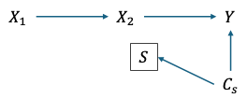 DAG (a)
$E[Y^{x_{1},x_{2},s=1}]$
$=E\left[E[Y^{x_{1},x_{2}} | C_{s}, S=1\right]]$ ((1) and causal consistency)
$=E\left[E[Y | C_{s}, S=1, X_{1}=x_{1},X_{2}=x_{2}\right]]$ ((2), (3), and causal consistency)
$=E[\frac{I(S=1)I(X_{1}=x_{1})I(X_{2}=x_{2})}{P(S=1|C_{s})P(X_{1}=x_{1},X_{2}=x_{2})}Y]$ (g-formula = IPTW mathematically)
$=\frac{1}{P(X_{1}=x_{1},X_{2}=x_{2})n}\sum_{i=1}^{n}{\frac{1}{P(S=1|C_{si})} {×Y}_{i}×I(S_{i}=1,X_{1_{i}}=x_{1},X_{2i}=x_{2})}$
$=\frac{1}{P(X_{1}=x_{1},X_{2}=x_{2})n}\sum_{i=1}^{n}{\frac{1}{P(S_{i}=1)} {×Y}_{i}×I(X_{1_{i}}=x_{1},X_{2i}=x_{2})}$
$=\frac{1}{P(X_{1}=x_{1},X_{2}=x_{2})n}\sum_{i=1}^{n}{w_{i}{×Y}_{i}×I(X_{1_{i}}=x_{1},X_{2i}=x_{2})}$
$=\frac{1}{P(X_{1}=x_{1},X_{2}=x_{2})n}\sum_{i=1}^{n}{w_{i}{×Y}_{i}×I(X_{1_{i}}=x_{1},X_{2i}=x_{2})}$

If we chose to conditionally randomize the exposure based on risk factors of the outcome (i.e., introduce confounding) in the target population before selecting subjects for the study population, we would have the DAG (b) and the following exchangeability conditions: (1) $S⊥Y^{x_{1},x_{2}, s=1} | C_{s}$, (2) $X_{1}⊥Y^{x_{1}, x_{2}, s=1} |C_{0}$, (3) $X_{2}⊥Y^{x_{1}, x_{2}, s=1} |C_{0},X_{1},C_{1}$. Under the assumptions of causal consistency, no interference, and positivity, we would have:

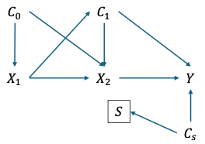DAG (b)
$E[Y^{x_{1},x_{2},s=1}]$
$=E\left[E[Y^{x_{1},x_{2}} | C_{s}, S=1\right]]$ ((1) and causal consistency)
$=E\left[E[{E[Y}^{x_{2}}|C_{0},X_{1}=x_{1}] | C_{s}, S=1\right]]$ ((2) and causal consistency)
$=E\left[E\left[E[E[Y|C_{1},X_{2}=x_{2}]|C_{0},X_{1}=x_{1}\right] | C_{s}, S=1\right]]$ ((3) and causal consistency)
$= E[\frac{I(S=1)}{P(S=1|C_{s})}×\frac{I(X_{1}=x_{1})I(X_{2}=x_{2})}{P(X_{1}=x|C_{0})P(X_{2}=x|C_{0},X_{1}=x_{1},C_{1})}Y]$ (g-formula = IPTW mathematically)
$=$ $E[\frac{I(S=1)}{P(S=1|C_{s})}×\frac{\left(X_{1}=x_{1}\right)I\left(X_{2}=x_{2}\right)P(X_{1}=x_{1},X_{2}=x_{2})}{P(X_{1}=x|C_{0})P(X_{2}=x|C_{0},X_{1}=x_{1},C_{1})P(X_{1}=x_{1},X_{2}=x_{2})}Y]$ (Using the stabilized IPTW)
$=\frac{1}{P\left(X_{1}=x_{1},X_{2}=x_{2}\right)}E[\frac{I(S=1)}{P(S=1|C_{s})}×\frac{I\left(X_{1}=x_{1}\right)I\left(X_{2}=x_{2}\right)P(X_{1}=x_{1},X_{2}=x_{2})}{P(X_{1}=x|C_{0})P(X_{2}=x|C_{0},X_{1}=x_{1},C_{1})}Y]$
$=\frac{1}{P(X_{1}=x_{1},X_{2}=x_{2})n}\sum_{i=1}^{n}{w_{i}×IPTW_{i}{×Y}_{i}×I(X_{1_{i}}=x_{1},X_{2i}=x_{2})}$
$=\frac{1}{P(X_{1}=x_{1},X_{2}=x_{2})n}\sum_{i=1}^{n}{w_{i}^{*} {×Y}_{i}×I(X_{1_{i}}=x_{1},X_{2i}=x_{2})}$

Since the sampling procedure and treatment assignment mechanism are independent, we have:
$E\left[w^{*}\right]=E\left[w×IPTW\right]=E\left[w\right]E\left[IPTW\right]=E\left[w\right]×1=E\left[w\right]=\frac{1}{n}\sum_{i=1}^{N}{w_{i}}=\frac{N}{n}$
Therefore $\sum_{i=1}^{n}{w_{i}^{*}}=\sum_{i=1}^{n}{w_{i}}=N$, the size of the target population. This suggests that IPTW is a scaling factor of the original sampling weight but does not affect the sum of the new sampling weight; therefore, WFPBB is valid to use.
By using the IPTW to update the sampling weight, $w_{i}$, we can derive the same causal estimand from the target population with randomized exposure assignment. Under the unidirectionality assumption, $δ, W_{1},$and $W_{2}$ would be the causal parameters of the life-course effect, and the contribution of period 1 and 2.

Multiple imputation
The Table below shows the number of missingness and missing rate of variables in this study. Only parental highest education levels had a missing rate >10%. Therefore, for computational efficiency, we generated five imputed datasets with 10 iterations for each. Multiple imputation was performed using mice and miceadd R package. Besides the included variables, Hispanic/Latino background and cigarette use were also included in predicting the missing values. Results were pooled across imputed datasets by directly taking the average for MSBRLM⁸ and using Rubin’s rule for causal mediation analysis and MSM.
Variables | Missing N | Missing rate (%)
Age | 0 | 0
Sex | 0 | 0
Nativity | 1 | 0.1
Parental highest education levels | 107 | 11.0
Highest education levels | 2 | 0.2
Household income | 0 | 0
Substance abuse by someone close in childhood | 9 | 0.9
Substance abuse by someone close in childhood | 9 | 0.9
Material deprivation in childhood | 7 | 0.7
Material deprivation in adulthood | 1 | 0.1
Physical abuse in childhood | 15 | 1.6
Physical abuse in adulthood | 7 | 0.7
Sexual abuse in childhood | 13 | 1.3
Sexual abuse in adulthood | 3 | 0.3

Table S1. Demographic characteristics of comparison with the total HCHS/SOL population and the study samples
Baseline Characteristic | Overall Cohort  (N=16415) |  | Study samples  (N=1000)
Baseline Characteristic | N | % | N | %
Center  Bronx | 4118 | 25.1 | 250 | 25.0
Chicago | 4134 | 25.2 | 250 | 25.0
Miami | 4077 | 24.8 | 250 | 25.0
San Diego | 4086 | 24.9 | 250 | 25.0
Ages  18-24 | 1665 | 10.1 | 96 | 9.6
25-34 | 2082 | 12.7 | 113 | 11.3
35-44 | 2954 | 18.0 | 268 | 26.8
45-54 | 4922 | 30.0 | 278 | 27.8
55-64 | 3460 | 21.1 | 192 | 19.2
65+ | 1332 | 8.1 | 53 | 5.3
Sex  Female | 9835 | 59.9 | 617 | 61.7
Male | 6580 | 40.1 | 383 | 38.3
Education  < HS Education | 6207 | 37.8 | 369 | 36.9
HS or more | 10117 | 61.6 | 629 | 62.9
Income  < $30,000 | 10516 | 64.1 | 679 | 67.9
$30,000 or more | 4877 | 29.7 | 261 | 26.1
Background  Dominican | 1473 | 9.0 | 112 | 11.2
Central American | 1732 | 10.6 | 107 | 10.7
Cuban | 2348 | 14.3 | 139 | 13.9
Mexican | 6472 | 39.4 | 407 | 40.7
Puerto Rican | 2728 | 16.6 | 142 | 14.2
South American | 1072 | 6.5 | 67 | 6.7
Other/Mixed | 590 | 3.6 | 26 | 2.6
US Born | 2863 | 17.4 | 183 | 18.3
Language Preference  Spanish | 13119 | 79.9 | 801 | 80.1
English | 3296 | 20.1 | 199 | 19.9
Years in U.S.  <10 yrs | 3805 | 23.2 | 246 | 24.6
10 or more yrs | 12490 | 76.1 | 753 | 75.3

Table S2. Measures of psychosocial adversity in childhood and adulthood
Types | Life stage | Tool | Question | Categorization
Substance abuse by someone close | Childhood | ACE questionnaire⁹ | Did you live with anyone who was a problem drinker or alcoholic or who used street drugs? | 1 = Yes  0 = No
Substance abuse by someone close | Adulthood | Chronic stress scale¹⁰ | Has someone close to you had an ongoing problem with alcohol or drug use? | 1 = Yes  0 = No
Material deprivation | Childhood | - | Did your family ever experience a period of time when they had trouble paying for their basic needs, such as  food, housing, medical care, and utilities, when you were a child? | 1 = Yes  0 = No
Material deprivation | Adulthood | - | In the past 12 months, was there ever a time when you had trouble paying for your basic needs, such as food,  housing, medical care, and heating? | 1 = Yes  0 = No
Physical abuse | Childhood | ACE questionnaire | Before age 18, did a parent or other adult in the household often or very often push, grab, slap, or throw something at you? Or  ever hit you so hard that you had marks or were injured? | 1 = Yes  0 = No
Physical abuse | Adulthood | Traumatic stress schedule¹¹ | Did anyone ever beat you up or attack you in the past 6 months, 6-12 months, or 1-5 years ago? | 1 = Yes when (1) any one of the time periods (aged ≥ 23); (2) in the past 6 months or 6-12 months (aged 19-23)  0 = No or yes when (1) at any time periods (aged 18) or (2) 1-5 years ago (aged 19-23)ª
Sexual abuse | Childhood | ACE questionnaire | Before age 18, did an adult or person at least 5 years older than you ever touch or fondle you or have you touch their body in a  sexual way? Or attempt or actually have oral, anal, or vaginal intercourse with you? | 1 = Yes  0 = No
Sexual abuse | Adulthood | Traumatic stress schedule | Did anyone ever make you have sex by using force or threatening to harm you in the past 6 months, 6-12 months, or 1-5 years ago? This includes any type of  unwanted sexual activity. | 1 = Yes in (1) any one of the time periods (aged ≥ 23); (2) in the past 6 months or 6-12 months (aged 19-23)  0 = No or yes when (1) at any time periods (aged 18) or (2) 1-5 years ago (aged 19-23)^{b}
a Only 2 participants answering yes were classified to no physical abuse in adulthood
b No participants answering yes were classified to no sexual abuse in adulthood

Table S3. Prevalence of life-course adversity
Adversity | Childhood | Adulthood
(N=970) | N (%)
Substance abuse by someone close | 287 (29.9) | 206 (21.4)
Material deprivation | 522 (54.2) | 504 (52.0)
Physical abuse | 304 (31.8) | 72 (7.5)
Sexual abuse | 162 (16.9) | 11 (1.1)

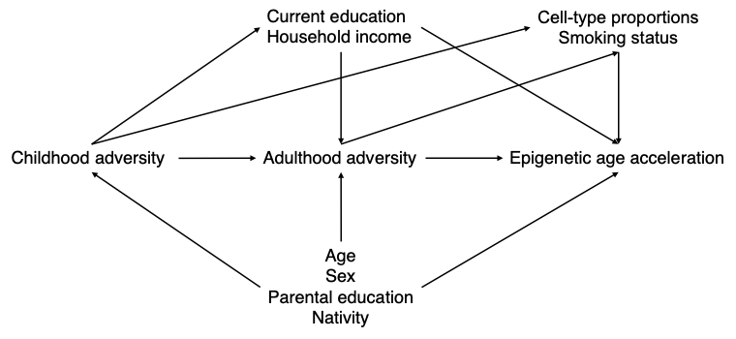

Figure S1. Direct acyclic graph for the hypothetical relationship between childhood adversity, adulthood adversity, EAA, and covariates

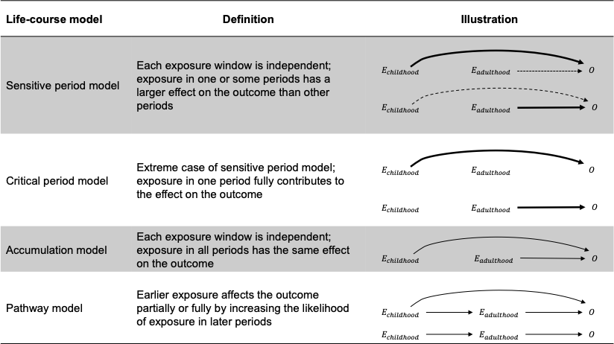

Figure S2. Description of included life-course models
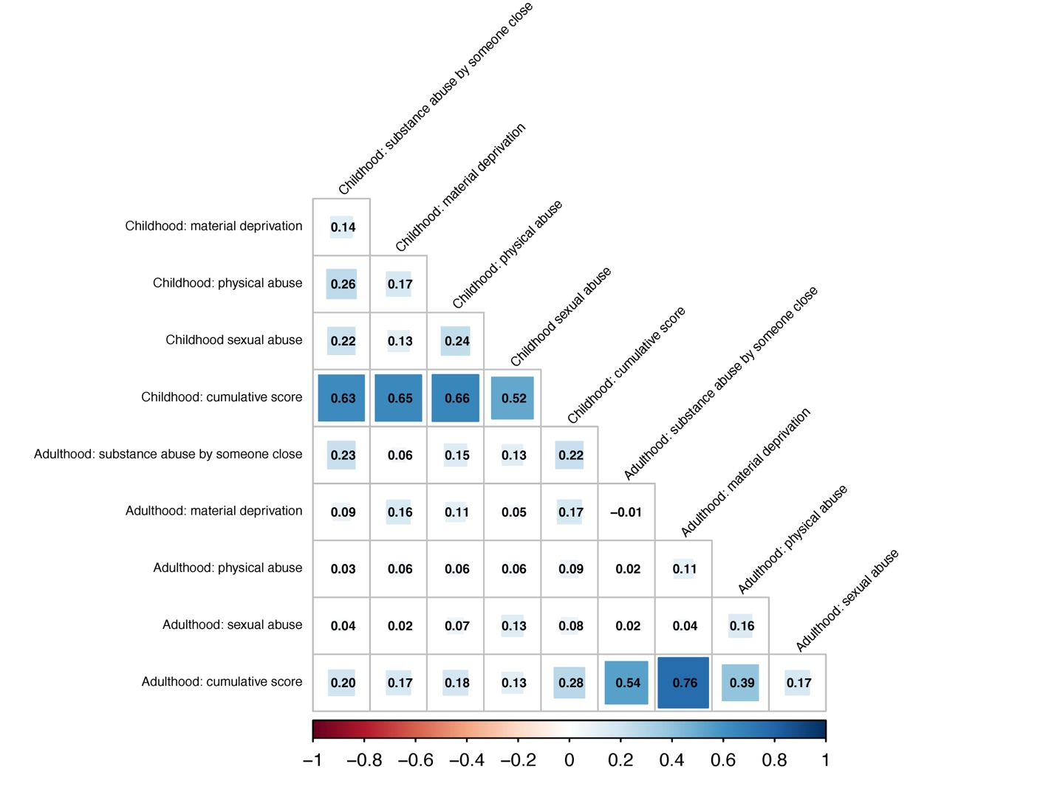

Figure S3. Correlation between childhood and adulthood adversity
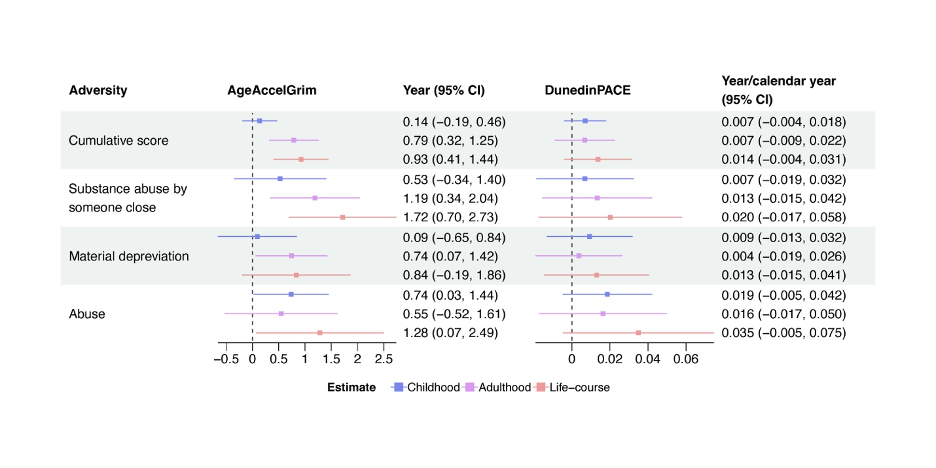

Figure S4. The association between life-course adversity and EAA assessed by the Marginal Structural Model (MSM)
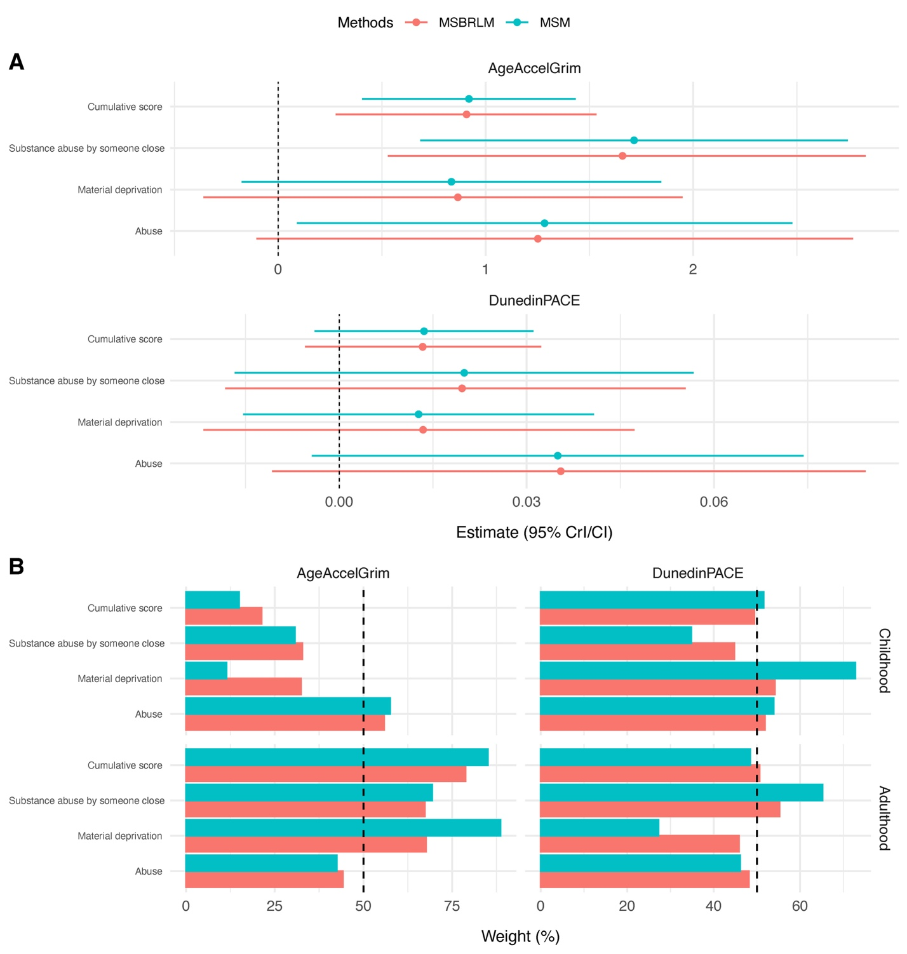

Figure S5. Comparison between MSBRLM and MSM
(A) The estimates of life-course association between adversity and EAA derived from MSM and MSBRLM; (B) The estimated weights contributed by childhood and adulthood derived from MSM and MSBRLM.
Note: The estimates of life-course association from MSM were the sum of the estimates for childhood and adulthood ($β_{childhood}+β_{adulthood}$). MSM did not directly estimate the weights in childhood and adulthood like MSBRLM. We calculated $W_{childhood}=β_{childhood}/(β_{childhood}+β_{adulthood})$ and $W_{adulthood}=β_{adulthood}/(β_{childhood}+β_{adulthood})$.
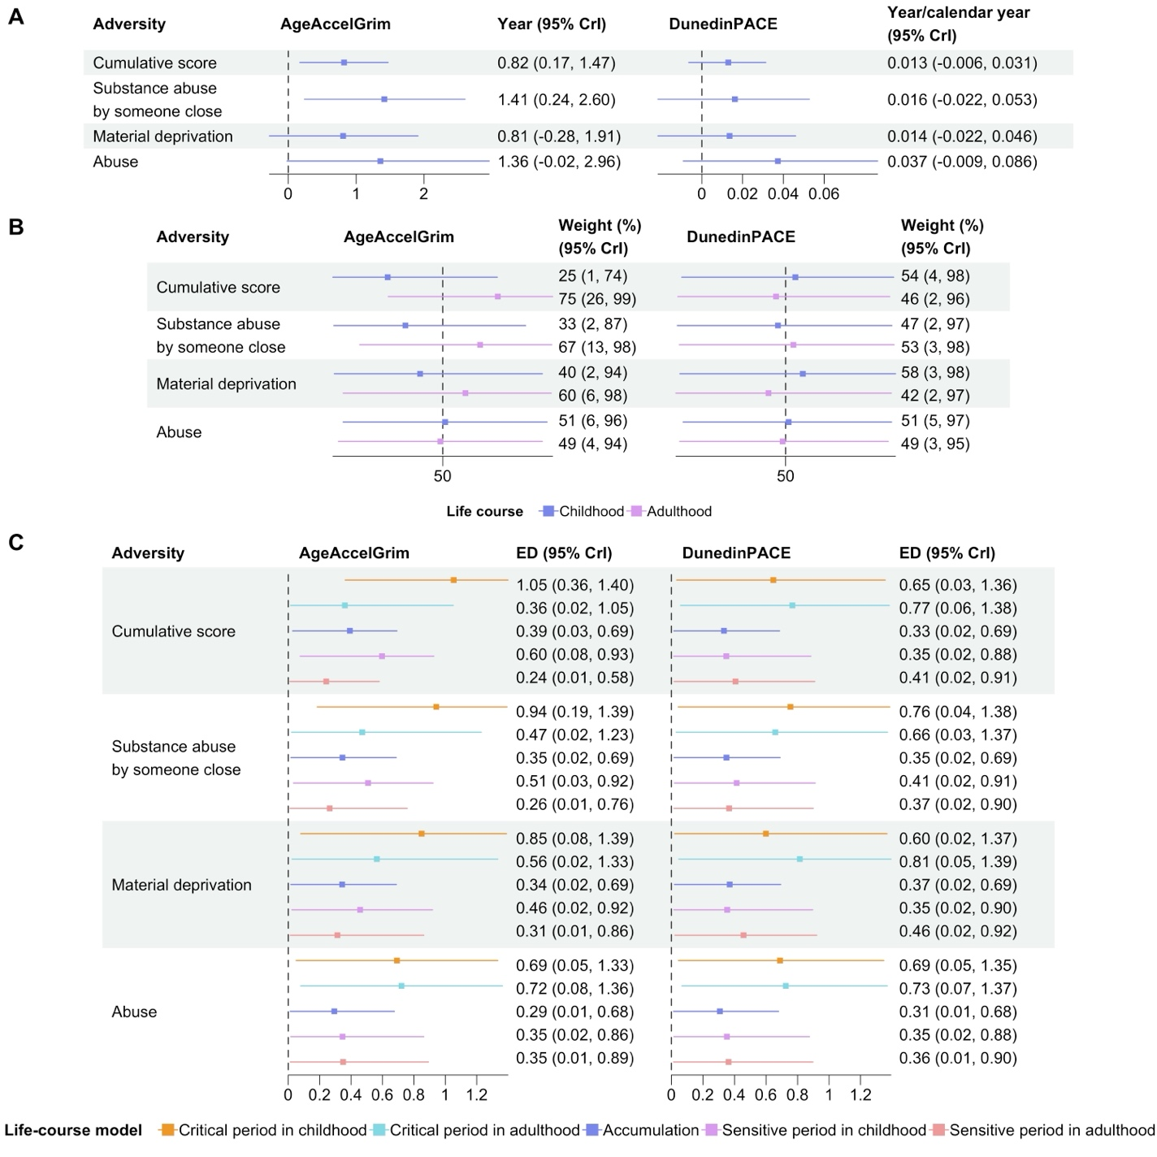

Figure S6. The association between life-course adversity and EAA assessed by the MSBRLM adjusting for cell-type proportions
(A) The estimates of the life-course association between adversity and EAA; (B) The estimates of weights for childhood and adulthood; (C) The ED from reference life-course models to estimated weights.
Note: The ED reflects the compatibility between estimated weights for childhood ($W_{childhood}$) and adulthood ($W_{adulthood}$) and reference life-course models, including critical period in childhood ($W_{childhood}$ = 1, $W_{adulthood}$ = 0), critical period in adulthood ($W_{childhood}$ = 0, $W_{adulthood}$ = 1), accumulation ($W_{childhood}$ = 0.5, $W_{adulthood}$ = 0.5), sensitive period in childhood ($W_{childhood}$ = 0.67, $W_{adulthood}$ = 0.33), and sensitive period in adulthood ($W_{childhood}$ = 0.33, $W_{adulthood}$ = 0.67). A smaller ED indicates higher compatibility with the corresponding life-course model.

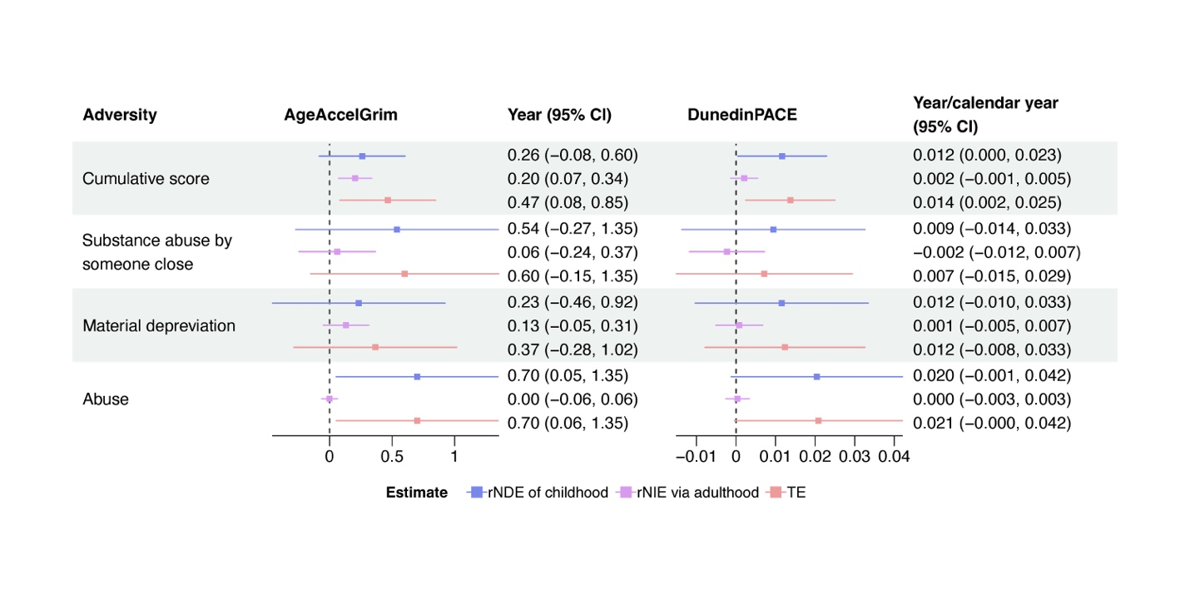

Figure S7. Causal mediation analysis for childhood adversity and EAA adjusting for cell-type proportions
Abbreviation: rNDE, randomized interventional analogue of natural direct effect; rNIE, randomized interventional analogue of natural indirect effect; TE, total effect
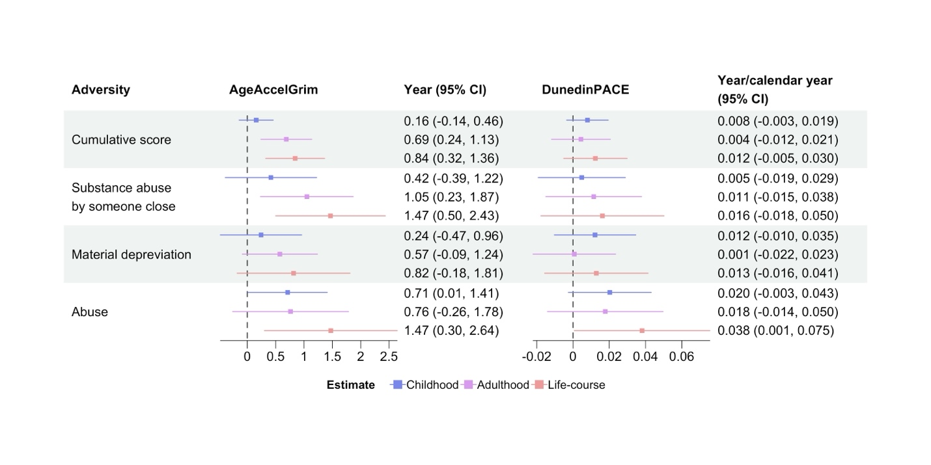

Figure S8. The association between life-course adversity and epigenetic age acceleration assessed by the MSM adjusting for cell-type proportions

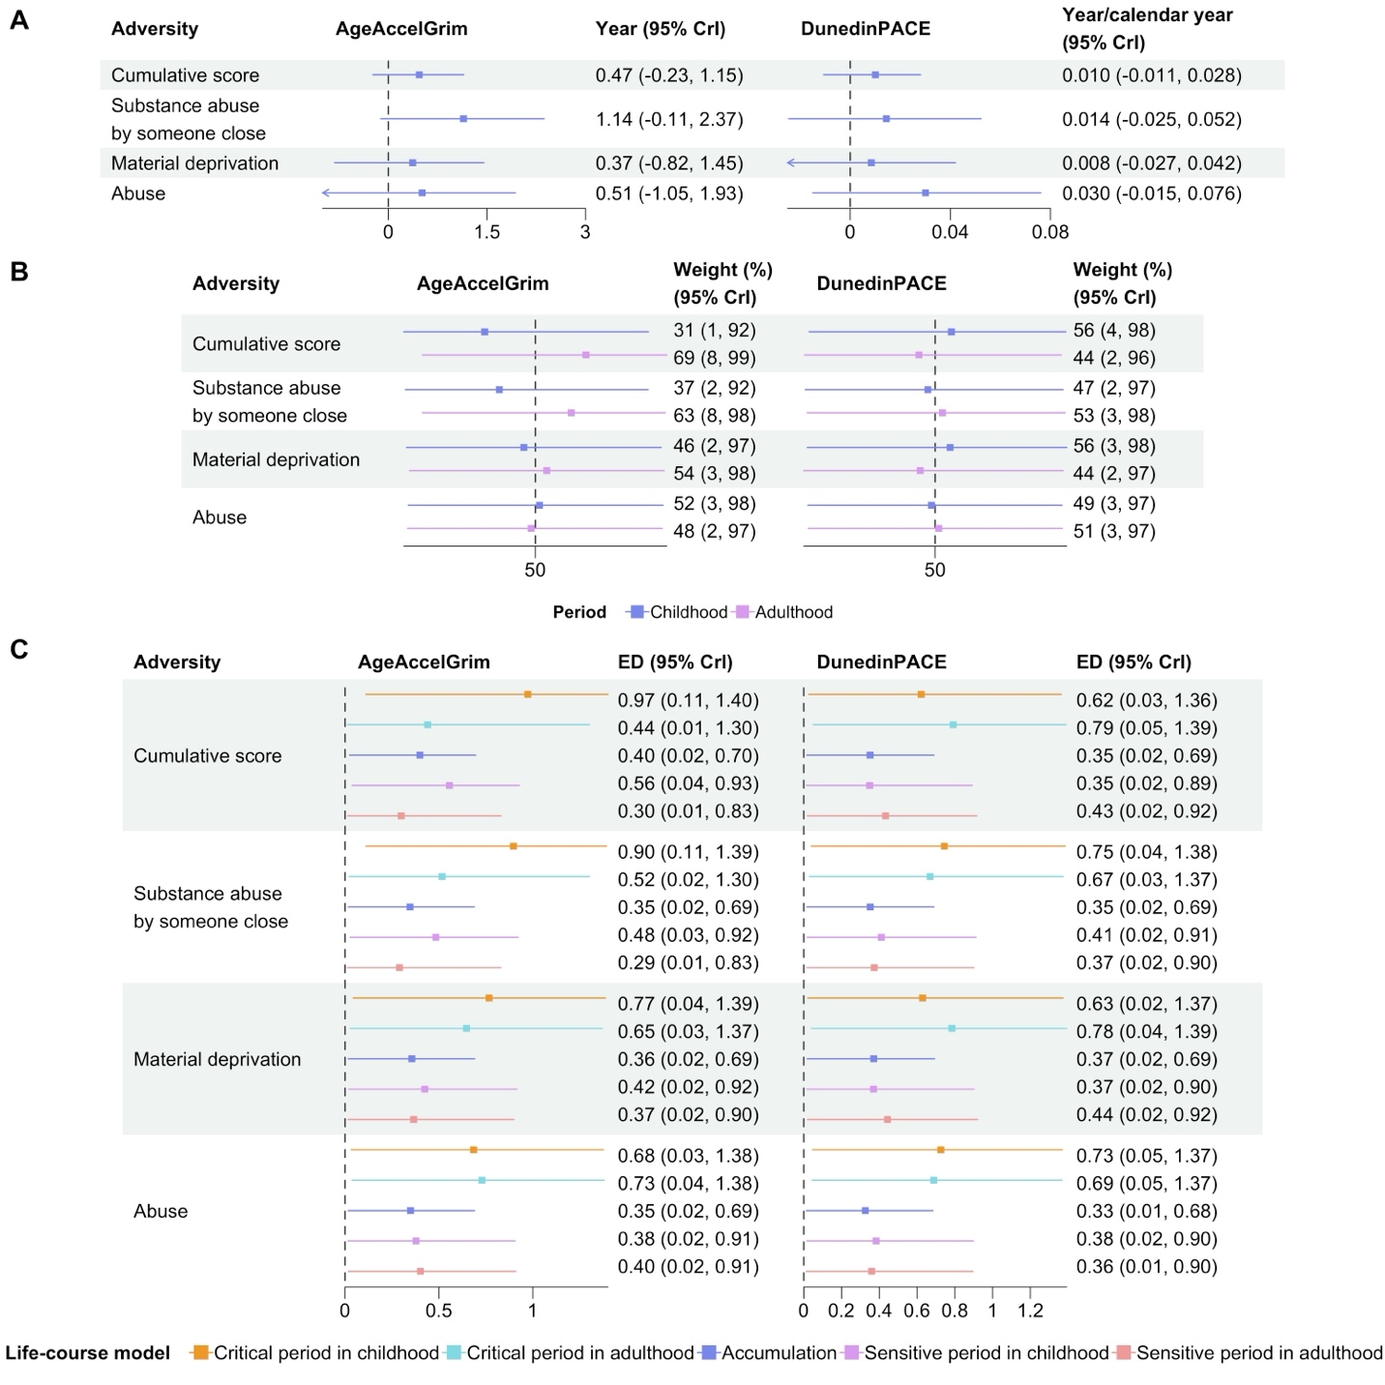

Figure S9. The association of life-course adversity on epigenetic age acceleration assessed by the MSBRLM adjusting for smoking status
(A) The estimates of the life-course association between adversity and EAA; (B) The estimates of weights for childhood and adulthood; (C) The ED from reference life-course models to estimated weights.
Note: The ED reflects the compatibility between estimated weights for childhood ($W_{childhood}$) and adulthood ($W_{adulthood}$) and reference life-course models, including critical period in childhood ($W_{childhood}$ = 1, $W_{adulthood}$ = 0), critical period in adulthood ($W_{childhood}$ = 0, $W_{adulthood}$ = 1), accumulation ($W_{childhood}$ = 0.5, $W_{adulthood}$ = 0.5), sensitive period in childhood ($W_{childhood}$ = 0.67, $W_{adulthood}$ = 0.33), and sensitive period in adulthood ($W_{childhood}$ = 0.33, $W_{adulthood}$ = 0.67). A smaller ED indicates higher compatibility with the corresponding life-course model.

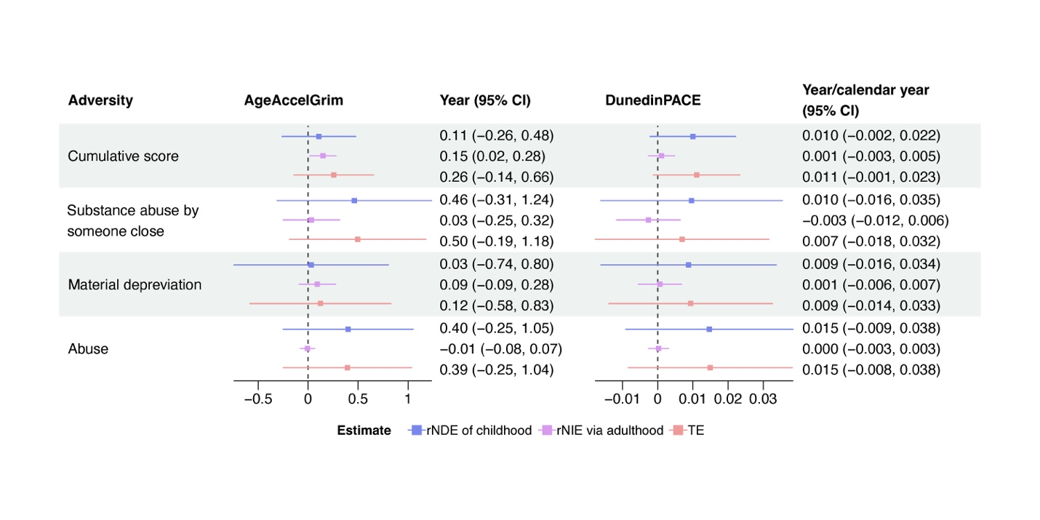

Figure S10. Causal mediation analysis for childhood adversity and EAA adjusting for smoking status
Abbreviation: rNDE, randomized interventional analogue of natural direct effect; rNIE, randomized interventional analogue of natural indirect effect; TE, total effect

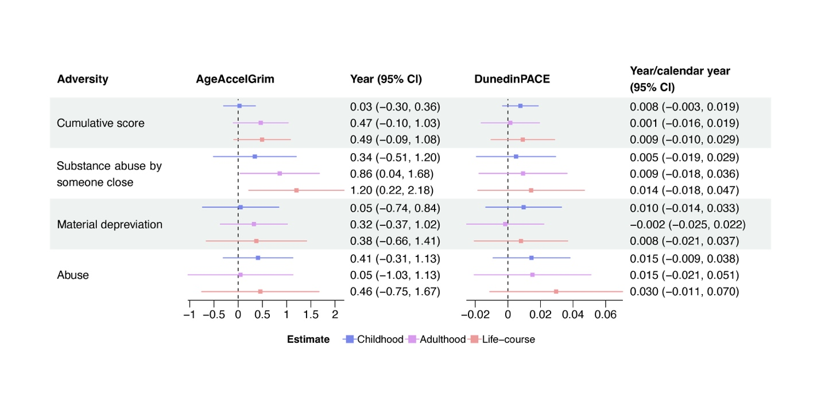

Figure S11. The association between life-course adversity and EAA assessed by the MSM adjusting for smoking status

References
1. Du P, Kibbe WA, Lin SM. lumi: a pipeline for processing Illumina microarray. Bioinformatics. 2008;24(13):1547-1548. doi:10.1093/bioinformatics/btn224
2. Pidsley R, Y Wong CC, Volta M, Lunnon K, Mill J, Schalkwyk LC. A data-driven approach to preprocessing Illumina 450K methylation array data. BMC Genomics. 2013/05/01 2013;14(1):293. doi:10.1186/1471-2164-14-293
3. Dawber TR, Meadors GF, Moore FE, Jr. Epidemiological approaches to heart disease: the Framingham Study. Am J Public Health Nations Health. Mar 1951;41(3):279-81. doi:10.2105/ajph.41.3.279
4. Poulton R, Moffitt TE, Silva PA. The Dunedin Multidisciplinary Health and Development Study: overview of the first 40 years, with an eye to the future. Soc Psychiatry Psychiatr Epidemiol. May 2015;50(5):679-93. doi:10.1007/s00127-015-1048-8
5. Madathil S, Joseph L, Hardy R, Rousseau MC, Nicolau B. A Bayesian approach to investigate life course hypotheses involving continuous exposures. Int J Epidemiol. Oct 1 2018;47(5):1623-1635. doi:10.1093/ije/dyy107
6. Gunawan D, Panagiotelis A, Griffiths W, Chotikapanich D. Bayesian weighted inference from surveys. Australian & New Zealand Journal of Statistics. 2020;62(1):71-94. doi:https://doi.org/10.1111/anzs.12284
7. Dong Q, Elliott MR, Raghunathan TE. A nonparametric method to generate synthetic populations to adjust for complex sampling design features. Surv Methodol. Jun 2014;40(1):29-46.
8. Hewson P. Bayesian Data Analysis 3rd edn A. Gelman, J. B. Carlin, H. S. Stern, D. B. Dunson, A. Vehtari and D. B. Rubin, 2013 Boca Raton, Chapman and Hall–CRC 676 pp., £44.99 ISBN 1‐439‐84095‐4. Journal of the Royal Statistical Society: Series A (Statistics in Society). 01/01 2015;178doi:10.1111/j.1467-985X.2014.12096_1.x
9. Felitti VJ, Anda RF, Nordenberg D, et al. Relationship of childhood abuse and household dysfunction to many of the leading causes of death in adults. The Adverse Childhood Experiences (ACE) Study. Am J Prev Med. May 1998;14(4):245-58. doi:10.1016/s0749-3797(98)00017-8
10. Bromberger JT, Matthews KA. A longitudinal study of the effects of pessimism, trait anxiety, and life stress on depressive symptoms in middle-aged women. Psychol Aging. Jun 1996;11(2):207-13. doi:10.1037//0882-7974.11.2.207
11. Norris FH. Screening for traumatic stress: A scale for use in the general population 1. Journal of Applied Social Psychology. 1990;20(20):1704-1715.

