Supplementary materials

Supplementary Figure S1. Liver histological improvement after bariatric surgery. Sleeve gastrectomy reduces MASH prevalence, improving liver histology by reversing steatosis and ballooning, and modulating immune and fibrotic responses. H&E slides at 10x magnification.

Supplementary Figure S2. Hepatic zonation made by the LiverExplore algorithm and proportion of steatotic and ballooned cells over all cells in the different hepatic zones in the first and second intervention.

Supplementary Table 1. Median distribution of different cell types before and after LSG.
 | 1st Intervention | 2nd Intervention | p-value
Normal Hepatocytes | 0.393 [0.280 - 0.486] | 0.480 [0.357 - 0.527] | 0.031
Steatotic Hepatocytes | 0.067 [0.020 - 0.114] | 0.003 [0.001 - 0.009] | 7.2x10⁻⁹
Ballooned Hepatocytes | 2.53x10⁻⁶ [0 - 2.71x10⁻⁵] | 0.000 [0 - 8.32x10⁻⁷] | 2.6x10⁻⁴
Fibroblasts | 0.076 [0.055 - 0.103] | 0.089 [0.056 - 0.132] | 0.284
Macrophages | 0.073 [0.059 - 0.102] | 0.071 [0.060 - 0.097] | 0.440
Eosinophils | 0.003 [0.002 - 0.005] | 0.005 [0.003 - 0.007] | 5.3x10⁻⁴
Neutrophils | 0.029 [0.023 - 0.043] | 0.051 [0.031 - 0.078] | 6.4x10⁻⁵
Plasma Cells | 0.019 [0.010 - 0.031] | 0.025 [0.014 - 0.055] | 0.128
Lymphocytes | 0.140 [0.111- 0.158] | 0.135 [0.128 - 0.154] | 0.466
Other Hepatocytes | 0.051 [0.016 - 0.088] | 0.003 [0.001 - 0.011] | 4.5x10⁻⁸
Count of each cell type divided by the total number of cells in evaluable tissue

Supplementary Figure S3. The time interval between interventions does not influence the increase in neutrophil proportions. Comparison of the proportion of neutrophils relative to all cells in the liver tissue before and after surgery in two patient groups: one consisting of 22 individuals who underwent the second intervention less than 5 years after the first, and another group who underwent the second intervention 5 or more years after the first. The results indicate that the observed increase in neutrophil infiltration is independent of the time elapsed between interventions.

Supplementary Figure S4. Zonal reorganization of immune cell populations following bariatric surgery. Proportion of immune cell subtypes within each hepatic zone before and after surgery. Data presented as the proportion of each immune cell subtype relative to total immune cells within each respective hepatic zone.

Supplementary Figure S5. Characterization of fibrosis subtypes in liver tissue. Representative images show distinct fibrosis patterns identified by the LiverExplore algorithm at 10x magnification. Nodular fibrosis image is represented at 5x magnification.

Supplementary materials – methodology

Supplementary Note1. Qupath positive cell detection protocol.

- Import whole slide image file in TIFF format to QuPath software.
- Select DAB in the pop-up screen which appears at the moment of opening each image.
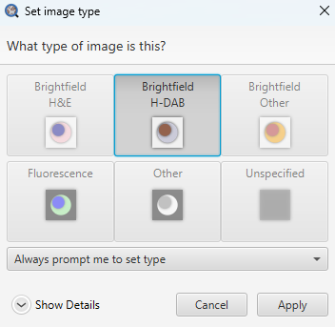

- From the tool bar, select Analyze> Preprocessing > Estimate stain vectors> select Yes on pop up window > select Auto on Visual Stain Editor screen > select OK on Visual Stain Editor screen > select OK on pop up window:

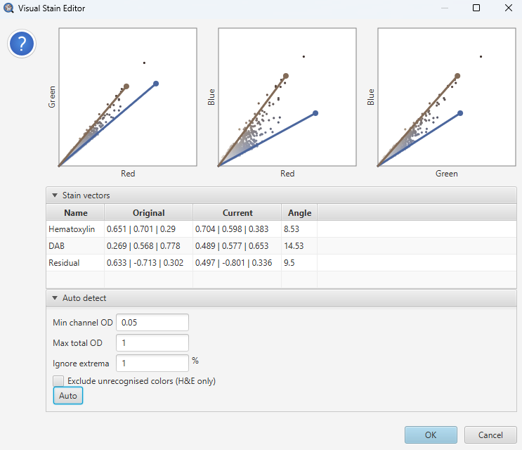

- Draw a region of interest (ROI) manually over the entire tissue slide:

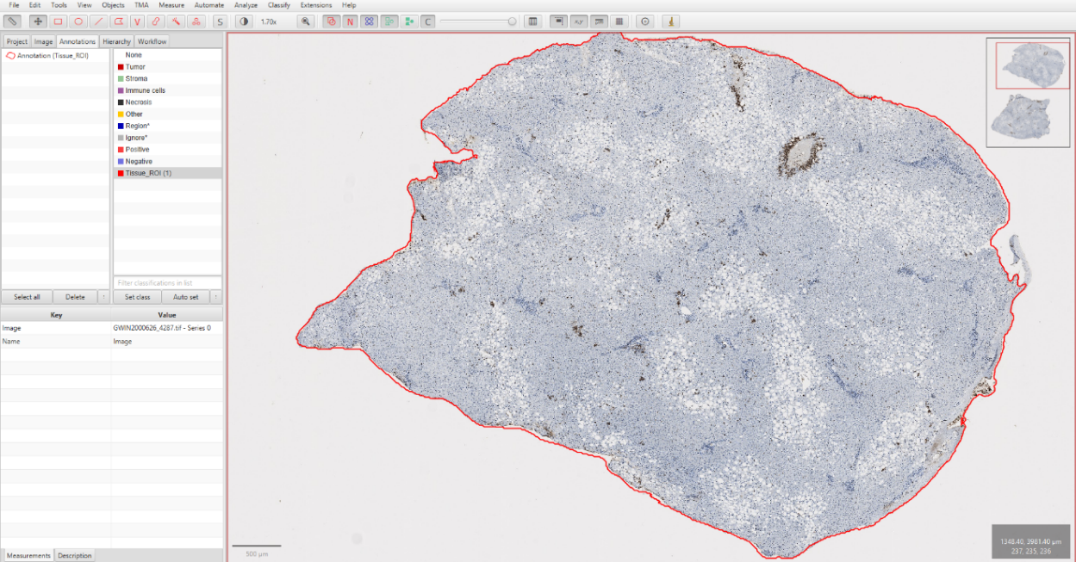

- From the tool bar select Analyze > Cell Detection > Positive Cell Detection > in the pop up window add the following parameters > select Run

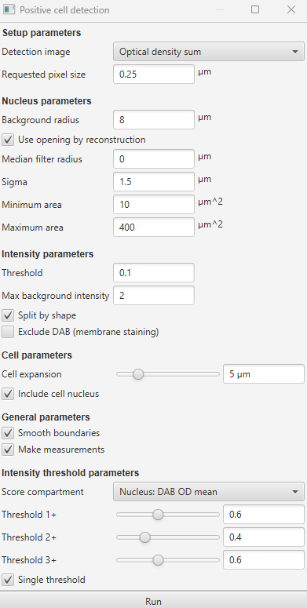

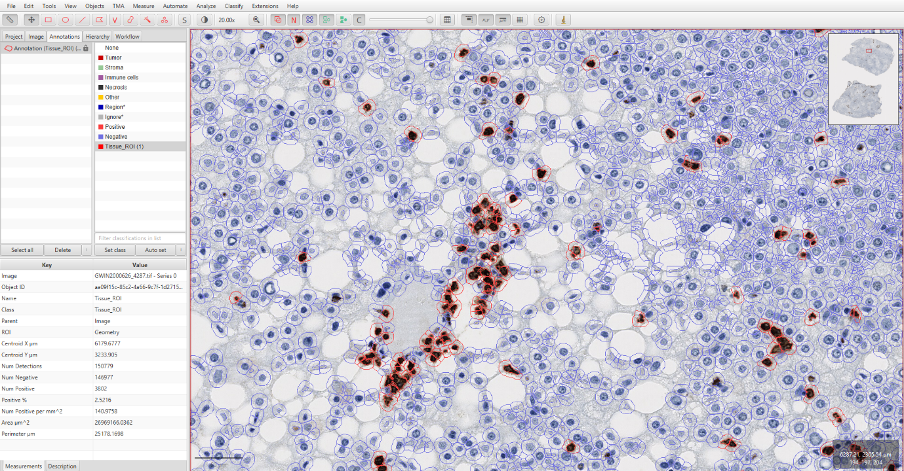

- In the tool bar select Show Measurements Table (highlighted tool - blue):

- Select Save to export data to a text file:
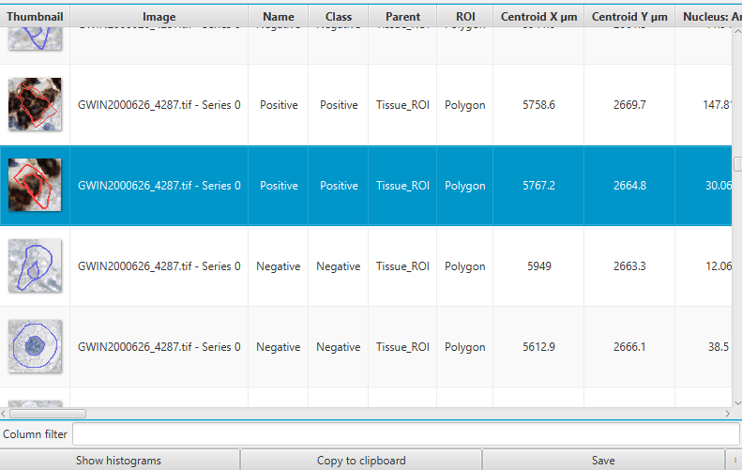

To address false positives, only positive cells with an area exceeding the minimum threshold 110 µm² type were retained. This area threshold was determined based on scientific literature. For false negatives, the dataset included only objects with an H-DAB staining intensity of at least 0.05. This staining intensity threshold was consistently applied across all slides since the staining procedure was uniform.

