Supporting information

FT-IR spectrum
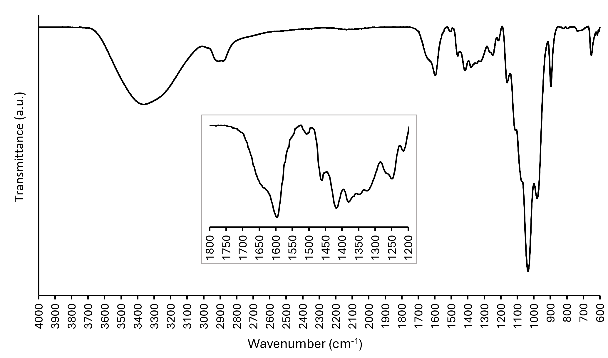
Figure SI 1: MGX infrared spectrum (attenuated total reflectance mode)

NMR Analysis

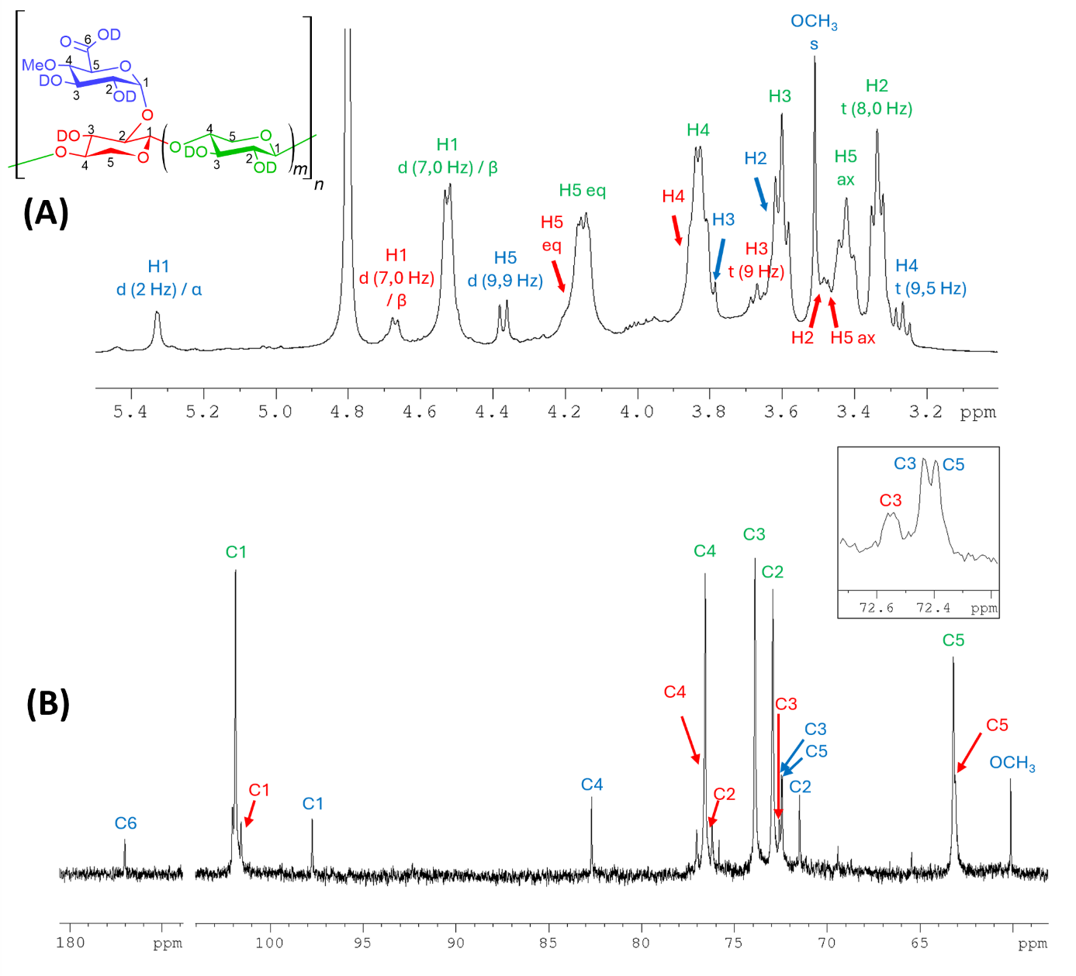
Figure SI 2: NMR analysis (in D2O) of MGX. (A) ¹H NMR (B) ¹³C NMR. ax = axial; eq = equatorial; s = singlet; d = doublet; t = triplet; α = alpha configuration of the anomeric carbon; β = beta configuration of the anomeric carbon.
Table SI 1: Chemical shifts of protons and carbons of the three constituent elements of 4-O-methylglucuronoxylan.
Protons and carbons (ppm) |  |  |  | unsubstituted  xylose |  |  |  |  | Substituted  Xylose |  |  |  | 4-O-methylglucuronique Acide
H1 |  | C1 |  | 4.52 |  | 101.87 |  |  | 4.67 |  | 101.57 |  | 5.33 | 97.73
H2 |  | C2 |  | 3.34 |  |  | 72.90 |  | 3.49 |  | ≈ 76.5 |  | 3.62 | 71.46
H3 |  | C3 |  | 3.60 |  |  | 73.86 |  | 3.67 |  | 72,54 |  | 3.80 | 72.44
H4 |  | C4 |  | 3.83 |  |  | 76.55 |  | 3.85 |  | ≈ 76.6 |  | 3.27 | 82.67
H5 ax | H5 eq |  | C5 | 3.42 | 4.15 |  |  | 63.17 | 3.46 | 4.20 |  | 63.1 | 4.37 | 72.39
C6 |  |  |  |  |  |  |  |  |  |  |  |  | 177.01
H(OMe) |  | C(OMe) |  |  |  |  |  |  |  |  |  |  | 3,51 | 60,08

Development of substitution degree of ferulic acid (equation (2)):

From equation (2) the molar concentration of MGX solution can be determined by equation (4):
$$C_{MGX-FA}= \frac{{Cm}_{MGX-FA}}{M_{MGX-FA}}$$ | (4)
With Cm_{MGX-FA}, the concentration in g.L⁻¹ of analysed samples and M_{MGX-FA,} the molar mass of the repeated unit of MGX-FA
The development of M_{MGX-FA} according to equation (5):
$$M_{MGX-FA}=M_{Xylose}+{DS}_{UA}{×(M}_{UA-}M_{OH})+{DS}_{FA}×(M_{FA}-M_{H_{2}O})$$ | (5)
With M_{Xylose}, the molar mass of xylose unit, DS_{UA} et M_{UA,} respectively the substitution degree and the molar mass of uronic acid, DS_{FA} et M_{FA,} respectively the substitution degree and the molar mass of ferulic acid, and M_{OH} and M_{H2O} the molar mass of an alcohol and water released.
The development of equation (2) by equation (4) enabled to obtain equation (6):
$${DS}_{FA}=\frac{C_{FA}{×Cm}_{MGX-FA}}{M_{MGX-FA}}$$ | (6)
With equation (5), equation (6) can be develop to obtain the substitution degree of ferulic acid on the MGX backbone with equation (7):
$${DS}_{FA}=\frac{M_{Xylose}+{DS}_{UA}×(M_{UA}-M_{OH})}{\frac{{Cm}_{MGX-FA}}{C_{FA}}-(M_{FA}-M_{H_{2}O})}$$ | (7)

SEC/MALS/DRI/Viscometer
Figure SI 3: Molar masses distribution with suitable linearization of lyophilized (red) and atomized (blue) MGX sample at 2 g/L⁻¹ in 0.1 M LiNO₃ (stirred for 6 h at 20 °C). DRI (―), light scattering (---), molar mass (●).
Table SI 2: Results of SEC/MALS/DRI/Visco analyses of lyophilized and atomized MGX at 2 g.L⁻¹ after solvation at 20 °C for 6 hours in LiNO₃ 0.1 M.
 | Mn  (g.mol⁻¹) | Mw  (g.mol⁻¹) | Đ | Rh_{w} (nm) | Recovery (%) | Mass fraction (%)
Atomized
Pop 1 + Pop 2 | 156 000 | 4 545 000 | 29 | 19.4 | 62.6 | 100
Pop 1 | 12 000 000 | 20 000 000 | 1.7 | 52.7 | 13.5 | 21.6
Pop 2 | 124 000 | 205 000 | 1.6 | 10 | 49.1 | 78.4
Lyophilized
Pop 1 + Pop 2 | 4 640 000 | 9 800 000 | 2.1 | 41.8 | 61.5 | 100
Pop 1 | 8 200 000 | 12 900 000 | 1.6 | 49.5 | 42.5 | 69.2
Pop 2 | 2 380 000 | 2 860 000 | 1.2 | 24.6 | 19 | 30.8
SEC/MALS/VD/DRI data accuracy: Mn $±$ 5 %; Mw $±$ 0.3 %; Ð $±$ 5 %; Rh_{w} $±$ 5.5 %.

