Supplementary Material

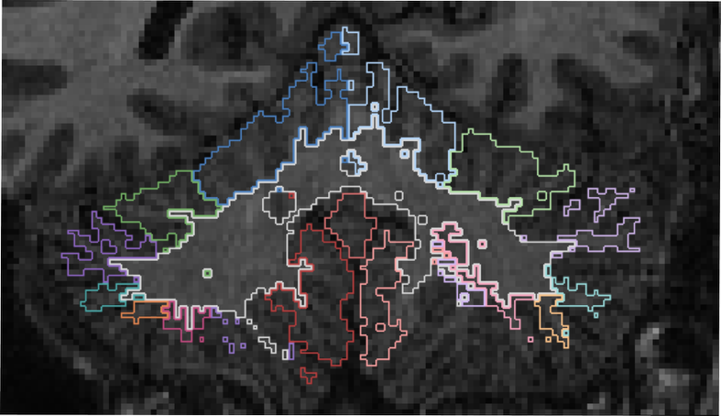
Supplementary Fig. 1 Example of segmentation with CerebNet, showing a failure in the inferior portion of the cerebellum, present across all sessions
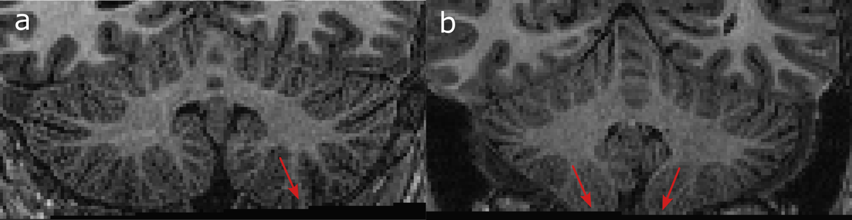
Supplementary Fig. 2 Examples of poor cerebellar coverage. Data with missing cerebellum in the inferior part (as shown in panels a and b) were excluded from the analysis
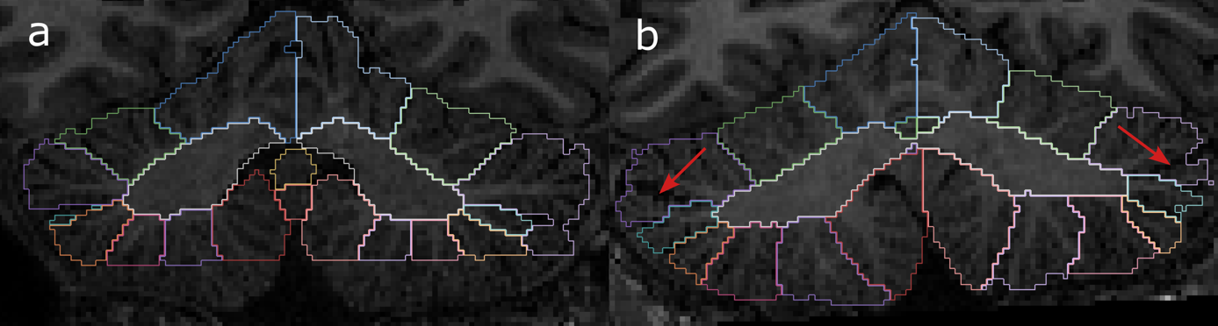
Supplementary Fig. 3 Examples of poor segmentation. Most of the excluded segmentations had either a total failure, a partial failure (a), or missegmentation between lobules (b). In panel b, missegmentation is present in Crus I, Crus II, and VIIB

Supplementary Table 1 Number and frequency of sessions with good segmentation and number and frequency of subjects having all 10 sessions with good segmentation among those with good cerebellar coverage. ACAPULCO has the higher failure rate and lower number of subjects with good segmentation, lowering the total number of subjects used in the analysis
 | CERES | ACAPULCO | DeepCERES
Number of good sessions | 189 | 150 | 207
% of good sessions | 86 | 68 | 94
Number of good subjects | 16 | 10 | 18
% of good subjects | 73 | 45 | 82

Supplementary Table 2 Posthoc Nemenyi results for ICC. Only DeepCERES and ACAPULCO show a significant difference
Comparisons | p-value
DeepCERES vs CERES | 0.917
DeepCERES vs ACAPULCO | 0.023*
DeepCERES vs SUIT | 0.335
CERES vs ACAPULCO | 0.125
CERES vs SUIT | 0.73
ACAPULCO vs SUIT | 0.651
(∗) p<0.05

Supplementary Table 3 Mean ICC, between-subject variation and within-subject variation computed using only subjects with no failures for each method. ACAPULCO maintains roughly the same results, which is expected as only one additional subject was included. DeepCERES and CERES show improved ICC values with the addition of multiple subjects, supporting their good reliability
Metrics (mean) | CERES | ACAPULCO | DeepCERES
ICC | 0.896 | 0.816 | 0.922
Between-subject var. | 0.045 | 0.044 | 0.049
Within-subject var. | 0.004 | 0.008 | 0.003

Supplementary Table 4 Paired t-tests results for between-subject variation. After correction, DeepCERES and ACAPULCO, SUIT and ACAPULCO and CERES and ACAPULCO show a significant difference
Comparisons | p-value | Corrected p-value
DeepCERES vs CERES | 0.356 | 0.427
DeepCERES vs ACAPULCO | 0.002** | 0.009**
DeepCERES vs SUIT | 0.201 | 0.301
CERES vs ACAPULCO | 0.015* | 0.03*
CERES vs SUIT | 0.96 | 0.96
ACAPULCO vs SUIT | 0.003** | 0.009**
(∗) p<0.05, (∗∗) p<0.01

Supplementary Table 5 Posthoc Nemenyi results for within-subject variation. DeepCERES and ACAPULCO and CERES and ACAPULCO show a significant difference
Comparisons | p-value
DeepCERES vs CERES | 1
DeepCERES vs ACAPULCO | 0.048*
DeepCERES vs SUIT | 0.408
CERES vs ACAPULCO | 0.048*
CERES vs SUIT | 0.408
ACAPULCO vs SUIT | 0.73
(∗) p<0.05

