Supplementary Table I: List of Functional Movements Performed by the Participants
Activities | Position | Functional Movement
Food | Sit | Pour a drink
Food | Sit | Drink a glass
Food | Sit | Open a jar
Food | Sit | Eat
Office | Sit | Type on a keyboard
Office | Sit | Use a pair of scissors
Office | Sit | Write with a pen
Office | Sit | Browse a magazine
Dressing | Sit/Stand | Putting on/removing shoes
Dressing | Sit/Stand | Putting on/removing shorts
Preparing | Stand | Wiping a surface
Preparing | Stand | Wash your hands
Preparing | Stand | Take a high object and place it on a table
Preparing | Stand | Open a drawer and take an object
Preparing | Stand | Using a hammer
Preparing | Stand | Turning a light on/off
Preparing | Stand | Operating a door handle
Preparing | Stand | Pick up the phone
Beauty care | Stand | Wear deodorant
Beauty care | Stand | Brushing your teeth
Beauty care | Stand | Style hair
Beauty care | Stand | Putting on/removing glasses
Non  manual activity | Sit/Stand | Stand up, walk, step over obstacles, turn around, slalom and sit down

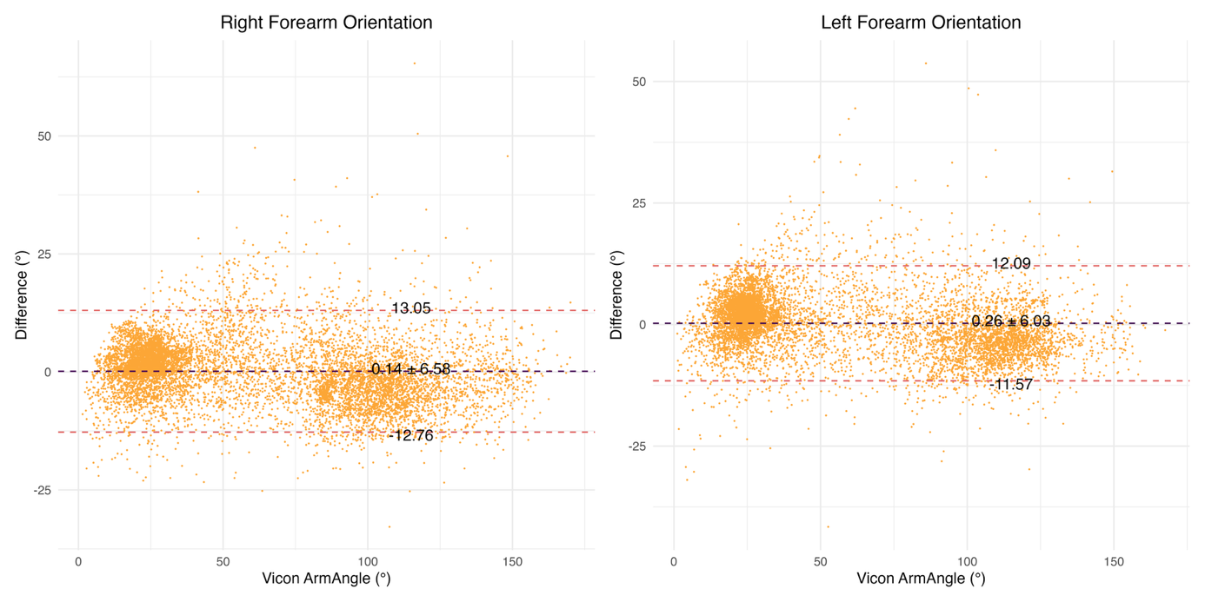
Supplementary Figure 1. Bland–Altman statistics (mean bias and limits of agreement) were computed on a randomly selected subset consisting of 1 out of every 100 samples, in order to improve readability.
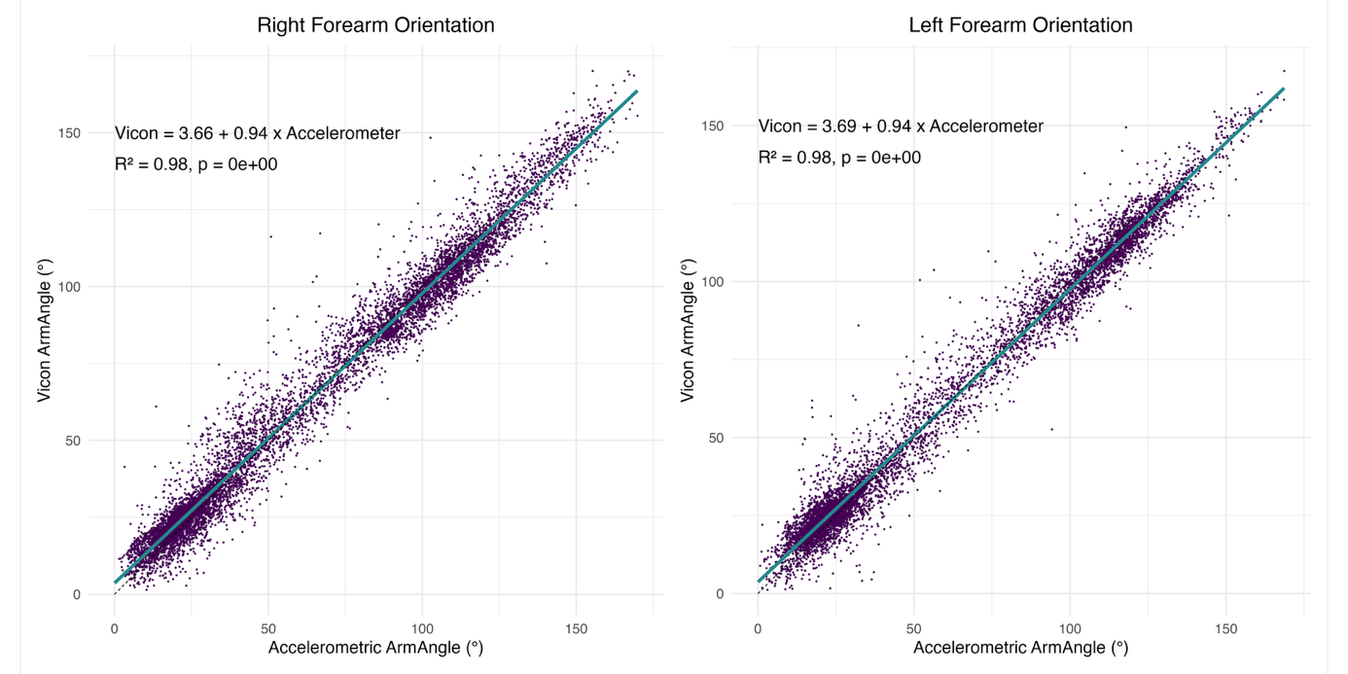
Supplementary material Figure 2. Linear regression models were fitted using a randomly selected subset of the forearm orientation data (1 sample out of 100). This subsampling was applied both for model estimation and for visualization purposes.
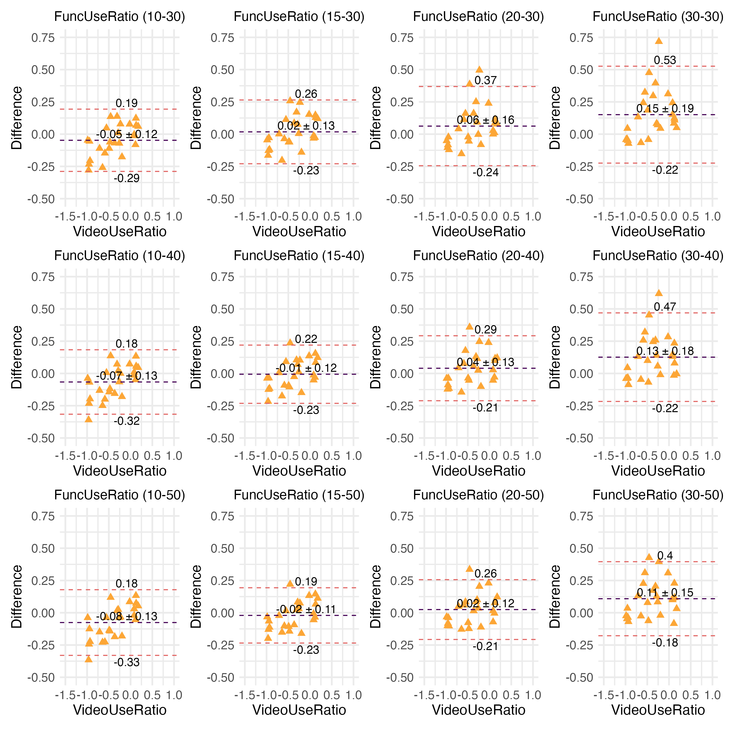
Supplementary material Figure 3. Bland–Altman plots of FuncUseRation for all parameter combinations.
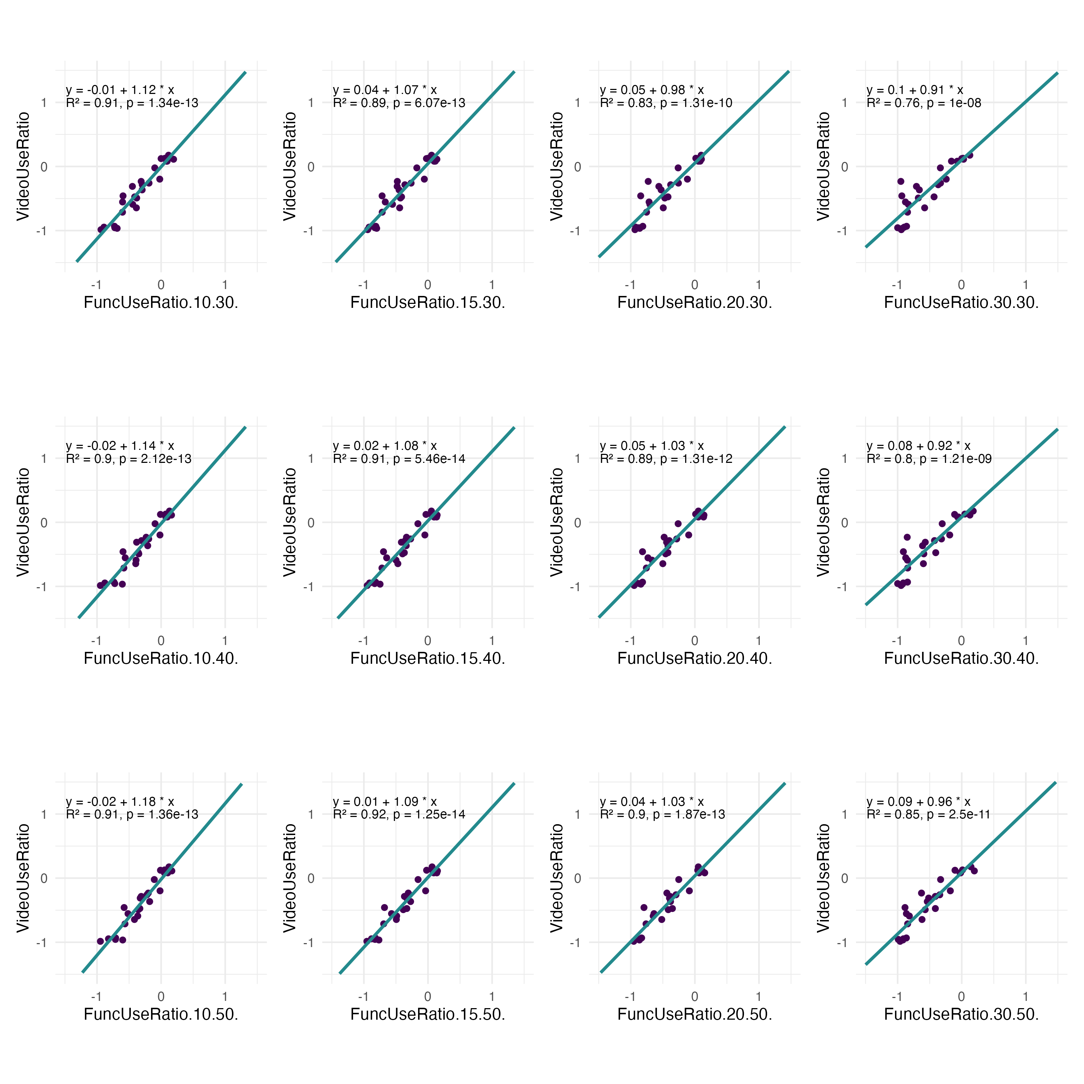
Supplementary material Figure 4. Linear regression models of FuncUseRation for all parameter combinations.
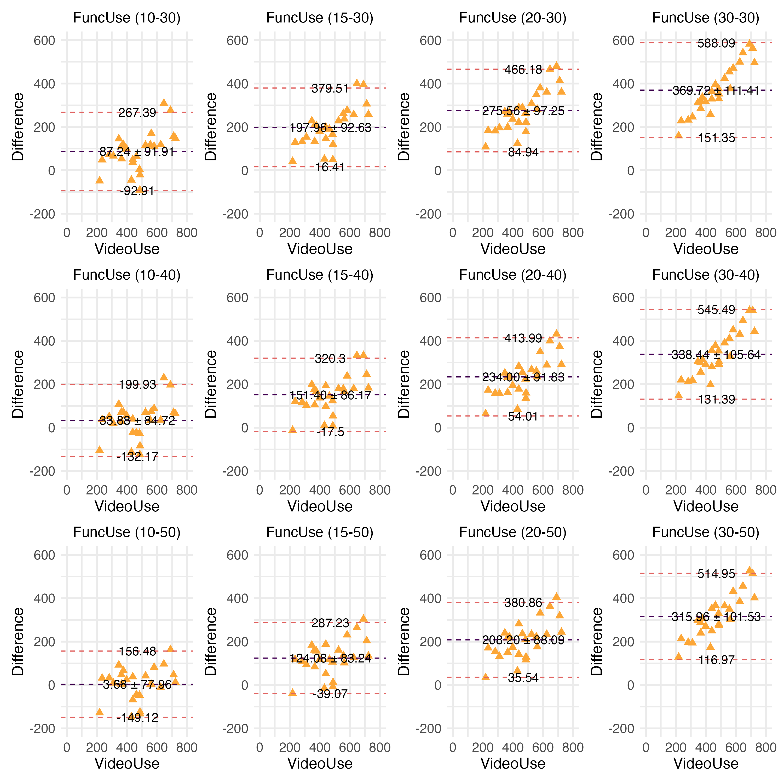
Supplementary material Figure 5. Bland–Altman plots of all non-paretic FuncUse parameters.
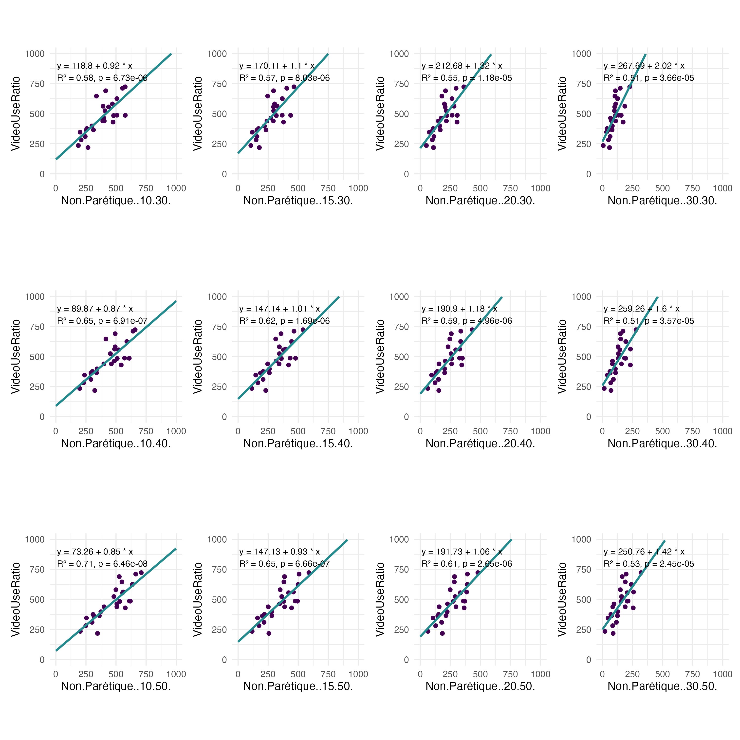
Supplementary material Figure 6. Linear regression models of all non-paretic FuncUse parameters.
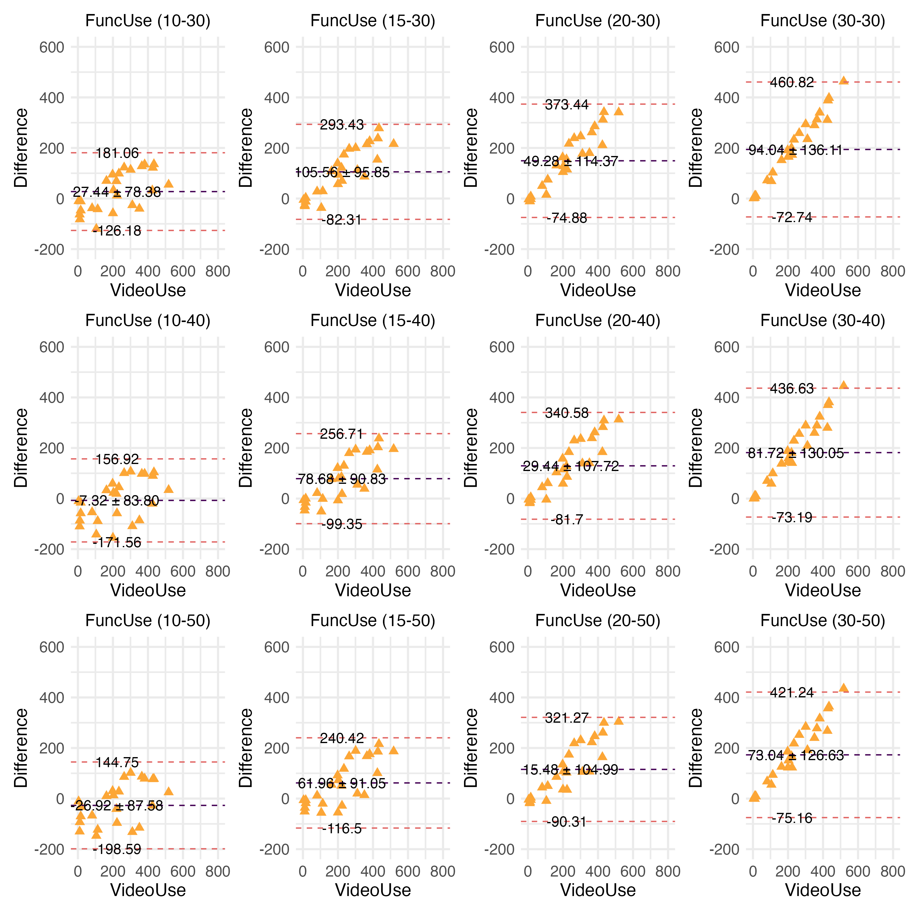
Supplementary material Figure 7. Bland-Altman plot of all paretic FuncUse parameters.
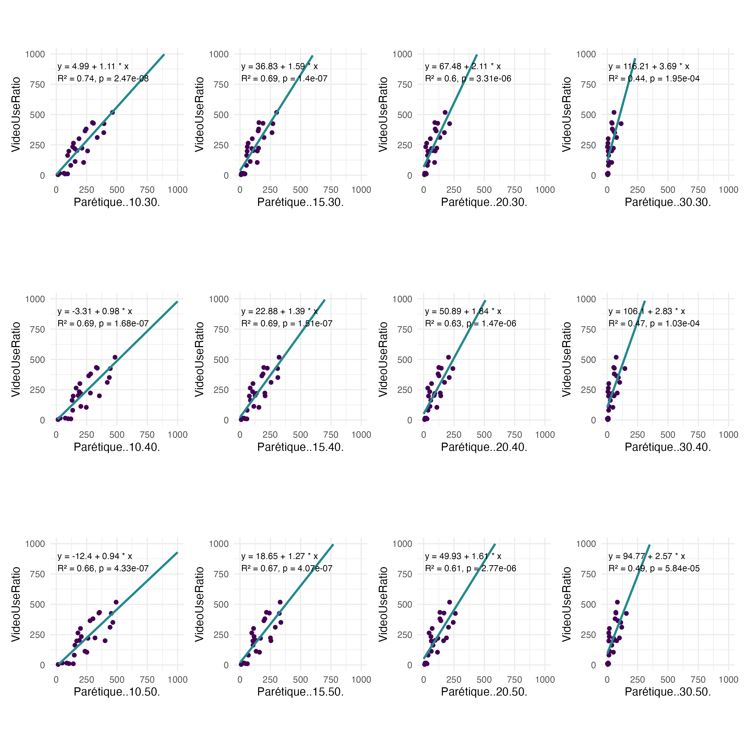
Supplementary material Figure 8. Linear regression model of all paretic FuncUse parameters.

