Chromatographic Method Development and Validation for Nitroglycerin Determination in Semi-Solid Dosage Forms by RP-HPLC

Pradip Patil¹, Bhavin Dhaduk¹, Pankajkumar Nariya¹, Shamkumar P. Deshmukh², Mahesh Savant^{1*}

¹ Department of Chemical Sciences, Faculty of Science, Atmiya University, Rajkot

²Department of Chemistry, D.B.F. Dayanand College of Arts and Science, Solapur, 413004 India.

*Email: mahesh.savant@atmiyauni.ac.in.

Supplementary Material

Table S1. Analytical eco-scale (EAS) calculation for the proposed HPLC method
Category | Details | Penalty points (PP)

Reagent
Reagent amount | 15 mL / run | 2
Reagent Hazardous (Methanol) | More severe hazard | 2
Total PP = |  | ∑ 2+2 = 4

Instruments
Energy consumption (HPLC) | < 0.1 kWh/sample | 0
Waste generation | > 10 mL/sample | 5
Occupational Hazard | Controlled lab use.  But might be exposure to air | 3
Heater (column temperature) | 25 ⁰C | 0
pH of the method (Mobile phase) | 6.5 | 0
Conditioning and washing time | Normal | 0
Total PP = |  | ∑ 1+5+3 = 9
Analytical eco scale (EAS) score = 100 - 13 |  | 87

Table S2. Assessment of greenness for the proposed method
Method | Chromatographic Conditions | MoGAPI | EAS | AGREE prep.
Proposed method | RP- HPLC method, for determination of NTG and its mono and dinitrate metabolites, using water and methanol in a 60:40 (v/v) ratio. | 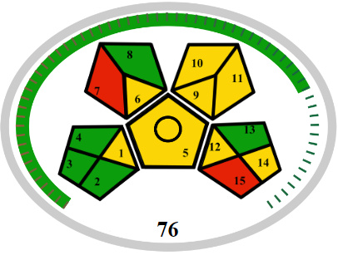 | 1+5+3 = 9  ∑ = 89 | 