Table S1. Correlation-stability coefficients for the Strength centrality index

Cross-sectional samples | Sample 1: Caregiver Report Preschool-Aged Children | Sample 2: Caregiver Report Children & Adolescents |  | Sample 3: Self-report School-Aged Children |  | Sample 4: Self-report Adolescents |  | Sample 5: Self-report Adults
Strength CS-coefficient | .68 | .25 |  | .51 |  | .53 |  | .63
Longitudinal samples | Sample 6; Time 1:  Self-Report Children and Adolescents |  | Sample 6; Time 2:  Self-Report Children and Adolescents |  | Sample 7; Time 1:  Self-Report Adults |  | Sample 7; Time 2:  Self-Report Adults
Strength CS-coefficient | .25 |  | .23 |  | .60 |  | .64
Note. CS=Correlation- Stability

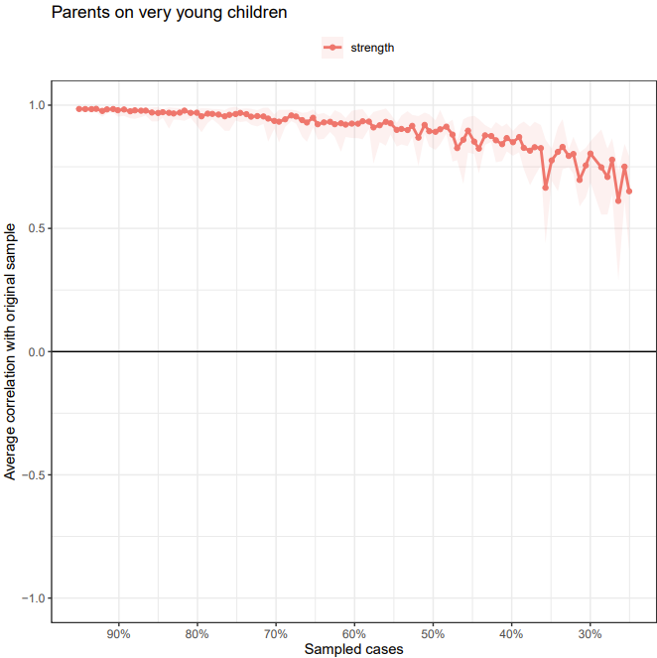

Figure S1. Subset bootstrap test. Subsetting bootstrap for the 17 DSM-IV-TR symptom network, estimated based on the caregiver report of preschool-aged children dataset. The table shows the average correlation between centrality indices from the original estimated network.

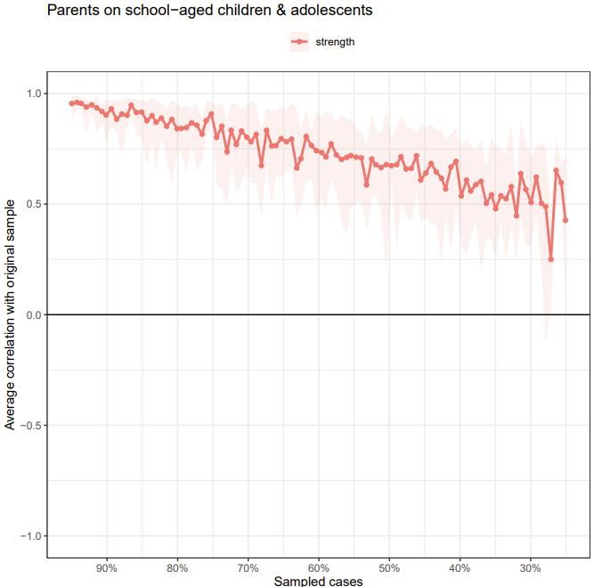
Figure S2. Subset bootstrap test. Subsetting bootstrap for the 17 DSM-IV-TR symptom network, estimated based on the caregiver report of children and adolescents dataset. The table shows the average correlation between centrality indices from the original estimated network.

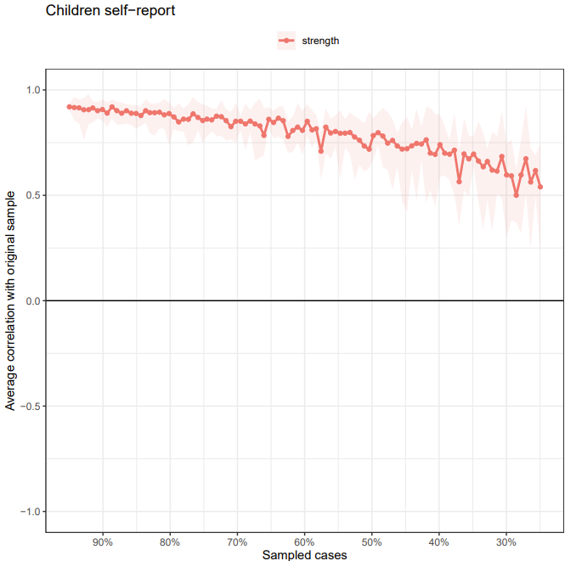
Figure S3. Subset bootstrap test. Subsetting bootstrap for the 17 DSM-IV-TR symptom network, estimated based on the self-report of children dataset. The table shows the average correlation between centrality indices from the original estimated network.

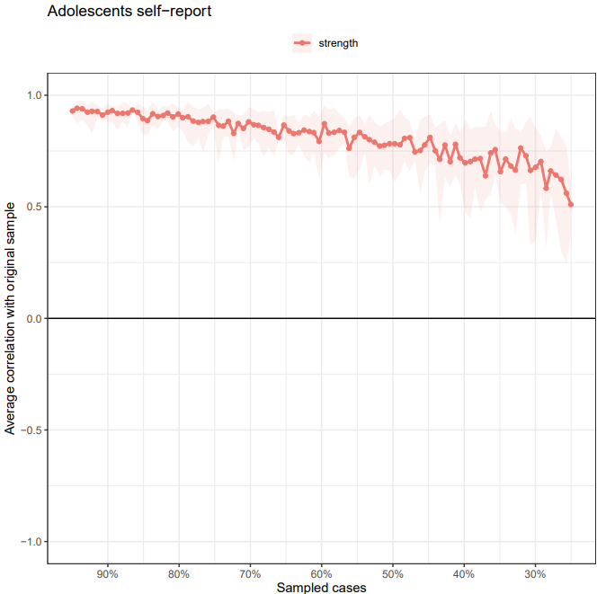
Figure S4. Subset bootstrap test. Subsetting bootstrap for the 17 DSM-IV-TR symptom network, estimated based on the self-report of adolescents dataset. The table shows the average correlation between centrality indices from the original estimated network.

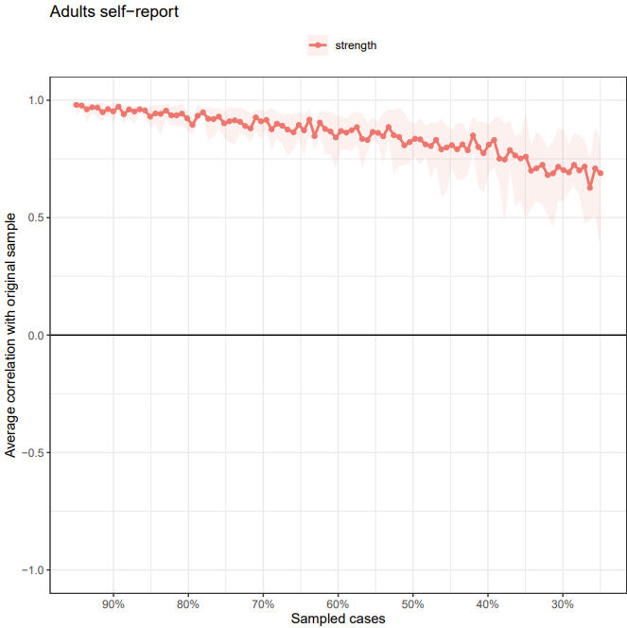
Figure S5. Subset bootstrap test. Subsetting bootstrap for the 17 DSM-IV-TR symptom network, estimated based on the self-report of adults dataset. The table shows the average correlation between centrality indices from the original estimated network.

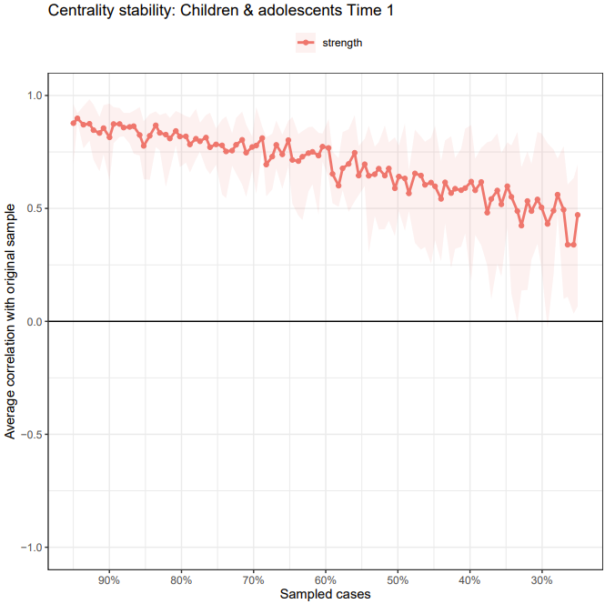

Figure S6. Subset bootstrap test. Subsetting bootstrap for the 17 DSM-IV-TR symptom network, estimated based on the self-report of the longitudinal child & adolescent dataset (time 1). The table shows the average correlation between centrality indices from the original estimated network

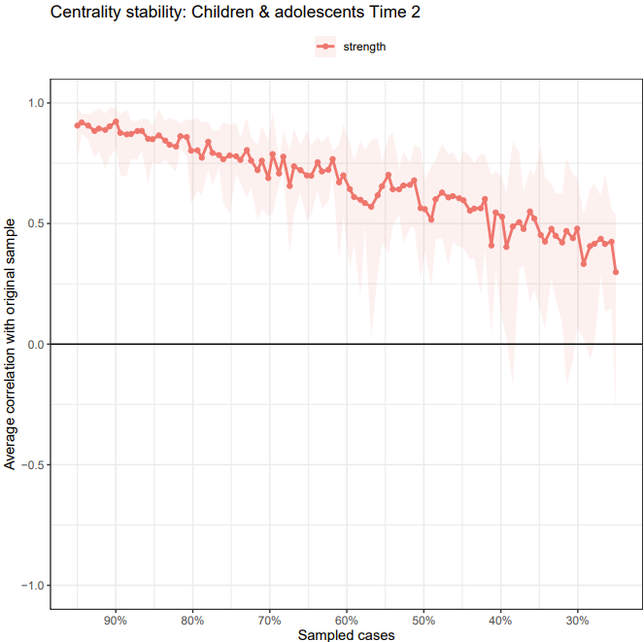
Figure S7. Subset bootstrap test. Subsetting bootstrap for the 17 DSM-IV-TR symptom network, estimated based on the self-report of the longitudinal child & adolescent dataset (time 2). The table shows the average correlation between centrality indices from the original estimated network

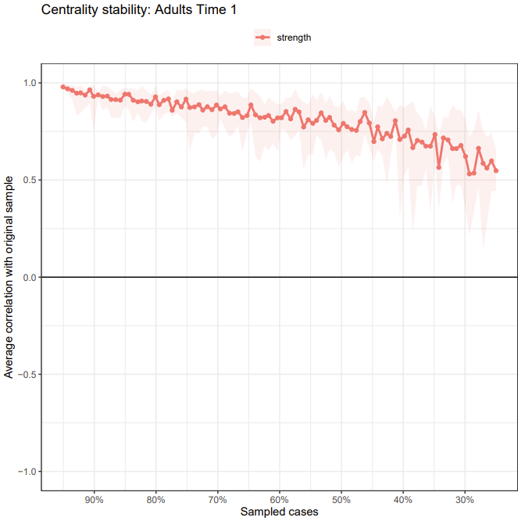

Figure S8. Subset bootstrap test. Subsetting bootstrap for the 17 DSM-IV-TR symptom network, estimated based on the self-report of the longitudinal adult dataset (time 1). The table shows the average correlation between centrality indices from the original estimated network.

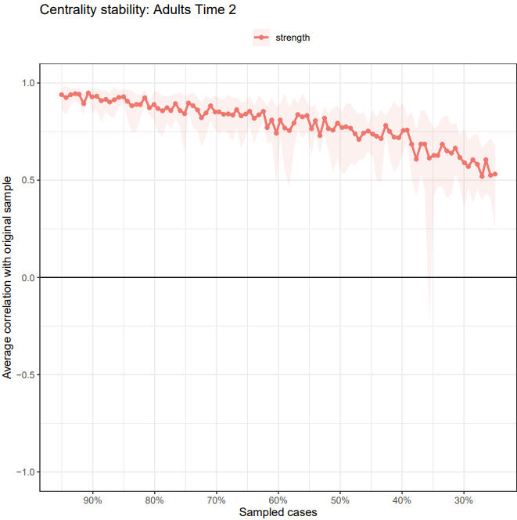
Figure S9. Subset bootstrap test. Subsetting bootstrap for the 17 DSM-IV-TR symptom network, estimated based on the self-report of the longitudinal adult dataset (time 2). The table shows the average correlation between centrality indices from the original estimated network.

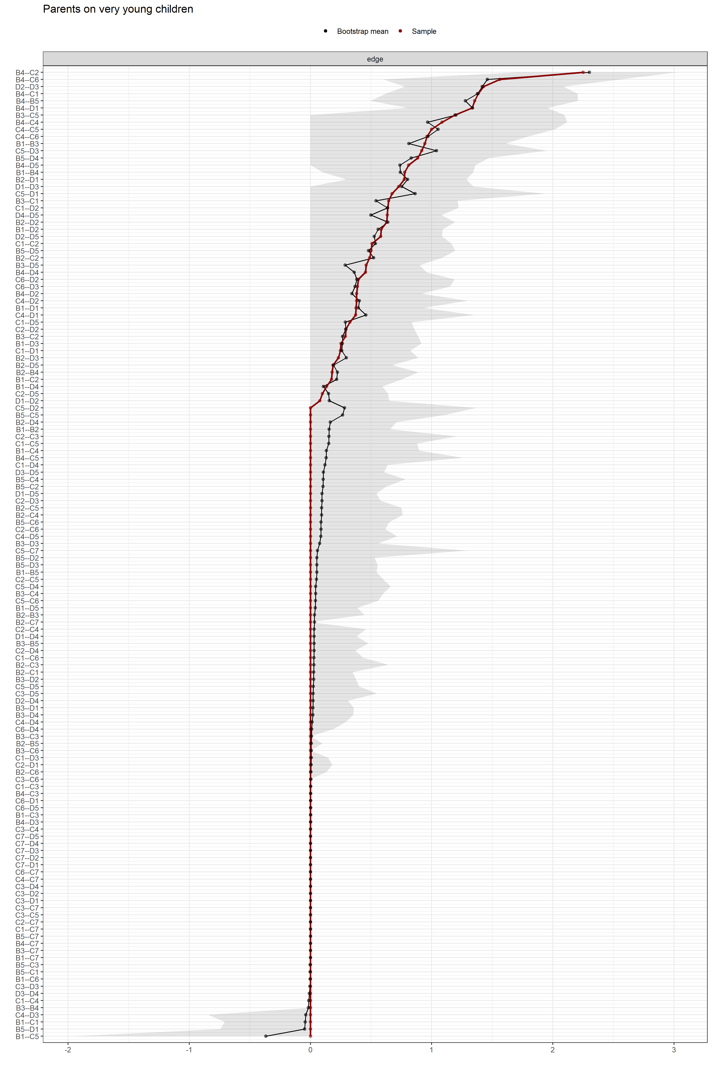
Figure S10. Edge-weight accuracy test. Bootstrapped confidence intervals (CIs) of the estimated edge-weights for the estimated network of the 17 DSM-IV-TR symptoms from the caregiver report of preschool-aged children dataset. The y-axis comprises all edges in the network, ordered from the edge with the highest weight-strength to the edge with the lowest weight-strength. The red dots represent the edge-weights of the network, the gray area the 95% CIs.

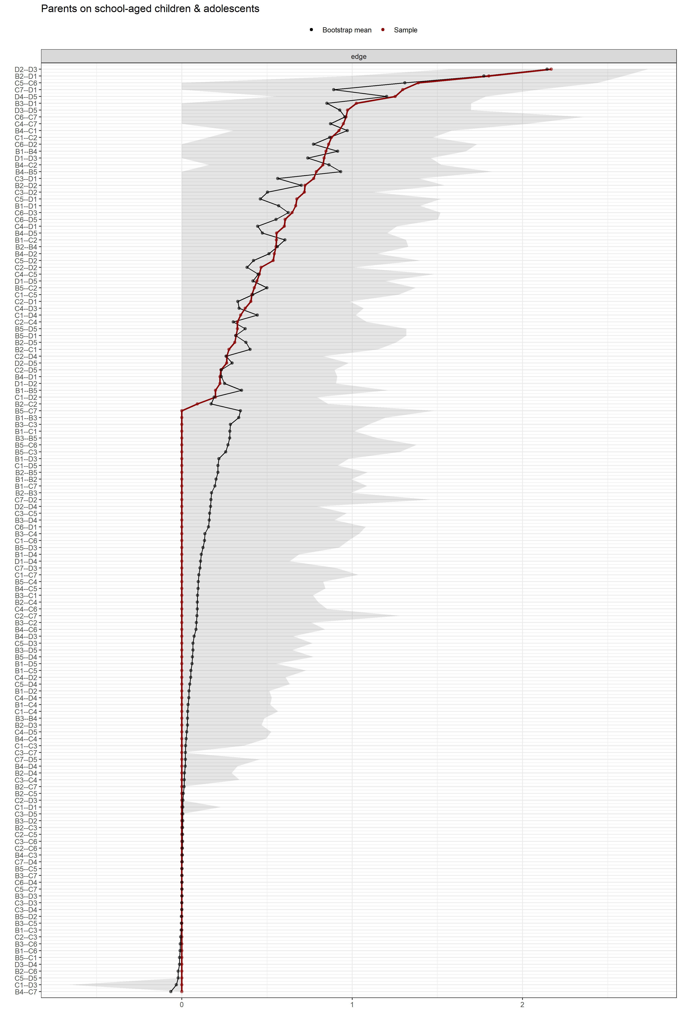
Figure S11. Edge-weight accuracy test. Bootstrapped confidence intervals (CIs) of the estimated edge-weights for the estimated network of the 17 DSM-IV-TR symptoms from the caregiver report of children and adolescents dataset. The y-axis comprises all edges in the network, ordered from the edge with the highest weight-strength to the edge with the lowest weight-strength. The red dots represent the edge-weights of the network, the gray area the 95% CIs.
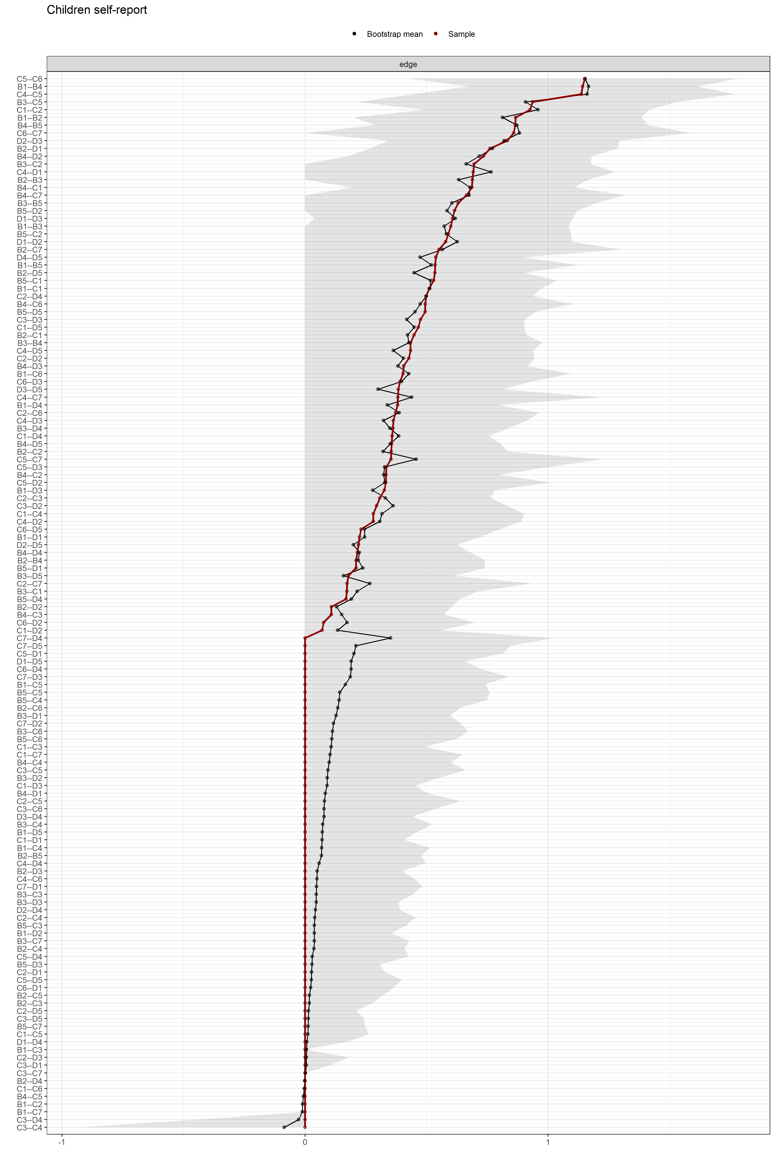
Figure S12. Edge-weight accuracy test. Bootstrapped confidence intervals (CIs) of the estimated edge-weights for the estimated network of the 17 DSM-IV-TR symptoms from the child self report dataset. The y-axis comprises all edges in the network, ordered from the edge with the highest weight-strength to the edge with the lowest weight-strength. The red dots represent the edge-weights of the network, the gray area the 95% CIs.

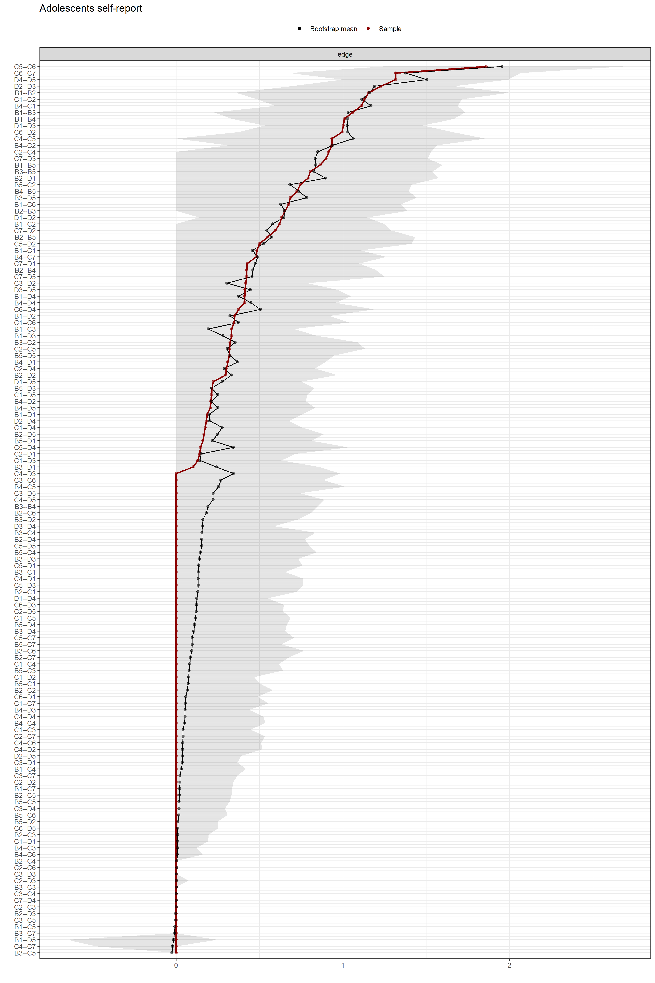
Figure S13. Edge-weight accuracy test. Bootstrapped confidence intervals (CIs) of the estimated edge-weights for the estimated network of the 17 DSM-IV-TR symptoms from the adolescent self-report dataset. The y-axis comprises all edges in the network, ordered from the edge with the highest weight-strength to the edge with the lowest weight-strength. The red dots represent the edge-weights of the network, the gray area the 95% CIs.

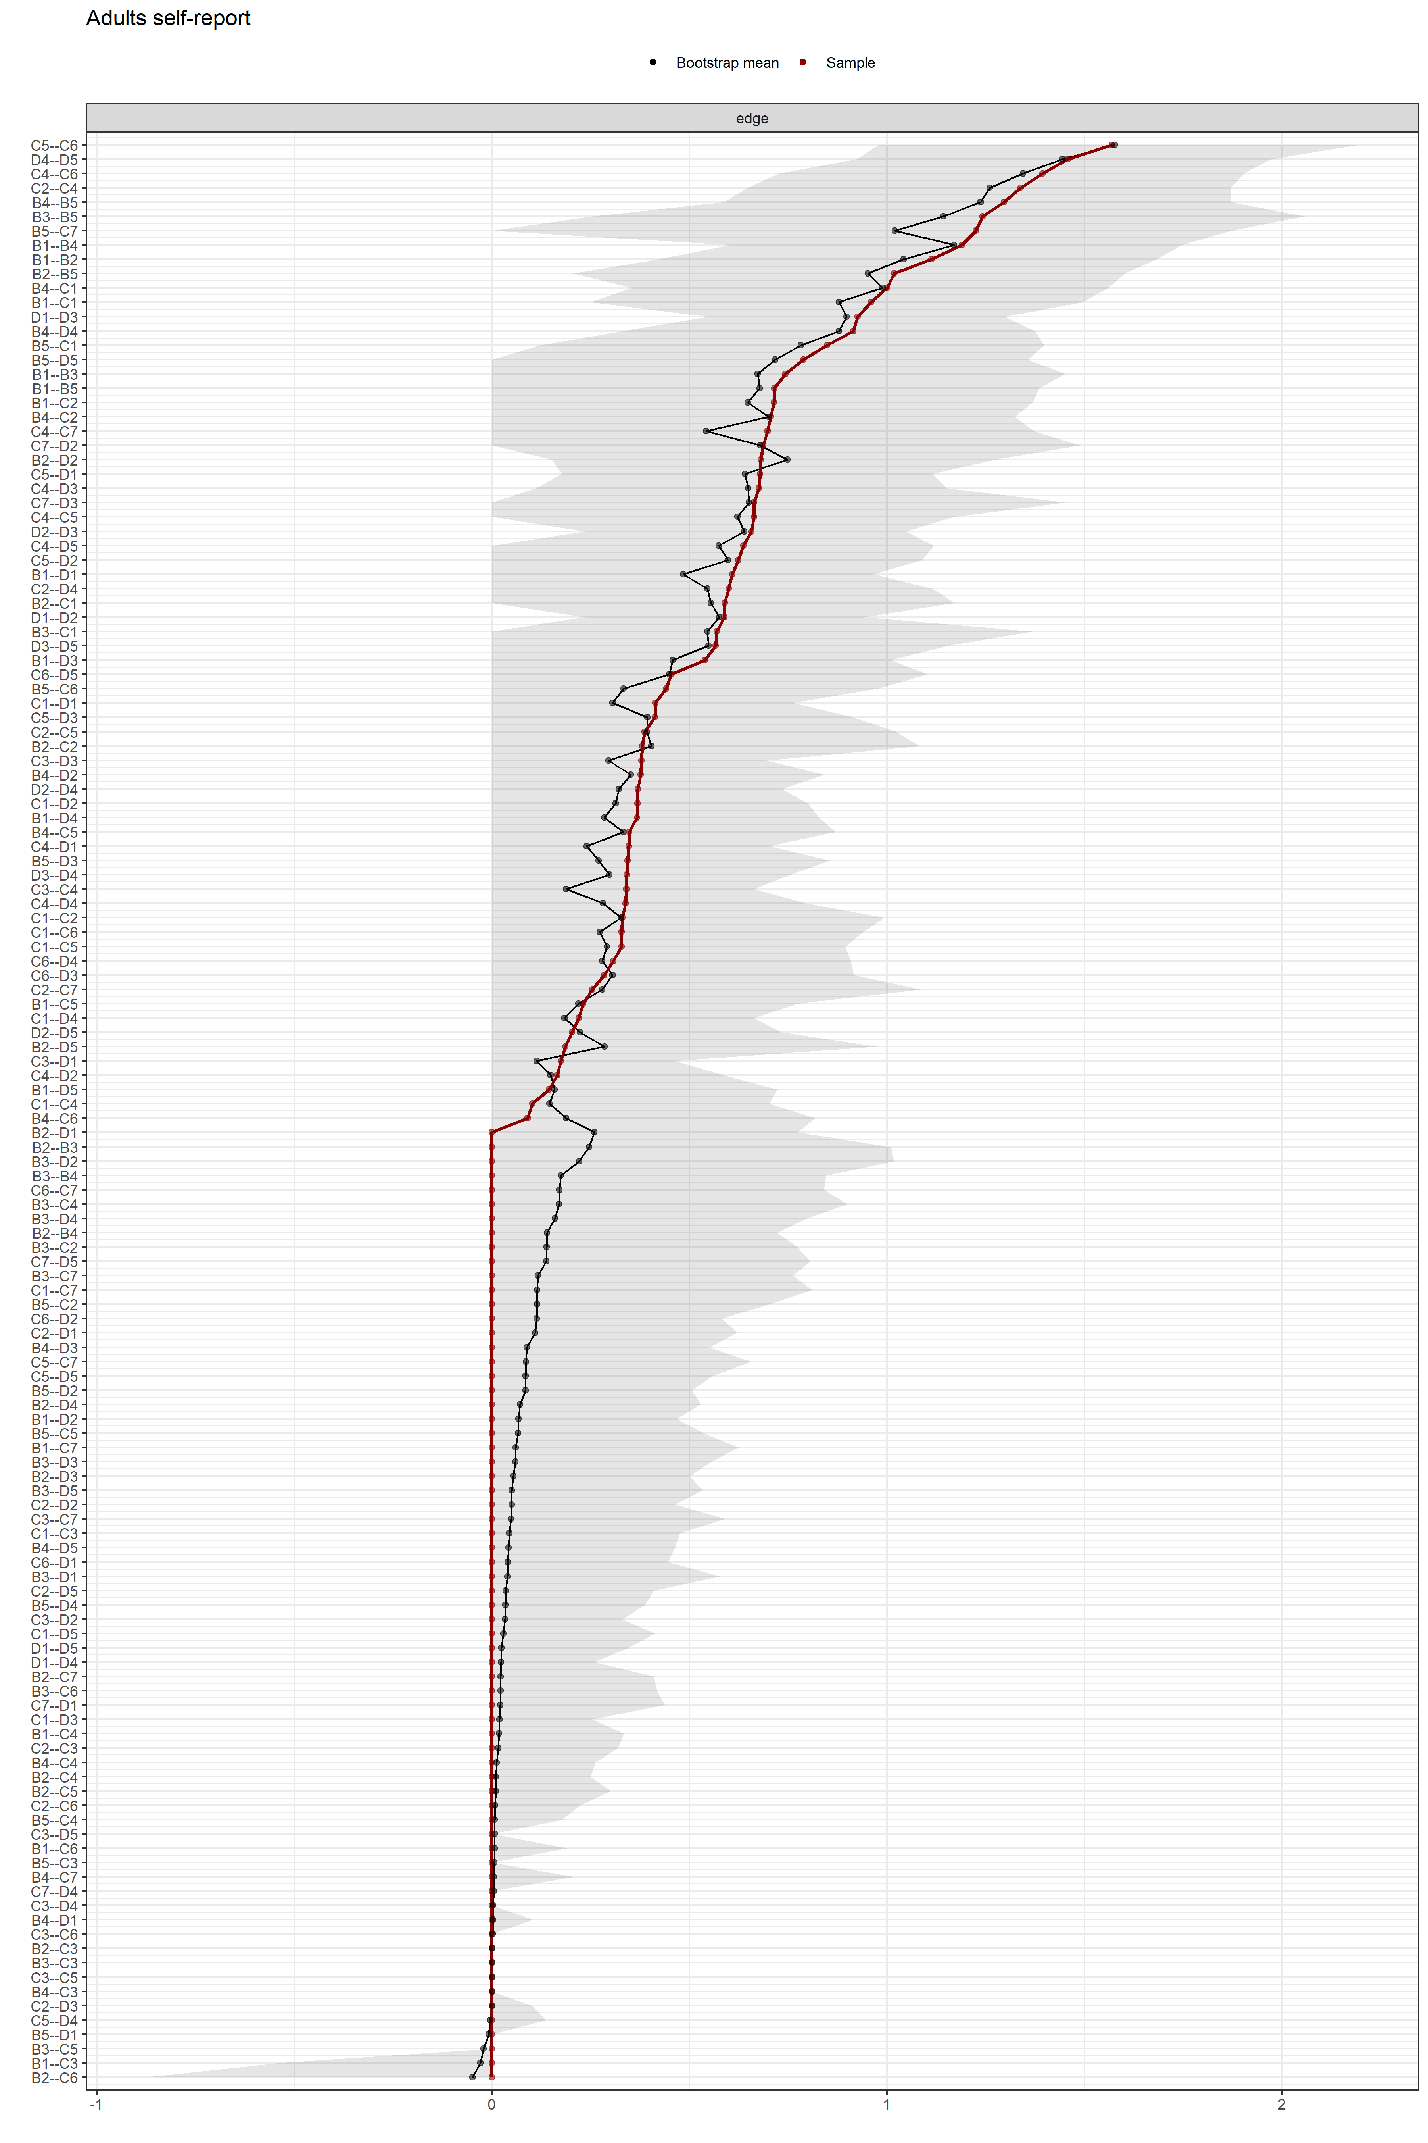
Figure S14. Edge-weight accuracy test. Bootstrapped confidence intervals (CIs) of the estimated edge-weights for the estimated network of the 17 DSM-IV-TR symptoms from the adult self-report dataset. The y-axis comprises all edges in the network, ordered from the edge with the highest weight-strength to the edge with the lowest weight-strength. The red dots represent the edge-weights of the network, the gray area the 95% CIs.
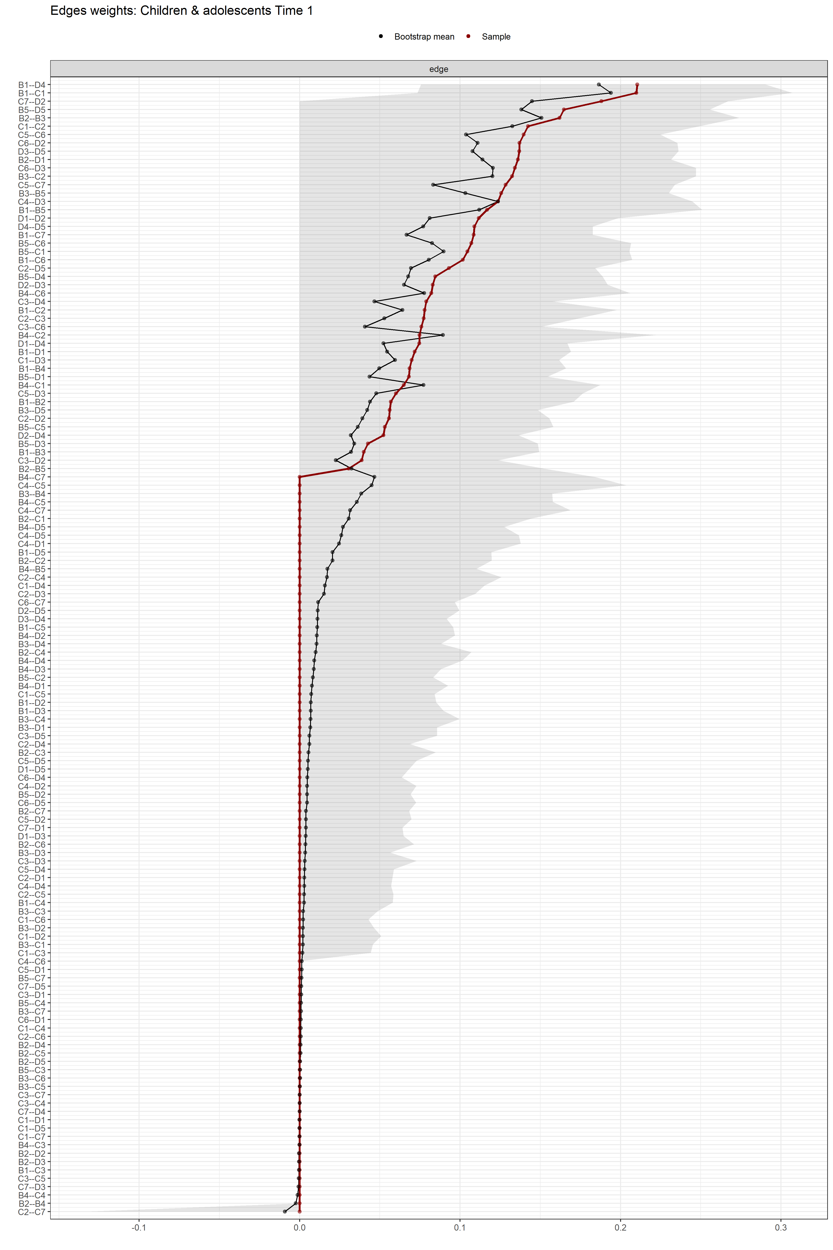
Figure S15. Edge-weight accuracy test. Bootstrapped confidence intervals (CIs) of the estimated edge-weights for the estimated network of the 17 DSM-IV-TR symptoms from the children and adolescents longitudinal self-report dataset (Time 1). The y-axis comprises all edges in the network, ordered from the edge with the highest weight-strength to the edge with the lowest weight-strength. The red dots represent the edge-weights of the network, the gray area the 95% CIs.
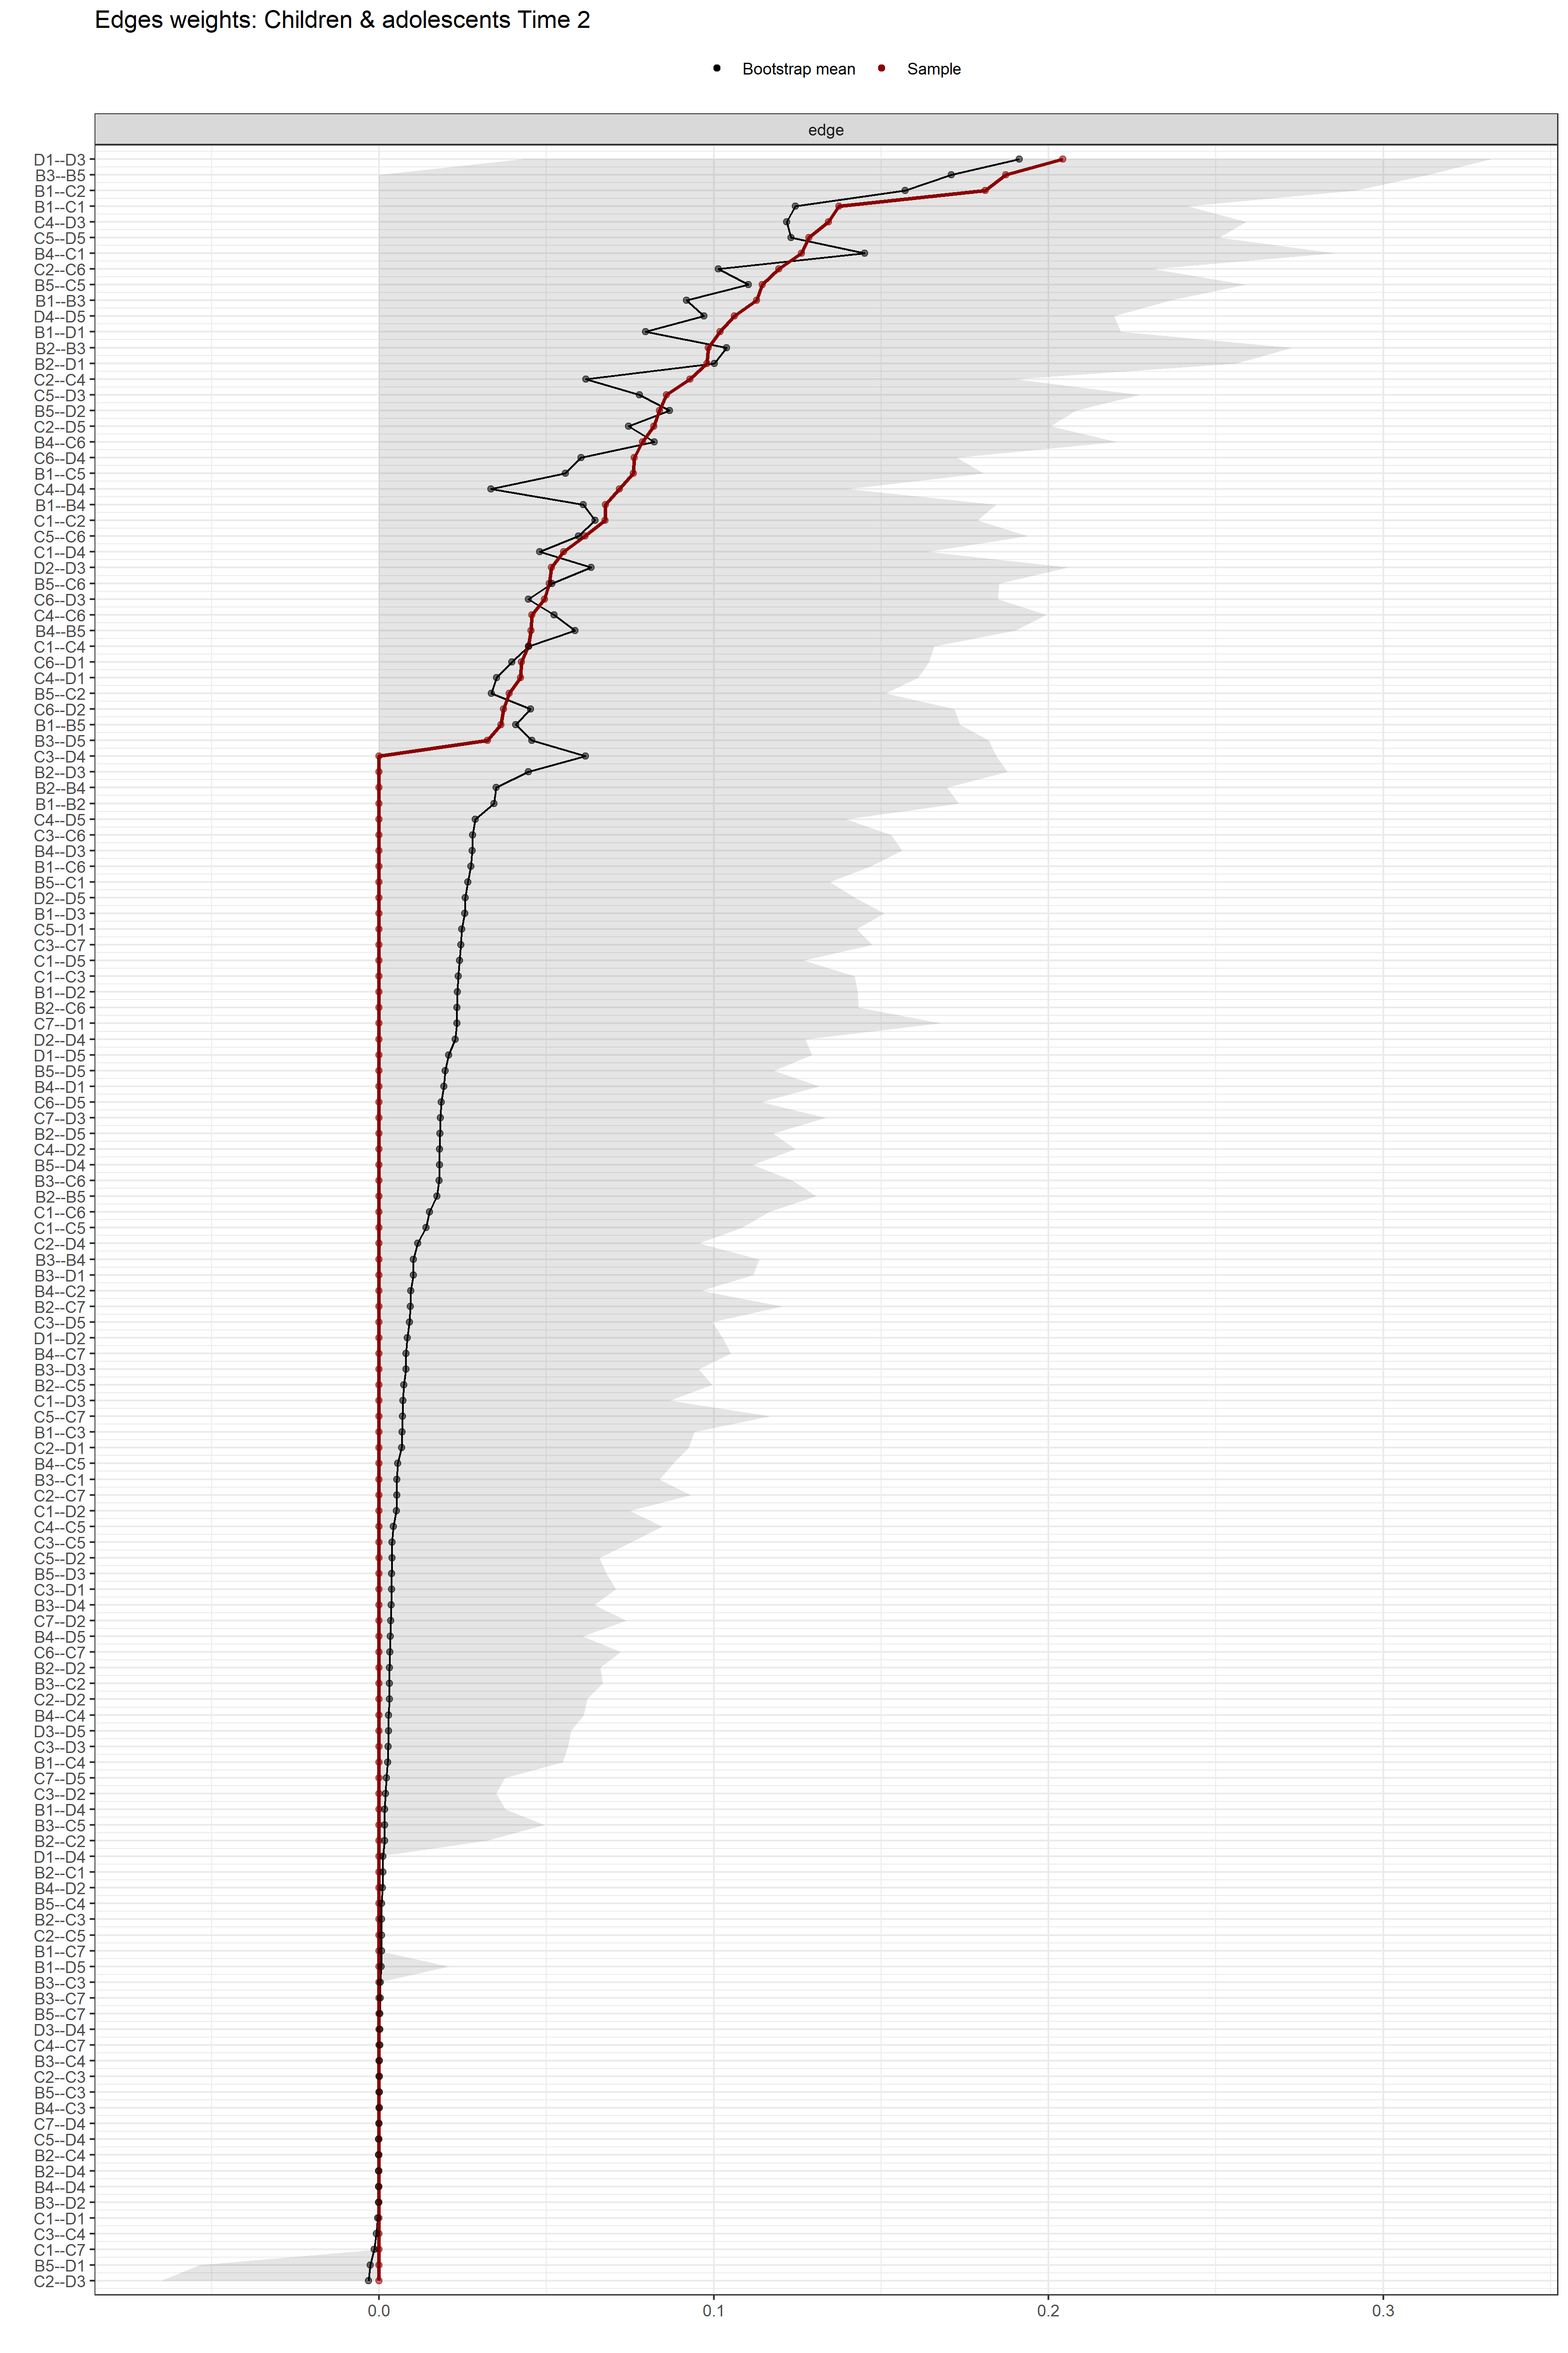
Figure S16. Edge-weight accuracy test. Bootstrapped confidence intervals (CIs) of the estimated edge-weights for the estimated network of the 17 DSM-IV-TR symptoms from the children and adolescents longitudinal self-report dataset (Time 2). The y-axis comprises all edges in the network, ordered from the edge with the highest weight-strength to the edge with the lowest weight-strength. The red dots represent the edge-weights of the network, the gray area the 95% CIs.
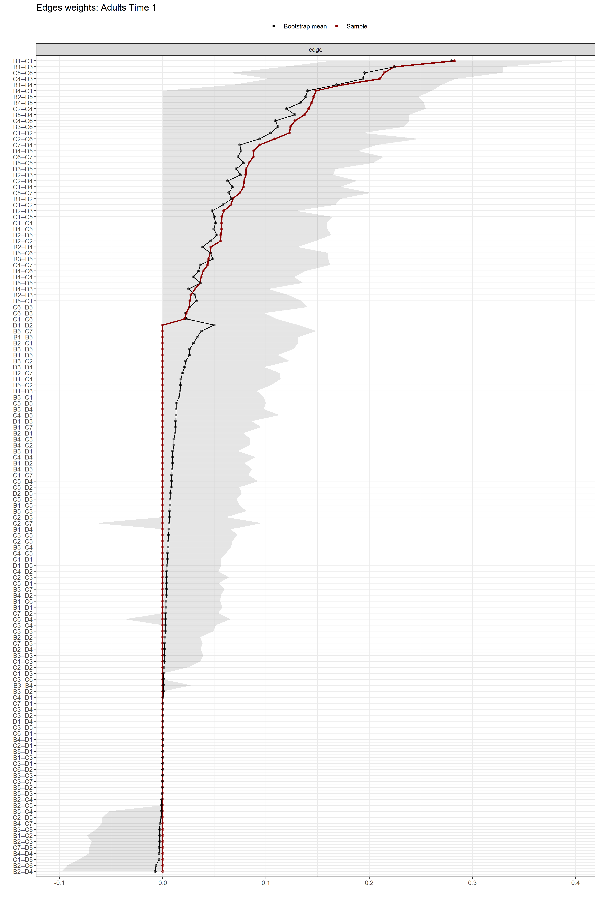
Figure S17. Edge-weight accuracy test. Bootstrapped confidence intervals (CIs) of the estimated edge-weights for the estimated network of the 17 DSM-IV-TR symptoms from the adult longitudinal self-report dataset (Time 1). The y-axis comprises all edges in the network, ordered from the edge with the highest weight-strength to the edge with the lowest weight-strength. The red dots represent the edge-weights of the network, the gray area the 95% CIs.
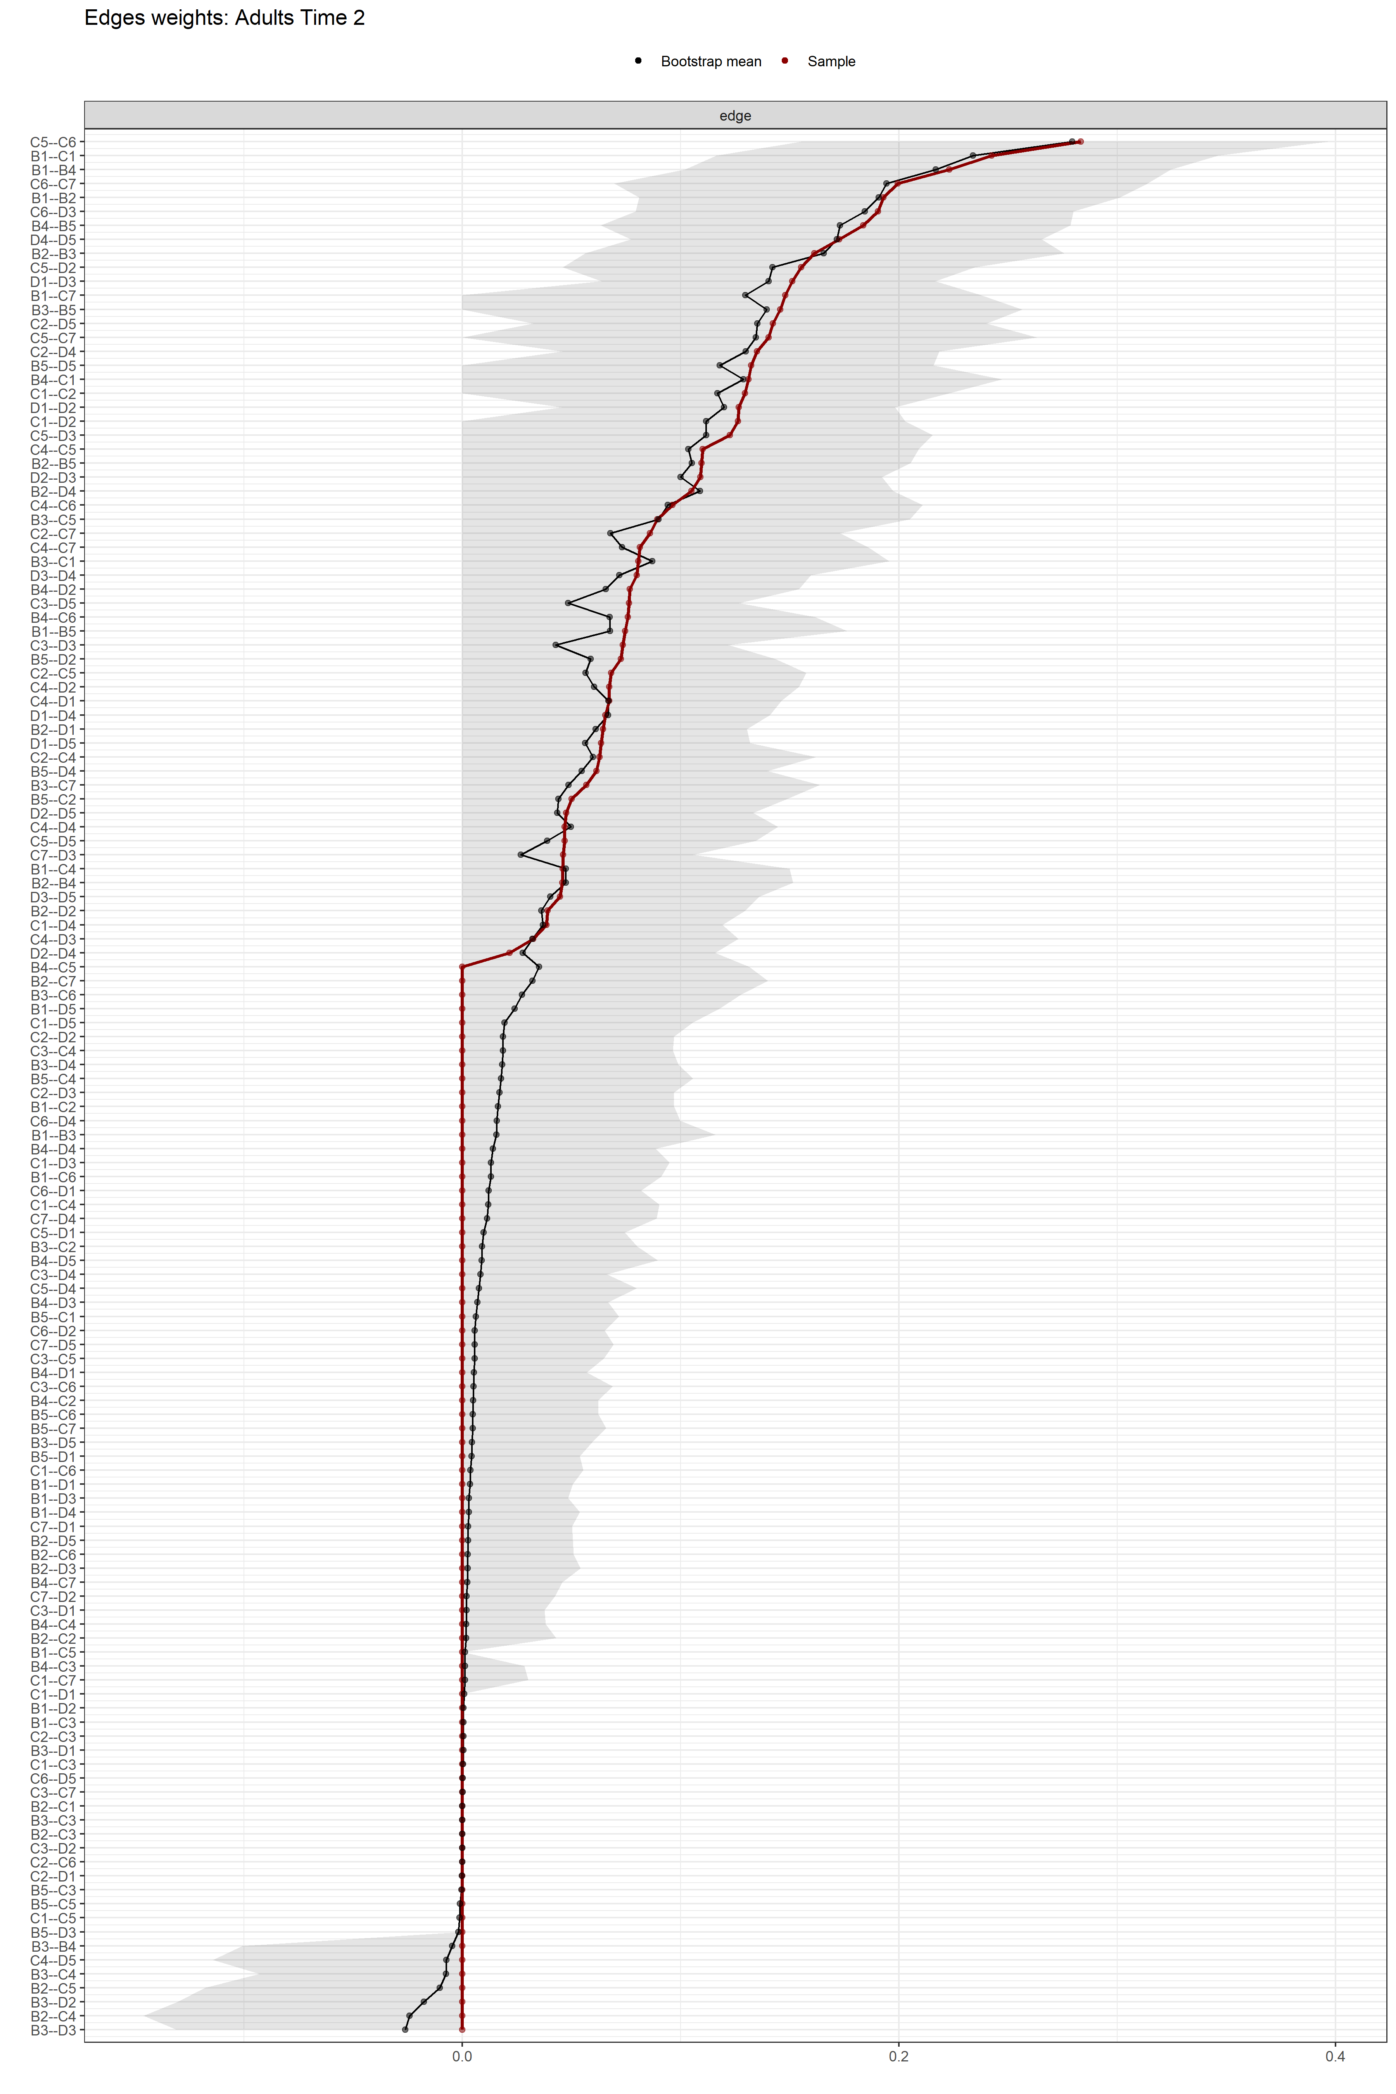
Figure S18. Edge-weight accuracy test. Bootstrapped confidence intervals (CIs) of the estimated edge-weights for the estimated network of the 17 DSM-IV-TR symptoms from the adult longitudinal self-report dataset (Time 2). The y-axis comprises all edges in the network, ordered from the edge with the highest weight-strength to the edge with the lowest weight-strength. The red dots represent the edge-weights of the network, the gray area the 95% CIs.

