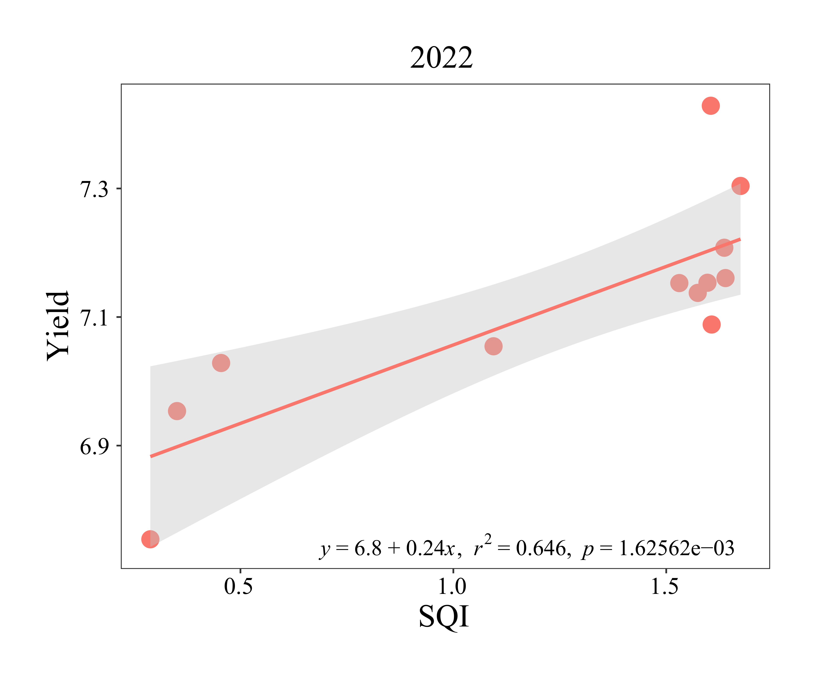
C
D
A
B

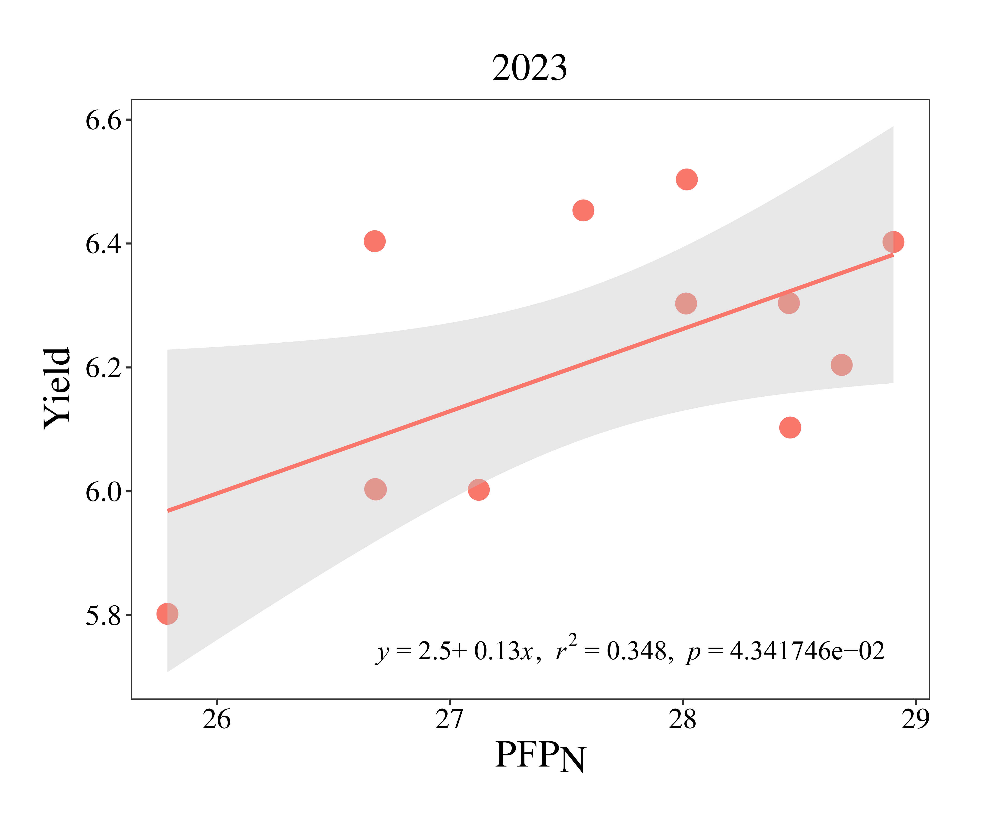
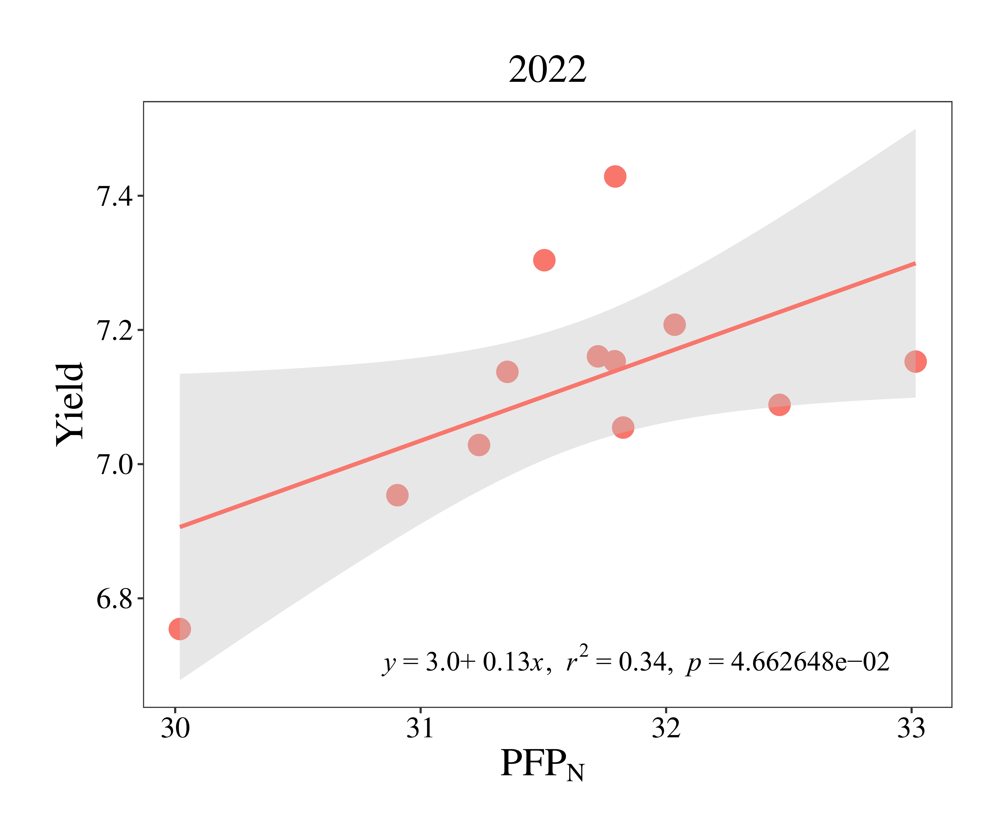
F
E

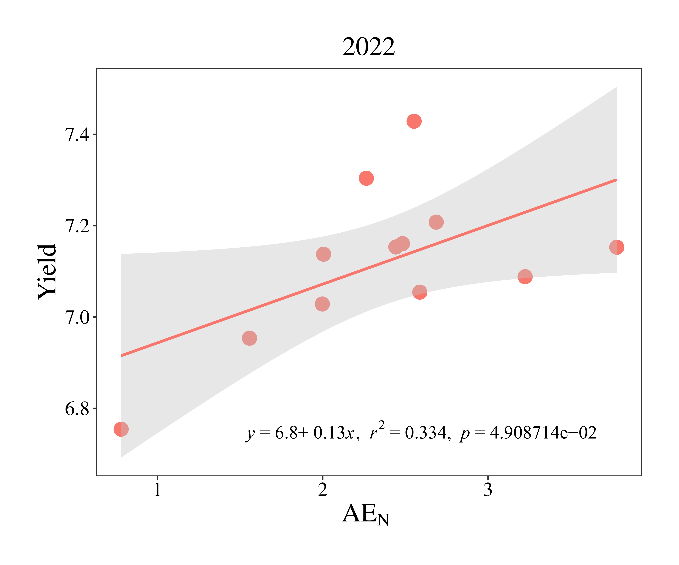
H
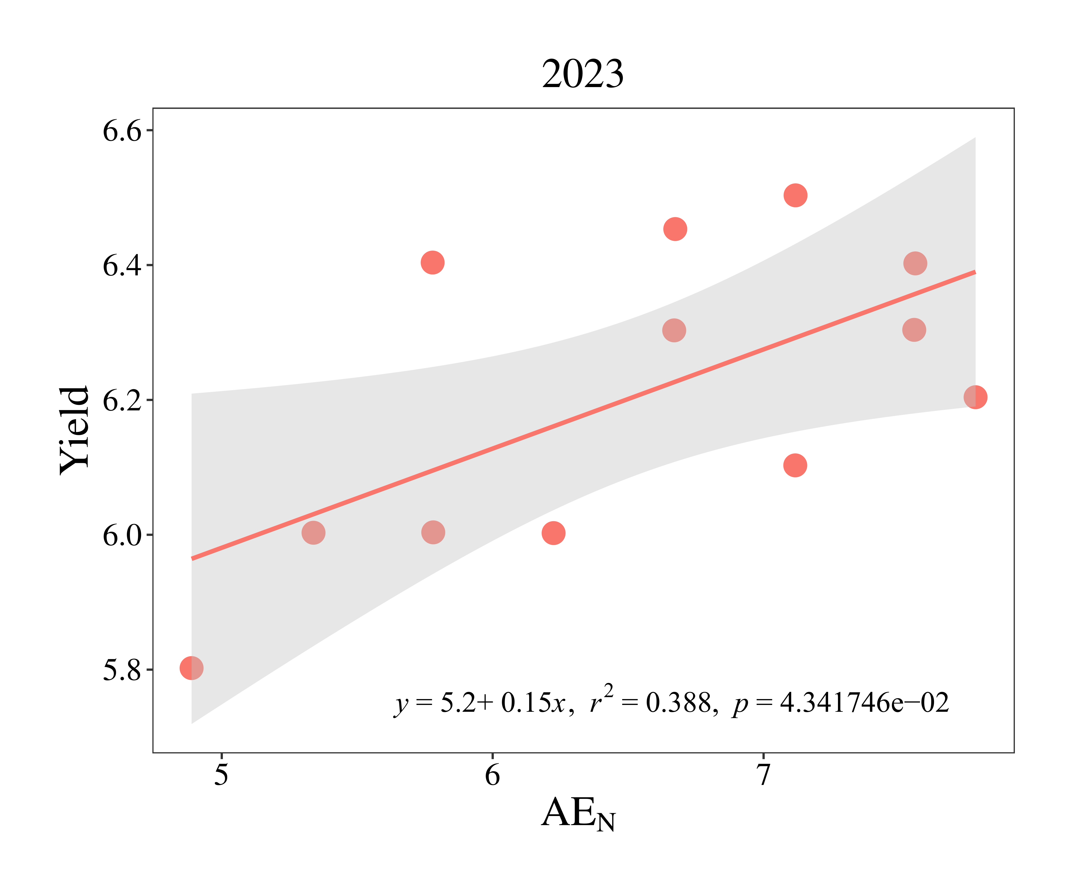
G

Fig. S1. The relationships between the soil quality index (SQI) and ecological multifunctionality (EMF; A and B) and yield (C and D), as well as relationships between yield and nitrogen partial productivity (PFP_{N}; E and F) and nitrogen agronomic efficiency (AE_{N}; G and H) from 2022 to 2023. The orange lines represent the general regression, and the shaded areas show the 95% confidence intervals of the fit.
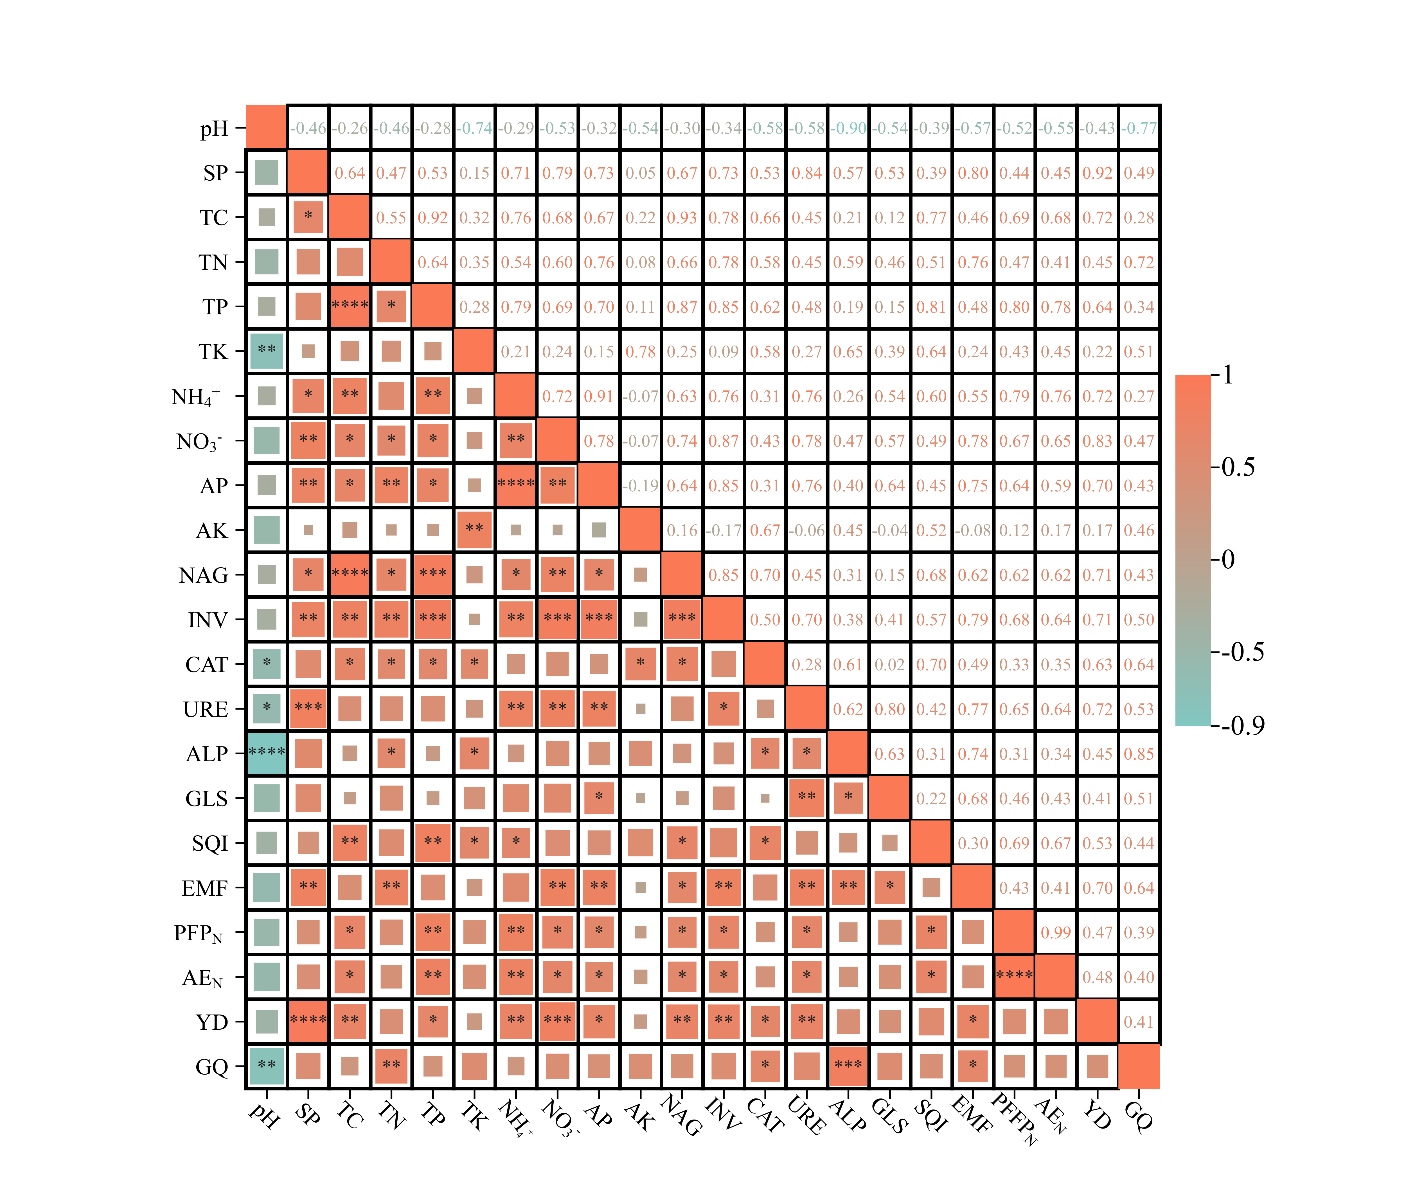
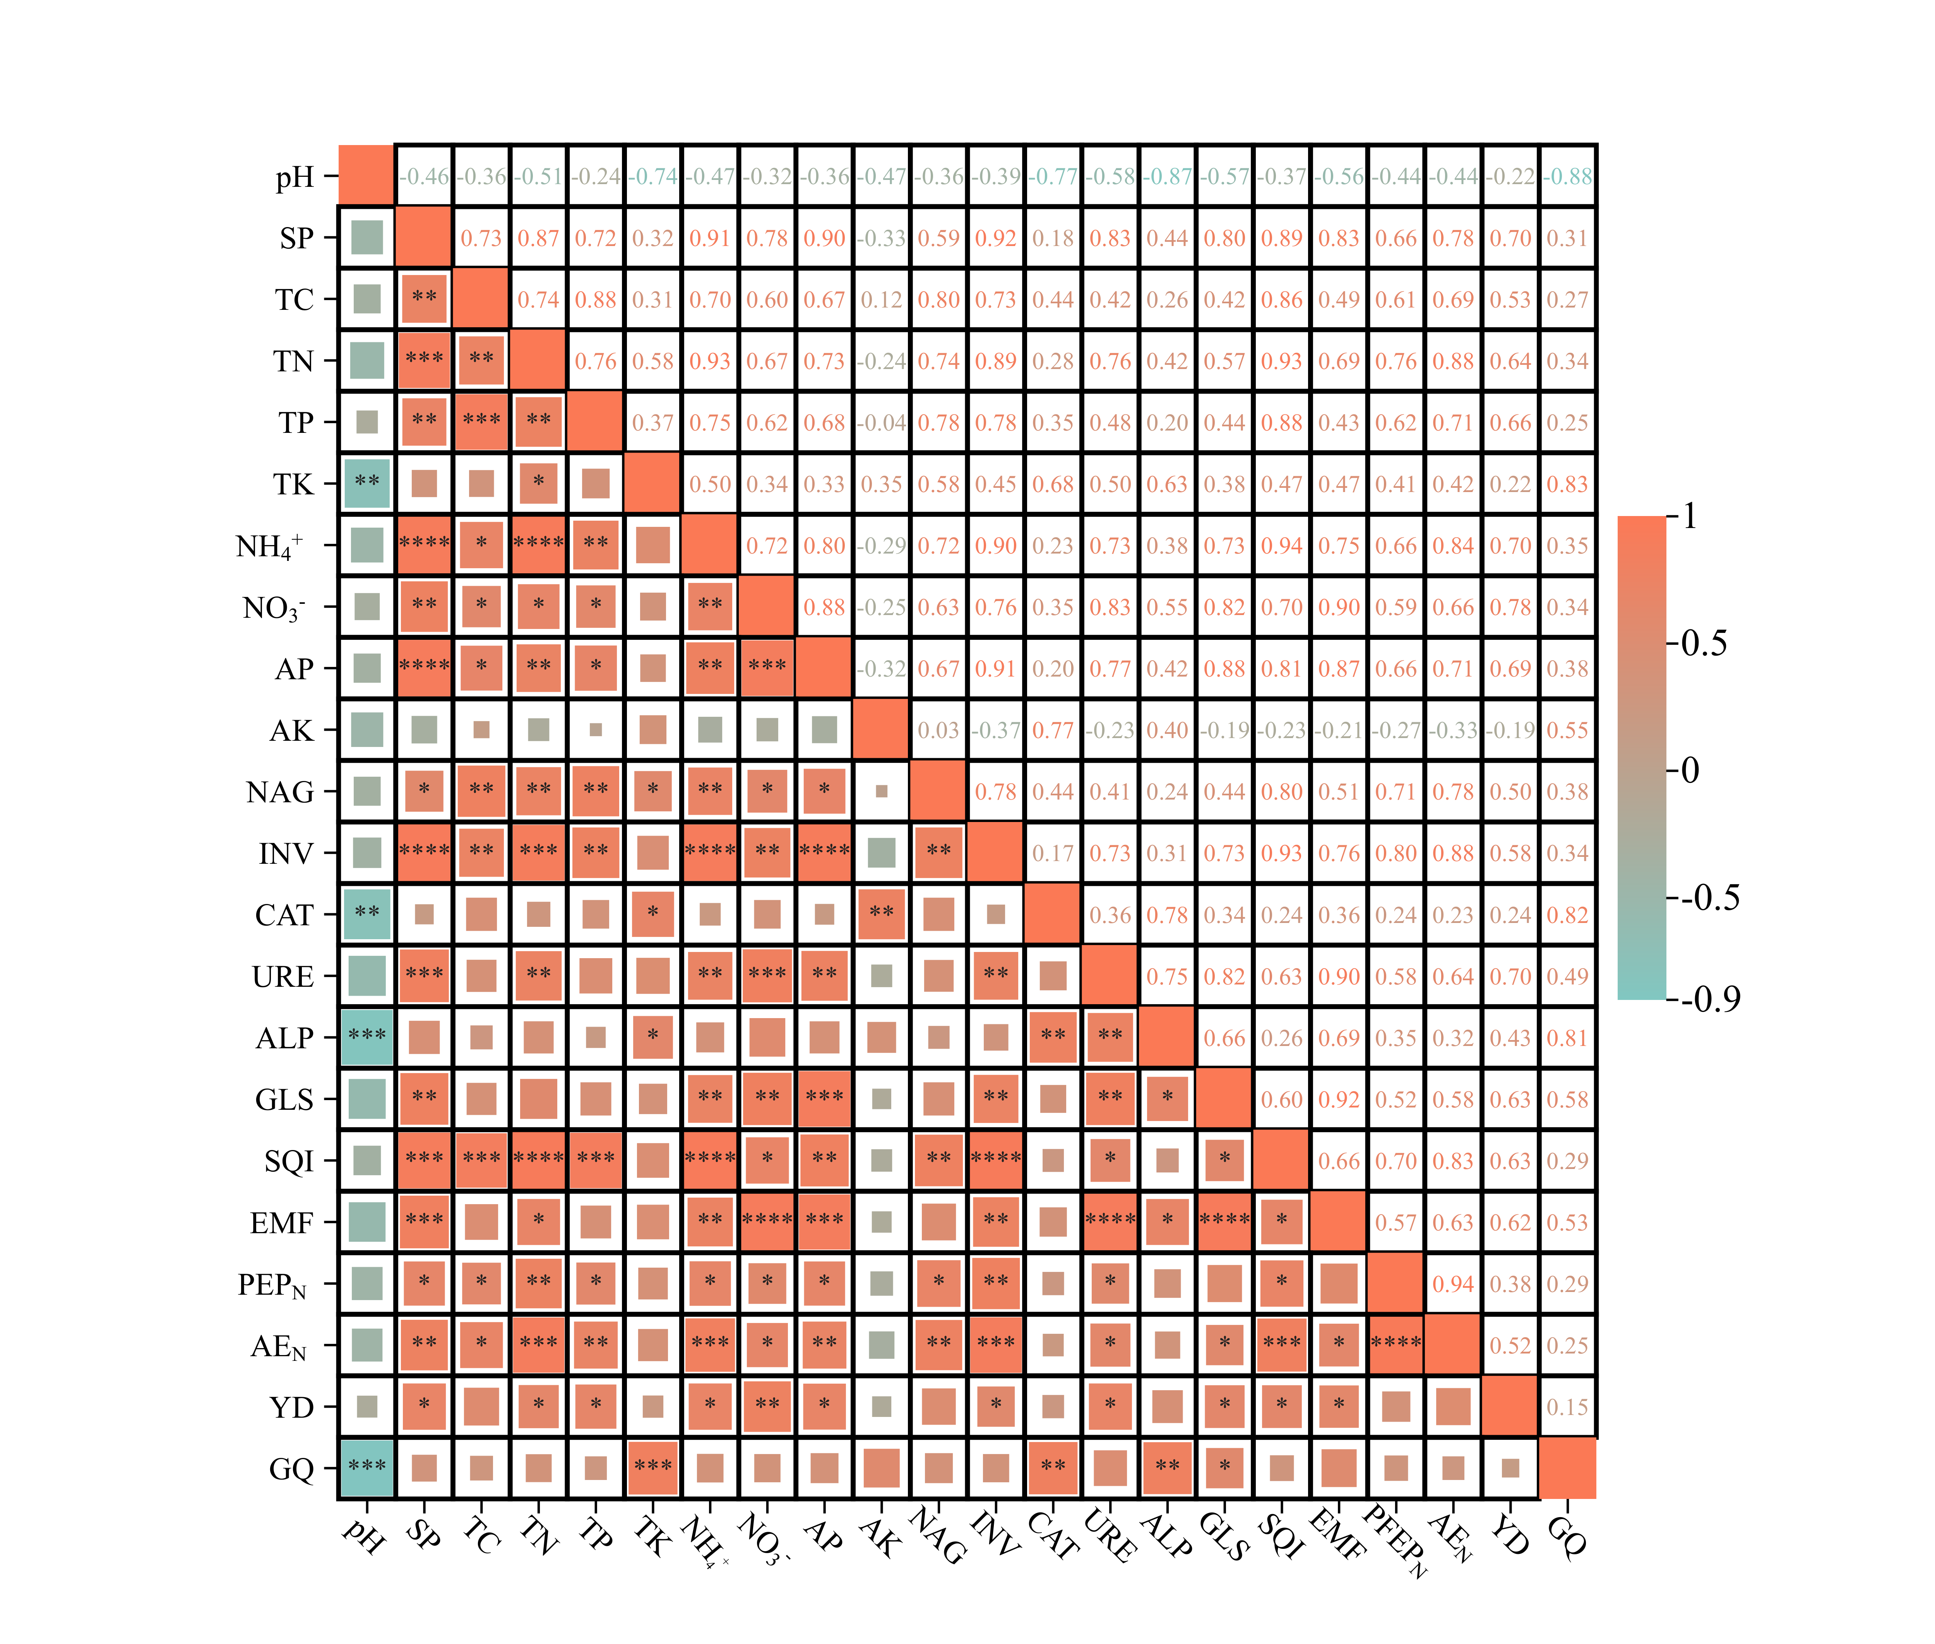
A
2022
B
2023

Fig. S2. The relationship among soil physicochemical properties (TC, total organic carbon; TN, total nitrogen; TP, total phosphorus; TK, total potassium; NH₄⁺, ammonium nitrogen; NO₃⁻, nitrate nitrogen; AP, available phosphorus; AK, available potassium), enzyme activities (ALP, soil alkaline phosphatase; NAG, β-N-acetylglucosaminidase; CAT, catalase; INV, invertase; URE, urease; GLS, glutaminase), soil quality index (SQI), ecological multifunctionality (EMF), nitrogen use efficiency (PFP_{N}, N partial factor productivity; AE_{N}, N agronomic efficiency), yield (YD), and grain quality (GQ, total flavonoids content) from 2022 (A) to 2023 (B). * denotes p < 0.05, ** denotes p < 0.01, *** denotes p < 0.001, and **** denotes p < 0.0001.

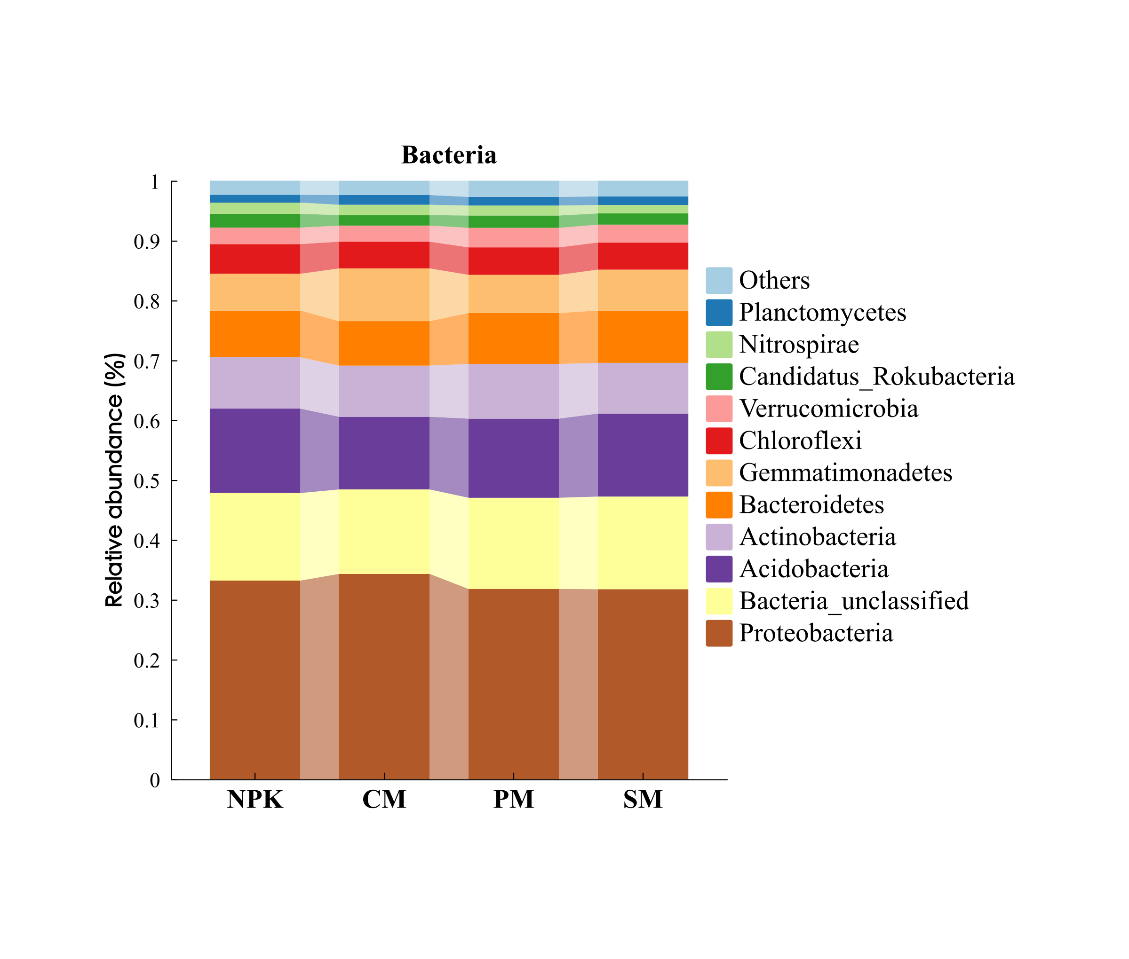
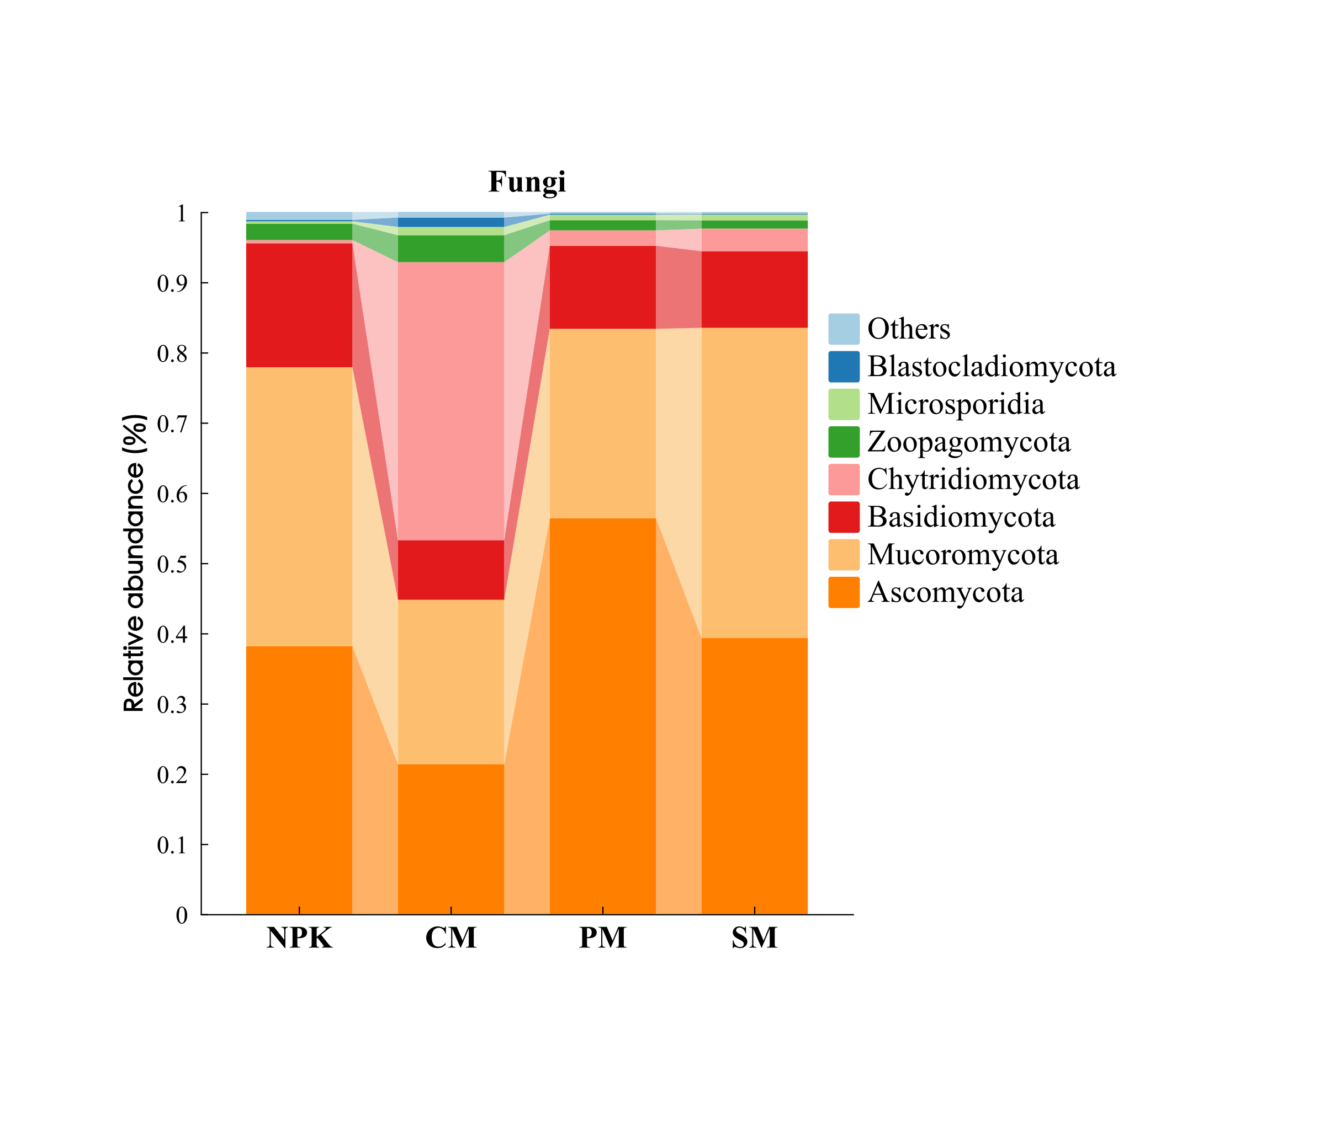
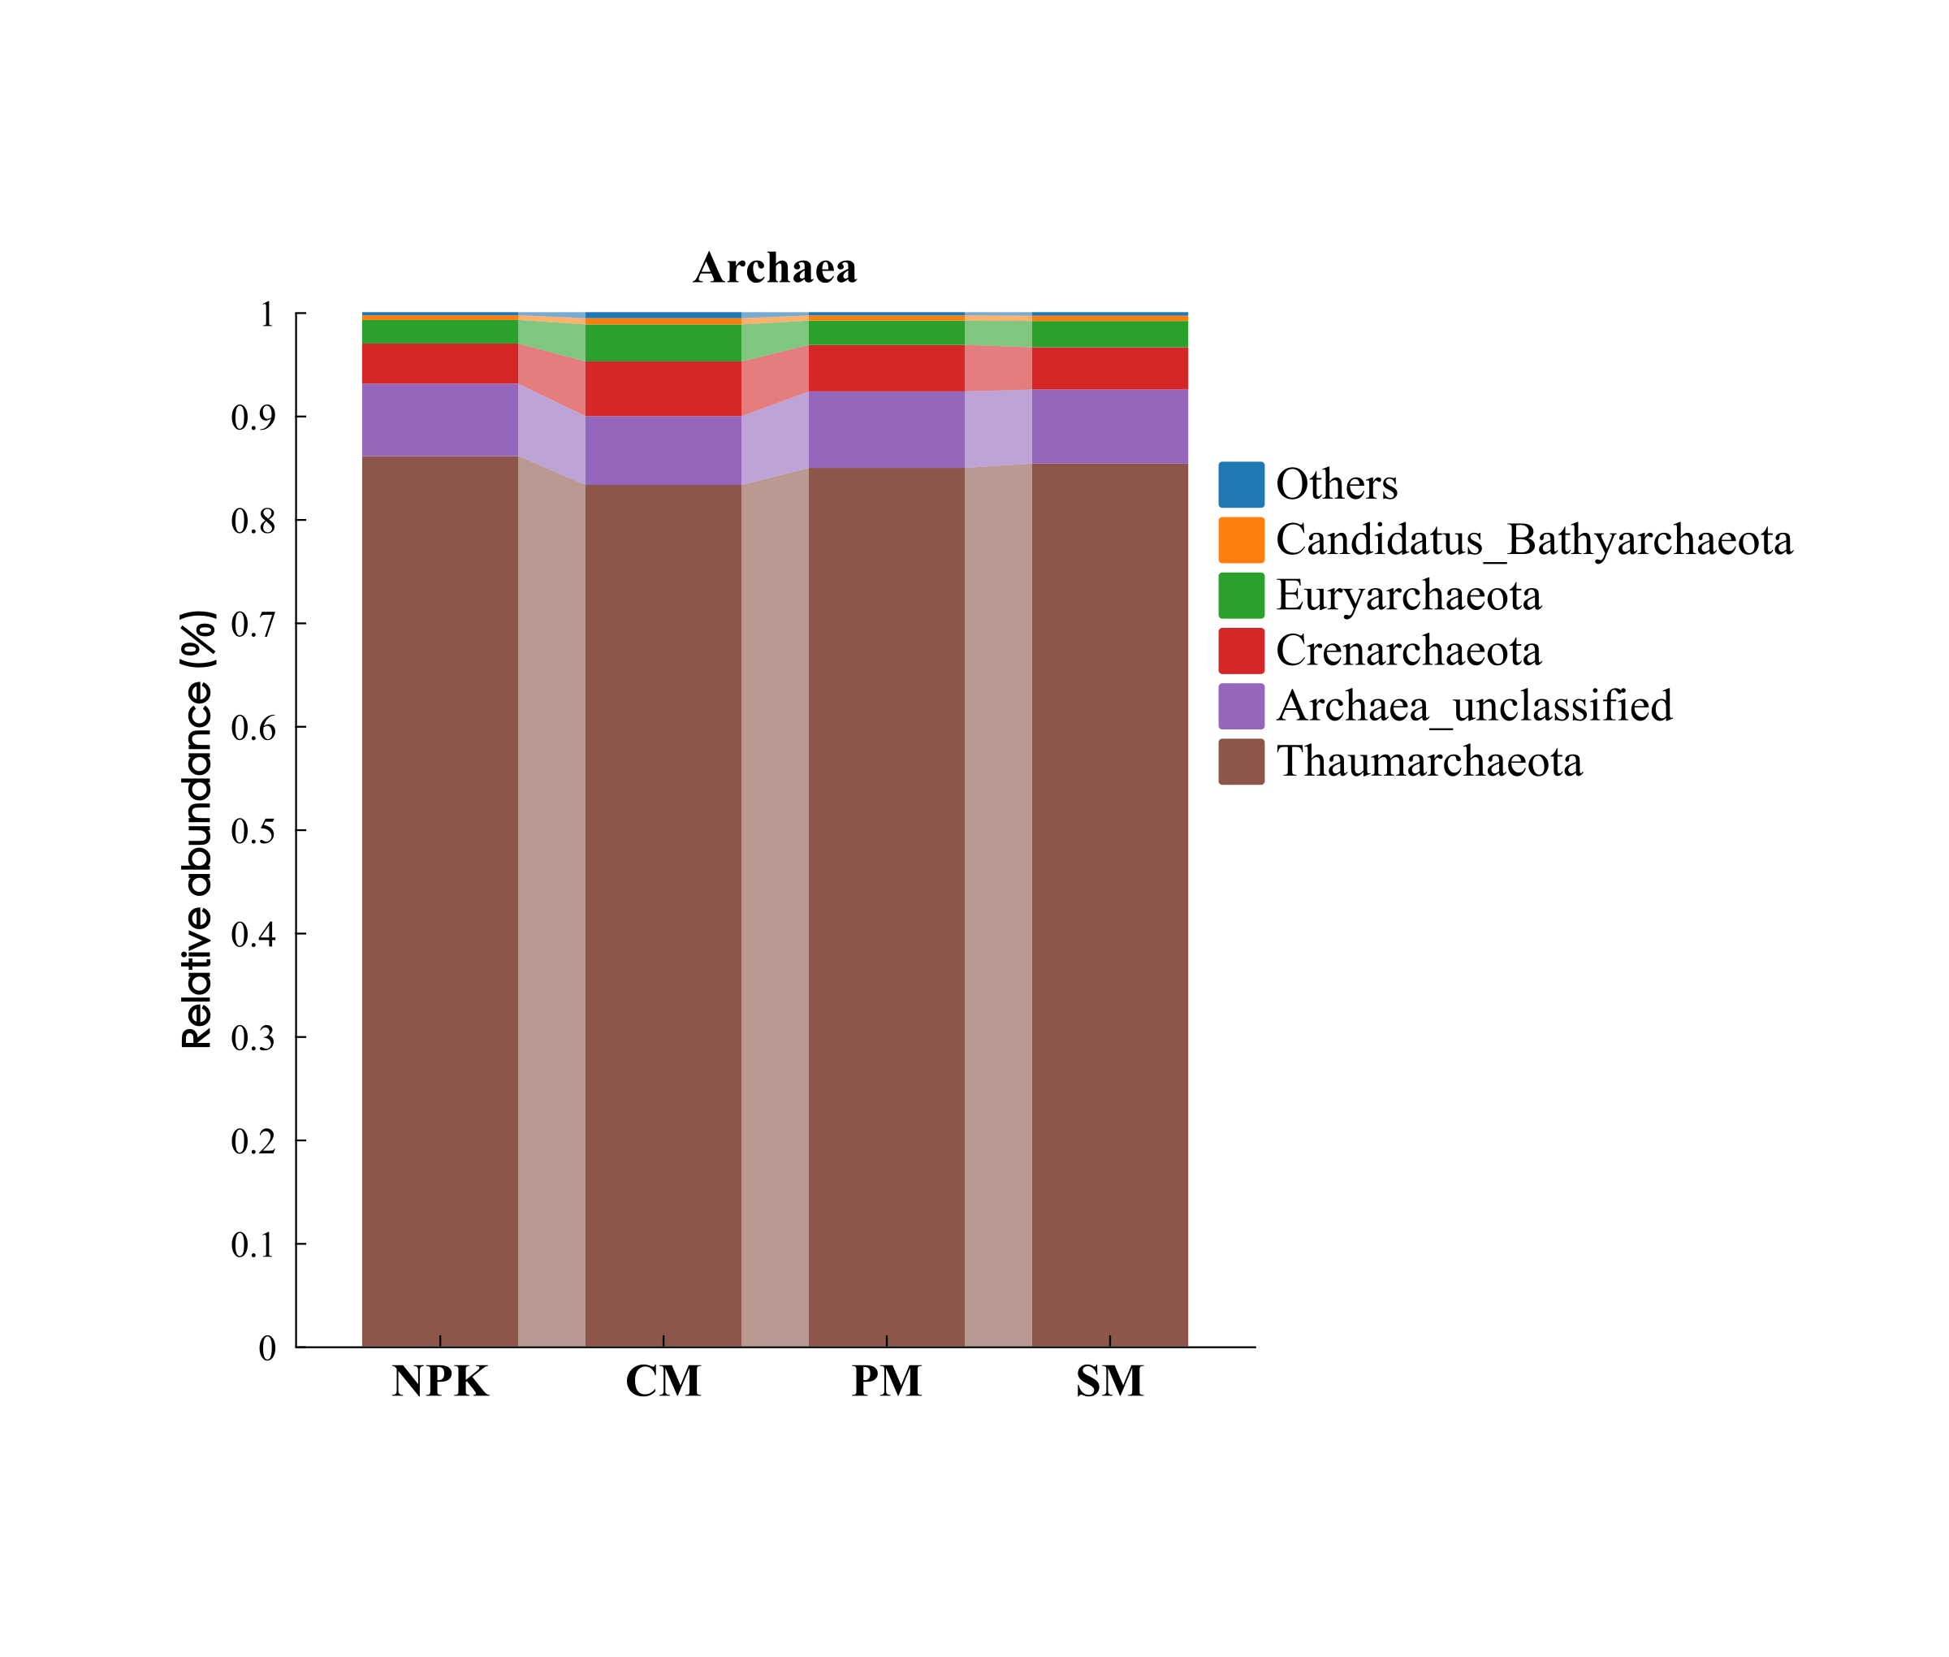
B
C
D
A

Fig. S3. Venn diagram based on unigenes level (A). The composition of bacterial (B), fungal (C), and archaeal (D) communities at the phylum level under different fertilization regimes. NPK: pure chemical fertilizer; CM: cow manure replacement; PM: pig manure replacement; SM: sheep manure replacement.

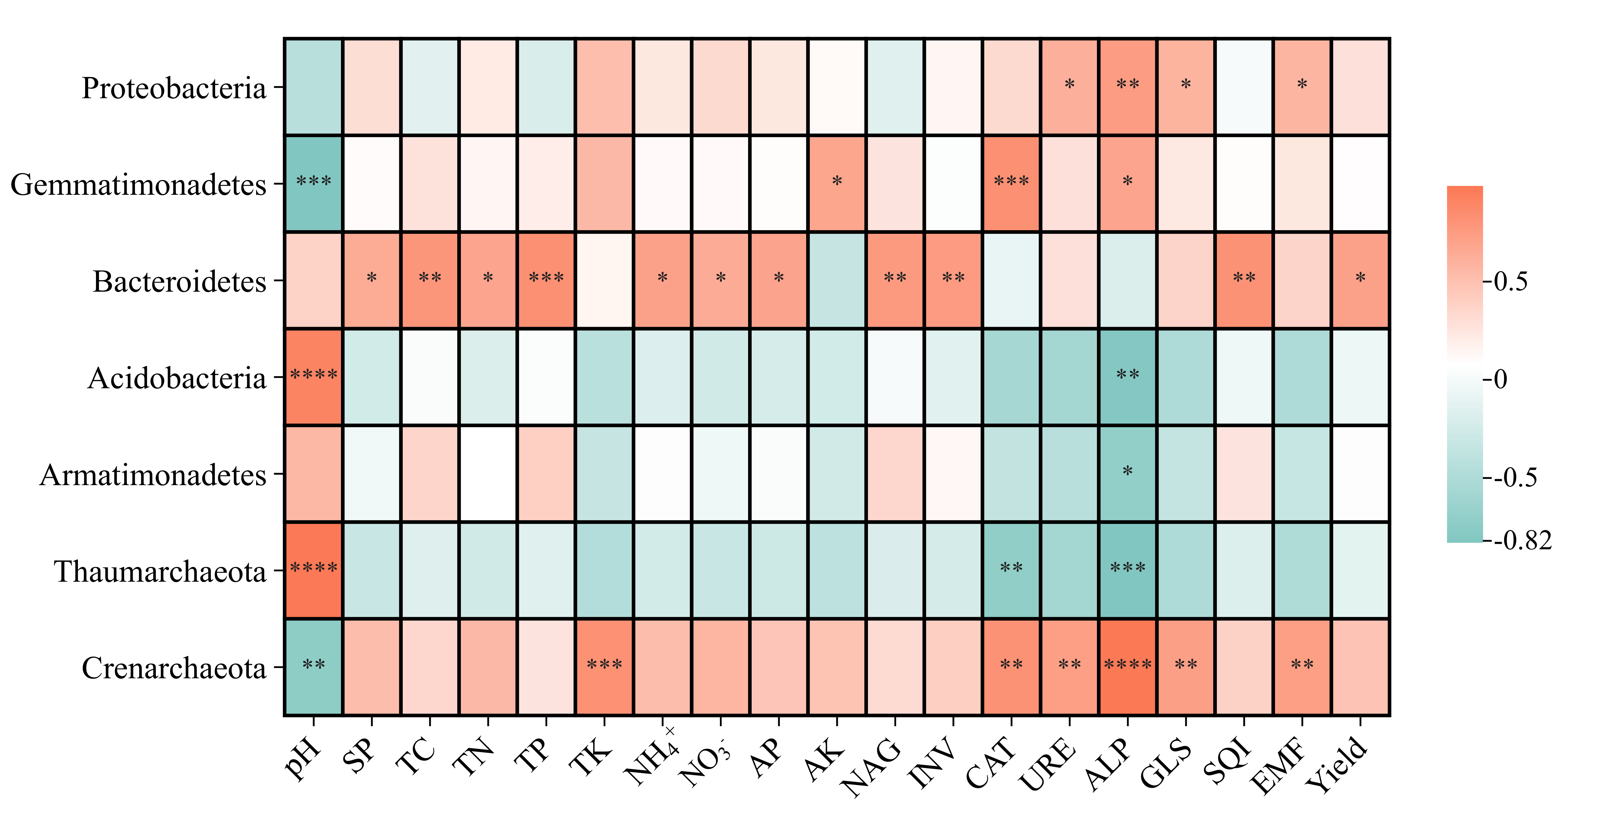

Fig. S4. Spearman's correlation analysis heat maps of soil physicochemical properties and key phyla relative abundance corresponding to the key nodes. TC, total organic carbon; TN, total nitrogen; TP, total phosphorus; TK, total potassium; NH₄⁺, ammonium nitrogen; NO₃⁻, nitrate nitrogen; AP, available phosphorus; AK, available potassium; ALP, soil alkaline phosphatase; NAG, β-N-acetylglucosaminidase; CAT, catalase; INV, invertase; URE, urease; GLS, glutaminase; SQI, soil quality index; EMF, ecological multifunctionality; Yield, the annual yield of foxtail millet grain in 2023. Asterisks indicate significantly different values: * p < 0.05; ** p < 0.01; *** p < 0.001; **** p < 0.001.

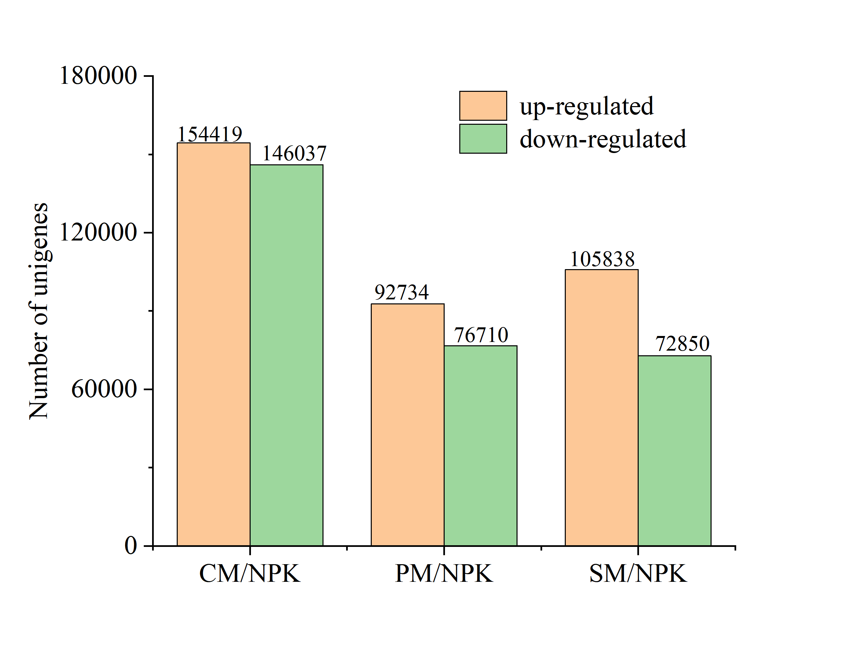

Fig. S5. The number of differentially expressed unigenes (DEGs) between inorganic fertilizer treatment and organic replacement treatments. NPK: pure chemical fertilizer; CM: cow manure replacement; PM: pig manure replacement; SM: sheep manure replacement.

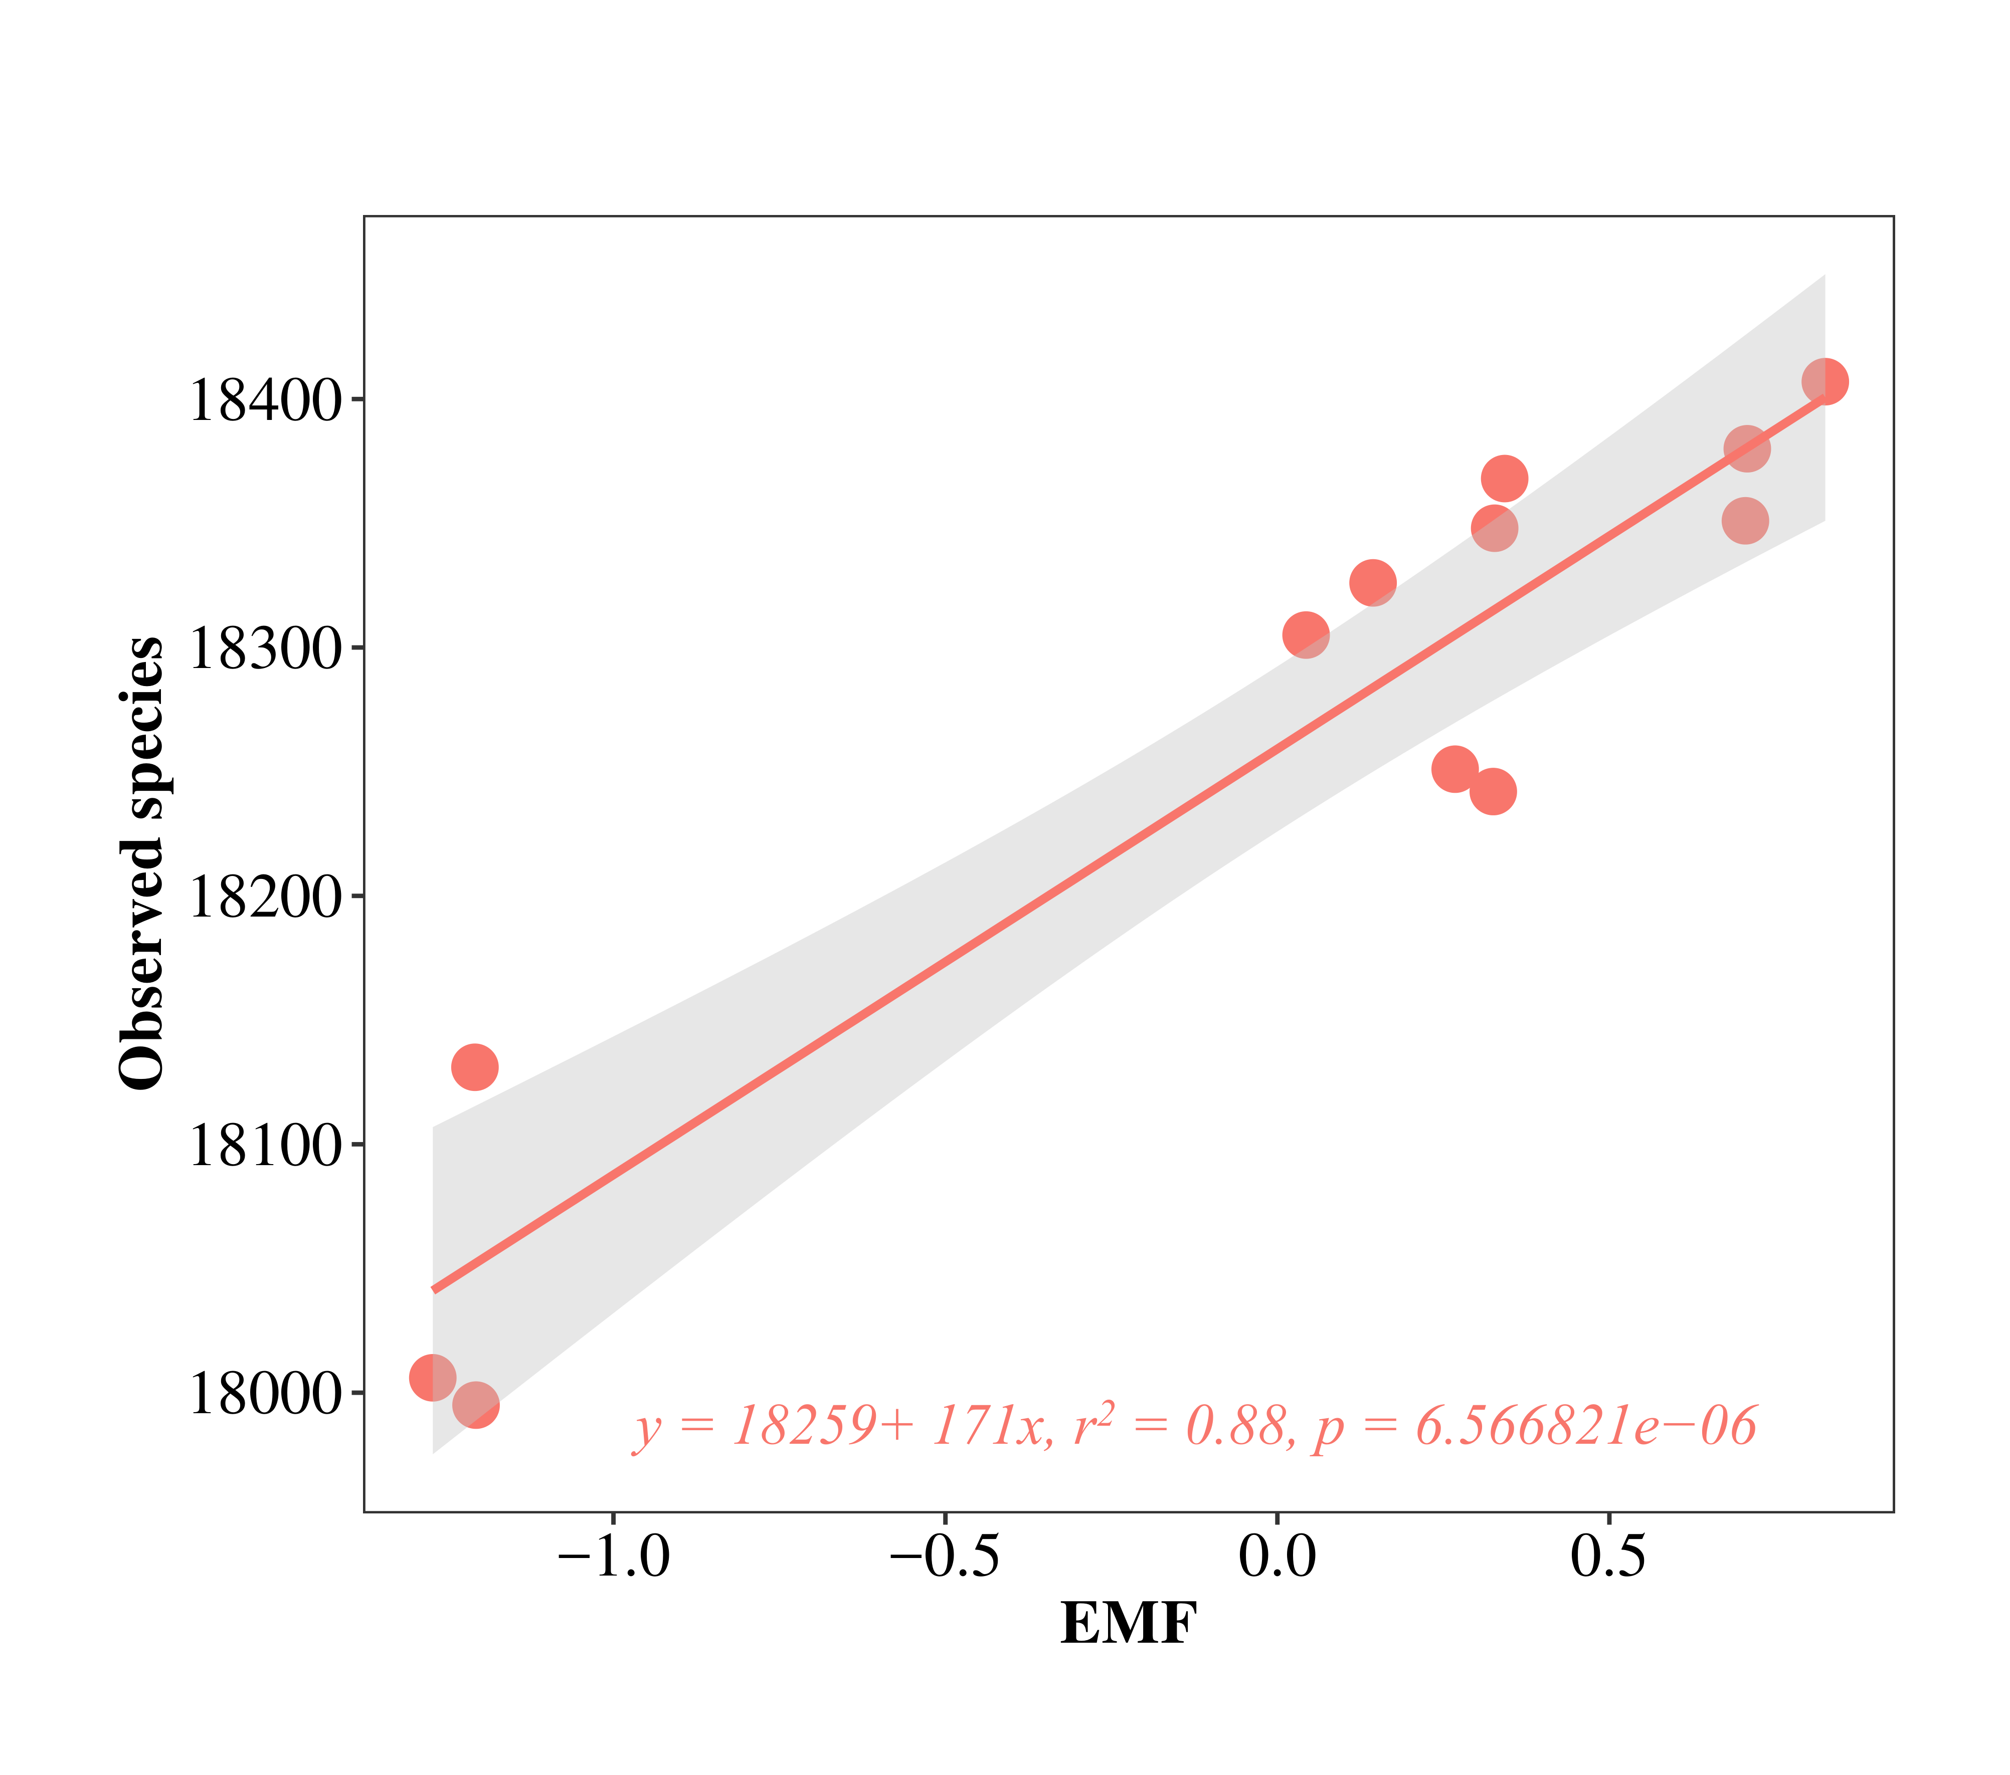
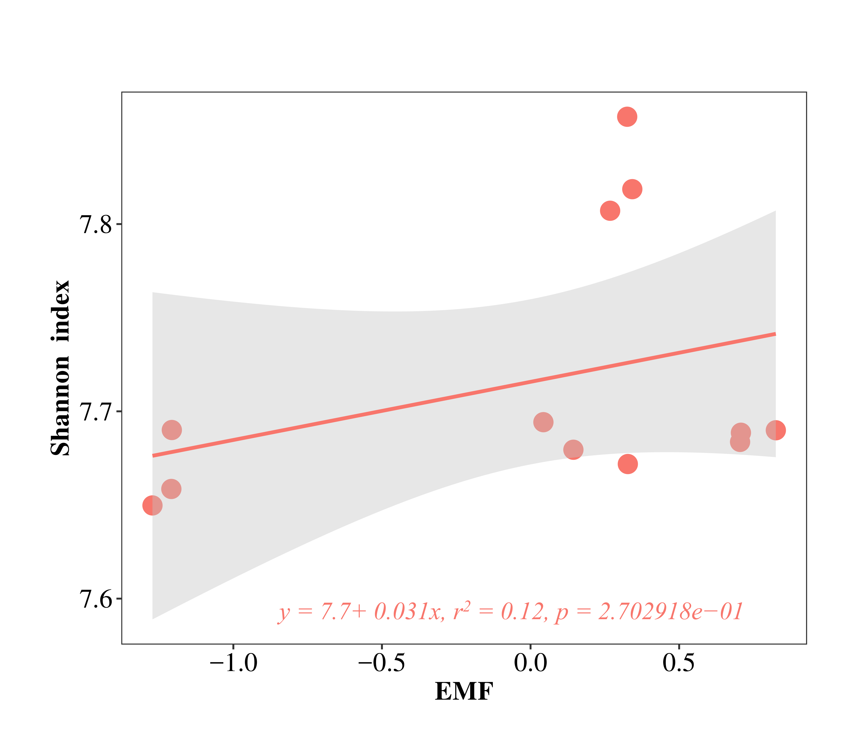
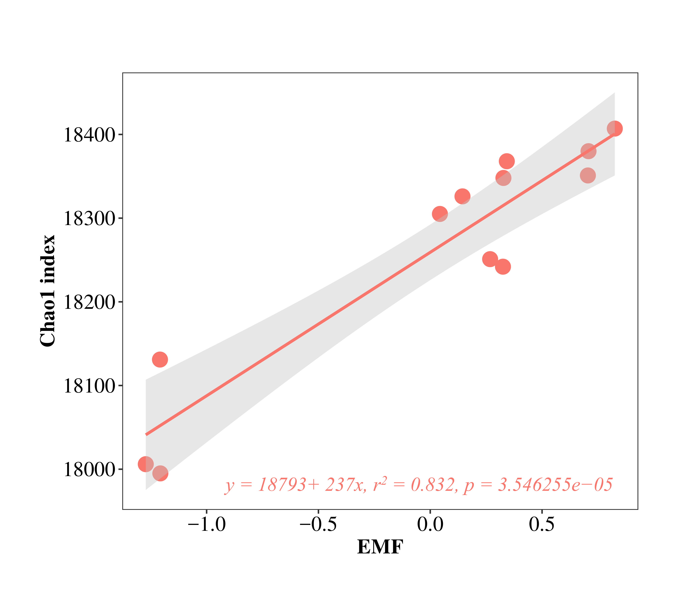

Fig. S6. The relationship between soil microbial functional diversity and EMF.

