Sex differences in cardiac recovery and ventricular gene expression in a rat model of donation after circulatory death
Anja Helmer^{1,2,3}, Alexia Clavier^{1,2,3}, Maria Arnold^{1,2}, Adrian Segiser^{1,2}, Heidi E. L. Lischer^{4,5}, Selianne Graf^{1,2,3}, Mojgan Masoodi⁶, Georgia Beer^{1,2,3}, Rahel Ottersberg^{1,2,3}, Manuel Egle^{1,2,3}, Matthias Siepe¹, Sarah Longnus^{1,2}

¹Department of Cardiac Surgery, Inselspital, Bern University Hospital, University of Bern, Bern, Switzerland
²Department for BioMedical Research, University of Bern, Bern, Switzerland
³Graduate School of Cellular and Biomedical Sciences, University of Bern, Bern, Switzerland
⁴Interfaculty Bioinformatics Unit, University of Bern, Bern, Switzerland
⁵Swiss Institute of Bioinformatics, Lausanne, Switzerland
⁶University Institute of Clinical Chemistry, Inselspital, Bern University Hospital, University of Bern, Bern, Switzerland

Corresponding author's contact information:
Assoc. Prof. Dr. Sarah Longnus
Email: sarah.henninglongus@insel.ch

Supplementary tables:
Characteristic | Females | Males | OVX
n | 31 | 35 | 36
Body weight [g] | 230 [210-250]^{p<0,0001 vs. M and OVX} | 390 [364-420]^{p<0,0001 vs.OVX} | 290 [271-298]
Heart weight [g] | 1,1 [0,1-1,1]^{p<,0001 vs. M; 0,0083 vs.OVX} | 1,6 [1,4-1,9]^{p<0,0001 vs. OVX} | 1,2 [1,1-1,3]
HW/BW Ratio [g/kg] | 4,6 [4,2-5,1] | 4,3 [3,8-4,5] | 4,3 [3,7-4,7]
OVX, Ovariectomized; HW, heart weight; BW, body weight; statistical analysis was performed by Kruskal-Wallis test and adjusted for multiple comparison by Dunn’s multiple comparison test; values are presented as median and interquartile range; n= 31-36 per sex
Supplementary Table S1: Base characteristics represented as median and interquartile range

Characteristic | Females | Males | OVX
n | 25 | 28 | 31
Systolic arterial pressure [mmHg] | 78,4 [74,7-80,9]^{p<0,0001 vs. M and OVX} | 91,9 [87,1-98,0] | 78,1 [74,6-84,6]
Heart rate [bpm] | 218,7 [201,2-234,7] | 227,9 [213,1-245,6] | 216,9 [194,8-231,2]
Pulse pressure [mmHg] | 29,8 [23,5-39,6] | 28,8 [15,2-36,5] | 29,9 [13,1-26,7]
Statistical analysis was performed by Kruskal-Wallis test and adjusted for multiple comparison by Dunn’s multiple comparison test; values are presented as median and interquartile range; n= 25-31 per sex
Supplementary Table S2: In situ hemodynamic measurements represented as median and interquartile range measured at BL:

 | BL |  |  | EI-0 |  |  | EI-22 |  |  | ER-0 |  |  | ER-22
 | Females | Males | OVX | Females | Males | OVX | Females | Males | OVX | Females | Males | OVX | Females | Males | OVX
n | 6 | 7 | 6 | 6 | 8 | 9 | 5 | 7 | 7 | 8 | 6 | 7 | 6 | 7 | 7
BW | 225 [215-258]^{p=0,0004 vs. M} | 380 [370-415] | 280 [249-290] | 237 [220-251]^{p=0,0026 vs. M} | 363 [357-390] | 290 [282-315] | 235 [215-275]^{p=0,0037 vs. M} | 415 [370-420] | 285 [263-300] | 237 [215-258]^{p=0,0003 vs. M} | 420 [368-440] | 278 [275-290] | 215 [202-231]^{p<0,0001 vs. M} | 402 [375-423] | 290 [288-300]
HW | 0,90 [0,5-1,2]^{p=0,023 vs. M} | 1,5 [1,4-1,5]^{p=0,0122} | 0,9 [0,9-1,1] | 1,1 [1,0-1,3] | 1,4 [1,3-1,7] | 1,1 [1,1-1,2] | 1,0 [0,9-1,3]^{p=0,0059 vs. M} | 1,8 [1,5-1,8] | 1,2 [1,1-1,3] | 1,0 [1,0-1,1]^{p=0,0003 vs. M} | 1,8 [1,6-2,0] | 1,2 [1,2-1,4] | 1,2 [0,9-1,4]^{p=0,0298 vs. M} | 1,9 [1,7-1,9] | 1,3 [1,2-1,5]
BW/HW | 4,43 [2,4-5,4] | 3,8 [3,5-3,9] | 3,9 [3,3-4,1] | 4,9 [4,1-5,1] | 3,7 [3,6-4,4] | 3,8 [3,6-4,2] | 4,3 [4,2-4,8] | 4,3 [4,1-4,3] | 4,3 [3,9-4,9] | 4,4 [4,2-4,8] | 4,5 [4,1-4,7] | 4,3 [4,1-5,1] | 5,6 [4,2-6,2] | 4,5 [4,2-4,9] | 4,8 [4,3-5,0]
PSP | - | - | - | 98,3 [85,7-103,8] | 109,6 [96,6-119,3]^{p=0,0262 vs. OVX} | 88,8 [83-8-96,5] | 100,4 [88,7-103,5] | 106,7 [99,9-123,3] | 96,3 [85,9-111,6] | 90,2 [86,0-101,4] | 107,5 [96,1-113,2] | 92,5 [87,9-100,5] | 89,0 [86,7-100,3] | 103,0 [91,3-125,7] | 97,0 [88,2-108,2]
MAP | - | - | - | 78,3 [73,6-28,3]^{p=0,0312 vs. M} | 94,6 [87,3-99,4]^{p=0,0029 vs. OVX} | 77,2 [72,6-82,9] | 79,3 [74,5-82,5] | 89,4 [87,1-109,5] | 82,5 [74,6-89,3] | 76,4 [73,1-80,7] | 89,6 [86,3-92,1] | 78,1 [73,3-79,5] | 78,1 [61,6-85,6]^{p=0,0130 vs. M} | 95,4 [90,7-100,3] | 81,3 [76,1-92,8]
PP | - | - | - | 31,7 [21,5-38,1] | 23,3 [14,4-36,7] | 26,5 [12,9-36,6] | 40,2 [37,8-45,7] | 27,4 [17,4-36,2] | 33,8 [13,1-38,4] | 28,5 [24,5-42,8] | 31,2 [23,6-38,1] | 33,5 [19,4-36,8] | 23,2 [19,9-29,2] | 20,1 [10,5-46,3] | 28,6 [12,7-37,6]
HR | - | - | - | 222,60 [202,8-237,9] | 232,3 [207,0-249,8] | 222,1 [198,1-231,7] | 228,6 [212,2-244,7] | 213,5 [205,7-246,4] | 216,90 [192,40-270,90] | 217,8 [200,8-235,5] | 237,8 [223,8-250,2] | 209,4 [190,5-226,8] | 205,5 [187,5-232,1] | 227,1 [184,5-243,7] | 217,1 [207,3-243,4]
Supplementary Table S3: Base characteristics and in situ hemodynamic measurements represented as median and interquartile range measured at BL:
statistical analysis was performed by Kruskal-Wallis test and adjusted for multiple comparison by Dunn’s multiple comparison test; BL, baseline (control timepoint); EI-0, end ischemia timepoint without in-situ ischemia; EI-22, end ischemia timepoint with 22 minutes of ischemia; ER-0, end reperfusion timepoint without in-situ ischemia; ER-22, end reperfusion timepoint with 22 minutes of ischemia; values are presented median and interquartile range; n= 5-9 per group

Ensembl | Gene Symbol | log2FoldChange | Adjusted p value | Comparison
ENSRNOG00000015880 | Dpep1 | -0,818410844 | 1,92783E-11 | F vs. M
ENSRNOG00000006119 | Slc7a15 | -0,743882344 | 2,0782E-10 | F vs. M
ENSRNOG00000002488 | Galnt10 | -0,527902863 | 6,21301E-10 | F vs. M
ENSRNOG00000068017 | Fam78b | 0,559684143 | 1,25534E-09 | F vs. M
ENSRNOG00000028822 | Bex3 | 0,424004278 | 4,30146E-09 | F vs. M
ENSRNOG00000061910 | Igfbp3 | 0,606963039 | 2,58519E-08 | F vs. M
ENSRNOG00000016055 | Fkrp | 0,257687959 | 1,26971E-06 | F vs. M
ENSRNOG00000068261 | Pacrg | -0,646259417 | 1,55858E-06 | F vs. M
ENSRNOG00000008074 | Cyp11a1 | -0,585422352 | 2,70995E-06 | F vs. M
ENSRNOG00000019453 | Rps5 | 0,255123605 | 2,95618E-06 | F vs. M
ENSRNOG00000006947 | Pdhx | -0,292282491 | 3,2388E-06 | F vs. M
ENSRNOG00000024207 | Fgfrl1 | 0,448567622 | 8,27735E-06 | F vs. M
ENSRNOG00000023383 | Ddx3x | 0,463779767 | 8,51297E-06 | F vs. M
ENSRNOG00000012934 | Arhgef7 | -0,248916417 | 1,844E-05 | F vs. M
ENSRNOG00000011425 | Ptpn3 | -0,365436699 | 2,01117E-05 | F vs. M
ENSRNOG00000018019 | Hspa12a | -0,358504353 | 2,36374E-05 | F vs. M
ENSRNOG00000018319 | Pisd | -0,252836023 | 2,36374E-05 | F vs. M
ENSRNOG00000053172 | Ssr4 | 0,229749477 | 2,36374E-05 | F vs. M
ENSRNOG00000003549 | Cnpy2 | 0,201426638 | 3,6531E-05 | F vs. M
ENSRNOG00000007650 | Cd63 | 0,235066575 | 3,6531E-05 | F vs. M
ENSRNOG00000016558 | Pllp | -0,500081408 | 3,75725E-05 | F vs. M
ENSRNOG00000019473 | Dcun1d2 | -0,260426588 | 4,67712E-05 | F vs. M
ENSRNOG00000017781 | Dnajc7 | -0,225925916 | 5,26197E-05 | F vs. M
ENSRNOG00000056457 | Gpd1 | -0,337860365 | 7,53031E-05 | F vs. M
ENSRNOG00000004072 | Myo1c | -0,222648747 | 8,11955E-05 | F vs. M
ENSRNOG00000029662 | Wdfy4 | -0,555029842 | 8,11955E-05 | F vs. M
ENSRNOG00000031273 | Rpl27al7 | 0,367753013 | 9,73625E-05 | F vs. M
ENSRNOG00000022043 | Yipf2 | 0,29539669 | 0,000100739 | F vs. M
ENSRNOG00000011994 | Perp | 0,365126397 | 0,000134278 | F vs. M
ENSRNOG00000002125 | Ccni | 0,273309178 | 0,000149837 | F vs. M
ENSRNOG00000003884 | Acmsd | -0,542357211 | 0,000149837 | F vs. M
ENSRNOG00000023664 | Lepr | 0,511130278 | 0,000149837 | F vs. M
ENSRNOG00000001135 | Wsb2 | -0,29885992 | 0,000171405 | F vs. M
ENSRNOG00000013023 | Nop53 | 0,270342616 | 0,000171405 | F vs. M
ENSRNOG00000019959 | Kcnc3 | -0,48827747 | 0,000171405 | F vs. M
ENSRNOG00000001177 | Acads | -0,346057912 | 0,000171581 | F vs. M
ENSRNOG00000071101 | Tmem127 | -0,22429057 | 0,000171581 | F vs. M
ENSRNOG00000016483 | Myo16 | -0,52741481 | 0,000177522 | F vs. M
ENSRNOG00000010298 | Xbp1 | 0,375536863 | 0,000177853 | F vs. M
ENSRNOG00000059344 | Tpcn1 | -0,247915527 | 0,000177853 | F vs. M
ENSRNOG00000055450 | Ckmt2 | -0,207795285 | 0,000194713 | F vs. M
ENSRNOG00000004337 | Fam20b | -0,209863257 | 0,000219837 | F vs. M
ENSRNOG00000005061 | Dlst | -0,212318926 | 0,000233933 | F vs. M
ENSRNOG00000006957 | Gria4 | 0,516293876 | 0,000258586 | F vs. M
ENSRNOG00000028047 | Mecr | -0,229536012 | 0,000258586 | F vs. M
ENSRNOG00000070974 | Rpl7a | 0,220645867 | 0,000273548 | F vs. M
Supplementary Table S4: Top 50 significantly different expressed genes between at ER-22:

Ensembl | Gene Symbol | log2FoldChange | Adjusted p value | Comparison
ENSRNOG00000004466 | Fam210b | -0,266502191 | 0,000306938 | F vs. M
ENSRNOG00000009333 | Osgep | 0,335677386 | 0,000306938 | F vs. M
ENSRNOG00000057378 | Clec16a | -0,253729373 | 0,000306938 | F vs. M
ENSRNOG00000002615 | Pmm2 | -0,271898895 | 0,000313095 | F vs. M
ENSRNOG00000003884 | Acmsd | -0,5867148 | 0,000603605 | F vs. OVX
ENSRNOG00000068017 | Fam78b | 0,387373297 | 0,005079134 | F vs. OVX
ENSRNOG00000048712 | Ccdc137 | 0,374881562 | 0,01994196 | F vs. OVX
ENSRNOG00000061910 | Igfbp3 | 0,412580997 | 0,01994196 | F vs. OVX
ENSRNOG00000025388 | Mrpl33 | 0,238726669 | 0,034812756 | F vs. OVX
ENSRNOG00000047656 | Gaa | -0,246597588 | 0,034812756 | F vs. OVX
ENSRNOG00000002488 | Galnt10 | -0,30674579 | 0,047508924 | F vs. OVX
ENSRNOG00000008965 | Socs2 | 0,296797544 | 0,049905161 | F vs. OVX
ENSRNOG00000019453 | Rps5 | 0,278492646 | 0,049905161 | F vs. OVX
FDR < 0,05; log2-fold change <-0,2 or >0,2; statistical significance was assessed using Student's t-test and adjusted for multiple testing n by Benjamini-Hochberg correction; X and Y chromosomal genes were excluded; F, females; M, males; OVX, ovariectomized; n = 6-8 per group

Supplementary figures:
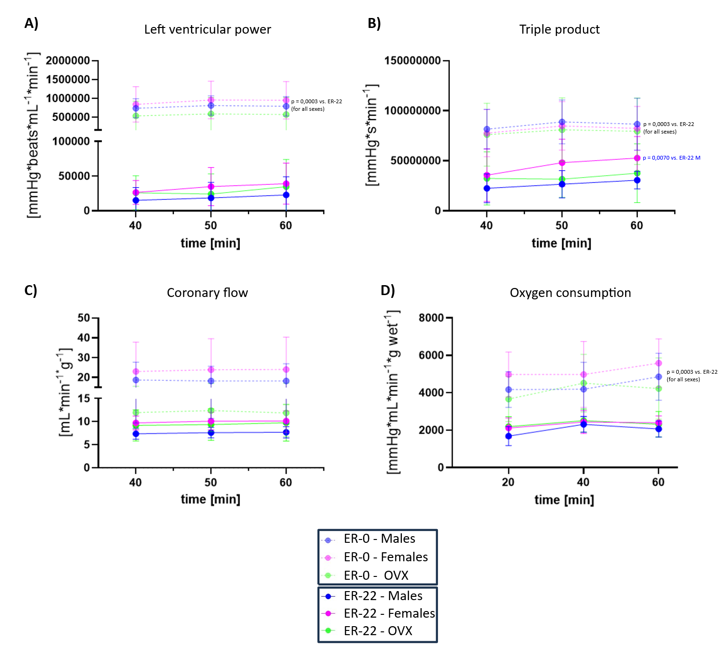
Supplementary Figure S1: Left ventricular cardiac recovery: Cardiac recovery measurements during loaded reperfusion. A) Left ventricular power, B) Triple products, C) Coronary flow, D) Oxygen consumption; ER-0, end reperfusion timepoint without in-situ ischemia; ER-22, end reperfusion timepoint with 22 minutes of ischemia; OVX, ovariectomized; statistical significance was performed by linear regression analysis and adjusted for multiple comparison by the modified, sequential, rejective Bonferroni procedure; values are presented as means ±SD; n = 6-8 per group

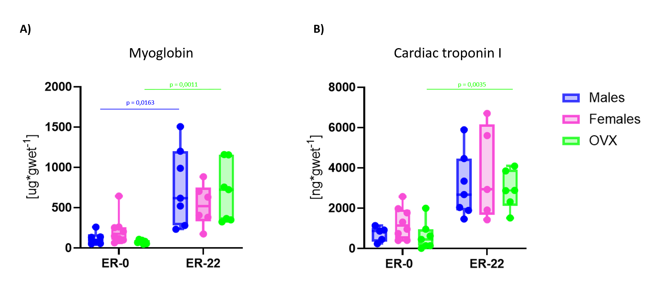
Supplementary Figure S2: Release of myocardial cell death markers myoglobin and cardiac troponin I during reperfusion; A) Myoglobin in recirculating perfusate after 60 minutes of reperfusion in timepoints ER-0 and ER-22 in females, males and OVX rats, B) Cardiac troponin I in recirculating perfusate after 60 minutes of reperfusion in timepoints ER-0 and ER-22 in females, males and OVX rats; ER-0, end reperfusion timepoint without in-situ ischemia; ER-22, end reperfusion timepoint with 22 minutes of ischemia; OVX, ovariectomized; statistical analysis was performed by Kruskal-Wallis test followed by Dunn’s multiple comparison test; values are presented as median with interquartile range; n = 6-8 per group

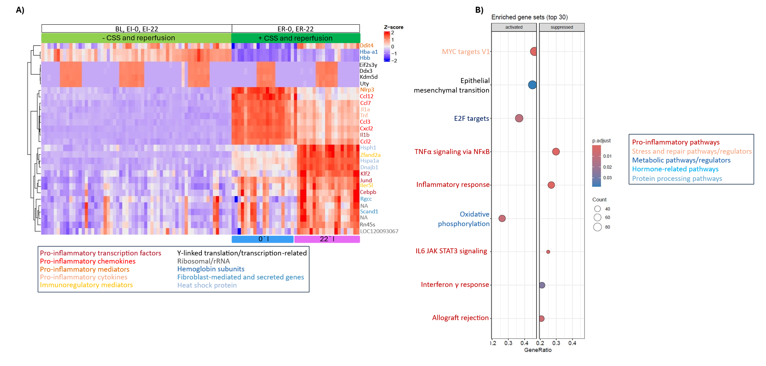
Supplementary Figure S3: Bulk RNA Sequencing data overview. A) Heat map representing the top 30 differentially expressed genes of PC2 B) Gene set enrichment analysis of differentially expressed genes in PC2; genes and pathways are colour coded according to cellular process; BL, baseline (control timepoint); EI-0, end ischemia timepoint without in-situ ischemia; EI-22, end ischemia timepoint with 22 minutes of ischemia; ER-0, end reperfusion timepoint without 0 in-situ ischemia; ER-22, end reperfusion timepoint with 22 minutes of ischemia; CSS, cold static storage; GSEA, gene set enrichment analysis; MSigDB, The Molecular Signature Database; n= 5-9 per group; n= 19-23 per timepoint

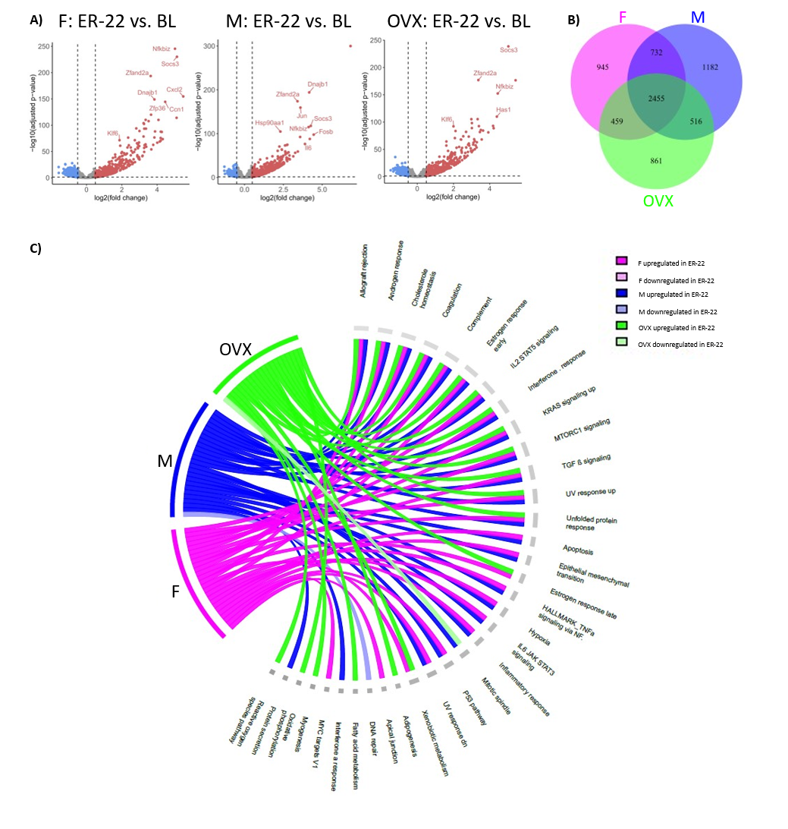
Supplementary Figure S4: Comparison of differential gene expression between ER-22 and BL: A) Volcano plots of differentially expressed genes between ER-22 and BL for females, males and OVX (FDR <0,05; log 2-fold change > 0,5 or < -0,5). B) Venn diagram of differentially expressed genes (all genes are represented as up-regulated) between ER-22 and BL of all three sexes. C) GSEA chord plot of all MSigDB pathways significantly differentially expressed between ER-22 and BL timepoint; Statistical significance was assessed using Student's t-test and adjusted for multiple testing by Benjamini-Hochberg correction; BL, baseline; ER-22, end reperfusion timepoint with 22 minutes of ischemia; GSEA, gene set enrichment analysis; MSigDB, The Molecular Signature Database; F, females; M, males; OVX, ovariectomized; FDR, false discovery rate n= 6-8 per group

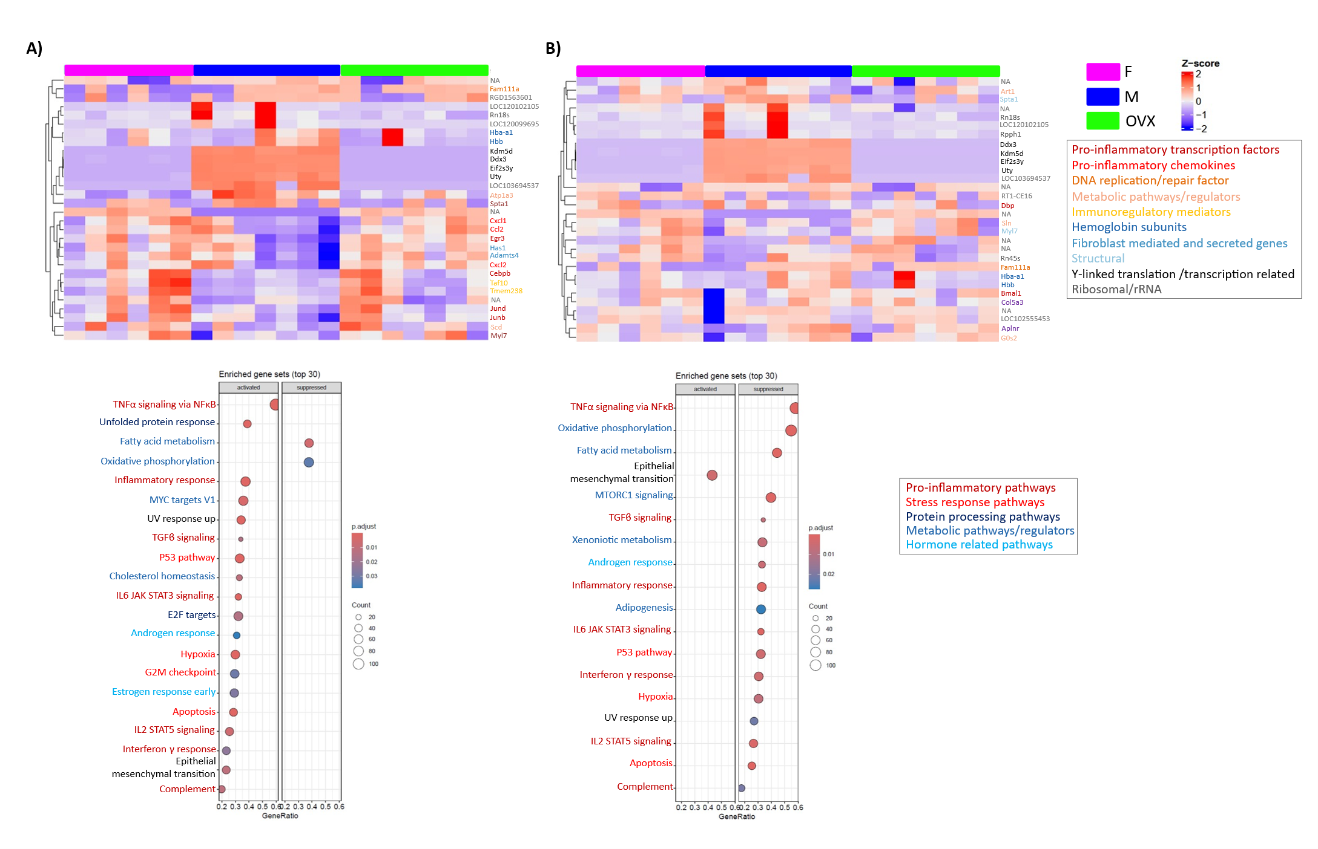
Supplementary Figure S5: Sex differences at ER-22: Sex differences after simulated DCD, CSS and reperfusion: A) Heat map representing the top 30 differentially expressed genes of PC1 and GSEA (MSigDB) of PC2 B) Heat map representing the top 30 differentially expressed genes of PC2 and GSEA (MSigDB) of PC2; genes and pathways are colour coded according to cellular process; F, females; M, males; OVX, ovariectomized; CSS, Cold static storage; DCD; Donation after circulatory death; GSEA, gene set enrichment analysis; MSigDB The Molecular Signature Database; n= 6-8 per group

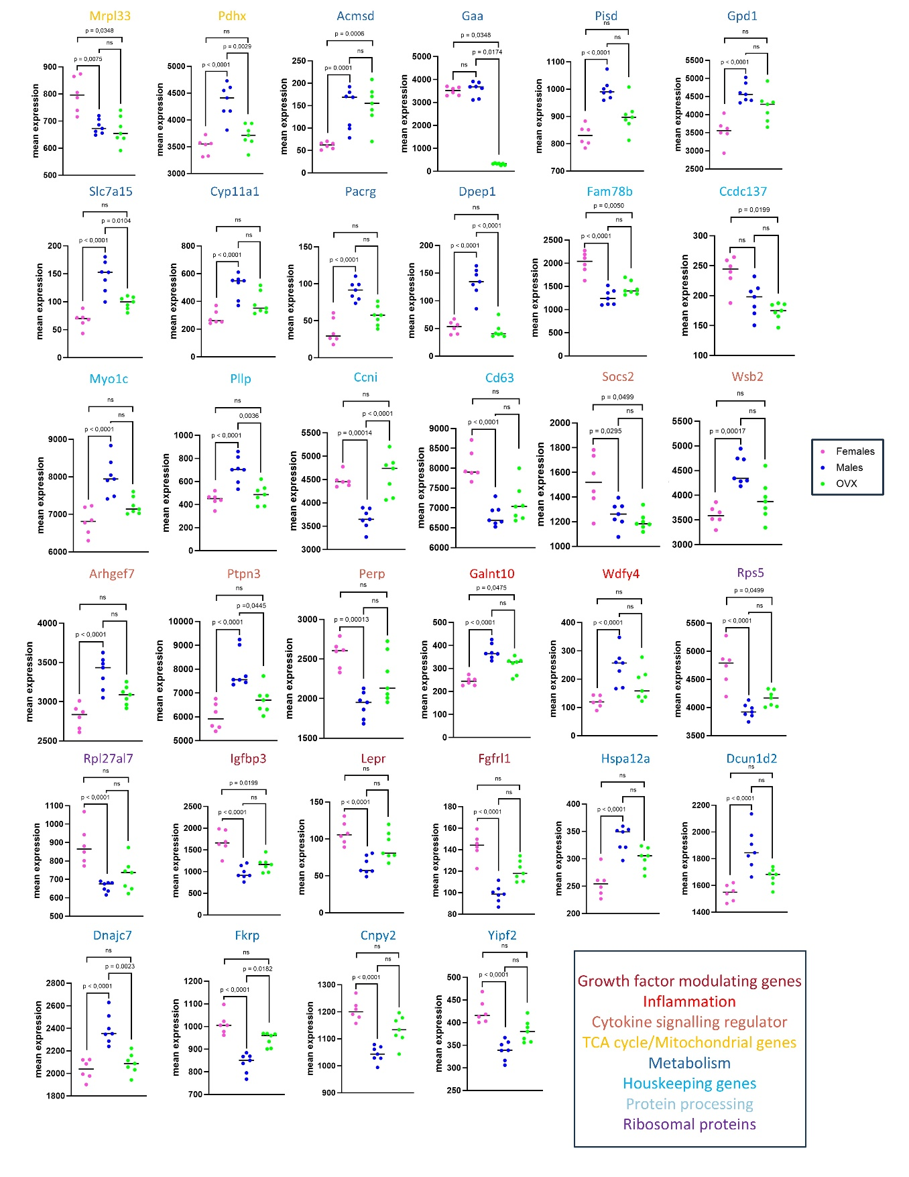

Supplementary Figure S6: Sex differences at ER-22: Sex differences after simulated DCD, CSS and reperfusion: Normal expression values of top 30 differentially expressed genes (FDR < 0,05; log2-fold change <-0,2 or >0,2 ); Genes and pathways are colour coded according to cellular process; Statistical significance was assessed using Student's t-test and adjusted for multiple testing by Benjamini-Hochberg correction; ER-22, end reperfusion timepoint with 22 minutes of in-situ ischemia; F, females; M, males; OVX, ovariectomized; CSS, Cold static storage; DCD; Donation after circulatory death; Values are depicted as individual values with mean indicated; n= 6-8 per group
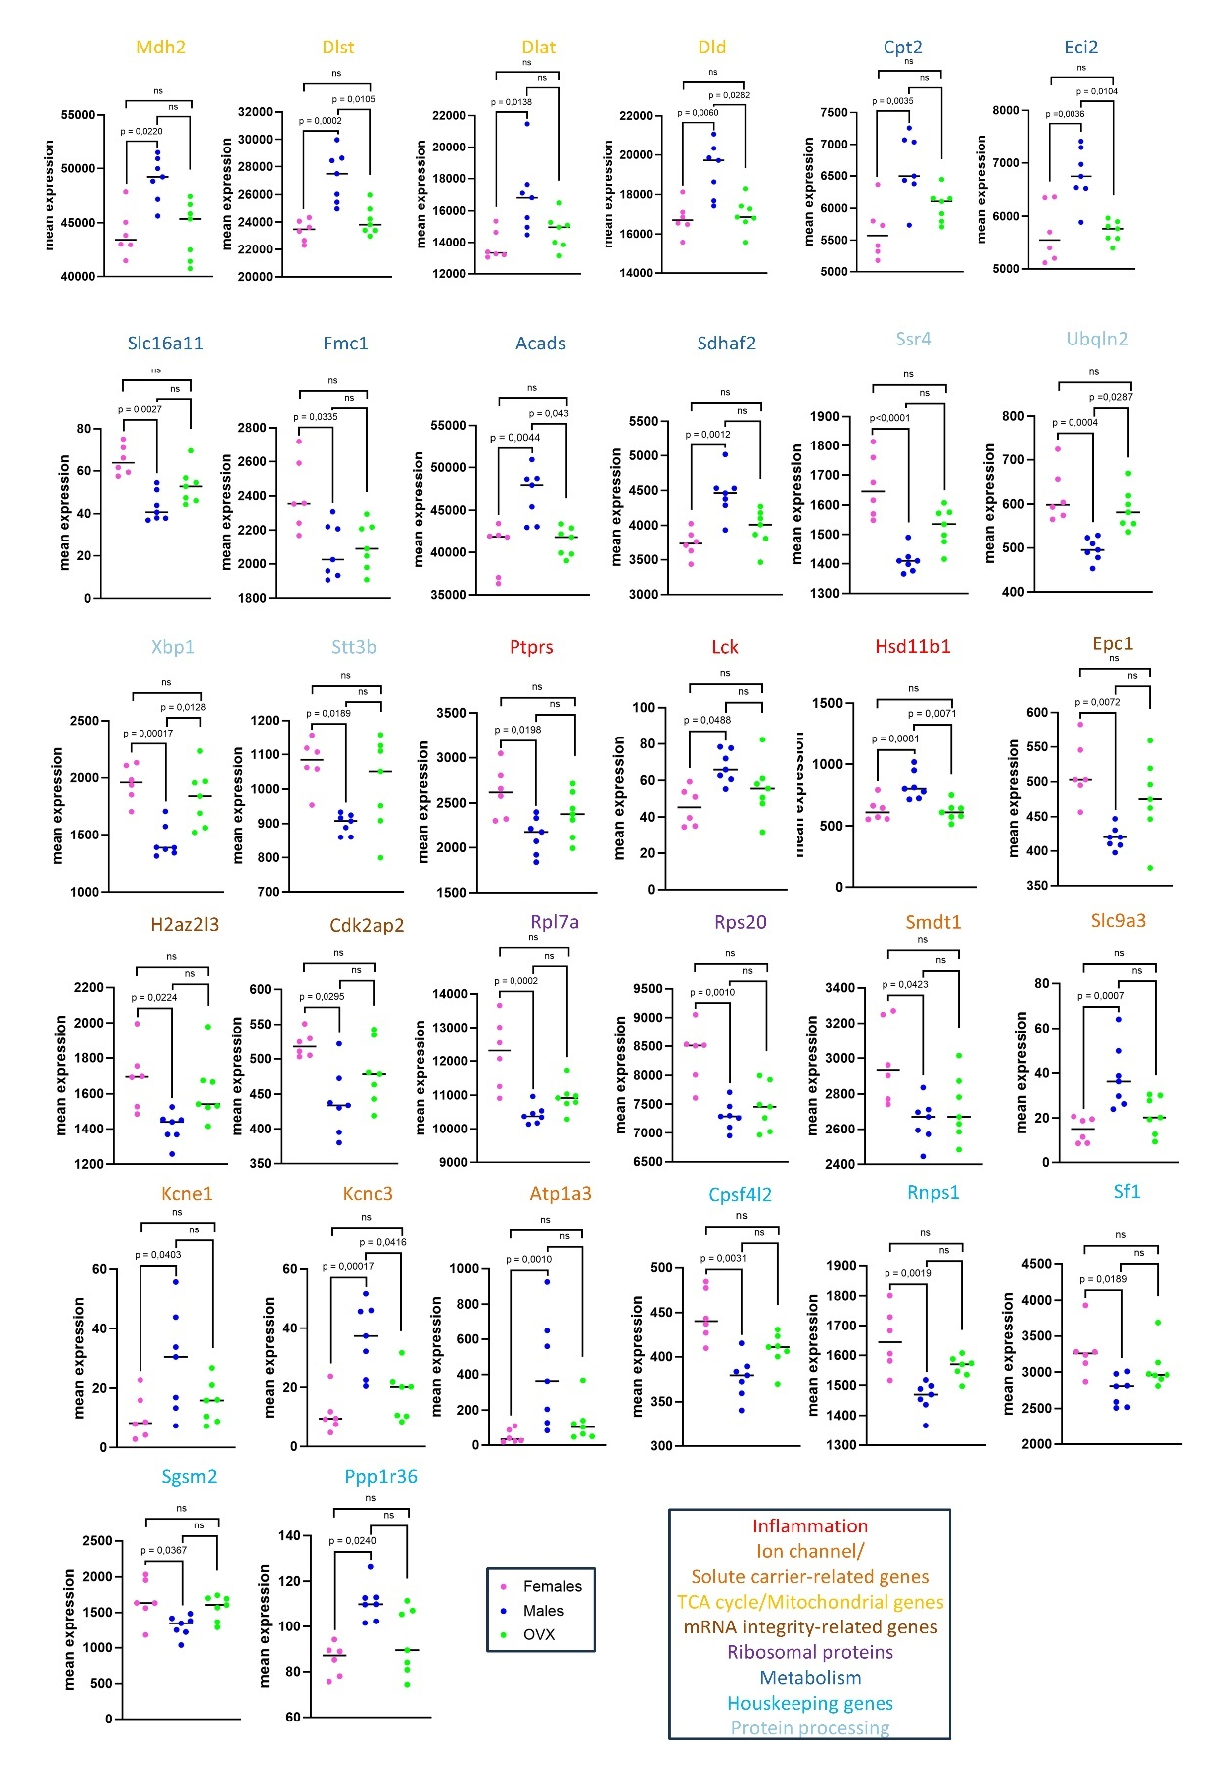

Supplementary Figure S7: Sex differences at ER-22: Sex differences after simulated DCD, CSS and reperfusion: Normal expression values of significantly differentially expressed genes between females and males after DCD induced IRI (FDR < 0,05; log2-fold change <-0,2 or >0,2 ); Genes and pathways are colour coded according to cellular process; Statistical significance was assessed using Student's t-test and adjusted for multiple testing by Benjamini-Hochberg correction; ER-22, end reperfusion timepoint with 22 minutes of in-situ ischemia; F, females; M, males; OVX, ovariectomized; CSS, Cold static storage; DCD; Donation after circulatory death; Values are depicted as individual values with mean indicated; n= 6-8 per group

