Supplementary figures
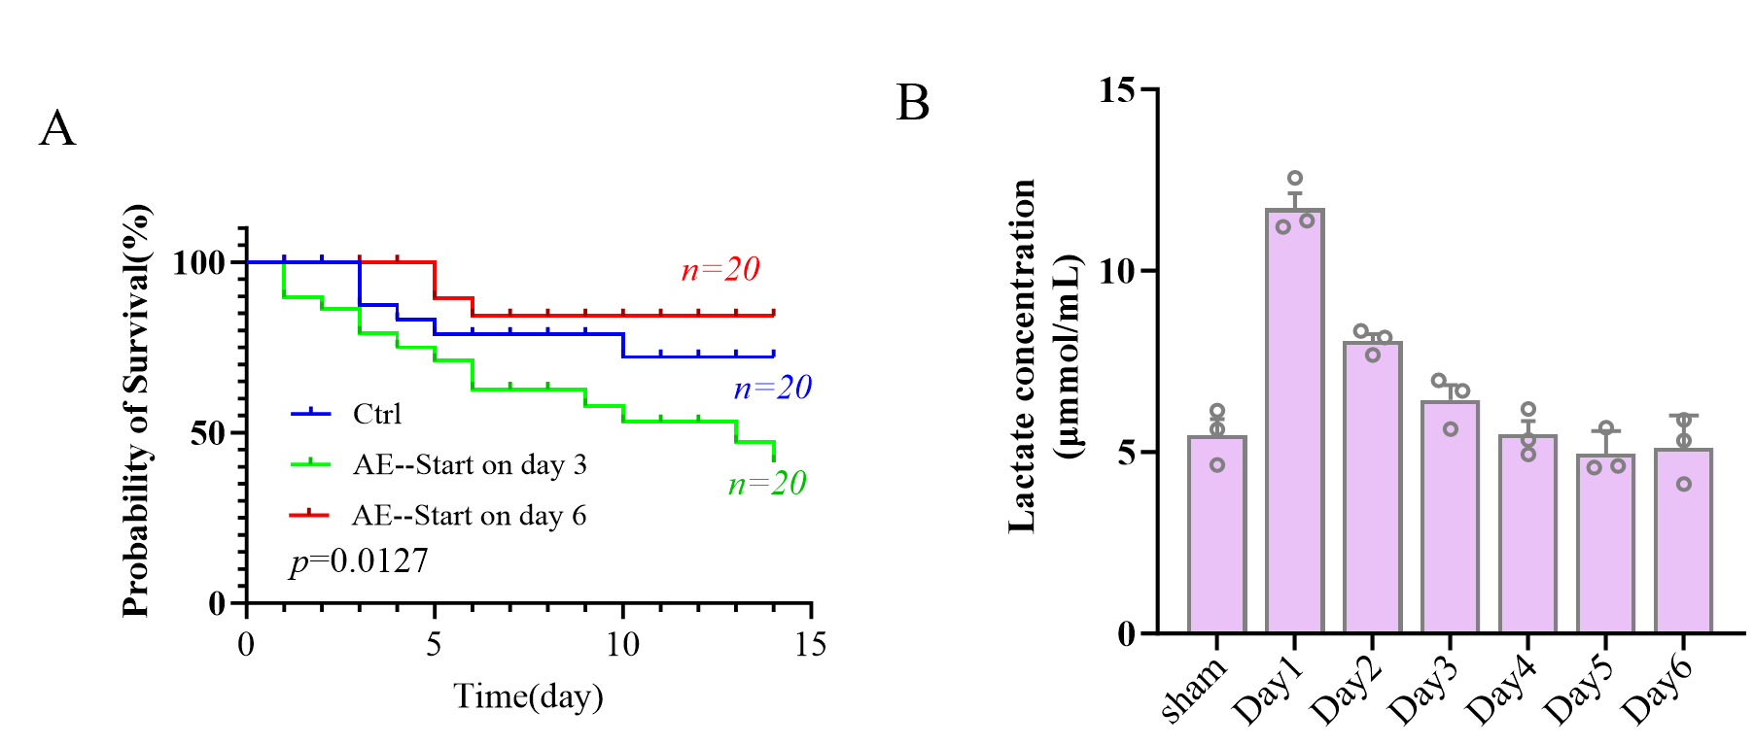
Figure S1 Premature exercise following ischemia exacerbates brain injury.
A Mice that commenced aerobic exercise on the third day following ischemia stroke exhibited a lower survival rate than those that began exercise on the sixth day. B Changes in brain lactate levels in mice within one week following ischemia stroke. n=3 per group.
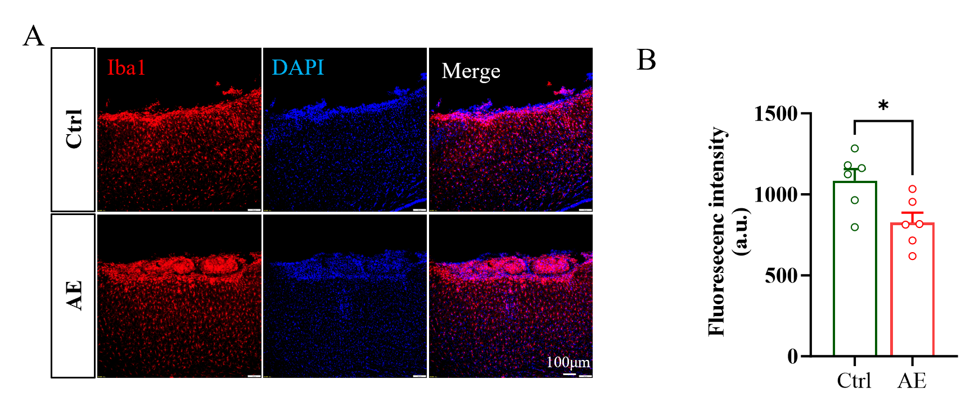
Figure S2 Microglial morphology differed significantly in exercise/lactate groups vs control/DCA+AE groups in the ischemic penumbra, indicating attenuated inflammatory responses. Scale bar, 100 μm.
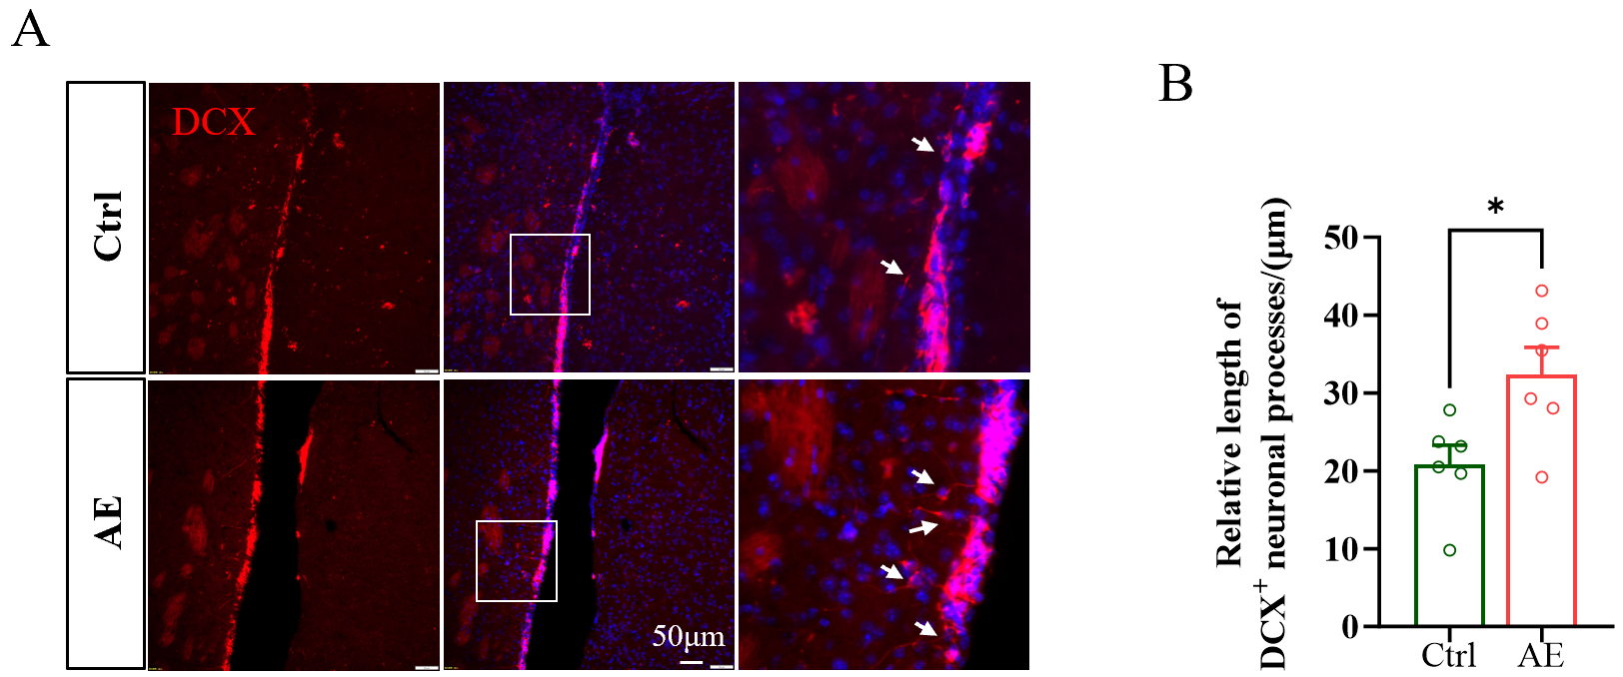
Figure S3 The exercise group showed higher DCX expression and longer neurites in immature neurons than control in the SVZ. Scale bar, 50 μm

