Supplementary Materials
Study of bioformulations of thymol with potential phytosanitary application

Table S1. IR/FT vibrational bands of thyme essential oil.
Table S2. Water activity required for the growth of some microorganisms (Fontana, 2007).
Fig. S1 Chromatoplate of a) thymol standard, b) commercial thyme oil, and, c) thyme extract.
Fig. S2 Structure of a) thymol, b) carvacrol and c) p-cymene (Ruiz-Posadas, 2018).
Fig. S3 Micrographs of microcapsules of a) calcium alginate (Alg), b) Alg-Bt (1:0.5), c) Alg-Bt (1:1), and, d) Alg-Bt (1:2).
Fig. S4 Particle size distribution of microcapsules.

Table S2. Water activity required for the growth of some microorganisms (Fontana, 2007).

Microorganism | Water activity
Most bacteria | 0.756
Most yeast | 0.642
Most fungi | 0.523
Halophilic bacteria | 0.503

Table S1. IR/FT vibrational bands of thyme essential oil.
Thymol |  | Carvacrol |  | p-Cimeno
Functional group | wavelength  (cm⁻¹) | Functional group | wavelength  (cm⁻¹) | Functional group | wavelength (cm⁻¹)
C-H  out-plane | 806-804 | C-H  out-plane | 810-807 | C-H  out-plane | 812-811
1:3:4 substitution | 1045,1003 | 1:2:4 substitution | 990-995 | Para substitution | 1055-1019
meta substitution | 1170,1140 | orto substitution | 1125-1080 | Isopropyl group | 1380-1360
Isopropyl group | 1520,1513 | Isopropyl group | 1380-1360 | CH-(CH₃) | 1520-1513
CH-(CH₃) | 1600,1580,1500 | CH-(CH₃) | 1520-1513 | C-H | 3000-2850
C=C | 3000-2850 | C=C | 1600,1580, 1500
-OH | 3360-3330 | C-H | 3000-2850

Fig. S1. Chromatoplate of a) thymol standard, b) commercial thyme oil, and, c) thyme extract.

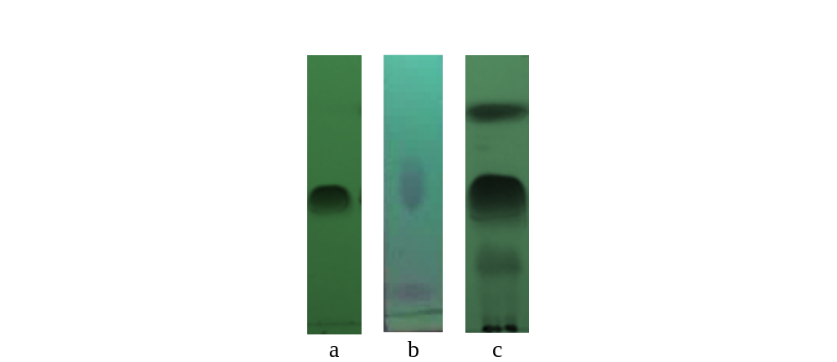

Fig. S2 Structure of a) thymol, b) carvacrol and c) p-cymene (Ruiz-Posadas, 2018).

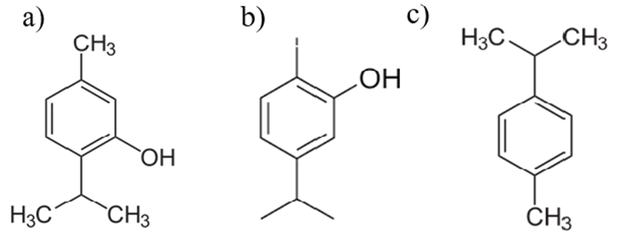
Fig. S3 Micrographs of microcapsules of a) calcium alginate (Alg), b) Alg-Bt (1:0.5), c) Alg-Bt (1:1), and, d) Alg-Bt (1:2).

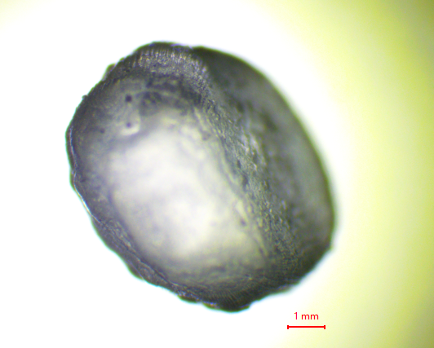  a) | 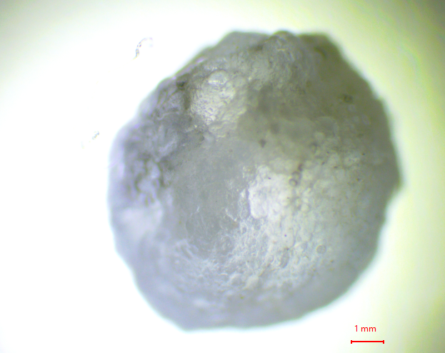  b)
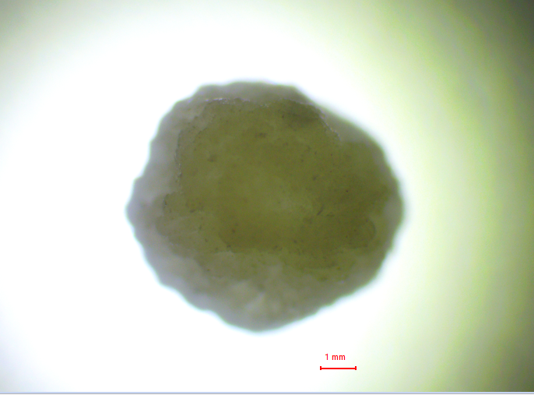  c) | 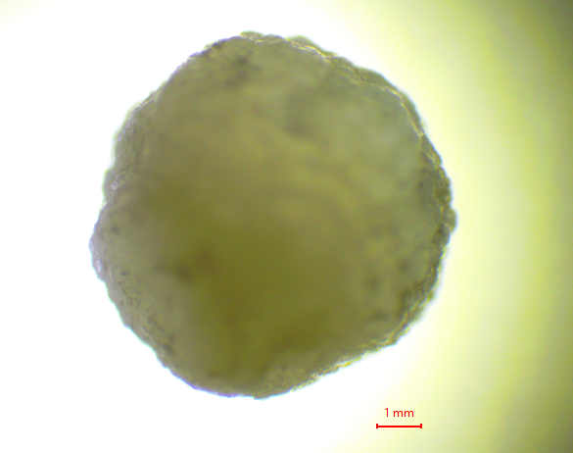  d)

Fig. S4 Particle size distribution of microcapsules

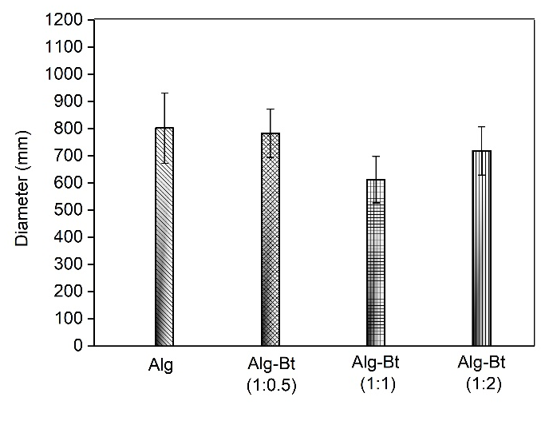

References

Fontana, A. J. (2007). Appendix D: Minimum Water Activity Limits for Growth of Microorganisms. Water Activity in Foods, 406, 405–405. https://doi.org/10.1002/9780470376454.app4
Ruiz-Posadas, L. M. (2018). Actividad antimicrobiana del aceite esencial de tomillo (Thymus vulgaris L.). Agro Productividad, 9(11). https://doi.org/10.32854/agrop.v9i11.849

