Evaluation of the diffusion time dependence of the IVIM effect based on realistic capillary flow simulations – SUPPLEMENTARY FILE
Franciszek Hennel¹, Manuel Fernández López ², Franca Schmid²

This file contains Figures 1, 2 and 3-8 reproduced for the network MVN1. Additionally, Figure 9 contains a comparison of the time-dependent pseudodiffusion for different vessel sizes of MVN2.

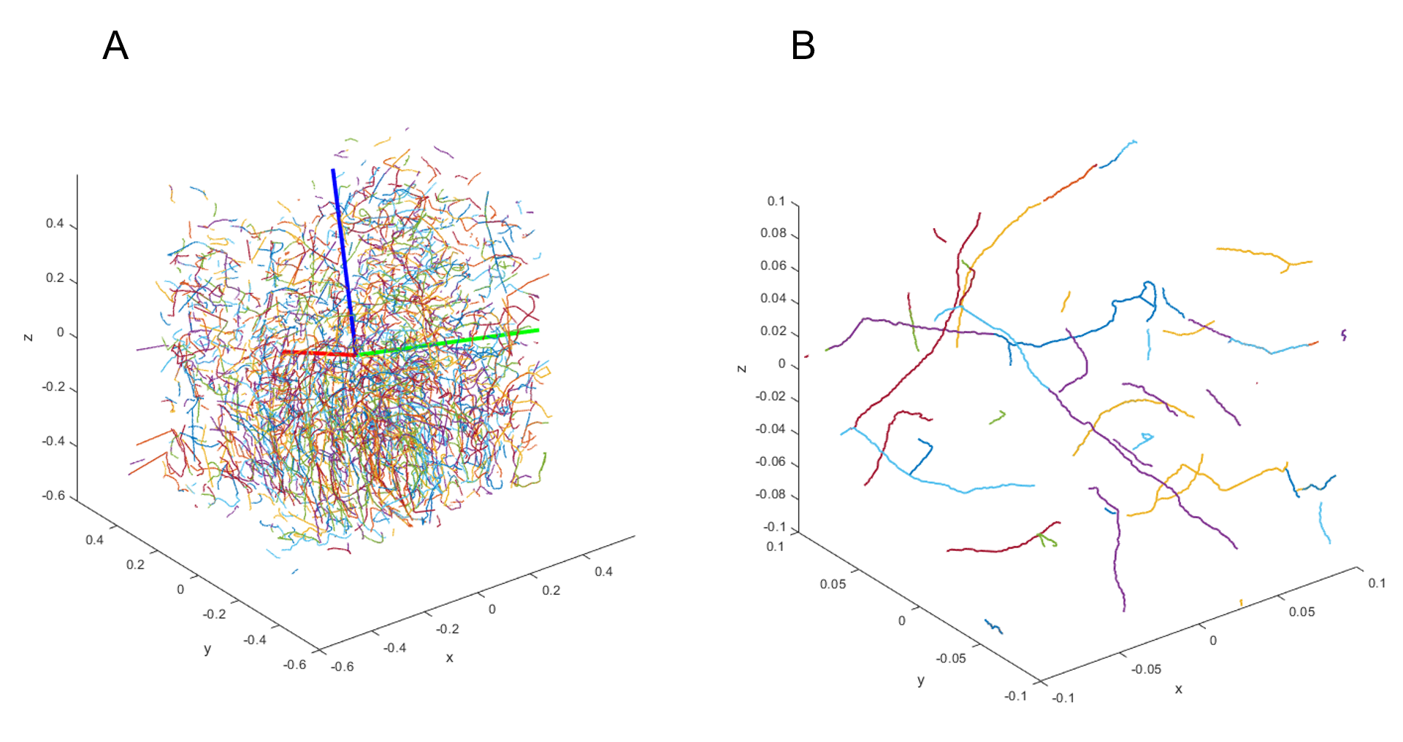
Figure S1. Trajectories of randomly selected 20% of capillary blood spins traced by the flow simulation in MVN1 – the full sample (A), and its central part (B). Blue, red and green lines in (A) show the directions of the eigenvectors of the pseudo-diffusion tensor at zero frequency (see figure 2 for further details). Coordinates are in mm. The z-axis points down the cortex; x and y are in the pial plane with an arbitrary orientation.
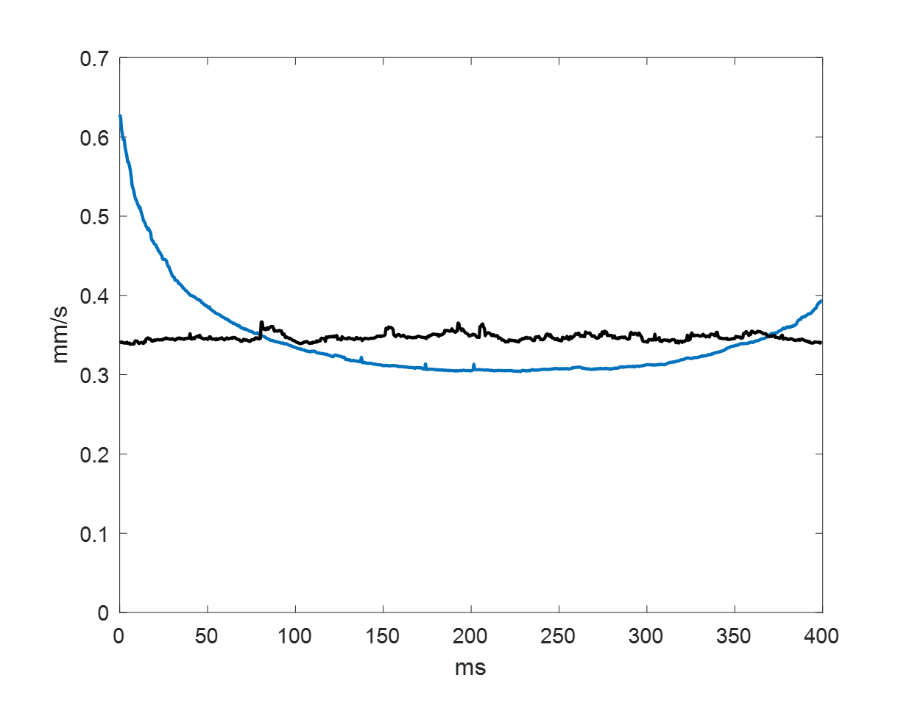
Figure S2. Root mean square velocity of all spins included in the analysis as a function of time before and after randomization by random cyclic shifts of spin velocity time courses in MVN1. Randomization makes the flow system stationary (with a constant v_{rms}), which is required for the Gaussian phase approximation.
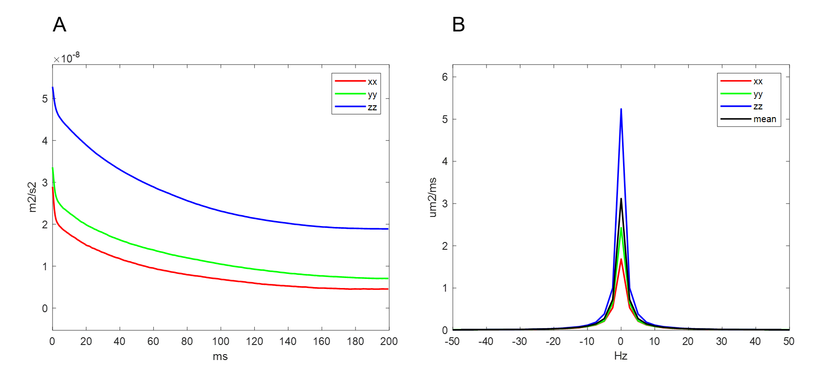
Fig. S4. Velocity autocorrelation functions (A) and corresponding spectral densities (B), i.e., diagonal elements of the frequency-dependent pseudo-diffusion tensor D(f) obtained in MVN1. The x,y,z coordinates follow the directions of the eigenvectors of D(0) and are shown in Fig. S1.

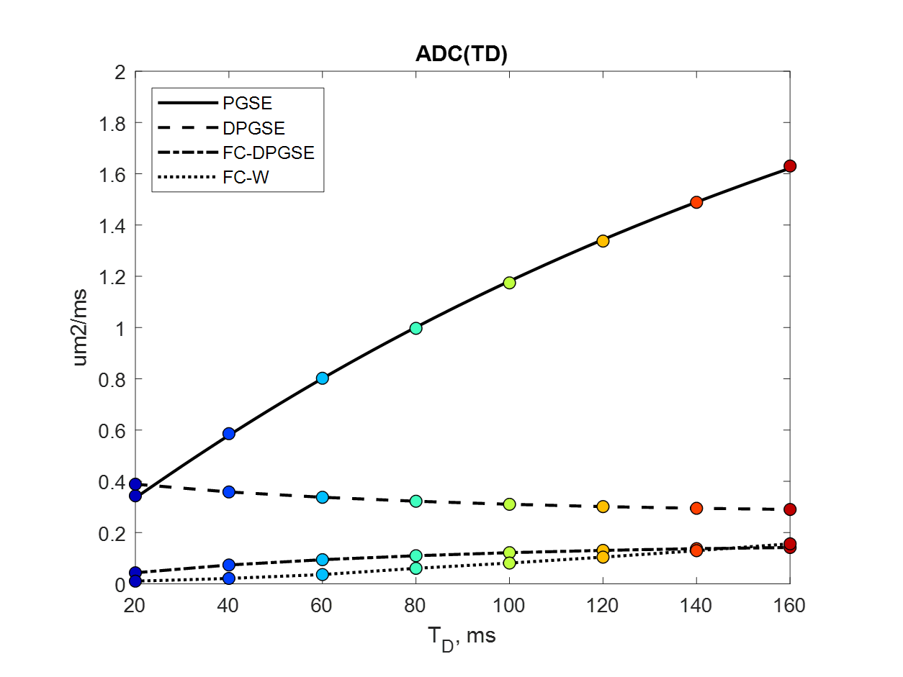
Fig. S5. Dependence of the apparent pseudo-diffusion coefficient on diffusion time for the sequences represented in Fig. 3 obtained from the simulated flow spectral density in MVN1 using Gaussian phase approximation. The continuous line represents the Kennan model fitted to the PGSE case. Note that 1μm²/ms equals 10⁻³ mm²/s.

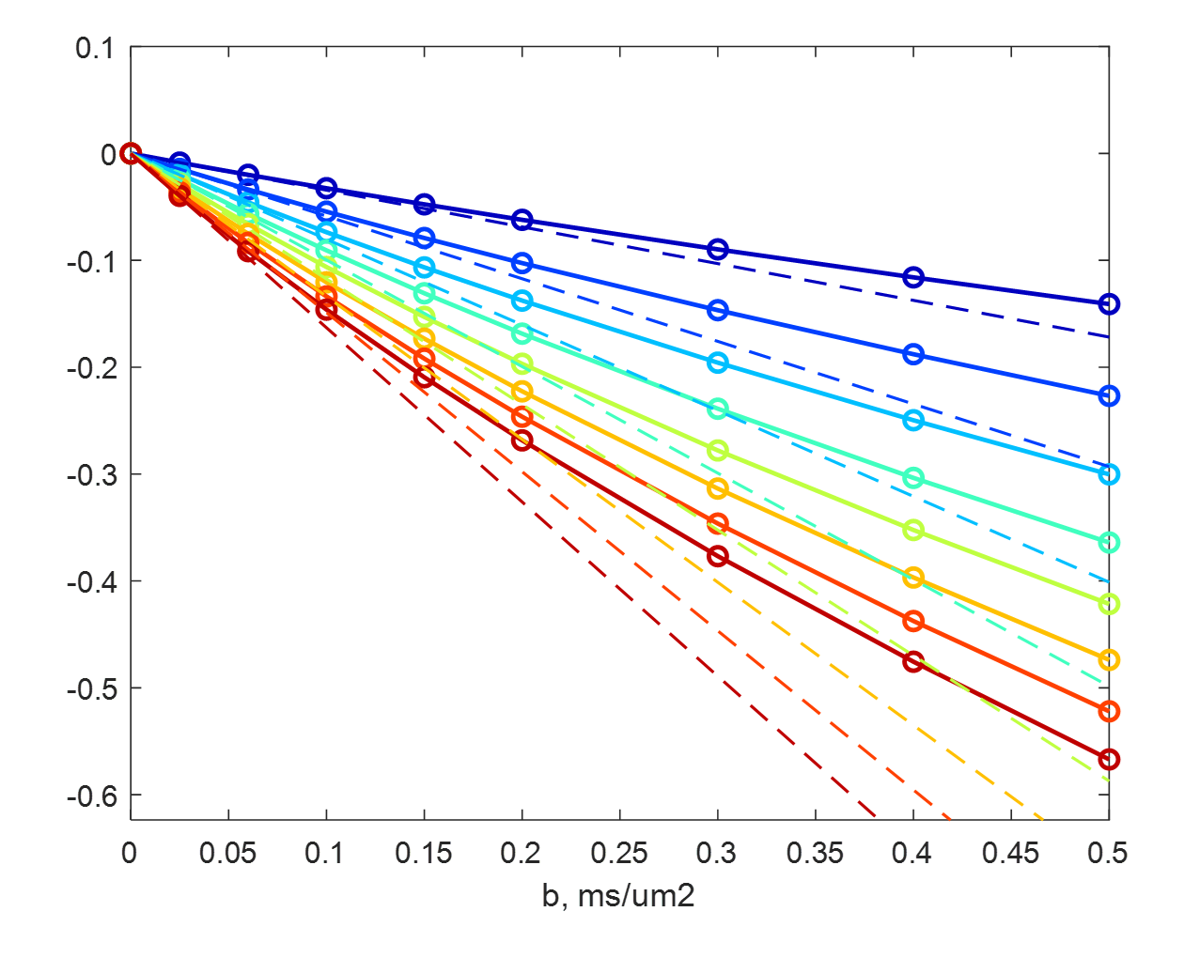
Fig. S6. Logarithmic signal attenuation vs. b-value for the PGSE sequence calculated using the strict formula (Eq. 1, circles) for MVN1. Colors correspond to diffusion times in the manner defined in Fig. 3. The dashed lines show the prediction of the Gaussian phase approximation. Note that 1ms/μm² equals 10³ s/mm².

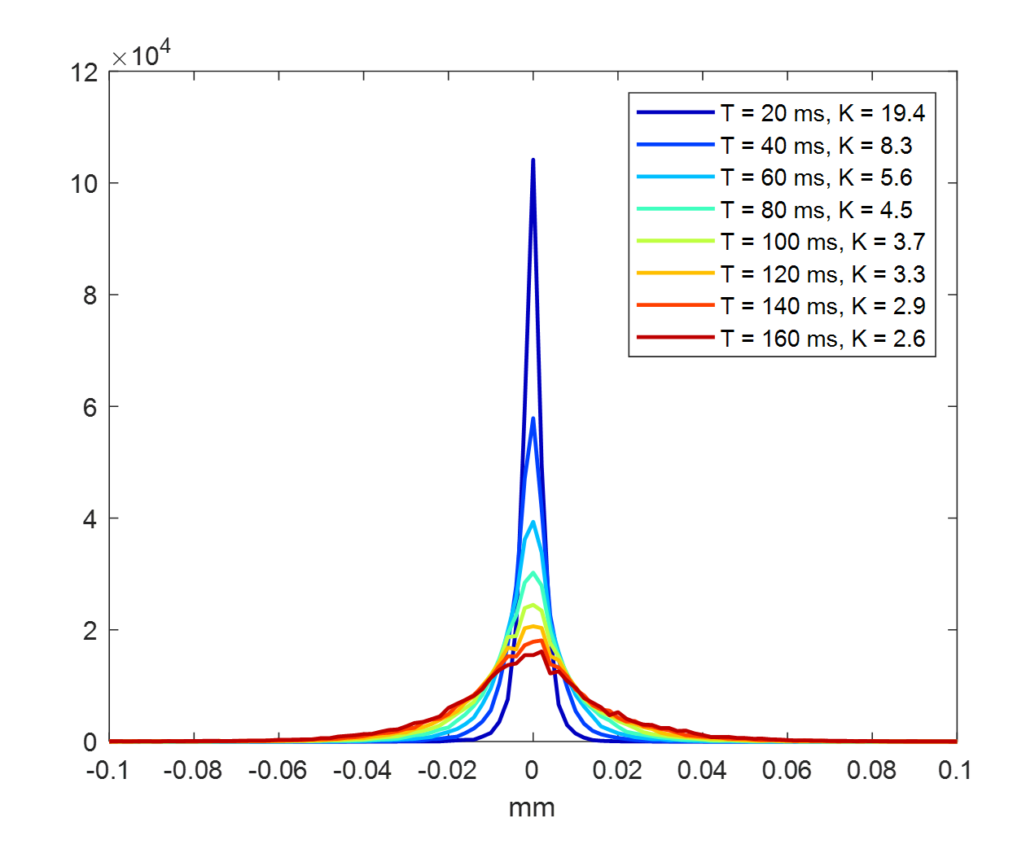
Fig. S7. Displacement propagator (probability density of a given random displacement) at different diffusion times for the spins included in the simulation in MVN1. Kurtosis values are listed in the legend. High positive K numbers explain the discrepancy of strict and GPA-predicted attenuations in Fig. S6.
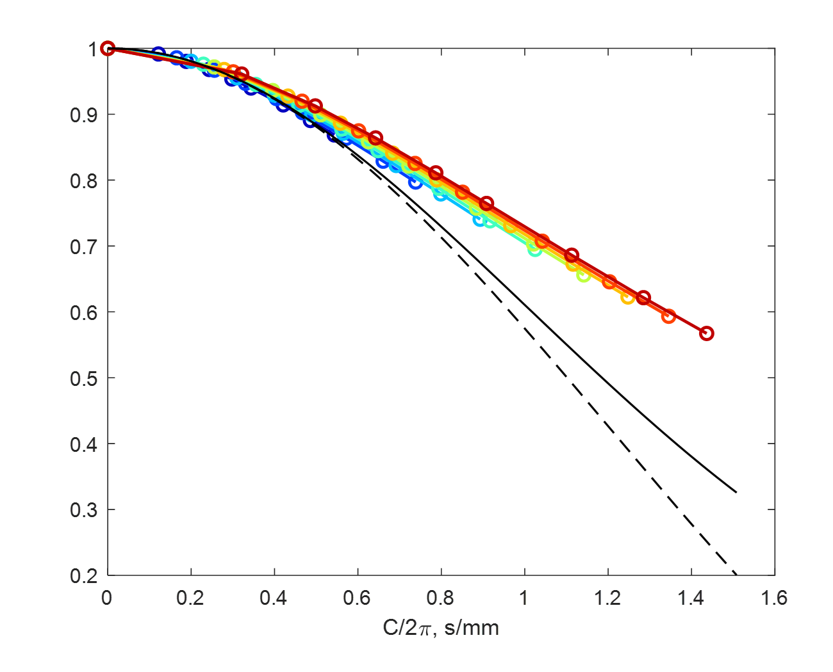
Fig. S8. PGSE signal attenuations for all b-values and diffusion times in MVN1 plotted against the flow-encoding factor c using the color scheme of Fig. 3. The continuous black line shows the fit of Ahlgren’s ballistic model to the shortest $T_{D}$ points (where the ballistic assumption is most adequate). The dashed line shows the sinc model for the same average velocity.

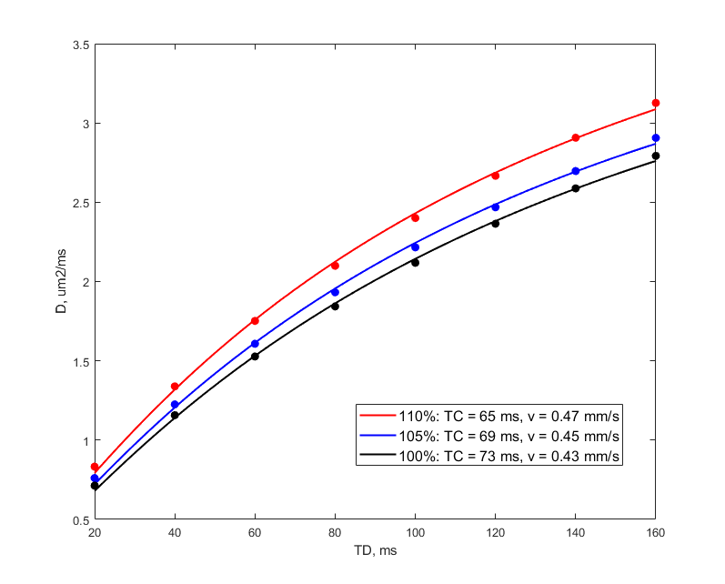
Figure 9: Comparison of the diffusion time dependence of the IVIM pseudo-diffusion coefficient for the network MVN2 with different vessel diameter corrections. The 100% case is a repetition of the simulation shown for PGSE in Fig. 5 of the main paper; the 105% and 110% cases represent simulations with correspondingly increased vessel sizes. The continuous curves show the fits of the Kennan model, the parameters of which (correlation time TC, and r.m.s velocity v) are listed in the legend. It appears that the increase of the vessel size leads to an increase of velocity and a reduction of the correlation time.

