Reactive Oxygen Species -responsive release of tanshinone IIA for polycystic ovary syndrome treatment
Limin Fan^{1,2}, Jiani Xie¹, Jianhua Zhou¹, Yili Wang¹, Yijiao Yang¹, Xiaorong Ni^{1*}

¹ Department of Gynecology, Shanghai Municipal Hospital of Traditional Chinese Medicine, Shanghai University of Traditional Chinese Medicine, Shanghai 200071, China.
² School of Medicine, Tongji University, Shanghai 200092, P. R. China.

*Correspondence:
Xiaorong Ni
Department of Gynecology, Shanghai Municipal Hospital of Traditional Chinese Medicine, Shanghai University of Traditional Chinese Medicine, Shanghai 200071, China.
E-mail: szy1120@shutcm.edu.cn
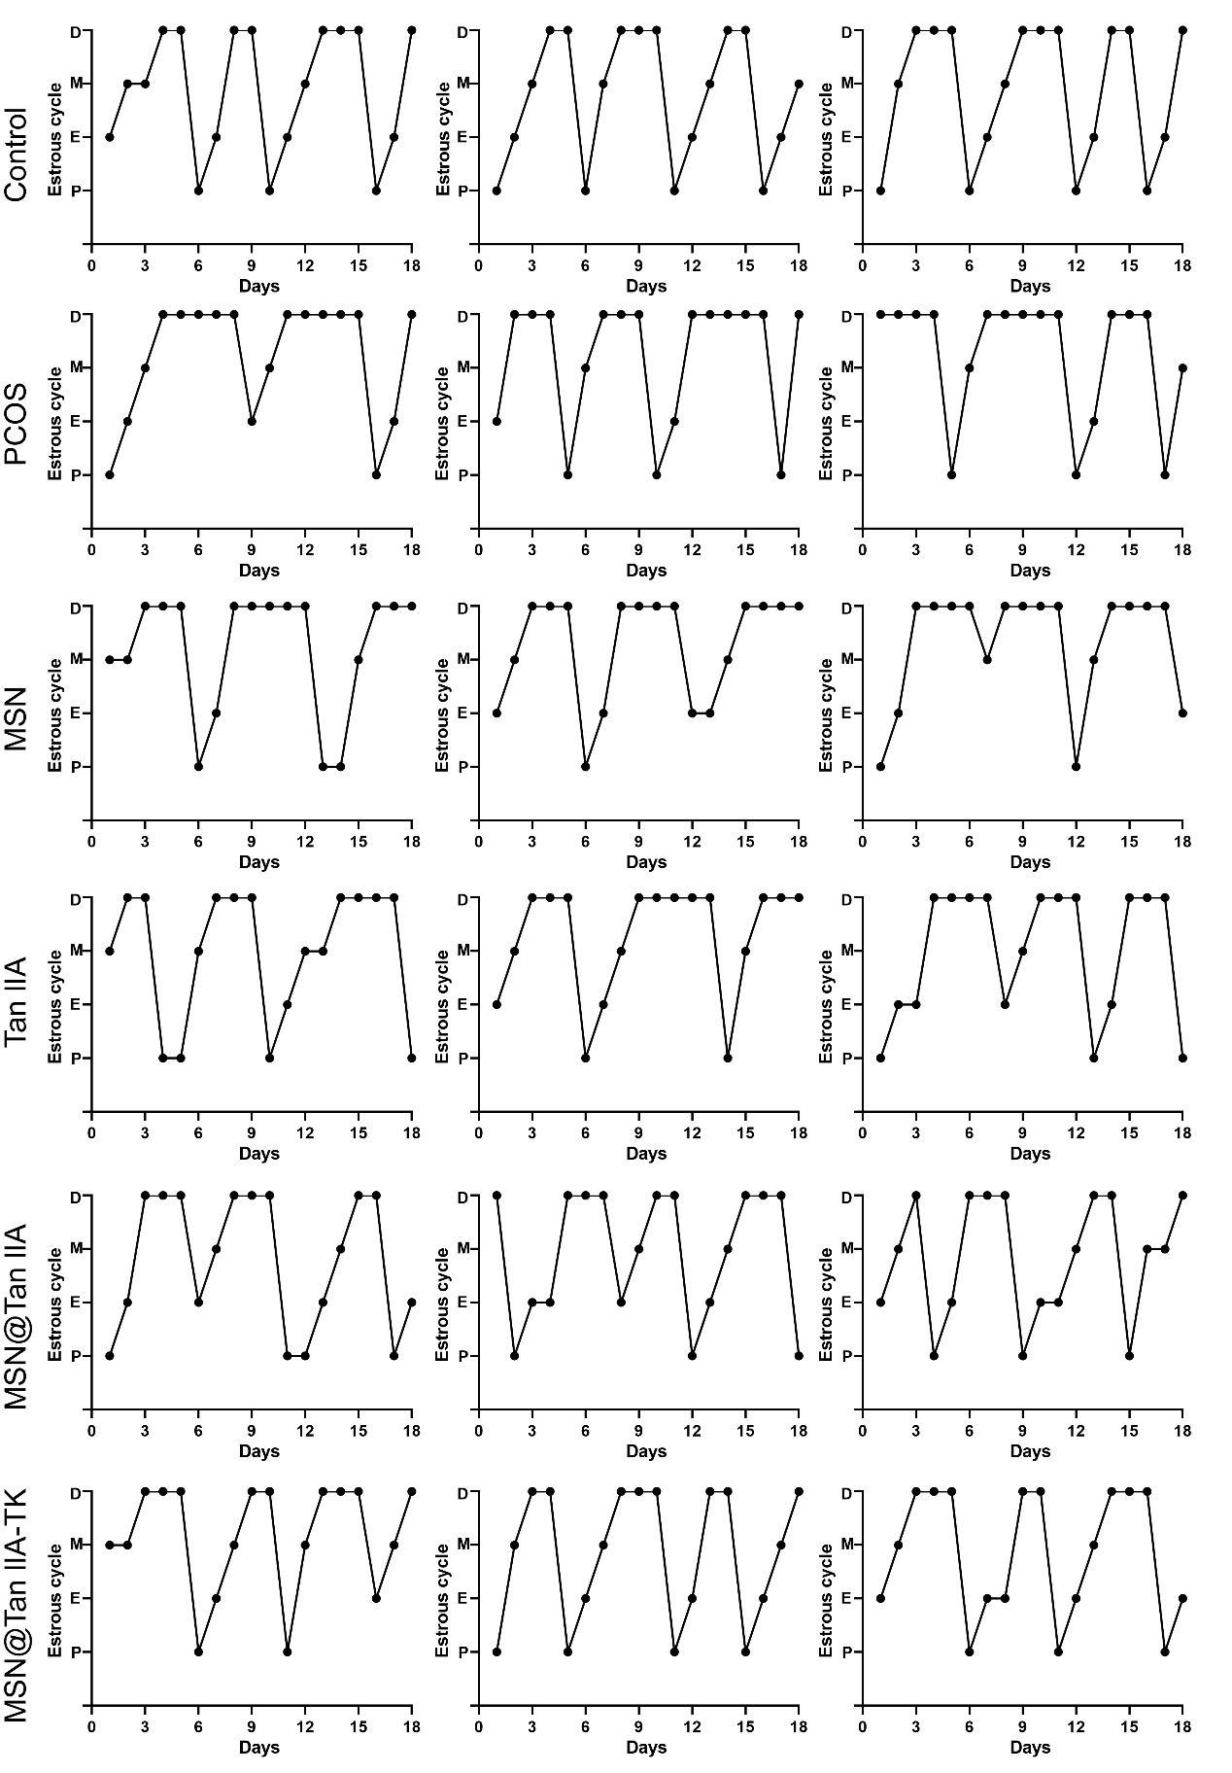
Fig. S1 Assessment of estrous cycles. (A) and (B) Estrus cycle lengths and stages, including proestrus, estrus, metestrus and diestrus were counted.

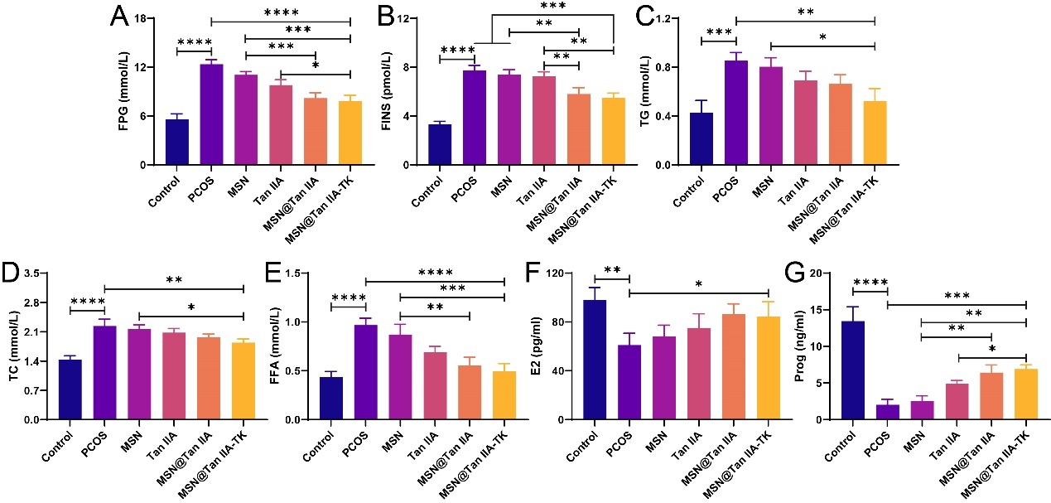
Fig. S2 Detection of (A) FPG, (B) FINS, (C) TG, (D) TC, (E) FFA, (F) E2, and (G) Prog levels in rat blood.
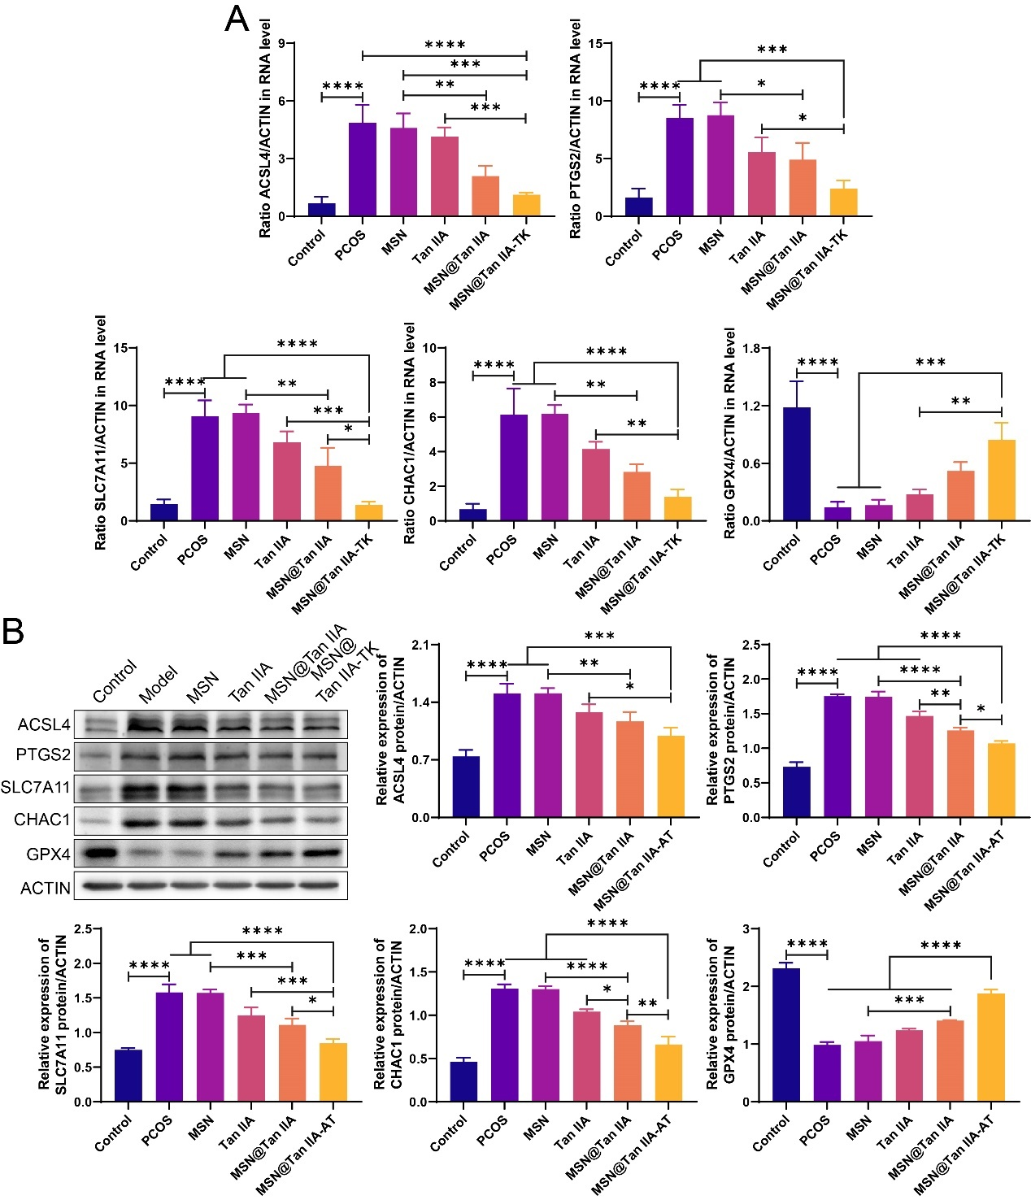
Fig. S3 Detection of ferroptosis markers in rat ovarian tissue. (A) qPCR results of mRNA expression levels of ferroptosis-related genes ACSL4, PTGS2, SLC7A11, CHAC1, and GPX4; (B) Western blot results of protein expression levels of ferroptosis-related genes ACSL4, PTGS2, SLC7A11, CHAC1, and GPX4.

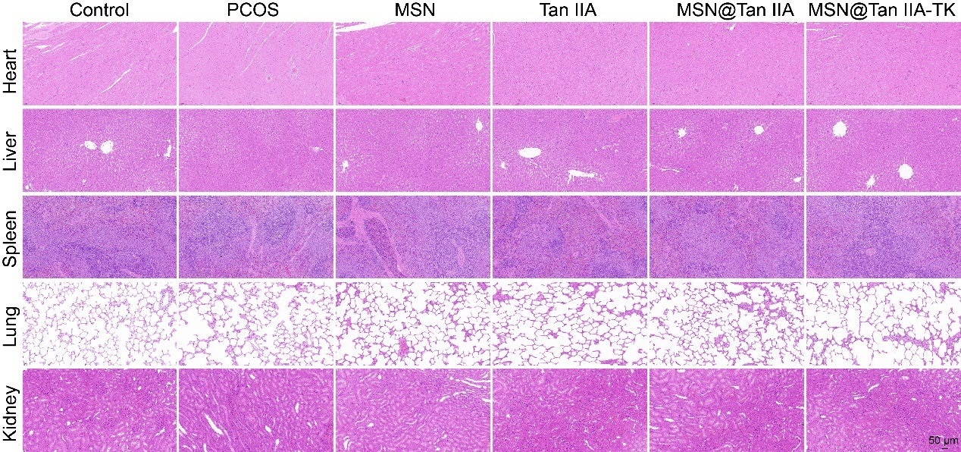
Fig. S4 Representative H&E stained images of major organs (heart, liver, spleen, lung, kidney).

