Supplementary information S1
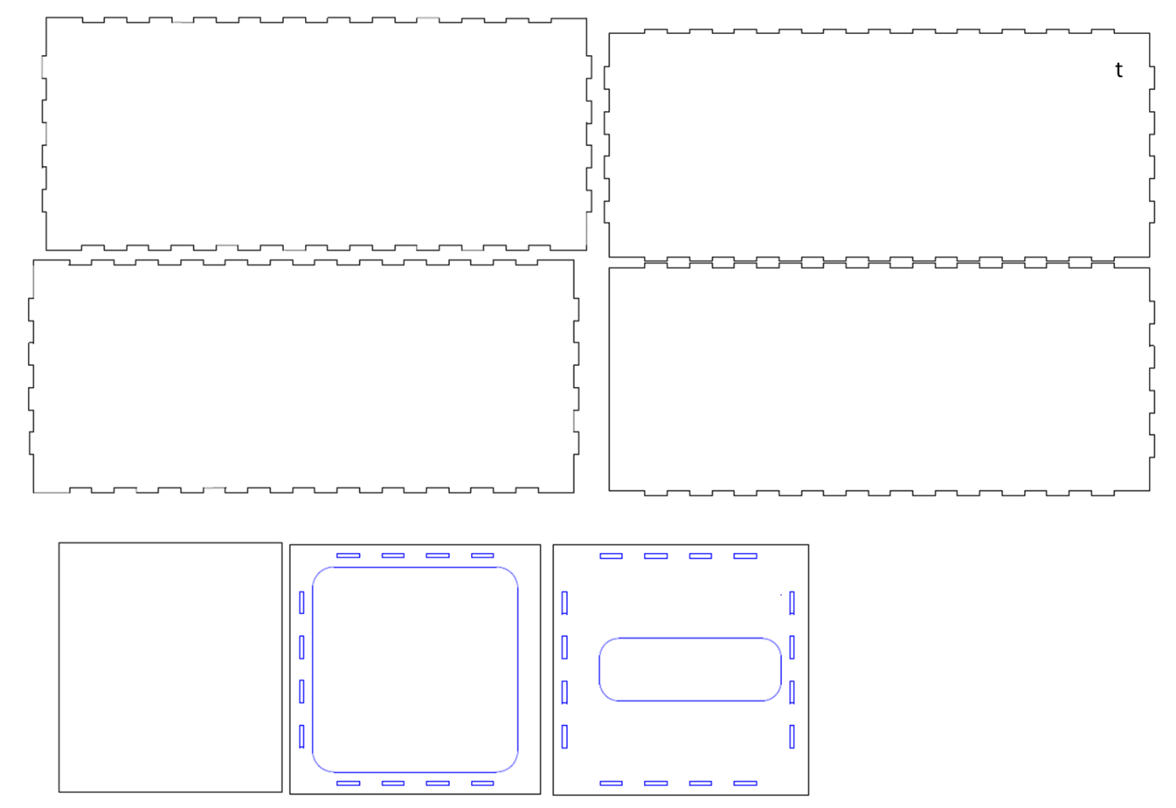
Figure S1: The CAD sketch of the dismountable plexiglas tunnel. The panel t is transparent. All other elements are opaque to have a more homogeneous light for the video tracking.

