Supporting information
Table S1: Cell culture media composition
Media |  | Components
Osteoblastic media | Basal growth medium (GM) | αMEM, 10% (v/v) FBS, 1% (v/v) P/S
Osteoblastic media | Osteogenic medium (OM) | αMEM, 10% (v/v) FBS, 1% (v/v) P/S, ascorbate-2-phosphate (50 µg/mL), β-glycerophosphate (10 mM), dexamethasone (100 nM)
Osteoblastic media | Mineralization medium (MM) | αMEM, 10% (v/v) FBS, 1% (v/v) P/S, milk-extracted osteopontin (100 µg mL⁻¹), calcium chloride dihydrate (9 mM), dipotassium phosphate (4.2 mM), HEPES (25 mM)
Adipogenic media | Adipocyte proliferation medium (APM) | DMEM, 10% (v/v) FBS, 1% (v/v) P/S and Glutamine (200 mM), heparin (90 μg/mL), FGF-1 (1 ng/mL)
Adipogenic media | Adipogenic induction medium (AIM) | DMEM, 10% (v/v) FBS, 1% (v/v) P/S and Glutamine (200mM), heparin (90 μg/mL), FGF-1 (1 ng/mL), IBMX (500 μM), rosiglitazone (2 μM), dexamethasone (250 nM), insulin (10 µg/mL) and indomethacin (100 μM)
Adipogenic media | Adipogenic medium (AM) | DMEM, 10% (v/v) FBS, 1% (v/v) P/S and Glutamine (200 mM), heparin (90 μg/mL), FGF-1 (1 ng/mL), IBMX (500 μM), dexamethasone (250 nM), insulin (10 µg/mL) and indomethacin (100 μM)
Cancer proliferation medium (CM) |  | RPMI 1640, 5% (v/v) FBS
Coculture medium (CoM) |  | DMEM, 10% (v/v) FBS, 1% (v/v) P/S and Glutamine (200 mM)

αMEM and DMEM from Gibco™, fetal bovine serum (FBS), Penicillin/Streptomycin (P/S) and FGF-1 from ThermoFisher. Ascorbate-2-phosphate, β-glycerophosphate, dexamethasone, calcium chloride dihydrate, dipotassium phosphate, HEPES, heparin, IBMX, rosiglitazone, insulin, and indomethacin from Sigma-Aldrich. Milk-extracted osteopontin was a gift from Arla Food.

Table S2: Primers sequences used for RTqPCR
Target Genes | Primers sequence (5’-3’)
Ribosomal protein L32 (RPL32) | F: GCACCAGTCAGACCGATATG  R: ACTGGGCAGCATGTGCTTTG
Beta-actin (ACTB) | F: CACCATTGGCAATGAGCGGTTC  R: AGGTCTTTGCGGATGTCCACGT
Fatty acid binding protein 4 (FABP4) | F: GGATGATAAACTGGTGGTGGAATG  R: CAGAATGTTGTAGAGTTCAATGCGA
Adiponectin (ADIPOQ) | F: AGTCTCACATCTGGTTGGGG  R: CTCTCTGTGCCTCTGGTTCC
Leptin (LEP) | F: CGGATTCTTGTGGCTTTGG  R: TGACTGCGTGTGTGAAATG
Perilipin-1 (PLIN1) | F: ACCCCCCTGAAAAGATTGCTT  R: GATGGGAACGCTGATGCTGTT
Hormone-sensitive lipase (LIPE) | F: GCGGATCACACAGAACCTGGAC  R: AGCAGGCGGCTTACCCTCAC
Peroxisome proliferator-activated receptor gamma (PPARγ) | F: GAAACTTCAAGAGTACCAAAGTG  R: AGGCTTATTGTAGAGCTGAGTCTTCTC
Glucose transporter type 4 (SLC2A4) | F: ATGCTGCTGCCTCCTATGAA  R: CAGTTGGTTGAGCGTCCC
Prostate specific antigen (KLK3) | F: AGTGCGAGAAGCATTCCCAAC  R: CCAGCAAGATCACGCTTTTGTT
Androgen receptor (AR) | F: CTGGACACGACAACAACCAG  R: CAGATCAGGGGCGAAGTAGA
Adipose triglyceride lipase (PNPLA2) | F: GTGTCAGACGGCGAGAATG  R: TGGAGGGAGGGAGGGATG
Fatty acid translocase (CD36) | F: CTTTGGCTTAATGAGACTGGGAC  R: GCAACAAACATCACCACACCA
Lipoprotein lipase (LPL) | F: GGAAAGGCACCTGCGGTATT  R: AGATTCGCCCAGTTTCAGCC
Aquaporin 7 (AQP7) | F: GGCACAGGCGGTCCAC  R: CATGAACTCGGCCAGGAACT
Colony-stimulating factor 1 (CSF1) | F: GCCAGTGAGATTCCCGTACC  R: TGCCTCTCATGGCCAGTTAC
ATP-binding cassette (ABCC3) | F: GCCCCAGTTAATCAGCAACC  R: TATGGTGATGGCATAGCCTGG
Fibroblast growth factor 7 (FGF7) | F: AAGTTGCACCAGGCAGACA  R: CGCTGTTTGCTATTTGACTTTTGT
Serine proteinase inhibitor E1 (SERPINE1) | F: CTCCTCATCCACAGGAGCTT  R: ATGGGGGACATTCACTCTGC
Ferritin heavy chain 1 (FTH1) | F: CAGAACTACCACCAGGACTCAG  R: GTCATCACAGTCTGGTTTCTTGATA

Table S3: Antibodies used for chromogenic immunohistochemistry
Protein | Cat. No. | Company | RRID | Anti (species) | Antigen retrieval | Dilution | Incub. | Color dev.
PSA | A0562 | Dako Omnis | - | Human | Sodium Citrate pH 6.0, 5 min, 95°C | 1:500 | o/n, 4°C | 1min30s
Ki67 | ab15580 | Abcam | AB_443209 | Human, Mouse | Automatic staining on Ventana
CD68 | ab108595 | Abcam | AB_10866185 | Human | Tris-EDTA pH 9.0, 5min, 95°C | 1:300 | 1 h, RT | 3min
vWf | GA527 | Dako Omnis | - | Human | Proteinase K, 5min, RT | Read-to-use | o/n, 4°C | 2min
PaI-1 | MA517171 | ThermoFisher | AB_2538642 | Human, Mouse | Proteinase K, 5min, RT | 1:500 | o/n, 4°C | 3min
Ferritin | PA572921 | ThermoFisher | AB_ 2913583 | Human, Mouse, Rat | Proteinase K, 5min, RT | 1:500 | o/n, 4°C | 2min30s

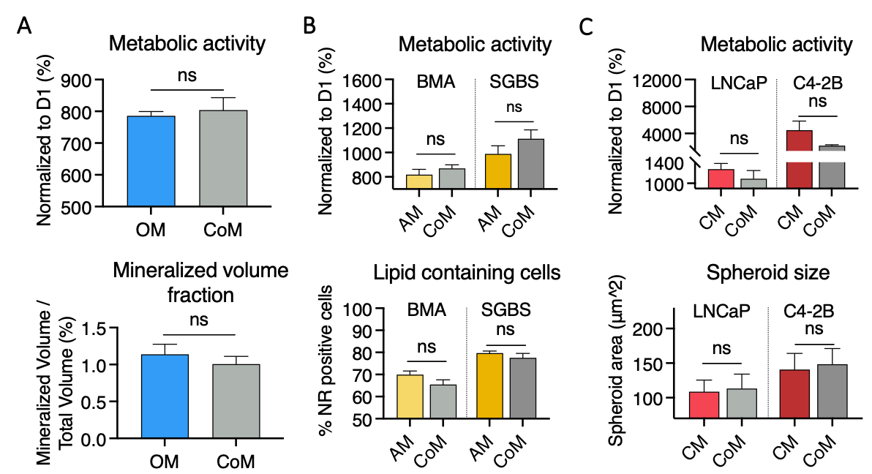
Figure S1: Validation of the simplified medium for the coculture between osteoblasts, adipocytes and prostate cancer cells.
A) Metabolic activity and mineralized volume fraction quantification from osteoblastic microtissues (already differentiated and mineralized for four weeks) after one week of culture in coculture medium (CoM) compared to osteogenic medium (OM). B) Metabolic activity and quantification of the proportion of lipid droplet (LD) containing cells from adipose microtissues (SGBS or BMSCs already differentiated for three weeks) after one week of culture in coculture medium (CoM) compared to adipogenic medium (AM), from nile red (NR) staining. C) Metabolic activity and spheroid area quantification from prostate cancer microtissues (already grown as spheroids for one week) after one week of culture in coculturcoculture medium (CoM) compared to cancer proliferation medium (CM).

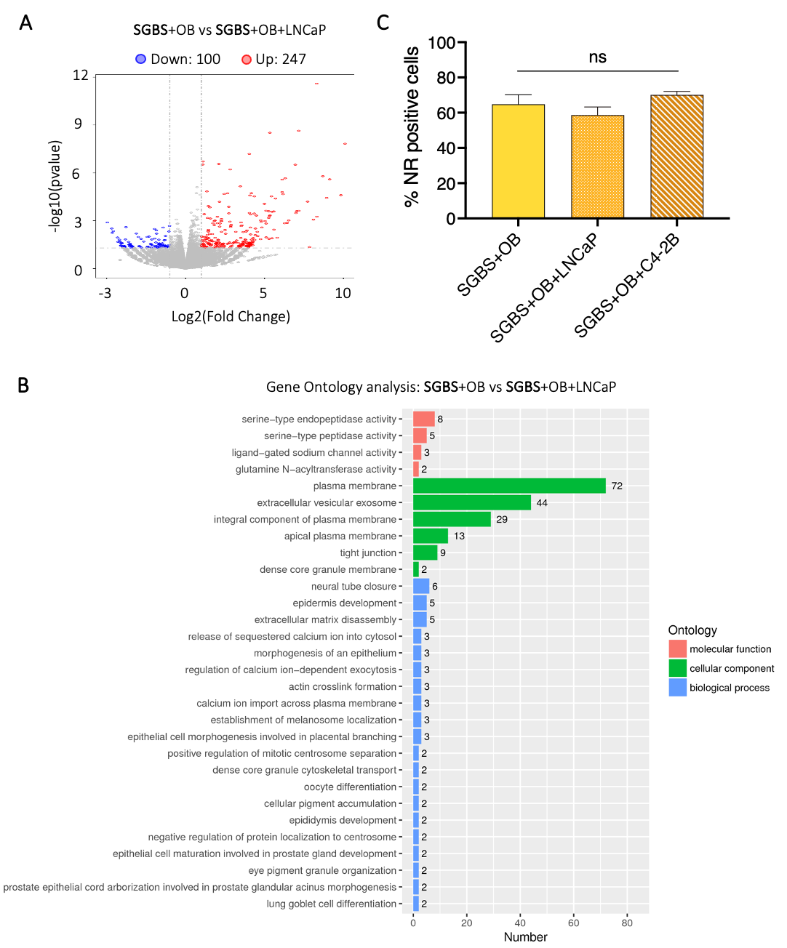
Figure S2: Differential gene expression in SGBS cells after one week of coculture with LNCaP cells.
RNAseq analyses with A) volcano plot and B) gene ontology (GO) analyses of differentially expressed genes between SGBS-derived adipocytes after coculture with osteoblast microtissues ± LNCaP cells for one week. C) Quantification of the proportion of lipid droplets-containing adipocytes from nile red staining (NR). Graphs: Mean+SE, n=3 per condition, General Linear Model (Univariate), ns: not significant.

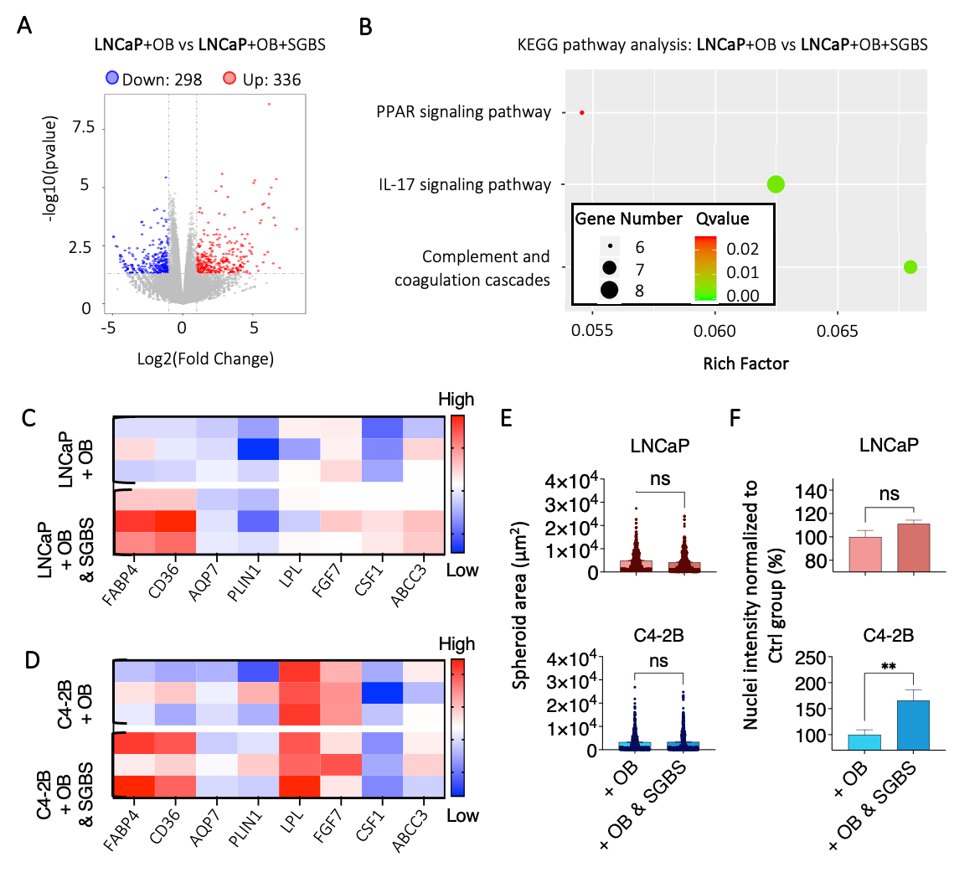
Figure S3: SGBS-derived adipocytes enhance lipid metabolism in PCa cells without affecting cell proliferation, similarly to bone marrow adipocytes.
RNAseq analyses on LNCaP cells after one week of coculture with osteoblast microtissues ± SGBS adipocytes, with A) volcano plot, and B) KEGG pathway. Heatmap analyses of differentially expressed genes from C) LNCaP and D) C4-2B cells after one week of coculture with osteoblast microtissues ± SGBS-derived adipocytes (mean ΔCq, n = 3). E) Spheroid size and F) nuclei intensity quantification from immunofluorescence images (OB: osteoblasts). Graphs: Mean+SE, all data points, n = 3, General Linear Model (Univariate), ns: not significant, **p<0.01.

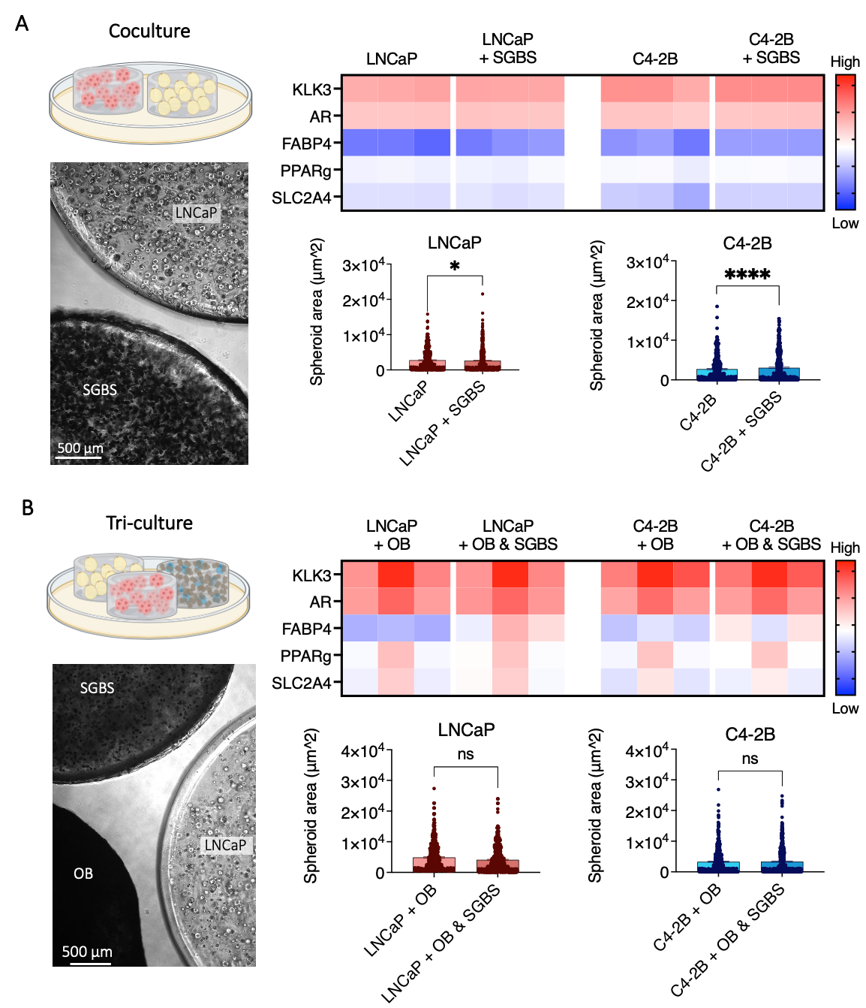

Figure S4: Integration of osteoblasts into the coculture system alters the influence of adipocytes on prostate cancer cells.
Representative brightfield images, gene expression analysis by RT-qPCR (mean ΔCq, n = 3) and quantification of spheroid size from LNCaP and C4-2B cells after one week of coculture with SGBS-derived cells A) without, or B) with osteoblasts. Graphs: Mean+SE, all data points, n = 3, General Linear Model (Univariate), ns: not significant, *p<0.05, ****p<0.0001.

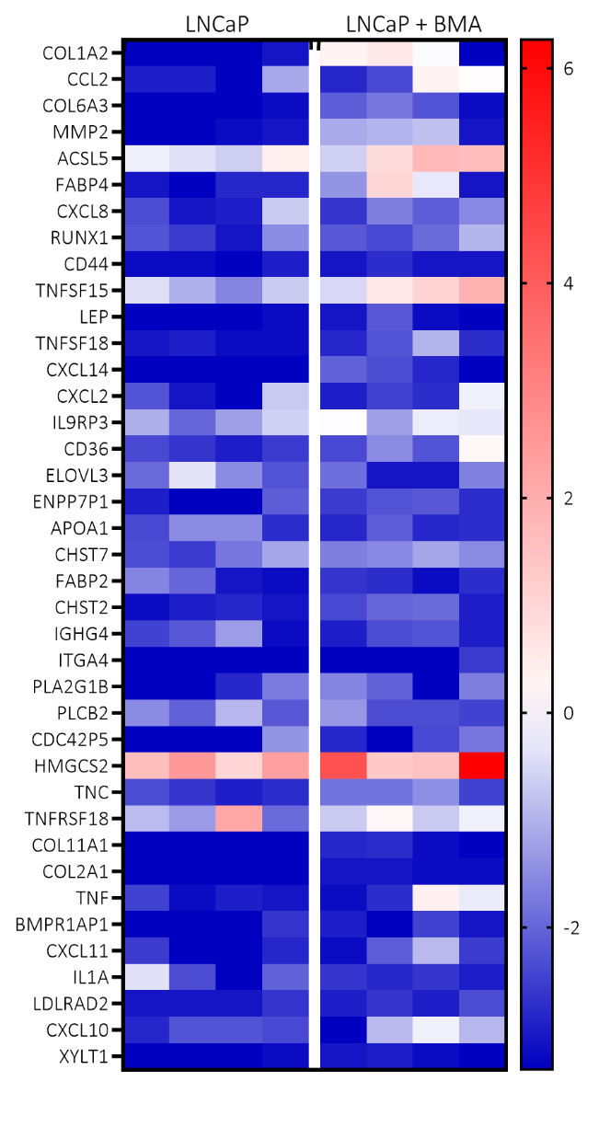
Figure S5: Effects of bone marrow adipocytes on LNCaP bone xenografts gene expression
Heatmap of differentially expressed genes between LNCaP tumors ± adipocytes and treated with vehicle for four weeks. Selection of the 40 genes the most significantly affected by the presence of adipocytes, related to the most affected pathways. Log2(FPKM+0.1) shown, n=4 per condition.
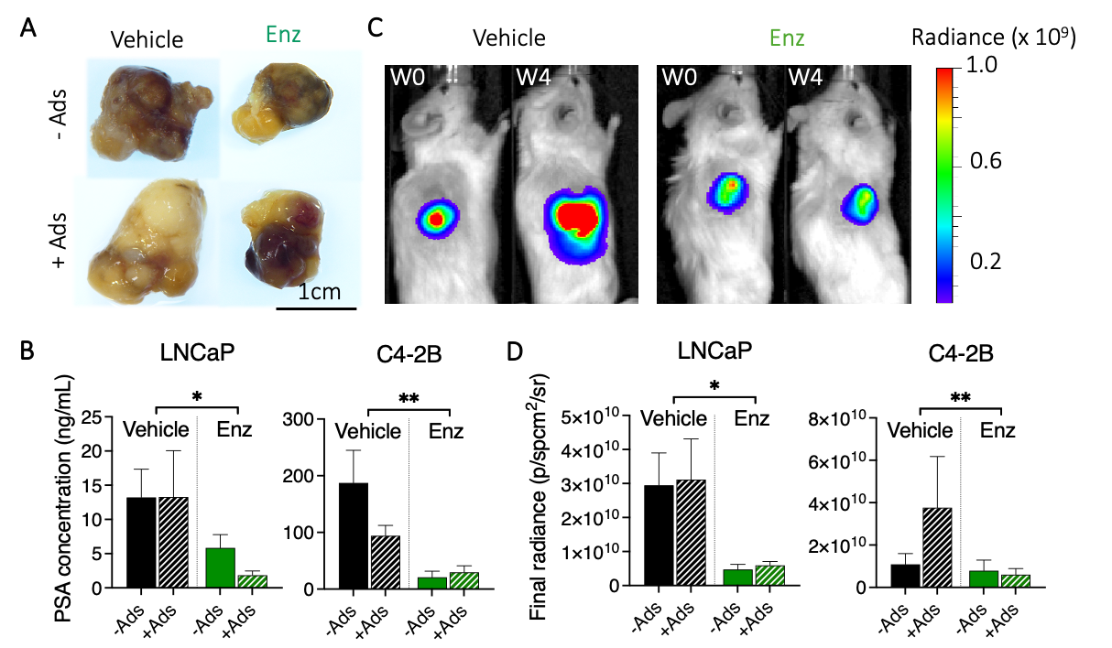
Figure S6: Effect of human adipocytes on PCa bone xenografts in response to enzalutamide.
A) Representative macroscopic images of ex vivo LNCaP-derived bone tumors after fixation with paraformaldehyde. B) Prostate-specific antigen (PSA) concentration after four weeks of treatment ± enzalutamide from LNCaP- and C4-2B-derived bone tumors. C) Representative images of bioluminescence on LNCaP-derived bone tumors at week 0 and week 4 after castration and D) quantification of bioluminescence signal at endpoint from LNCaP- and C4-2B-derived bone tumors. Graphs: Mean+SE, n = 8-9 for LNCaP, n = 4 for C4-2B, General Linear Model (Univariate), *p<0.05, **p<0.01. Ads: SGBS-derived adipocytes.

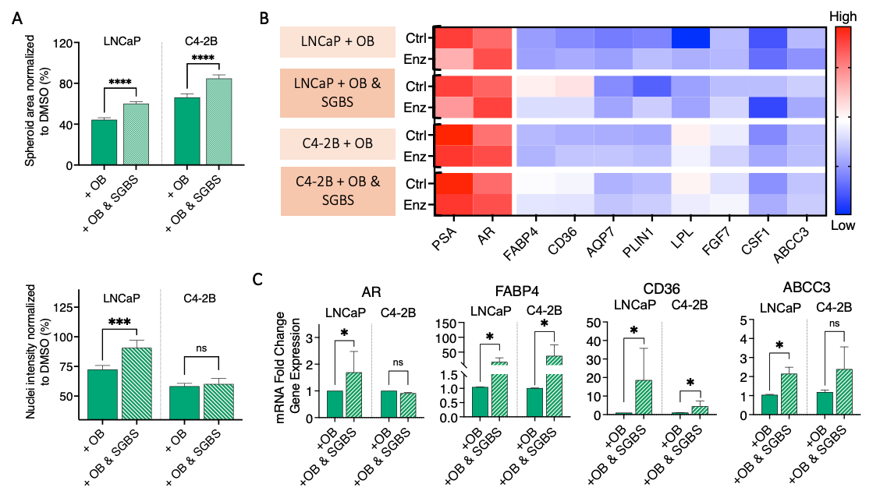

Figure S7: Cancer-associated human SGBS-derived adipocytes enhance enzalutamide resistance in PCa cells
A) Quantification of spheroid area and nuclei intensity from immunofluorescence images, B) heatmap analyses of differentially expressed genes (mean ΔCq, n = 3) and C) mRNA fold change from AR, FABP4, CD36 and ABCC3 under enzalutamide treatment (normalised to enzalutamide treatment without SGBS) from LNCaP and C4-2B cells after one week of coculture with osteoblast microtissues ± SGBS-derived adipocytes. Graphs: Mean+SE, n = 3, General Linear Model (Univariate), ns: not significant, *p<0.05, ***p<0.001, ****p<0.0001.

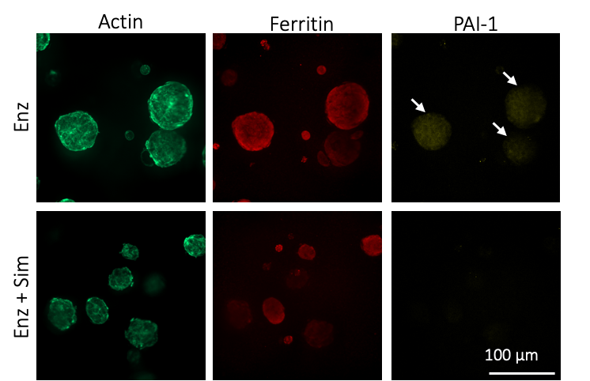

Figure S8: Combination of enzalutamide with simvastatin on LNCaP cells reduced ferritin and PAI-1 expression.
Representative images of the detection of PAI-1 (white arrows) and ferritin using immunofluorescence on LNCaP spheroids cocultured with human BMAs after one week of treatment with enzalutamide + simvastatin compared to enzalutamide treatment.
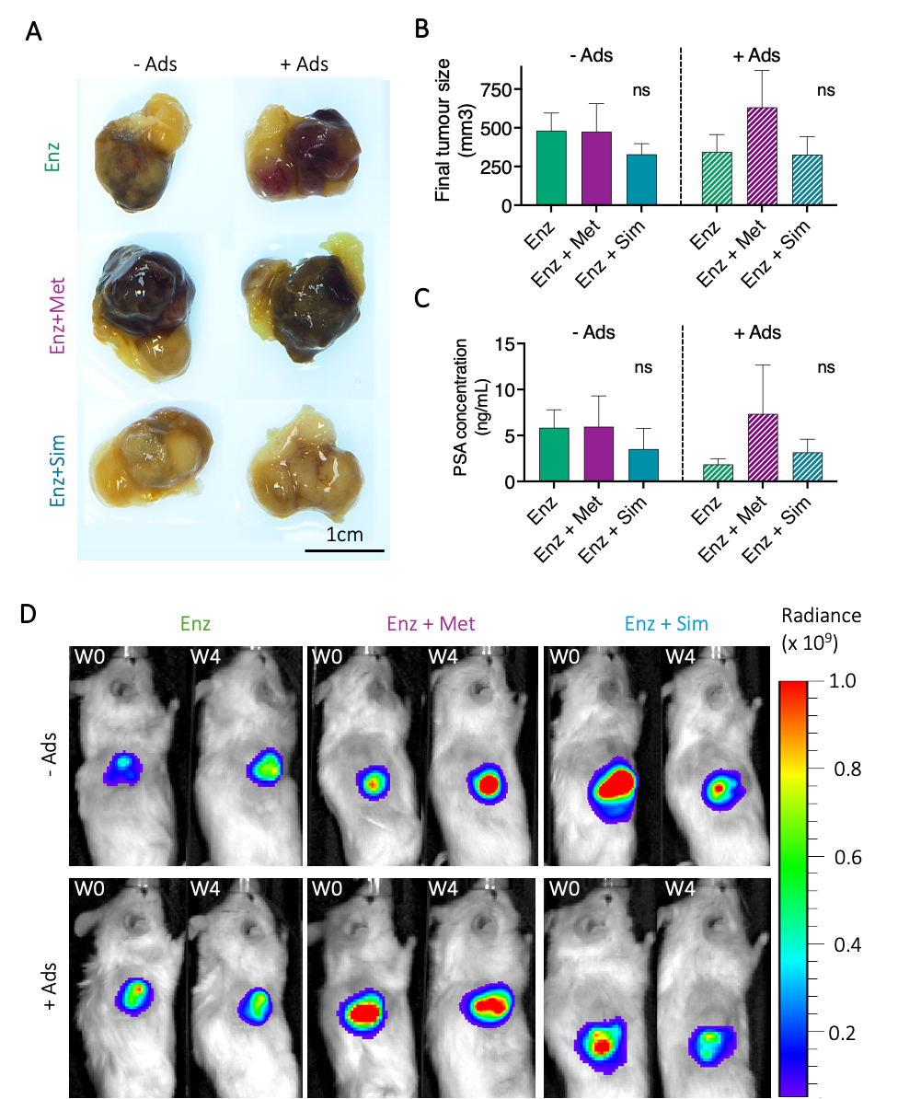

Figure S9: Effect of combined treatments on LNCaP bone metastases size and PSA level at endpoint.
A) Representative macroscopic images and B) quantification of ex vivo bone tumors at endpoint. C) Prostate specific antigen (PSA) concentration at endpoint and D) Representative images of bioluminescence at week 0 and week 4 after castration. Graphs: Mean+SE, n = 8-9, General Linear Model (Univariate), ns: not significant. Ads: SGBS-derived adipocytes.

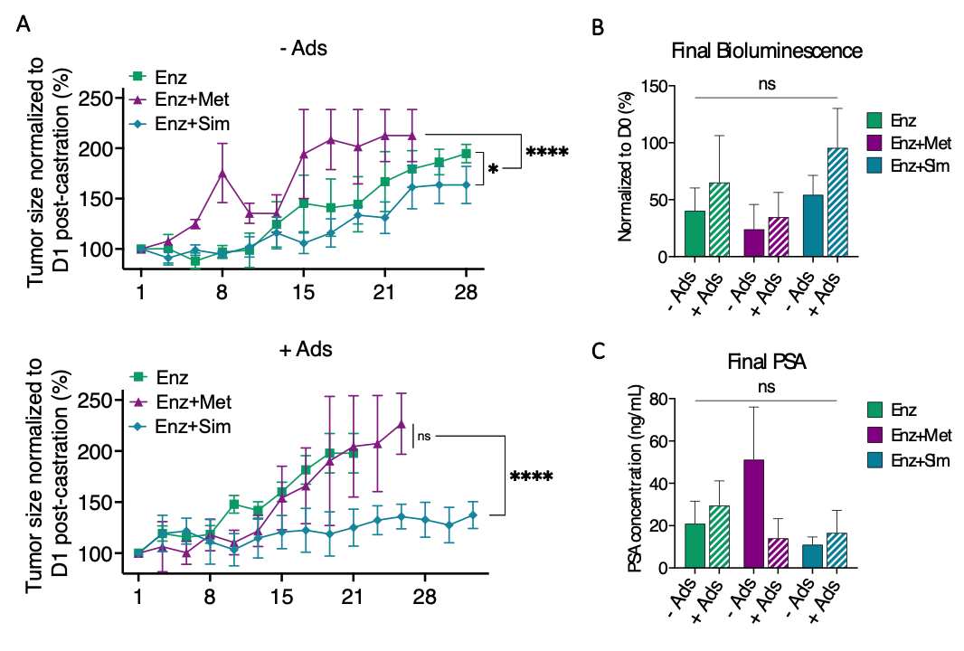
Figure S10: Effect of combined treatments on C4-2B bone metastases.
A) Tumor size progression overtime when treated with enzalutamide ± metformin or simvastatin in absence or presence of human adipocytes. B) Final bioluminescence radiance value normalized to day 0 of treatment. C) Prostate specific antigen (PSA) concentration at endpoint. Graphs: Mean+SE, n = 4, General Linear Model (Univariate), ns: not significant, *p<0.05, ****p<0.0001. Ads: SGBS-derived adipocytes.

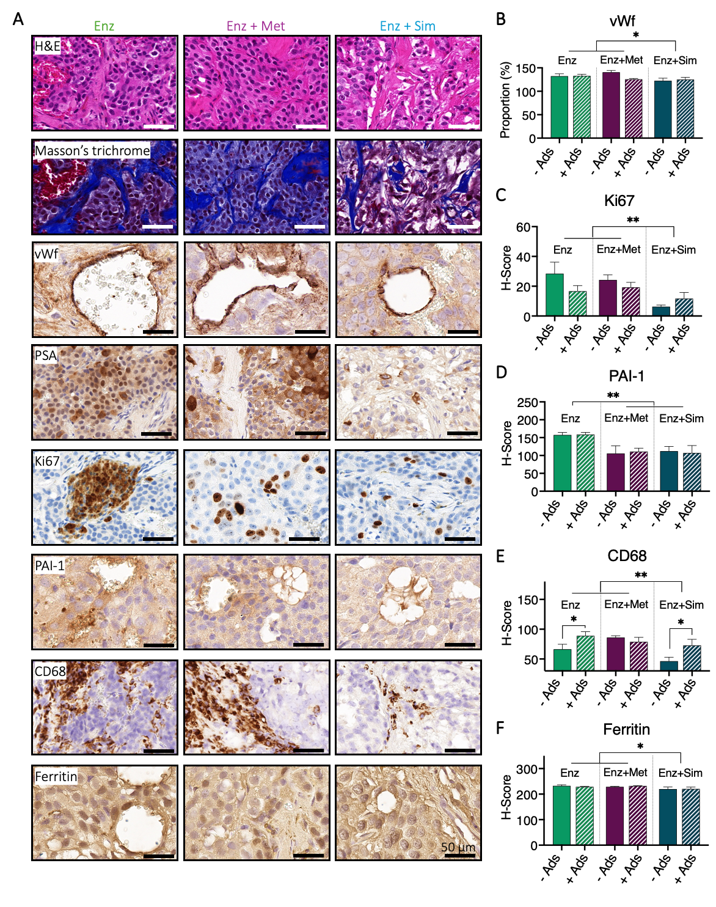

Figure S11: Histology analyses of LNCaP xenografts treated for four weeks with enzalutamide or combined treatments.
A) Representative images and quantification of B) vascularization (endothelial cells, vWf) C) proliferation marker (Ki67), D) plasminogen activator inhibitor-1 (PAI-1), E) macrophages (CD68) markers, and F) ferritin staining from immunohistochemistry. Graphs: Mean+SE, n = 8-9, General Linear Model (Univariate), ns: not significant, *p<0.05, **p<0.01, ***p<0.001. Ads: SGBS-derived adipocytes.

