Supporting information
Polymer Brush-Enhanced Extraction and Spreading of Oil from Lubricating Greases
Luciana Buonaiuto¹, Vincent Siekman¹, Sander Reuvekamp^{1,2}, Piet M. Lugt^{3,4}, Frieder Mugele¹
- Physics of Complex Fluids, MESA+ Institute, University of Twente, PO box 217, 7500AE, Enschede, The Netherlands
- Department of Molecules & Materials, MESA+ Institute, University of Twente, PO box 217, 7500AE, Enschede, The Netherlands
- Tribology-based Maintenance, Faculty of Engineering Technology, University of Twente, PO Box 217, 7500AE, Enschede, The Netherlands
- SKF Research & Technology Development, Meidoornkade 14, 3992AE, Houten, The Netherlands

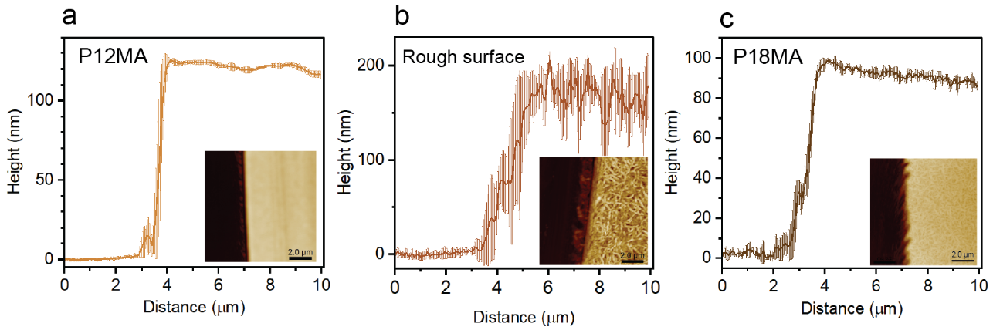
Fig. S1 Thickness profile of P12MA brushes (a), rough surface (b) and P18MA brushes (c) measured via AFM in tapping mode. The insets show the corresponding topographic images, highlighting the boundary between the SiO₂ substrate (dark stripe, left) and the brush/rough surface (light stripe, right)

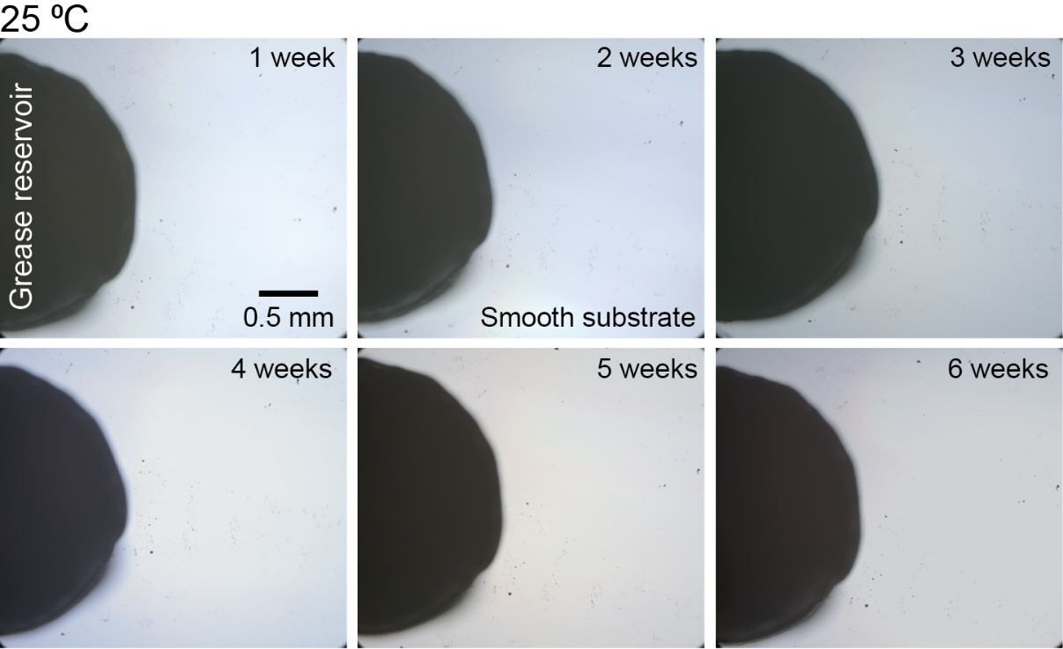
Fig. S2 Optical top-view images of cylindrical Li/M grease patches (black) deposited on the smooth substrate. Samples were stored at room temperature for six weeks; one representative image per week is shown

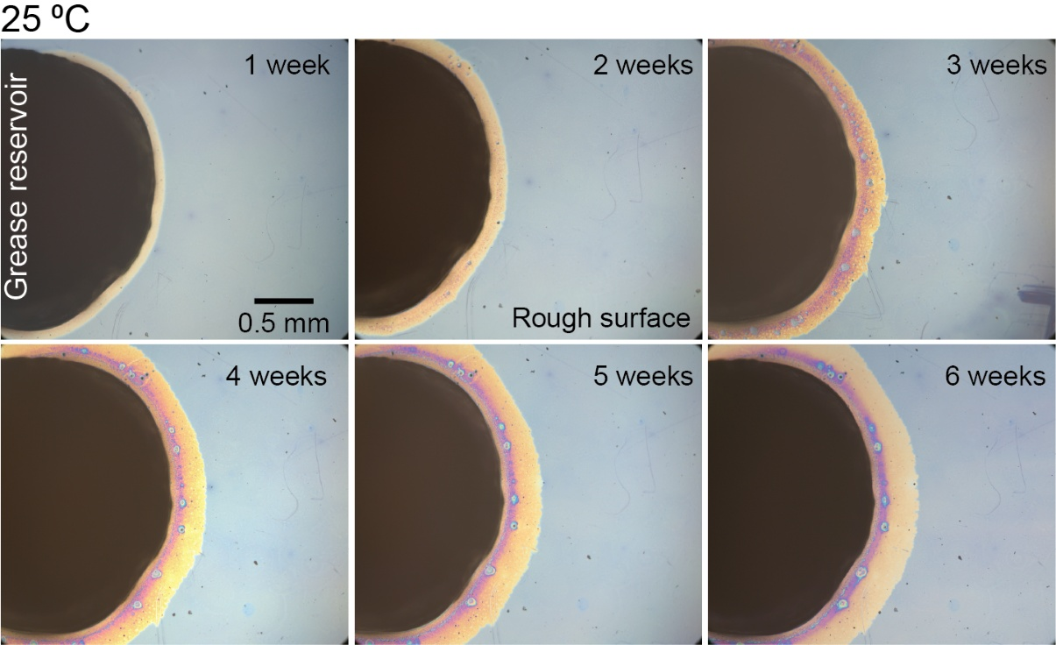
Fig. S3 Optical top-view images of cylindrical Li/M grease patches (black) deposited on the rough surface. Samples were stored at room temperature for six weeks; one representative image per week is shown

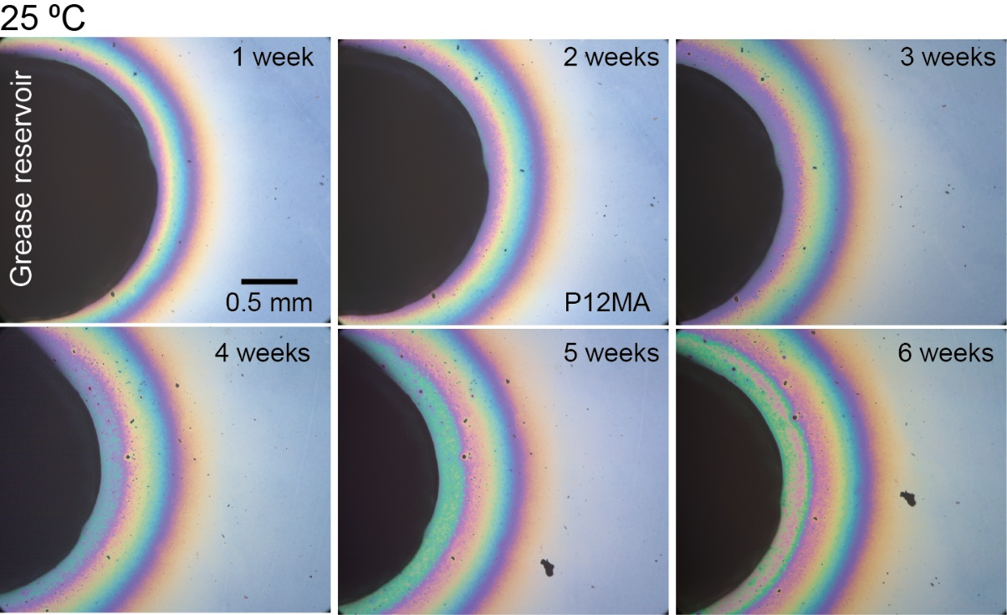
Fig. S4 Optical top-view images of cylindrical Li/M grease patches (black) deposited on the P12MA brush layer. Samples were stored at room temperature for six weeks; one representative image per week is shown

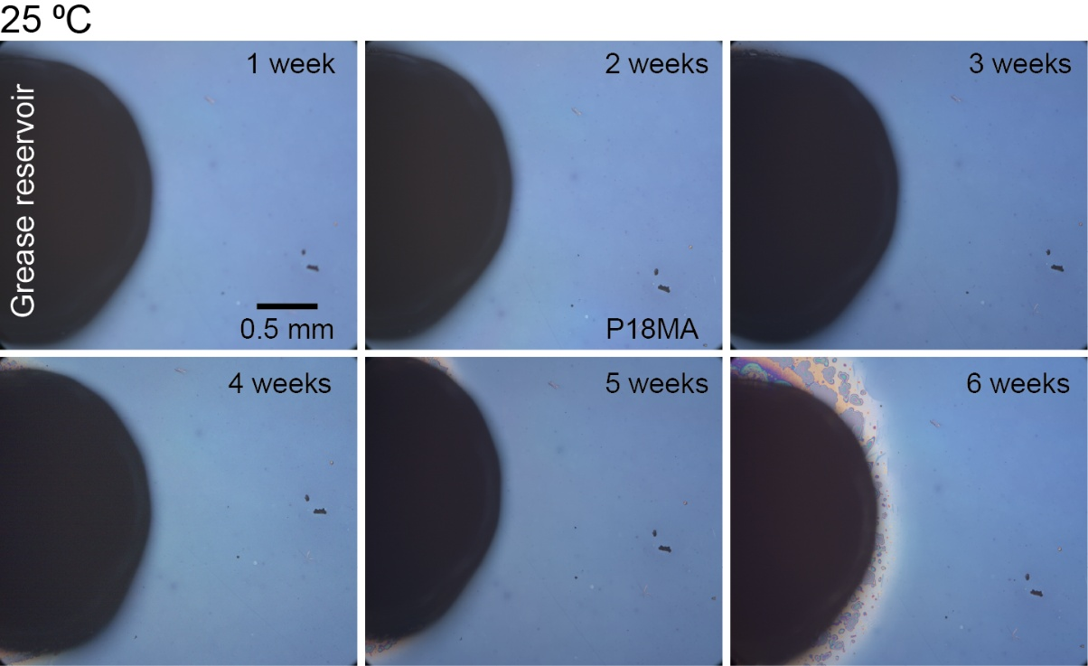
Fig. S5 Optical top-view images of cylindrical Li/M grease patches (black) deposited on the P18MA brush layer. Samples were stored at room temperature for six weeks; one representative image per week is shown

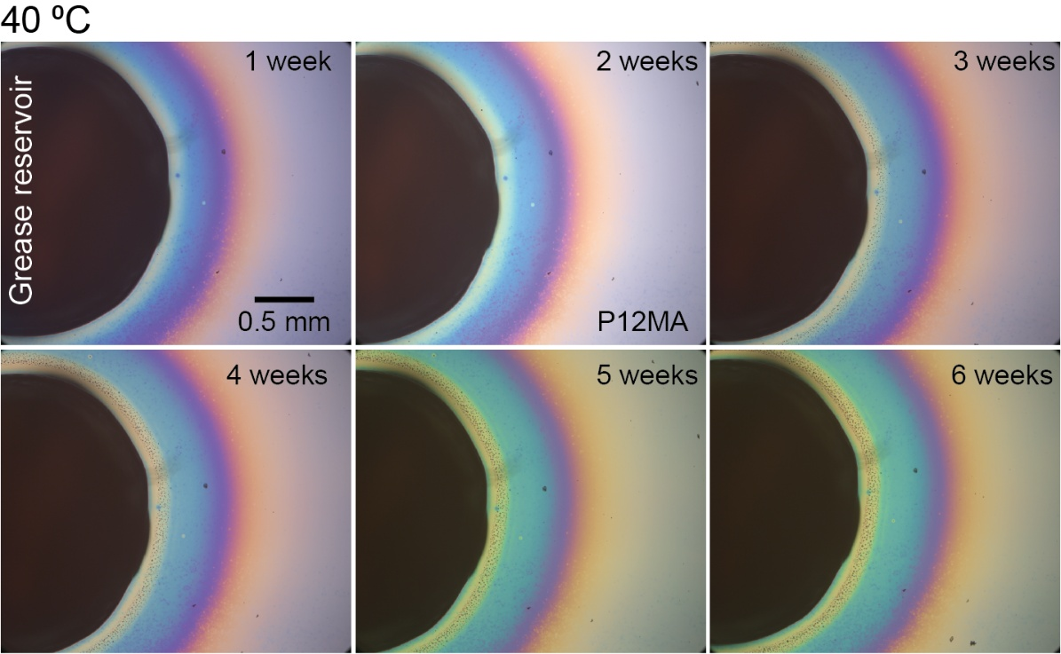
Fig. S6 Optical top-view images of cylindrical Li/M grease patches (black) deposited on the P12MA brush layer. Samples were heated at 40⁰ C for six weeks; one representative image per week is shown

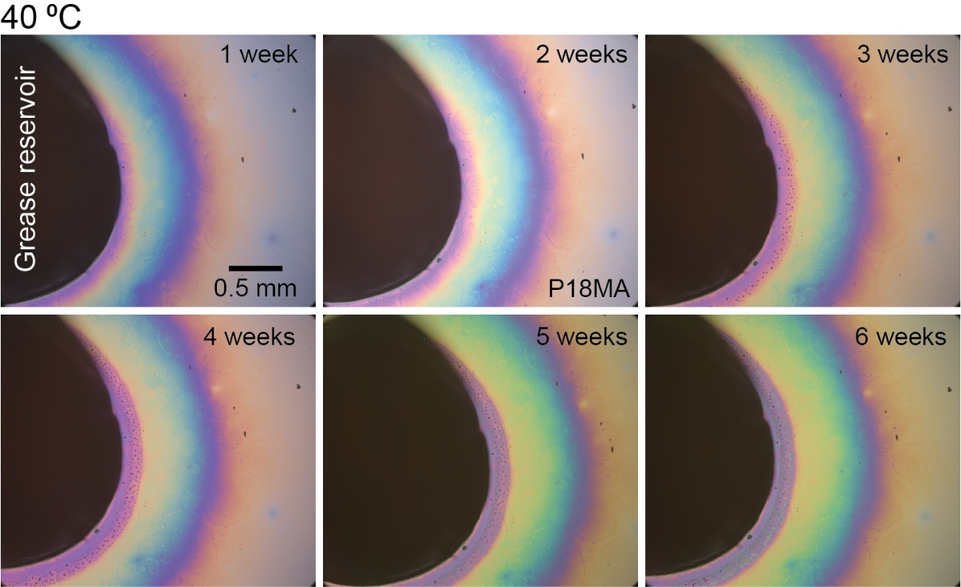
Fig. S7 Optical top-view images of cylindrical Li/M grease patches (black) deposited on the P18MA brush layer. Samples were heated at 40⁰ C for six weeks; one representative image per week is shown

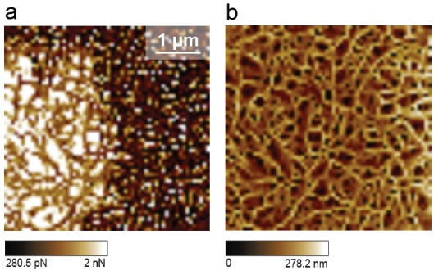
Fig. S8 a) Adhesion map obtained from force–volume measurements over the area indicated by the dashed square in Fig. 3b. Dark regions correspond to lower adhesion (dry areas), whereas brighter regions indicate higher adhesion (oil-infused areas). b) Corresponding surface topography reconstructed from the same force–distance curves. The adhesion map is extracted from the minimum of the retract curve, whereas the height map is determined from the minimum of the approach curve, corresponding to the point at which the AFM tip contacts the hard substrate

