Index
Supplementary methods 2
Initial Coronavirus screening 2
Primer design for Betacoronavirus enrichment before Next-Generation Sequencing 2
Sample preparation for sequencing 2
Amplicon sequencing 3
Genome assembly and finishing 3
Recombination and phylogenetic analyses 3
Generation of lentiviral pseudoviruses 3
Spike-pseudotyped lentivirus entry assays 4
Neutralization assays 4
Virus isolation 4
Molecular Dynamics simulations of RBD/hACE2 complexes 4
Supplementary Tables 6
Table S1: Total number of bats collected and morphological identification. 6
Table S2: List of study sites in Laos with coordinates 8
Table S3: Results from pan-coronavirus RT nested PCR and Sanger sequencing 9
Table S4. List of the MD simulations performed. 11
Table S5: Acknowledgment of sharing of SARS-CoV-2-related genome sequences from the GISAID database. Related to Figures 1-2 and Supp. Figures 1-4. 12
Table S6. Data collection and refinement statistics of the crystal structure of RBD236 in complex with hACE2. 18
Supplementary Figures 20
Figure S1: Identity matrices at the genus level of representative sarbecoviruses. 20
Figure S2: Complete phylogenetic reconstructions of recombinant fragments, as described in Figure 2. 24
Figure S3: Alignment of spike RBD domain. 39
Figure S4: Alignment of the whole spike amino-acid sequences. 40
Figure S5: Analysis of the stability and conformational heterogeneity of RBD/hACE2 complexes. 42
Figure S6: Estimation of RBD-hACE2 binding energy 43
Figure S7: Analysis of the inter-subunits hydrogen bonds at the interface of RBD and hACE2 44
Figure S8: Isolation of BANAL-236 on VeroE6 cells. 45
References 46

Supplementary methods

Initial Coronavirus screening
Total RNA was extracted from feces samples using the NucleoSpin 8 virus kit (Macherey Nagel). cDNA was synthesized using the Maxima H minus first strand cDNA synthesis kit (Thermo Scientific) and random hexamers following the manufacturer’s instructions. The presence of coronaviruses was tested by a nested PCR approach using PCR master mix (Promega) and by targeting the RNA-dependent RNA Polymerase gene using combinations of degenerate and non-degenerate consensus primers as previously described¹. PCR products of the expected size were directly sequenced on both strands by Sanger sequencing using the nested PCR primers. The sequences obtained were confirmed by similarity analysis using the NCBI BLASTn search (http://www.ncbi.nlm.nih.gov/BLAST).

Primer design for Betacoronavirus enrichment before Next-Generation Sequencing
Betacoronavirus enrichment was performed at the genus level by adapting a previously described protocol² based on k-mers for targeted-sequence enrichment prior to NGS. Briefly, 2,000 complete Betacoronavirus genomes were downloaded from the GenBank and GISAID databases and then clustered to a 95% sequence identity using CD-HIT-EST³. Overall, 185 representative sequences of all betacoronaviruses were used for further analysis. Due to the high diversity within the genus Betacoronavirus, the full genomes belonging to the subgenera Sarbecovirus, Nobecovirus, and Merbecovirus plus Embecovirus were separately aligned using MAFFT multiple sequence alignment software and used to design 13-mer spiked primers per cluster. The genomic position of the full set of primers was extracted from some representative subgenera sequences and close primers were removed. Finally, 416 spiked primers were synthesized by Eurofins Genomics Germany GmbH.

Sample preparation for sequencing
Reverse transcription was performed using the mix of spiked primers and random hexamers at a 10:1 ratio using the SuperScript™ IV First-Strand Synthesis System (Invitrogen). After a denaturation step at 95°C for 3 min in the presence of dNTPs (500 µM), DTT (5 mM), and RNaseOUT inhibitor, the RT reaction was incubated for 10 thermal cycles consisting of 6 steps at 8°C for 12 s, 15°C for 45 s, 20°C for 45 s, 30°C for 30 s, 35°C for 2 min and 42°C for 3 min, followed by a final incubation step at 42°C for 20 min, as previously described⁴. Double-stranded cDNA was generated using the Sequenase2.0 DNA Polymerase (Applied Biosystems™) in presence of dNTPs and then purified using the Beckman Coulter™ Agencourt AMPure XP.
For samples with a low nucleic acid content, a random amplification step was performed using the MALBAC Single Cell WGA kit (Yikon Genomics, Promega). The amplified product was then purified using AMPure XP Beads, eluted in a final volume of 20 μL of low TE (10 mM Tris-HCl (pH 8,0), 0,1 mM EDTA), and quantified with the Qubit™ DNA HS Assay (Life Technologies, Thermo Fisher Scientific Inc.).
Libraries were generated using the NEBNext Ultra II DNA Library Prep kit (New England Biolabs) after a fragmentation step using the Covaris M220 Focused-ultrasonicator using microTUBE-15 (Peak Incident power (W)=18, Duty Factor=20%, Cycles per Burst=50, Treatment time (sec)=60). The PCR amplified libraries were cleaned up using 0.9X AMPure XP Beads and checked on the 2100 Bioanalyzer system with the High-Sensitivity DNA kit (Agilent Technologies, France) and quantified with the Qubit™ DNA HS Assay. Finally, the dual-multiplexed libraries were pooled (six samples/pool) and run on the Illumina NextSeq500 platform with High Output Kit v2.5 (150 Cycles).

Amplicon sequencing
In addition to enrichment-based sequencing, cDNA was amplified using the AmpliSeq for Illumina SARS-CoV-2 Research Panel (cat# 20020496), applying twenty-six amplification cycles in PCR1 and nine cycles in PCR2. Primers at the end of the amplicons were partially digested during the library preparation, following manufacturer’s instructions. Libraries were barcoded individually using the Illumina UD dual-indexes and normalized with the AmpliSeq Library Equalizer for Illumina (cat# 20019171), then pooled and sequenced on the Illumina NextSeq500 instrument using a Mid Output v2.5 kit (SR 150 cycles). To eliminate residual PCR primer sequences, raw reads were trimmed by 15 bases at each end and special attention was paid to checking that internal sequences corresponding to primer regions in overlapping amplicons did not derive from primer sequences of the multiplex PCR. As an internal control, we verified that sequences of the complete genome of sample BANAL-236 obtained from the enrichment-based sequencing approach and from the AmpliSeq approach were identical.

Genome assembly and finishing
Raw reads from the enrichment-based sequencing were processed with an in-house bioinformatics pipeline (Microseek; Bigot et al., submitted) comprising quality check and trimming, reads normalization, de novo assembly, and ORF prediction of contigs and singletons, followed by 3 levels of taxonomic assignation⁵. Sequences identified as Sarbecovirus were then mapped onto appropriate reference sequences using CLC Genomics Workbench 20.0 (Qiagen). Trimmed reads from the amplicon sequencing were mapped to the SARS-CoV-2 genome first, then mapped again (refined mapping) to the closest genome relative. When needed, complete genomes were obtained by conventional PCR and Sanger sequencing. Briefly, viral RNA was reverse transcribed using the SuperScript IV reverse transcriptase (Invitrogen, USA) and cDNA was subsequently used to fill the gaps in the genomes using the Phusion High Fidelity DNA polymerase (New England Biolabs, France) and specific primers flanking the missing regions. Positive PCR products were further purified and sequenced by Sanger sequencing at Eurofins Genomics.

Recombination and phylogenetic analyses
Identification of recombination events occurring during the evolutionary history of bat sarbecoviruses was performed using the IDPlot package⁶, a web-based workflow that includes multiple sequence alignment and phylogeny-based breakpoints prediction using the GARD algorithm from the HyPhy genetic analysis suite⁷. First, a comprehensive analysis comprising 106 sequences and covering all non-human Sarbecovirus and Sarbecovirus-related complete genomes available in GenBank and GISAID databases was performed, including prototype strains of SARS-CoV-2 isolated in 2019. Special attention was paid to including bat-borne and pangolin-borne viral sequences in order to maximize the ability to capture a large diversity of the sarbecoviruses. Then, a reduced set of 36 sequences was chosen because of their phylogenetic proximity with SARS-CoV-2, and the GARD algorithm was run to identify recombination breakpoints in Laotian and representative human, bat, and pangolin sarbecoviruses. Breakpoint coordinates were confirmed by performing phylogenetic analyses on the corresponding fragments using PhyML implemented through the NGPhylogeny portal⁸. Branch support was evaluated with the aBayes parameter.

Generation of lentiviral pseudoviruses
The BANAL-236 and Wuhan synthetic spike genes were cloned into the pVAX1 vector with a cytoplasmic tail truncation of 19 amino acids. Pseudotyped lentiviral particles were prepared using HEK-293T cells seeded in 10-cm dishes. 293T cells were co-transfected with a 5 µg of spike-encoding plasmid, 10 µg of lentiviral backbone plasmid expressing the firefly luciferase (pHAGE-CMV-Luc2-IRES-ZsGreen-W), and 3.3 µg of each lentiviral helper plasmid expressing HIV Gag-Pol (HDM-Hgpm2), Tat (HDM-tat1b), and Rev (pRC-CMV-Rev1b) using calcium-phosphate precipitation¹¹. The medium was replaced 5 h post-transfection by 6 mL of DMEM without fetal calf serum (FCS) and phenol red. Pseudotyped particles were harvested 48 h post-transfection, clarified by centrifugation at 2500 g for 5 min and frozen at −80°C. Mock pseudotyped lentivirus was generated as above but in the absence of an S-expressing plasmid.

Spike-pseudotyped lentivirus entry assays
HEK-293T cells stably expressing human ACE2 (293T-ACE2) were transduced in suspension by mixing 50 µL of 3-fold serial dilutions of S-pseudotyped lentiviruses with 50 µL of cells at 4.10⁵ cells/mL in 96-well white culture plates. At 60-72 h post-transduction, 100 µL of Bright-Glo luciferase substrate (Promega) were added to the wells and luminescence was measured using a Berthold Centro XS luminometer.

Neutralization assays
Sera were decomplemented at 56°C for 30 min and 2.5 µL were incubated with 0.5 µL of S-pseudotyped lentiviruses in a final volume of 50 µL of DMEM-10% FCS without phenol red in 96-well white culture plates. After 30 min at room temperature, 50 µL of 293T-ACE2 cells in suspension at 4.10⁵ cells/mL were mixed to the wells. Luminescence was measured at 60-72 h post-transduction as described above. Neutralization was calculated using the following formula: 1 – (RLU in presence of serum / (mean of RLU in absence of serum determined in 12 wells – 3 x STD).

Virus isolation
Rectal swabs were inoculated in duplicate in 24-well plates containing VeroE6 cells (1/5 dilution in 100 µL of DMEM without FCS supplemented with 1% Penicillin-Streptomycin, 1% Fungizone, and 1 µg/mL TPCK-treated trypsin. After 1h of adsorption at 37°C, inoculum was removed and 1 mL of the medium described above was added. Three and 4 days after infection, cytopathic effect (CPE) was monitored and 100 µL of supernatant was collected for RNA extraction. RT-qPCR targeting a conserved sequence in the E gene was performed as described¹². Culture supernatant (C1) was harvested at day 4 and titrated by plaque assay on VeroE6 overlaid with 0.5% carboxymethylcellulose containing 1 µg/mL TPCK-treated trypsin. A viral stock was prepared by amplification on VeroE6 cells at a MOI of 10⁻⁴. Culture supernatant (C2) was harvested at day 4 when massive CPE was observed and titrated by plaque assay on VeroE6 as described above. RNA was extracted from the viral stock and submitted to random NGS analysis using the SMARTer® Stranded Total RNA-Seq Kit v3 - Pico Input Mammalian (Takara Bio USA, Inc.). Raw reads were processed with Microseek pipeline, as described above.

Molecular Dynamics simulations of RBD/hACE2 complexes
Generation of homology models. Homology models of the BANAL-236 and BANAL-52/103 RBD/hACE2 complexes were constructed using the X-ray structure of the SARS-CoV-2 RBD/hACE2 complex (PDB code 6M0J; resolution 2.45 Å) as template. These models included the fragments S19-D615 and T333-G526 of hACE2 and RBD, respectively, which were the regions resolved in the template. In these regions, BANAL-236 and BANAL-52/103 RBDs have a sequence identity to SARS-CoV-2 RBD equal to 96.9% and 97.4%, respectively. The alignment reported in Supp. Figure S3 was used. The zinc and chloride atoms present in the template were retained during homology modeling; N-Acetylglucosamine (NAG) and water residues were removed. Distance restraints were added to ensure the formation of the 7 disulfide bonds present in the template. For each construct, 100 homology models were built using MODELLER v. 10.1¹³ and ranked based on the normalized DOPE score¹⁴. The top 3 scoring models of each complex were used as starting points of 3 independent MD simulations, as described in the following section.
Details of the MD simulations: setup, equilibration, and production. The 6 homology models described in the previous section along with the X-ray structure of the SARS-CoV-2 RBD/hACE2 complex (PDB code 6M0J) were used as input to the CHARMM-GUI server¹⁵. In the case of the X-ray structure, for consistency with the homology models, the zinc and chloride atoms present in 6M0J were retained while the NAG and water residues were removed. The 7 systems were solvated in a triclinic box of initial x-y-z dimensions of ~13.5 nm * 9.2 nm * 8.3 nm. Potassium and chloride ions were added to ensure charge neutrality at a salt concentration of 0.15 M. The total number of atoms was ~104000. Additional details of the systems are reported in Table S4. The CHARMM36m force field¹⁶ was used for the protein and ions and the TIP3P model¹⁷ was used for the water molecules. The CHARMM-GUI models were first energy-minimized using the steepest descent algorithm. After minimization, the systems were equilibrated using a 1-ns long simulation in the NPT ensemble followed by a 1-ns long simulation in the NVT ensemble. The temperature T was set at 300 K and the pressure P at 1 atm using the Bussi-Donadio-Parrinello thermostat¹⁸ and the Berendsen barostat¹⁹, respectively. During equilibration, harmonic restraints on the positions of the protein backbone and sidechains heavy atoms were applied. For each system studied, production simulations were performed in the NVT ensemble for 1 µs. A time step of 2 fs was used together with LINCS constraints on h-bonds²⁰. The van der Waals interactions were gradually switched off at 1.0 nm and cut off at 1.2 nm; the particle-mesh Ewald method was used to calculate electrostatic interactions with cutoff at 1.2 nm²¹.
Details of the analysis. To evaluate the stability of the starting model during the production simulations, we calculated the backbone Root Mean Square Deviation (RMSD) with respect to the energy-minimized structure for each frame of the trajectories. The RMSD was calculated separately for the residues in: RBD (Supp. Figure S5A), hACE2 (Supp. Figure S5B), and at the RBD-hACE2 interface (Supp. Figure S5C), which were defined as the residues in one subunit closer than 0.8 nm to the residues in the other subunit in the X-ray structure of the SARS-Cov-2 RBD/hACE2 complex. RMSD calculations were performed using the driver utility of PLUMED v. 2.7¹⁰. To characterize conformational heterogeneity at the RBD-hACE2 interface, we performed a cluster analysis of the MD trajectories using as similarity metrics the backbone RMSD of the interfacial residues and the GROMOS clustering approach²² with a cutoff equal to 0.2 nm. The 9 trajectories were first concatenated, clustering was then performed, and finally the population of each cluster was calculated separately for each trajectory (Supp. Figure S5D). To estimate the binding energy between RBD and hACE2, we used the InterfaceAnalyzer tool in ROSETTA v. 3.11²³ (Supp. Figure S6A) and the AnalyseComplex tool in FoldX v. 4²⁴ (Supp. Figure S6B). To identify relevant interactions at the RBD and hACE2 interface that could contribute to the binding affinity of the complex, we quantified the frequency of formation of inter-subunits salt bridges (Fig. 3B) and hydrogen bonds (Supp. Figure S7) during the course of the MD simulations. For each frame of the trajectories, we used PLUMED to calculate the distances between the sidechain charged groups of aspartic acids (OD1/OD2), glutamic acids (OE1/OE2), lysines (NZ), and arginines (NH1/NH2). An inter-subunits salt bridge was then defined as formed if the distance between groups with opposite charge was lower than 0.32 nm. We confirmed this calculation using the Salt Bridges tool available in VMD²⁵. To monitor the formation of inter-subunits hydrogen bonds, we used the Hydrogen Bond Analysis module of the MDAnalysis library v. 1.0.0²⁶. A donor-acceptor distance and angular cutoffs of 0.3 nm and 150° were used to define the formation of a hydrogen bond. We confirmed this calculation using the Hydrogen Bonds tool available in VMD.

Supplementary Tables

Table S1: Total number of bats collected and morphological identification.
Family | Genus | Species | Vientiane Province |  | Oudomxay Province |  | Total No. of bats
Family | Genus | Species | Fueng  (Site 1) | Meth  (Site 2) | Xay  (Site 3) | Na Mor  (Site 4)
Hipposideridae | Aselliscus | stoliczkanus | 5 | 5 | 30 |  | 40
 | Hipposideros | cineraceus | 14 | 3 |  |  | 17
 |  | khaokhouayensis | 12 | 4 |  |  | 16
 |  | larvatus | 47 |  |  |  | 47
 |  | gentilis | 55 | 7 | 1 |  | 63
 |  | rotalis | 1 |  |  |  | 1
Megadermatidae | Megaderma | spasma | 3 | 6 |  | 2 | 11
Molossidae | Chaerephon | plicatus | 45 |  |  |  | 45
Pteropodidae | Cynopterus | horsfieldii |  |  | 2 |  | 2
 |  | sphinx |  | 10 | 1 | 1 | 12
 | Eonycteris | spelaea | 1 | 9 |  | 1 | 11
 | Macroglossus | sobrinus | 5 | 45 | 7 | 3 | 60
 | Megaerops | niphanae |  | 1 |  | 1 | 2
 | Sphaerias | blanfordi |  | 1 |  |  | 1
Rhinolophidae | Rhinolophus | affinis | 2 |  |  |  | 2
 |  | coelophyllus | 10 | 2 |  |  | 12
 |  | luctus | 1 |  |  |  | 1
 |  | malayanus | 46 | 1 | 9 | 1 | 57
 |  | marshalli | 1 |  |  |  | 1
 |  | microglobosus | 5 | 1 | 1 |  | 7
 |  | pearsonii | 46 | 19 | 1 |  | 66
 |  | pusillus | 7 | 11 |  |  | 18
 |  | rex |  |  | 2 |  | 2
 |  | shameli |  |  | 1 |  | 1
 |  | siamensis |  |  | 6 | 4 | 10
 |  | sp. | 2 |  |  |  | 2
 |  | thomasi | 1 | 5 | 2 |  | 8
Vespertilionidae | Arielulus | aureocollaris |  |  | 1 |  | 1
 | Glischropus | bucephalus |  | 2 | 2 |  | 4
 | Ia | io |  |  | 1 |  | 1
 | Kerivoula | cf.hardwickii |  | 9 |  |  | 9
 |  | cf.titania |  | 1 |  |  | 1
 |  | depressa |  |  | 8 |  | 8
 |  | hardwickii | 5 |  |  |  | 5
 | Murina | feae | 1 | 1 | 1 |  | 3
 |  | sp1 |  | 4 | 2 |  | 6
 |  | sp2 |  | 1 | 2 |  | 3
 | Myotis | sp. | 7 |  |  |  | 7
 |  | sp1 |  |  | 45 |  | 45
 |  | sp2 |  |  | 3 |  | 3
 |  | sp3 |  |  | 1 |  | 1
 | Pipistrellus | sp. | 8 |  |  |  | 8
 | Scotomanes | ornatus |  |  | 1 |  | 1
 | Tylonycteris | fulvida |  | 3 |  |  | 3
 |  | malayana |  | 14 |  |  | 14
 |  | sp. | 5 |  | 2 |  | 7
Grand Total |  |  | 335 | 165 | 132 | 13 | 645

Table S2: List of study sites in Laos with coordinates
Province | District | Village | Locality | Latitude | Longitude
Vientiane Province | Site 1 :  Fueng | Na Ang | Pha Tong | 18° 32.879'N | 101° 58.938'E
 |  |  | Tham Nam cave | 18° 32.914'N | 101° 58.459'E
 |  |  | Tham Pha | 18° 34.018'N | 101° 58.338'E
 |  | Noon Hin Hae | Pha Nouk Kok | 18° 31.743'N | 101° 58.648'E
 |  | Pha Louang | Tham Pha Louang | 18° 30.495'N | 101° 57.421'E
 | Site 2 :  Meth | Had Yao | Pha Keo Phong Mon | 18° 54.426'N | 101° 58.789'E
 |  |  | Pha Khee Chear (Keo Tao) | 18° 54.898'N | 101° 59.048'E
 |  | Houay Pa Mak | Pha Mum | 18° 53.717'N | 101° 56.957'E
 |  |  | Pha Mum, Keo Tao | 18° 54.787'N | 101° 58.292'E
 |  |  | Pha Yao, Keo Tao | 18° 55.386'N | 101° 57.723'E
Oudomxay Province | Site 3 :  Xay | Chom Ong | Chom Ong Cave | 20° 43.071'N | 101° 45.811'E
 |  |  | Houay Om Loung | 20° 43.111'N | 101° 46.577'E
 |  |  | Houay Pak Veuk | 20° 41.647'N | 101° 47.179'E
 |  |  | Pa Noo Khom | 20° 44.143'N | 101° 46.770'E
 | Site 4 :  Na Mor | Na Thong | Nam Ook Hoo Cave | 20° 52.396'N | 101° 46.973'E
 |  |  |  | 20° 51.907'N | 101° 46.926'E

Table S3: Results from pan-coronavirus RT nested PCR and Sanger sequencing
Anal Swab ID | Bat Genus | Bat Species | Genus | Subgenus | Closest sequence | % blastN similarity | District | Village | Locality
BANAL-20-27 | Rhinolophus | pusillus | co-infection Alpha/Betacoronavirus | unclassified Decacovirus/ Sarbecovirus | Rhinolophus bat coronavirus HKU32 / SARS-CoV-2 | 80% | Feuang (Site 1) | Nonhinhae | Pha Nok Kok
BANAL-20-51 | Hipposideros | pomona | Alphacoronavirus | Decacovirus | Bat coronavirus HKU10 | 98% | Feuang (Site 1) | Nonhinhae | Pha Nok Kok
BANAL-20-52 | Rhinolophus | malayanus | Betacoronavirus | Sarbecovirus | SARS-CoV-2 | 99% | Feuang (Site 1) | Nonhinhae | Pha Nok Kok
BANAL-20-103 | Rhinolophus | pusillus | Betacoronavirus | Sarbecovirus | SARS-CoV-2 | 99% | Feuang (Site 1) | Na Ang | Tham Pha
BANAL-20-115 | Hipposideros | pomona | Alphacoronavirus | Decacovirus | Bat coronavirus HKU10 | 98% | Feuang (Site 1) | Pha Luang | Tham Pha Luang
BANAL-20-116 | Rhinolophus | malayanus | Betacoronavirus | Sarbecovirus | SARS-CoV-2 | 98% | Feuang (Site 1) | Pha Luang | Tham Pha Luang
BANAL-20-178 | Hipposideros | pomona | Alphacoronavirus | Decacovirus | Bat coronavirus HKU10 | 98% | Feuang (Site 1) | Pha Luang | Tham Pha Luang
BANAL-20-191 | Chaerephon | plicatus | Alphacoronavirus | Pedacovirus | Porcine epidemic diarrhea virus (PEDV) | 93% | Feuang (Site 1) | Pha Luang | Tham Pha Luang
BANAL-20-197 | Chaerephon | plicatus | Alphacoronavirus | Pedacovirus | Porcine epidemic diarrhea virus (PEDV) | 93% | Feuang (Site 1) | Pha Luang | Tham Pha Luang
BANAL-20-212 | Chaerephon | plicatus | Alphacoronavirus | Pedacovirus | Porcine epidemic diarrhea virus (PEDV) | 93% | Feuang (Site 1) | Pha Luang | Tham Pha Luang
BANAL-20-213 | Chaerephon | plicatus | Alphacoronavirus | Pedacovirus | Porcine epidemic diarrhea virus (PEDV) | 93% | Feuang (Site 1) | Pha Luang | Tham Pha Luang
BANAL-20-236 | Rhinolophus | marshalli | Betacoronavirus | Sarbecovirus | SARS-CoV-2 | 99% | Feuang (Site 1) | Na Ang | Pha Tong
BANAL-20-242 | Rhinolophus | malayanus | Betacoronavirus | Sarbecovirus | SARS-CoV-2 | 99% | Feuang (Site 1) | Na Ang | Pha Tong
BANAL-20-247 | Rhinolophus | malayanus | Betacoronavirus | Sarbecovirus | SARS-CoV-2 | 99% | Feuang (Site 1) | Na Ang | Pha Tong
BANAL-20-251 | Hipposideros | khaokhouayensis | Alphacoronavirus | Decacovirus | Bat coronavirus HKU10 | 97% | Feuang (Site 1) | Na Ang | Pha Tong
BANAL-20-273 | Rhinolophus | pusillus | Alphacoronavirus | unclassified Decacovirus | Rhinolophus bat coronavirus HKU32 | 92% | Feuang (Site 1) | Na Ang | Pha Tong
BANAL-20-289 | Rhinolophus | affinis | Alphacoronavirus | Rhinacovirus | Rhinolophus affinis bat coronavirus HKU2-related / Swine acute diarrhea syndrome related coronavirus (SADS-CoV) | 98% | Feuang (Site 1) | Na Ang | Pha Tong
BANAL-20-290 | Eonycteris | spelaea | Betacoronavirus | Nobecovirus | Rousettus bat coronavirus GCCDC1 | 99% | Maed (Site 2) | Had Yao | Keo tao + Had Yao
BANAL-20-390 | Eonycteris | spelaea | Betacoronavirus | Nobecovirus | Rousettus bat coronavirus GCCDC1 | 97% | Maed (Site 2) | Huay Pa Mak | Keo Tao
BANAL-20-395 | Eonycteris | spelaea | Betacoronavirus | Nobecovirus | Rousettus bat coronavirus GCCDC1 | 99% | Maed (Site 2) | Huay Pa Mak | Keo Tao
BANAL-20-398 | Eonycteris | spelaea | Betacoronavirus | Nobecovirus | Rousettus bat coronavirus GCCDC1 | 99% | Maed (Site 2) | Huay Pa Mak | Keo Tao
BANAL-20-403 | Eonycteris | spelaea | Betacoronavirus | Nobecovirus | Rousettus bat coronavirus GCCDC1 | 99% | Maed (Site 2) | Huay Pa Mak | Keo Tao
BANAL-20-416 | Cynopterus | sphinx | Betacoronavirus | Nobecovirus | Rousettus bat coronavirus GCCDC1 | 99% | Maed (Site 2) | Huay Pa Mak | Pha Moum
BANAL-20-497 | Myotis | sp. | Alphacoronavirus | Pedacovirus | Bat alphacoronavirus* | 99% | Xay (Site 3) | Chom-Ong | Near Chom-Ong Cave

- Due to the low genome coverage of BANAL-20-497 (< 1%), the taxonomic assignation is not robust.

Table S4. List of the MD simulations performed.
The 3 production simulations of the SARS-CoV-2 RBD/hACE2 complex were initiated from the same equilibrated model with different random velocities. Production simulations of the BANAL-236 and BANAL-52/103 RBD/hACE2 complexes were initiated from different equilibrated models obtained, for each construct, from the top 3 scoring homology models.
ID | Construct | Initial model | # K/Cl ions | # waters | Total # atoms | Production time [µs]
SARS-CoV-2.1 | SARS-CoV-2 RBD/hACE2 | X-ray | 121/97 | 30621 | 104592 | 1
SARS-CoV-2.2 | SARS-CoV-2 RBD/hACE2 | X-ray | 121/97 | 30621 | 104592 | 1
SARS-CoV-2.3 | SARS-CoV-2 RBD/hACE2 | X-ray | 121/97 | 30621 | 104592 | 1
BANAL-236-CoV.1 | BANAL-236 RBD/hACE2 | Homology model (top1) | 121/97 | 30502 | 104228 | 1
BANAL-236-CoV.2 | BANAL-236 RBD/hACE2 | Homology model (top2) | 120/96 | 30140 | 103140 | 1
BANAL-236-CoV.3 | BANAL-236 RBD/hACE2 | Homology model (top3) | 120/96 | 30090 | 102990 | 1
BANAL-52/103-CoV.1 | BANAL-52/103 RBD/hACE2 | Homology model (top1) | 123/98 | 30808 | 105144 | 1
BANAL-52/103-CoV.2 | BANAL-52/103 RBD/hACE2 | Homology model (top2) | 121/96 | 30135 | 103121 | 1
BANAL-52/103-CoV.3 | BANAL-52/103 RBD/hACE2 | Homology model (top3) | 124/99 | 31307 | 106643 | 1

Table S5: Acknowledgment of sharing of SARS-CoV-2-related genome sequences from the GISAID database. Related to Figures 1-2 and Supp. Figures 1-4.
We thank the authors listed in the table below for sharing their genomic sequences of coronaviruses analyzed in this study.
Accession ID | Virus name | Location | Host | Collection date | Originating lab | Submitting lab | Authors
EPI_ISL_529214 | hCoV-19/Wuhan/IME-WH02/2019 | Asia / China / Hubei / Wuhan | Human | 2019-12-30 | Beijing Institute of Microbiology and Epidemiology | Beijing Institute of Microbiology and Epidemiology | Fan, Hang; Qin, E.; Wu, Y.; Guo, Y.; Zhang, X.; Yong, Y.; Hou, J.; Xu, Z.; Mu, J.; Teng, Yue; Mi, Z.; Yang, R.; Song, Yajun.; Li, B.; Cui, Y.
EPI_ISL_529213 | hCoV-19/Wuhan/IME-WH01/2019 | Asia / China / Hubei / Wuhan | Human | 2019-12-30 | Beijing Institute of Microbiology and Epidemiology | Beijing Institute of Microbiology and Epidemiology | Fan, Hang; Qin, E.; Wu, Y.; Guo, Y.; Zhang, X.; Yong, Y.; Hou, J.; Xu, Z.; Mu, J.; Teng, Yue; Mi, Z.; Yang, R.; Song, Yajun.; Li, B.; Cui, Y.
EPI_ISL_402132 | hCoV-19/Wuhan/HBCDC-HB-01/2019 | Asia / China / Hubei / Wuhan | Human | 2019-12-30 | Wuhan Jinyintan Hospital | Hubei Provincial Center for Disease Control and Prevention | Bin Fang, Xiang Li, Xiao Yu, Linlin Liu, Bo Yang, Faxian Zhan, Guojun Ye, Xixiang Huo, Junqiang Xu, Bo Yu, Kun Cai, Jing Li, Yongzhong Jiang.
EPI_ISL_402123 | hCoV-19/Wuhan/IPBCAMS-WH-01/2019 | Asia / China / Hubei / Wuhan | Human | 2019-12-24 | Institute of Pathogen Biology, Chinese Academy of Medical Sciences & Peking Union Medical College | Institute of Pathogen Biology, Chinese Academy of Medical Sciences & Peking Union Medical College | Lili Ren, Jianwei Wang, Qi Jin, Zichun Xiang, Zhiqiang Wu, Chao Wu, Yiwei Liu
EPI_ISL_402119 | hCoV-19/Wuhan/IVDC-HB-01/2019 | Asia / China / Hubei / Wuhan | Human | 2019-12-30 | National Institute for Viral Disease Control and Prevention, China CDC | National Institute for Viral Disease Control and Prevention, China CDC | Wenjie Tan，Xiang Zhao, Wenling Wang，Xuejun Ma, Yongzhong Jiang, Roujian Lu, Ji Wang, Weimin Zhou，Peihua Niu，Peipei Li, Faxian Zhan，Weifeng Shi，Baoying Huang, Jun Liu, Li Zhao，Yao Meng，Xiaozhou He, Fei Ye，Na Zhu，Yang Li，Jing Chen, Wenbo Xu，George F. Gao，Guizhen Wu
EPI_ISL_406798 | hCoV-19/Wuhan/WH01/2019 | Asia / China / Hubei / Wuhan | Human | 2019-12-26 | General Hospital of Central Theater Command of People's Liberation Army of China | BGI & Institute of Microbiology, Chinese Academy of Sciences & Shandong First Medical University & Shandong Academy of Medical Sciences & General Hospital of Central Theater Command of People's Liberation Army of China | Weijun Chen, Yuhai Bi, Weifeng Shi and Zhenhong Hu
EPI_ISL_408515 | hCoV-19/env/Wuhan/IVDC-HBF13-21/2020 | Asia / China / Hubei / Wuhan | Environment (Huanan Seafood Market) | 2020-01-01 | Institute of Viral Disease Control and Prevention, China CDC | Institute of Viral Disease Control and Prevention, China CDC | William J. Liu, Peipei Liu, Xiang Zhao, Peihua Niu, Yingze Zhao, Wenwen Lei, Ziqian Xu, Shumei Zou, Wei Zhen, Beiwei Ye, Mengjie Yang, Weifeng Shi, Roujian Lu, Wenjie Tan, Zhixiao Chen, Yuchao Wu, Juan Song, Weimin Zhou, Dayan Wang, Jun Han, Wenbo Xu, George F. Gao, Guizhen Wu
EPI_ISL_408514 | hCoV-19/env/Wuhan/IVDC-HBF13-20/2020 | Asia / China / Hubei / Wuhan | Environment (Huanan Seafood Market) | 2020-01-01 | Institute of Viral Disease Control and Prevention, China CDC | Institute of Viral Disease Control and Prevention, China CDC | William J. Liu, Peipei Liu, Xiang Zhao, Peihua Niu, Yingze Zhao, Wenwen Lei, Ziqian Xu, Shumei Zou, Wei Zhen, Beiwei Ye, Mengjie Yang, Weifeng Shi, Roujian Lu, Wenjie Tan, Zhixiao Chen, Yuchao Wu, Juan Song, Weimin Zhou, Dayan Wang, Jun Han, Wenbo Xu, George F. Gao, Guizhen Wu
EPI_ISL_412977 | hCoV-19 /bat/Yunnan/RmYN02/2019 | Asia / China / Yunnan / Xishuangbanna | Rhinolophus malayanus | 2019-06-25 | Shandong First Medical University & Shandong Academy of Medical Sciences | Institute of Microbiology, Chinese Academy of Sciences | Weifeng Shi, Tao Hu, Hong Zhou, Juan Li, Xing Chen, Alice Catherine Hughes, Yuhai Bi
EPI_ISL_1699446 | hCoV-19 /bat/Yunnan/RpYN06/2020 | Asia / China / Yunnan / Xishuangbanna | Rhinolophus pusillus | 2020-05-25 | Shandong First Medical University & Shandong Academy of Medical Sciences | Shandong First Medical University & Shandong Academy of Medical Sciences | Weifeng Shi, Edward C. Holmes, Alice C. Hughes, Hong Zhou, Jingkai Ji, Xing Chen, Yuhai Bi, Juan Li, Tao Hu, Yanhua Chen
EPI_ISL_1098866 | hCoV-19 /bat/Yunnan/PrC31/2018 | Asia / China / Yunnan / Pu'er City | Rhinolophus sp. | 2018-08 | Yunnan Tropical and Subtropical Animal Viral Disease Laboratory, Yunnan Animal Science and Veterinary Institute | Diarrhea department, National Institute for Viral Disease Control and Prevention, China CDC | Lili Li
EPI_ISL_402131 | hCoV-19 /bat/Yunnan/RaTG13/2013 | Asia / China / Yunnan / Pu'er | Rhinolophus affinis | 2013-07-24 | Wuhan Institute of Virology, Chinese Academy of Sciences | Wuhan Institute of Virology, Chinese Academy of Sciences | Yan Zhu, Ping Yu, Bei Li, Ben Hu, Hao-Rui Si, Xing-Lou Yang, Peng Zhou, Zheng-Li Shi
EPI_ISL_852604 | hCoV-19 /bat/Cambodia/RShSTT182 /2010 | Asia / Cambodia / Steung Treng | Rhinolophus shameli | 2010-12-06 | Virology Unit, Institut Pasteur du Cambodge | G5 Evolutionary Genomics of RNA viruses, Virology Department, Institut Pasteur | Vibol Hul, Deborah Delaune, Erik A Karlsson, Ou Tey Putita, Alexandre Hassanin, Artem Baidaliuk, Fabiana Gámbaro, Vuong Tan Tu, Lucy Keatts, Jonna Mazet, Christine Johnson, Philippe Buchy, Philippe Dussart, Tracey Goldstein, Etienne Simon-Lorière, Veasna Duong
EPI_ISL_852605 | hCoV-19 /bat/Cambodia/RShSTT200 /2010 | Asia / Cambodia / Steung Treng | Rhinolophus shameli | 2010-12-06 | Virology Unit, Institut Pasteur du Cambodge | G5 Evolutionary Genomics of RNA viruses, Virology Department, Institut Pasteur | Vibol Hul, Deborah Delaune, Erik A Karlsson, Ou Tey Putita, Alexandre Hassanin, Artem Baidaliuk, Fabiana Gámbaro, Vuong Tan Tu, Lucy Keatts, Jonna Mazet, Christine Johnson, Philippe Buchy, Philippe Dussart, Tracey Goldstein, Etienne Simon-Lorière, Veasna Duong
EPI_ISL_410721 | hCoV-19 /pangolin/Guangdong/1/2019 | Asia / China / Guangdong | Manis javanica | 2019 | South China Agricultural University | South China Agricultural University | Yongyi Shen, Lihua Xiao, Wu Chen
EPI_ISL_471467 | hCoV-19 /pangolin/Guangdong/A22-2 /2019 | Asia / China / Guangdong | Manis javanica | 2019 | South China Agricultural University | South China Agricultural University | Yongyi Shen, Wu Chen
EPI_ISL_410541 | hCoV-19 /pangolin/Guangxi/P5E/2017 | Asia / China / Guangxi | Manis javanica | 2017 | Beijing Institute of Microbiology and Epidemiology | Beijing Institute of Microbiology and Epidemiology | Wu-Chun Cao; Tommy Tsan-Yuk Lam; Na Jia; Ya-Wei Zhang; Jia-Fu Jiang; Bao-Gui Jiang
EPI_ISL_410540 | hCoV-19 /pangolin/Guangxi/P5L/2017 | Asia / China / Guangxi | Manis javanica | 2017 | Beijing Institute of Microbiology and Epidemiology | Beijing Institute of Microbiology and Epidemiology | Wu-Chun Cao; Tommy Tsan-Yuk Lam; Na Jia; Ya-Wei Zhang; Jia-Fu Jiang; Bao-Gui Jiang
EPI_ISL_410539 | hCoV-19 /pangolin/Guangxi/P1E/2017 | Asia / China / Guangxi | Manis javanica | 2017 | Beijing Institute of Microbiology and Epidemiology | Beijing Institute of Microbiology and Epidemiology | Wu-Chun Cao; Tommy Tsan-Yuk Lam; Na Jia; Ya-Wei Zhang; Jia-Fu Jiang; Bao-Gui Jiang
EPI_ISL_410538 | hCoV-19 /pangolin/Guangxi/P4L/2017 | Asia / China / Guangxi | Manis javanica | 2017 | Beijing Institute of Microbiology and Epidemiology | Beijing Institute of Microbiology and Epidemiology | Wu-Chun Cao; Tommy Tsan-Yuk Lam; Na Jia; Ya-Wei Zhang; Jia-Fu Jiang; Bao-Gui Jiang
EPI_ISL_410542 | hCoV-19 /pangolin/Guangxi/P2V/2017 | Asia / China / Guangxi | Manis javanica | 2017 | Beijing Institute of Microbiology and Epidemiology | Beijing Institute of Microbiology and Epidemiology | Wu-Chun Cao; Tommy Tsan-Yuk Lam; Na Jia; Ya-Wei Zhang; Jia-Fu Jiang; Bao-Gui Jiang
EPI_ISL_1699444 | hCoV-19 /bat/Yunnan/RsYN04/2020 | Asia / China / Yunnan / Xishuangbanna | Rhinolophus stheno | 2020-04-18 | Shandong First Medical University & Shandong Academy of Medical Sciences | Shandong First Medical University & Shandong Academy of Medical Sciences | Weifeng Shi, Edward C. Holmes, Alice C. Hughes, Hong Zhou, Jingkai Ji, Xing Chen, Yuhai Bi, Juan Li, Tao Hu, Yanhua Chen
EPI_ISL_1699448 | hCoV-19 /bat/Yunnan/RmYN08/2020 | Asia / China / Yunnan / Xishuangbanna | Rhinolophus malayanus | 2020-07-14 | Shandong First Medical University & Shandong Academy of Medical Sciences | Shandong First Medical University & Shandong Academy of Medical Sciences | Weifeng Shi, Edward C. Holmes, Alice C. Hughes, Hong Zhou, Jingkai Ji, Xing Chen, Yuhai Bi, Juan Li, Tao Hu, Yanhua Chen
EPI_ISL_1699445 | hCoV-19 /bat/Yunnan/RmYN05/2020 | Asia / China / Yunnan / Xishuangbanna | Rhinolophus malayanus | 2020-05-25 | Shandong First Medical University & Shandong Academy of Medical Sciences | Shandong First Medical University & Shandong Academy of Medical Sciences | Weifeng Shi, Edward C. Holmes, Alice C. Hughes, Hong Zhou, Jingkai Ji, Xing Chen, Yuhai Bi, Juan Li, Tao Hu, Yanhua Chen
EPI_ISL_1699447 | hCoV-19 /bat/Yunnan/RmYN07/2020 | Asia / China / Yunnan / Xishuangbanna | Rhinolophus malayanus | 2020-06-03 | Shandong First Medical University & Shandong Academy of Medical Sciences | Shandong First Medical University & Shandong Academy of Medical Sciences | Weifeng Shi, Edward C. Holmes, Alice C. Hughes, Hong Zhou, Jingkai Ji, Xing Chen, Yuhai Bi, Juan Li, Tao Hu, Yanhua Chen
EPI_ISL_1699449 | hCoV-19 /bat/Yunnan/RsYN09/2020 | Asia / China / Yunnan / Xishuangbanna | Rhinolophus stheno | 2020-07-28 | Shandong First Medical University & Shandong Academy of Medical Sciences | Shandong First Medical University & Shandong Academy of Medical Sciences | Weifeng Shi, Edward C. Holmes, Alice C. Hughes, Hong Zhou, Jingkai Ji, Xing Chen, Yuhai Bi, Juan Li, Tao Hu, Yanhua Chen
EPI_ISL_1699443 | hCoV-19 /bat/Yunnan/RsYN03/2019 | Asia / China / Yunnan / Xishuangbanna | Rhinolophus sinicus | 2019-10-22 | Shandong First Medical University & Shandong Academy of Medical Sciences | Shandong First Medical University & Shandong Academy of Medical Sciences | Weifeng Shi, Edward C. Holmes, Alice C. Hughes, Hong Zhou, Jingkai Ji, Xing Chen, Yuhai Bi, Juan Li, Tao Hu, Yanhua Chen

Table S6. Data collection and refinement statistics of the crystal structure of RBD236 in complex with hACE2.
Wavelength | 0.978
Resolution range | 48.63 - 2.942 (3.047 - 2.942)
Space group | P 65 2 2
Unit cell | 341.535 341.535 68.153 90 90 120
Total reflections | 87290 (1228)
Unique reflections | 43645 (614)
Multiplicity | 2.0 (2.0)
Completeness (%) | 86.98 (12.53)
Mean I/sigma(I) | 11.42 (1.50)
Wilson B-factor | 68.40
R-merge | 0.05642 (0.4364)
R-meas | 0.07979 (0.6171)
R-pim | 0.05642 (0.4364)
CC1/2 | 0.996 (0.687)
CC* | 0.999 (0.903)
Reflections used in refinement | 43634 (614)
Reflections used for R-free | 2169 (28)
R-work | 0.2143 (0.3388)
R-free | 0.2270 (0.3702)
CC (work) | 0.945 (0.656)
CC (free) | 0.935 (0.767)
Number of non-hydrogen atoms | 6610
macromolecules | 6418
ligands | 184
solvent | 8
Protein residues | 793
RMS (bonds) | 0.004
RMS (angles) | 0.65
Ramachandran favored (%) | 98.23
Ramachandran allowed (%) | 1.65
Ramachandran outliers (%) | 0.13
Rotamer outliers (%) | 0.72
Clashscore | 4.11
Average B-factor | 64.68
macromolecules | 63.72
ligands | 99.31
solvent | 42.82
Statistics for the highest-resolution shell are shown in parentheses.

Supplementary Figures

Figure S1: Identity matrices at the genus level of representative sarbecoviruses.
Amino-acid (lower) and nucleotide (upper) identity matrices of Laotian and representative human, bat, and pangolin sarbecoviruses. Individual genes and proteins were aligned with MAFFT, and identity matrices were constructed using CLC Main Workbench 21.0.4 (Qiagen). Matrices were colored according to the identity scale, from 25% (red) to 100% (green) of nucleotide or amino-acid identity.
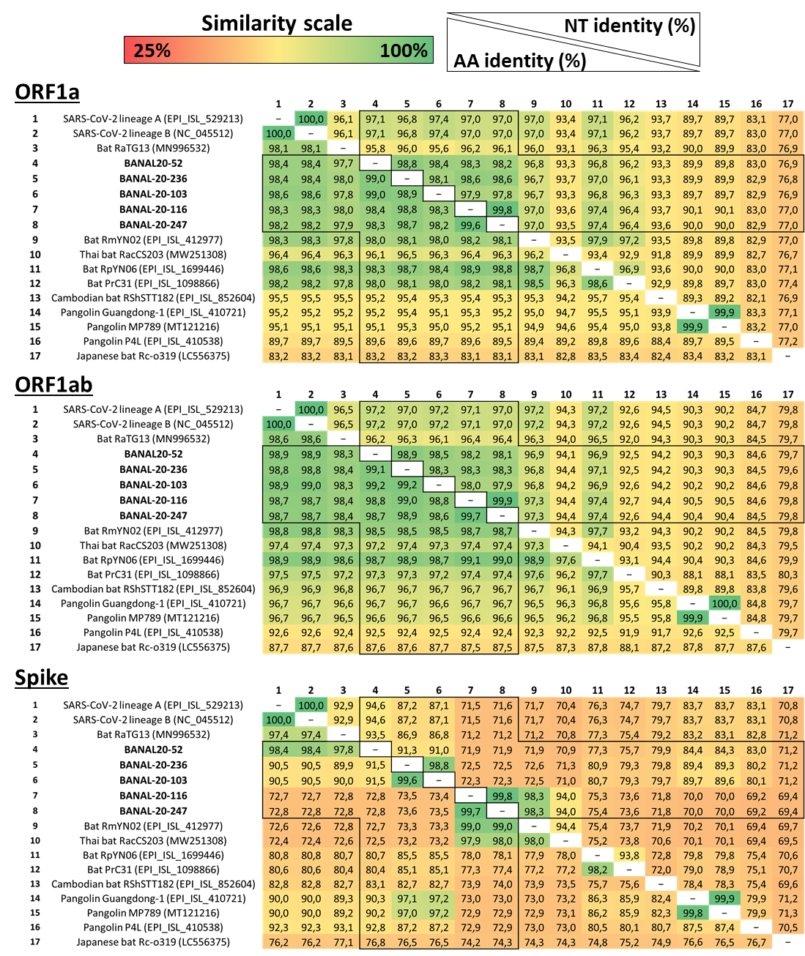

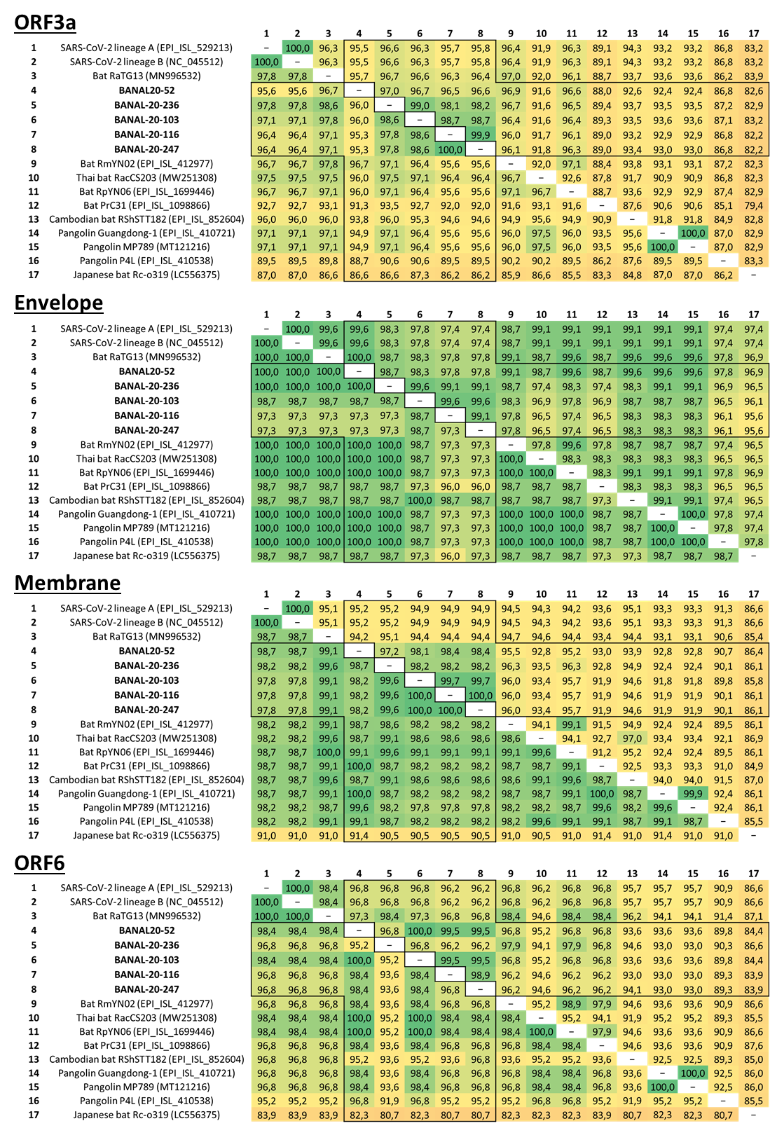

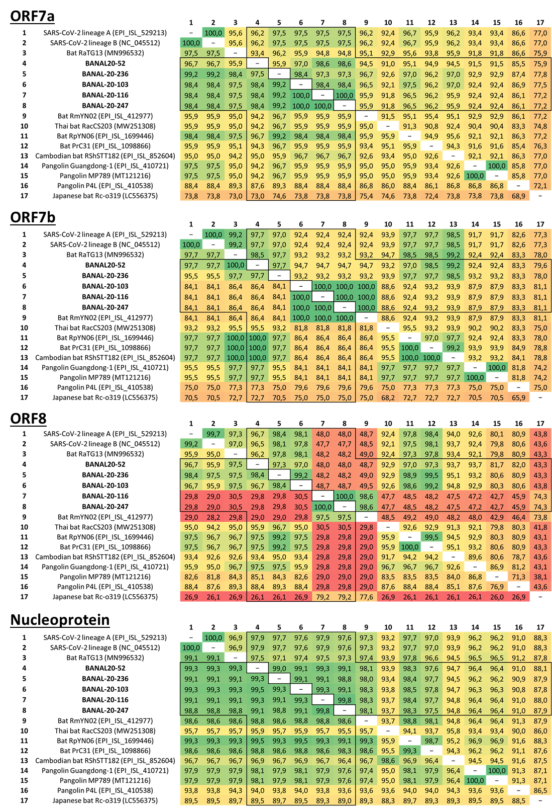

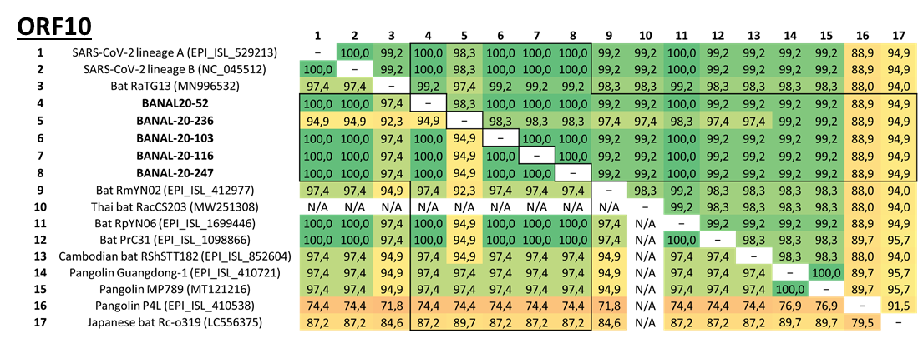

Figure S2: Complete phylogenetic reconstructions of recombinant fragments, as described in Figure 2. 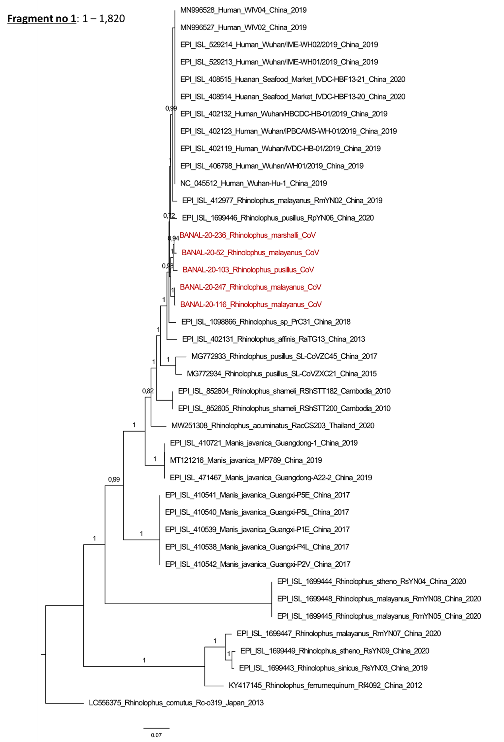
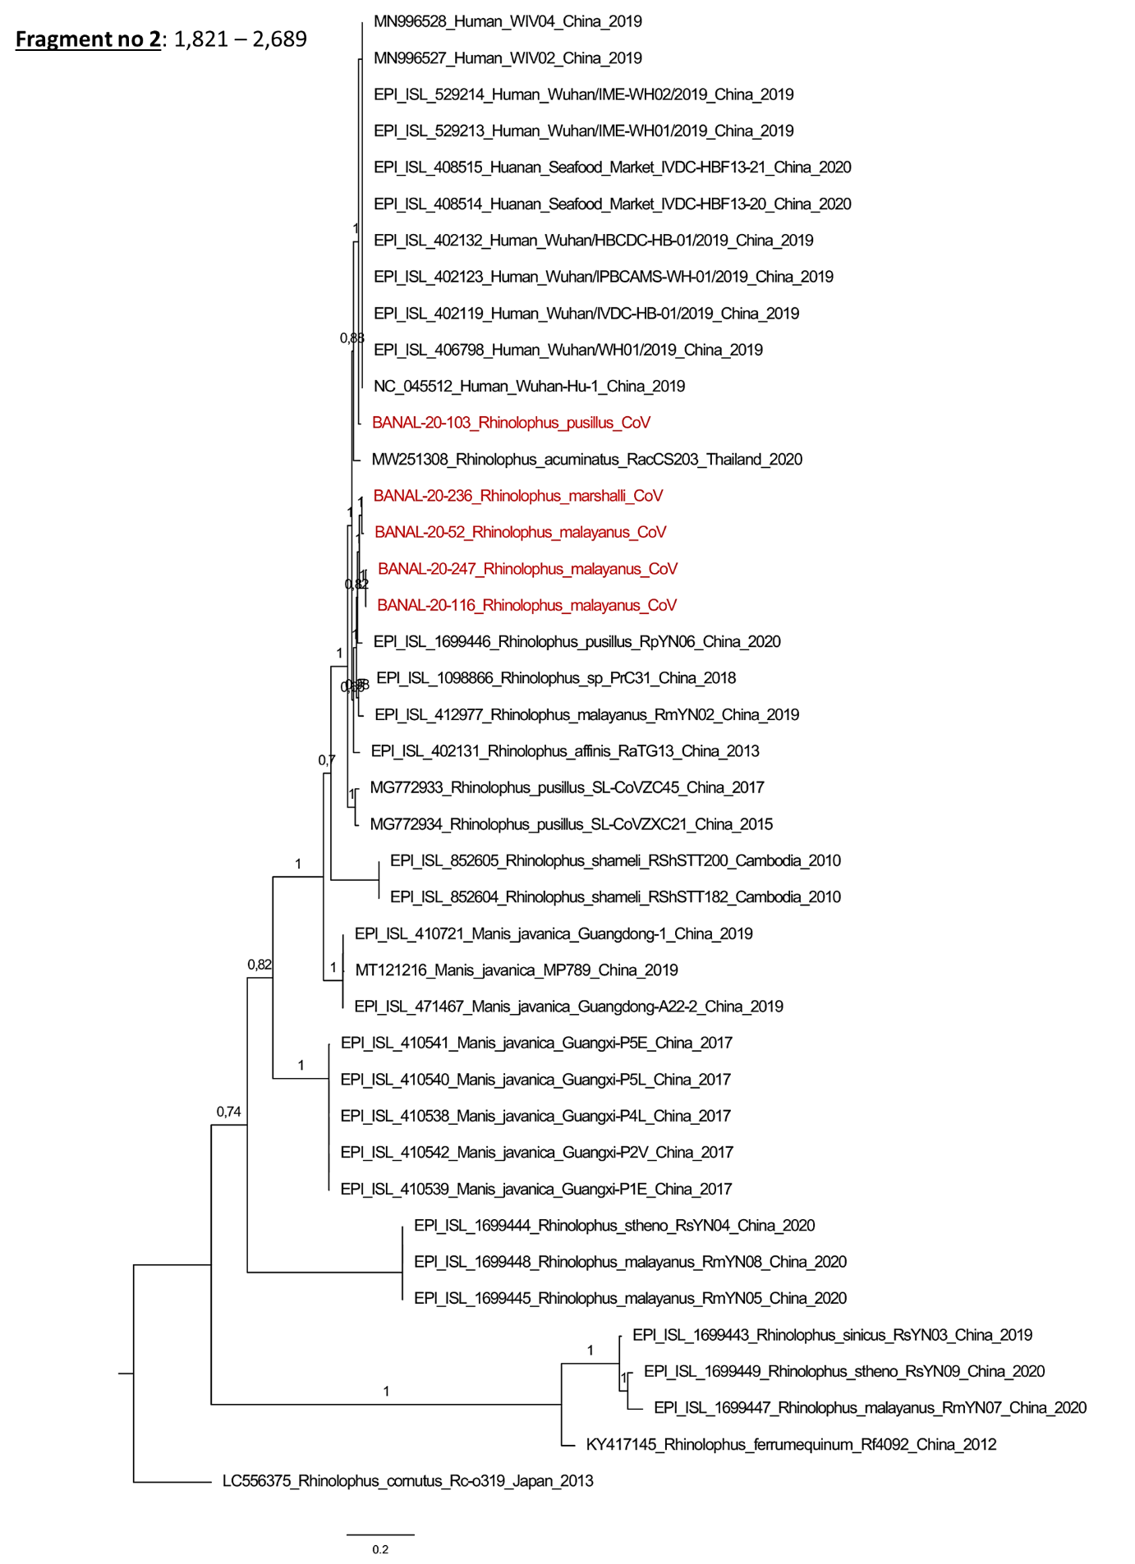
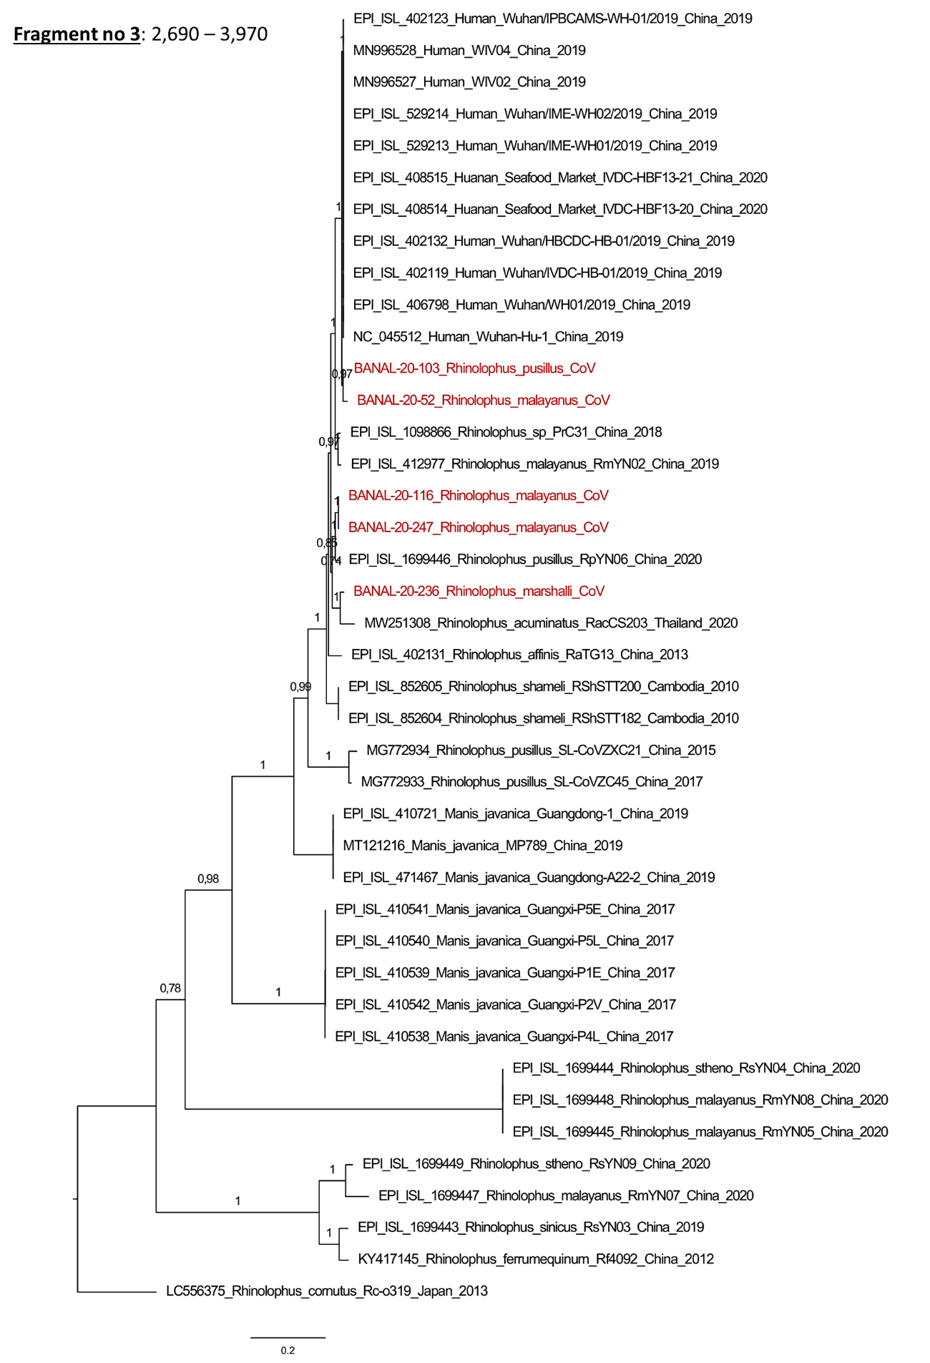
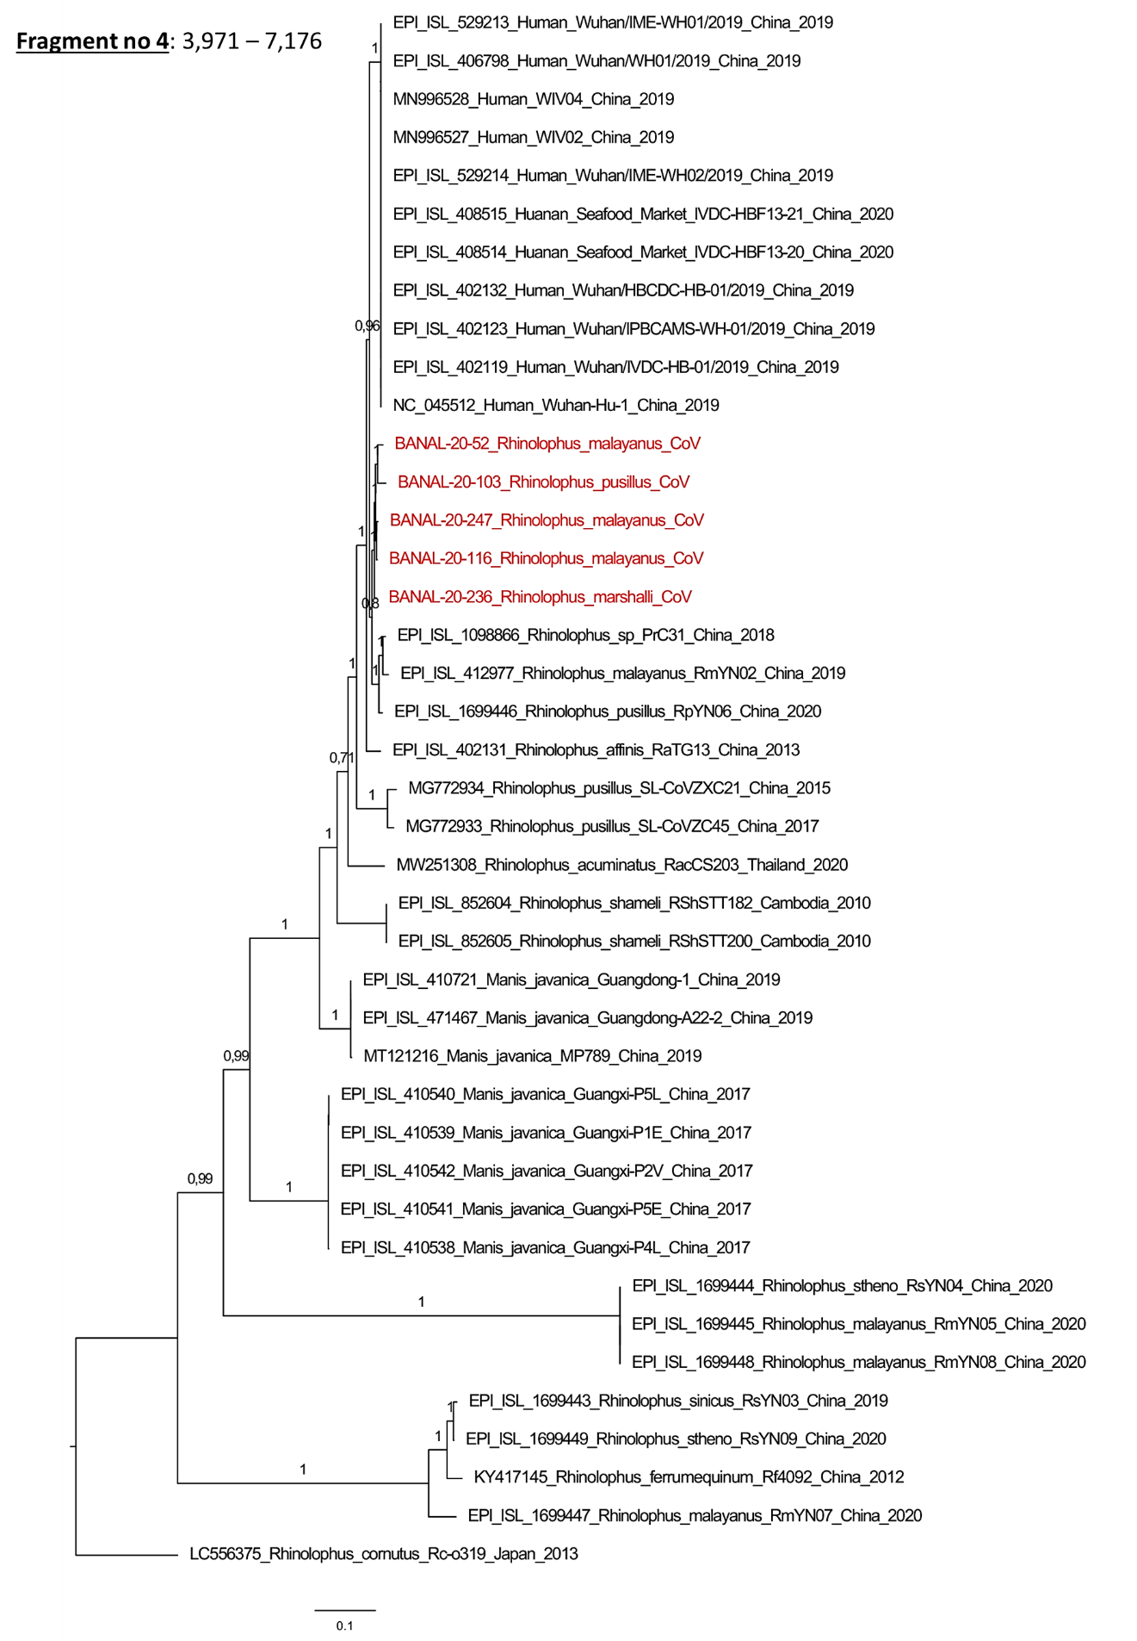
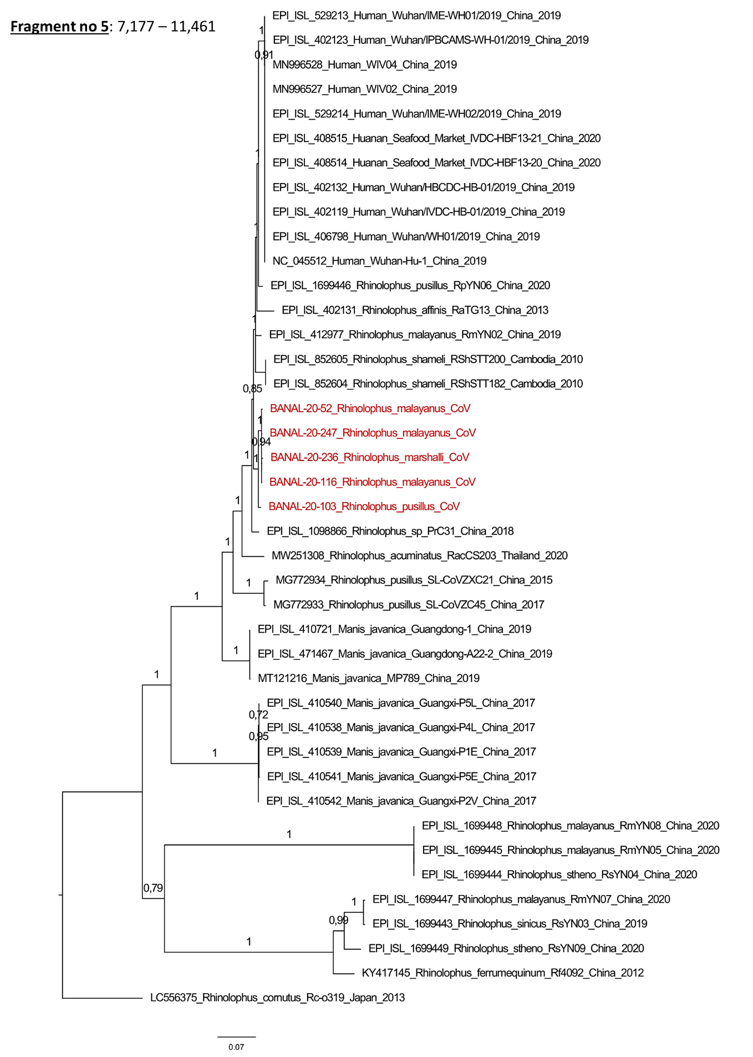
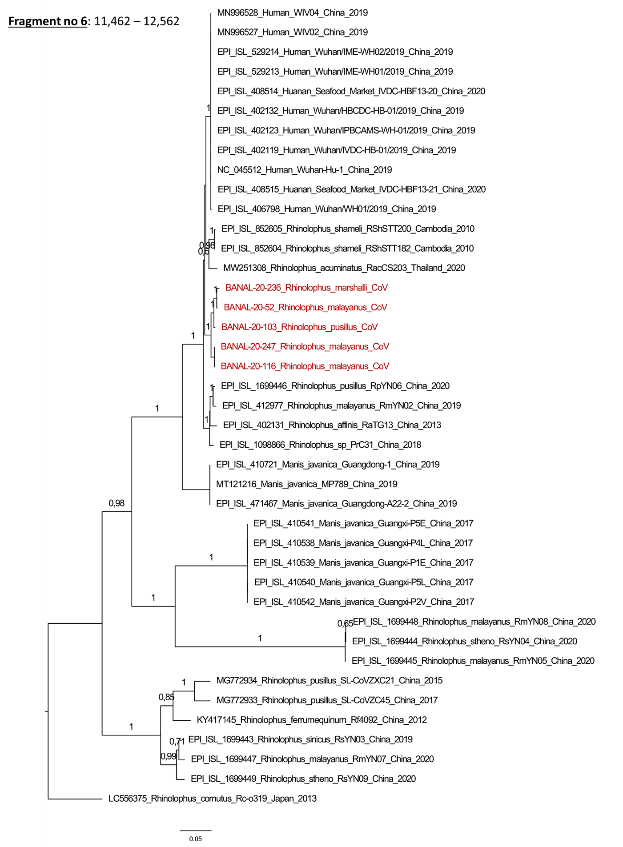
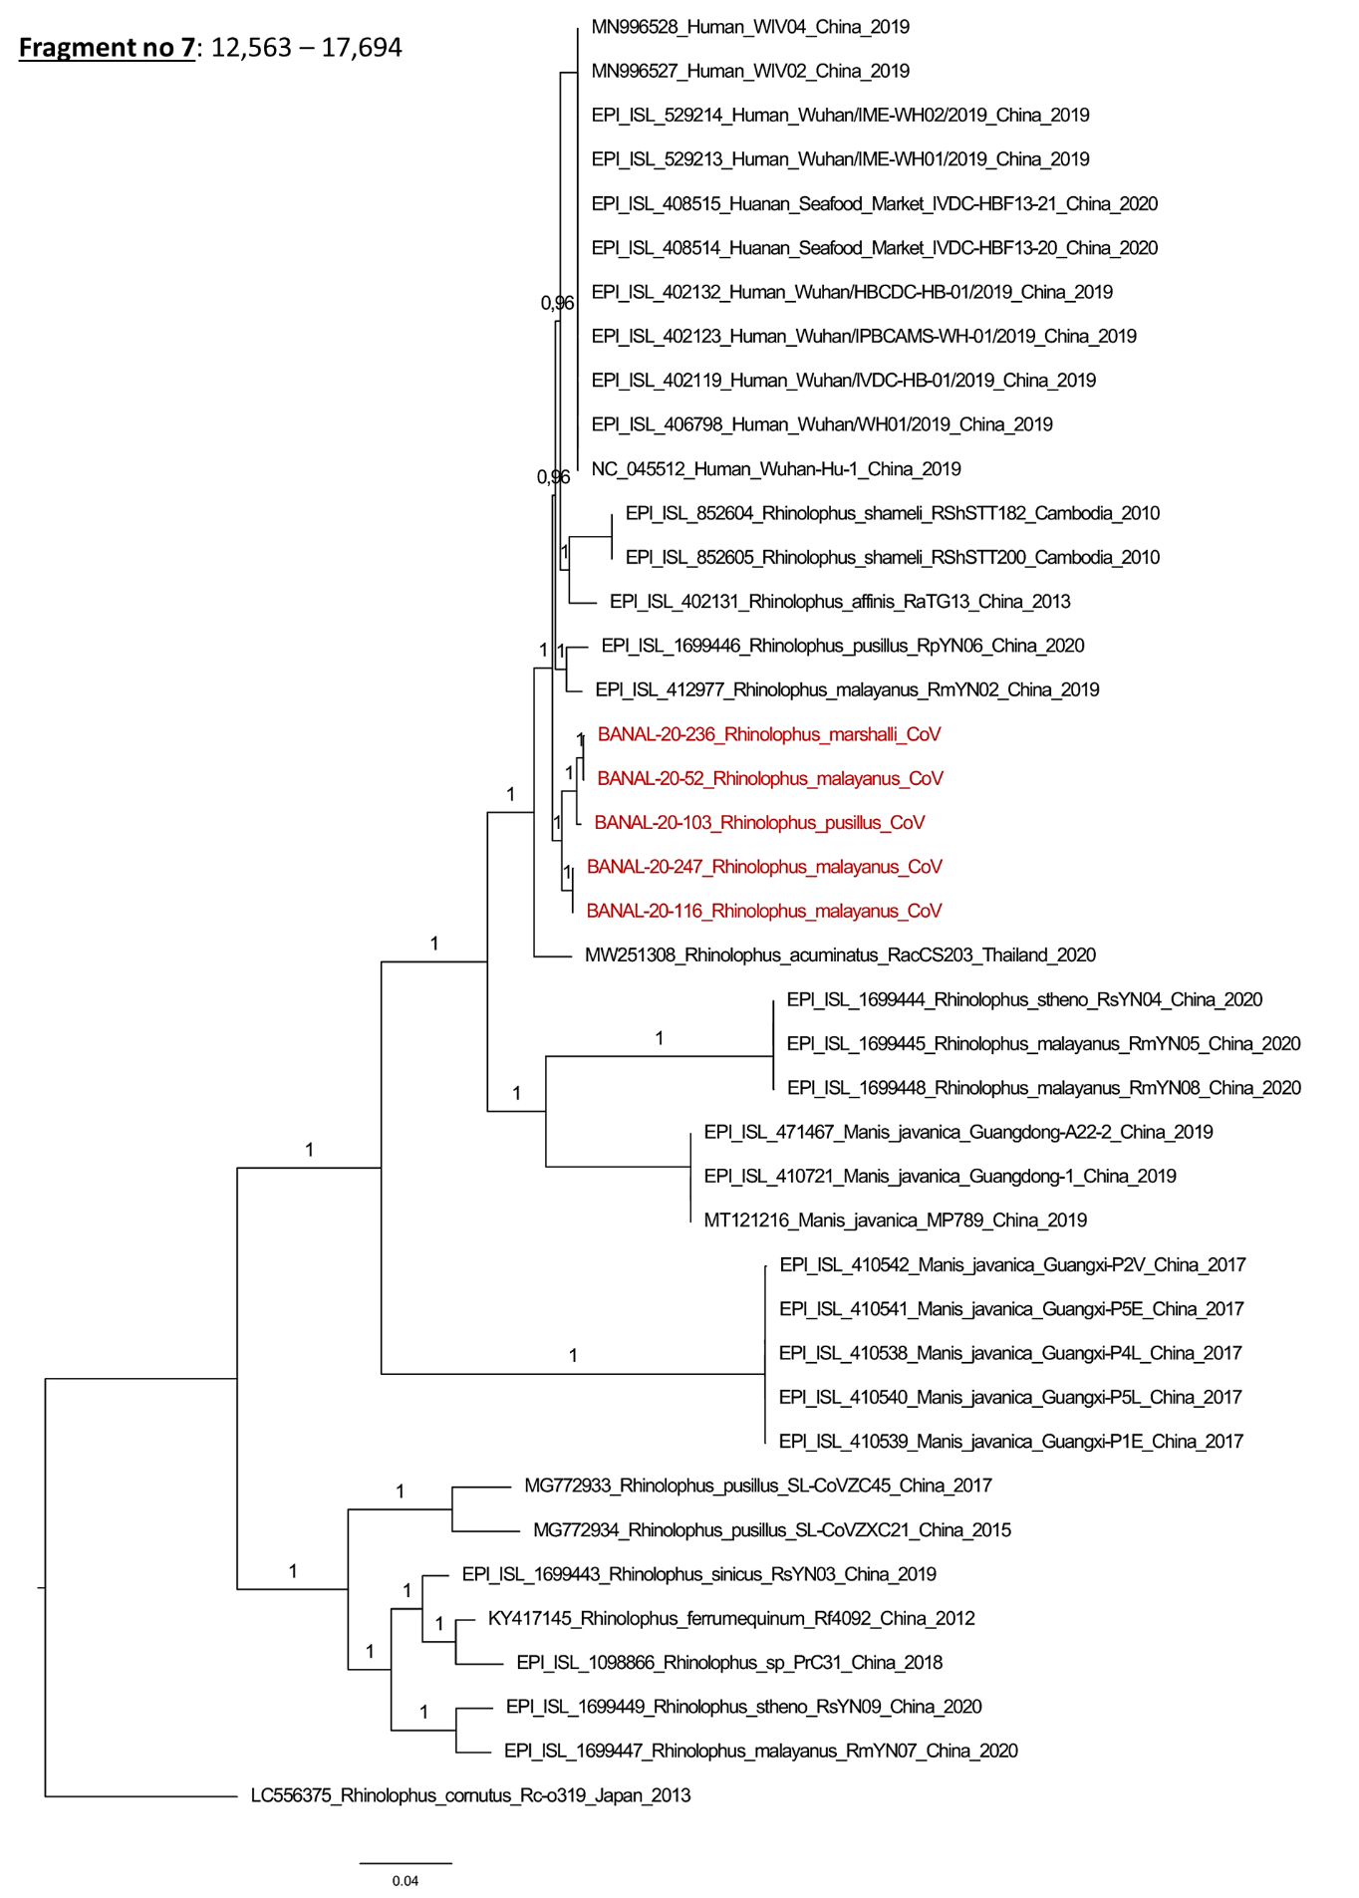
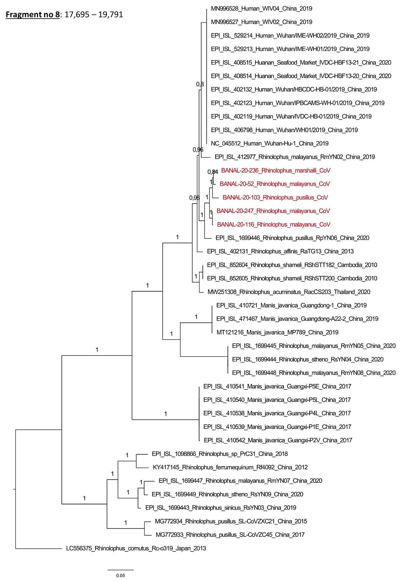
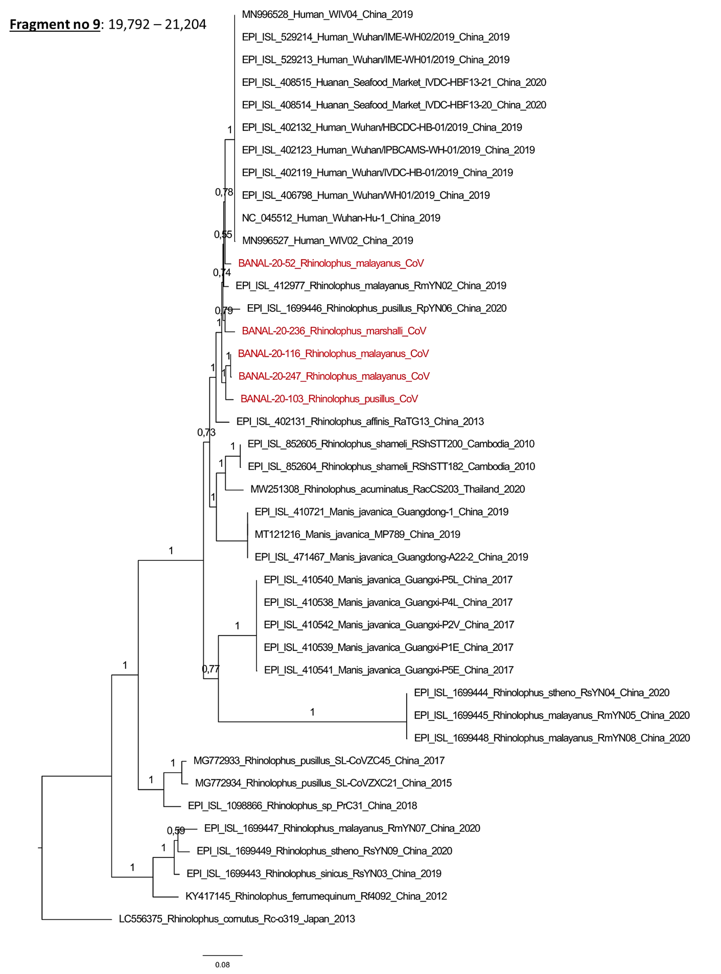
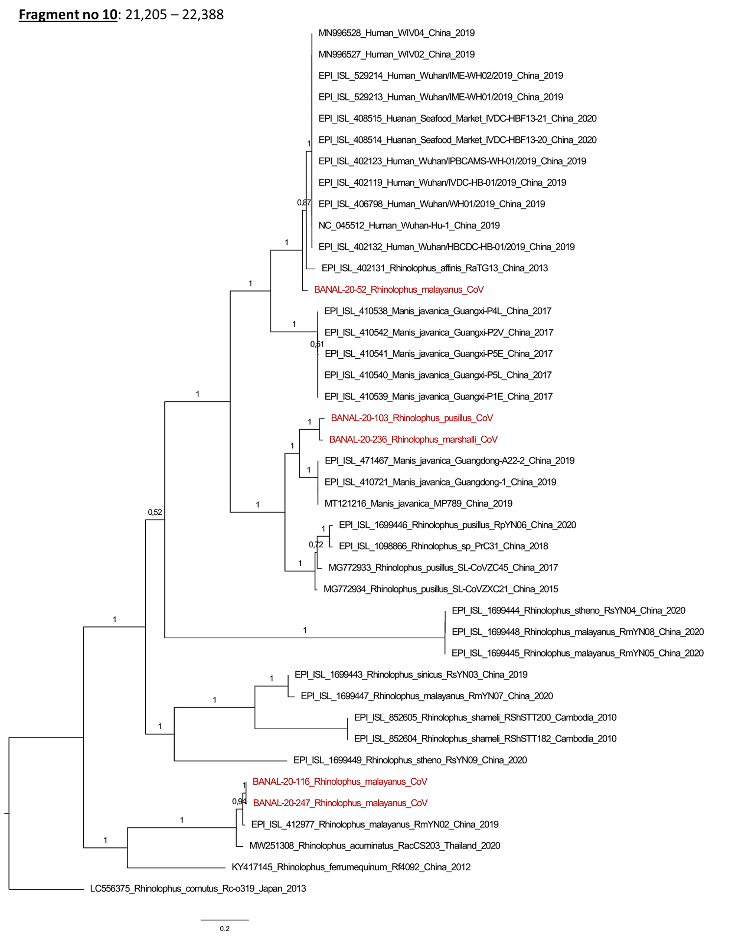
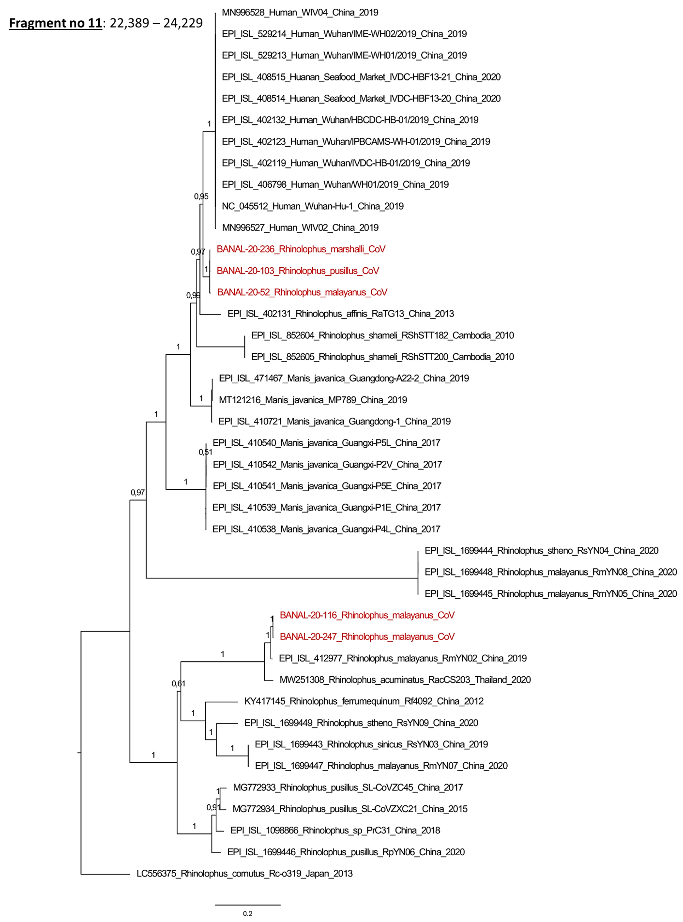
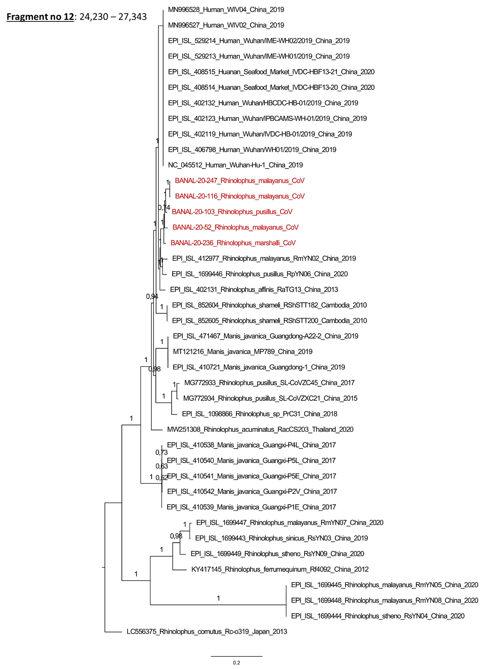
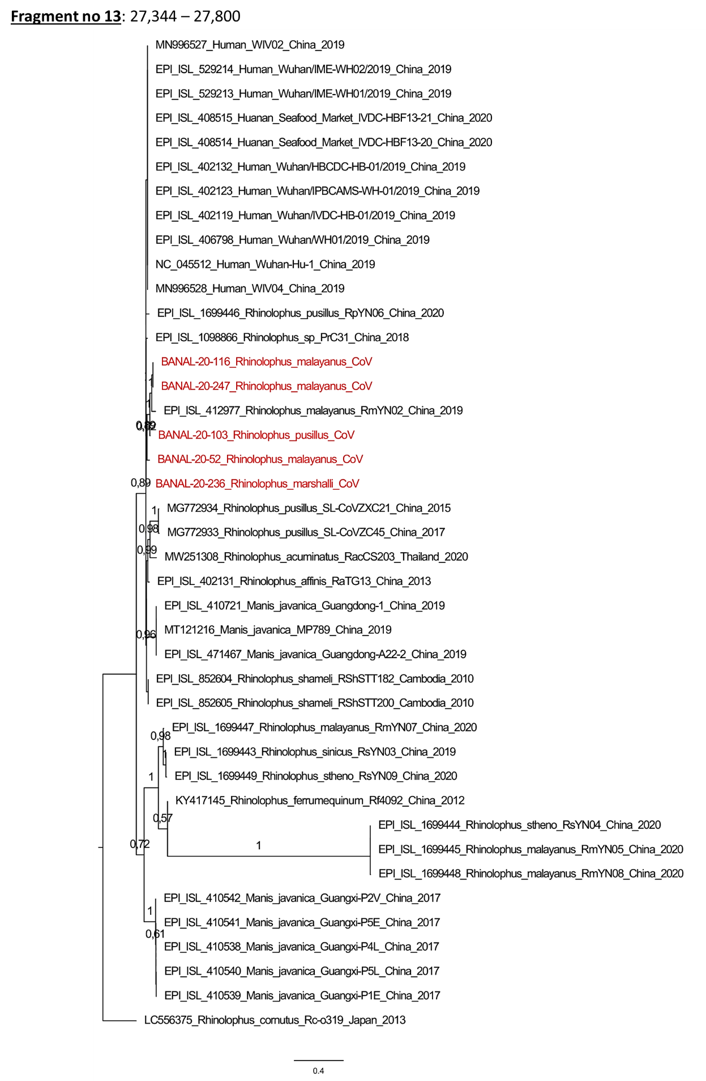
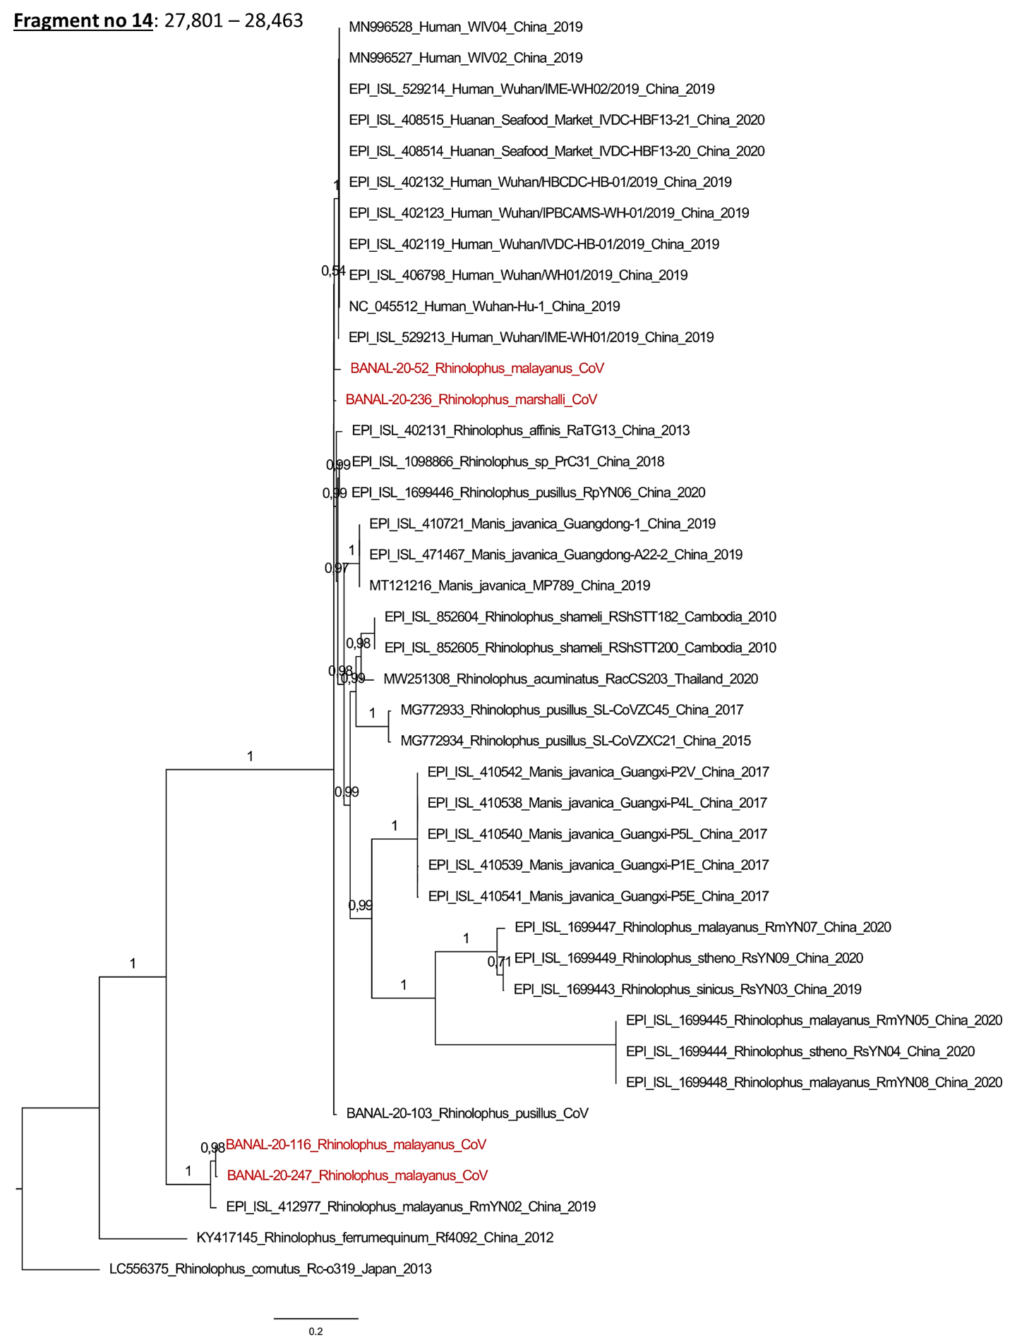
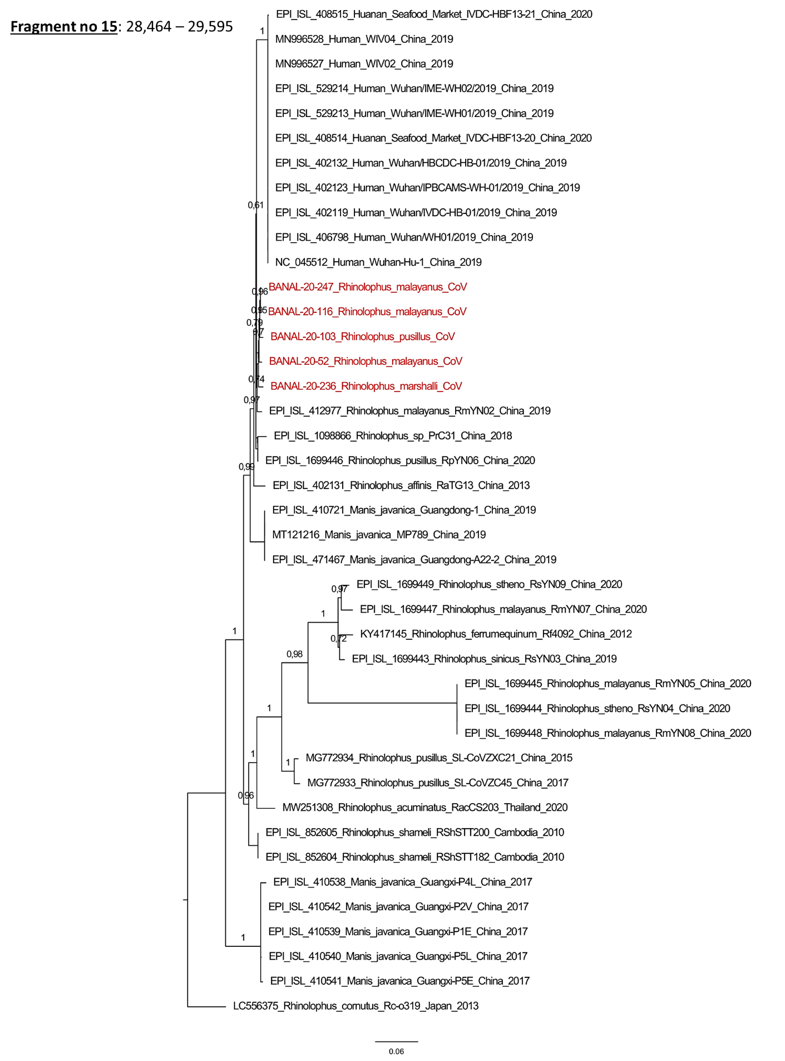

Figure S3: Alignment of spike RBD domain.
Protein alignment of the Receptor Binding Domain (RBD) of Laotian and representative human, bat and pangolin sarbecoviruses. Sequences were aligned with MAFFT in G-iNS-I mode. Residues interacting with human ACE2 receptor are highlighted in grey. The domain used for interactions modeling, based on the X-ray structure 6M0J (residues T333 to G526), is highlighted by a black line.

Figure S4: Alignment of the whole spike amino-acid sequences.

Figure S5: Analysis of the stability and conformational heterogeneity of RBD/hACE2 complexes.
Distributions of backbone Root Mean Square Deviation (RMSD) from the initial, energy-minimized model calculated on the residues in RBD (A), hACE2 (B), and at the interface of RBD and hACE2 (C). Population of the 3 most significant clusters visited during the course of the MD simulations (D). The analysis is performed for 9 different MD simulations: 3 replicates of the SARS-CoV-2 (shades of green), BANAL-236 (shades of red), and BANAL-52/103 (shades of blue) RBD/hACE2 complexes.

Figure S6: Estimation of RBD-hACE2 binding energy.
Distributions of RBD-hACE2 binding energy estimated using ROSETTA (A) and FoldX (B). The analysis is performed for 9 different MD simulations: 3 replicates of the SARS-CoV-2 (shades of green), BANAL-236 (shades of red), and BANAL-52/103 (shades of blue) RBD/hACE2 complexes.

Figure S7: Analysis of the inter-subunits hydrogen bonds at the interface of RBD and hACE2.
Frequency of formation of hydrogen bonds at the interface of RBD and hACE2 in the knob (A), base (B), and tip regions (C). The analysis is performed for 9 different MD simulations: 3 replicates of the SARS-CoV-2 (shades of green), BANAL-236 (shades of red), and BANAL-52/103 (shades of blue) RBD/hACE2 complexes.

Figure S8: Isolation of BANAL-236 on VeroE6 cells. (A) CPE observed on VeroE6 4 days after inoculation at an MOI of 10-4 from the C1. (B) Uninfected VeroE6 cells layer. (C) Plaque assay performed from the C2 stock on VeroE6 cells.

References

1. Chu, D. K. W. et al. Avian coronavirus in wild aquatic birds. Journal of Virology 85, 12815–12820 (2011).
2. Deng, X. et al. Metagenomic sequencing with spiked primer enrichment for viral diagnostics and genomic surveillance. Nat. Microbiol. 5, 443–454 (2020). doi:10.1038/s41564-019-0637-9
3. Fu, L., Niu, B., Zhu, Z., Wu, S. & Li, W. CD-HIT: accelerated for clustering the next-generation sequencing data. Bioinformatics 28, 3150–3152 (2012). doi:10.1093/bioinformatics/bts565
4. Regnault, B. et al. Deep impact of random amplification and library construction methods on viral metagenomics results. Viruses 13, 253 (2021). doi:10.3390/v13020253
5. Bratuleanu, B. E. et al. The virome of Rhipicephalus, Dermacentor and Haemaphysalis ticks from Eastern Romania includes novel viruses with potential relevance for public health. Transboundary and Emerging Diseases (2021). doi:10.1111/tbed.14105
6. Kosakovsky Pond, S. L., Posada, D., Gravenor, M. B., Woelk, C. H. & Frost, S. D. W. Automated phylogenetic detection of recombination using a genetic algorithm. Mol. Biol. Evol. 23, 1891–1901 (2006). doi:10.1093/molbev/msl051
7. Kosakovsky Pond, S. L., Posada, D., Gravenor, M. B., Woelk, C. H. & Frost, S. D. W. GARD: A genetic algorithm for recombination detection. Bioinformatics 22, 3096–3098 (2006). doi:10.1093/bioinformatics/btl474
8. Lemoine, F. et al. NGPhylogeny.fr: New generation phylogenetic services for non-specialists. Nucleic Acids Res. 47, W260–W265 (2019). doi:10.1093/nar/gkz303
9. Abraham, M. J. et al. GROMACS: High performance molecular simulations through multi-level parallelism from laptops to supercomputers. SoftwareX 1–2, 19–25 (2015). doi:org/10.1016/j.softx.2015.06.001
10. PLUMED Consortium. Promoting transparency and reproducibility in enhanced molecular simulations. Nat. Methods 16, 670–673 (2019). doi:10.1038/s41592-019-0506-8
11. Crawford, K. H. D. et al. Protocol and reagents for pseudotyping lentiviral particles with SARS-CoV-2 spike protein for neutralization assays. Viruses 12, E513 (2020). doi.org/10.3390/v12050513
12. Corman, V. M. et al. Detection of 2019 novel coronavirus (2019-nCoV) by real-time RT-PCR. Euro Surveill. 25, (2020). doi:10.2807/1560-7917.ES.2020.25.3.2000045
13. Sali, A. & Blundell, T. L. Comparative protein modelling by satisfaction of spatial restraints. J Mol Biol 234, 779–815 (1993). doi:10.1006/jmbi.1993.1626
14. Shen, M.-Y. & Sali, A. Statistical potential for assessment and prediction of protein structures. Protein Sci 15, 2507–2524 (2006). doi:10.1110/ps.062416606
15. Jo, S., Kim, T., Iyer, V. G. & Im, W. CHARMM-GUI: a web-based graphical user interface for CHARMM. J Comput Chem 29, 1859–1865 (2008). doi:10.1002/jcc.20945
16. Huang, J. et al. CHARMM36m: an improved force field for folded and intrinsically disordered proteins. Nat Methods 14, 71–73 (2017). doi:10.1038/nmeth.4067
17. Jorgensen, W. L., Chandrasekhar, J., Madura, J. D., Impey, R. W. & Klein, M. L. Comparison of simple potential functions for simulating liquid water. J. Chem. Phys. 79, 926–935 (1983). doi:10.1063/1.445869
18. Bussi, G., Donadio, D. & Parrinello, M. Canonical sampling through velocity rescaling. J Chem Phys 126, 014101 (2007). doi:10.1063/1.2408420
19. Berendsen, H. J. C., Postma, J. P. M., van Gunsteren, W. F., DiNola, A. & Haak, J. R. Molecular dynamics with coupling to an external bath. J. Chem. Phys. 81, 3684–3690 (1984). doi:10.1063/1.448118
20. Hess, B., Bekker, H., Berendsen, H. J. C. & Fraaije, J. G. E. M. LINCS: A linear constraint solver for molecular simulations. J. Comput. Chem. 18, 1463–1472 (1997). doi:10.1002/(SICI)1096-987X(199709)18:12<1463::AID-JCC4>3.0.CO;2-H
21. Essmann, U., Perera, L. & Berkowitz, M. L. A smooth particle mesh Ewald method. J. Chem. Phys. 103, 8577–8593 (1995). doi.org/10.1063/1.470117
22. Daura, X. et al. Peptide folding: When simulation meets experiment. Angewandte Chemie-International Edition in English 38, 236–240 (1999). doi:10.1002/(SICI)1521-3773(19990115)38:1/2<236::AID-ANIE236>3.0.CO;2-M
23. Stranges, P. B. & Kuhlman, B. A comparison of successful and failed protein interface designs highlights the challenges of designing buried hydrogen bonds. Protein Sci 22, 74–82 (2013). doi.org/10.1002/pro.2187
24. Schymkowitz, J. et al. The FoldX web server: An online force field. Nucleic Acids Res 33, W382-388 (2005). doi.org/10.1093/nar/gki387
25. Humphrey, W., Dalke, A. & Schulten, K. VMD: visual molecular dynamics. J Mol Graph 14, 33–38, 27–28 (1996). doi:10.1016/0263-7855(96)00018-5
26. Michaud-Agrawal, N., Denning, E. J., Woolf, T. B. & Beckstein, O. MDAnalysis: A toolkit for the analysis of molecular dynamics simulations. J Comput Chem 32, 2319–2327 (2011). doi:10.1002/jcc.21787

