Supporting information

Design and Construction of Novel Frustrated Lewis Pairs Based on Modified Lewis Acid B(C₆F₅)₃
Wei Li,^{1,2} Quanwei Wang*,¹ Zonggui Li,¹ Yanuo Cui,¹ Jiashuo Zhang,¹ Huilin Li,¹ Xunlei Ding*^{1,2}

S1 The absolute change in the single point energy of the FLPs monomers before and after interaction (kcal/mol)

FLPs | |∆_{S-LA}| | |∆_{S-LB}|
B(C₆F₅)₃-ItBu | 0.4687 | 0.1901
B(C₆F₅)₂H-ItBu | 36.3911 | 7.0356
B(C₆F₅)₂(C₆Cl₅)-ItBu  (x = 2; Y = Cl) | 0.1543 | 0.2205
B(C₆F₅)(C₆Cl₅)₂-ItBu  (x = 1; Y = Cl) | 0.3652 | 0.4273
B(C₆Cl₅)₃-ItBu  (x = 0; Y = Cl) | 0.3236 | 0.4442
B(C₆F₅)₂(C₆Br₅)-ItBu  (x = 2; Y = Br) | 0.0001 | 0.1255
B(C₆F₅)(C₆Br₅)₂-ItBu  (x = 1; Y = Br) | 0.1951 | 0.0483
B(C₆Br₅)₃-ItBu  (x = 0; Y = Br) | 0.0319 | 0.8935
B(C₆F₅)₂(C₆I₅)-ItBu  (x = 2; Y = I) | 0.0734 | 0.1493
B(C₆F₅)(C₆I₅)₂-ItBu  (x = 1; Y = I) | 1.3440 | 0.0928
B(C₆I₅)₃-ItBu  (x = 0; Y = I) | 2.5489 | 0.0545

S2 Schematic representations of the LUMO and HOMO localized on the B and C in the FLPs
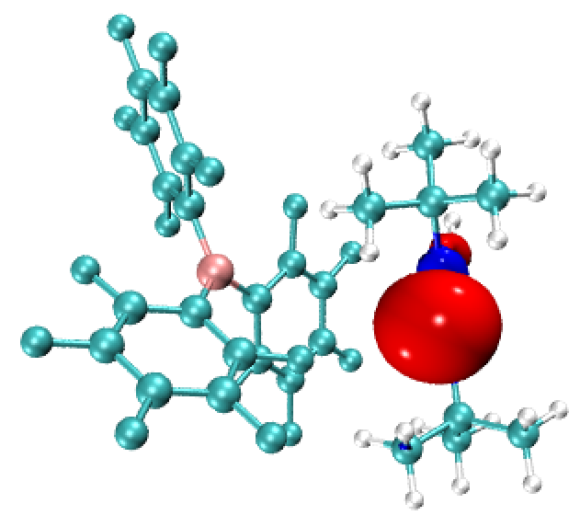  HOMO(B(C₆F₅)₃-ItBu) | 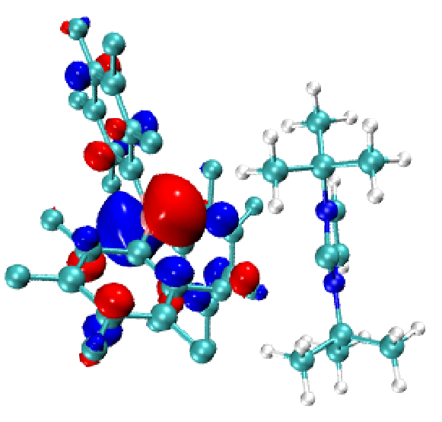  LUMO(B(C₆F₅)₃-ItBu)
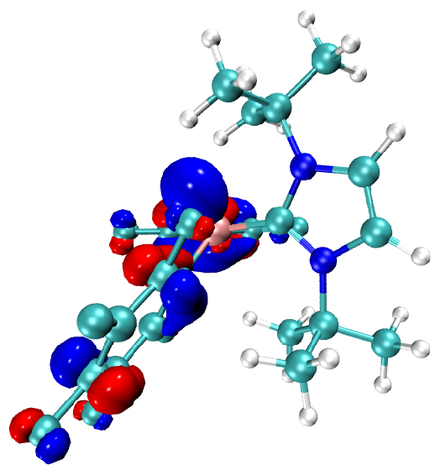  HOMO(B(C₆F₅)₂H-ItBu) | 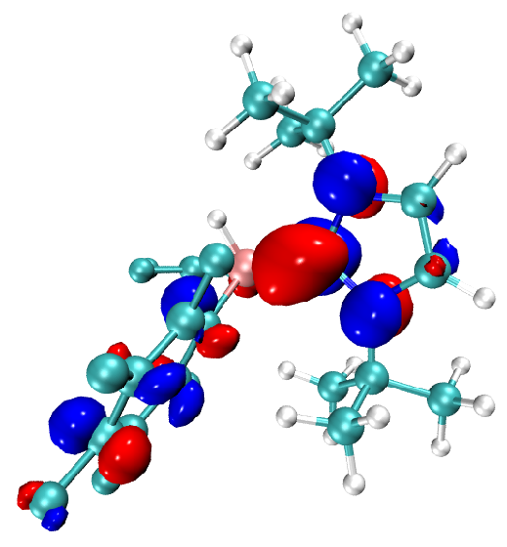  LUMO(B(C₆F₅)₂H-ItBu)
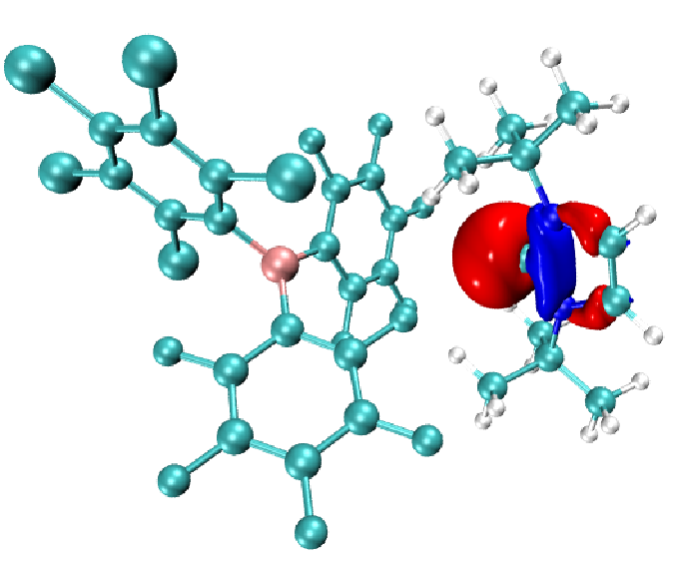  HOMO(B(C₆F₅)₂(C₆Cl₅)-ItBu)  (x = 2; Y = Cl) | 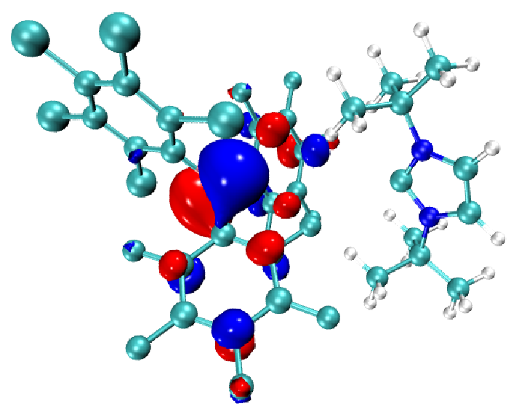  LUMO(B(C₆F₅)₂(C₆Cl₅)-ItBu)  (x = 2; Y = Cl)
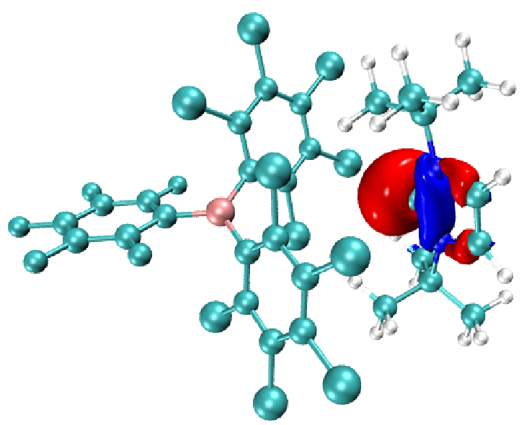  HOMO(B(C₆F₅)(C₆Cl₅)₂-ItBu)  (x = 1; Y = Cl) | 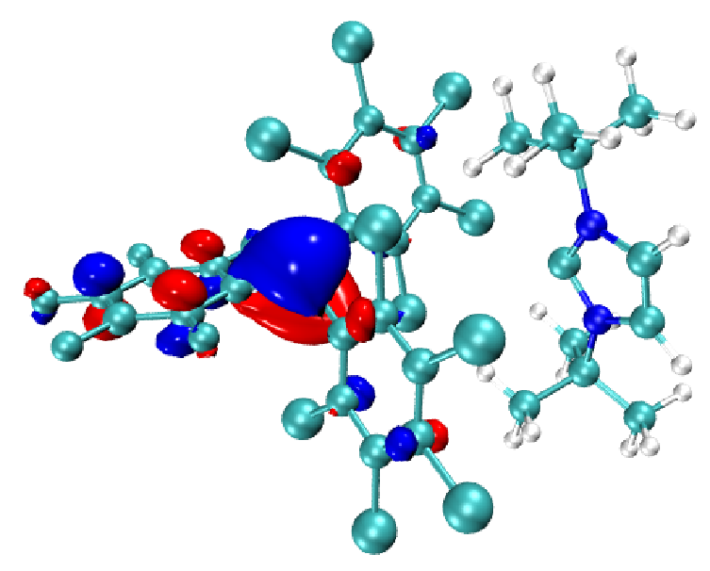  LUMO(B(C₆F₅)(C₆Cl₅)₂-ItBu)  (x = 1; Y = Cl)
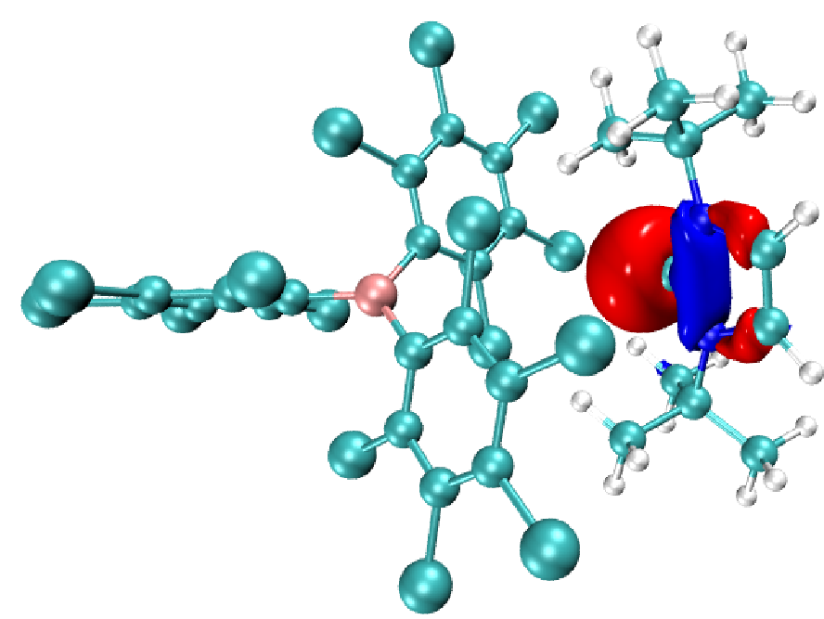  HOMO(B(C₆Cl₅)₃-ItBu)  (x = 1; Y = Cl) | 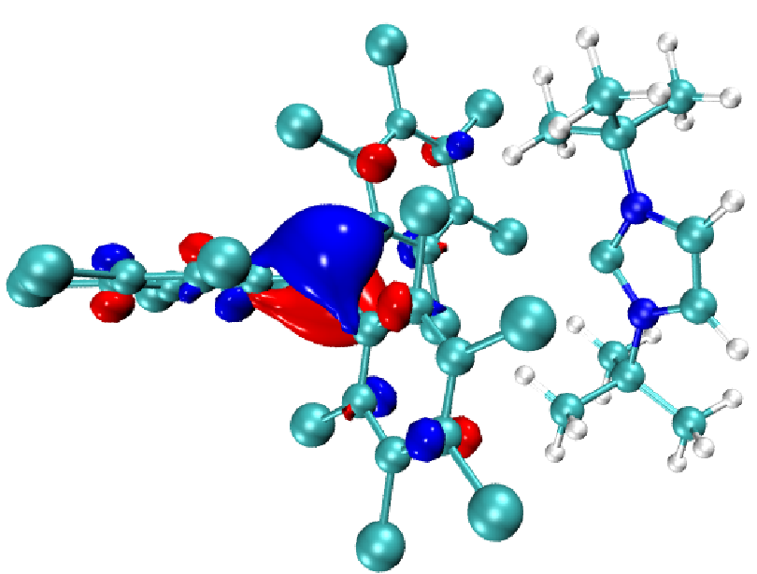  LUMO(B(C₆Cl₅)₃-ItBu)  (x = 1; Y = Cl)
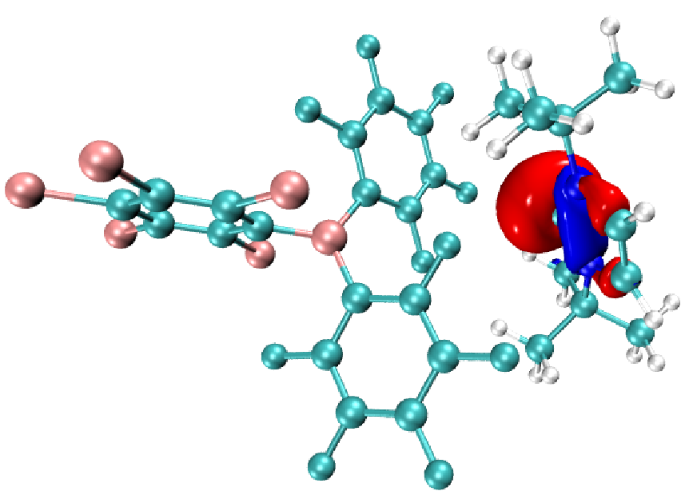  HOMO(B(C₆F₅)₂(C₆Br₅)-ItBu)  (x = 2; Y = Br) | 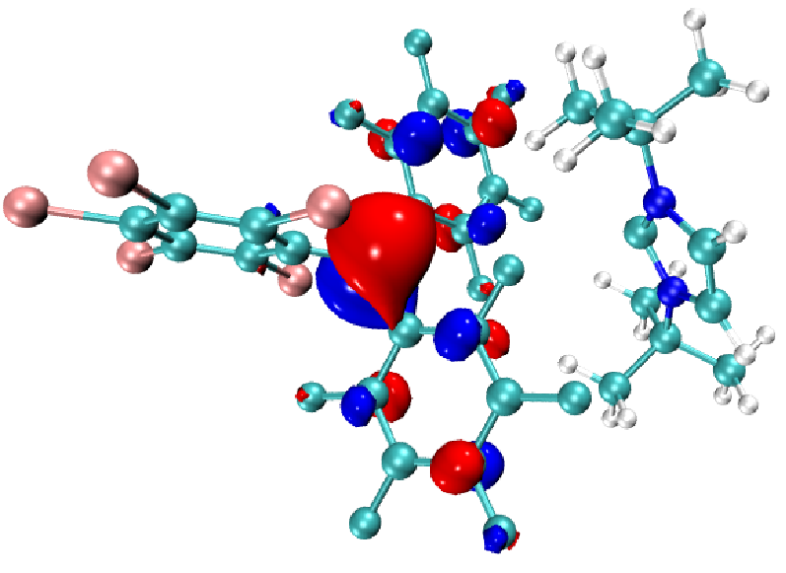  LUMO(B(C₆F₅)₂(C₆Br₅)-ItBu)  (x = 2; Y = Br)
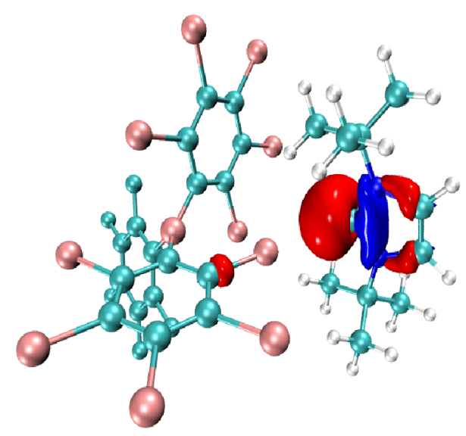  HOMO(B(C₆F₅)(C₆Br₅)₂-ItBu)  (x = 1; Y = Br) | 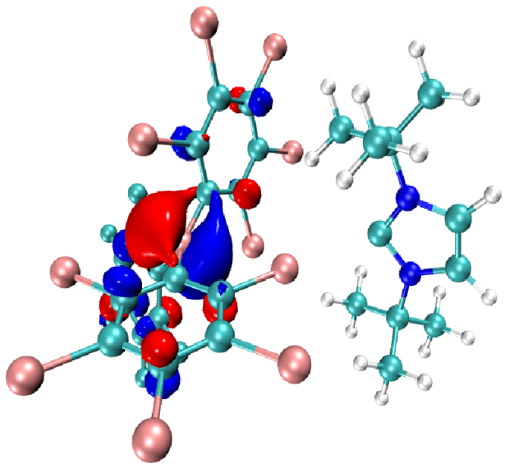  LUMO(B(C₆F₅)(C₆Br₅)₂-ItBu)  (x = 1; Y = Br)
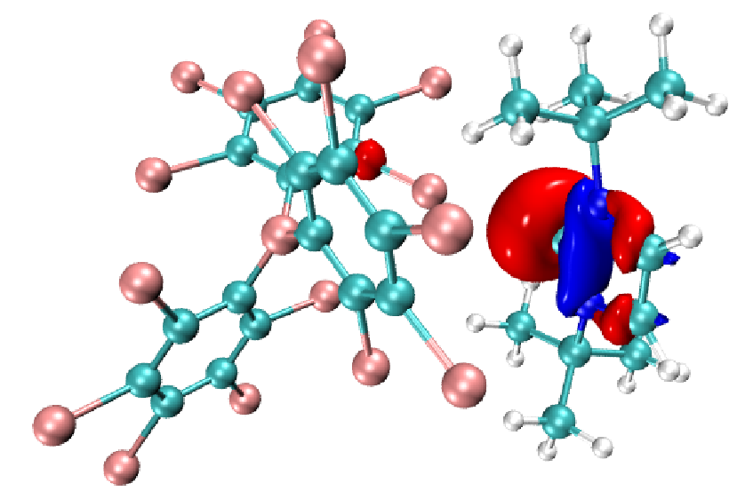  HOMO(B(C₆Br₅)₃-ItBu)  (x = 0; Y = Br) | 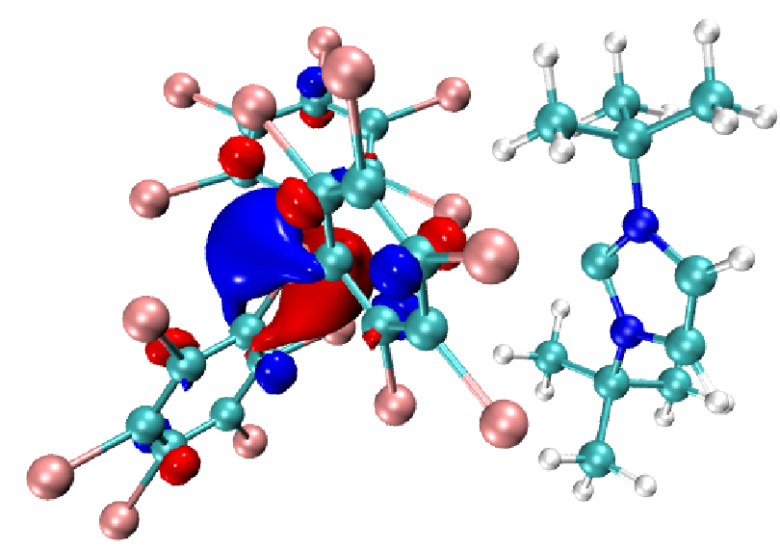  LUMO(B(C₆Br₅)₃-ItBu)  (x = 0; Y = Br)
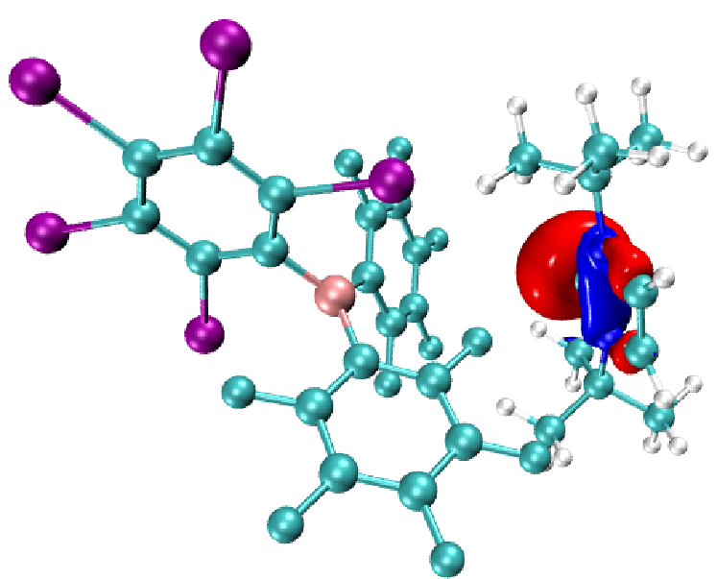  HOMO(B(C₆F₅)₂(C₆I₅)-ItBu)  (x = 2; Y = I) | 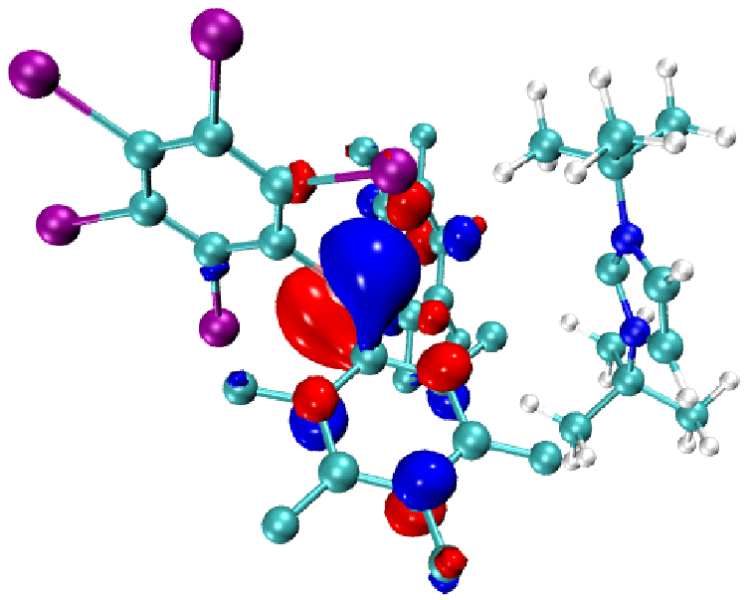  LUMO(B(C₆F₅)₂(C₆I₅)-ItBu)  (x = 2; Y = I)
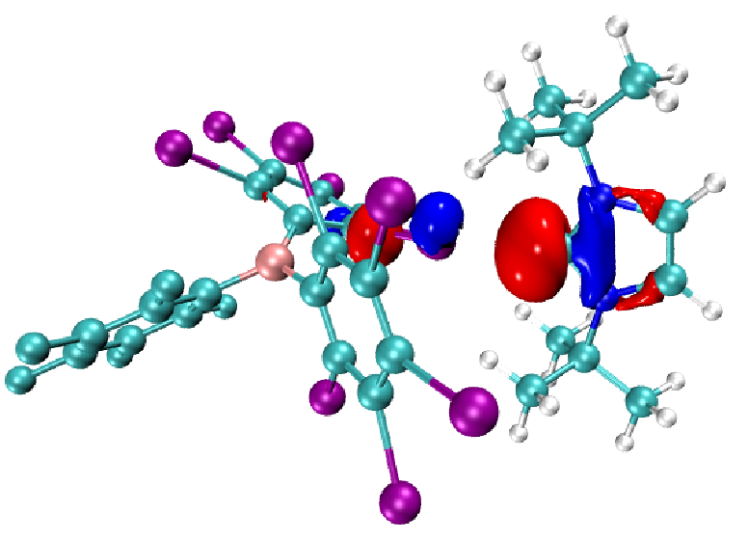  HOMO(B(C₆F₅)(C₆I₅)₂-ItBu)  (x = 1; Y = I) | 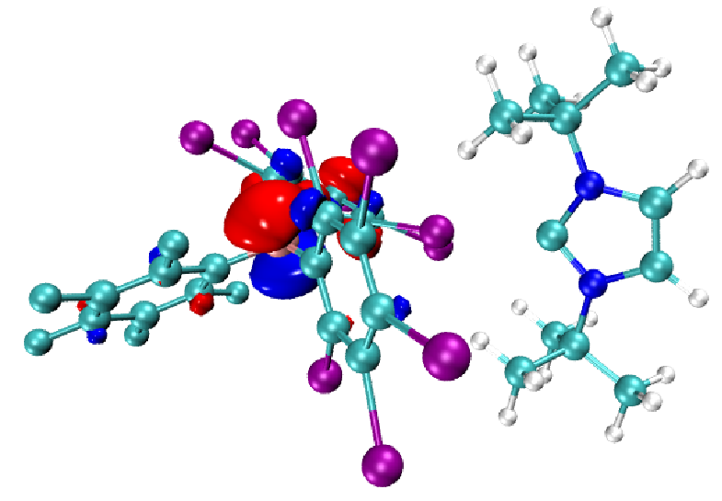  LUMO(B(C₆F₅)(C₆I₅)₂-ItBu)  (x = 1; Y = I)
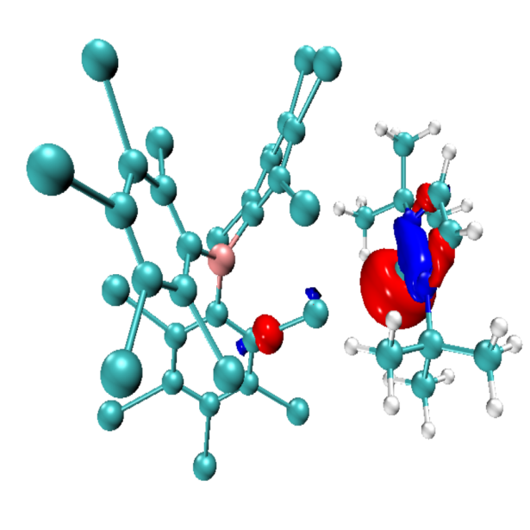  HOMO(B(C₆I₅)₃-ItBu)  (x = 0; Y = I) | 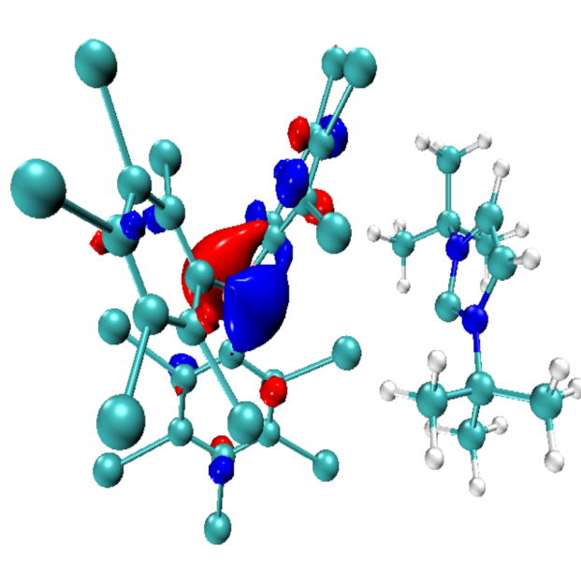  LUMO(B(C₆I₅)₃-ItBu)  (x = 0; Y = I)

S3 Structural coordinates of the FLPs
FLP_{S} | Symbols | x | y | Z
B(C₆F₅)₃-ItBu | B | -3.296945 | 0.237099 | 8.133653
B(C₆F₅)₃-ItBu | C | -3.335378 | 1.759672 | 7.795209
B(C₆F₅)₃-ItBu | C | -4.531210 | 2.461021 | 7.621599
B(C₆F₅)₃-ItBu | C | -2.167290 | 2.518321 | 7.681253
B(C₆F₅)₃-ItBu | C | -4.575513 | 3.821538 | 7.370738
B(C₆F₅)₃-ItBu | C | -2.173560 | 3.874858 | 7.408416
B(C₆F₅)₃-ItBu | C | -3.387809 | 4.531009 | 7.259184
B(C₆F₅)₃-ItBu | C | -4.290532 | -0.775097 | 7.485329
B(C₆F₅)₃-ItBu | C | -4.696687 | -1.946593 | 8.135073
B(C₆F₅)₃-ItBu | C | -4.817382 | -0.594025 | 6.202179
B(C₆F₅)₃-ItBu | C | -5.555221 | -2.870135 | 7.570281
B(C₆F₅)₃-ItBu | C | -5.679026 | -1.497690 | 5.606047
B(C₆F₅)₃-ItBu | C | -6.052135 | -2.640358 | 6.297000
B(C₆F₅)₃-ItBu | C | -2.218066 | -0.270262 | 9.148618
B(C₆F₅)₃-ItBu | C | -1.470707 | -1.425881 | 8.926079
B(C₆F₅)₃-ItBu | C | -1.942170 | 0.412984 | 10.332678
B(C₆F₅)₃-ItBu | C | -0.507826 | -1.881506 | 9.809077
B(C₆F₅)₃-ItBu | C | -1.004686 | -0.025886 | 11.252245
B(C₆F₅)₃-ItBu | C | -0.279039 | -1.178062 | 10.984151
B(C₆F₅)₃-ItBu | F | -6.156772 | -1.281270 | 4.379939
B(C₆F₅)₃-ItBu | F | -4.476345 | 0.473266 | 5.471454
B(C₆F₅)₃-ItBu | F | -4.272773 | -2.218355 | 9.376876
B(C₆F₅)₃-ItBu | F | -5.899924 | -3.976245 | 8.227285
B(C₆F₅)₃-ItBu | F | -6.888154 | -3.510089 | 5.742413
B(C₆F₅)₃-ItBu | F | -0.966704 | 1.934445 | 7.803179
B(C₆F₅)₃-ItBu | F | -1.033325 | 4.555112 | 7.288200
B(C₆F₅)₃-ItBu | F | -3.411988 | 5.833760 | 7.006337
B(C₆F₅)₃-ItBu | F | -5.739933 | 4.453464 | 7.229886
B(C₆F₅)₃-ItBu | F | -5.699115 | 1.826824 | 7.721567
B(C₆F₅)₃-ItBu | F | -2.615671 | 1.530454 | 10.639088
B(C₆F₅)₃-ItBu | F | -0.789282 | 0.645309 | 12.383674
B(C₆F₅)₃-ItBu | F | 0.632882 | -1.606750 | 11.849157
B(C₆F₅)₃-ItBu | F | 0.195525 | -2.983269 | 9.548616
B(C₆F₅)₃-ItBu | F | -1.654571 | -2.136377 | 7.803884
B(C₆F₅)₃-ItBu | N | -8.706301 | -0.672957 | 8.144527
B(C₆F₅)₃-ItBu | N | -7.675765 | -0.780672 | 10.006955
B(C₆F₅)₃-ItBu | C | -9.436421 | -0.097739 | 6.984253
B(C₆F₅)₃-ItBu | C | -9.760185 | -1.193156 | 5.969484
B(C₆F₅)₃-ItBu | H | -10.239099 | -0.739364 | 5.102258
B(C₆F₅)₃-ItBu | H | -8.861130 | -1.703466 | 5.623877
B(C₆F₅)₃-ItBu | H | -10.449627 | -1.934866 | 6.374402
B(C₆F₅)₃-ItBu | C | -8.558846 | 0.969623 | 6.329865
B(C₆F₅)₃-ItBu | H | -8.280543 | 1.728961 | 7.055640
B(C₆F₅)₃-ItBu | H | -7.645013 | 0.529432 | 5.930932
B(C₆F₅)₃-ItBu | H | -9.101951 | 1.435786 | 5.506511
B(C₆F₅)₃-ItBu | C | -10.731972 | 0.531062 | 7.507675
B(C₆F₅)₃-ItBu | H | -11.351735 | -0.220803 | 7.999535
B(C₆F₅)₃-ItBu | H | -10.498587 | 1.312515 | 8.229645
B(C₆F₅)₃-ItBu | H | -11.303147 | 0.966031 | 6.685767
B(C₆F₅)₃-ItBu | C | -7.017043 | -0.339832 | 11.264744
B(C₆F₅)₃-ItBu | C | -5.835671 | 0.563257 | 10.904919
B(C₆F₅)₃-ItBu | H | -5.082603 | -0.001741 | 10.356195
B(C₆F₅)₃-ItBu | H | -6.172248 | 1.390314 | 10.284701
B(C₆F₅)₃-ItBu | H | -5.372077 | 0.954506 | 11.811189
B(C₆F₅)₃-ItBu | C | -8.044864 | 0.438550 | 12.091332
B(C₆F₅)₃-ItBu | H | -8.400751 | 1.298381 | 11.526020
B(C₆F₅)₃-ItBu | H | -8.900474 | -0.195023 | 12.331393
B(C₆F₅)₃-ItBu | H | -7.597133 | 0.784334 | 13.024612
B(C₆F₅)₃-ItBu | C | -6.520597 | -1.550776 | 12.052373
B(C₆F₅)₃-ItBu | H | -6.002118 | -1.201201 | 12.944978
B(C₆F₅)₃-ItBu | H | -7.344231 | -2.187619 | 12.377722
B(C₆F₅)₃-ItBu | H | -5.820261 | -2.149156 | 11.469312
B(C₆F₅)₃-ItBu | C | -8.111242 | 0.114547 | 9.079576
B(C₆F₅)₃-ItBu | C | -8.015332 | -2.084466 | 9.674697
B(C₆F₅)₃-ItBu | H | -7.755486 | -2.944858 | 10.260664
B(C₆F₅)₃-ItBu | C | -8.670039 | -2.016762 | 8.493962
B(C₆F₅)₃-ItBu | H | -9.076720 | -2.808438 | 7.894018

FLPs | Symbols | x | y | z
B(C₆F₅)₂H-ItBu | B | -3.015558 | 4.745802 | 6.421723
B(C₆F₅)₂H-ItBu | C | -2.236860 | 4.115242 | 7.715280
B(C₆F₅)₂H-ItBu | C | -1.182673 | 3.238516 | 7.471259
B(C₆F₅)₂H-ItBu | C | -2.431732 | 4.410242 | 9.058994
B(C₆F₅)₂H-ItBu | C | -0.383459 | 2.685246 | 8.456569
B(C₆F₅)₂H-ItBu | C | -1.656603 | 3.881816 | 10.083866
B(C₆F₅)₂H-ItBu | C | -0.623354 | 3.011066 | 9.783117
B(C₆F₅)₂H-ItBu | C | -3.988512 | 6.021094 | 6.692564
B(C₆F₅)₂H-ItBu | C | -5.288020 | 6.174186 | 6.231293
B(C₆F₅)₂H-ItBu | C | -3.466493 | 7.149488 | 7.320698
B(C₆F₅)₂H-ItBu | C | -6.042302 | 7.325913 | 6.408438
B(C₆F₅)₂H-ItBu | C | -4.179320 | 8.319183 | 7.524468
B(C₆F₅)₂H-ItBu | C | -5.486080 | 8.408300 | 7.067201
B(C₆F₅)₂H-ItBu | F | -3.428784 | 5.228669 | 9.450508
B(C₆F₅)₂H-ItBu | F | -1.902508 | 4.202146 | 11.35861
B(C₆F₅)₂H-ItBu | F | 0.130272 | 2.490964 | 10.754173
B(C₆F₅)₂H-ItBu | F | 0.604939 | 1.837783 | 8.147336
B(C₆F₅)₂H-ItBu | F | -0.914790 | 2.857995 | 6.202972
B(C₆F₅)₂H-ItBu | F | -2.194155 | 7.136794 | 7.755801
B(C₆F₅)₂H-ItBu | F | -3.623313 | 9.363610 | 8.147189
B(C₆F₅)₂H-ItBu | F | -6.192484 | 9.526607 | 7.249887
B(C₆F₅)₂H-ItBu | F | -7.295100 | 7.400775 | 5.940079
B(C₆F₅)₂H-ItBu | F | -5.897230 | 5.180164 | 5.539048
B(C₆F₅)₂H-ItBu | H | -2.110186 | 5.196119 | 5.779712
B(C₆F₅)₂H-ItBu | N | -4.410074 | 2.484977 | 5.802202
B(C₆F₅)₂H-ItBu | N | -3.455858 | 3.489466 | 4.125029
B(C₆F₅)₂H-ItBu | C | -5.000917 | 2.053903 | 7.126806
B(C₆F₅)₂H-ItBu | C | -3.961401 | 1.236141 | 7.897195
B(C₆F₅)₂H-ItBu | H | -4.432083 | 0.795279 | 8.776468
B(C₆F₅)₂H-ItBu | H | -3.573580 | 0.427243 | 7.276474
B(C₆F₅)₂H-ItBu | H | -3.129977 | 1.847292 | 8.227983
B(C₆F₅)₂H-ItBu | C | -6.220376 | 1.159191 | 6.854935
B(C₆F₅)₂H-ItBu | H | -6.924429 | 1.637325 | 6.173948
B(C₆F₅)₂H-ItBu | H | -5.949595 | 0.178549 | 6.464791
B(C₆F₅)₂H-ItBu | H | -6.728928 | 0.995230 | 7.803780
B(C₆F₅)₂H-ItBu | C | -5.504010 | 3.250545 | 7.926970
B(C₆F₅)₂H-ItBu | H | -4.747648 | 3.999830 | 8.099637
B(C₆F₅)₂H-ItBu | H | -6.346449 | 3.720475 | 7.423680
B(C₆F₅)₂H-ItBu | H | -5.840650 | 2.892627 | 8.899890
B(C₆F₅)₂H-ItBu | C | -2.744667 | 4.452241 | 3.196551
B(C₆F₅)₂H-ItBu | C | -3.269569 | 5.875576 | 3.401301
B(C₆F₅)₂H-ItBu | H | -4.356084 | 5.897701 | 3.314309
B(C₆F₅)₂H-ItBu | H | -2.987833 | 6.287734 | 4.361557
B(C₆F₅)₂H-ItBu | H | -2.851895 | 6.514364 | 2.622915
B(C₆F₅)₂H-ItBu | C | -1.231361 | 4.345397 | 3.399495
B(C₆F₅)₂H-ItBu | H | -0.930867 | 4.651919 | 4.394709
B(C₆F₅)₂H-ItBu | H | -0.898861 | 3.318990 | 3.240429
B(C₆F₅)₂H-ItBu | H | -0.730925 | 4.984814 | 2.671124
B(C₆F₅)₂H-ItBu | C | -3.057059 | 4.061945 | 1.745209
B(C₆F₅)₂H-ItBu | H | -2.597633 | 4.806829 | 1.098072
B(C₆F₅)₂H-ItBu | H | -2.635083 | 3.095258 | 1.471047
B(C₆F₅)₂H-ItBu | H | -4.128592 | 4.060441 | 1.542976
B(C₆F₅)₂H-ItBu | C | -3.668714 | 3.584341 | 5.471385
B(C₆F₅)₂H-ItBu | C | -4.021799 | 2.326706 | 3.644559
B(C₆F₅)₂H-ItBu | H | -3.978870 | 2.028713 | 2.618516
B(C₆F₅)₂H-ItBu | C | -4.607073 | 1.704329 | 4.681284
B(C₆F₅)₂H-ItBu | H | -5.148471 | 0.781761 | 4.696263

FLPs | Symbols | x | y | z
B(C₆F₅)₂(C₆Cl₅)-ItBu  (x = 2; Y = Cl) | B | -1.732579 | 0.019081 | -1.274712
B(C₆F₅)₂(C₆Cl₅)-ItBu  (x = 2; Y = Cl) | C | -2.684611 | 1.237782 | -1.413426
B(C₆F₅)₂(C₆Cl₅)-ItBu  (x = 2; Y = Cl) | C | -2.515289 | 2.206762 | -2.408027
B(C₆F₅)₂(C₆Cl₅)-ItBu  (x = 2; Y = Cl) | C | -3.752549 | 1.456226 | -0.536444
B(C₆F₅)₂(C₆Cl₅)-ItBu  (x = 2; Y = Cl) | C | -3.359241 | 3.293353 | -2.549831
B(C₆F₅)₂(C₆Cl₅)-ItBu  (x = 2; Y = Cl) | C | -4.602876 | 2.539176 | -0.639845
B(C₆F₅)₂(C₆Cl₅)-ItBu  (x = 2; Y = Cl) | C | -4.413111 | 3.455981 | -1.663284
B(C₆F₅)₂(C₆Cl₅)-ItBu  (x = 2; Y = Cl) | C | -0.235012 | 0.148084 | -1.743620
B(C₆F₅)₂(C₆Cl₅)-ItBu  (x = 2; Y = Cl) | C | 0.191043 | -0.459558 | -2.917460
B(C₆F₅)₂(C₆Cl₅)-ItBu  (x = 2; Y = Cl) | C | 0.694324 | 0.869359 | -1.005978
B(C₆F₅)₂(C₆Cl₅)-ItBu  (x = 2; Y = Cl) | C | 1.509246 | -0.363803 | -3.360856
B(C₆F₅)₂(C₆Cl₅)-ItBu  (x = 2; Y = Cl) | C | 2.024276 | 0.984434 | -1.409655
B(C₆F₅)₂(C₆Cl₅)-ItBu  (x = 2; Y = Cl) | C | 2.430582 | 0.361938 | -2.596245
B(C₆F₅)₂(C₆Cl₅)-ItBu  (x = 2; Y = Cl) | C | -2.209674 | -1.352956 | -0.701199
B(C₆F₅)₂(C₆Cl₅)-ItBu  (x = 2; Y = Cl) | C | -1.390757 | -2.152731 | 0.097594
B(C₆F₅)₂(C₆Cl₅)-ItBu  (x = 2; Y = Cl) | C | -3.462496 | -1.887208 | -1.012889
B(C₆F₅)₂(C₆Cl₅)-ItBu  (x = 2; Y = Cl) | C | -1.790136 | -3.386784 | 0.584941
B(C₆F₅)₂(C₆Cl₅)-ItBu  (x = 2; Y = Cl) | C | -3.885493 | -3.123734 | -0.560309
B(C₆F₅)₂(C₆Cl₅)-ItBu  (x = 2; Y = Cl) | C | -3.045085 | -3.874791 | 0.250815
B(C₆F₅)₂(C₆Cl₅)-ItBu  (x = 2; Y = Cl) | F | -3.973087 | 0.612522 | 0.479384
B(C₆F₅)₂(C₆Cl₅)-ItBu  (x = 2; Y = Cl) | F | -5.601679 | 2.710845 | 0.224443
B(C₆F₅)₂(C₆Cl₅)-ItBu  (x = 2; Y = Cl) | F | -5.237432 | 4.485142 | -1.793592
B(C₆F₅)₂(C₆Cl₅)-ItBu  (x = 2; Y = Cl) | F | -3.179625 | 4.172759 | -3.535417
B(C₆F₅)₂(C₆Cl₅)-ItBu  (x = 2; Y = Cl) | F | -1.534907 | 2.090293 | -3.310987
B(C₆F₅)₂(C₆Cl₅)-ItBu  (x = 2; Y = Cl) | F | -4.297404 | -1.216646 | -1.810426
B(C₆F₅)₂(C₆Cl₅)-ItBu  (x = 2; Y = Cl) | F | -5.084597 | -3.602362 | -0.895020
B(C₆F₅)₂(C₆Cl₅)-ItBu  (x = 2; Y = Cl) | F | -3.440349 | -5.059664 | 0.701544
B(C₆F₅)₂(C₆Cl₅)-ItBu  (x = 2; Y = Cl) | F | -0.985041 | -4.107012 | 1.366130
B(C₆F₅)₂(C₆Cl₅)-ItBu  (x = 2; Y = Cl) | F | -0.172910 | -1.728923 | 0.455204
B(C₆F₅)₂(C₆Cl₅)-ItBu  (x = 2; Y = Cl) | Cl | 3.150663 | 1.877161 | -0.462022
B(C₆F₅)₂(C₆Cl₅)-ItBu  (x = 2; Y = Cl) | Cl | 0.155253 | 1.606251 | 0.472251
B(C₆F₅)₂(C₆Cl₅)-ItBu  (x = 2; Y = Cl) | Cl | -0.998768 | -1.306551 | -3.860560
B(C₆F₅)₂(C₆Cl₅)-ItBu  (x = 2; Y = Cl) | Cl | 1.994921 | -1.122169 | -4.828418
B(C₆F₅)₂(C₆Cl₅)-ItBu  (x = 2; Y = Cl) | Cl | 4.066428 | 0.490812 | -3.117651
B(C₆F₅)₂(C₆Cl₅)-ItBu  (x = 2; Y = Cl) | N | -7.846300 | 0.017481 | -2.777959
B(C₆F₅)₂(C₆Cl₅)-ItBu  (x = 2; Y = Cl) | N | -6.644011 | 0.335329 | -4.507839
B(C₆F₅)₂(C₆Cl₅)-ItBu  (x = 2; Y = Cl) | C | -8.351805 | 0.120725 | -1.384042
B(C₆F₅)₂(C₆Cl₅)-ItBu  (x = 2; Y = Cl) | C | -9.631480 | -0.698469 | -1.224235
B(C₆F₅)₂(C₆Cl₅)-ItBu  (x = 2; Y = Cl) | H | -9.995409 | -0.584015 | -0.203446
B(C₆F₅)₂(C₆Cl₅)-ItBu  (x = 2; Y = Cl) | H | -10.416527 | -0.355176 | -1.899582
B(C₆F₅)₂(C₆Cl₅)-ItBu  (x = 2; Y = Cl) | H | -9.457052 | -1.761518 | -1.395893
B(C₆F₅)₂(C₆Cl₅)-ItBu  (x = 2; Y = Cl) | C | -8.645420 | 1.592706 | -1.085322
B(C₆F₅)₂(C₆Cl₅)-ItBu  (x = 2; Y = Cl) | H | -7.752150 | 2.193941 | -1.231923
B(C₆F₅)₂(C₆Cl₅)-ItBu  (x = 2; Y = Cl) | H | -9.424715 | 1.968019 | -1.750780
B(C₆F₅)₂(C₆Cl₅)-ItBu  (x = 2; Y = Cl) | H | -8.984050 | 1.704675 | -0.054153
B(C₆F₅)₂(C₆Cl₅)-ItBu  (x = 2; Y = Cl) | C | -7.274135 | -0.419376 | -0.441009
B(C₆F₅)₂(C₆Cl₅)-ItBu  (x = 2; Y = Cl) | H | -7.068471 | -1.469159 | -0.655221
B(C₆F₅)₂(C₆Cl₅)-ItBu  (x = 2; Y = Cl) | H | -6.352605 | 0.140140 | -0.569224
B(C₆F₅)₂(C₆Cl₅)-ItBu  (x = 2; Y = Cl) | H | -7.599863 | -0.330922 | 0.596538
B(C₆F₅)₂(C₆Cl₅)-ItBu  (x = 2; Y = Cl) | C | -5.547806 | 0.832044 | -5.378658
B(C₆F₅)₂(C₆Cl₅)-ItBu  (x = 2; Y = Cl) | C | -5.544068 | 2.360920 | -5.323660
B(C₆F₅)₂(C₆Cl₅)-ItBu  (x = 2; Y = Cl) | H | -6.464657 | 2.760524 | -5.751925
B(C₆F₅)₂(C₆Cl₅)-ItBu  (x = 2; Y = Cl) | H | -5.481652 | 2.696979 | -4.292556
B(C₆F₅)₂(C₆Cl₅)-ItBu  (x = 2; Y = Cl) | H | -4.696675 | 2.756564 | -5.884850
B(C₆F₅)₂(C₆Cl₅)-ItBu  (x = 2; Y = Cl) | C | -4.228719 | 0.266190 | -4.847648
B(C₆F₅)₂(C₆Cl₅)-ItBu  (x = 2; Y = Cl) | H | -4.105405 | 0.540367 | -3.804054
B(C₆F₅)₂(C₆Cl₅)-ItBu  (x = 2; Y = Cl) | H | -4.227161 | -0.823251 | -4.910092
B(C₆F₅)₂(C₆Cl₅)-ItBu  (x = 2; Y = Cl) | H | -3.383892 | 0.648538 | -5.421912
B(C₆F₅)₂(C₆Cl₅)-ItBu  (x = 2; Y = Cl) | C | -5.764458 | 0.374545 | -6.819870
B(C₆F₅)₂(C₆Cl₅)-ItBu  (x = 2; Y = Cl) | H | -4.972637 | 0.790283 | -7.442793
B(C₆F₅)₂(C₆Cl₅)-ItBu  (x = 2; Y = Cl) | H | -5.721445 | -0.711383 | -6.91313
B(C₆F₅)₂(C₆Cl₅)-ItBu  (x = 2; Y = Cl) | H | -6.719961 | 0.725240 | -7.212498
B(C₆F₅)₂(C₆Cl₅)-ItBu  (x = 2; Y = Cl) | C | -6.769642 | 0.727304 | -3.210700
B(C₆F₅)₂(C₆Cl₅)-ItBu  (x = 2; Y = Cl) | C | -7.601839 | -0.601702 | -4.866172
B(C₆F₅)₂(C₆Cl₅)-ItBu  (x = 2; Y = Cl) | H | -7.681395 | -1.039975 | -5.842275
B(C₆F₅)₂(C₆Cl₅)-ItBu  (x = 2; Y = Cl) | C | -8.364975 | -0.802032 | -3.769619
B(C₆F₅)₂(C₆Cl₅)-ItBu  (x = 2; Y = Cl) | H | -9.215496 | -1.442696 | -3.638834

FLPs | Symbols | x | y | z
B(C₆F₅)(C₆Cl₅)₂-ItBu  (x = 1; Y = Cl) | B | 0.064427 | 0.284737 | 0.029016
B(C₆F₅)(C₆Cl₅)₂-ItBu  (x = 1; Y = Cl) | C | -0.455157 | -0.072416 | 1.451416
B(C₆F₅)(C₆Cl₅)₂-ItBu  (x = 1; Y = Cl) | C | 0.354377 | -0.704200 | 2.399278
B(C₆F₅)(C₆Cl₅)₂-ItBu  (x = 1; Y = Cl) | C | -1.760149 | 0.215524 | 1.859789
B(C₆F₅)(C₆Cl₅)₂-ItBu  (x = 1; Y = Cl) | C | -0.088299 | -1.021645 | 3.671411
B(C₆F₅)(C₆Cl₅)₂-ItBu  (x = 1; Y = Cl) | C | -2.241447 | -0.106587 | 3.116351
B(C₆F₅)(C₆Cl₅)₂-ItBu  (x = 1; Y = Cl) | C | -1.396642 | -0.724628 | 4.028633
B(C₆F₅)(C₆Cl₅)₂-ItBu  (x = 1; Y = Cl) | C | 1.158315 | -0.618067 | -0.661706
B(C₆F₅)(C₆Cl₅)₂-ItBu  (x = 1; Y = Cl) | C | 2.389065 | -0.087851 | -1.049382
B(C₆F₅)(C₆Cl₅)₂-ItBu  (x = 1; Y = Cl) | C | 0.940014 | -1.975567 | -0.911945
B(C₆F₅)(C₆Cl₅)₂-ItBu  (x = 1; Y = Cl) | C | 3.360667 | -0.852531 | -1.695042
B(C₆F₅)(C₆Cl₅)₂-ItBu  (x = 1; Y = Cl) | C | 1.882141 | -2.765414 | -1.570299
B(C₆F₅)(C₆Cl₅)₂-ItBu  (x = 1; Y = Cl) | C | 3.098120 | -2.197795 | -1.964326
B(C₆F₅)(C₆Cl₅)₂-ItBu  (x = 1; Y = Cl) | C | -0.509453 | 1.546855 | -0.727542
B(C₆F₅)(C₆Cl₅)₂-ItBu  (x = 1; Y = Cl) | C | -1.125057 | 1.420517 | -1.973243
B(C₆F₅)(C₆Cl₅)₂-ItBu  (x = 1; Y = Cl) | C | -0.428890 | 2.832816 | -0.184976
B(C₆F₅)(C₆Cl₅)₂-ItBu  (x = 1; Y = Cl) | C | -1.601994 | 2.520559 | -2.686772
B(C₆F₅)(C₆Cl₅)₂-ItBu  (x = 1; Y = Cl) | C | -0.913041 | 3.952597 | -0.861888
B(C₆F₅)(C₆Cl₅)₂-ItBu  (x = 1; Y = Cl) | C | -1.502382 | 3.792579 | -2.120026
B(C₆F₅)(C₆Cl₅)₂-ItBu  (x = 1; Y = Cl) | F | -2.619358 | 0.798544 | 1.016532
B(C₆F₅)(C₆Cl₅)₂-ItBu  (x = 1; Y = Cl) | F | -3.499240 | 0.168222 | 3.460647
B(C₆F₅)(C₆Cl₅)₂-ItBu  (x = 1; Y = Cl) | F | -1.839707 | -1.031381 | 5.241283
B(C₆F₅)(C₆Cl₅)₂-ItBu  (x = 1; Y = Cl) | F | 0.721277 | -1.607024 | 4.553278
B(C₆F₅)(C₆Cl₅)₂-ItBu  (x = 1; Y = Cl) | F | 1.625799 | -1.001877 | 2.112086
B(C₆F₅)(C₆Cl₅)₂-ItBu  (x = 1; Y = Cl) | Cl | 1.552424 | -4.421053 | -1.915512
B(C₆F₅)(C₆Cl₅)₂-ItBu  (x = 1; Y = Cl) | Cl | -0.56274 | -2.699213 | -0.425260
B(C₆F₅)(C₆Cl₅)₂-ItBu  (x = 1; Y = Cl) | Cl | 2.750172 | 1.552541 | -0.627475
B(C₆F₅)(C₆Cl₅)₂-ItBu  (x = 1; Y = Cl) | Cl | 4.860153 | -0.153316 | -2.160453
B(C₆F₅)(C₆Cl₅)₂-ItBu  (x = 1; Y = Cl) | Cl | 4.265590 | -3.153210 | -2.790901
B(C₆F₅)(C₆Cl₅)₂-ItBu  (x = 1; Y = Cl) | Cl | 0.323906 | 3.056519 | 1.363310
B(C₆F₅)(C₆Cl₅)₂-ItBu  (x = 1; Y = Cl) | Cl | -0.764789 | 5.525452 | -0.176074
B(C₆F₅)(C₆Cl₅)₂-ItBu  (x = 1; Y = Cl) | Cl | -2.086245 | 5.164530 | -2.979631
B(C₆F₅)(C₆Cl₅)₂-ItBu  (x = 1; Y = Cl) | Cl | -2.289705 | 2.317698 | -4.250701
B(C₆F₅)(C₆Cl₅)₂-ItBu  (x = 1; Y = Cl) | Cl | -1.390467 | -0.167786 | -2.610278
B(C₆F₅)(C₆Cl₅)₂-ItBu  (x = 1; Y = Cl) | N | 1.230202 | 0.959208 | -5.820461
B(C₆F₅)(C₆Cl₅)₂-ItBu  (x = 1; Y = Cl) | N | 1.949870 | 2.851178 | -5.156840
B(C₆F₅)(C₆Cl₅)₂-ItBu  (x = 1; Y = Cl) | C | 1.055918 | -0.500610 | -6.005521
B(C₆F₅)(C₆Cl₅)₂-ItBu  (x = 1; Y = Cl) | C | 1.883200 | -0.933328 | -7.222075
B(C₆F₅)(C₆Cl₅)₂-ItBu  (x = 1; Y = Cl) | H | 1.784407 | -2.008056 | -7.381828
B(C₆F₅)(C₆Cl₅)₂-ItBu  (x = 1; Y = Cl) | H | 1.553066 | -0.423373 | -8.128162
B(C₆F₅)(C₆Cl₅)₂-ItBu  (x = 1; Y = Cl) | H | 2.936619 | -0.701384 | -7.062035
B(C₆F₅)(C₆Cl₅)₂-ItBu  (x = 1; Y = Cl) | C | -0.428160 | -0.804408 | -6.234619
B(C₆F₅)(C₆Cl₅)₂-ItBu  (x = 1; Y = Cl) | H | -1.028860 | -0.428726 | -5.408259
B(C₆F₅)(C₆Cl₅)₂-ItBu  (x = 1; Y = Cl) | H | -0.795615 | -0.354911 | -7.157738
B(C₆F₅)(C₆Cl₅)₂-ItBu  (x = 1; Y = Cl) | H | -0.575422 | -1.882248 | -6.311315
B(C₆F₅)(C₆Cl₅)₂-ItBu  (x = 1; Y = Cl) | C | 1.553469 | -1.233404 | -4.764419
B(C₆F₅)(C₆Cl₅)₂-ItBu  (x = 1; Y = Cl) | H | 2.611307 | -1.044253 | -4.603360
B(C₆F₅)(C₆Cl₅)₂-ItBu  (x = 1; Y = Cl) | H | 1.018252 | -0.905175 | -3.877554
B(C₆F₅)(C₆Cl₅)₂-ItBu  (x = 1; Y = Cl) | H | 1.398116 | -2.305151 | -4.898461
B(C₆F₅)(C₆Cl₅)₂-ItBu  (x = 1; Y = Cl) | C | 2.610836 | 3.887945 | -4.323800
B(C₆F₅)(C₆Cl₅)₂-ItBu  (x = 1; Y = Cl) | C | 1.712847 | 4.175650 | -3.119673
B(C₆F₅)(C₆Cl₅)₂-ItBu  (x = 1; Y = Cl) | H | 0.761345 | 4.590805 | -3.450550
B(C₆F₅)(C₆Cl₅)₂-ItBu  (x = 1; Y = Cl) | H | 1.525014 | 3.255014 | -2.572213
B(C₆F₅)(C₆Cl₅)₂-ItBu  (x = 1; Y = Cl) | H | 2.183326 | 4.894657 | -2.447015
B(C₆F₅)(C₆Cl₅)₂-ItBu  (x = 1; Y = Cl) | C | 3.970145 | 3.357400 | -3.867010
B(C₆F₅)(C₆Cl₅)₂-ItBu  (x = 1; Y = Cl) | H | 3.853721 | 2.430323 | -3.314763
B(C₆F₅)(C₆Cl₅)₂-ItBu  (x = 1; Y = Cl) | H | 4.612152 | 3.161251 | -4.727117
B(C₆F₅)(C₆Cl₅)₂-ItBu  (x = 1; Y = Cl) | H | 4.455823 | 4.098913 | -3.230367
B(C₆F₅)(C₆Cl₅)₂-ItBu  (x = 1; Y = Cl) | C | 2.811335 | 5.165384 | -5.139715
B(C₆F₅)(C₆Cl₅)₂-ItBu  (x = 1; Y = Cl) | H | 3.367910 | 5.884271 | -4.538606
B(C₆F₅)(C₆Cl₅)₂-ItBu  (x = 1; Y = Cl) | H | 3.381477 | 4.969724 | -6.048975
B(C₆F₅)(C₆Cl₅)₂-ItBu  (x = 1; Y = Cl) | H | 1.863741 | 5.631845 | -5.411674
B(C₆F₅)(C₆Cl₅)₂-ItBu  (x = 1; Y = Cl) | C | 1.967131 | 1.528162 | -4.829493
B(C₆F₅)(C₆Cl₅)₂-ItBu  (x = 1; Y = Cl) | C | 1.208935 | 3.096641 | -6.304130
B(C₆F₅)(C₆Cl₅)₂-ItBu  (x = 1; Y = Cl) | H | 1.058014 | 4.071502 | -6.726762
B(C₆F₅)(C₆Cl₅)₂-ItBu  (x = 1; Y = Cl) | C | 0.760213 | 1.897317 | -6.729687
B(C₆F₅)(C₆Cl₅)₂-ItBu  (x = 1; Y = Cl) | H | 0.161558 | 1.653262 | -7.587516

FLPs | Symbols | x | y | z
B(C₆Cl₅)₃-ItBu  (x = 0; Y = Cl) | B | -2.167580 | 0.472303 | 7.755077
B(C₆Cl₅)₃-ItBu  (x = 0; Y = Cl) | C | -2.448151 | 2.023739 | 7.825315
B(C₆Cl₅)₃-ItBu  (x = 0; Y = Cl) | C | -2.992595 | 2.619283 | 8.965936
B(C₆Cl₅)₃-ItBu  (x = 0; Y = Cl) | C | -2.159073 | 2.860605 | 6.744549
B(C₆Cl₅)₃-ItBu  (x = 0; Y = Cl) | C | -3.242064 | 3.990612 | 9.037351
B(C₆Cl₅)₃-ItBu  (x = 0; Y = Cl) | C | -2.378294 | 4.237064 | 6.789642
B(C₆Cl₅)₃-ItBu  (x = 0; Y = Cl) | C | -2.938025 | 4.800634 | 7.939148
B(C₆Cl₅)₃-ItBu  (x = 0; Y = Cl) | C | -3.326550 | -0.554997 | 8.053275
B(C₆Cl₅)₃-ItBu  (x = 0; Y = Cl) | C | -3.168907 | -1.580032 | 8.991727
B(C₆Cl₅)₃-ItBu  (x = 0; Y = Cl) | C | -4.555977 | -0.480773 | 7.390592
B(C₆Cl₅)₃-ItBu  (x = 0; Y = Cl) | C | -4.185590 | -2.495135 | 9.269162
B(C₆Cl₅)₃-ItBu  (x = 0; Y = Cl) | C | -5.588621 | -1.386374 | 7.637896
B(C₆Cl₅)₃-ItBu  (x = 0; Y = Cl) | C | -5.401032 | -2.397768 | 8.584968
B(C₆Cl₅)₃-ItBu  (x = 0; Y = Cl) | C | -0.725461 | -0.043746 | 7.380020
B(C₆Cl₅)₃-ItBu  (x = 0; Y = Cl) | C | -0.521464 | -0.922131 | 6.312516
B(C₆Cl₅)₃-ItBu  (x = 0; Y = Cl) | C | 0.401644 | 0.359293 | 8.101130
B(C₆Cl₅)₃-ItBu  (x = 0; Y = Cl) | C | 0.749928 | -1.373477 | 5.958581
B(C₆Cl₅)₃-ItBu  (x = 0; Y = Cl) | C | 1.684679 | -0.086415 | 7.783831
B(C₆Cl₅)₃-ItBu  (x = 0; Y = Cl) | C | 1.856802 | -0.957070 | 6.704234
B(C₆Cl₅)₃-ItBu  (x = 0; Y = Cl) | Cl | -7.081495 | -1.270835 | 6.786154
B(C₆Cl₅)₃-ItBu  (x = 0; Y = Cl) | Cl | -4.789997 | 0.724886 | 6.166948
B(C₆Cl₅)₃-ItBu  (x = 0; Y = Cl) | Cl | -1.695879 | -1.680411 | 9.899428
B(C₆Cl₅)₃-ItBu  (x = 0; Y = Cl) | Cl | -3.956556 | -3.732752 | 10.445152
B(C₆Cl₅)₃-ItBu  (x = 0; Y = Cl) | Cl | -6.663939 | -3.520222 | 8.908130
B(C₆Cl₅)₃-ItBu  (x = 0; Y = Cl) | Cl | 0.189409 | 1.362996 | 9.495787
B(C₆Cl₅)₃-ItBu  (x = 0; Y = Cl) | Cl | 3.043835 | 0.424353 | 8.703858
B(C₆Cl₅)₃-ItBu  (x = 0; Y = Cl) | Cl | 3.432428 | -1.502152 | 6.281263
B(C₆Cl₅)₃-ItBu  (x = 0; Y = Cl) | Cl | 0.965207 | -2.417715 | 4.605050
B(C₆Cl₅)₃-ItBu  (x = 0; Y = Cl) | Cl | -1.880300 | -1.414051 | 5.351813
B(C₆Cl₅)₃-ItBu  (x = 0; Y = Cl) | Cl | -3.314093 | 1.637564 | 10.358938
B(C₆Cl₅)₃-ItBu  (x = 0; Y = Cl) | Cl | -3.897028 | 4.689868 | 10.468891
B(C₆Cl₅)₃-ItBu  (x = 0; Y = Cl) | Cl | -3.229315 | 6.495188 | 8.011622
B(C₆Cl₅)₃-ItBu  (x = 0; Y = Cl) | Cl | -1.937003 | 5.236078 | 5.460291
B(C₆Cl₅)₃-ItBu  (x = 0; Y = Cl) | Cl | -1.603425 | 2.157374 | 5.264687
B(C₆Cl₅)₃-ItBu  (x = 0; Y = Cl) | N | 2.014298 | 4.153719 | 5.200562
B(C₆Cl₅)₃-ItBu  (x = 0; Y = Cl) | N | 1.864553 | 5.131571 | 7.086948
B(C₆Cl₅)₃-ItBu  (x = 0; Y = Cl) | C | 2.245190 | 3.134403 | 4.150544
B(C₆Cl₅)₃-ItBu  (x = 0; Y = Cl) | C | 3.667199 | 3.316739 | 3.606125
B(C₆Cl₅)₃-ItBu  (x = 0; Y = Cl) | H | 3.873369 | 2.573327 | 2.834668
B(C₆Cl₅)₃-ItBu  (x = 0; Y = Cl) | H | 3.801031 | 4.306769 | 3.168069
B(C₆Cl₅)₃-ItBu  (x = 0; Y = Cl) | H | 4.395264 | 3.195426 | 4.408804
B(C₆Cl₅)₃-ItBu  (x = 0; Y = Cl) | C | 1.217326 | 3.326903 | 3.030419
B(C₆Cl₅)₃-ItBu  (x = 0; Y = Cl) | H | 0.204355 | 3.282599 | 3.427202
B(C₆Cl₅)₃-ItBu  (x = 0; Y = Cl) | H | 1.344110 | 4.284967 | 2.525180
B(C₆Cl₅)₃-ItBu  (x = 0; Y = Cl) | H | 1.334740 | 2.541481 | 2.283046
B(C₆Cl₅)₃-ItBu  (x = 0; Y = Cl) | C | 2.105904 | 1.740814 | 4.753384
B(C₆Cl₅)₃-ItBu  (x = 0; Y = Cl) | H | 2.843046 | 1.583023 | 5.536225
B(C₆Cl₅)₃-ItBu  (x = 0; Y = Cl) | H | 1.121862 | 1.603410 | 5.192742
B(C₆Cl₅)₃-ItBu  (x = 0; Y = Cl) | H | 2.253841 | 0.997789 | 3.968050
B(C₆Cl₅)₃-ItBu  (x = 0; Y = Cl) | C | 1.730806 | 5.346774 | 8.550210
B(C₆Cl₅)₃-ItBu  (x = 0; Y = Cl) | C | 0.272620 | 5.096174 | 8.938588
B(C₆Cl₅)₃-ItBu  (x = 0; Y = Cl) | H | -0.378807 | 5.808791 | 8.433434
B(C₆Cl₅)₃-ItBu  (x = 0; Y = Cl) | H | -0.017960 | 4.088185 | 8.651789
B(C₆Cl₅)₃-ItBu  (x = 0; Y = Cl) | H | 0.133388 | 5.209151 | 10.015127
B(C₆Cl₅)₃-ItBu  (x = 0; Y = Cl) | C | 2.656418 | 4.370980 | 9.277321
B(C₆Cl₅)₃-ItBu  (x = 0; Y = Cl) | H | 2.418888 | 3.346117 | 9.010327
B(C₆Cl₅)₃-ItBu  (x = 0; Y = Cl) | H | 3.696933 | 4.558898 | 9.008192
B(C₆Cl₅)₃-ItBu  (x = 0; Y = Cl) | H | 2.545888 | 4.498947 | 10.355524
B(C₆Cl₅)₃-ItBu  (x = 0; Y = Cl) | C | 2.123564 | 6.781223 | 8.905557
B(C₆Cl₅)₃-ItBu  (x = 0; Y = Cl) | H | 2.100867 | 6.895262 | 9.989233
B(C₆Cl₅)₃-ItBu  (x = 0; Y = Cl) | H | 3.132332 | 7.012706 | 8.560781
B(C₆Cl₅)₃-ItBu  (x = 0; Y = Cl) | H | 1.431593 | 7.512447 | 8.486097
B(C₆Cl₅)₃-ItBu  (x = 0; Y = Cl) | C | 1.945897 | 3.888957 | 6.532448
B(C₆Cl₅)₃-ItBu  (x = 0; Y = Cl) | C | 1.862235 | 6.133707 | 6.127364
B(C₆Cl₅)₃-ItBu  (x = 0; Y = Cl) | H | 1.792078 | 7.181139 | 6.350348
B(C₆Cl₅)₃-ItBu  (x = 0; Y = Cl) | C | 1.965697 | 5.515161 | 4.932567
B(C₆Cl₅)₃-ItBu  (x = 0; Y = Cl) | H | 2.010805 | 5.933684 | 3.944233

FLPs | Symbols | x | y | z
B(C₆F₅)₂(C₆Br₅)-ItBu  (x = 2; Y = Br) | B | -1.638078 | 0.098071 | 0.078155
B(C₆F₅)₂(C₆Br₅)-ItBu  (x = 2; Y = Br) | C | -0.069805 | 0.224798 | 0.192033
B(C₆F₅)₂(C₆Br₅)-ItBu  (x = 2; Y = Br) | C | 0.496504 | 1.202876 | 0.999939
B(C₆F₅)₂(C₆Br₅)-ItBu  (x = 2; Y = Br) | C | 0.783172 | -0.625855 | -0.499506
B(C₆F₅)₂(C₆Br₅)-ItBu  (x = 2; Y = Br) | C | 1.876585 | 1.358441 | 1.117964
B(C₆F₅)₂(C₆Br₅)-ItBu  (x = 2; Y = Br) | C | 2.170752 | -0.507509 | -0.412948
B(C₆F₅)₂(C₆Br₅)-ItBu  (x = 2; Y = Br) | C | 2.717961 | 0.496457 | 0.399324
B(C₆F₅)₂(C₆Br₅)-ItBu  (x = 2; Y = Br) | C | -2.401898 | 1.157689 | -0.781690
B(C₆F₅)₂(C₆Br₅)-ItBu  (x = 2; Y = Br) | C | -3.580150 | 1.745289 | -0.318239
B(C₆F₅)₂(C₆Br₅)-ItBu  (x = 2; Y = Br) | C | -1.921432 | 1.637505 | -1.999356
B(C₆F₅)₂(C₆Br₅)-ItBu  (x = 2; Y = Br) | C | -4.246187 | 2.740592 | -1.009508
B(C₆F₅)₂(C₆Br₅)-ItBu  (x = 2; Y = Br) | C | -2.581988 | 2.607566 | -2.736472
B(C₆F₅)₂(C₆Br₅)-ItBu  (x = 2; Y = Br) | C | -3.750181 | 3.162776 | -2.235356
B(C₆F₅)₂(C₆Br₅)-ItBu  (x = 2; Y = Br) | C | -2.368069 | -1.061406 | 0.813328
B(C₆F₅)₂(C₆Br₅)-ItBu  (x = 2; Y = Br) | C | -3.509149 | -1.670699 | 0.279705
B(C₆F₅)₂(C₆Br₅)-ItBu  (x = 2; Y = Br) | C | -1.869530 | -1.634201 | 1.988070
B(C₆F₅)₂(C₆Br₅)-ItBu  (x = 2; Y = Br) | C | -4.107709 | -2.777618 | 0.852441
B(C₆F₅)₂(C₆Br₅)-ItBu  (x = 2; Y = Br) | C | -2.465267 | -2.718429 | 2.605789
B(C₆F₅)₂(C₆Br₅)-ItBu  (x = 2; Y = Br) | C | -3.587695 | -3.295331 | 2.029524
B(C₆F₅)₂(C₆Br₅)-ItBu  (x = 2; Y = Br) | F | -2.104224 | 3.016411 | -3.912224
B(C₆F₅)₂(C₆Br₅)-ItBu  (x = 2; Y = Br) | F | -0.790961 | 1.146751 | -2.521123
B(C₆F₅)₂(C₆Br₅)-ItBu  (x = 2; Y = Br) | F | -4.078637 | 1.388170 | 0.868254
B(C₆F₅)₂(C₆Br₅)-ItBu  (x = 2; Y = Br) | F | -5.349707 | 3.300210 | -0.515151
B(C₆F₅)₂(C₆Br₅)-ItBu  (x = 2; Y = Br) | F | -4.390201 | 4.102884 | -2.922589
B(C₆F₅)₂(C₆Br₅)-ItBu  (x = 2; Y = Br) | F | -0.786143 | -1.123220 | 2.584734
B(C₆F₅)₂(C₆Br₅)-ItBu  (x = 2; Y = Br) | F | -1.979128 | -3.209978 | 3.746027
B(C₆F₅)₂(C₆Br₅)-ItBu  (x = 2; Y = Br) | F | -4.168083 | -4.338458 | 2.608899
B(C₆F₅)₂(C₆Br₅)-ItBu  (x = 2; Y = Br) | F | -5.161066 | -3.360659 | 0.288567
B(C₆F₅)₂(C₆Br₅)-ItBu  (x = 2; Y = Br) | F | -4.030321 | -1.229598 | -0.870257
B(C₆F₅)₂(C₆Br₅)-ItBu  (x = 2; Y = Br) | Br | -0.040380 | -1.947542 | -1.598410
B(C₆F₅)₂(C₆Br₅)-ItBu  (x = 2; Y = Br) | Br | 3.285130 | -1.688842 | -1.381241
B(C₆F₅)₂(C₆Br₅)-ItBu  (x = 2; Y = Br) | Br | 4.596577 | 0.687335 | 0.529751
B(C₆F₅)₂(C₆Br₅)-ItBu  (x = 2; Y = Br) | Br | 2.586895 | 2.709891 | 2.233211
B(C₆F₅)₂(C₆Br₅)-ItBu  (x = 2; Y = Br) | Br | -0.724672 | 2.273643 | 2.000226
B(C₆F₅)₂(C₆Br₅)-ItBu  (x = 2; Y = Br) | N | -7.604056 | 0.533616 | 0.471846
B(C₆F₅)₂(C₆Br₅)-ItBu  (x = 2; Y = Br) | N | -6.753267 | 0.793554 | 2.407459
B(C₆F₅)₂(C₆Br₅)-ItBu  (x = 2; Y = Br) | C | -7.939313 | -0.012607 | -0.865935
B(C₆F₅)₂(C₆Br₅)-ItBu  (x = 2; Y = Br) | C | -9.370817 | 0.391250 | -1.233688
B(C₆F₅)₂(C₆Br₅)-ItBu  (x = 2; Y = Br) | H | -9.650333 | -0.088494 | -2.171799
B(C₆F₅)₂(C₆Br₅)-ItBu  (x = 2; Y = Br) | H | -10.072468 | 0.072405 | -0.461999
B(C₆F₅)₂(C₆Br₅)-ItBu  (x = 2; Y = Br) | H | -9.474694 | 1.467304 | -1.373846
B(C₆F₅)₂(C₆Br₅)-ItBu  (x = 2; Y = Br) | C | -7.840315 | -1.535090 | -0.834901
B(C₆F₅)₂(C₆Br₅)-ItBu  (x = 2; Y = Br) | H | -6.838277 | -1.859744 | -0.577885
B(C₆F₅)₂(C₆Br₅)-ItBu  (x = 2; Y = Br) | H | -8.524716 | -1.952578 | -0.096419
B(C₆F₅)₂(C₆Br₅)-ItBu  (x = 2; Y = Br) | H | -8.103276 | -1.925706 | -1.819481
B(C₆F₅)₂(C₆Br₅)-ItBu  (x = 2; Y = Br) | C | -6.949701 | 0.559689 | -1.887436
B(C₆F₅)₂(C₆Br₅)-ItBu  (x = 2; Y = Br) | H | -6.991925 | 1.649660 | -1.900073
B(C₆F₅)₂(C₆Br₅)-ItBu  (x = 2; Y = Br) | H | -5.935398 | 0.250811 | -1.638245
B(C₆F₅)₂(C₆Br₅)-ItBu  (x = 2; Y = Br) | H | -7.184539 | 0.196641 | -2.889298
B(C₆F₅)₂(C₆Br₅)-ItBu  (x = 2; Y = Br) | C | -6.098331 | 0.538104 | 3.710961
B(C₆F₅)₂(C₆Br₅)-ItBu  (x = 2; Y = Br) | C | -5.175151 | -0.669493 | 3.589036
B(C₆F₅)₂(C₆Br₅)-ItBu  (x = 2; Y = Br) | H | -5.726218 | -1.555792 | 3.285792
B(C₆F₅)₂(C₆Br₅)-ItBu  (x = 2; Y = Br) | H | -4.404955 | -0.478991 | 2.845393
B(C₆F₅)₂(C₆Br₅)-ItBu  (x = 2; Y = Br) | H | -4.698045 | -0.851422 | 4.553426
B(C₆F₅)₂(C₆Br₅)-ItBu  (x = 2; Y = Br) | C | -5.267952 | 1.763182 | 4.110667
B(C₆F₅)₂(C₆Br₅)-ItBu  (x = 2; Y = Br) | H | -4.538525 | 2.000063 | 3.336208
B(C₆F₅)₂(C₆Br₅)-ItBu  (x = 2; Y = Br) | H | -5.888827 | 2.642649 | 4.281620
B(C₆F₅)₂(C₆Br₅)-ItBu  (x = 2; Y = Br) | H | -4.733553 | 1.553741 | 5.037774
B(C₆F₅)₂(C₆Br₅)-ItBu  (x = 2; Y = Br) | C | -7.187409 | 0.264049 | 4.754036
B(C₆F₅)₂(C₆Br₅)-ItBu  (x = 2; Y = Br) | H | -6.739974 | 0.076170 | 5.731330
B(C₆F₅)₂(C₆Br₅)-ItBu  (x = 2; Y = Br) | H | -7.864381 | 1.114696 | 4.846331
B(C₆F₅)₂(C₆Br₅)-ItBu  (x = 2; Y = Br) | H | -7.772581 | -0.609380 | 4.464718
B(C₆F₅)₂(C₆Br₅)-ItBu  (x = 2; Y = Br) | C | -6.840134 | -0.113514 | 1.395956
B(C₆F₅)₂(C₆Br₅)-ItBu  (x = 2; Y = Br) | C | -7.438356 | 1.966272 | 2.121271
B(C₆F₅)₂(C₆Br₅)-ItBu  (x = 2; Y = Br) | H | -7.498969 | 2.805052 | 2.789141
B(C₆F₅)₂(C₆Br₅)-ItBu  (x = 2; Y = Br) | C | -7.968123 | 1.805880 | 0.892332
B(C₆F₅)₂(C₆Br₅)-ItBu  (x = 2; Y = Br) | H | -8.552001 | 2.489165 | 0.305085

FLPs | Symbols | x | y | z
B(C₆F₅)(C₆Br₅)₂-ItBu  (x = 1; Y = Br) | B | 1.082842 | -2.202562 | 0.735490
B(C₆F₅)(C₆Br₅)₂-ItBu  (x = 1; Y = Br) | C | 2.620979 | -2.270286 | 0.381449
B(C₆F₅)(C₆Br₅)₂-ItBu  (x = 1; Y = Br) | C | 3.49601 | -3.126849 | 1.060694
B(C₆F₅)(C₆Br₅)₂-ItBu  (x = 1; Y = Br) | C | 3.177987 | -1.427513 | -0.592990
B(C₆F₅)(C₆Br₅)₂-ItBu  (x = 1; Y = Br) | C | 4.869883 | -3.125805 | 0.806769
B(C₆F₅)(C₆Br₅)₂-ItBu  (x = 1; Y = Br) | C | 4.544627 | -1.412231 | -0.871957
B(C₆F₅)(C₆Br₅)₂-ItBu  (x = 1; Y = Br) | C | 5.399334 | -2.262692 | -0.156776
B(C₆F₅)(C₆Br₅)₂-ItBu  (x = 1; Y = Br) | C | 0.466202 | -0.807222 | 1.089308
B(C₆F₅)(C₆Br₅)₂-ItBu  (x = 1; Y = Br) | C | 1.165374 | 0.141249 | 1.834938
B(C₆F₅)(C₆Br₅)₂-ItBu  (x = 1; Y = Br) | C | -0.815793 | -0.440467 | 0.682020
B(C₆F₅)(C₆Br₅)₂-ItBu  (x = 1; Y = Br) | C | 0.631328 | 1.372904 | 2.169586
B(C₆F₅)(C₆Br₅)₂-ItBu  (x = 1; Y = Br) | C | -1.373354 | 0.790407 | 0.979222
B(C₆F₅)(C₆Br₅)₂-ItBu  (x = 1; Y = Br) | C | -0.645282 | 1.700725 | 1.733288
B(C₆F₅)(C₆Br₅)₂-ItBu  (x = 1; Y = Br) | C | 0.119076 | -3.45841 | 0.754772
B(C₆F₅)(C₆Br₅)₂-ItBu  (x = 1; Y = Br) | C | -0.041274 | -4.28626 | -0.360179
B(C₆F₅)(C₆Br₅)₂-ItBu  (x = 1; Y = Br) | C | -0.661225 | -3.753438 | 1.882561
B(C₆F₅)(C₆Br₅)₂-ItBu  (x = 1; Y = Br) | C | -0.948664 | -5.349303 | -0.375468
B(C₆F₅)(C₆Br₅)₂-ItBu  (x = 1; Y = Br) | C | -1.573931 | -4.807926 | 1.901362
B(C₆F₅)(C₆Br₅)₂-ItBu  (x = 1; Y = Br) | C | -1.729037 | -5.60106 | 0.757178
B(C₆F₅)(C₆Br₅)₂-ItBu  (x = 1; Y = Br) | F | -2.594411 | 1.112143 | 0.550957
B(C₆F₅)(C₆Br₅)₂-ItBu  (x = 1; Y = Br) | F | -1.548958 | -1.274966 | -0.066736
B(C₆F₅)(C₆Br₅)₂-ItBu  (x = 1; Y = Br) | F | 2.390109 | -0.136671 | 2.300299
B(C₆F₅)(C₆Br₅)₂-ItBu  (x = 1; Y = Br) | F | 1.32327 | 2.243801 | 2.905135
B(C₆F₅)(C₆Br₅)₂-ItBu  (x = 1; Y = Br) | F | -1.169232 | 2.883262 | 2.037075
B(C₆F₅)(C₆Br₅)₂-ItBu  (x = 1; Y = Br) | Br | 2.014832 | -0.340006 | -1.648753
B(C₆F₅)(C₆Br₅)₂-ItBu  (x = 1; Y = Br) | Br | 5.24726 | -0.258208 | -2.200748
B(C₆F₅)(C₆Br₅)₂-ItBu  (x = 1; Y = Br) | Br | 7.261122 | -2.245922 | -0.502885
B(C₆F₅)(C₆Br₅)₂-ItBu  (x = 1; Y = Br) | Br | 6.014811 | -4.298018 | 1.766481
B(C₆F₅)(C₆Br₅)₂-ItBu  (x = 1; Y = Br) | Br | 2.798406 | -4.32755 | 2.383462
B(C₆F₅)(C₆Br₅)₂-ItBu  (x = 1; Y = Br) | Br | -2.574891 | -5.18627 | 3.462173
B(C₆F₅)(C₆Br₅)₂-ItBu  (x = 1; Y = Br) | Br | -0.399099 | -2.73323 | 3.470319
B(C₆F₅)(C₆Br₅)₂-ItBu  (x = 1; Y = Br) | Br | 0.975303 | -3.907489 | -1.925127
B(C₆F₅)(C₆Br₅)₂-ItBu  (x = 1; Y = Br) | Br | -1.101249 | -6.457994 | -1.903045
B(C₆F₅)(C₆Br₅)₂-ItBu  (x = 1; Y = Br) | Br | -2.969038 | -7.030859 | 0.756268
B(C₆F₅)(C₆Br₅)₂-ItBu  (x = 1; Y = Br) | N | 2.915635 | -6.467959 | 5.390185
B(C₆F₅)(C₆Br₅)₂-ItBu  (x = 1; Y = Br) | N | 2.44712 | -7.728489 | 3.733054
B(C₆F₅)(C₆Br₅)₂-ItBu  (x = 1; Y = Br) | C | 3.004622 | -5.310399 | 6.314768
B(C₆F₅)(C₆Br₅)₂-ItBu  (x = 1; Y = Br) | C | 4.349084 | -4.610766 | 6.084609
B(C₆F₅)(C₆Br₅)₂-ItBu  (x = 1; Y = Br) | H | 4.447031 | -3.752279 | 6.750670
B(C₆F₅)(C₆Br₅)₂-ItBu  (x = 1; Y = Br) | H | 5.181872 | -5.288635 | 6.278868
B(C₆F₅)(C₆Br₅)₂-ItBu  (x = 1; Y = Br) | H | 4.424256 | -4.262178 | 5.055000
B(C₆F₅)(C₆Br₅)₂-ItBu  (x = 1; Y = Br) | C | 2.902916 | -5.818018 | 7.757401
B(C₆F₅)(C₆Br₅)₂-ItBu  (x = 1; Y = Br) | H | 1.977991 | -6.377362 | 7.903241
B(C₆F₅)(C₆Br₅)₂-ItBu  (x = 1; Y = Br) | H | 3.741153 | -6.459175 | 8.030218
B(C₆F₅)(C₆Br₅)₂-ItBu  (x = 1; Y = Br) | H | 2.903875 | -4.969237 | 8.441499
B(C₆F₅)(C₆Br₅)₂-ItBu  (x = 1; Y = Br) | C | 1.854761 | -4.3444 | 6.044670
B(C₆F₅)(C₆Br₅)₂-ItBu  (x = 1; Y = Br) | H | 1.914996 | -3.919929 | 5.048201
B(C₆F₅)(C₆Br₅)₂-ItBu  (x = 1; Y = Br) | H | 0.891611 | -4.84519 | 6.133768
B(C₆F₅)(C₆Br₅)₂-ItBu  (x = 1; Y = Br) | H | 1.90174 | -3.533726 | 6.773659
B(C₆F₅)(C₆Br₅)₂-ItBu  (x = 1; Y = Br) | C | 1.911247 | -8.25176 | 2.451920
B(C₆F₅)(C₆Br₅)₂-ItBu  (x = 1; Y = Br) | C | 0.717302 | -7.412871 | 2.010744
B(C₆F₅)(C₆Br₅)₂-ItBu  (x = 1; Y = Br) | H | -0.061372 | -7.408604 | 2.772013
B(C₆F₅)(C₆Br₅)₂-ItBu  (x = 1; Y = Br) | H | 1.004941 | -6.385006 | 1.818411
B(C₆F₅)(C₆Br₅)₂-ItBu  (x = 1; Y = Br) | H | 0.31068 | -7.841032 | 1.094084
B(C₆F₅)(C₆Br₅)₂-ItBu  (x = 1; Y = Br) | C | 3.021273 | -8.184636 | 1.396818
B(C₆F₅)(C₆Br₅)₂-ItBu  (x = 1; Y = Br) | H | 3.351926 | -7.155734 | 1.259000
B(C₆F₅)(C₆Br₅)₂-ItBu  (x = 1; Y = Br) | H | 3.882639 | -8.784631 | 1.694532
B(C₆F₅)(C₆Br₅)₂-ItBu  (x = 1; Y = Br) | H | 2.655849 | -8.563506 | 0.441286
B(C₆F₅)(C₆Br₅)₂-ItBu  (x = 1; Y = Br) | C | 1.452532 | -9.699486 | 2.657967
B(C₆F₅)(C₆Br₅)₂-ItBu  (x = 1; Y = Br) | H | 0.995276 | -10.068699 | 1.739820
B(C₆F₅)(C₆Br₅)₂-ItBu  (x = 1; Y = Br) | H | 2.280671 | -10.364673 | 2.902667
B(C₆F₅)(C₆Br₅)₂-ItBu  (x = 1; Y = Br) | H | 0.713676 | -9.757479 | 3.458135
B(C₆F₅)(C₆Br₅)₂-ItBu  (x = 1; Y = Br) | C | 2.179742 | -6.49744 | 4.246845
B(C₆F₅)(C₆Br₅)₂-ItBu  (x = 1; Y = Br) | C | 3.350278 | -8.430827 | 4.517536
B(C₆F₅)(C₆Br₅)₂-ItBu  (x = 1; Y = Br) | H | 3.696249 | -9.421496 | 4.289590
B(C₆F₅)(C₆Br₅)₂-ItBu  (x = 1; Y = Br) | C | 3.646641 | -7.634212 | 5.564905
B(C₆F₅)(C₆Br₅)₂-ItBu  (x = 1; Y = Br) | H | 4.294629 | -7.814337 | 6.401965

FLPs | Symbols | x | y | z
B(C₆Br₅)₃-ItBu  (x = 0; Y = Br) | B | -5.050647 | 2.943079 | 13.439462
B(C₆Br₅)₃-ItBu  (x = 0; Y = Br) | C | -5.152791 | 2.900814 | 15.025685
B(C₆Br₅)₃-ItBu  (x = 0; Y = Br) | C | -5.050858 | 4.068035 | 15.796043
B(C₆Br₅)₃-ItBu  (x = 0; Y = Br) | C | -5.343508 | 1.699342 | 15.721925
B(C₆Br₅)₃-ItBu  (x = 0; Y = Br) | C | -5.116906 | 4.049638 | 17.190651
B(C₆Br₅)₃-ItBu  (x = 0; Y = Br) | C | -5.423728 | 1.64819 | 17.115011
B(C₆Br₅)₃-ItBu  (x = 0; Y = Br) | C | -5.304222 | 2.831202 | 17.854296
B(C₆Br₅)₃-ItBu  (x = 0; Y = Br) | C | -3.825194 | 3.678471 | 12.755170
B(C₆Br₅)₃-ItBu  (x = 0; Y = Br) | C | -4.022164 | 4.639193 | 11.750485
B(C₆Br₅)₃-ItBu  (x = 0; Y = Br) | C | -2.501285 | 3.409769 | 13.131612
B(C₆Br₅)₃-ItBu  (x = 0; Y = Br) | C | -2.948958 | 5.293719 | 11.143162
B(C₆Br₅)₃-ItBu  (x = 0; Y = Br) | C | -1.412618 | 4.062248 | 12.550219
B(C₆Br₅)₃-ItBu  (x = 0; Y = Br) | C | -1.639222 | 5.01145 | 11.546066
B(C₆Br₅)₃-ItBu  (x = 0; Y = Br) | C | -6.175028 | 2.243861 | 12.558078
B(C₆Br₅)₃-ItBu  (x = 0; Y = Br) | C | -5.854104 | 1.342754 | 11.531688
B(C₆Br₅)₃-ItBu  (x = 0; Y = Br) | C | -7.53869 | 2.485568 | 12.777184
B(C₆Br₅)₃-ItBu  (x = 0; Y = Br) | C | -6.832736 | 0.698394 | 10.771303
B(C₆Br₅)₃-ItBu  (x = 0; Y = Br) | C | -8.539688 | 1.883411 | 12.012401
B(C₆Br₅)₃-ItBu  (x = 0; Y = Br) | C | -8.183551 | 0.967682 | 11.016963
B(C₆Br₅)₃-ItBu  (x = 0; Y = Br) | Br | -5.39537 | 0.065463 | 14.744080
B(C₆Br₅)₃-ItBu  (x = 0; Y = Br) | Br | -5.685573 | -0.003319 | 18.005590
B(C₆Br₅)₃-ItBu  (x = 0; Y = Br) | Br | -5.398241 | 2.783744 | 19.744271
B(C₆Br₅)₃-ItBu  (x = 0; Y = Br) | Br | -4.962695 | 5.655955 | 18.183254
B(C₆Br₅)₃-ItBu  (x = 0; Y = Br) | Br | -4.942087 | 5.748838 | 14.907414
B(C₆Br₅)₃-ItBu  (x = 0; Y = Br) | Br | -10.361935 | 2.310101 | 12.298209
B(C₆Br₅)₃-ItBu  (x = 0; Y = Br) | Br | -8.053017 | 3.731421 | 14.119913
B(C₆Br₅)₃-ItBu  (x = 0; Y = Br) | Br | -4.028115 | 0.894583 | 11.231618
B(C₆Br₅)₃-ItBu  (x = 0; Y = Br) | Br | -6.345526 | -0.513076 | 9.399197
B(C₆Br₅)₃-ItBu  (x = 0; Y = Br) | Br | -9.527028 | 0.109894 | 9.994099
B(C₆Br₅)₃-ItBu  (x = 0; Y = Br) | Br | 0.357444 | 3.668819 | 13.102544
B(C₆Br₅)₃-ItBu  (x = 0; Y = Br) | Br | -2.160734 | 2.025349 | 14.397612
B(C₆Br₅)₃-ItBu  (x = 0; Y = Br) | Br | -5.802502 | 5.138191 | 11.244840
B(C₆Br₅)₃-ItBu  (x = 0; Y = Br) | Br | -3.261509 | 6.569869 | 9.772013
B(C₆Br₅)₃-ItBu  (x = 0; Y = Br) | Br | -0.177896 | 5.905798 | 10.738573
B(C₆Br₅)₃-ItBu  (x = 0; Y = Br) | N | -9.687441 | 6.027426 | 10.763838
B(C₆Br₅)₃-ItBu  (x = 0; Y = Br) | N | -8.967405 | 5.012042 | 9.027225
B(C₆Br₅)₃-ItBu  (x = 0; Y = Br) | C | -9.799457 | 6.975115 | 11.902120
B(C₆Br₅)₃-ItBu  (x = 0; Y = Br) | C | -10.401652 | 8.280912 | 11.367341
B(C₆Br₅)₃-ItBu  (x = 0; Y = Br) | H | -10.501729 | 9.007026 | 12.175300
B(C₆Br₅)₃-ItBu  (x = 0; Y = Br) | H | -9.75658 | 8.704992 | 10.597144
B(C₆Br₅)₃-ItBu  (x = 0; Y = Br) | H | -11.389246 | 8.114904 | 10.935001
B(C₆Br₅)₃-ItBu  (x = 0; Y = Br) | C | -8.421381 | 7.255633 | 12.491351
B(C₆Br₅)₃-ItBu  (x = 0; Y = Br) | H | -7.961954 | 6.349338 | 12.876337
B(C₆Br₅)₃-ItBu  (x = 0; Y = Br) | H | -7.753239 | 7.680438 | 11.746078
B(C₆Br₅)₃-ItBu  (x = 0; Y = Br) | H | -8.532814 | 7.963985 | 13.313667
B(C₆Br₅)₃-ItBu  (x = 0; Y = Br) | C | -10.71031 | 6.369222 | 12.974340
B(C₆Br₅)₃-ItBu  (x = 0; Y = Br) | H | -11.731998 | 6.240117 | 12.615886
B(C₆Br₅)₃-ItBu  (x = 0; Y = Br) | H | -10.334147 | 5.400027 | 13.296201
B(C₆Br₅)₃-ItBu  (x = 0; Y = Br) | H | -10.747489 | 7.032881 | 13.838698
B(C₆Br₅)₃-ItBu  (x = 0; Y = Br) | C | -8.059768 | 4.489455 | 7.968432
B(C₆Br₅)₃-ItBu  (x = 0; Y = Br) | C | -6.985607 | 5.53812 | 7.674104
B(C₆Br₅)₃-ItBu  (x = 0; Y = Br) | H | -7.4428 | 6.465264 | 7.325672
B(C₆Br₅)₃-ItBu  (x = 0; Y = Br) | H | -6.397437 | 5.761029 | 8.558458
B(C₆Br₅)₃-ItBu  (x = 0; Y = Br) | H | -6.320717 | 5.162906 | 6.894638
B(C₆Br₅)₃-ItBu  (x = 0; Y = Br) | C | -7.429768 | 3.183331 | 8.452422
B(C₆Br₅)₃-ItBu  (x = 0; Y = Br) | H | -6.87351 | 3.343671 | 9.372108
B(C₆Br₅)₃-ItBu  (x = 0; Y = Br) | H | -8.201926 | 2.436609 | 8.632909
B(C₆Br₅)₃-ItBu  (x = 0; Y = Br) | H | -6.745721 | 2.788706 | 7.699989
B(C₆Br₅)₃-ItBu  (x = 0; Y = Br) | C | -8.859588 | 4.225165 | 6.690580
B(C₆Br₅)₃-ItBu  (x = 0; Y = Br) | H | -8.169085 | 3.932331 | 5.900120
B(C₆Br₅)₃-ItBu  (x = 0; Y = Br) | H | -9.575419 | 3.411956 | 6.814443
B(C₆Br₅)₃-ItBu  (x = 0; Y = Br) | H | -9.392591 | 5.118551 | 6.362529
B(C₆Br₅)₃-ItBu  (x = 0; Y = Br) | C | -8.537096 | 5.728538 | 10.103960
B(C₆Br₅)₃-ItBu  (x = 0; Y = Br) | C | -10.345616 | 4.852603 | 9.033510
B(C₆Br₅)₃-ItBu  (x = 0; Y = Br) | H | -10.889952 | 4.307032 | 8.287349
B(C₆Br₅)₃-ItBu  (x = 0; Y = Br) | C | -10.800907 | 5.50066 | 10.124805
B(C₆Br₅)₃-ItBu  (x = 0; Y = Br) | H | -11.806471 | 5.620871 | 10.481479

FLPs | Symbols | x | y | z
B(C₆F₅)₂(C₆I₅)-ItBu  (x = 2; Y = I) | B | -1.705928 | 0.150804 | -0.173094
B(C₆F₅)₂(C₆I₅)-ItBu  (x = 2; Y = I) | C | -0.204936 | 0.260081 | 0.311862
B(C₆F₅)₂(C₆I₅)-ItBu  (x = 2; Y = I) | C | 0.149634 | 1.100734 | 1.361971
B(C₆F₅)₂(C₆I₅)-ItBu  (x = 2; Y = I) | C | 0.799135 | -0.481207 | -0.302631
B(C₆F₅)₂(C₆I₅)-ItBu  (x = 2; Y = I) | C | 1.46987 | 1.219585 | 1.802518
B(C₆F₅)₂(C₆I₅)-ItBu  (x = 2; Y = I) | C | 2.132245 | -0.406534 | 0.108640
B(C₆F₅)₂(C₆I₅)-ItBu  (x = 2; Y = I) | C | 2.468708 | 0.455305 | 1.169917
B(C₆F₅)₂(C₆I₅)-ItBu  (x = 2; Y = I) | C | -2.296994 | 1.29641 | -1.064511
B(C₆F₅)₂(C₆I₅)-ItBu  (x = 2; Y = I) | C | -3.637871 | 1.6837 | -0.968165
B(C₆F₅)₂(C₆I₅)-ItBu  (x = 2; Y = I) | C | -1.519697 | 2.044054 | -1.951810
B(C₆F₅)₂(C₆I₅)-ItBu  (x = 2; Y = I) | C | -4.179353 | 2.719496 | -1.707029
B(C₆F₅)₂(C₆I₅)-ItBu  (x = 2; Y = I) | C | -2.033266 | 3.077474 | -2.719471
B(C₆F₅)₂(C₆I₅)-ItBu  (x = 2; Y = I) | C | -3.371599 | 3.416801 | -2.595493
B(C₆F₅)₂(C₆I₅)-ItBu  (x = 2; Y = I) | C | -2.556803 | -1.088914 | 0.255835
B(C₆F₅)₂(C₆I₅)-ItBu  (x = 2; Y = I) | C | -3.536146 | -1.637143 | -0.578034
B(C₆F₅)₂(C₆I₅)-ItBu  (x = 2; Y = I) | C | -2.364414 | -1.757945 | 1.466429
B(C₆F₅)₂(C₆I₅)-ItBu  (x = 2; Y = I) | C | -4.285428 | -2.74573 | -0.238805
B(C₆F₅)₂(C₆I₅)-ItBu  (x = 2; Y = I) | C | -3.118095 | -2.854183 | 1.851816
B(C₆F₅)₂(C₆I₅)-ItBu  (x = 2; Y = I) | C | -4.087501 | -3.349756 | 0.995279
B(C₆F₅)₂(C₆I₅)-ItBu  (x = 2; Y = I) | F | -1.254891 | 3.74831 | -3.569529
B(C₆F₅)₂(C₆I₅)-ItBu  (x = 2; Y = I) | F | -0.219478 | 1.774416 | -2.113986
B(C₆F₅)₂(C₆I₅)-ItBu  (x = 2; Y = I) | F | -4.448767 | 1.076248 | -0.099355
B(C₆F₅)₂(C₆I₅)-ItBu  (x = 2; Y = I) | F | -5.462188 | 3.062105 | -1.574665
B(C₆F₅)₂(C₆I₅)-ItBu  (x = 2; Y = I) | F | -3.878828 | 4.409825 | -3.317728
B(C₆F₅)₂(C₆I₅)-ItBu  (x = 2; Y = I) | F | -1.445404 | -1.332387 | 2.341710
B(C₆F₅)₂(C₆I₅)-ItBu  (x = 2; Y = I) | F | -2.926874 | -3.426549 | 3.040596
B(C₆F₅)₂(C₆I₅)-ItBu  (x = 2; Y = I) | F | -4.817438 | -4.399934 | 1.347022
B(C₆F₅)₂(C₆I₅)-ItBu  (x = 2; Y = I) | F | -5.190104 | -3.243906 | -1.082904
B(C₆F₅)₂(C₆I₅)-ItBu  (x = 2; Y = I) | F | -3.752918 | -1.115971 | -1.793981
B(C₆F₅)₂(C₆I₅)-ItBu  (x = 2; Y = I) | I | 0.143683 | -1.653879 | -1.939254
B(C₆F₅)₂(C₆I₅)-ItBu  (x = 2; Y = I) | I | 3.583423 | -1.584512 | -0.866388
B(C₆F₅)₂(C₆I₅)-ItBu  (x = 2; Y = I) | I | 4.475786 | 0.601658 | 1.814684
B(C₆F₅)₂(C₆I₅)-ItBu  (x = 2; Y = I) | I | 1.916277 | 2.535718 | 3.387995
B(C₆F₅)₂(C₆I₅)-ItBu  (x = 2; Y = I) | I | -1.481752 | 2.098488 | 2.271149
B(C₆F₅)₂(C₆I₅)-ItBu  (x = 2; Y = I) | N | -7.54272 | 0.371543 | 0.729486
B(C₆F₅)₂(C₆I₅)-ItBu  (x = 2; Y = I) | N | -6.435939 | 0.9249 | 2.462305
B(C₆F₅)₂(C₆I₅)-ItBu  (x = 2; Y = I) | C | -8.155323 | -0.408015 | -0.372093
B(C₆F₅)₂(C₆I₅)-ItBu  (x = 2; Y = I) | C | -9.582389 | 0.099304 | -0.607723
B(C₆F₅)₂(C₆I₅)-ItBu  (x = 2; Y = I) | H | -10.065587 | -0.510723 | -1.371473
B(C₆F₅)₂(C₆I₅)-ItBu  (x = 2; Y = I) | H | -10.168475 | 0.032381 | 0.309599
B(C₆F₅)₂(C₆I₅)-ItBu  (x = 2; Y = I) | H | -9.599078 | 1.133284 | -0.952810
B(C₆F₅)₂(C₆I₅)-ItBu  (x = 2; Y = I) | C | -8.205349 | -1.884645 | 0.010316
B(C₆F₅)₂(C₆I₅)-ItBu  (x = 2; Y = I) | H | -7.213097 | -2.277463 | 0.207150
B(C₆F₅)₂(C₆I₅)-ItBu  (x = 2; Y = I) | H | -8.802266 | -2.033548 | 0.909344
B(C₆F₅)₂(C₆I₅)-ItBu  (x = 2; Y = I) | H | -8.654038 | -2.444887 | -0.811530
B(C₆F₅)₂(C₆I₅)-ItBu  (x = 2; Y = I) | C | -7.306313 | -0.215523 | -1.633760
B(C₆F₅)₂(C₆I₅)-ItBu  (x = 2; Y = I) | H | -7.246893 | 0.838149 | -1.910009
B(C₆F₅)₂(C₆I₅)-ItBu  (x = 2; Y = I) | H | -6.294559 | -0.581835 | -1.470537
B(C₆F₅)₂(C₆I₅)-ItBu  (x = 2; Y = I) | H | -7.741154 | -0.765023 | -2.469840
B(C₆F₅)₂(C₆I₅)-ItBu  (x = 2; Y = I) | C | -5.720642 | 0.817418 | 3.756422
B(C₆F₅)₂(C₆I₅)-ItBu  (x = 2; Y = I) | C | -4.653638 | -0.269248 | 3.637094
B(C₆F₅)₂(C₆I₅)-ItBu  (x = 2; Y = I) | H | -5.111662 | -1.217412 | 3.368518
B(C₆F₅)₂(C₆I₅)-ItBu  (x = 2; Y = I) | H | -3.933871 | -0.004043 | 2.864546
B(C₆F₅)₂(C₆I₅)-ItBu  (x = 2; Y = I) | H | -4.123691 | -0.376416 | 4.584378
B(C₆F₅)₂(C₆I₅)-ItBu  (x = 2; Y = I) | C | -5.053762 | 2.152253 | 4.092706
B(C₆F₅)₂(C₆I₅)-ItBu  (x = 2; Y = I) | H | -4.421737 | 2.49077 | 3.270128
B(C₆F₅)₂(C₆I₅)-ItBu  (x = 2; Y = I) | H | -5.783159 | 2.932995 | 4.310706
B(C₆F₅)₂(C₆I₅)-ItBu  (x = 2; Y = I) | H | -4.428466 | 2.028596 | 4.976400
B(C₆F₅)₂(C₆I₅)-ItBu  (x = 2; Y = I) | C | -6.737191 | 0.448454 | 4.841452
B(C₆F₅)₂(C₆I₅)-ItBu  (x = 2; Y = I) | H | -6.247141 | 0.365424 | 5.813251
B(C₆F₅)₂(C₆I₅)-ItBu  (x = 2; Y = I) | H | -7.51767 | 1.208219 | 4.911310
B(C₆F₅)₂(C₆I₅)-ItBu  (x = 2; Y = I) | H | -7.205096 | -0.505263 | 4.599532
B(C₆F₅)₂(C₆I₅)-ItBu  (x = 2; Y = I) | C | -6.838433 | -0.169836 | 1.758113
B(C₆F₅)₂(C₆I₅)-ItBu  (x = 2; Y = I) | C | -6.882528 | 2.10837 | 1.891051
B(C₆F₅)₂(C₆I₅)-ItBu  (x = 2; Y = I) | H | -6.676157 | 3.084917 | 2.285579
B(C₆F₅)₂(C₆I₅)-ItBu  (x = 2; Y = I) | C | -7.574124 | 1.75804 | 0.787239
B(C₆F₅)₂(C₆I₅)-ItBu  (x = 2; Y = I) | H | -8.053094 | 2.378653 | 0.053489

FLPs | Symbols | x | y | z
B(C₆F₅)(C₆I₅)₂-ItBu  (x = 1; Y = I) | B | -0.723121 | 0.23445 | 0.391986
B(C₆F₅)(C₆I₅)₂-ItBu  (x = 1; Y = I) | C | -2.229481 | -0.263318 | 0.342542
B(C₆F₅)(C₆I₅)₂-ItBu  (x = 1; Y = I) | C | -2.755157 | -1.072833 | 1.349539
B(C₆F₅)(C₆I₅)₂-ItBu  (x = 1; Y = I) | C | -3.106875 | 0.213767 | -0.633729
B(C₆F₅)(C₆I₅)₂-ItBu  (x = 1; Y = I) | C | -4.106419 | -1.42092 | 1.391910
B(C₆F₅)(C₆I₅)₂-ItBu  (x = 1; Y = I) | C | -4.470492 | -0.091899 | -0.616890
B(C₆F₅)(C₆I₅)₂-ItBu  (x = 1; Y = I) | C | -4.965906 | -0.947203 | 0.383138
B(C₆F₅)(C₆I₅)₂-ItBu  (x = 1; Y = I) | C | 0.558032 | -0.556165 | -0.037516
B(C₆F₅)(C₆I₅)₂-ItBu  (x = 1; Y = I) | C | 1.838093 | -0.244317 | 0.482104
B(C₆F₅)(C₆I₅)₂-ItBu  (x = 1; Y = I) | C | 0.51941 | -1.400634 | -1.171056
B(C₆F₅)(C₆I₅)₂-ItBu  (x = 1; Y = I) | C | 3.010516 | -0.527906 | -0.217627
B(C₆F₅)(C₆I₅)₂-ItBu  (x = 1; Y = I) | C | 1.671269 | -1.576181 | -1.946954
B(C₆F₅)(C₆I₅)₂-ItBu  (x = 1; Y = I) | C | 2.911051 | -1.096211 | -1.505512
B(C₆F₅)(C₆I₅)₂-ItBu  (x = 1; Y = I) | C | -0.576666 | 1.770123 | 0.757735
B(C₆F₅)(C₆I₅)₂-ItBu  (x = 1; Y = I) | C | -1.313488 | 2.368139 | 1.779268
B(C₆F₅)(C₆I₅)₂-ItBu  (x = 1; Y = I) | C | 0.26796 | 2.627757 | 0.048608
B(C₆F₅)(C₆I₅)₂-ItBu  (x = 1; Y = I) | C | -1.200276 | 3.708267 | 2.110217
B(C₆F₅)(C₆I₅)₂-ItBu  (x = 1; Y = I) | C | 0.390667 | 3.975211 | 0.337748
B(C₆F₅)(C₆I₅)₂-ItBu  (x = 1; Y = I) | C | -0.341422 | 4.518489 | 1.383504
B(C₆F₅)(C₆I₅)₂-ItBu  (x = 1; Y = I) | F | -2.142353 | 1.636015 | 2.536263
B(C₆F₅)(C₆I₅)₂-ItBu  (x = 1; Y = I) | F | 0.984405 | 2.175354 | -0.988371
B(C₆F₅)(C₆I₅)₂-ItBu  (x = 1; Y = I) | F | 1.198303 | 4.757427 | -0.380827
B(C₆F₅)(C₆I₅)₂-ItBu  (x = 1; Y = I) | F | -0.227841 | 5.809959 | 1.680021
B(C₆F₅)(C₆I₅)₂-ItBu  (x = 1; Y = I) | F | -1.904915 | 4.224781 | 3.119123
B(C₆F₅)(C₆I₅)₂-ItBu  (x = 1; Y = I) | I | 1.507943 | -2.537232 | -3.83924
B(C₆F₅)(C₆I₅)₂-ItBu  (x = 1; Y = I) | I | -1.200659 | -2.692845 | -1.552549
B(C₆F₅)(C₆I₅)₂-ItBu  (x = 1; Y = I) | I | 1.952665 | 0.538382 | 2.460144
B(C₆F₅)(C₆I₅)₂-ItBu  (x = 1; Y = I) | I | 4.905592 | -0.094559 | 0.614751
B(C₆F₅)(C₆I₅)₂-ItBu  (x = 1; Y = I) | I | 4.62178 | -1.225836 | -2.741092
B(C₆F₅)(C₆I₅)₂-ItBu  (x = 1; Y = I) | I | -4.835998 | -2.576509 | 3.000854
B(C₆F₅)(C₆I₅)₂-ItBu  (x = 1; Y = I) | I | -1.348439 | -1.738816 | 2.773441
B(C₆F₅)(C₆I₅)₂-ItBu  (x = 1; Y = I) | I | -2.205312 | 1.265312 | -2.232014
B(C₆F₅)(C₆I₅)₂-ItBu  (x = 1; Y = I) | I | -5.759033 | 0.810917 | -2.025937
B(C₆F₅)(C₆I₅)₂-ItBu  (x = 1; Y = I) | I | -6.988046 | -1.562597 | 0.33986
B(C₆F₅)(C₆I₅)₂-ItBu  (x = 1; Y = I) | N | -3.296925 | -5.824674 | -1.449623
B(C₆F₅)(C₆I₅)₂-ItBu  (x = 1; Y = I) | N | -3.90411 | -4.730706 | -3.191687
B(C₆F₅)(C₆I₅)₂-ItBu  (x = 1; Y = I) | C | -2.627599 | -6.200684 | -0.169512
B(C₆F₅)(C₆I₅)₂-ItBu  (x = 1; Y = I) | C | -3.196016 | -7.525363 | 0.342007
B(C₆F₅)(C₆I₅)₂-ItBu  (x = 1; Y = I) | H | -2.725379 | -7.754373 | 1.297302
B(C₆F₅)(C₆I₅)₂-ItBu  (x = 1; Y = I) | H | -4.272791 | -7.466543 | 0.505959
B(C₆F₅)(C₆I₅)₂-ItBu  (x = 1; Y = I) | H | -2.982858 | -8.352952 | -0.335602
B(C₆F₅)(C₆I₅)₂-ItBu  (x = 1; Y = I) | C | -2.909742 | -5.112561 | 0.865158
B(C₆F₅)(C₆I₅)₂-ItBu  (x = 1; Y = I) | H | -2.524142 | -4.149376 | 0.545451
B(C₆F₅)(C₆I₅)₂-ItBu  (x = 1; Y = I) | H | -3.982351 | -5.015236 | 1.030423
B(C₆F₅)(C₆I₅)₂-ItBu  (x = 1; Y = I) | H | -2.437935 | -5.36954 | 1.813767
B(C₆F₅)(C₆I₅)₂-ItBu  (x = 1; Y = I) | C | -1.127618 | -6.363564 | -0.426832
B(C₆F₅)(C₆I₅)₂-ItBu  (x = 1; Y = I) | H | -0.951534 | -7.139631 | -1.173526
B(C₆F₅)(C₆I₅)₂-ItBu  (x = 1; Y = I) | H | -0.68604 | -5.436238 | -0.782457
B(C₆F₅)(C₆I₅)₂-ItBu  (x = 1; Y = I) | H | -0.623423 | -6.652632 | 0.496376
B(C₆F₅)(C₆I₅)₂-ItBu  (x = 1; Y = I) | C | -4.035713 | -3.659308 | -4.22204
B(C₆F₅)(C₆I₅)₂-ItBu  (x = 1; Y = I) | C | -4.426598 | -2.3558 | -3.527472
B(C₆F₅)(C₆I₅)₂-ItBu  (x = 1; Y = I) | H | -5.372514 | -2.472675 | -2.997694
B(C₆F₅)(C₆I₅)₂-ItBu  (x = 1; Y = I) | H | -3.67088 | -2.043565 | -2.813738
B(C₆F₅)(C₆I₅)₂-ItBu  (x = 1; Y = I) | H | -4.542383 | -1.563897 | -4.266981
B(C₆F₅)(C₆I₅)₂-ItBu  (x = 1; Y = I) | C | -2.704602 | -3.524342 | -4.966476
B(C₆F₅)(C₆I₅)₂-ItBu  (x = 1; Y = I) | H | -1.900025 | -3.243677 | -4.291749
B(C₆F₅)(C₆I₅)₂-ItBu  (x = 1; Y = I) | H | -2.440907 | -4.467871 | -5.447253
B(C₆F₅)(C₆I₅)₂-ItBu  (x = 1; Y = I) | H | -2.78826 | -2.75652 | -5.736864
B(C₆F₅)(C₆I₅)₂-ItBu  (x = 1; Y = I) | C | -5.134101 | -4.032725 | -5.218908
B(C₆F₅)(C₆I₅)₂-ItBu  (x = 1; Y = I) | H | -5.24249 | -3.216201 | -5.931647
B(C₆F₅)(C₆I₅)₂-ItBu  (x = 1; Y = I) | H | -4.887142 | -4.931721 | -5.784827
B(C₆F₅)(C₆I₅)₂-ItBu  (x = 1; Y = I) | H | -6.096277 | -4.174825 | -4.72509
B(C₆F₅)(C₆I₅)₂-ItBu  (x = 1; Y = I) | C | -3.126229 | -4.634532 | -2.082133
B(C₆F₅)(C₆I₅)₂-ItBu  (x = 1; Y = I) | C | -4.53868 | -5.959956 | -3.252624
B(C₆F₅)(C₆I₅)₂-ItBu  (x = 1; Y = I) | H | -5.206132 | -6.249604 | -4.039694
B(C₆F₅)(C₆I₅)₂-ItBu  (x = 1; Y = I) | C | -4.156747 | -6.648025 | -2.156809
B(C₆F₅)(C₆I₅)₂-ItBu  (x = 1; Y = I) | H | -4.43894 | -7.631835 | -1.838404

FLPs | Symbols | x | y | z
B(C₆I₅)₃-ItBu  (x = 0; Y = I) | B | 0.277401 | -0.477619 | -0.439415
B(C₆I₅)₃-ItBu  (x = 0; Y = I) | C | -0.168137 | 1.055517 | -0.661051
B(C₆I₅)₃-ItBu  (x = 0; Y = I) | C | -1.378642 | 1.56664 | -0.131189
B(C₆I₅)₃-ItBu  (x = 0; Y = I) | C | 0.584435 | 1.949623 | -1.454813
B(C₆I₅)₃-ItBu  (x = 0; Y = I) | C | -1.887193 | 2.814032 | -0.511667
B(C₆I₅)₃-ItBu  (x = 0; Y = I) | C | 0.205539 | 3.289188 | -1.632056
B(C₆I₅)₃-ItBu  (x = 0; Y = I) | C | -1.071362 | 3.703829 | -1.226732
B(C₆I₅)₃-ItBu  (x = 0; Y = I) | C | -0.874235 | -1.580382 | -0.496083
B(C₆I₅)₃-ItBu  (x = 0; Y = I) | C | -1.053399 | -2.55194 | 0.510031
B(C₆I₅)₃-ItBu  (x = 0; Y = I) | C | -1.884173 | -1.500416 | -1.479072
B(C₆I₅)₃-ItBu  (x = 0; Y = I) | C | -2.261851 | -3.248378 | 0.652647
B(C₆I₅)₃-ItBu  (x = 0; Y = I) | C | -3.103073 | -2.170183 | -1.355373
B(C₆I₅)₃-ItBu  (x = 0; Y = I) | C | -3.317095 | -3.003435 | -0.243685
B(C₆I₅)₃-ItBu  (x = 0; Y = I) | C | 1.808775 | -0.804112 | -0.19059
B(C₆I₅)₃-ItBu  (x = 0; Y = I) | C | 2.531928 | -1.749294 | -0.940447
B(C₆I₅)₃-ItBu  (x = 0; Y = I) | C | 2.527106 | -0.042942 | 0.752757
B(C₆I₅)₃-ItBu  (x = 0; Y = I) | C | 3.923417 | -1.859448 | -0.841986
B(C₆I₅)₃-ItBu  (x = 0; Y = I) | C | 3.919376 | -0.075285 | 0.803452
B(C₆I₅)₃-ItBu  (x = 0; Y = I) | C | 4.631173 | -0.96675 | -0.013875
B(C₆I₅)₃-ItBu  (x = 0; Y = I) | I | -2.527731 | -4.637145 | 2.229783
B(C₆I₅)₃-ItBu  (x = 0; Y = I) | I | 0.508647 | -2.928289 | 1.893231
B(C₆I₅)₃-ItBu  (x = 0; Y = I) | I | -5.218364 | -3.872587 | 0.073931
B(C₆I₅)₃-ItBu  (x = 0; Y = I) | I | -4.624351 | -1.88684 | -2.796393
B(C₆I₅)₃-ItBu  (x = 0; Y = I) | I | -1.448533 | -0.42763 | -3.253528
B(C₆I₅)₃-ItBu  (x = 0; Y = I) | I | 1.488821 | -2.948951 | -2.339935
B(C₆I₅)₃-ItBu  (x = 0; Y = I) | I | 4.962256 | -3.352542 | -1.923365
B(C₆I₅)₃-ItBu  (x = 0; Y = I) | I | 6.74656 | -0.96664 | 0.000475
B(C₆I₅)₃-ItBu  (x = 0; Y = I) | I | 4.934815 | 1.267517 | 2.093671
B(C₆I₅)₃-ItBu  (x = 0; Y = I) | I | 1.398036 | 0.932875 | 2.296665
B(C₆I₅)₃-ItBu  (x = 0; Y = I) | I | -3.875807 | 3.353242 | -0.022496
B(C₆I₅)₃-ItBu  (x = 0; Y = I) | I | -2.386684 | 0.537947 | 1.423921
B(C₆I₅)₃-ItBu  (x = 0; Y = I) | I | -1.746968 | 5.661255 | -1.65784
B(C₆I₅)₃-ItBu  (x = 0; Y = I) | I | 1.564221 | 4.689904 | -2.452158
B(C₆I₅)₃-ItBu  (x = 0; Y = I) | I | 2.208522 | 1.244059 | -2.632358
B(C₆I₅)₃-ItBu  (x = 0; Y = I) | N | -1.297922 | 1.210885 | 4.943788
B(C₆I₅)₃-ItBu  (x = 0; Y = I) | N | -0.928004 | 3.162693 | 4.144587
B(C₆I₅)₃-ItBu  (x = 0; Y = I) | C | -1.136336 | -0.143143 | 5.540865
B(C₆I₅)₃-ItBu  (x = 0; Y = I) | C | -1.638641 | -0.084214 | 6.989714
B(C₆I₅)₃-ItBu  (x = 0; Y = I) | H | -1.486981 | -1.052136 | 7.467811
B(C₆I₅)₃-ItBu  (x = 0; Y = I) | H | -1.088332 | 0.670051 | 7.553347
B(C₆I₅)₃-ItBu  (x = 0; Y = I) | H | -2.701284 | 0.151376 | 7.046834
B(C₆I₅)₃-ItBu  (x = 0; Y = I) | C | 0.332387 | -0.552417 | 5.543832
B(C₆I₅)₃-ItBu  (x = 0; Y = I) | H | 0.717322 | -0.674978 | 4.536286
B(C₆I₅)₃-ItBu  (x = 0; Y = I) | H | 0.947457 | 0.186811 | 6.054235
B(C₆I₅)₃-ItBu  (x = 0; Y = I) | H | 0.422284 | -1.507508 | 6.062962
B(C₆I₅)₃-ItBu  (x = 0; Y = I) | C | -1.957196 | -1.151444 | 4.732342
B(C₆I₅)₃-ItBu  (x = 0; Y = I) | H | -3.010514 | -0.869455 | 4.689643
B(C₆I₅)₃-ItBu  (x = 0; Y = I) | H | -1.573136 | -1.22925 | 3.717391
B(C₆I₅)₃-ItBu  (x = 0; Y = I) | H | -1.893354 | -2.139458 | 5.188424
B(C₆I₅)₃-ItBu  (x = 0; Y = I) | C | -0.248217 | 4.375482 | 3.604935
B(C₆I₅)₃-ItBu  (x = 0; Y = I) | C | 1.225762 | 4.356488 | 4.009243
B(C₆I₅)₃-ItBu  (x = 0; Y = I) | H | 1.328245 | 4.318084 | 5.093959
B(C₆I₅)₃-ItBu  (x = 0; Y = I) | H | 1.751977 | 3.50508 | 3.589435
B(C₆I₅)₃-ItBu  (x = 0; Y = I) | H | 1.699961 | 5.268736 | 3.644905
B(C₆I₅)₃-ItBu  (x = 0; Y = I) | C | -0.396917 | 4.398612 | 2.083937
B(C₆I₅)₃-ItBu  (x = 0; Y = I) | H | 0.07435 | 3.527505 | 1.636044
B(C₆I₅)₃-ItBu  (x = 0; Y = I) | H | -1.449497 | 4.407594 | 1.802916
B(C₆I₅)₃-ItBu  (x = 0; Y = I) | H | 0.072218 | 5.292117 | 1.670417
B(C₆I₅)₃-ItBu  (x = 0; Y = I) | C | -0.905433 | 5.622727 | 4.206047
B(C₆I₅)₃-ItBu  (x = 0; Y = I) | H | -0.338558 | 6.501551 | 3.900066
B(C₆I₅)₃-ItBu  (x = 0; Y = I) | H | -1.928441 | 5.760171 | 3.856006
B(C₆I₅)₃-ItBu  (x = 0; Y = I) | H | -0.909243 | 5.579146 | 5.295875
B(C₆I₅)₃-ItBu  (x = 0; Y = I) | C | -0.313175 | 1.975346 | 4.400525
B(C₆I₅)₃-ItBu  (x = 0; Y = I) | C | -2.272623 | 3.119247 | 4.474745
B(C₆I₅)₃-ItBu  (x = 0; Y = I) | H | -2.948723 | 3.940231 | 4.334283
B(C₆I₅)₃-ItBu  (x = 0; Y = I) | C | -2.50519 | 1.891705 | 4.982268
B(C₆I₅)₃-ItBu  (x = 0; Y = I) | H | -3.414843 | 1.469379 | 5.3658

