Renal function changes in patients with chronic hepatitis B treated with pegylated interferon combined with nucleos(t)ide analogs

Supplementary Materials

Supplementary Figure
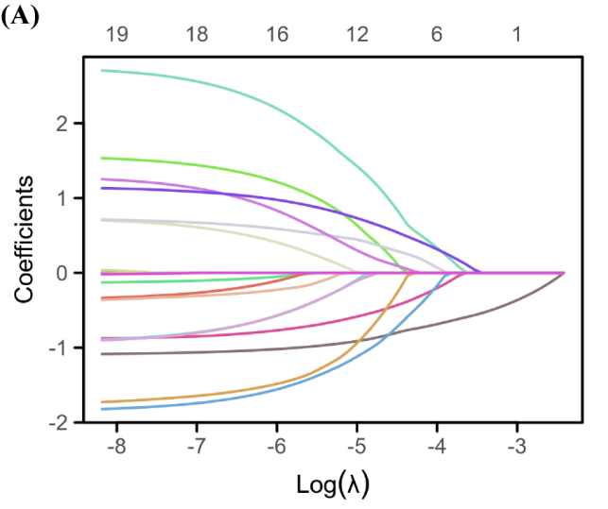
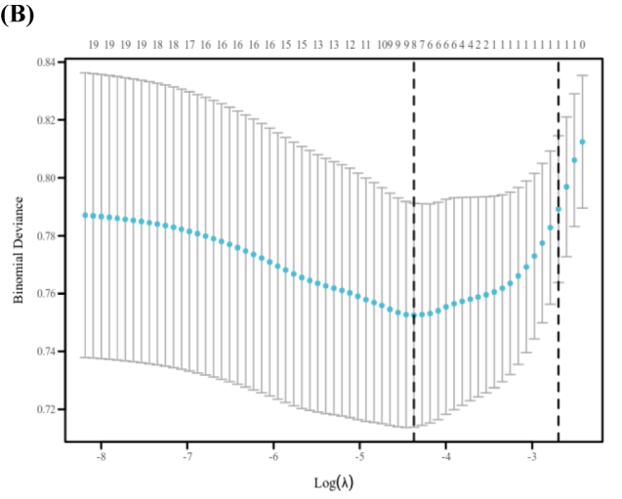
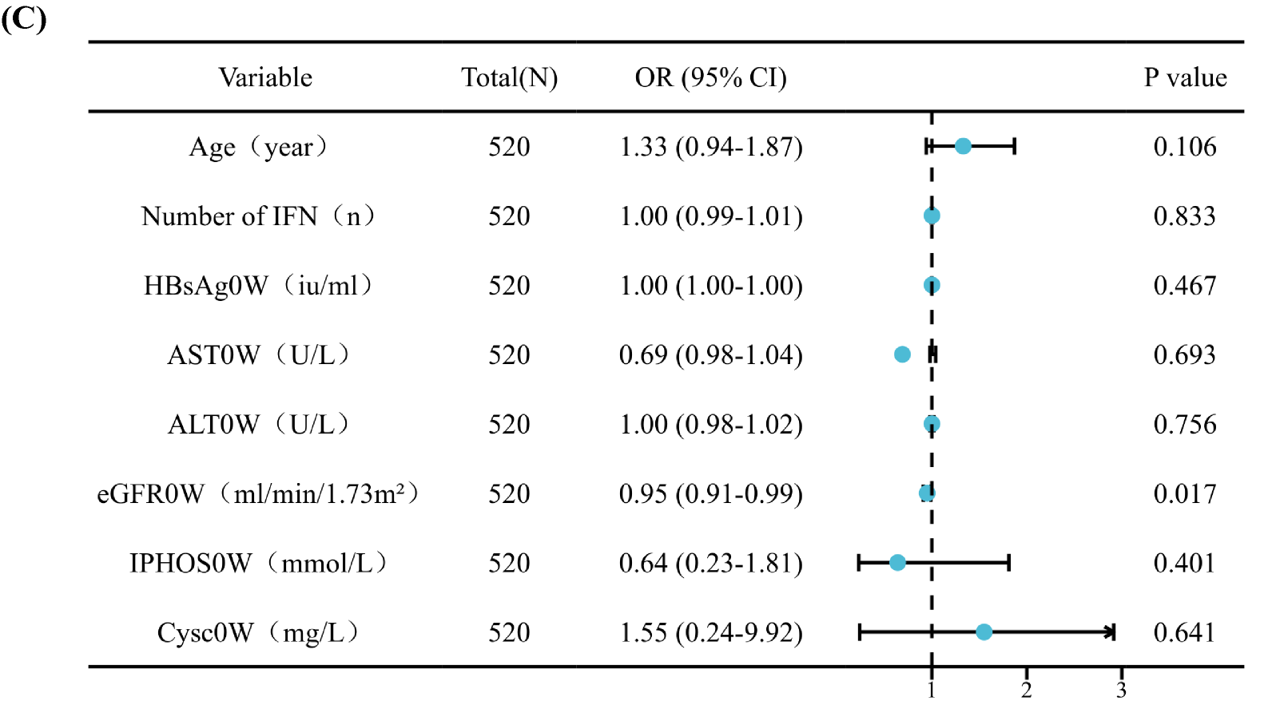
FigureS4 Analysis of factors predicting renal outcomes at 48 weeks.
- . Lasso coefficient path diagram. (B). LASSO regression analysis cross-validation. (C).Multivariate analysis forest plot of renal outcomes at 48 weeks.

