Renal function changes in patients with chronic hepatitis B treated with pegylated interferon combined with nucleos(t)ide analogs

Supplementary Materials
Supplementary figures
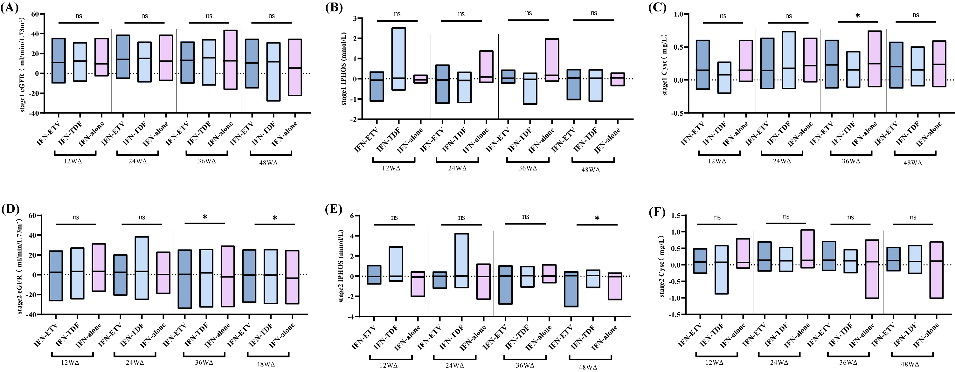

FigureS3.Variations at the different stages of renal function.
- . Variation in eGFR at stage 1. (B). Variation in IPHOS at stage 1. (C). Variation in Cysc at stage 1. (D). Variation in the eGFR at stage 2. (E). Variation in IPHOS at stage 2. (F). Variation in Cysc at stage 2.

