Supplementary Figure 1. The forest plot shows the regression coefficients (β) and 95% confidence intervals for the associations between CMI and the dimensions of intrinsic capacity (IC) among Chinese elderly (n=7,058) of the same age and gender, with data sourced from the Chinese Health and Retire Longitudinal Study (CHARLS). Each point estimate represents the β coefficient of the linear regression model, and the horizontal line indicates the 95% confidence interval. The dashed vertical line represents no effect (β=0). Colors indicate the direction of association: blue indicates positive association, orange indicates negative association. Solid dots indicate statistically significant associations (P<0.05), while hollow circles indicate no significance.
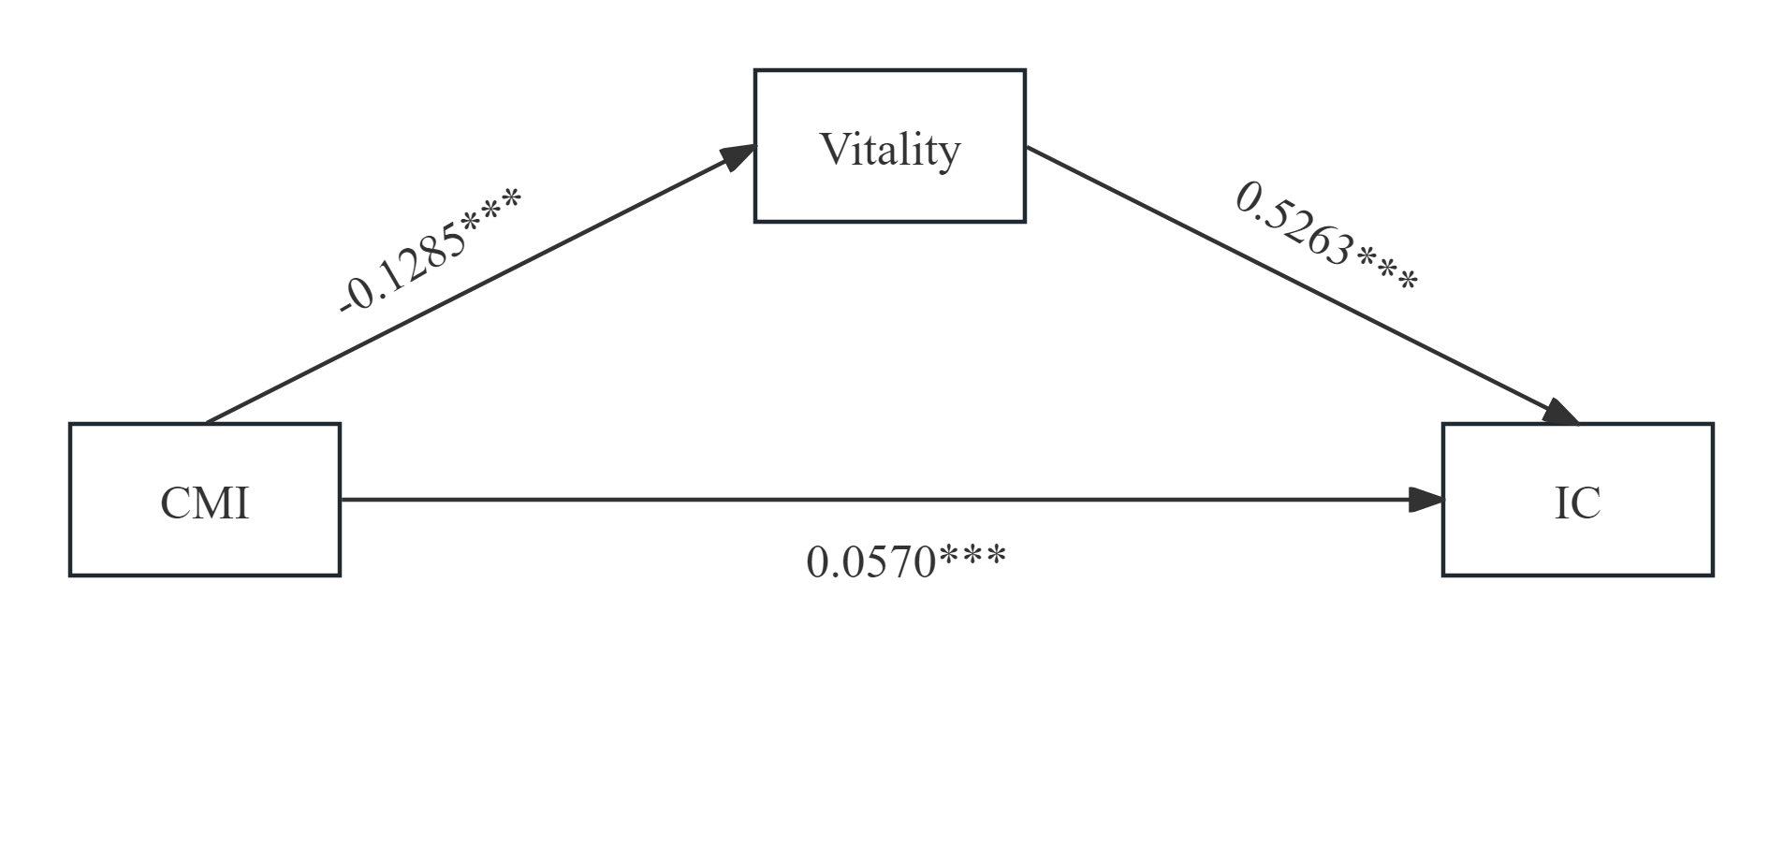
Supplementary Figure 2. Path coefficient diagram of vitality among CMI and IC.
Note: ***p＜0.001

Supplementary Table 1. Decomposition of total effect, direct effect, and mediating effect
 | Effect | SE | LLCI | ULCI | P value
Total | -0.0107 | 0.0113 | -0.0327 | 0.0114 | 0.3442
ADE | 0.0570 | 0.0099 | 0.0376 | 0.0763 | ＜0.001
ACME | -0.0676 | 0.0062 | -0.0796 | -0.0556 | -
Decomposition of total effect, direct effect, and mediating effect after controlling for age and gender. ACME, indirect effect; ADE, direct effect; Total, total effect; Effect, effect size; SE, Standard Error; LLCI, lower limit of 95% confidence interval; ULCI, upper limit of 95% confidence interval.

