Supporting Information for

Self-Bound Catalytic Layer of Porous Hollow Ru for Transport-Boosted Alkaline Water Electrolysis

Suibao Shen, Qiao Qiao, Erjie Kan, Xianfu Li and Long Kuai*

School of Chemical and Environmental Engineering, Anhui Laboratory of Clean Catalytic Engineering, Anhui Laboratory of Functional Coordinated Complexes for Materials Chemistry and Application, Hydrogen Energy Technology Research Center of Wuhu, Anhui Polytechnic University, Beijing Middle Road, Wuhu 241000, China

*E-mail: kuailong@ahpu.edu.cn

S1: Additional experimental details
S2: Additional figures and figure captions

S1 Additional experimental details

S1.1 Chemical reagents
RuCl₃·nH₂O and H₂PtCl₆·6H₂O were procured from Changzhou Yiding Metal Materials Co., Ltd. N-vinylpyrrolidone (NVP), potassium hydroxide (KOH, ≥99%), nickel nitrate hexahydrate (Ni(NO₃)₂·6H₂O), and cobalt nitrate hexahydrate (Co(NO₃)₂·6H₂O) were obtained from Aladdin Biochemical Technology Co., Ltd. Sodium nitrate (NaNO₃), ferric nitrate nonahydrate (Fe(NO₃)₃·9H₂O), manganese nitrate tetrahydrate (Mn(NO₃)₂·4H₂O), copper nitrate trihydrate (Cu(NO₃)₂·3H₂O), and isopropanol (C₃H₈O) were supplied by Sinopharm Chemical Reagents Co., Ltd. Additionally, a Nafion solution (5 wt%) was provided by DuPont, and Kojin carbon black (EC600JD) was sourced from Lion King Corporation. All aqueous solutions were prepared using deionized water.

S1.2 Sample preparation
Preparation of superhydrophilic porous hollow Ru-Cu-NVP precursor
A homogeneous aqueous solution was first prepared by dissolving 0.433 g of NVP, 0.761 g of NaNO₃ and 0.555 g of Cu(NO₃)₂·3H₂O in 67 mL of deionized water under ultrasonic agitation. After thorough mixing, 5.6 mL of RuCl₃ solution (0.41 M) was added to the mixture and homogenized. The resulting solution was subsequently processed following the same microdroplet confinement procedure described in the previous section, ultimately yielding the superhydrophilic porous hollow Ru-Cu-NVP precursor.
Preparation of superhydrophilic porous hollow Ru-Mn-NVP precursor
A homogeneous aqueous solution was first prepared by dissolving 0.433 g NVP and 0.761 g NaNO₃ in 55 mL of deionized water under ultrasonic agitation. After thorough mixing, 5.6 mL of RuCl₃ solution (0.41 M) and 11.5 mL of Mn(NO₃)₂ solution (0.2 M) were added to the mixture and homogenized. The resulting solution was subsequently processed following the same microdroplet confinement procedure described in the previous section, ultimately yielding the superhydrophilic porous hollow Ru-Mn-NVP precursor.
Preparation of superhydrophilic porous hollow Ru-Co-Ni-NVP precursor
A homogeneous aqueous solution was first prepared by dissolving 0.433 g NVP, 0.761 g NaNO₃, 0.334 g Co(NO3)₂·6H₂O and 0.334 g Ni(NO₃)₂·6H₂O in 67 mL of deionized water under ultrasonic agitation. After thorough mixing, 5.6 mL of RuCl₃ solution (0.41 M) was added to the mixture and homogenized. The resulting solution was subsequently processed following the same microdroplet confinement procedure described in the previous section, ultimately yielding the superhydrophilic porous hollow Ru-Co-Ni-NVP precursor.
Preparation of superhydrophilic porous hollow Ru-Fe-Co-Ni-NVP precursor
A homogeneous aqueous solution was first prepared by dissolving 0.433 g NVP, 0.761 g NaNO₃, 0.309 g Fe(NO₃)₃·9H₂O, 0.223 g Co(NO₃)₂·6H₂O and 0.223 g Ni(NO₃)₂·6H₂O in 67 mL of deionized water under ultrasonic agitation. After thorough mixing, 5.6 mL of RuCl₃ solution (0.41 M) was added to the mixture and homogenized. The resulting solution was subsequently processed following the same microdroplet confinement procedure described in the previous section, ultimately yielding the superhydrophilic porous hollow Ru-Fe-Co-Ni-NVP precursor.
Preparation of superhydrophilic porous hollow Ru-Fe-Co-Ni-Mn-NVP precursor
A homogeneous aqueous solution was first prepared by dissolving 0.433 g NVP, 0.761 g NaNO₃, 0.232 g Fe(NO₃)₃·9H₂O,0.167 g Co(NO₃)₂·6H₂O, and 0.167 g Ni(NO₃)₂·6H₂O in 64 mL of deionized water. After thorough mixing, 5.6 mL of RuCl₃ solution (0.41 M) and 2.9 mL of Mn(NO₃)₂ solution (0.2 M) were added to the mixture and homogenized. The resulting solution was subsequently processed following the same microdroplet confinement procedure described in the previous section, ultimately yielding the superhydrophilic porous hollow Ru-Fe-Co-Ni-Mn-NVP precursor.
Preparation of superhydrophilic porous hollow FeNiRu_{0.2}-NVP precursor
A homogeneous aqueous solution was first prepared by dissolving 0.433 g NVP, 0.761 g NaNO₃, 0.5407 g Fe(NO₃)₃·9H₂O, and 0.7784 g Ni(NO₃)₂·6H₂O in 71 mL of deionized water under ultrasonic agitation. After thorough mixing, 1.4 mL of RuCl₃ solution (0.41 M) was added to the mixture and homogenized. The resulting solution was subsequently processed following the same microdroplet confinement procedure described in the previous section, ultimately yielding the superhydrophilic porous hollow FeNiRu_{0.2}-NVP precursor.
Preparation of 60% Pt/C catalyst
The pretreated carbon black support was obtained by grinding for 0.5 hours followed by drying at 60 °C for 2 hours. Subsequently, 0.1 g of the pretreated support was impregnated with 0.80 g of chloroplatinic acid solution (mass concentration 18.8%) via dropwise addition under continuous stirring for 0.5 h. The resulting mixture was then subjected to calcination in a muffle furnace at 300 °C (heating rate: 2 °C/min) in air for 2 h to yield an intermediate complex. Finally, the intermediate was reduced under a 5% H₂/Ar atmosphere at 400 °C (heating rate: 2 °C/min) and cooled to room temperature, affording the final 60% Pt/C catalyst.

S1.3 Characterizations
The phase identification of the samples was conducted using an X-ray diffractometer (XRD, TD-3700, Dandong Tongda Technology Co., Ltd.) with Cu Kα radiation (λ = 0.15418 nm) operated at 40 kV and 30 mA. Data were collected in continuous scanning mode over a 2θ range of 20 to 80° at a speed of 5°/min. Morphological analysis was carried out using a scanning electron microscope (SEM, Hitachi S-4800) at an accelerating voltage of 5 kV and TEM (Technai G20 S-TWIN, FEI). The element mappings were analyzed by X-ray energy dispersive spectroscopy (EDX) equipped on high angle annular dark field-scanning transmission electron microscope (HAADF-STEM, Tecnai G2 20F/TWIN). The specific surface area and pore structure were determined from N₂ adsorption–desorption isotherms measured with a surface area and porosity analyzer (ASAP 2460). Fourier-transform infrared (FTIR) spectroscopy was performed using a Shimadzu IRAffinity-1S spectrometer. Water contact angles were measured at room temperature with an SL 250 contact angle analyzer. The samples were uniformly and densely coated onto a glass slide. A 2.5 μL droplet of deionized water was gently deposited onto the coating surface, and dynamic wetting behavior was recorded at 20 frames per second.

S1.4 Electrode fabrication with traditional ionomer-bound catalyst layer
Thermal treatment of precursors
As traditional route, Ru-NVP precursor was first transferred into catalysts powder. As for cathodic catalyst, Ru-NVP was heated at 360 °C (2 °C/min) under a 5% H₂/Ar atmosphere for 2 h, cooled naturally to room temperature, and subsequently calcined again at 300 °C (2 °C/min) in air for another 2 h, followed by cooling to room temperature. As for anodic catalyst, Ru-NVP was heated at 380 °C (2 °C/min) under a 5% H₂/Ar atmosphere for 2 h, cooled naturally to room temperature, and subsequently calcined again at 400 °C (2 °C/min) in air for another 2 h.
Ink preparation
The anodic or cathodic catalyst was weighed and transferred into an ink bottle. Isopropanol and Nafion solution were added to prepare a homogeneous ink with a concentration of 4 mg/mL. The ration of Nafion to metallic Ru was 0.4. The mixture was ultrasonicated for 30 minutes in an ice-water bath to ensure uniform dispersion.
Cathode fabrication
The prepared cathodic catalyst ink was sprayed onto Ti mesh substrates of two sizes: 1 × 1 cm² (for three-electrode electrochemical testing) with a Ru loading of approximately 0.6 mg_{Ru}/cm², and 2 × 2 cm² (for two-electrode alkaline water electrolysis evaluation) with a Ru loading of about 1.2 mg_{Ru}/cm².
Anode fabrication
The prepared anodic catalyst ink was sprayed onto Ni foam substrates of two sizes: 1 × 1 cm² (for three-electrode electrochemical testing) with a Ru loading of approximately 0.6 mg_{Ru}/cm², and 2 × 2 cm² (for two-electrode alkaline water electrolysis evaluation) with a Ru loading of about 1.2 mg_{Ru}/cm².

S2 Additional figures and figure captions

Figure S1
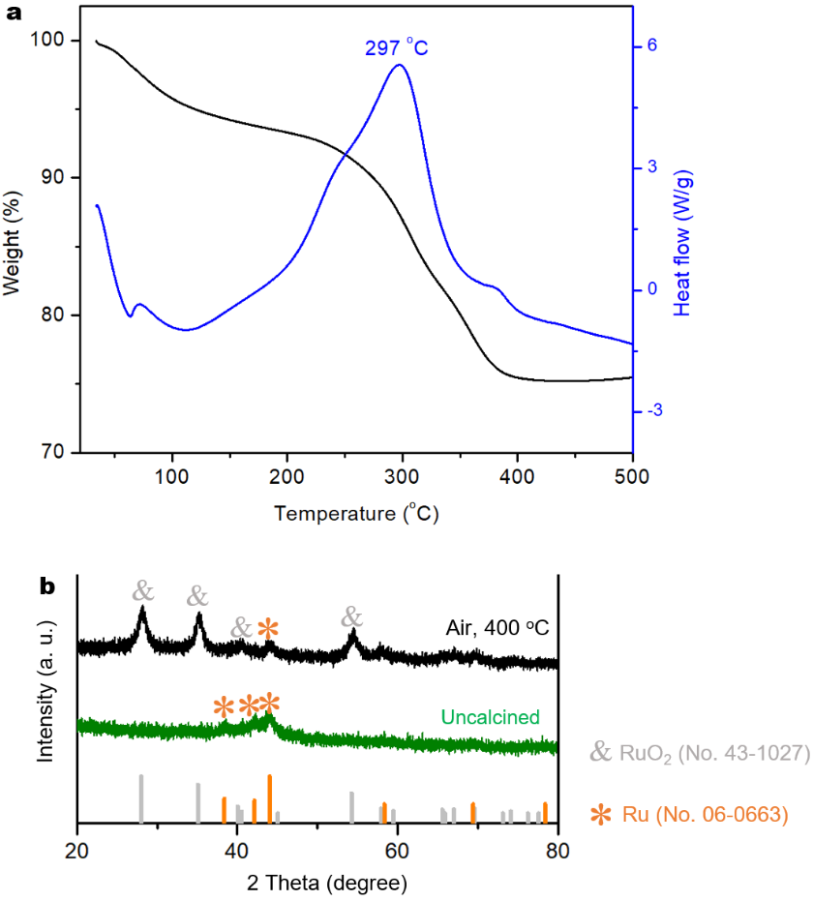
Figure S1. (a) TG (black) and heat flow (blue) curves of Ru-NVP precursor measured in air atmosphere. (b) XRD pattern of thermal treated product of Ru-NVP in air at 400 ºC.

Figure S2
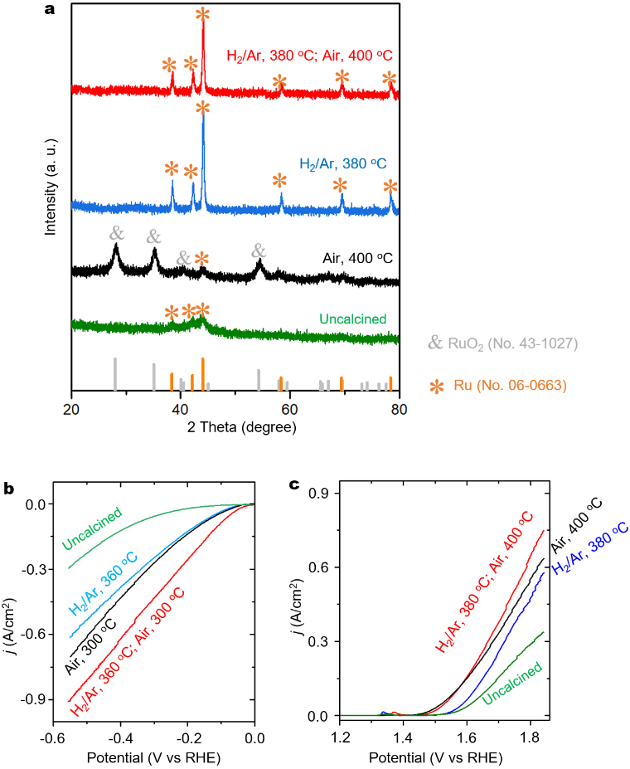
Figure S2. (a) XRD patterns, (b) HER and (c) OER polarization curves of uncalcined Ru-NVP precursor and the products calcined in air, H₂/Ar and H₂/Ar-subsequent air for condition optimization. The Ti mesh substrate was used for HER and Ni foam substrate was used for OER. The electrochemical measurements were performed in 10% KOH at room temperature.

Figure S3
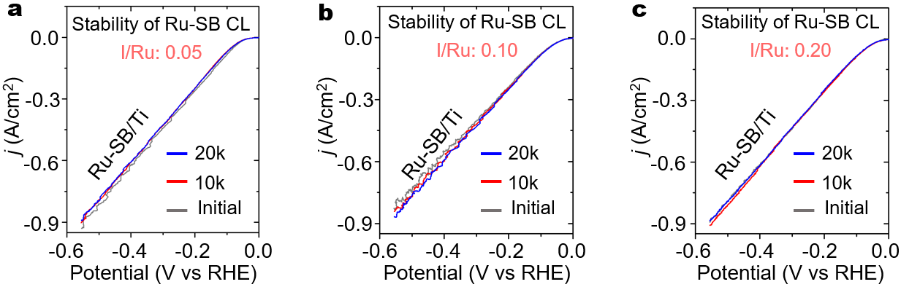
Figure S3. (a-c) HER polarization curves of the Ru-SB/Ti electrode prepared with I/Ru ratio of (a) 0.05, (b) 0.10 and (c) 0.20 measured initially, after 10,000 and 20,000 cycles. The measurements were performed in 10% KOH at room temperature.

Figure S4
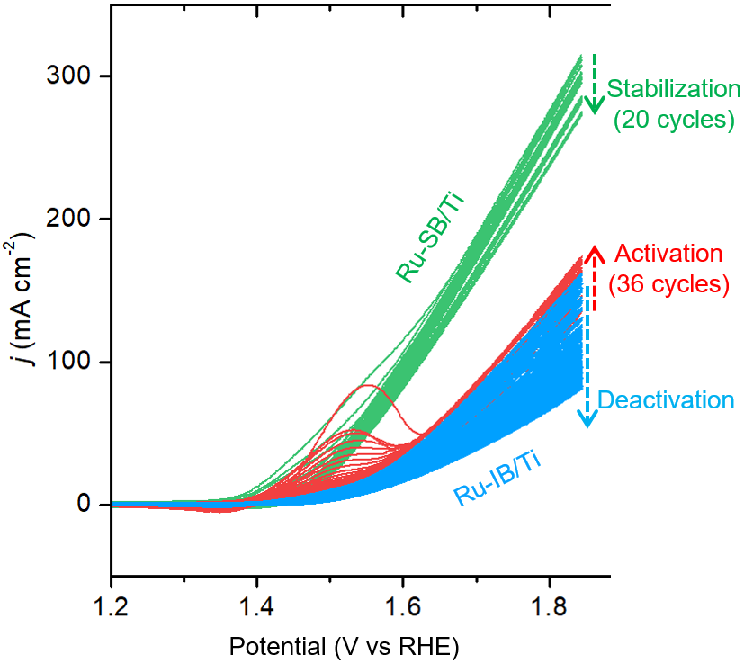
Figure S4. OER activation curves for the (a) Ru-IB/Ti and (b) Ru-SB/Ti electrodes in 10% KOH at room temperature.

Figure S5
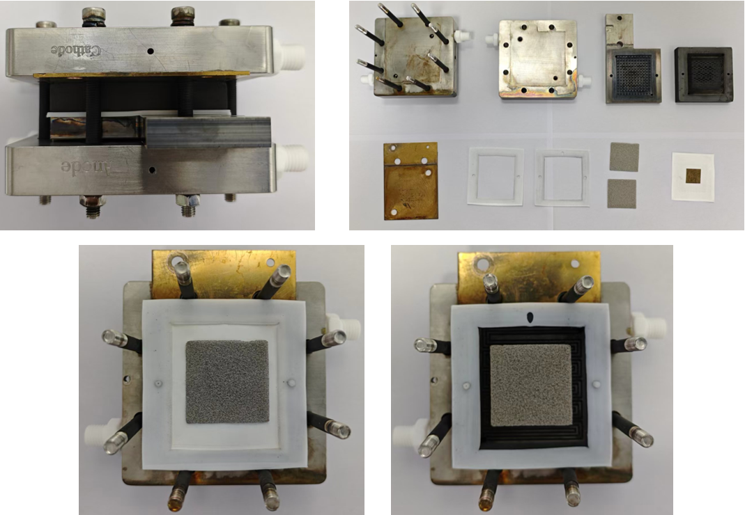
Figure S5. Components and structural photos of a two-electrode cell for alkaline water electrolysis.

Figure S6
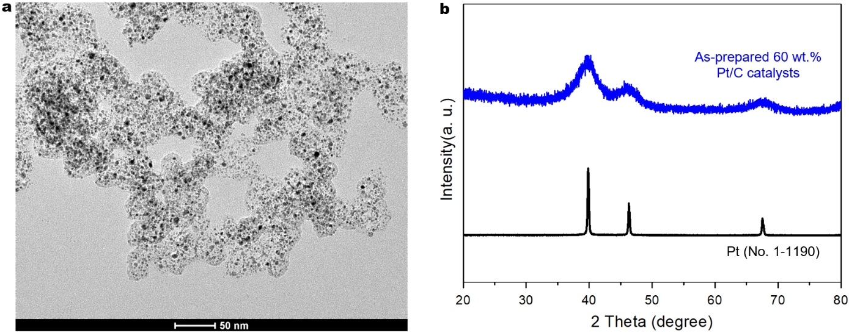
Figure S6. (a) TEM image and (b) XRD pattern of home-made 60 wt.% Pt/C catalysts.

Figure S7
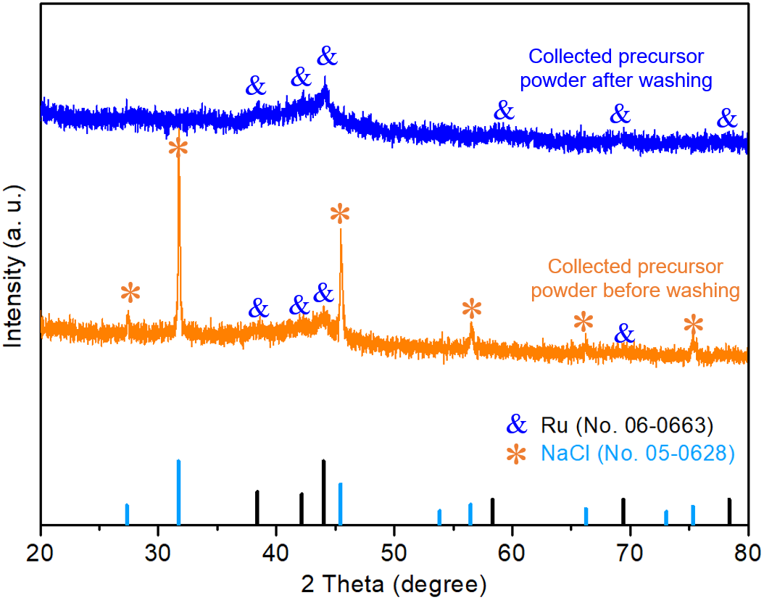
Figure S7. XRD patterns of collected precursor powder before (orange curve) and after (blue curve) washing with reference to the metallic Ru (black lines) and NaCl (light blue lines) standards.

Figure S8
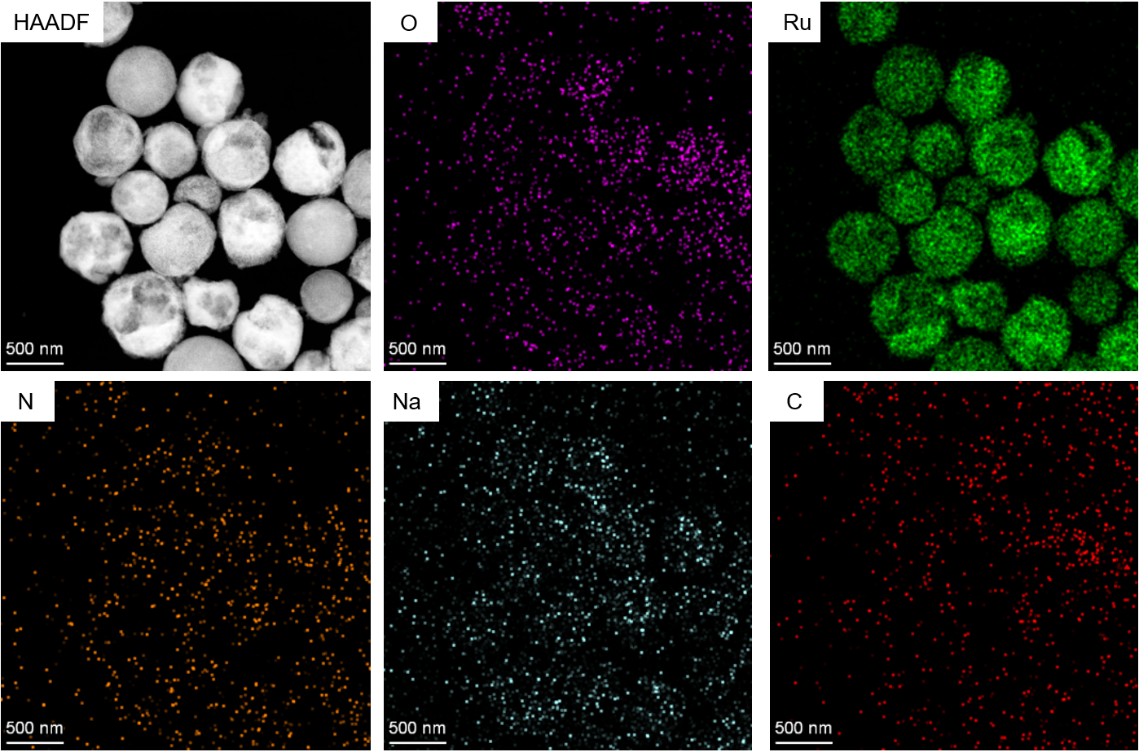
Figure S8. HAADF-STEM-EDS mappings of Ru precursor synthesized in the absence of NVP.

Figure S9
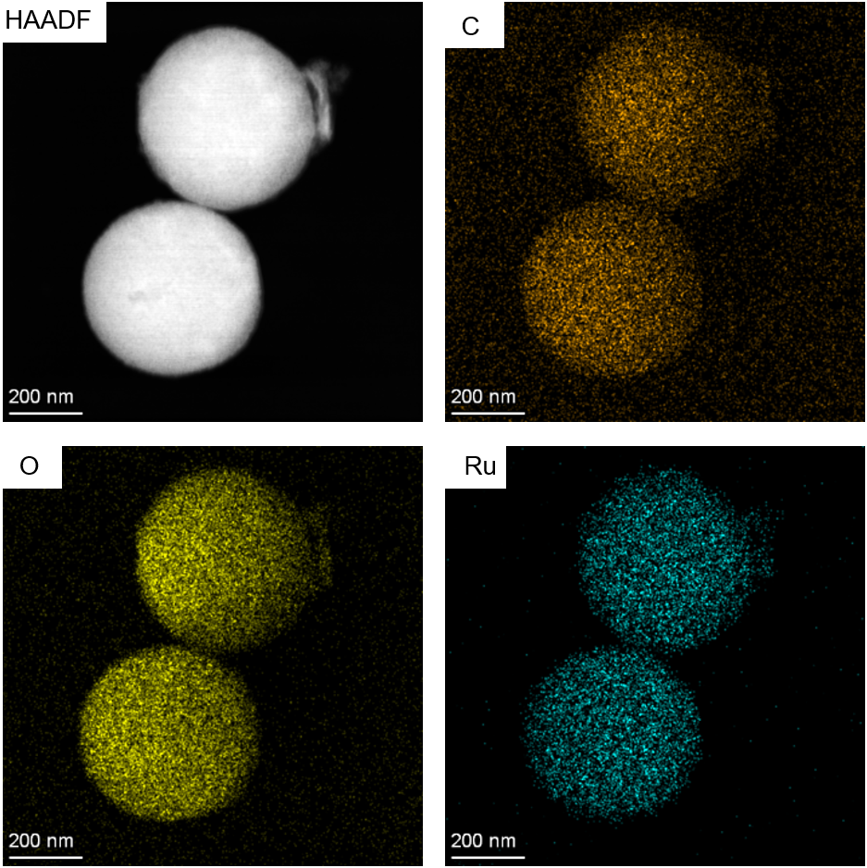
Figure S9. HAADF-STEM-EDS mappings of Ru precursor synthesized in the absence of NaNO₃.

Figure S10
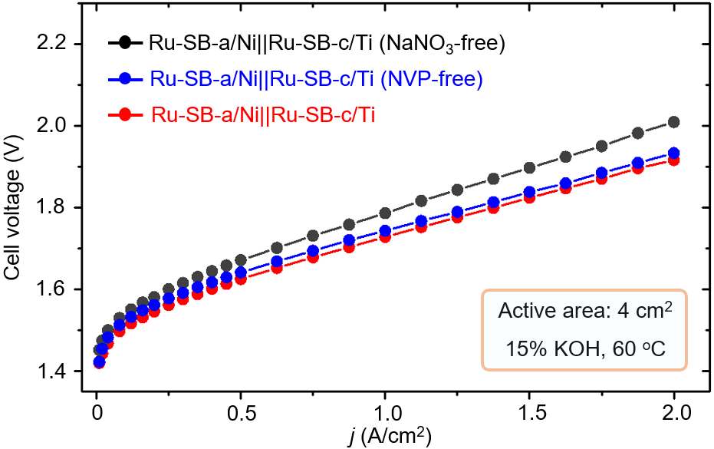
Figure S10. Alkaline water electrolysis performance equipped with Ru-SB-c/Ti||Ru-SB-a/Ni (red), NVP-free prepared Ru-SB-c/Ti||Ru-SB-a/Ni (blue) and NaNO₃-free prepared Ru-SB-c/Ti||Ru-SB-a/Ni (black) electrode pairs. The alkaline water electrolysis was performed in 15% KOH at 60 ºC.

Figure S11
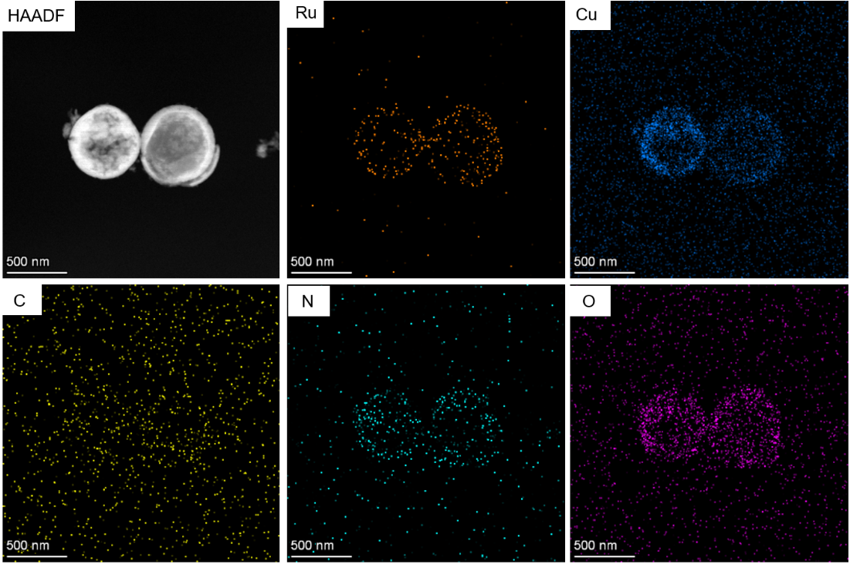
Figure S11. HAADF-STEM-EDS mappings of porous-hollow Ru-Cu-NVP precursor.

Figure S12
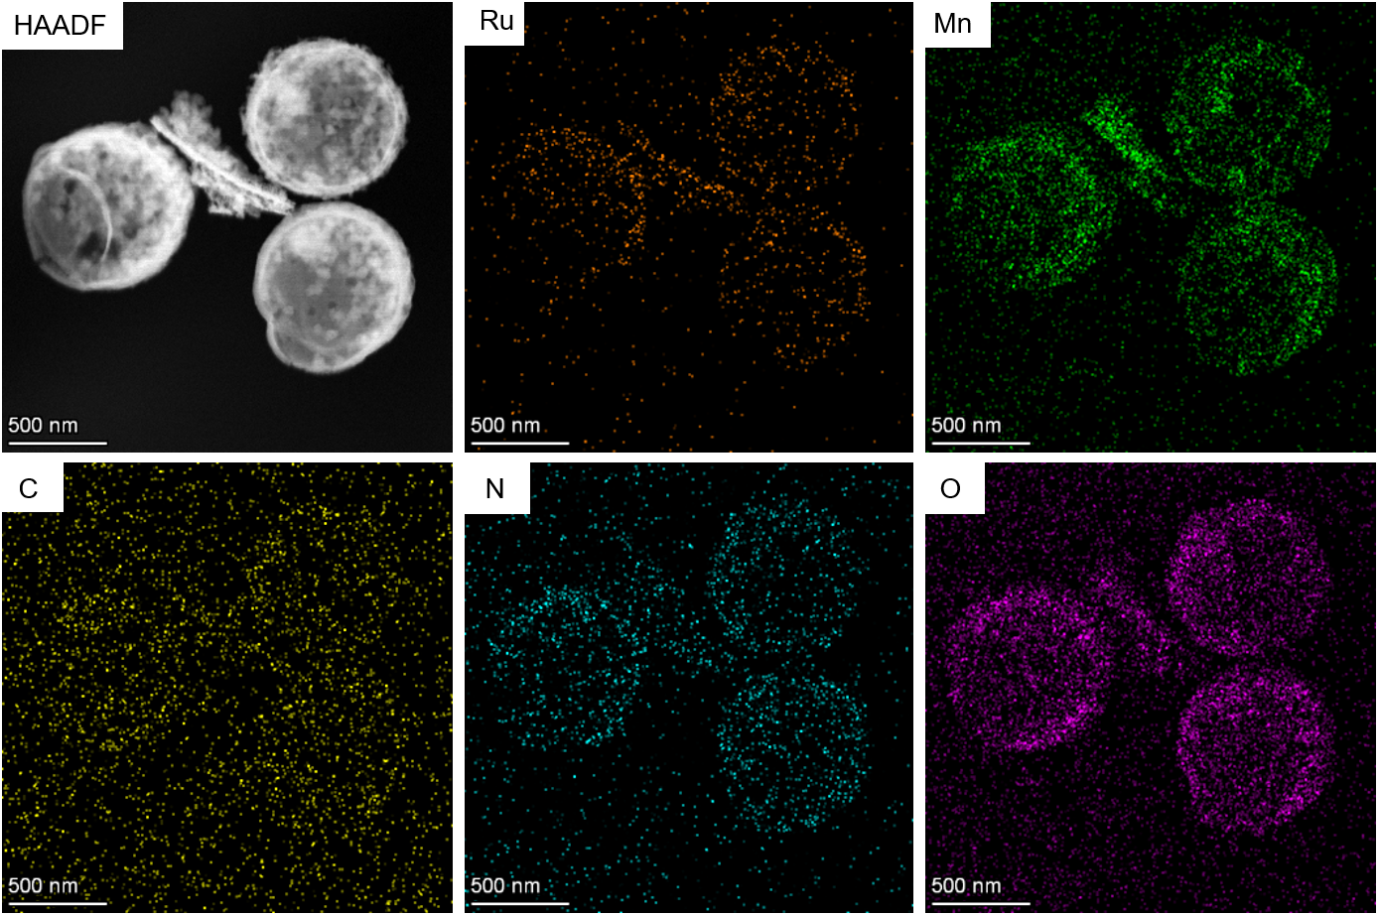
Figure S12. HAADF-STEM-EDS mappings of porous-hollow Ru-Mn-NVP precursor.

Figure S13
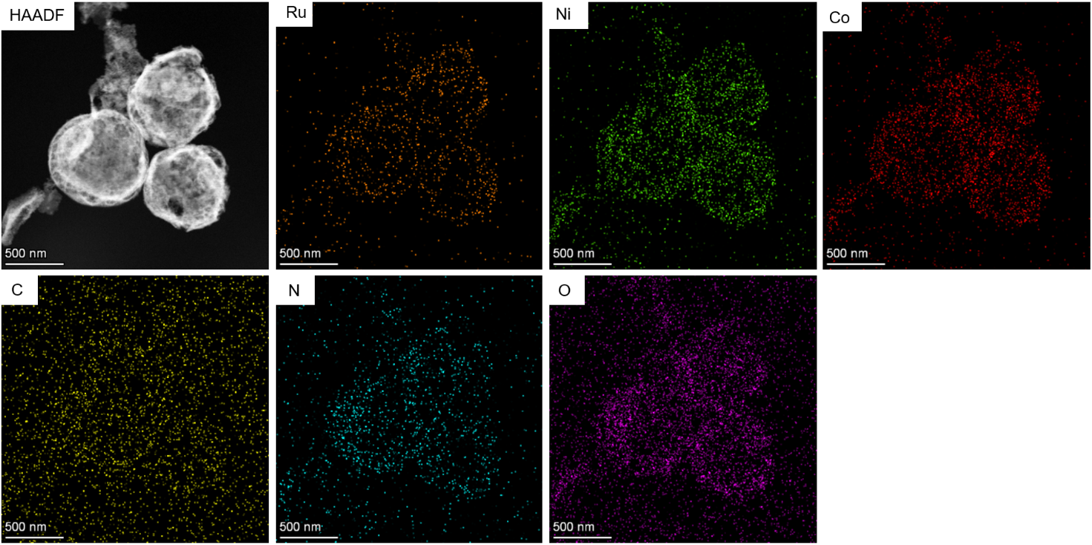
Figure S13. HAADF-STEM-EDS mappings of porous-hollow Ru-Co-Ni-NVP precursor.

Figure S14
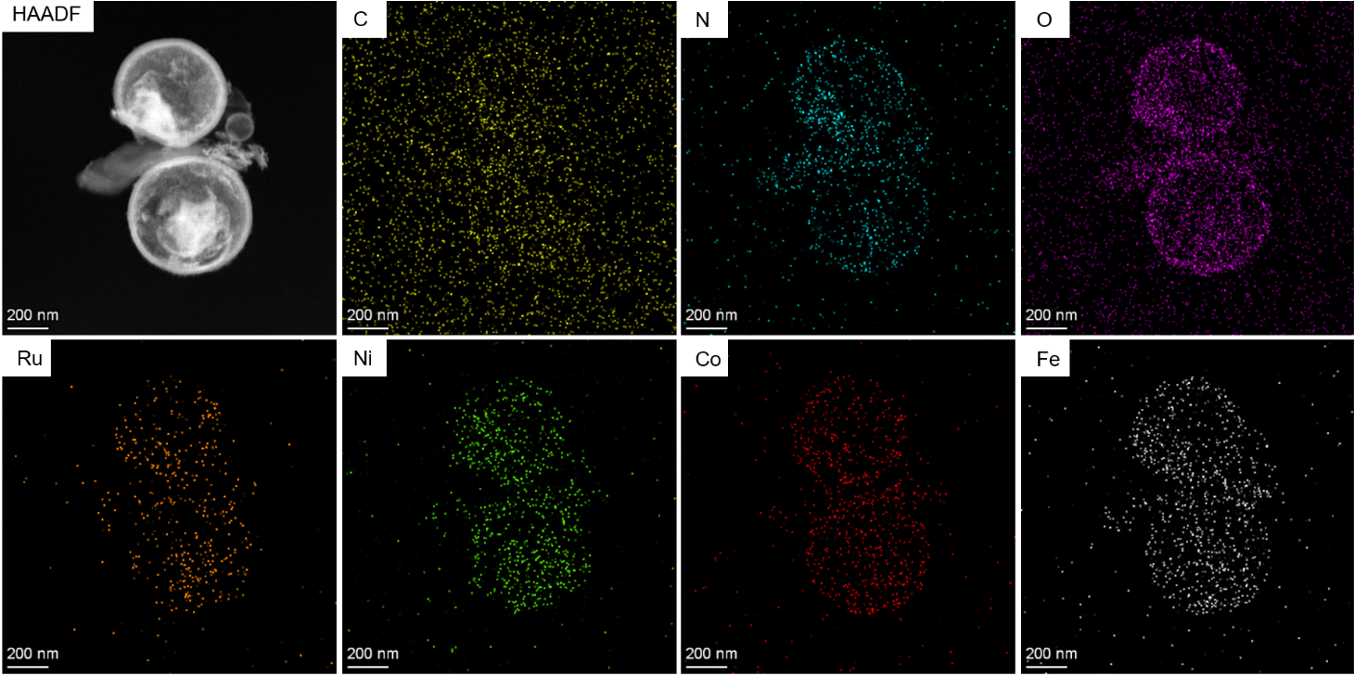
Figure S14. HAADF-STEM-EDS mappings of porous-hollow Ru-Fe- Co-Ni-NVP precursor.

Figure S15
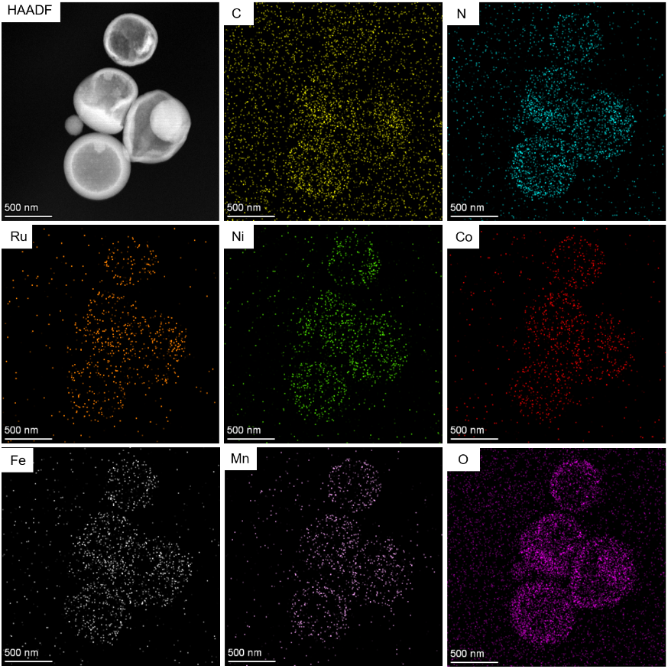
Figure S15. HAADF-STEM-EDS mappings of porous-hollow Ru-Fe- Co-Ni-Mn-NVP precursor.

Figure S16
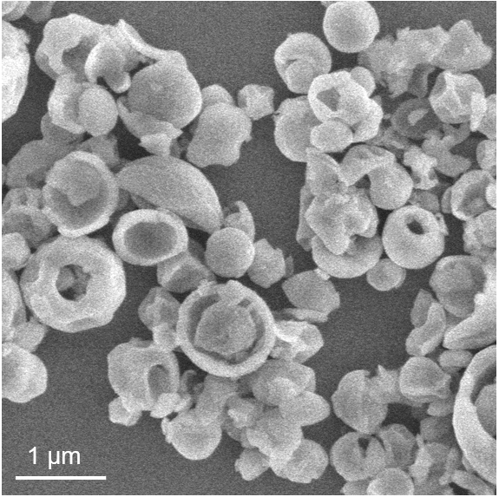
Figure S16. SEM image of porous hollow FeNiRu_{0.2}-NVP precursor.

