Melaminium Tris Dihydrogen Phosphate (MTDP): A New Green and Sustainable Tricationic Ionic Liquid Catalyst for the Knoevenagel Synthesis of 5-Arylidene(thio)barbituric Acids in Water
Hossein Khorramabadi,ª Nader Daneshvar,^{a,b} Farhad Shirini *^{a,b} Hassan Tajik ^{a,b}
ª Department of Organic Chemistry, Faculty of Chemistry, University of Guilan, Rasht, 41335-19141, Iran, Tel/Fax: +981313233262; e-mail: shirini@guilan.ac.ir (and also fshirini@gmail.com)
^{b} Department of Chemistry, University of Guilan, University Campus 2, Rasht, Iran; e-mail: ndxdanshvar@gmail.com

Table of Contents

Page | Content
2 | TGA/DTG analysis diagram of melamine
3 | TGA/DTG analysis diagram of [H₃-melamine][H₂PO₄]₃.
4 | FT-IR (KBr) spectrums of 5-(3-bromobenzylidene)-2-thioxodihydropyrimidine-4,6(1H,5H)-dione
5 | ¹H NMR (400 MHz, DMSO-d₆) of 5-(3-bromobenzylidene)-2-thioxodihydropyrimidine-4,6(1H,5H)-dione
6 | Mass analysis diagram of 5-(3-bromobenzylidene)-2-thioxodihydropyrimidine-4,6(1H,5H)-dione

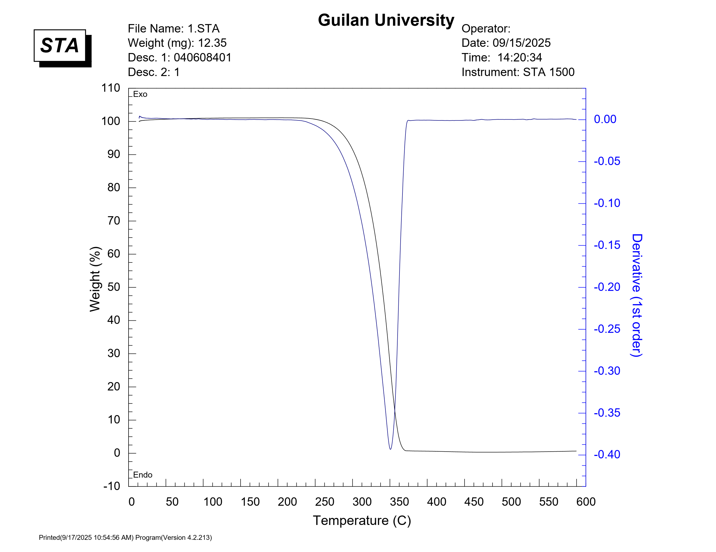
TGA/DTG analysis diagram of melamine

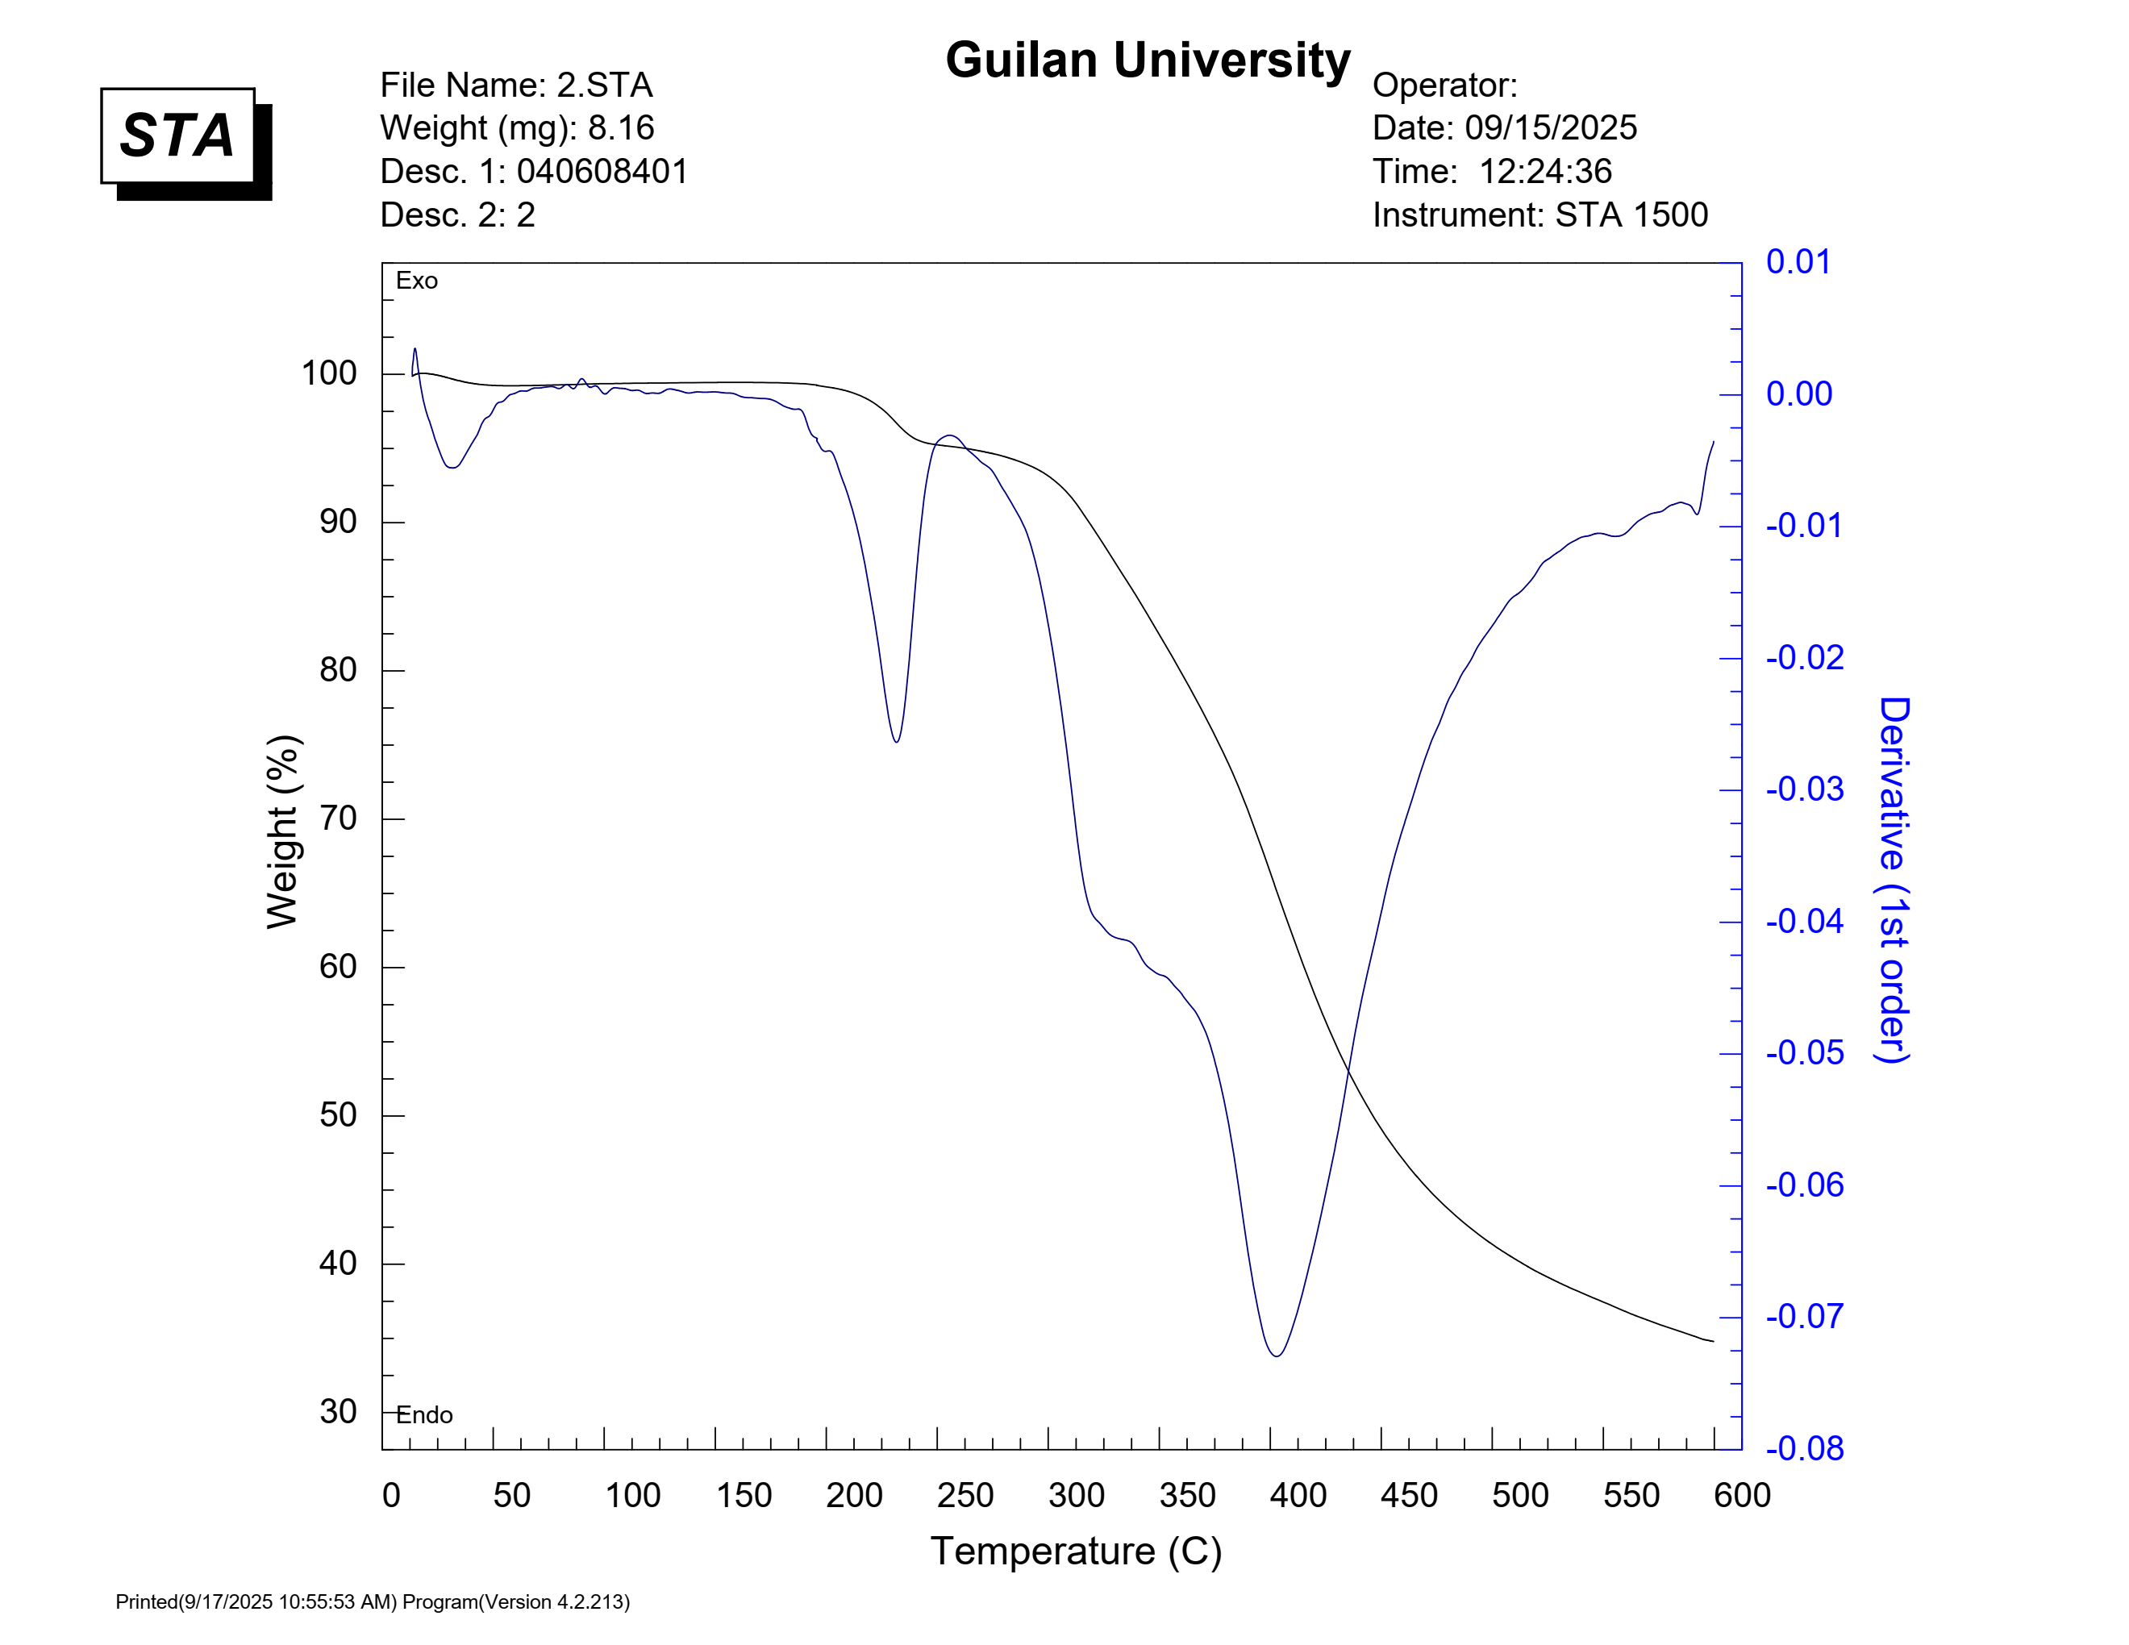
TGA/DTG analysis diagram of [H₃-melamine][H₂PO₄]₃

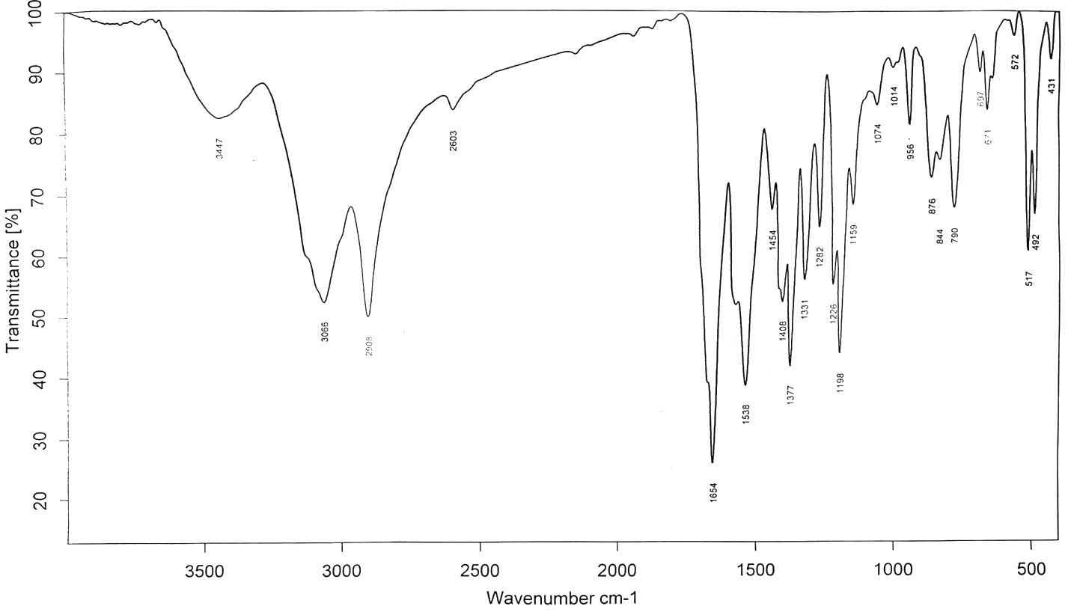

FT-IR (KBr) spectrums of 5-(3-bromobenzylidene)-2-thioxodihydropyrimidine-4,6(1H,5H)-dione (Table 2, Entry 27)
¹H NMR (400 MHz, DMSO-d₆) of 5-(3-bromobenzylidene)-2-thioxodihydropyrimidine-4,6(1H,5H)-dione (Table 2, Entry 27)

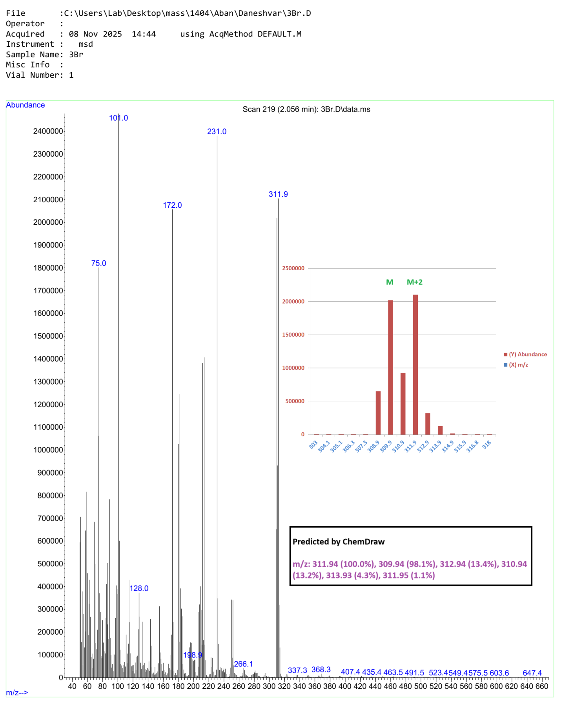
Mass analysis diagram of 5-(3-bromobenzylidene)-2-thioxodihydropyrimidine-4,6(1H,5H)-dione (Table 2, Entry 27)

