Supporting Information

Gold nanocluster-complexed dressings for instant closure of bacteria-infected wound

Shanchen Cai, Wenfu Zheng, Ting Lin, Siyuan Zhang, Lanye He, Mali Zu, Le Wang*

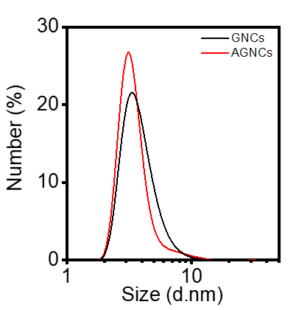
Figure S1. The size distribution of GNCs and the AGNCs.

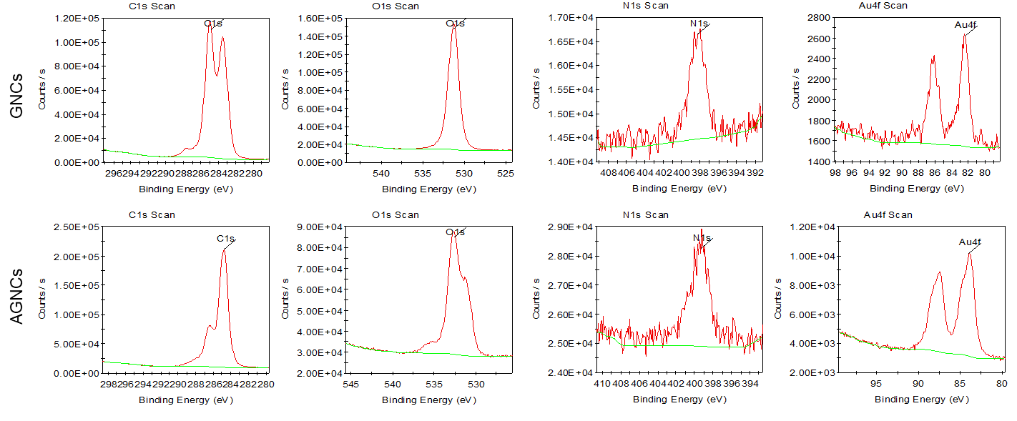
Figure S2. Chemical components of GNCs and AGNCs analyzed by XPS.

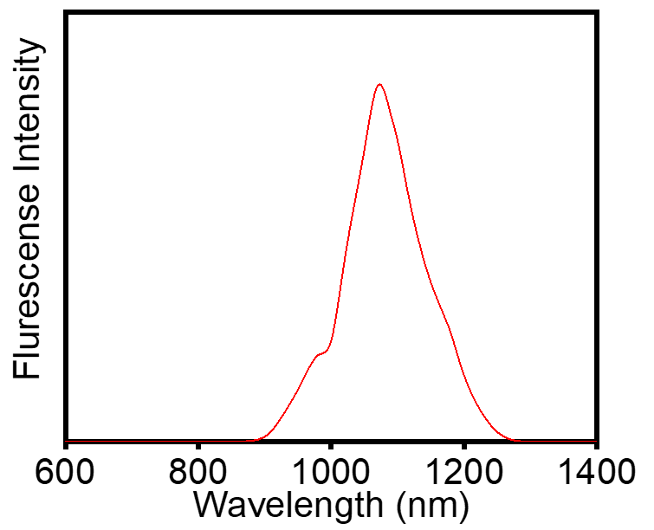
Figure S3. Fluorescence emission spectrum of AGNCs under 808 nm laser excitation.

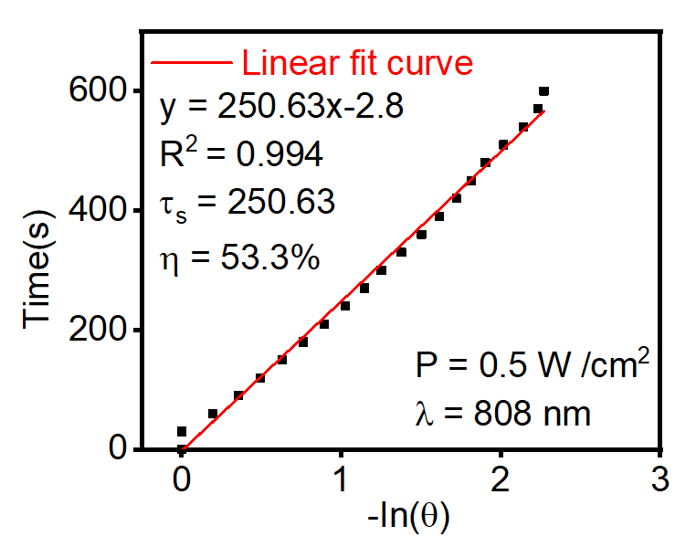
Figure S4. Photothermal conversion efficiency of AGNCs (200 µg/mL) was evaluated by monitoring the cooling process to room temperature and performing linear fitting analysis.

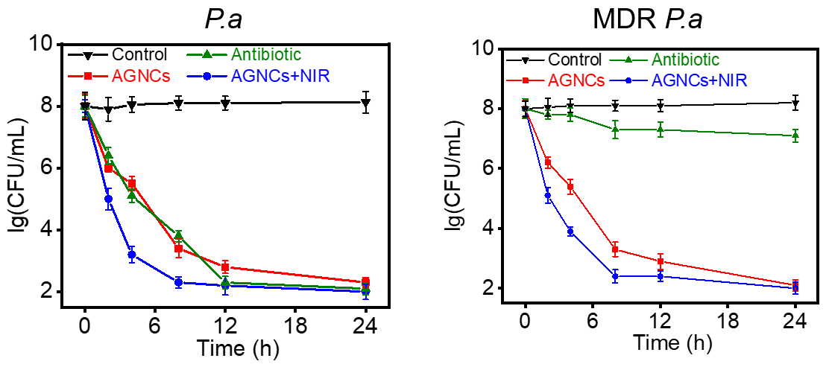
Figure S5. Bactericidal activities of AGNCs with and without NIR irradiation (0.5 W/cm², 5 min).
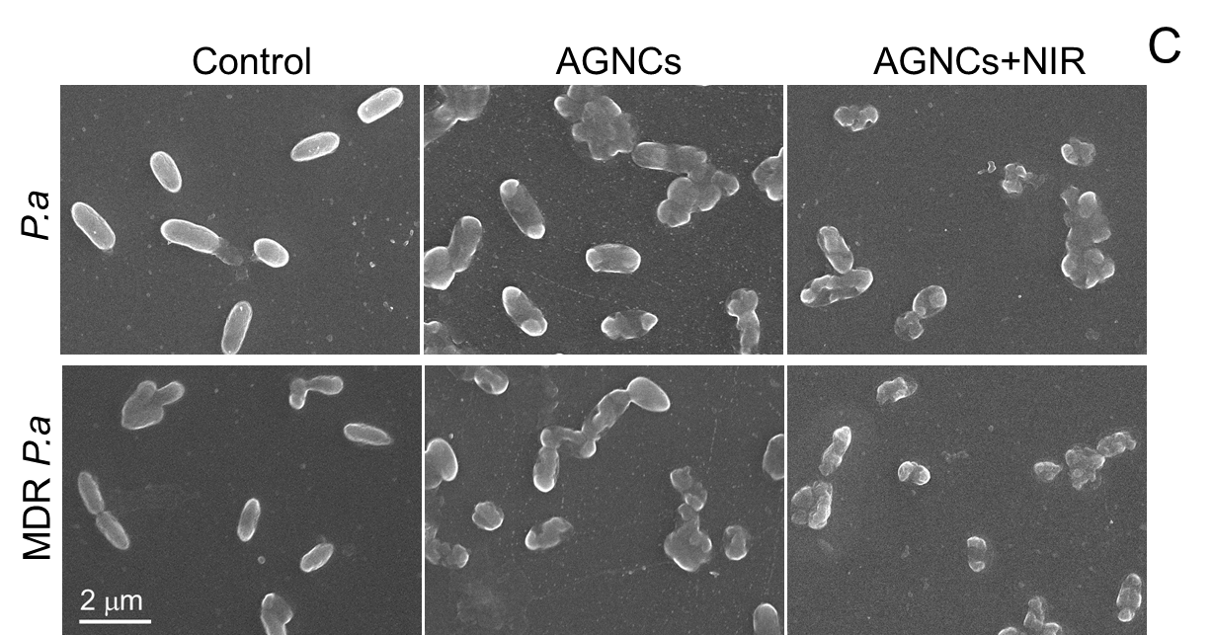
Figure S6. SEM images illustrating morphological changes in bacteria following treatment with AGNCs with or without NIR irradiation (0.5 W/cm², 5 min).

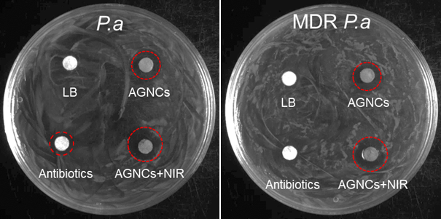
Figure S7. Antibacterial efficacy of AGNCs with or without NIR irradiation evaluated using the inhibition zone assay.

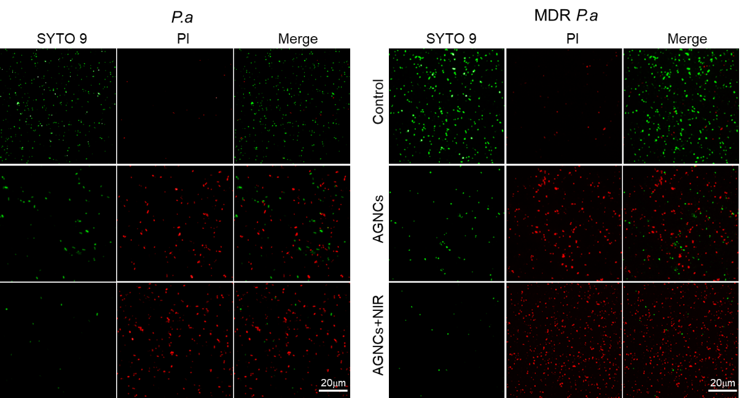
Figure S8. Assessment of P. a and MDR P. a viability following AGNC treatment with or without NIR irradiation, using SYTO 9 (green, live cells) and propidium iodide (red, dead cells) staining to evaluate membrane permeability. NIR irradiation condition was set as 0.5 W/cm² for 5 min.
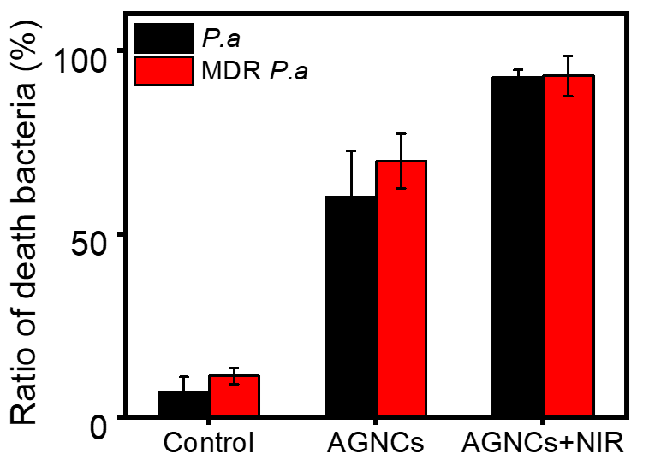
Figure S9. Changes in bacterial viability induced by AGNCs with and without NIR irradiation.
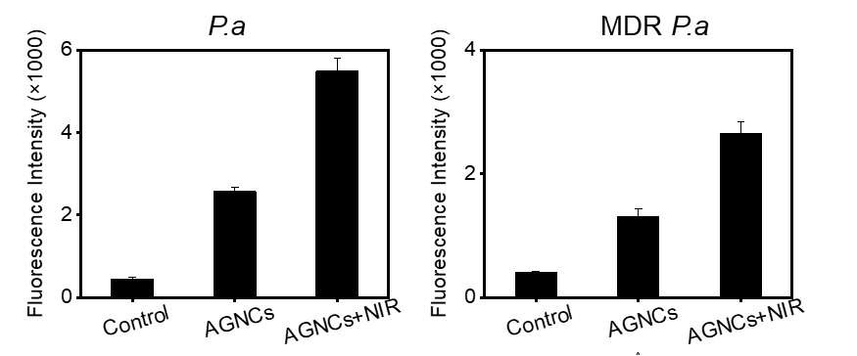
Figure S10. Total ROS levels in bacteria following AGNCs treatment with and without NIR irradiation measured by fluorescence intensity.
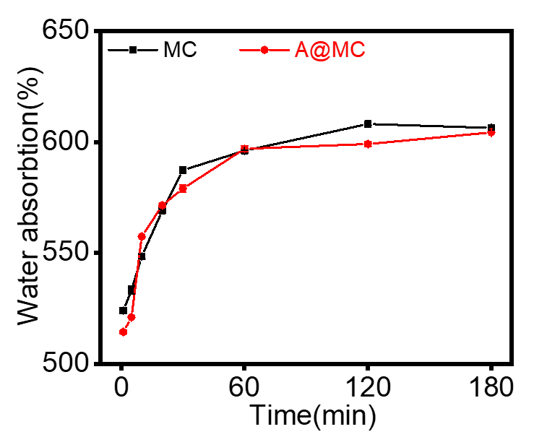
Figure S11. Swelling behavior of MC and A@MC hydrogels over time.
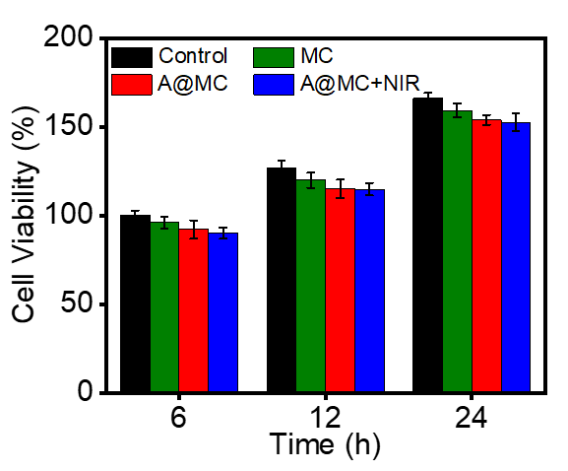
Figure S12. Viability of NIH-3T3 cells after co-incubation with solidified A@MC hydrogel with or without NIR irradiation.
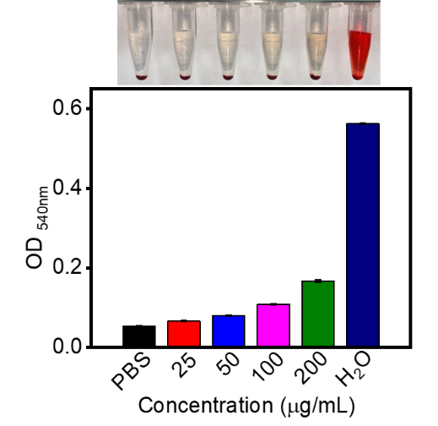
Figure S13. Hemolysis assay of AGNCs at different concentrations. PBS was used as the negative control and water as the positive control.
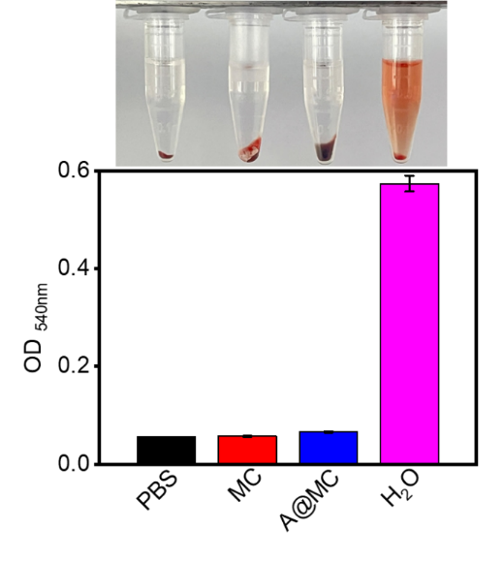
Figure S14. Hemolysis assay of MC and A@MC hydrogels. PBS was used as the negative control and water as the positive control.
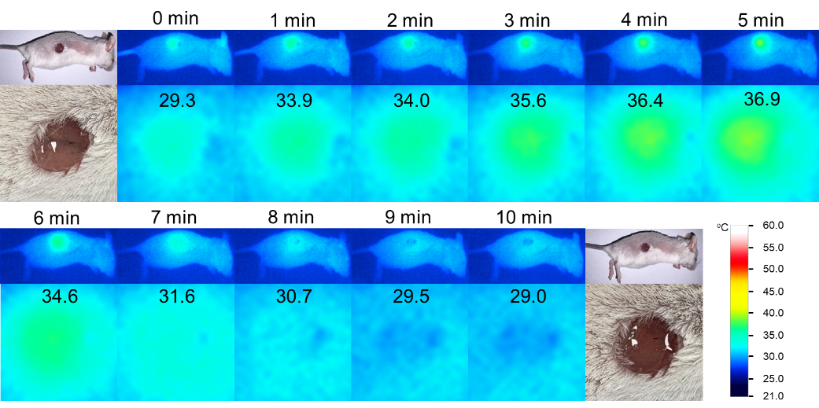
Figure S15. Thermal imaging of skin wounds in mice treated with MC hydrogels before and after NIR irradiation (808 nm, 0.5 W/cm²) for 5 min.
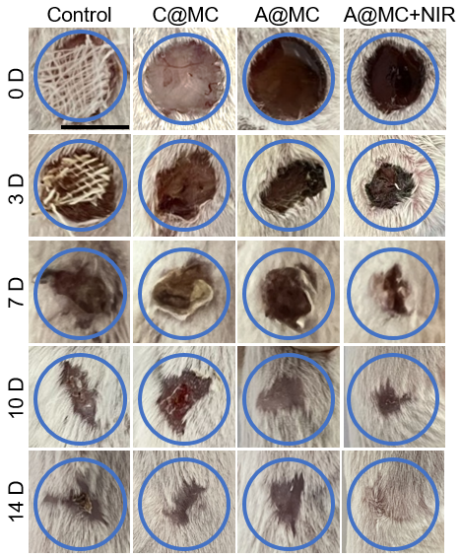
Figure S16. Representative photographs showing P. a-infected wound healing progression under various treatments on day 3, 7, 10, and 14 (scale bar, 1 cm).
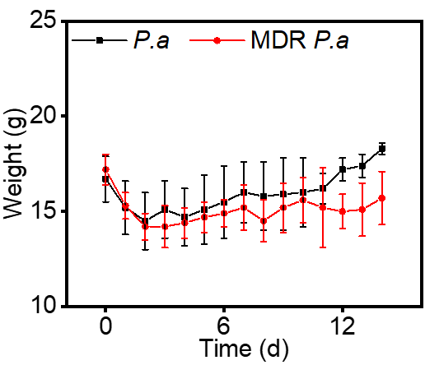
Figure S17. Body weight fluctuations following wound infections induced by P. a and MDR P. a.
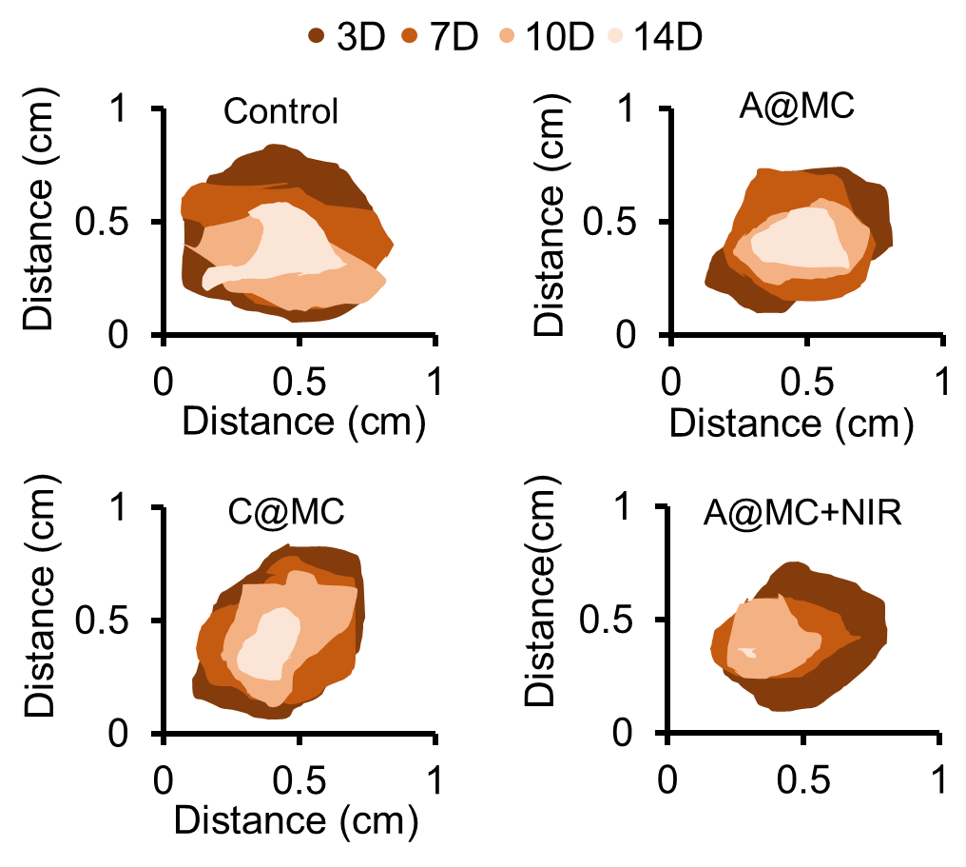
Figure S18. P. a-infected wound size tracking and analysis across different treatment groups over time.
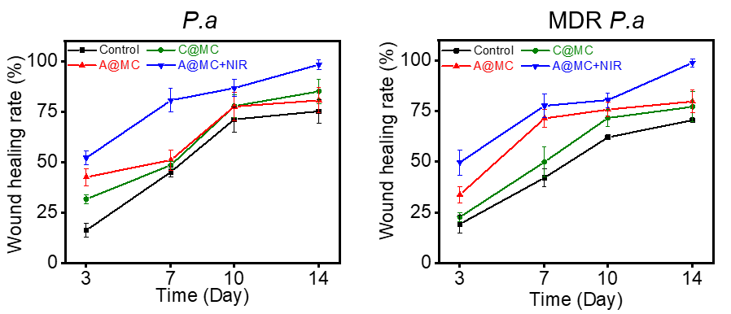
Figure S19. Wound closure ratios in P. a-infected and MDR P. a-infected wounds across four treatment groups at various time points.
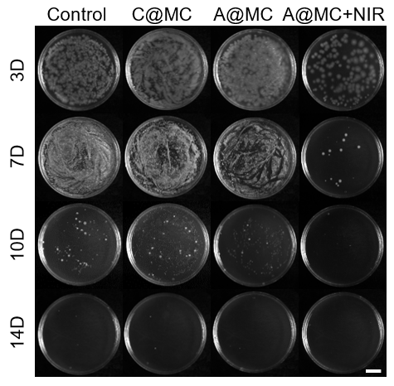
Figure S20. Quantification of bacterial load in P. a-infected tissues following different treatments (scale bar: 1 cm).
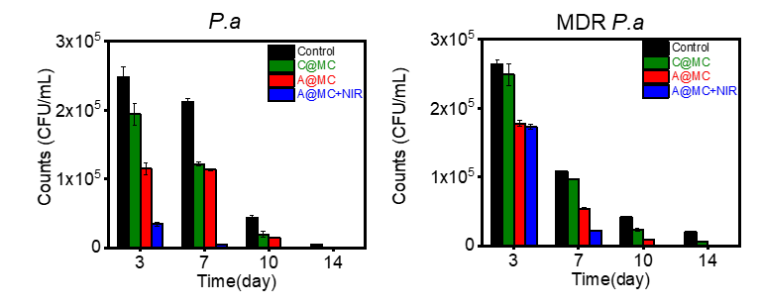
Figure S21. Quantitative analysis of bacterial residues in infected wounds following various treatments at different time points.
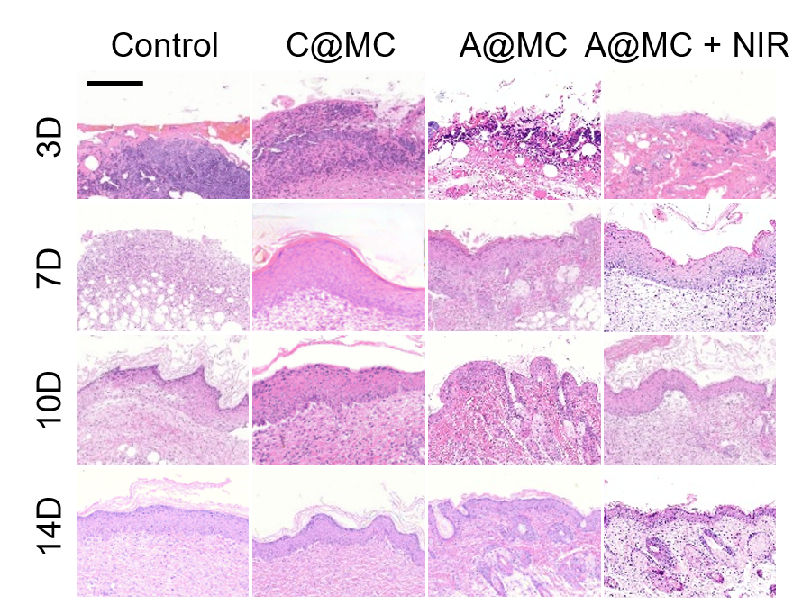
Figure S22. HE staining of wound tissues infected with P. a under various treatments (scale bar, 50 μm).
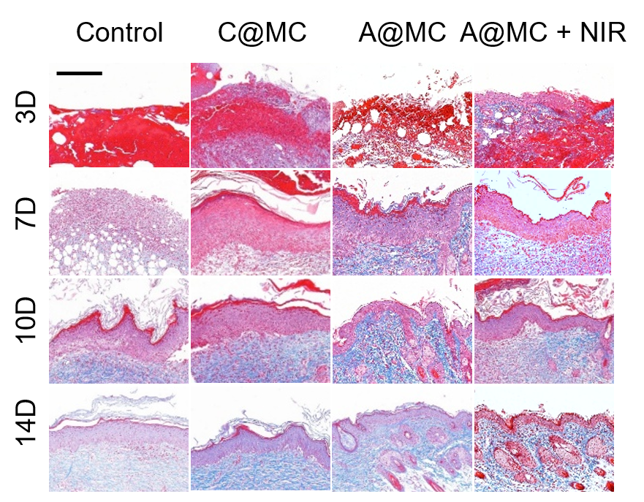
Figure S23. Masson’s trichromatic staining of wound tissues infected with P. a under various treatments (scale bar, 50 μm).
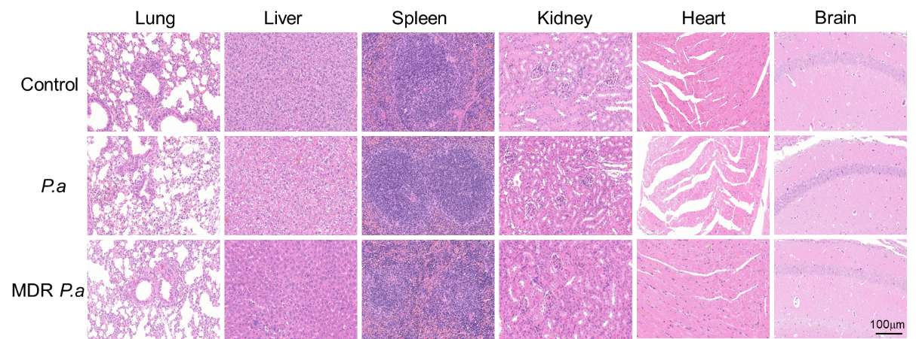
Figure S24. HE stained sections of various organs collected during bacterial infection treatment.

Table S1. MIC (μg/mL) of AGNCs and antibiotics against different bacteria.
 | E.coli | P.a | K.p | MDR E.coli | MDR P.a | MDR K.p
AGNCs | 10 | 5 | 20 | 10 | 5 | 10
Antibiotics | 1 | 2 | 2 | 32 | >64 | >64

Table S2. The antibacterial effects of various materials are evaluated by measuring the diameters and average areas of the inhibition zones.
 |  | Control | Antibiotics | AGNCs | AGNCs+NIR
P. a | Diameter (cm) | / | 0.72 | 0.84 | 1.03
P. a | Area (mm²) | / | 407.15 | 554.18 | 833.23
MDR P. a | Diameter (cm) | / | / | 0.86 | 1.05
MDR P. a | Area (mm²) | / | / | 580.88 | 865.90
Table S3. Comparison of the shrinkage of MC and A@MC hydrogels before and after light irradiation.
 | Area before irradiation (mm²) | Area after irradiation (mm²) | Shrinkage(%)
A@MC | 33.96 | 10.56 | 68.90
MC | 31.37 | 30.11 | 4.02
Table S4. Comparison of the shrinkage of MC and A@MC hydrogels before and after NIR irradiation (808 nm, 0.5 W/cm²) for 5 min on mice.
 | Area before irradiation (mm²) | Area after irradiation (mm²) | Shrinkage (%)
A@MC | 345.54 | 183.91 | 46.78
MC | 311.69 | 288.57 | 7.42
Table S5. Serum biochemical indicators reflecting the function of liver and kidney function during the treatment of bacterial infections.
 |  |  | P. a |  |  |  | MDR P. a
 | Ref | Unit | 3D | 7D | 10D | 14D | 3D | 7D | 10D | 14D
ALB | 23.0-45.0 | g/L | 31.2 | 30.4 | 32.0 | 33.0 | 30.3 | 32.3 | 35.8 | 33.1
TP | 50.0-75.0 | g/L | 57.3 | 55.8 | 62.5 | 63.2 | 56.9 | 64.1 | 57.8 | 60.9
GLB | 20.0-40.0 | g/L | 26.1 | 25.4 | 26.5 | 30.2 | 26.6 | 28.9 | 29.0 | 27.8
AST | 75-145 | U/L | 106 | 124 | 122 | 132 | 125 | 134 | 139 | 137
ALT | 8-60 | U/L | 44.2 | 31.5 | 36.3 | 44.6 | 40.9 | 42.5 | 33.5 | 35.8
ALP | 70-180 | U/L | 77.0 | 92.2 | 102.7 | 106.4 | 84.6 | 97.8 | 109.1 | 122.8
TBA | 1.00-11.00 | μmol/L | 3.38 | 4.04 | 5.63 | 4.26 | 2.38 | 3.82 | 3.91 | 4.67
BUN | 5.50-10.20 | mmol/L | 7.8 | 8.56 | 7.72 | 8.7 | 8.59 | 8.55 | 7.17 | 8.43
CREA | 25.0-40.0 | μmol/L | 32.4 | 30.0 | 32.3 | 30.4 | 33.1 | 31.9 | 32.8 | 34.8

