First Field Observations of Drupella feeding on Millepora in Indo Pacific reefs
Discover Animals
Febrianne Sukiato^{1,2}, Kok Lynn Chew³, Tanya Toofany^{4,5*}
¹Luminocean, Banda Neira, Maluku, Indonesia
²SeaChange Indonesia, Lombok, West Nusa Tenggara, Indonesia
³Coralku Solutions, Non-Profit Organization for Coral Reef Research and Restoration, Kuala Lumpur, Malaysia
⁴University of Bremen, Faculty of Biology and Chemistry, Bremen, Germany 28359
⁵Leibniz Centre for Tropical Marine Research (ZMT), Bremen, Germany 28359
*Corresponding author:
Tanya Toofany (tan_too@uni-bremen.de; tanya_1705@live.com)

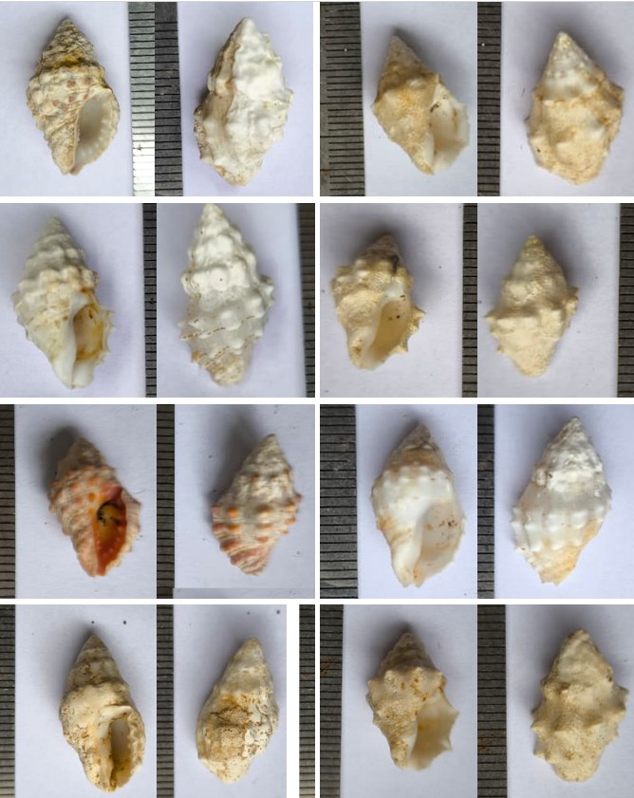Supp Fig. S2 Drupella spp. collected from the Millepora spp. colonies

