Bipolar physical reservoir computing for intrinsic processing of signed temporal signals
Ruiqi Chen^{1,2}, Ao Shi^{1,2}, Siyuan Chen^{1,2}, Jiaqi Li^{1,2}, Yading Yi^{1,2}, Junchen Dong³, Yulin Feng³, Zheng Zhou^{1,2}, Dedong Han^{1,2}, Lifeng Liu^{1,2}, Xiaoyan Liu^{1,2}*, Jinfeng Kang^{1,2}, Peng Huang^{1,2}*
¹School of Integrated Circuits, Peking University, Beijing 100871, China
²Beijing Advanced innovation Center for integrated Circuits, Beijing 100871, China
³Beijing Information Science and Technology University, Beijing 100192, China

*Corresponding authors. E-mails: xyliu@ime.pku.edu.cn, phwang@pku.edu.cn

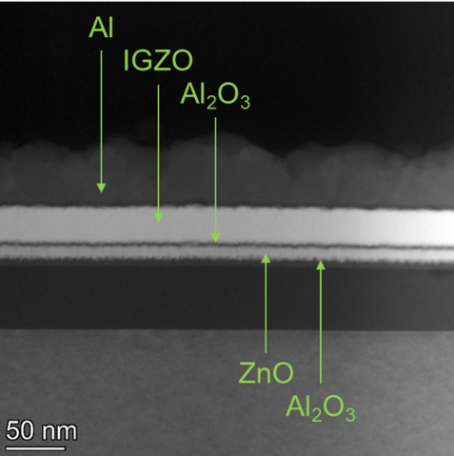
- | STEM sectional view of the device. The photo shows the stacking structure from the bottom gate electrode to the drain electrode, where clear interfaces and uniform layer thickness can be observed.
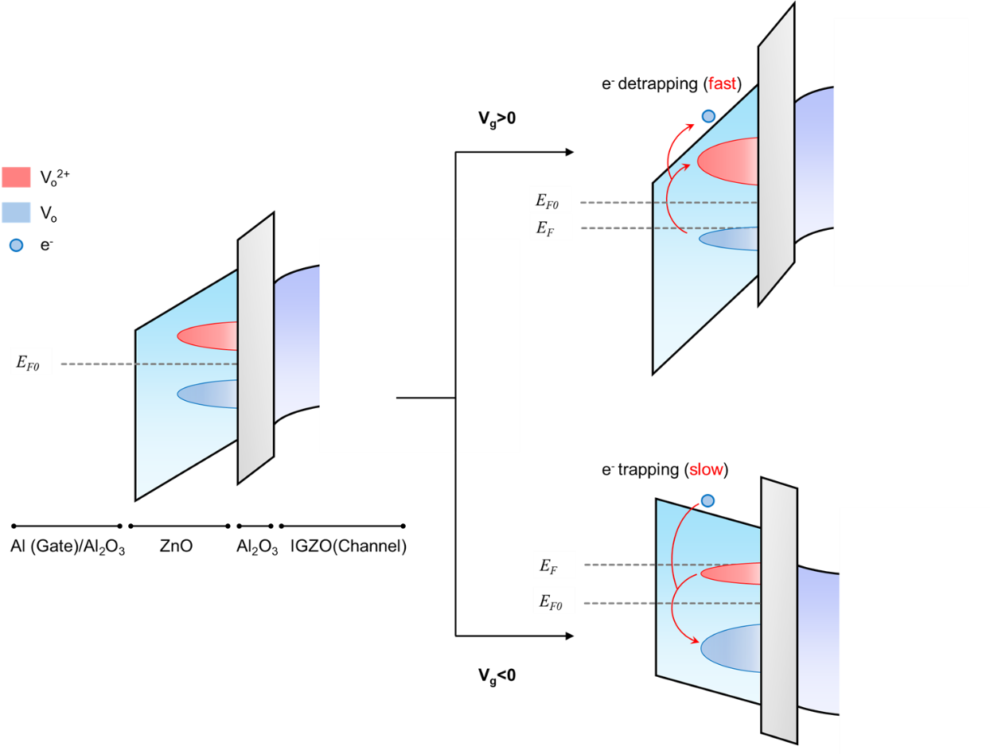♫
- | Bandgap diagram of the ionization of V_{o}. This diagram illustrates the distribution of energy levels of the positive V_{o}²⁺ and neutral V_{o} defects^{1,2}. When applying the positive gate voltage, electrons are emitted from the V_{o}, and the density of V_{o}²⁺ increases. When applying the negative gate voltage, the vacancies capture electrons and recover to the neutral state. It has been extensively observed that the trapping is notably slower than the detrapping process in typical amorphous oxide semiconductor (AOS) systems. The physical origin is the lattice relaxation effects resulting from the ionization, which lifts the energy barrier and therefore decelerates the recombination^{1,3,4}.

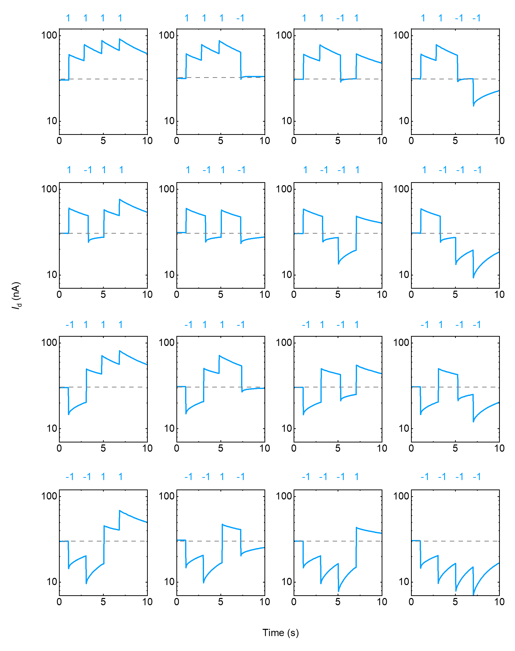
- | Bipolar pulse test. We performed the 4-bit bipolar pulses on the device. Results show that the I_{d} can freely range in the positive and negative range according to the stimulus. The final output states exhibit good separability.

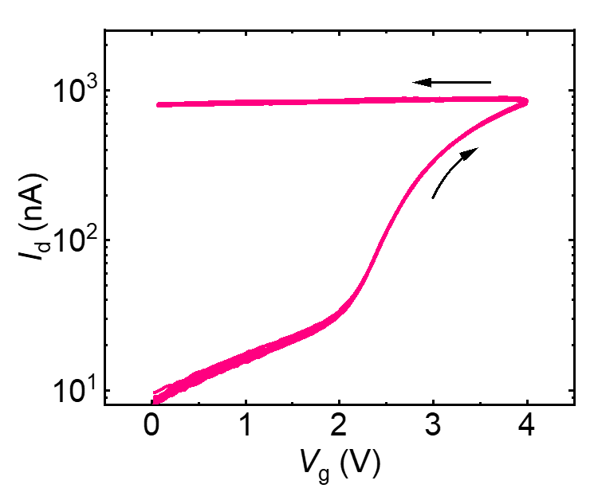
- | Cycle-to-cycle measurement of the FM. The DC V_{g} sweeping measurement is repeated 10 times on a single device, in which the V_{g} sweeps from 0 V to 4 V and back forth. I_{d} exhibits a stable memory window with minimal variations.

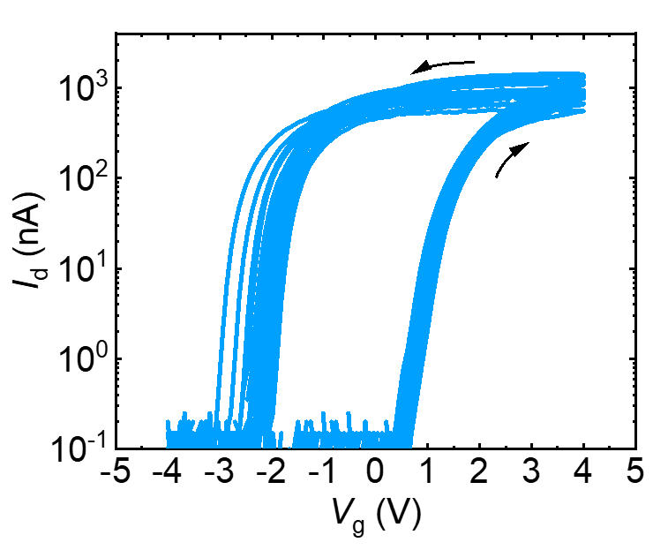
- | Device-to-device measurement of the FM. The DC V_{g} sweeping measurements were conducted on 20 randomly selected devices, with V_{g}​ swept from −4 V to 4 V and then back to −4 V. The resulting counter-clockwise hysteresis curves exhibit broadly similar profiles on the positive-voltage​ side, corresponding to comparable threshold voltages (V_{th})​ and on-state drain currents (I_{on}) across devices. In contrast, increased variation is observed on the negative-voltage​ side of the curves, which can be attributed to device-to-device differences in the FM timescale. Specifically, when V_{g}​ is swept to −4 V, devices with longer FM timescales show a slower decay of I_{d}, whereas devices with shorter timescales exhibit a faster response. Overall, the device-to-device measurements indicate consistent qualitative behavior in the transfer characteristics, while moderate quantitative variations—particularly in the FM dynamics—are present and remain compatible with the RC paradigm.

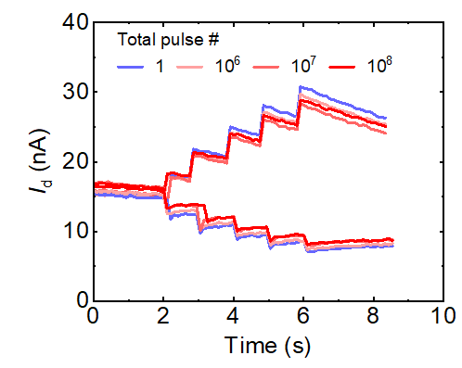
- | Endurance test. a The endurance test was performed by consecutively applying positive and negative V_{g​} pulses while monitoring the device response to the pulse sequence. The drain current responses are recorded after different total pulse counts ranging from 1 to 10⁸. The overall current evolution behavior remains well preserved with increasing pulse numbers, with no noticeable degradation or drift in the current levels. These results indicate robust endurance under electrical cycling.

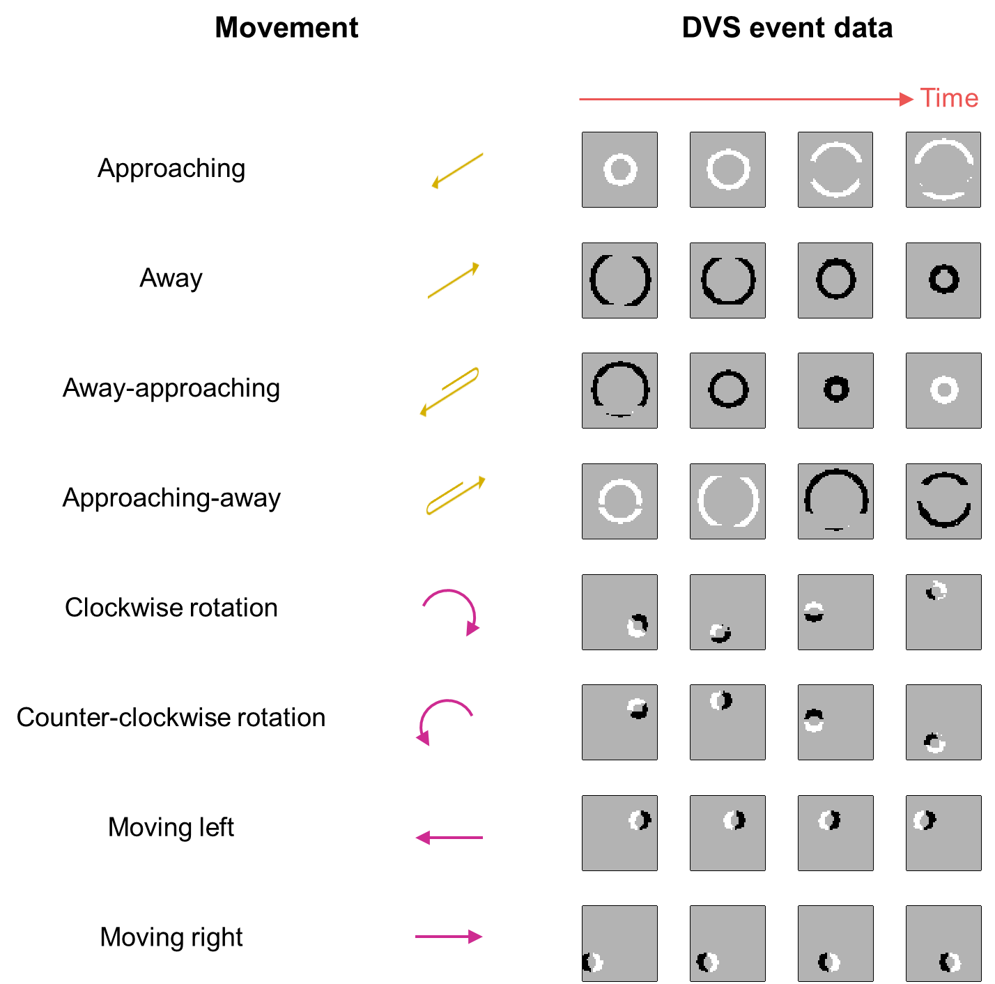
- | Time-dependent schematics of the ball-movement dataset. The diagrams show the four frames uniformly sampled from the 4-second sequence of event data recording the movements. The white pixel denotes the positive event, while the black pixel denotes the negative event. The events are normally recorded at the edge of objects while they move. For the in-depth movements (the first four categories), the edge is observed to expand as the object approaches and to contract as it moves away. Moreover, usually only a single particular polarity of events is recorded at a given moment, depending on the current direction of motion. For the in-plane movements, however, the positive and negative events almost always appear in pairs at the opposite edges of the object.
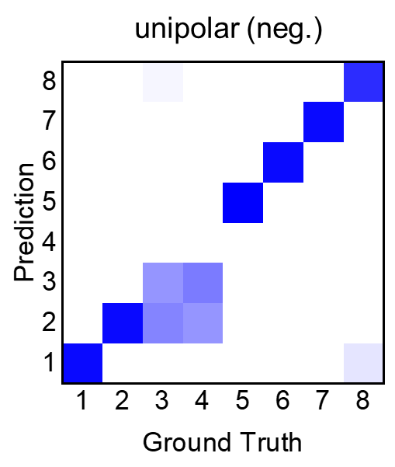
- | Confusion matrix of unipolar reservoir (negative channel). The samples of label 3 and label 4 are difficult for the unipolar reservoir to identify, similar to the situation of the positive channel. The two labels correspond to the “away-approaching” and the “approaching-away” movements. The closely coupled positive and negative channels make it challenging to make a correct inference based on a single channel.

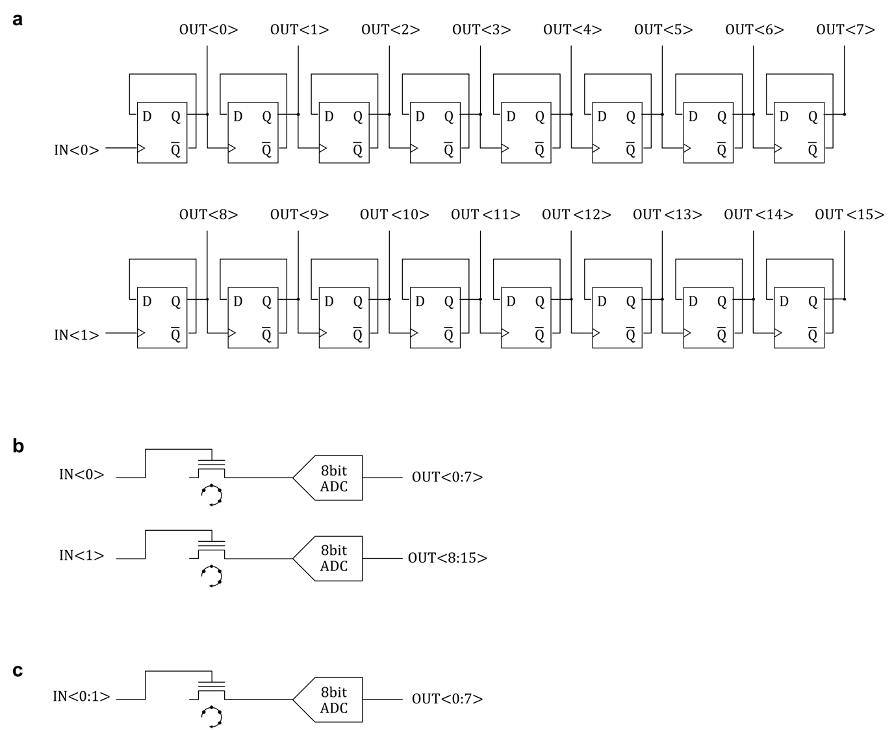
- | Schematics of the circuits for DVS data processing. a For the frame integration method, an 8-bit counter implemented with D flip-flops is needed for each sign channel. The event data is input in the form of pulses and counted. b and c show that for physical RC systems, the event data is directly input to the interlayered TFT, where the reservoir computation is conducted. After that, an 8-bit SAR ADC is needed for each channel to quantize the readout current of the physical reservoir.

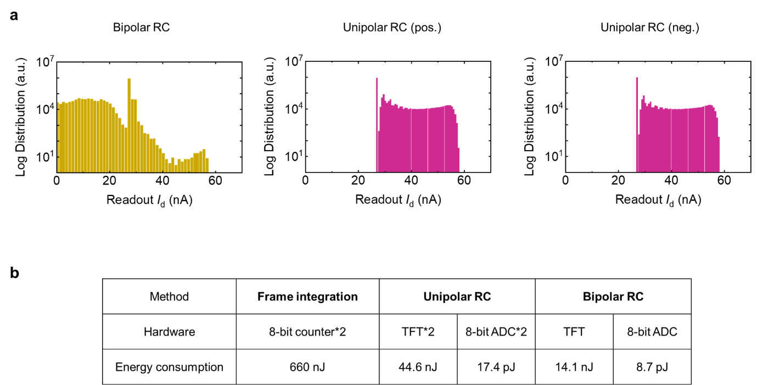
- | Comparison of the energy consumption. a The histograms of I_{d} in the bipolar and unipolar physical reservoir. In the bipolar case, the distribution of I_{d} is left-shifted due to the negative response. b The simulated energy consumed per sample for classification. The simulation is conducted with 28-nm PDK in Cadence. For frame integration, the energy consumption includes the two 8-bit digital counters. For physical reservoirs, it consists of the energy of the interlayered TFT and the 8-bit SAR ADC. It is demonstrated that the bipolar RC method is more advantageous in energy efficiency.

