Questionnaire for Patients with Preserved Ratio Impaired Spirometry (PRISm)
This questionnaire includes single-choice, multiple-choice, and open-ended questions. The estimated completion time is 4-6 minutes.
Part I. Demographic Information
Name: _________
Gender: _________
Age (years): _________
Current Height (cm): _________
Current Weight (kg): _________
Place of Residence: □ Urban □ Rural
Contact Telephone Number: _________
Highest Education Level Attained:
□ Junior high school or below
□ Senior high school or technical secondary school
□ College (associate degree) or above
Family History of Chronic Respiratory Diseases: □ Yes □ No
History of Respiratory Diseases in Childhood: □ Yes □ No
Part II. Lifestyle Factors
Occupational Exposure to Dust or Smoke: □ Yes □ No
Use of Biomass Fuels (e.g., coal, crop residues): □ Yes □ No
Smoking Habit: □ Yes □ No
Smoking History (Pack-Years):
□ Never smoker
□ < 10 pack-years
□ 10-20 pack-years
□ > 20 pack-years
Current Smoking Status (If applicable):
□ Former smoker
□ Current smoker
Years Since Smoking Cessation (For former smokers):
□ < 5 years
□ ≥ 5 years
Exposure to Secondhand Smoke (Defined as being in the same room with a smoker for >15 minutes per occasion and ≥3 times per week): □ Yes □ No
Alcohol Consumption Habit: □ Yes □ No
Regular Physical Exercise: □ Yes □ No
Part III. Symptoms and Comorbidities
Has a doctor ever diagnosed you with asthma? □ Yes □ No
Has a doctor ever diagnosed you with pulmonary tuberculosis? □ Yes □ No
Has a doctor ever told you that you have cardiovascular diseases? □ Yes □ No
Has a doctor ever told you that you have diabetes? □ Yes □ No
Has a doctor ever told you that you have hyperlipidemia? □ Yes □ No
Has a doctor ever told you that you have metabolic syndrome? □ Yes □ No
Has a doctor ever told you that you have immune system disorders? □ Yes □ No
Has a doctor ever told you that you have anxiety or depression? □ Yes □ No
COPD Assessment Test (CAT) score
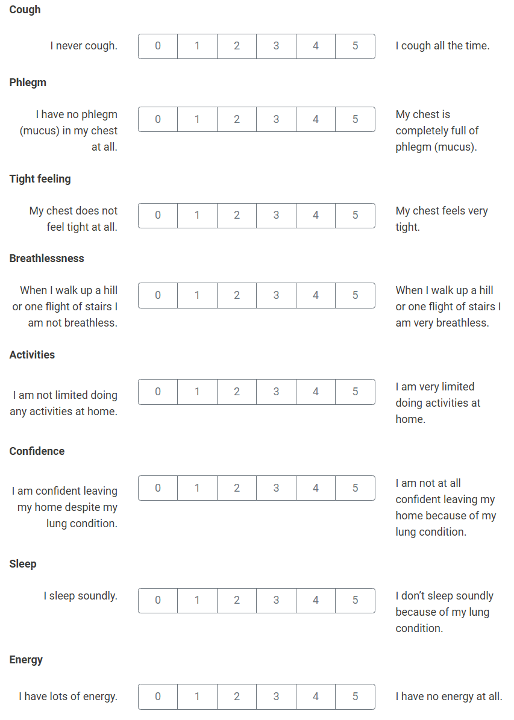
modified Medical Research Council (mMRC) dyspnea score（Select the one grade from 0 to 4 that best matches your condition.）
0 I only get breathless with strenuous exercise.
1 I get short of breath when hurrying on level ground or walking up a slight hill.
2 I walk slower than people of the same age on level ground because of breathlessness, OR I have to stop for breath when walking at my own pace on level ground.
3 I stop for breath after walking about 100 meters or after a few minutes on level ground.
4 I am too breathless to leave the house OR I am breathless when dressing or undressing.
Clinical COPD Questionnaire (CCQ) score
On average, during the past week, how often did you feel short of breath at rest?
Never Hardly ever A few times Several times Many times
On average, during the past week, how often did you feel short of breath while doing physical activities?
Never Hardly ever A few times Several times Many times
On average, during the past week, how often did you cough?
Never Hardly ever A few times Several times Many times
On average, during the past week, how often did you produce sputum (phlegm)?
Never Hardly ever A few times Several times Many times
On average, during the past week, how limited were you in these activities because of your breathing problems: Strenuous physical activities (e.g., hurrying, doing sports, carrying heavy loads)?
Never Hardly ever A few times Several times Many times
On average, during the past week, how limited were you in these activities because of your breathing problems: Moderate physical activities (e.g., walking, housework, carrying groceries)?
Never Hardly ever A few times Several times Many times
On average, during the past week, how limited were you in these activities because of your breathing problems: Daily activities at home (e.g., dressing, washing)?
Never Hardly ever A few times Several times Many times
On average, during the past week, how limited were you in these activities because of your breathing problems: Social activities (e.g., talking, being with children, visiting friends/relatives)?
Never Hardly ever A few times Several times Many times
On average, during the past week, how often did you feel concerned or worried about getting a cold or your breathing getting worse?
Never Hardly ever A few times Several times Many times
On average, during the past week, how often did you feel down or low because of your breathing problems?
Never Hardly ever A few times Several times Many times

