Appendix A: Stimuli, Instructions, and Measurement Items for Study 1

Participant Instructions:
Assume you are planning to purchase a new smartphone and are comparing price difference explanations across different sales channels (online store versus in-store). In this experiment, we ask you to imagine yourself as a real customer browsing the same smartphone model in different channel scenarios.
Please complete the experimental task according to the following steps:
1. Read the Task Background Information. Carefully read the background information provided to understand the shopping scenario and operational procedures. In different experimental conditions, the online and offline prices may differ, but the product model and other information remain consistent. This study aims to understand consumers' emotional responses to the brand under varying levels of price difference justification clarity.
2. Immerse Yourself in the Customer Role. Please imagine you are the customer in this scenario and carefully examine the image materials displayed below. The images show the smartphone you are interested in, with price difference explanations across channels (online versus in-store). Observe the content closely and respond based on the scenario.
3. Complete the Questionnaire. After viewing the images, please exit the materials interface and fill out the subsequent questionnaire. The questionnaire will ask about your emotional brand attachment in this shopping scenario.

Scenario Text and Stimuli
You are considering buying a new smartphone, the Pear P60 (256GB, Midnight Black, with 1-year official warranty and 7-day returns). While browsing, you notice the same model is priced differently between the online store and in-store. Below is the pricing information from both channels.

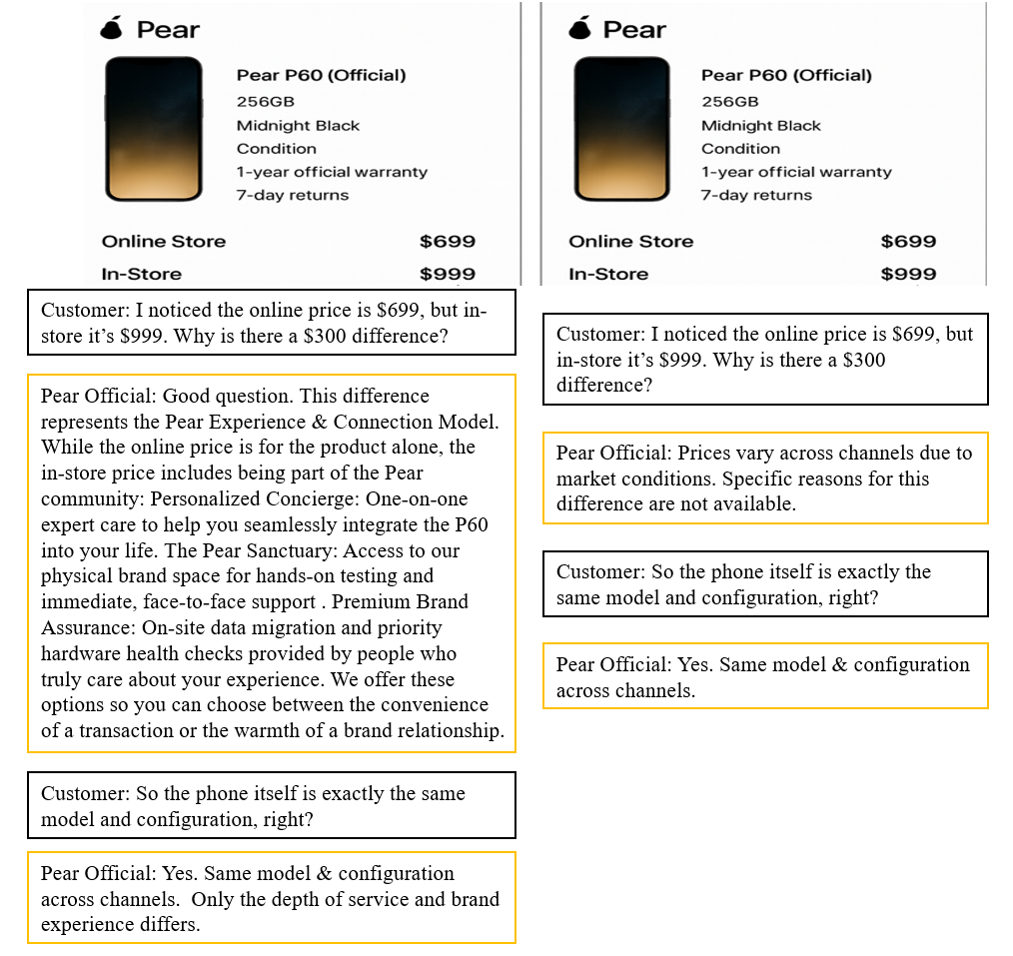

Measurement Items

Emotional Brand Attachment Scale (Adapted from Duong,2026)
1. I feel emotionally connected to this smartphone brand.
2. I feel a strong emotional bond with this smartphone brand.
3. I feel happy when engaging with this smartphone brand.
4. This smartphone brand is personally meaningful to me.
5. I am passionate about this smartphone brand.

Manipulation Check Items:
1.The retailer's explanation for the price difference was clear and understandable.
2.The justification provided for the price difference was specific and detailed.
3.The retailer's reason for the price difference was legitimate and credible.

Attention Checks:
1. Please select “Strongly Agree” to show you are paying attention.
2. For quality control, please select “Neutral” here.
Appendix B: Stimuli, Instructions, and Measurement Items for Study 2

Participant Instructions
Assume you are planning to purchase a new pair of wireless earbuds and are comparing price difference explanations across different sales channels (online store versus in-store). In this experiment, we ask you to imagine yourself as a real customer browsing the same earbuds model in different channel scenarios and engaging in a conversation with a sales associate.
Please complete the experimental task according to the following steps:
1.Read the Task Background Information. Carefully read the background information provided to understand the shopping scenario and operational procedures. In different experimental conditions, the online and offline prices may differ, but the product model and other information remain consistent. This study aims to understand consumers' emotional responses to the brand under varying levels of price difference justification clarity.
2. Immerse Yourself in the Customer Role. Please imagine you are the customer in this scenario and carefully examine the image materials displayed below. The images show the earbuds you are interested in, with price difference explanations across channels (online versus in-store) presented in a simulated chat interface. Observe the content closely and respond based on the scenario.
3. Complete the Questionnaire. After viewing the images, please exit the materials interface and fill out the subsequent questionnaire. The questionnaire will ask about your emotional brand attachment, perceptions of price unfairness, financial self-discrepancy, and related responses in this shopping scenario.

Scenario Text and Stimuli
You are considering buying a new pair of premium wireless earbuds, the CatEar CloudBuds Pro (White, with charging case, Bluetooth 5.3 / Active Noise Cancelling, up to 30-hour battery with case, 1-year official warranty, 7-day returns). While browsing, you notice the same model is priced differently between the online store and in-store. Below is the pricing information and a simulated conversation with a sales associate.

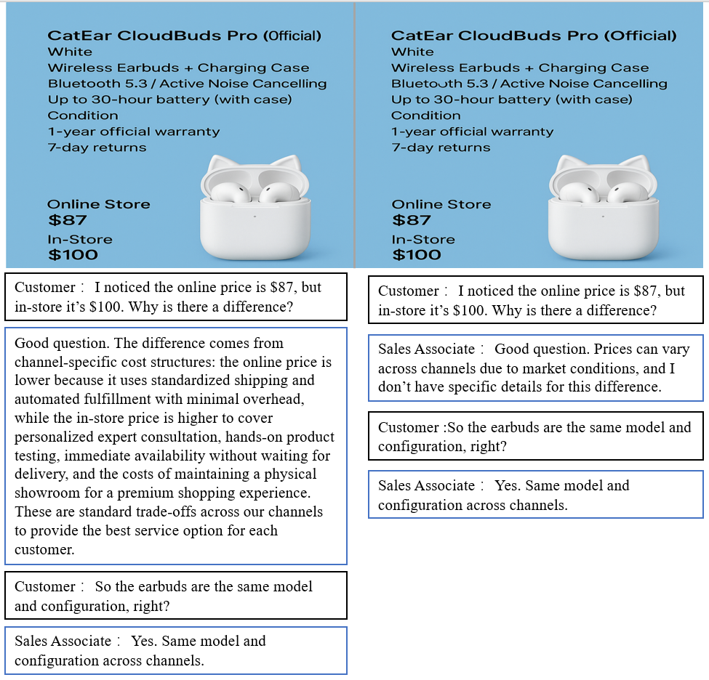

Measurement Items
Perceived Price Unfairness (Adapted from Pade & Feurer, 2022):
1. The price difference between the channels is unfair.
2. The price difference between the channels is unreasonable.
3. The price difference between the channels is dishonest.
4. The price difference between the channels is questionable.
5. The price difference between the channels is unacceptable.
6. The price difference between the channels is a rip-off.

Financial Self-Discrepancy (Adapted from T. T. Cao et al., 2025):
1. Facing this price difference, I feel I might miss out on a financially optimal deal.
2. Facing this price difference, my potential channel choice feels less financially savvy than I aspire to be.
3. Facing this price difference, my decision seems less financially rational than my ideal self expects.
4. Facing this price difference, I am disappointed that I may not achieve the smartest financial outcome possible.

Manipulation check items and attention checks were identical to those used in Study 1.
Appendix C: Stimuli, Instructions, and Measurement Items for Study 3

Participant Instructions
Assume you are planning to purchase a new air fryer and are comparing price difference explanations across different sales channels (online store versus in-store). In this experiment, we ask you to imagine yourself as a real customer browsing the same air fryer model in different channel scenarios and engaging in a conversation with a sales associate.
Please complete the experimental task according to the following steps:
1.Read the Task Background Information. Carefully read the background information provided to understand the shopping scenario and operational procedures. In different experimental conditions, the online and offline prices may differ, but the product model and other information remain consistent. This study aims to understand consumers' emotional responses to the brand under varying levels of price difference justification clarity.
2. Immerse Yourself in the Customer Role. Please imagine you are the customer in this scenario and carefully examine the image materials displayed below. The images show the air fryer you are interested in, with price difference explanations across channels (online versus in-store) presented in a simulated chat interface. Observe the content closely and respond based on the scenario.
3. Complete the Questionnaire. After viewing the images, please exit the materials interface and fill out the subsequent questionnaire. The questionnaire will ask about your emotional brand attachment, perceptions of price unfairness, financial self-discrepancy, and related responses in this shopping scenario.

Scenario Text and Stimuli
You are considering buying a new air fryer, the FastHeat Air Fryer (Green, with digital display & control dial, 5-quart/non-stick basket, 1-year official warranty, 7-day returns). While browsing, you notice the same model is priced differently between the online store and in-store. Below is the pricing information and a simulated conversation with a sales associate.
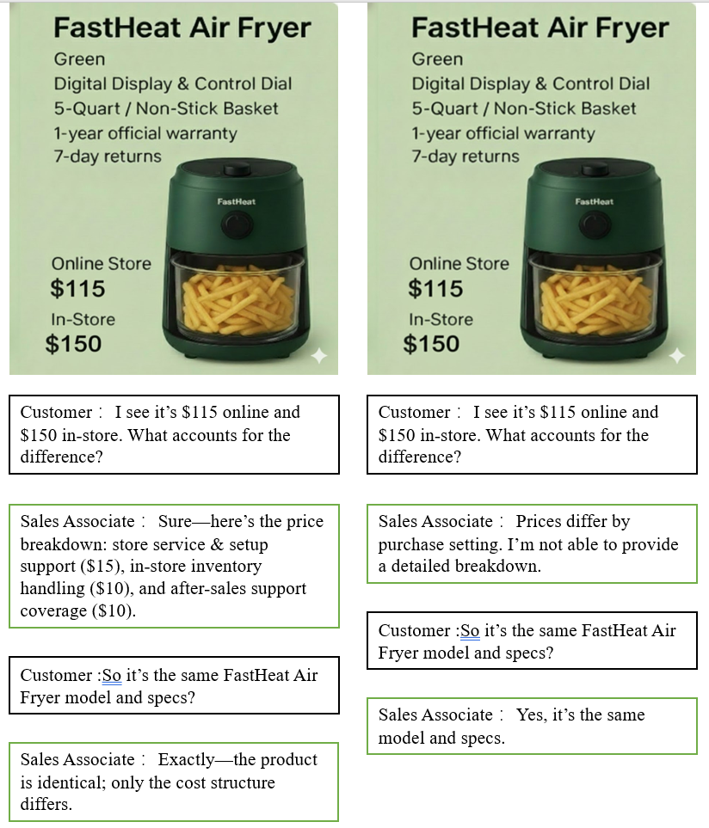
All measurement items for each construct used in Study 3 are identical to those used in Studies 1 and 2 (see Appendices A and B for full items), assessed on a 7-point Likert scale (1 = strongly disagree, 7 = strongly agree). Manipulation check items and attention checks were identical to those used in Studies 1 and 2.

Appendix D: Stimuli, Instructions, and Measurement Items for Study 4

Participant Instructions
Assume you are planning to purchase a new pair of waterproof hiking boots and are comparing price difference explanations across different sales channels (online platform versus in-store). In this experiment, we ask you to imagine yourself as a real customer browsing the same hiking boot model in different channel scenarios and engaging in a conversation with a sales associate.
Please complete the experimental task according to the following steps:
1.Read the Task Background Information. Carefully read the provided background information to understand the shopping scenario and operational procedures. In different experimental conditions, the online and offline prices may differ, but the product model and other information remain consistent. This study aims to understand consumers' emotional responses to the brand under varying levels of price differential justification clarity.
2. Immerse Yourself in the Customer Role. Please imagine you are the customer in this scenario and carefully examine the image materials displayed below. The images show the hiking boots you are interested in, with price difference explanations across channels (online platform versus in-store) presented in a simulated chat interface. Observe the content closely and respond based on the scenario.
3. Complete the Questionnaire. After viewing the images, please exit the materials interface and fill out the subsequent questionnaire. The questionnaire will ask about your emotional brand attachment, perceptions of price unfairness, financial self-discrepancy, price sensitivity, and related responses in this shopping scenario.

Scenario Text and Stimuli
You are considering buying a new pair of waterproof hiking boots, the SheShui Women’s Waterproof Hiking Boot (Wide, Elk/Mountain Red, 1-year warranty, 7-day returns). While browsing, you notice the same model is priced differently between the online platform ($86.51) and in-store ($100.00). Below is the pricing information and a simulated conversation with a sales associate across two experimental conditions.

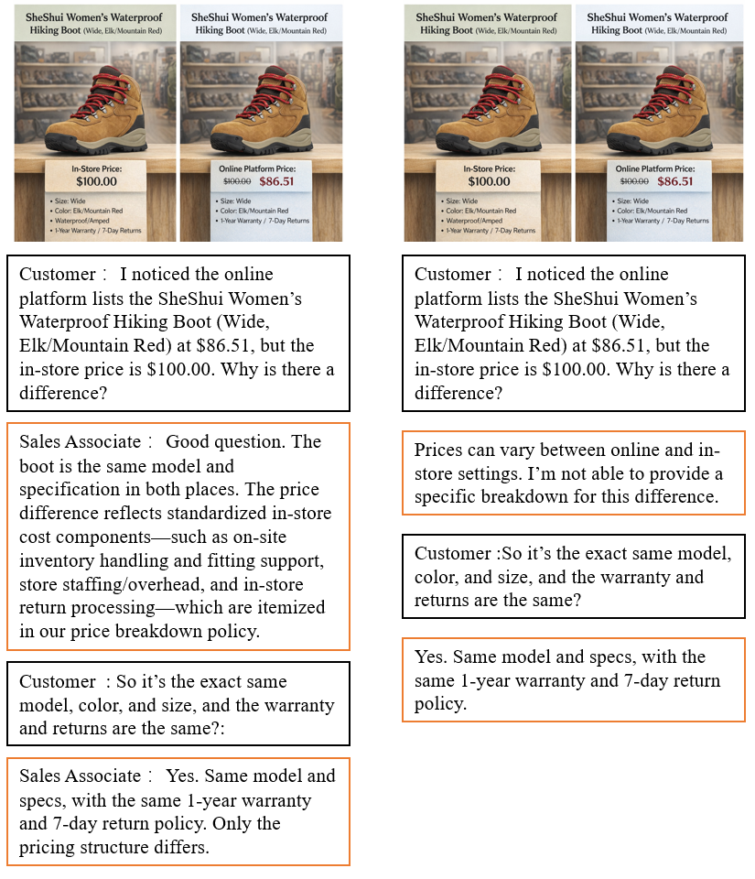
Measurement Items
Price sensitivity (Adapted from Cakici and Tekeli, 2021)
1. I tend to prioritize purchasing products that are offered at a discount or promotional price.
2. When choosing where to shop, I consistently prefer retailers that offer the lowest overall price levels.
3. I am willing to invest significant time and effort to identify the most competitive prices available in the market.
4. Before making a final purchase, I typically conduct a thorough price comparison across multiple service providers or retailers.
5. In my purchasing decisions, the absolute price of the product holds greater significance than the specific brand or retailer's identity.

All measurement items for the constructs examined in Study 4—with the exception of price sensitivity—remained identical to those employed in Studies 1, 2, and 3 (refer to Appendices A, B, and C for the complete list of items). All constructs were assessed using a 7-point Likert scale, ranging from 1 (strongly disagree) to 7 (strongly agree). Furthermore, the manipulation check items and attention checks were consistent with the protocols established in Studies 1, 2, and 3, ensuring methodological continuity across the research program.

