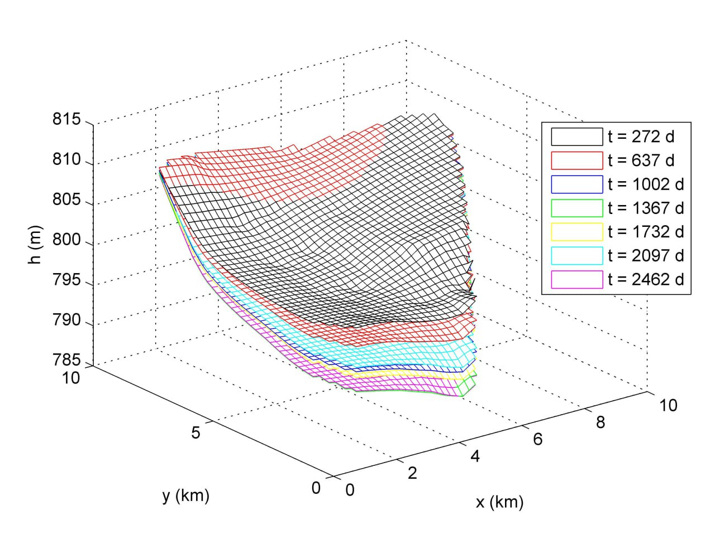  Transient head simulation in Moldflow | 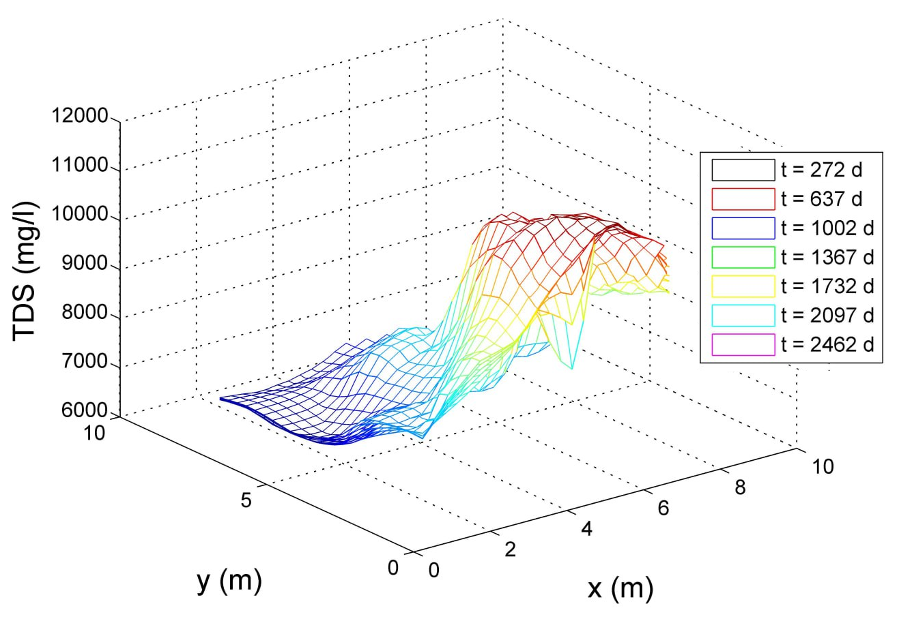  Transient salinity simulation in SEAWAT
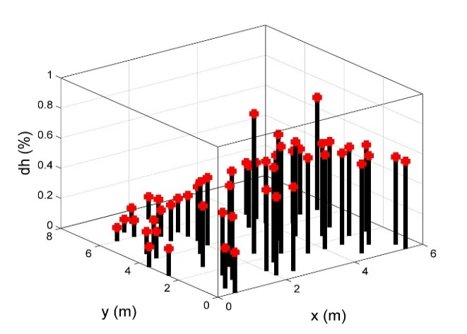  Identifying the wells impact for head | 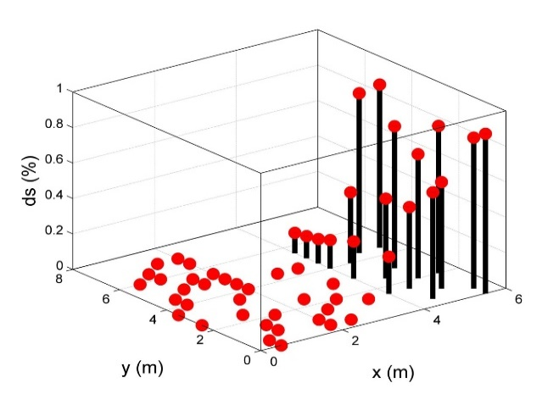  Identifying the wells impact for salinity

Finding the estimated pareto solution by (NSGAII-Clustering- RF)
Finding the estimated pareto solution by (NSGAII-SEAWAT-RF)

