Clinical characteristics, treatment patterns, and prognosis in vulvar cancer and vaginal cancer: A national multicenter retrospective study in China

Supplementary appendix

Xuelian Zhao, Honghao Wang, Yuting Hong, Qiaoyun Du, Yuanyuan Zhang, Shangying Hu, Meiwen Yuan, Hongying Yang, Yan Wang, Xiaoli Cui, Yongzhen Zhang, Shaokai Zhang, Wenjun Wang, Guang Han, Li Li, Chao Ding, Fanghui Zhao

Contents
- Table S1 Demographic characteristics and risk factors of vulvar and vaginal cancer patients
- Table S2 Comparation of treatment patterns among vulvar cancer and vaginal cancer patients with different FIGO stage
- Table S3 Clinical characteristics in patients who underwent HPV testing
- Table S4 Treatment patterns in patients who underwent HPV testing
- Figure S1 Distribution of age at diagnosis in all patients with different HPV status
- Figure S2 Distribution of age at diagnosis in HPV-tested patients with different HPV status
- Figure S3 OS and DFS of all patients with different HPV status
- Figure S4 OS and DFS of all patients aged 35-64 with different HPV status
- Figure S5 OS and DFS of all patients aged 65 or older with different HPV status
- Figure S6 OS and DFS of HPV-tested patients with different HPV status
- Figure S7 OS and DFS of HPV-tested patients aged 35-64 with different HPV status
- Figure S8 OS and DFS of HPV-tested patients aged 65 or older with different HPV status

Table S1 Demographic characteristics and risk factors of vulvar and vaginal cancer patients
Indicators [n (%)]ª | Vulvar cancer  (n = 131) | Vaginal cancer  (n = 87) | p-value
Region
urban | 70 (53.4) | 50 (57.5) | 0.654^{b}
rural | 61 (46.6) | 37 (42.5)
Job
worker/farmer | 46 (35.1) | 31 (35.6) | 0.617^{b}
employee | 10 ( 7.6) | 6 (6.9)
self-employed | 14 (10.7) | 5 (5.7)
unemployed/retired/other | 61 (46.6) | 45 (51.7)
Education
unknown | 32 (24.4) | 5 (5.7)
primary school and below | 44 (33.6) | 37 (42.5) | 0.518^{b}
junior high school | 21 (16.0) | 22 (25.3)
senior high school | 29 (22.1) | 17 (19.5)
junior college/undergraduate | 5 ( 3.8) | 6 (6.9)
Marriage
married | 118 (90.1) | 81 (93.1) | 0.282^{b}
unmarried | 13 (9.9) | 6 (6.9)
BMI
<18.5 | 4 ( 3.1) | 4 (4.6) | 0.616^{c}
18.5-23.9 | 53 (40.5) | 41 (47.1)
24-27.9 | 51 (38.9) | 27 (31.0)
>=28 | 23 (17.6) | 15 (17.2)
median (Q1, Q3) | 24.9 (21.8, 27.1) | 23.7 (22.0, 26.2) | 0.244^{d}
Previous CIN
undetected | 34 (26.0) | 7 (8.0)
detected | 97 (74.0) | 80 (92.0)
yes | 9 ( 9.3) | 27 (33.8) | <0.001^{b}
no | 88 (90.7) | 53 (66.2)
Genital warts
unknown | 27 (20.6) | 9 (10.3)
yes | 0 (0.0) | 0 (0.0) | -
no | 104 (79.4) | 78 (89.7)
HIV
unknown | 10 ( 7.6) | 1 (1.1)
yes | 0 (0.0) | 0 (0.0) | -
no | 121 (92.4) | 86 (98.9)
Syphilis
unknown | 19 (14.5) | 9 (10.3)
yes | 4 ( 3.1) | 0 (0.0) | -
no | 108 (82.4) | 78 (89.7)
Gonorrhea
unknown | 32 (24.4) | 24 (27.6)
yes | 0 (0.0) | 0 (0.0) | -
no | 99 (75.6) | 63 (72.4)
Family history of tumor
unknown | 38 (29.0) | 14 (16.1)
yes | 5 ( 3.8) | 3 (3.4) | 1.000^{c}
no | 88 (67.2) | 70 (80.5)
Other primary tumor
unknown | 11 ( 8.4) | 14 (16.1)
yes | 0 (0.0) | 0 (0.0) | -
no | 120 (91.6) | 73 (83.9)
Tabaco comsuption
unknown | 16 (12.2) | 15 (17.2)
current | 0 ( 0.0) | 3 (3.4) | -
former | 0 (0.0) | 0 (0.0)
never | 115 (87.8) | 69 (79.3)
Alcohol comsuption
unknown | 16 (12.2) | 14 (16.1)
current | 0 (0.0) | 0 (0.0) | -
former | 0 (0.0) | 0 (0.0)
never | 115 (87.8) | 73 (83.9)
a. BMI: body mass index, Q1: first quartile, Q3: third quatile, CIN: cervical intraepithelial neoplasia, HIV: human immunodeficiency virus; b. Chi-square test;
c. Fisher’s exact test; d. Wilcoxon rank-sum test
Table S2 Comparation of treatment patterns among vulvar cancer and vaginal cancer patients with different FIGO stage
Initial treatment/FIGO staging [n (%)]ª | Vulvar cancer | Vaginal cancer | p-value
Stage I | n = 74^{b} | n = 45
Unsurgical treatment | 6 (8.1) | 12 (26.7) | 0.013^{c}
Surgical treatment | 68 (91.9) | 33 (73.3)
without RT/CT | 60 (88.2) | 19 (57.6) | 0.001^{c}
combine with RT/CT | 8 (11.8) | 14 (42.4)
Stage II | n = 19 | n = 18
Unsurgical treatment | 4 (21.1) | 12 (66.7) | 0.014^{c}
Surgical treatment | 15 (78.9) | 6 (33.3)
without RT/CT | 10 (66.7) | 0 (0.0) | 0.012^{d}
combine with RT/CT | 5 (33.3) | 6 (100.0)
Stage III | n = 29 | n = 17
Unsurgical treatment | 6 (20.7) | 12 (70.6) | 0.002^{c}
Surgical treatment | 23 (79.3) | 5 (29.4)
without RT/CT | 8 (34.8) | 2 (40.0) | 1.000^{d}
combine with RT/CT | 15 (65.2) | 3 (60.0)
Stage IV | n = 8 | n = 7
Unsurgical treatment | 4 (50.0) | 7 (100.0) | 0.077^{d}
Surgical treatment | 4 (50.0) | 0 (0.0)
without RT/CT | 0 (0.0) | - | -
combine with RT/CT | 4 (100.0) | -
a. RT: radiotherapy, CT: chemotherapy, FIGO: International Federation of Gynecology and Obstetrics; b. One patient was excluded because of not reporting any treatment information; c. Chi-square test; d. Fisher’s exact test
Table S3 Clinical characteristics in patients who underwent HPV testing
Indicators/HPV status [n (%)]ª | Positive | Negative | p-value
Vulvar cancer | n = 22 | n = 43
Age at diagnosis
<=54 | 11 (50.0) | 14 ( 32.6) | 0.072^{b}
55-64 | 1 ( 4.5) | 14 ( 32.6)
65-74 | 9 (40.9) | 12 ( 27.9)
>=75 | 1 ( 4.5) | 3 ( 7.0)
Meidan (Q1, Q3) | 58.5 (50.0, 67.5) | 59.0 (45.5, 69.0) | 0.939^{c}
FIGO staging
I | 8 (36.4) | 28 ( 65.1) | 0.122^{b}
II | 4 (18.2) | 3 ( 7.0)
III | 7 (31.8) | 10 ( 23.3)
IV | 3 (13.6) | 2 ( 4.7)
Classification
Squamous cell carcinoma | 20 (90.9) | 35 ( 81.4) | 0.730^{b}
Adenocarcinoma | 1 ( 4.5) | 2 ( 4.7)
Other types | 1 (4.5) | 6 (14.0)
Differentiation
Not assessed | 6 (27.3) | 5 ( 11.6)
Assessed | 16 (72.7) | 38 (88.4)
Well differentiated | 4 (25.0) | 25 ( 65.8) | 0.027^{b}
Moderately to well differentiated | 2 ( 12.5) | 5 ( 13.2)
Moderately differentiated | 4 (25.0) | 3 ( 7.9)
Moderately to poorly differentiated | 3 (18.8) | 3 ( 7.9)
Poorly differentiated | 3 (18.8) | 2 ( 5.3)
Undifferentiated | 0 (0.0) | 0 (0.0)
Vaginal cancer | n = 35 | n = 11
Age at diagnosis
<=54 | 16 (45.7) | 6 ( 54.5) | 0.235^{b}
55-64 | 11 (31.4) | 4 ( 36.4)
65-74 | 8 (22.9) | 1 ( 9.1)
>=75 | 0 ( 0.0) | 0 ( 0.0)
Median (Q1, Q3) | 56.0 (48.5, 63.0) | 53.0 (48.0, 59.0) | 0.470^{c}
FIGO staging
I | 21 (60.0) | 7 ( 63.6) | 0.863^{b}
II | 9 (25.7) | 2 ( 18.2)
III | 3 ( 8.6) | 2 ( 18.2)
IV | 2 ( 5.7) | 0 ( 0.0)
Classification
Squamous cell carcinoma | 32 (91.4) | 8 ( 72.7) | 0.138^{b}
Adenocarcinoma | 0 ( 0.0) | 0 ( 0.0)
Other types | 3 (8.6) | 3 ( 27.3)
Differentiation
Not assessed | 16 (45.7) | 3 ( 27.3)
Assessed | 19 (54.3) | 8 (72.7)
Well differentiated | 1 ( 5.3) | 1 ( 12.5) | 0.122^{b}
Moderately to well differentiated | 3 ( 15.8) | 1 ( 12.5)
Moderately differentiated | 8 (42.1) | 0 ( 0.0)
Moderately to poorly differentiated | 2 ( 10.5) | 3 ( 37.5)
Poorly differentiated | 5 (26.3) | 3 ( 37.5)
Undifferentiated | 0 ( 0.0) | - ( 0.0)
a. HPV: human papillomavirus, Q1: first quartile, Q3: third quatile, FIGO: International Federation of Gynecology and Obstetrics; b. Fisher’s exact test; c. Wilcoxon rank-sum test
Table S4 Treatment patterns in patients who underwent HPV testing
Initial treatment/HPV status [n (%)]ª | Positive | Negative | p-value
Vulvar cancer | n = 22 | n = 43
RT | 1 (4.5) | 2 (4.7) | 0.906^{b}
CT | 0 (0.0) | 2 (4.7)
RT+CT | 1 (4.5) | 2 (4.7)
Surgical treatment | 20 (90.9) | 37 (86.0)
without RT/CT | 12 (60.0) | 26 (70.3) | 0.624^{c}
combine with RT/CT | 8 (40.0) | 11 (29.7)
Vaginal cancer | n = 35 | n = 11
RT | 4 (11.4) | 1 | 0.575^{b}
CT | 5 (14.3) | 1
RT+CT | 8 (22.9) | 5
Surgical treatment | 18 (51.4) | 4
without RT/CT | 10 (55.6) | 0 (0.0) | 0.097^{b}
combine with RT/CT | 8 (44.4) | - (100.0)
a. HPV: human papillomavirus, RT: radiotherapy, CT: chemotherapy; b. Fisher’s exact test; c. Chi-square test
Figure 1 Distribution of age at diagnosis in all patients with different HPV status
(A) Distribution of age-groups at diagnosis in vulvar cancer patients with different HPV status. The x-axis represents age-groups, y-axis represents the percentage within each age group. (B) Violin plot showing the distribution of age at diagnosis in vulvar cancer patients with different HPV status. The left plot represents HPV-positive patients, the right represents HPV-negative/not tested patients. (C) Distribution of age groups at diagnosis in vaginal cancer patients. (D) Violin plot for age distribution in vaginal cancer patients.
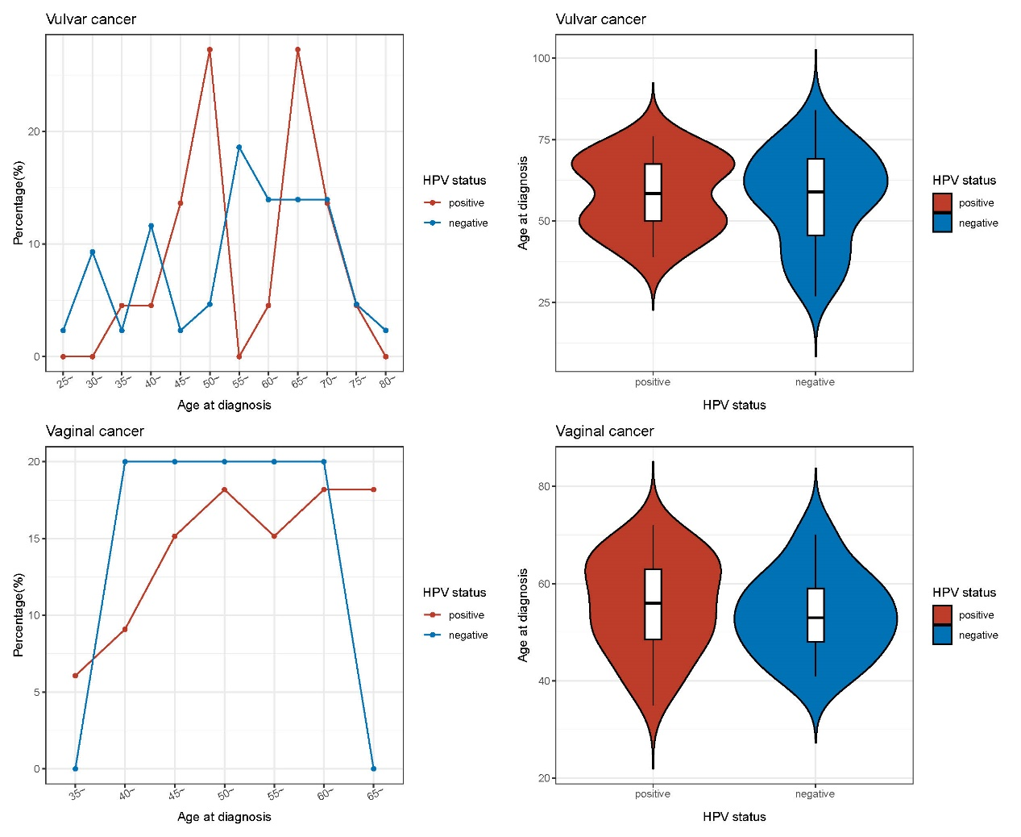
D
C
B
A
Figure S2 Distribution of age at diagnosis in HPV-tested patients with different HPV status
(A) Distribution of age-groups at diagnosis in vulvar cancer patients with different HPV status. The x-axis represents age-groups, y-axis represents the percentage within each age group. (B) Violin plot showing the distribution of age at diagnosis in vulvar cancer patients with different HPV status. The left plot represents HPV-positive patients, the right represents HPV-negative/not tested patients. (C) Distribution of age groups at diagnosis in vaginal cancer patients. (D) Violin plot for age distribution in vaginal cancer patients.
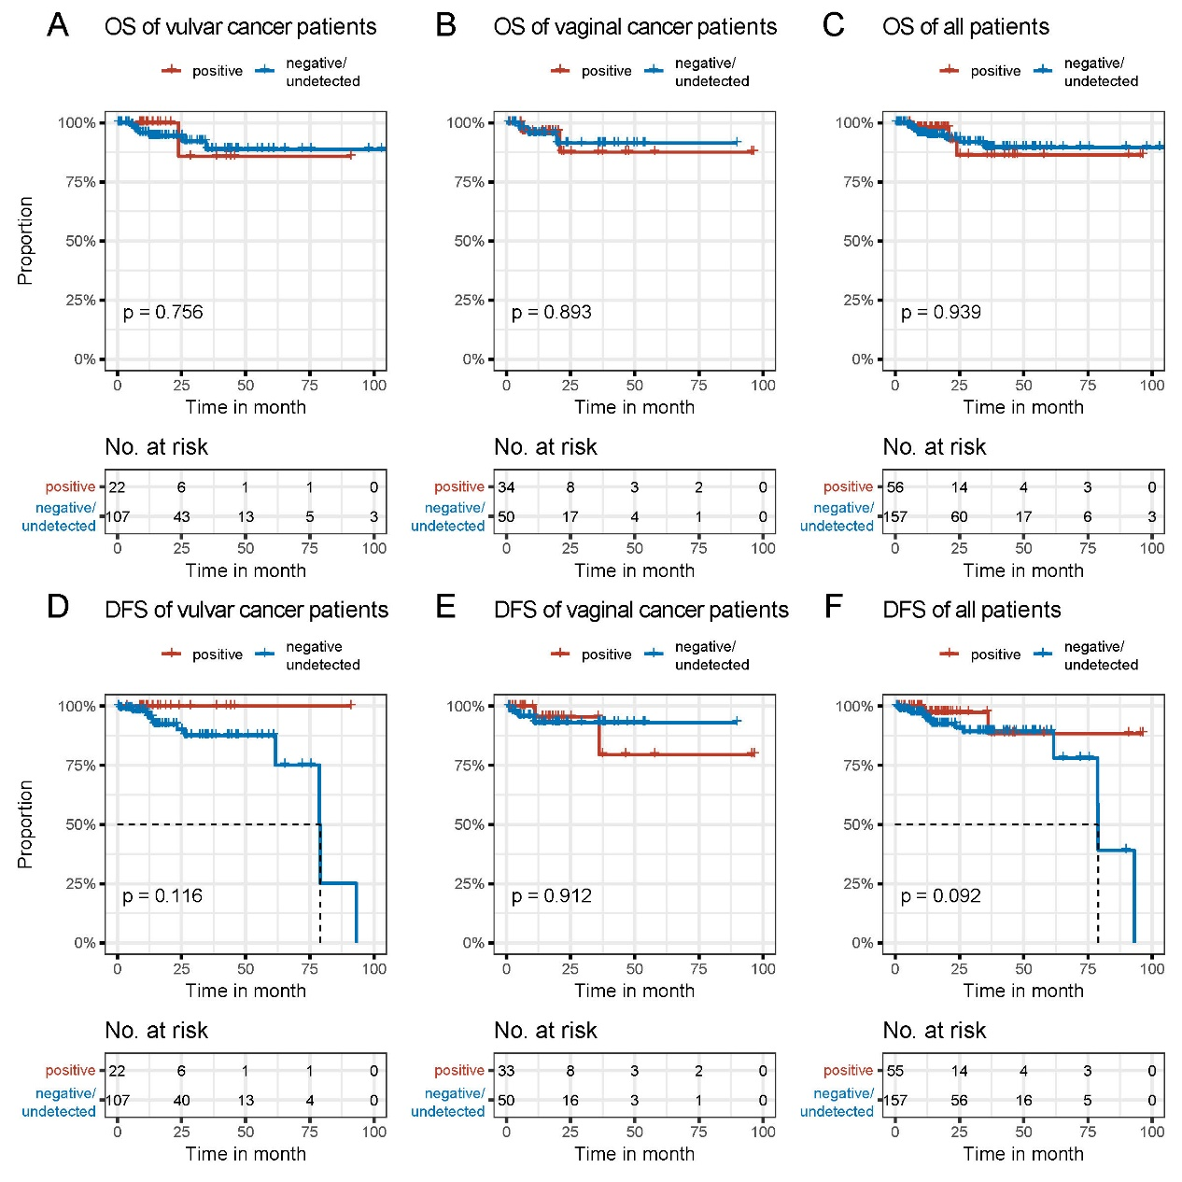
Figure S3 OS and DFS of all patients with different HPV status
(A-C) OS survival curves for all vulvar/vaginal/vulvar and vaginal cancer patients stratified by HPV status (HPV-positive vs. HPV-negative or undetected). (D-F) DFS survival curves for all vulvar/vaginal/vulvar and vaginal cancer patients stratified by HPV status (HPV-positive vs. HPV-negative or undetected). OS: overall survival, DFS: disease-free survival.

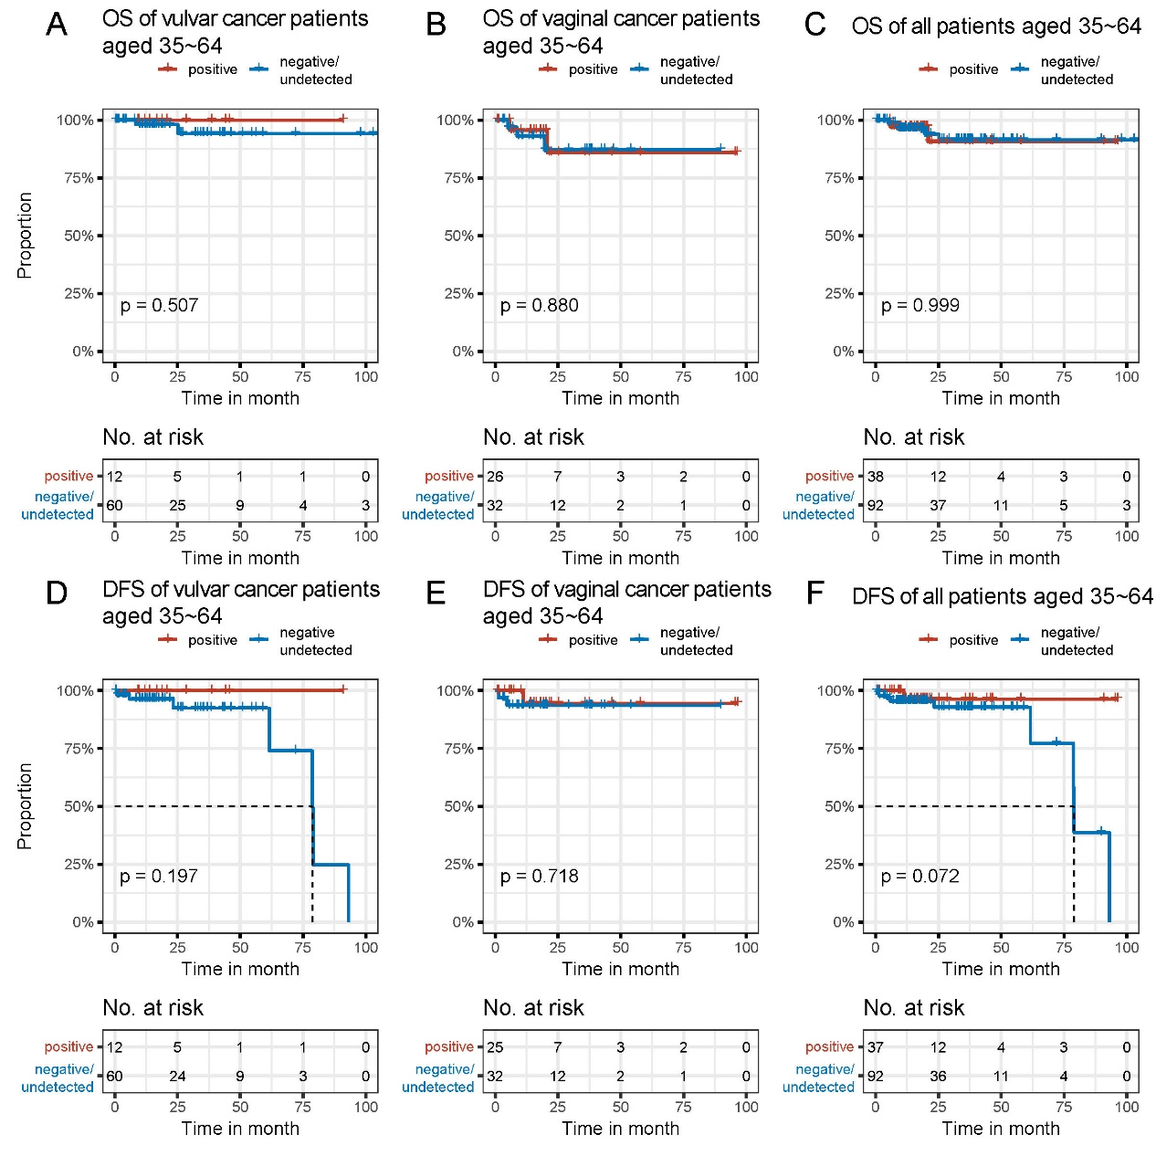
Figure S4 OS and DFS of all patients aged 35-64 with different HPV status
(A-C) OS survival curves for all vulvar/vaginal/vulvar and vaginal cancer patients aged 35-64 stratified by HPV status (HPV-positive vs. HPV-negative or undetected). (D-F) DFS survival curves for all vulvar/vaginal/vulvar and vaginal cancer patients aged 35-64 stratified by HPV status (HPV-positive vs. HPV-negative or undetected). OS: overall survival, DFS: disease-free survival.

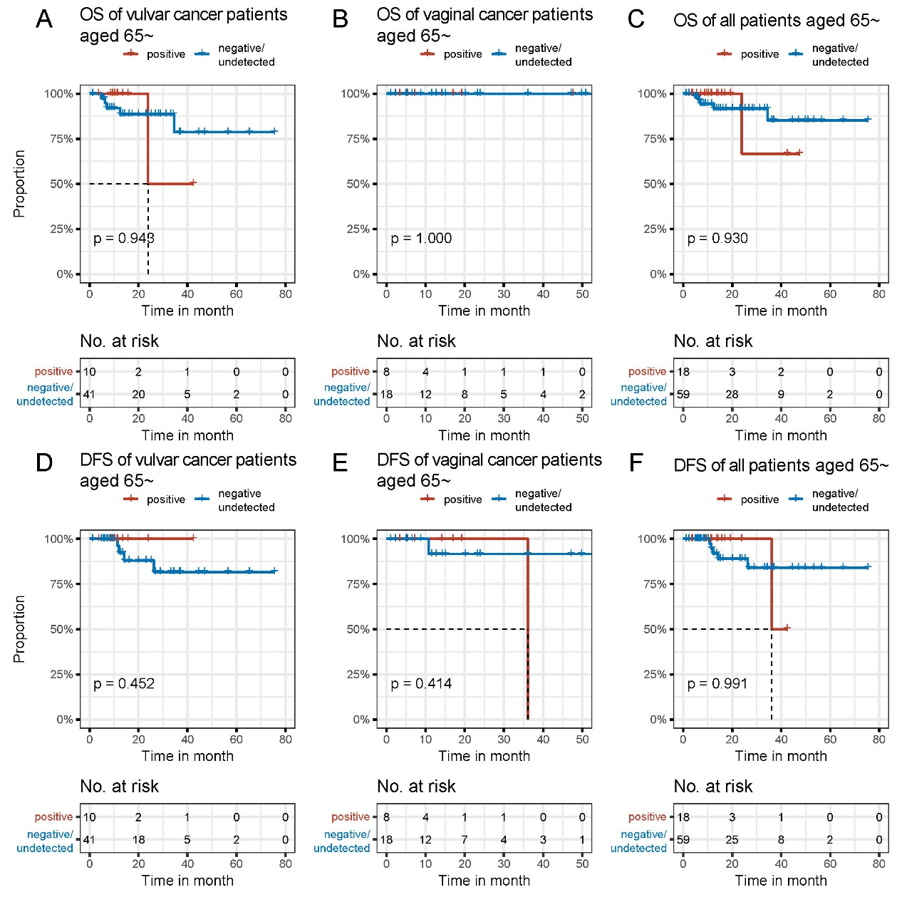
Figure S5 OS and DFS of all patients aged 65 or older with different HPV status
(A-C) OS survival curves for all vulvar/vaginal/vulvar and vaginal cancer patients aged 65 or older stratified by HPV status (HPV-positive vs. HPV-negative or undetected). (D-F) DFS survival curves for all vulvar/vaginal/vulvar and vaginal cancer patients aged 65 or older stratified by HPV status (HPV-positive vs. HPV-negative or undetected). OS: overall survival, DFS: disease-free survival.

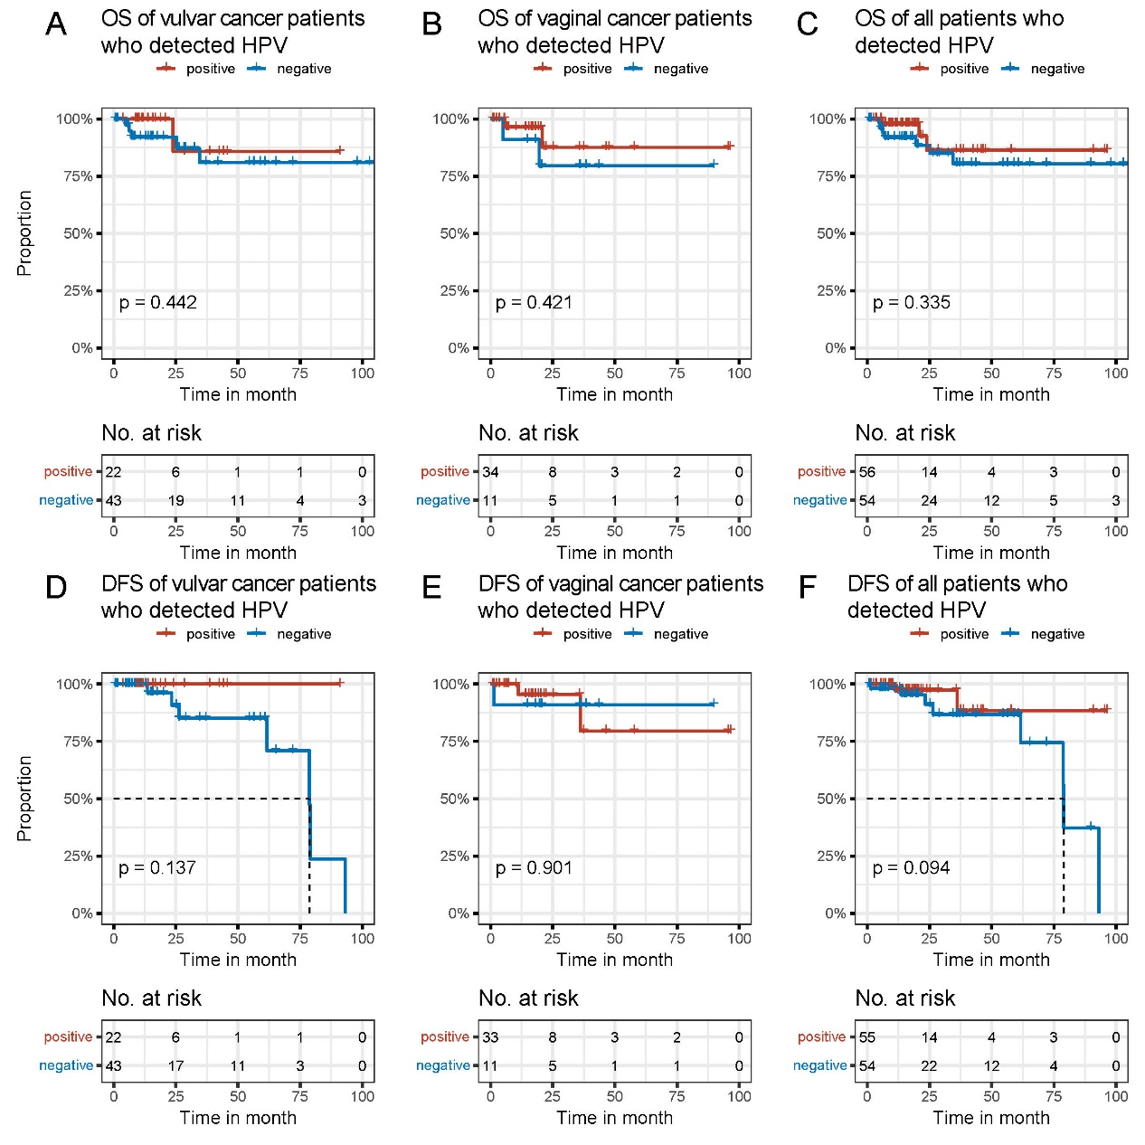
Figure S6 OS and DFS of HPV-tested patients with different HPV status
(A-C) OS survival curves for HPV-tested vulvar/vaginal/vulvar and vaginal cancer patients stratified by HPV status (HPV-positive vs. HPV-negative). (D-F) DFS survival curves for HPV-tested vulvar/vaginal/vulvar and vaginal cancer patients stratified by HPV status (HPV-positive vs. HPV-negative). OS: overall survival, DFS: disease-free survival.

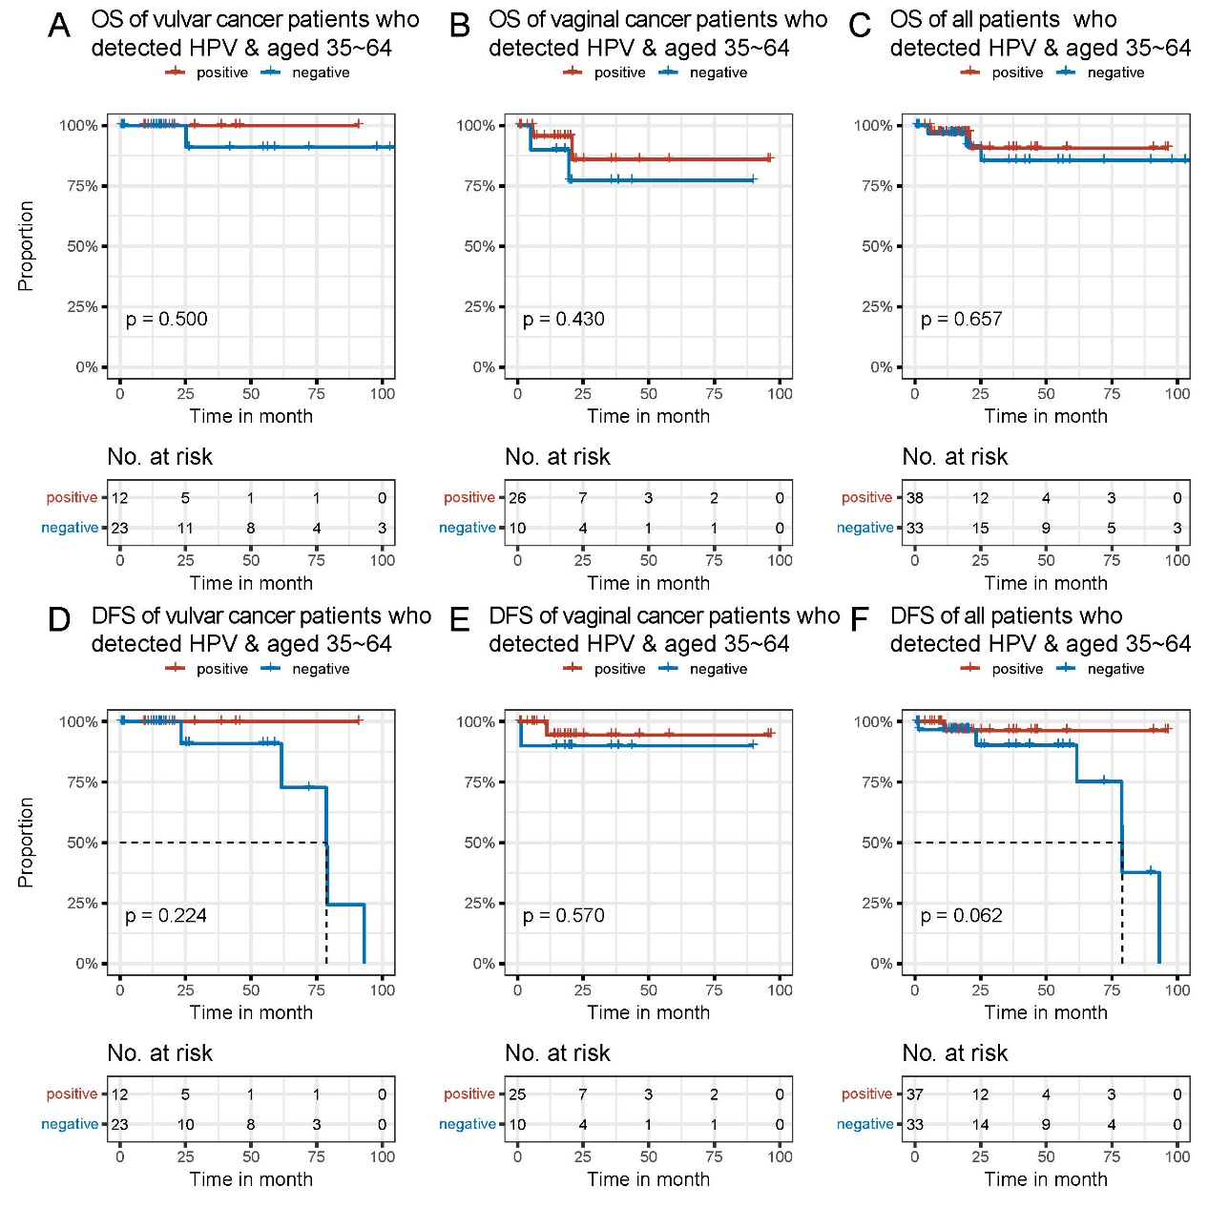
Figure S7 OS and DFS of HPV-tested patients aged 35-64 with different HPV status
(A-C) OS survival curves for HPV-tested vulvar/vaginal/vulvar and vaginal cancer patients aged 35-64 stratified by HPV status (HPV-positive vs. HPV-negative). (D-F) DFS survival curves for HPV-tested vulvar/vaginal/vulvar and vaginal cancer patients aged 35-64 stratified by HPV status (HPV-positive vs. HPV-negative). OS: overall survival, DFS: disease-free survival.

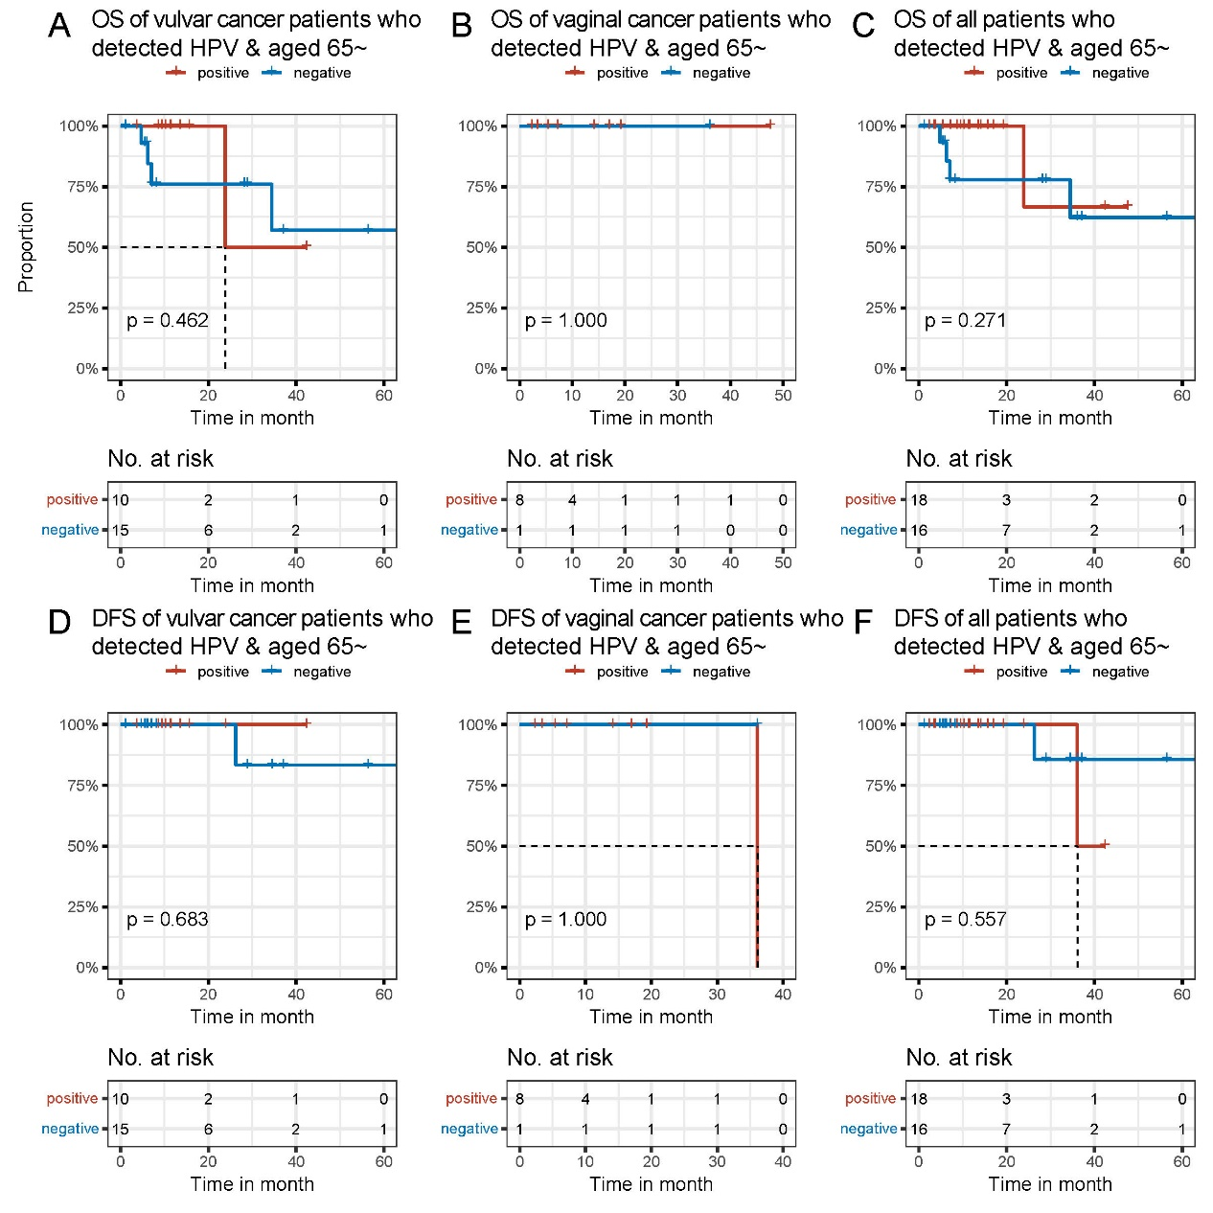
Figure S8 OS and DFS of HPV-tested patients aged 65 or older with different HPV status
(A-C) OS survival curves for HPV-tested vulvar/vaginal/vulvar and vaginal cancer patients aged 65 or older stratified by HPV status (HPV-positive vs. HPV-negative). (D-F) DFS survival curves for HPV-tested vulvar/vaginal/vulvar and vaginal cancer patients aged 65 or older stratified by HPV status (HPV-positive vs. HPV-negative). OS: overall survival, DFS: disease-free survival.

