Supplementary Material

Enhanced sorption of triclosan from aqueous solution to Rhizopus oryzae biomass biofunctionalized with lipids.

Water, Air & Soil Pollution

¹Juan José Benítez-Cortez, ²Araceli Tomasini, ²Wylma Dolores Pérez-Pérez, ³Julio César García-Martínez, ⁴Deyanira Angeles-Beltrán, ¹Héctor Hugo León-Santiestebán*

*Corresponding author:
^{1*}Héctor Hugo León Santiestebán, Universidad Autónoma Metropolitana Azcapotzalco, Departamento de Energía, Ciudad de México, México.
E-mail: hels@azc.uam.mx

¹José Benítez-Cortez, Universidad Autónoma Metropolitana-Azcapotzalco, Departamento de Energía, Ciudad de México, México.

²Araceli Tomasini, Universidad Autónoma Metropolitana-Iztapalapa, Departamento de Biotecnología, Ciudad de México, México.

²Wylma Dolores Pérez-Pérez, Iniversidad Autónoma Metropolitana-Iztapalapa, Departamento de Biotecnología, Ciudad de México, México.

³Julio César García-Martínez
Instituto Politécnico Nacional, Escuela Nacional de Ciencias Biológicas, Departamento de Biofísica, Ciudad de México, México.

⁴Deyanira Angeles-Beltrán
Universidad Autónoma Metropolitana-Azcapotzalco, Departamento de Ciencias Básicas, Ciudad de México, México.

List of Figures
Fig. S1 The main effect plots for the sorption efficiency of TCS (%S).
Fig. S2 The interaction plots for the sorption efficiency of TCS (%S).
Fig. S3 Response surface plot that shows the effect of pH and biomass dose on the sorption efficiency of TCS at 115.9 rpm.
Fig. S4 Response surface plot that shows the effect of biomass dose and agitation rate dose on the sorption efficiency of TCS at pH 5.68.
Fig. S5 Effect of lipids on the sorption isotherms of TCS. Data were modeled with the Freundlich isotherm (―).

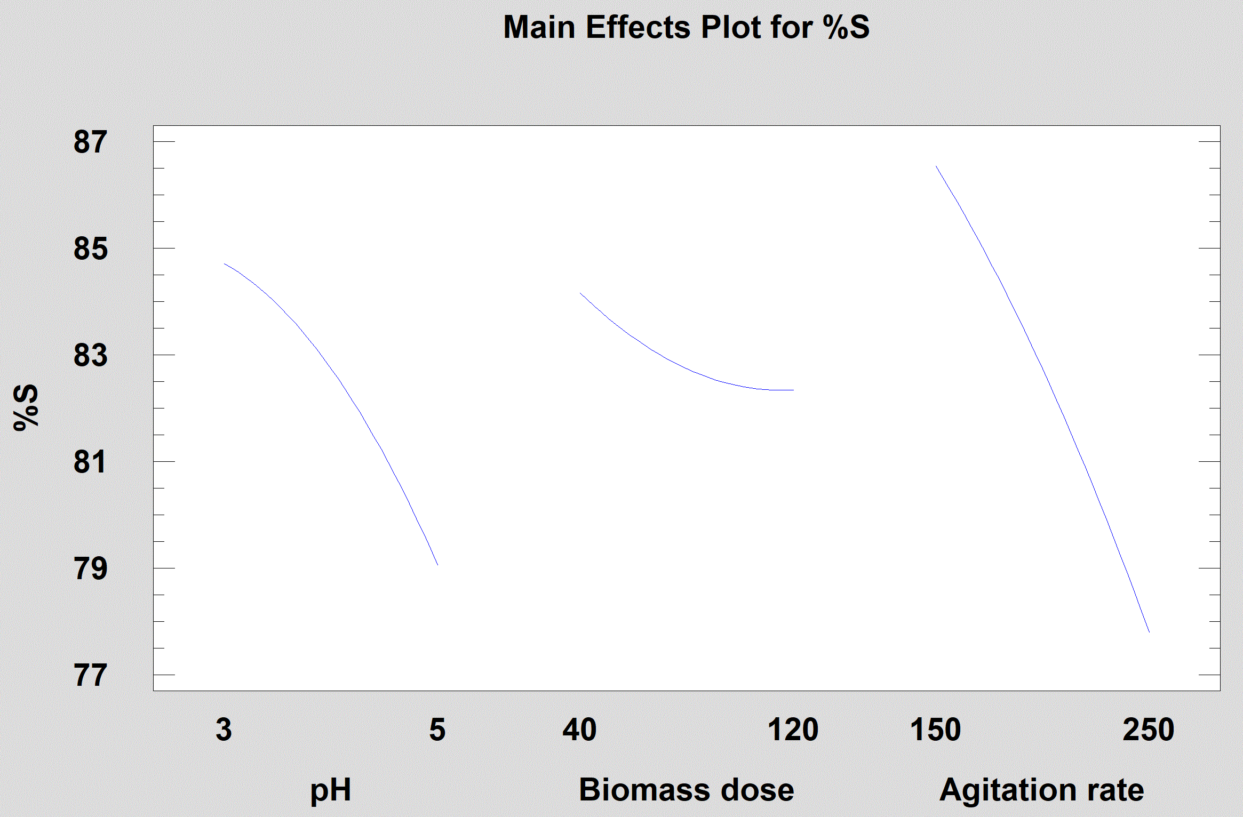
Fig. S1 The main effect plots for the sorption efficiency of TCS (%S).

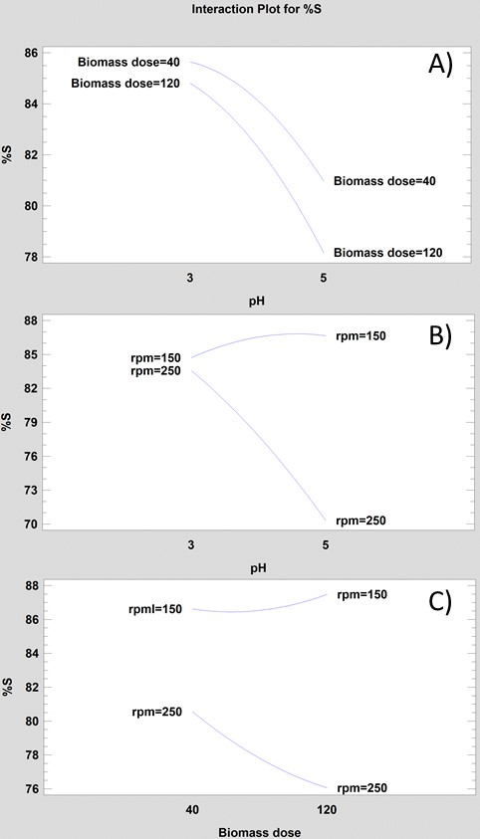
Fig. S2 The interaction plots for the sorption efficiency of TCS (%S).

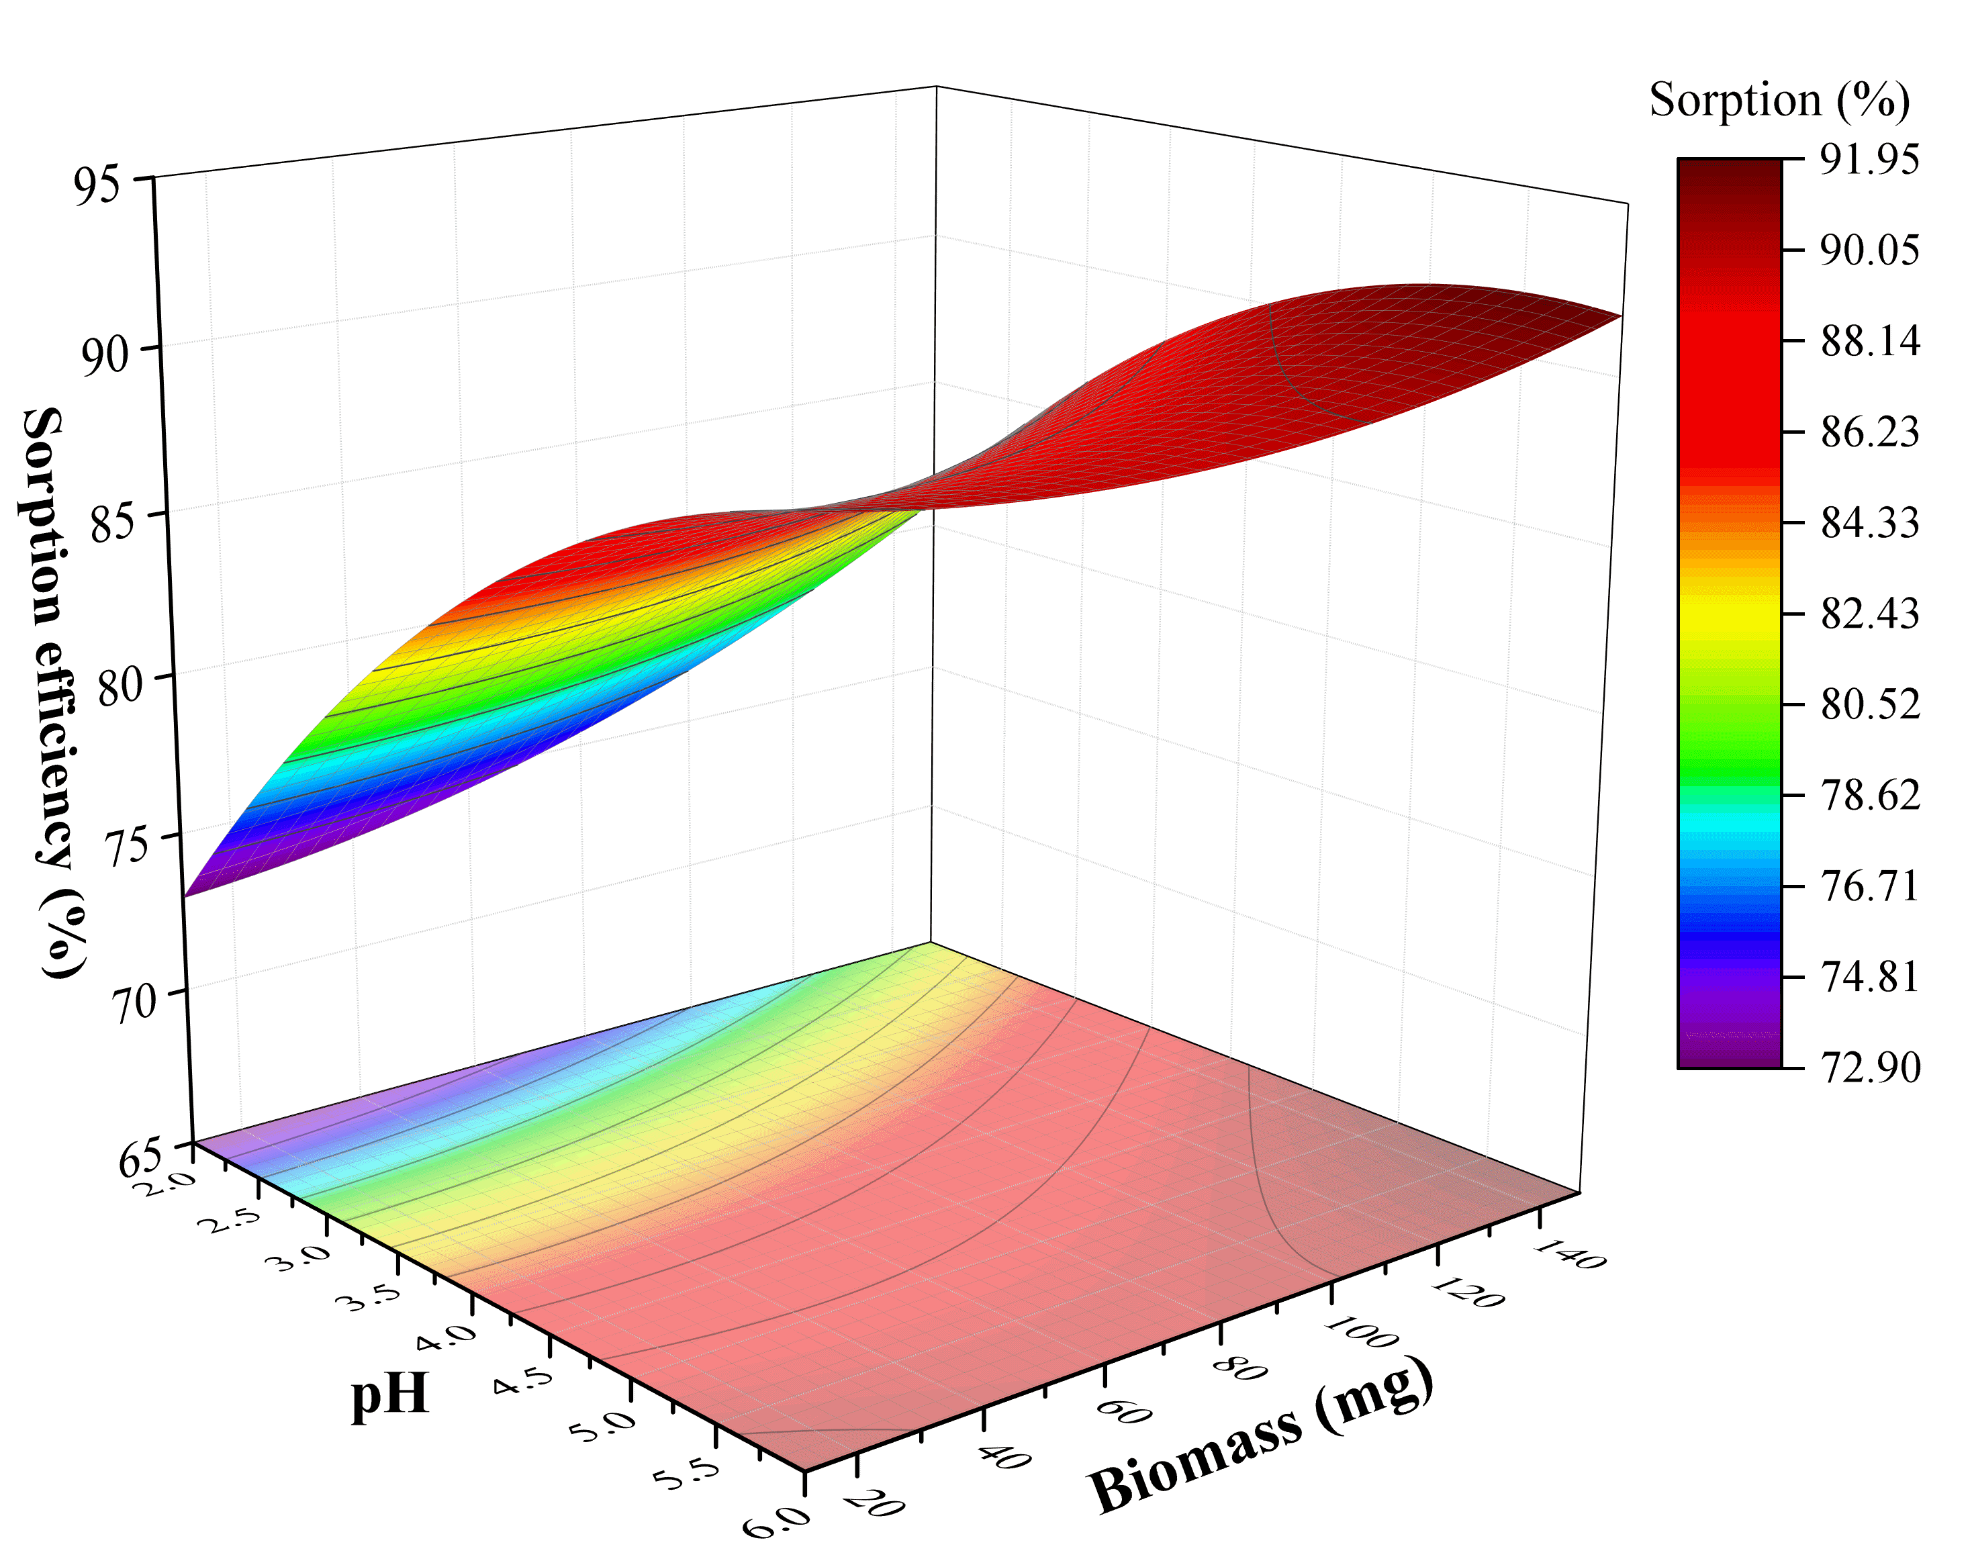
Fig. S3 Response surface plot that shows the effect of pH and biomass dose on the sorption efficiency of TCS at 115.9 rpm.

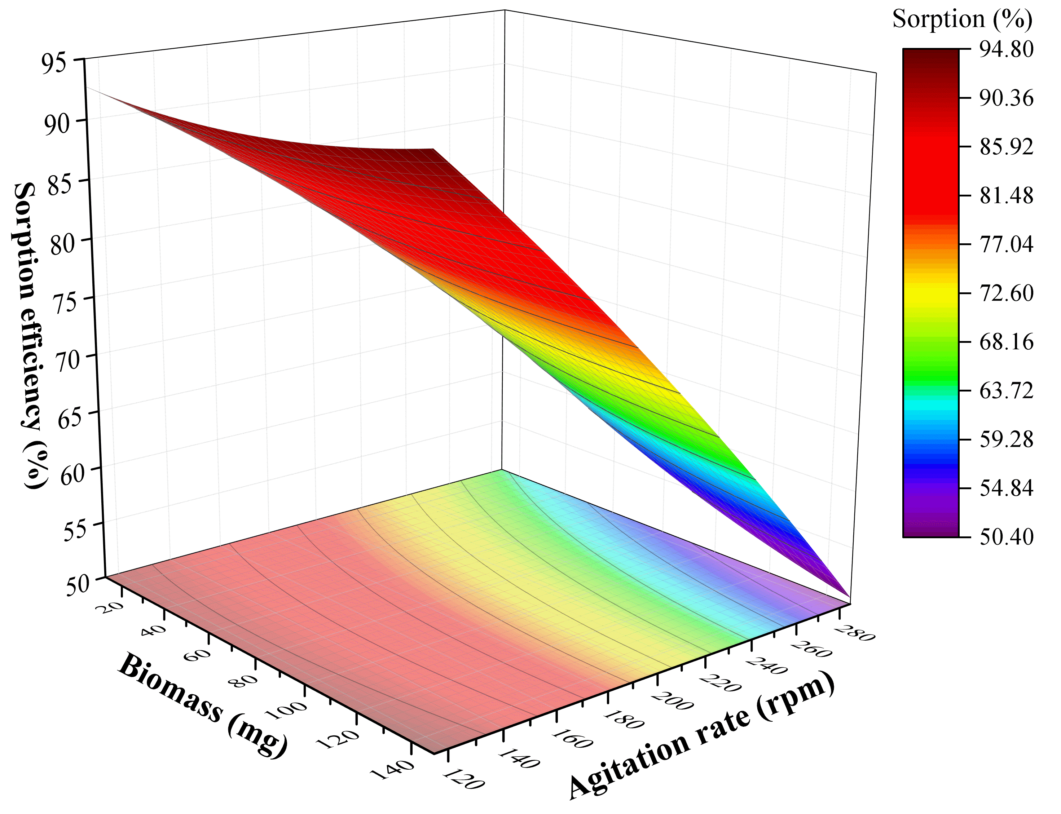
Fig. S4 Response surface plot that shows the effect of biomass dose and agitation rate dose on the sorption efficiency of TCS at pH 5.68.

Fig. S5 Effect of lipids on the sorption isotherms of TCS. Data were modeled with the Freundlich isotherm (―).

